EEE302 Control Systems
Pre-laboratory Report

Name And Number : TURHAN CAN KARGIN - 150403005
DIDEM KUCUKKAYA – 130403010
Assignment Number : 1

Objectıves of the Laboratory Assignment:

Objectives of this lab are learning MATLAB environment and how to find laplace and inverse laplace of a function.

Codes:
% CONTROL SYSTEM LAB ASSIGNMENT-1
% TURHAN CAN KARGIN 150403005
% DIDEM KUCUKKAYA 130403010

clear all % clears all variable definitions
close all % closes all figures
clc % clears the screen

syms s w t u b a % Creating Symbolic Variables

%QUESTION-1)

A=((3*exp(-5*t)*cos(t))-exp(-5*t)*sin(t));
A_Laplace=laplace(A)

%QUESTION-2)

B=(dirac(t)+2*heaviside(t-3)+(a*(t^2))+b*t*sin(w*t));
B_laplace=laplace(B)

%QUESTION-3)

C=((s+4)/(s^2+5*s+6));
C_inverse=ilaplace(C)

%QUESTION-4)

D=((11*s+28)/(((s+2)^2)*(5+s)));
D_inverse=ilaplace(D)

%QUESTION-4,With Partial Fraction

D_partfrac=partfrac(D);
D_inverse2=ilaplace(D_partfrac)

% COMMAND WINDOW

A_Laplace =

(3*(s + 5))/((s + 5)^2 + 1) - 1/((s + 5)^2 + 1)

B_laplace =

(2*exp(-3*s))/s + (2*a)/s^3 + (2*b*s*w)/(s^2 + w^2)^2 + 1

C_inverse =

2*exp(-2*t) - exp(-3*t)

D_inverse =

3*exp(-2*t) - 3*exp(-5*t) + 2*t*exp(-2*t)

D_inverse2 =

3*exp(-2*t) - 3*exp(-5*t) + 2*t*exp(-2*t)

Solutıons:

Question-1 :

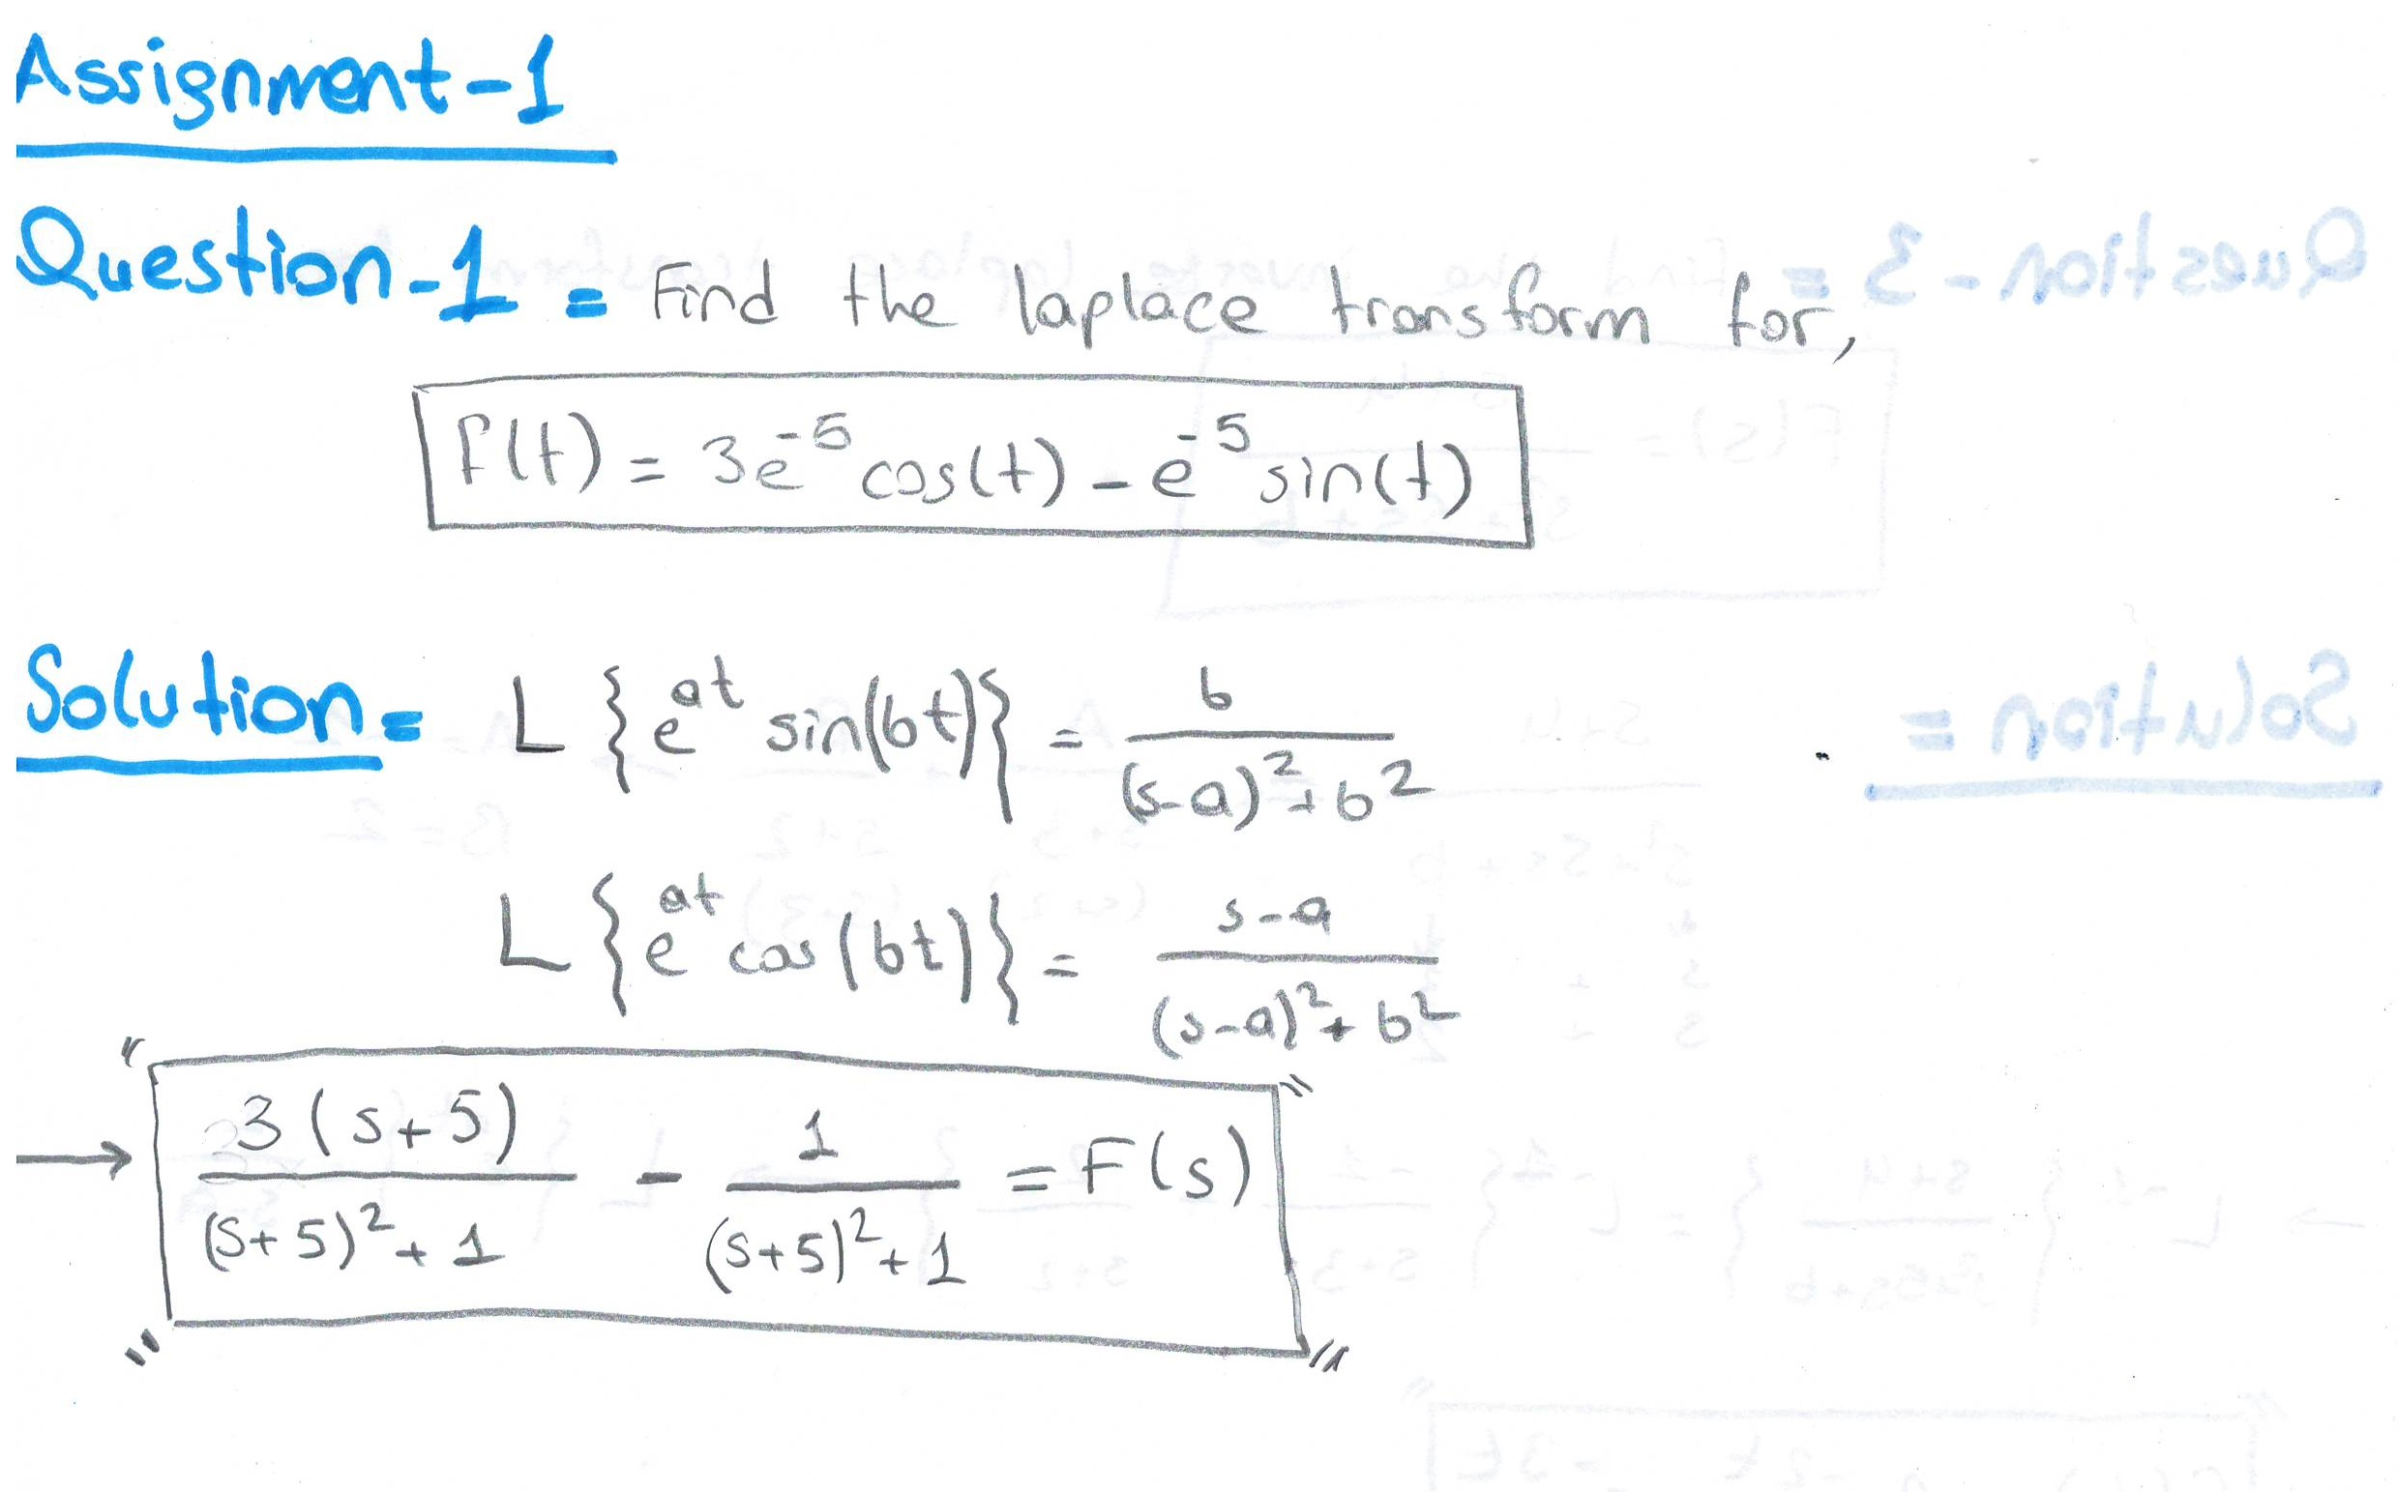

Question-2 :

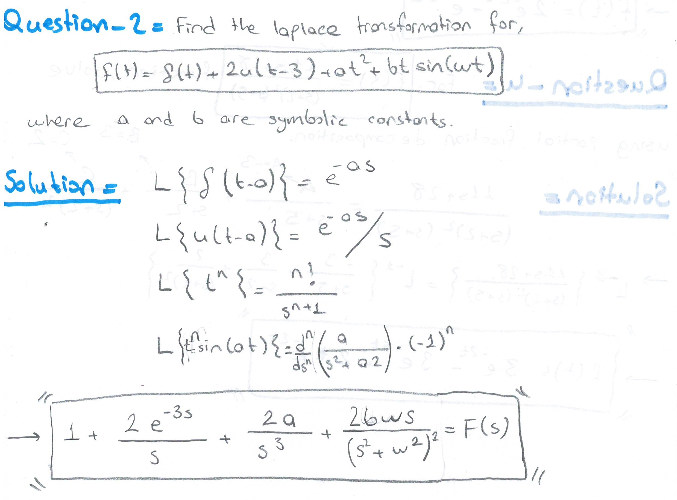

Question-3:

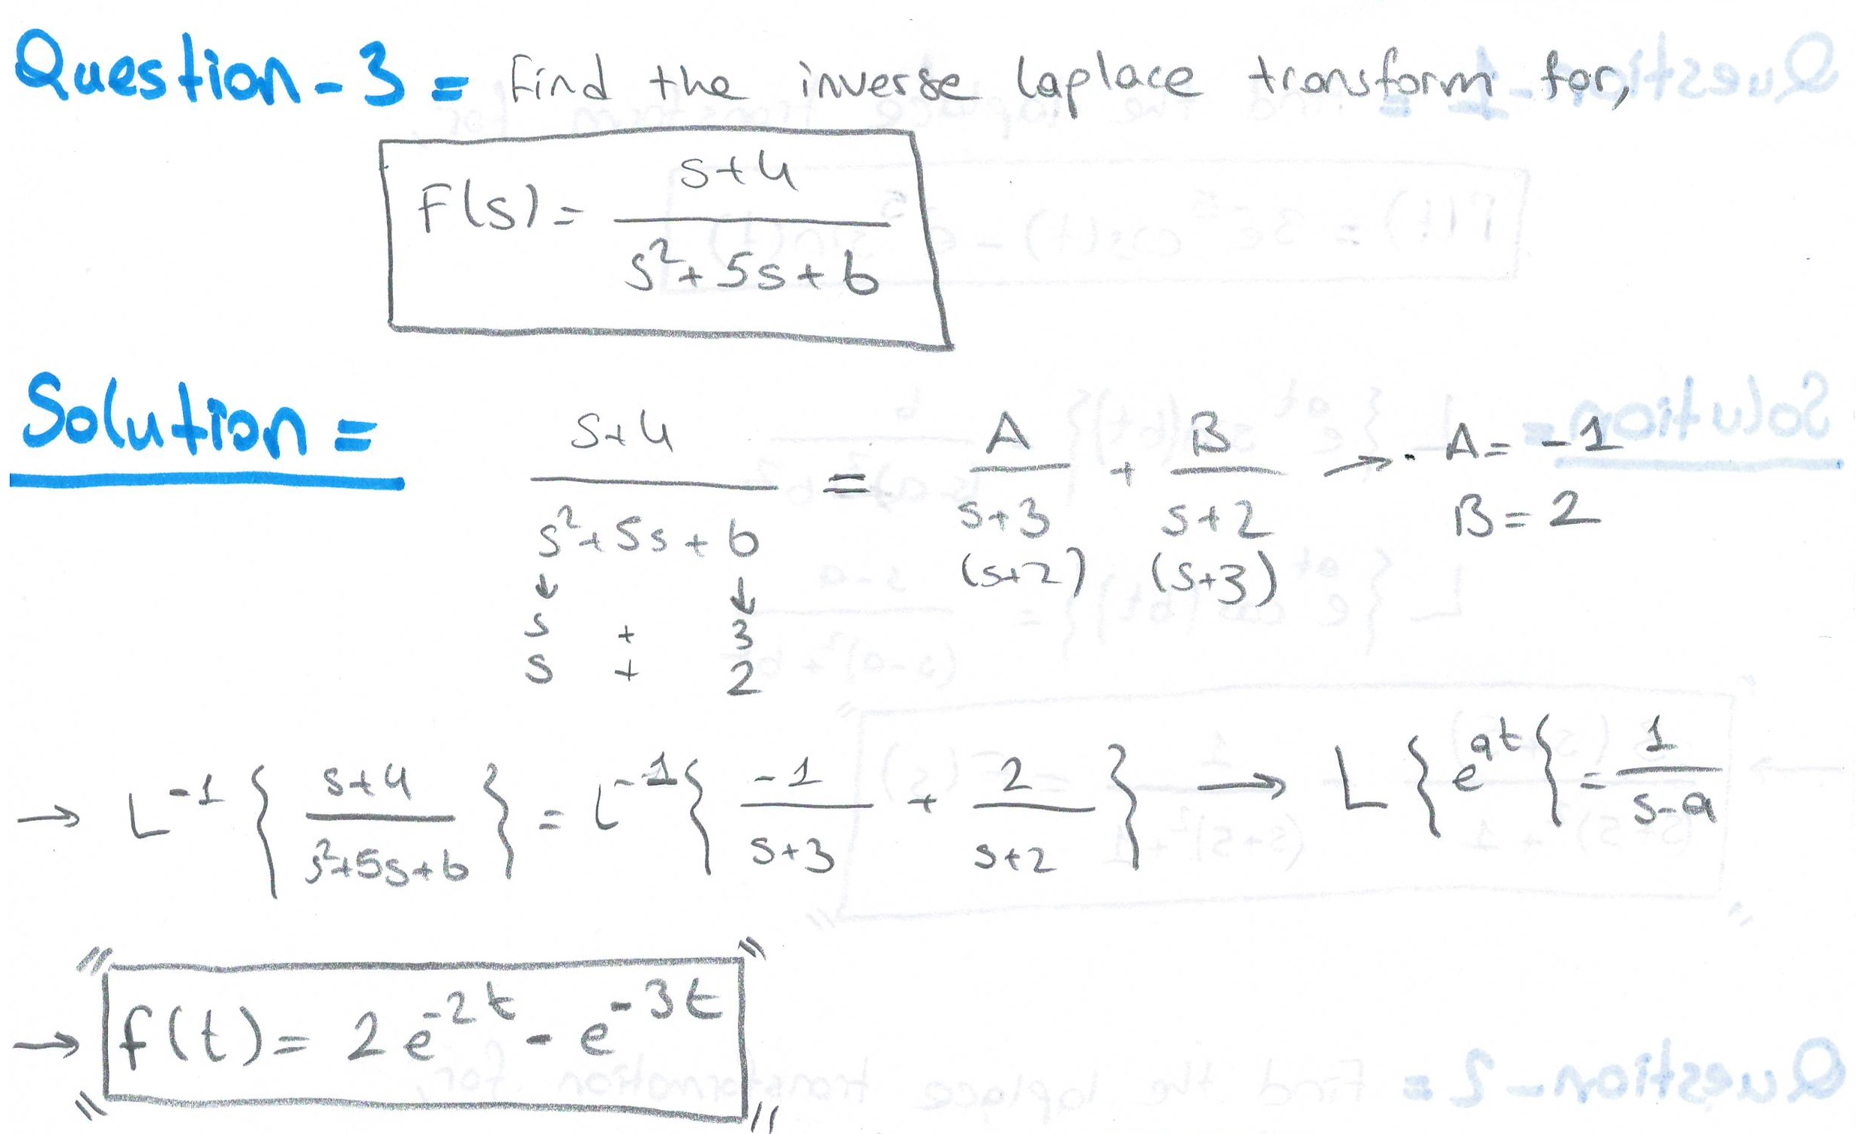

Question-4 :

