EEE302 Control Systems
Pre-laboratory Report

Name And Number : TURHAN CAN KARGIN - 150403005
Assignment Number : 2

Objectıves of the Laboratory Assignment:

Objectives of this lab are learning how to reduce of a block diagram with series, parallel or feedback connection by using MATLAB.

Codes:
% CONTROL SYSTEM LAB ASSIGNMENT-2
% TURHAN CAN KARGIN 150403005

clear all % clears all variable definitions
close all % closes all figures
clc % clears the screen

%QUESTION-1)
G1=tf(10,[1 2 10]);
G2=tf(5,[1 5]);
Gk_1=feedback(G1*G2,0) % Series
Gk_2=feedback(G1+G2,0) % Parallel

%QUESTION-2)
G=tf(10,[1 2 10]);
H=tf(5,[1 5]);
Gk_3=feedback(G,H) %'+'
Gk_4=feedback(G,-H) %'-'

%QUESTION-3)
G1_1=tf(2,[1 9 8]);
H=0.2;
G3_1=tf([1],[1 0]);
G2_1=4;
Z=feedback(G1_1,H)
GL=feedback(Z*G2_1*G3_1,1)

% COMMAND WINDOW

Gk_1 =

50
-----------------------
s^3 + 7 s^2 + 20 s + 50

Gk_2 =

5 s^2 + 20 s + 100
-----------------------
s^3 + 7 s^2 + 20 s + 50

Gk_3 =

10 s + 50
------------------------
s^3 + 7 s^2 + 20 s + 100

Gk_4 =

10 s + 50
------------------
s^3 + 7 s^2 + 20 s

Z =

2
---------------
s^2 + 9 s + 8.4

GL =

8
-----------------------
s^3 + 9 s^2 + 8.4 s + 8

Solutıons:

Question-1 :

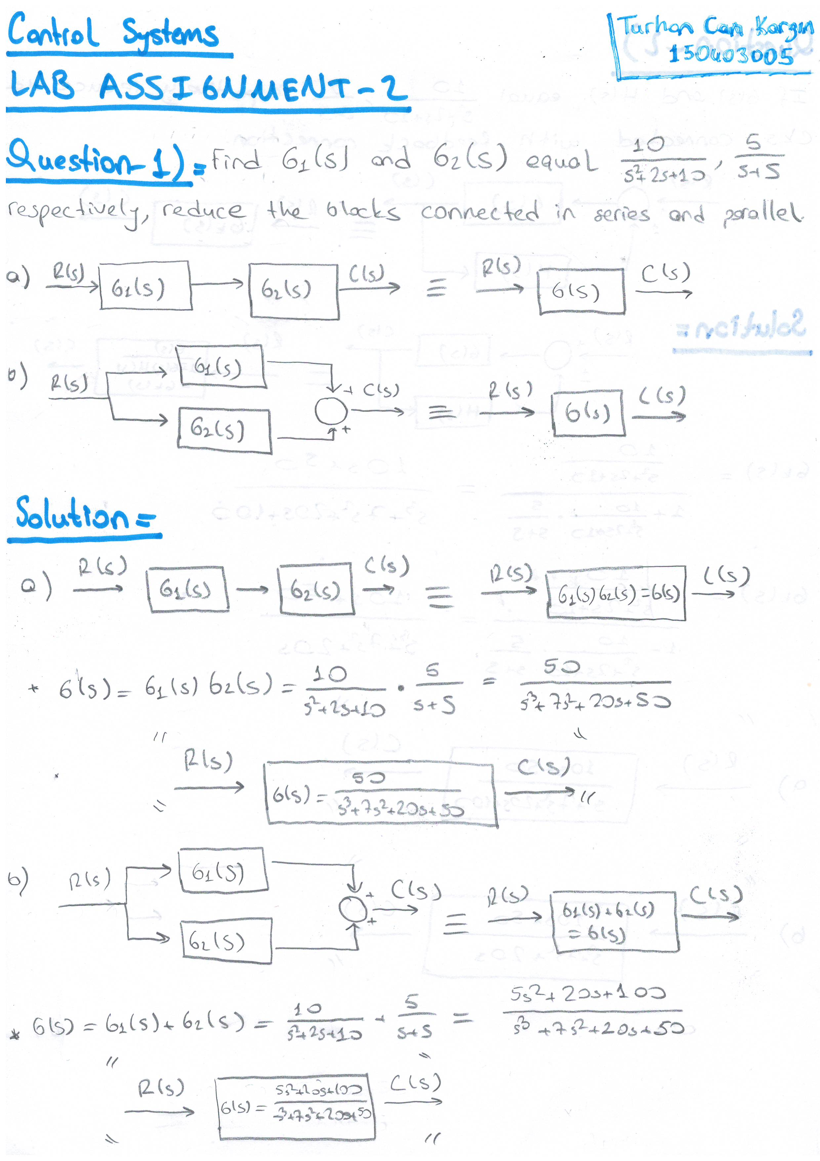

Question-2 :

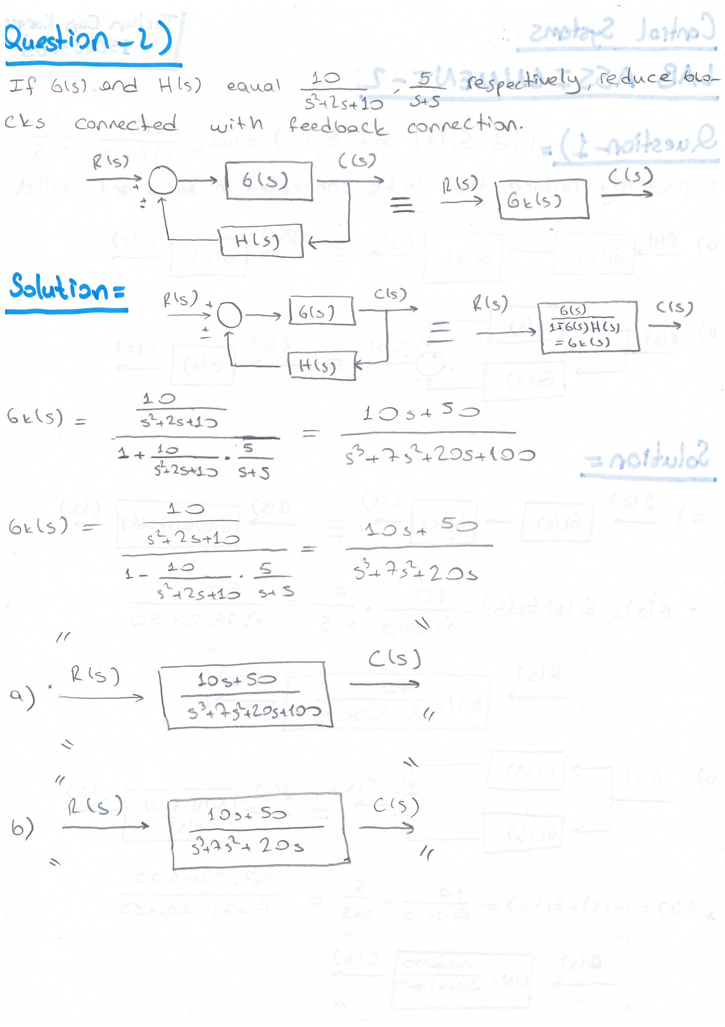

Question-3:

