EEE302 Control Systems
Pre-laboratory Report

Name And Number : TURHAN CAN KARGIN - 150403005
Assignment Number : 3

Objectıves of the Laboratory Assignment:

Objectives of this lab are learning and observing the changes of the control input and system output and comparing P, PD, PI and PID controller performances.

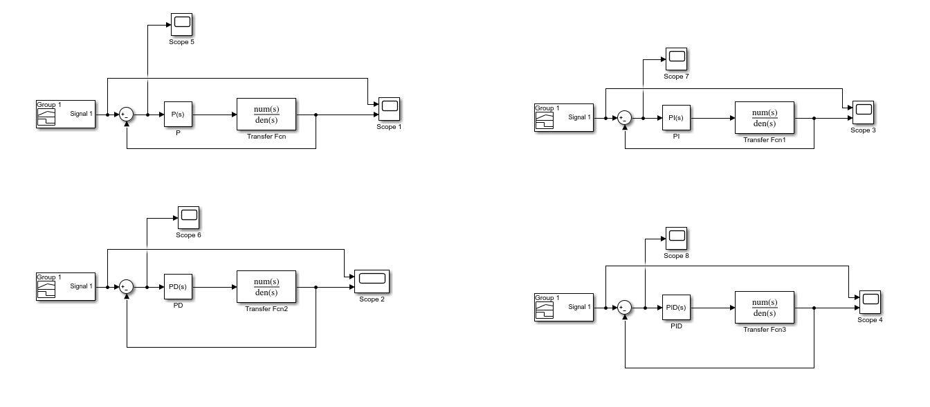
Simulink:

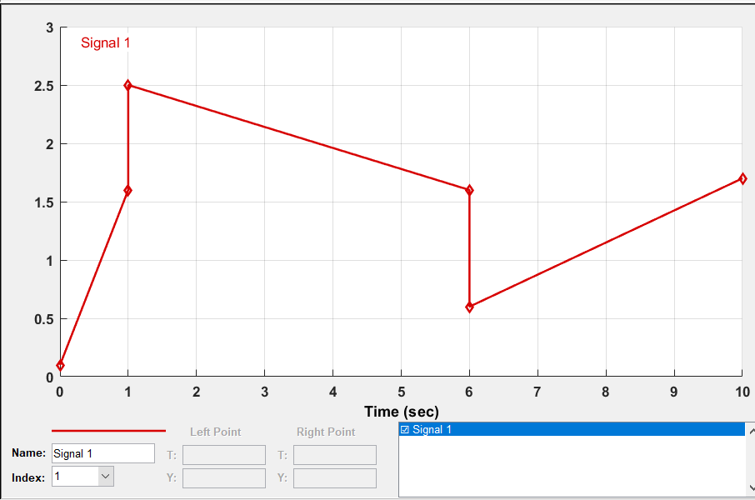

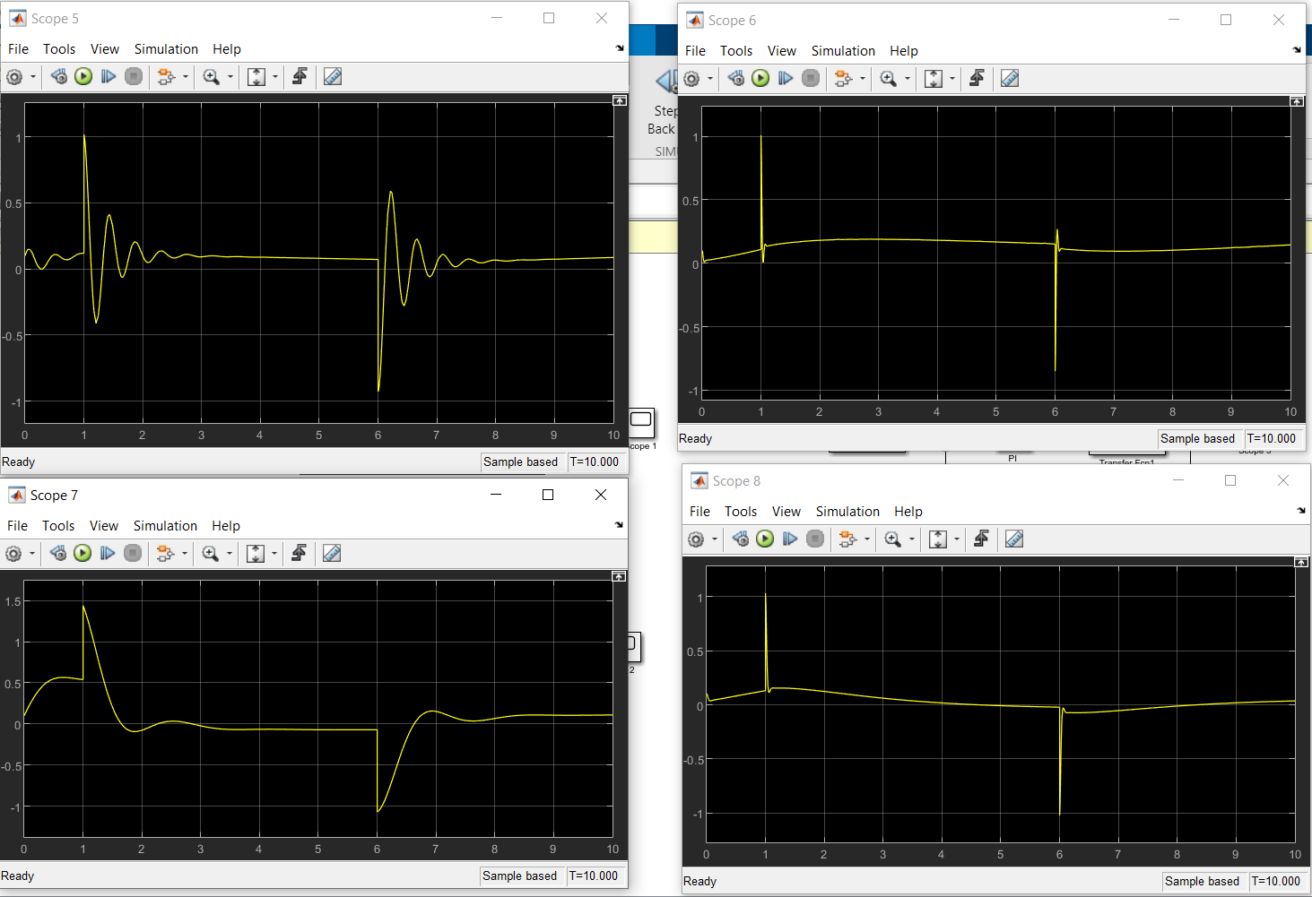
Control Input:

System Outputs:
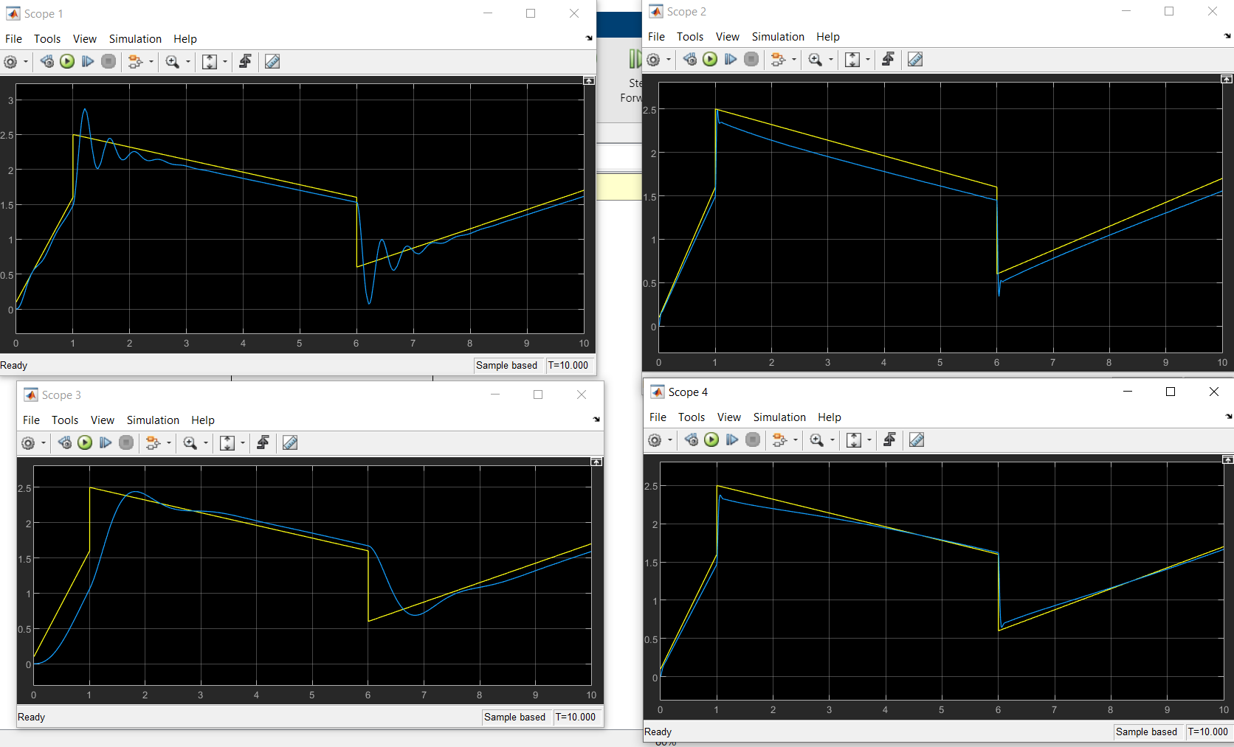

By Using PID TUNER:

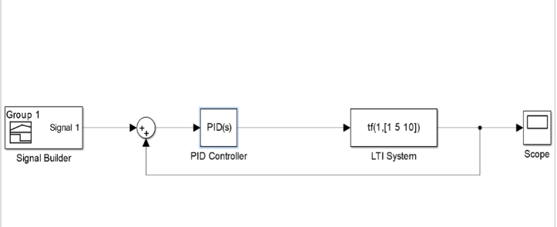

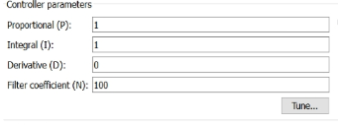
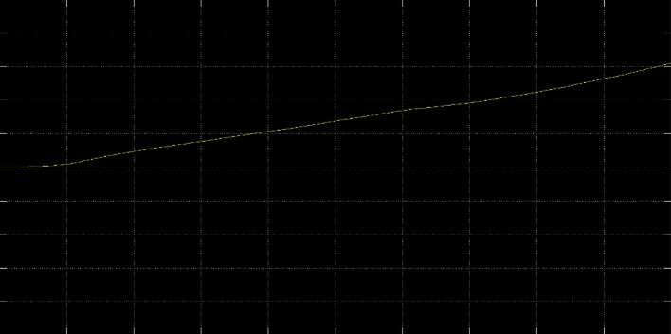

After Tuning

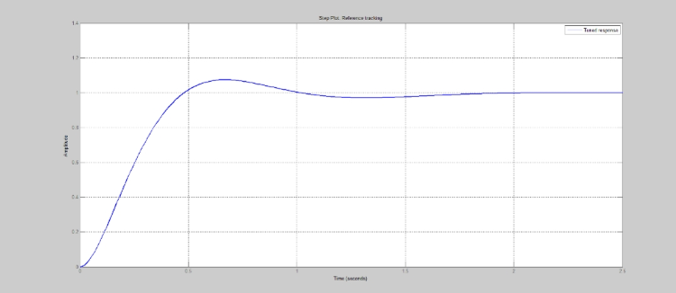
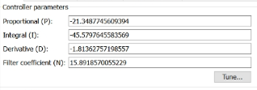

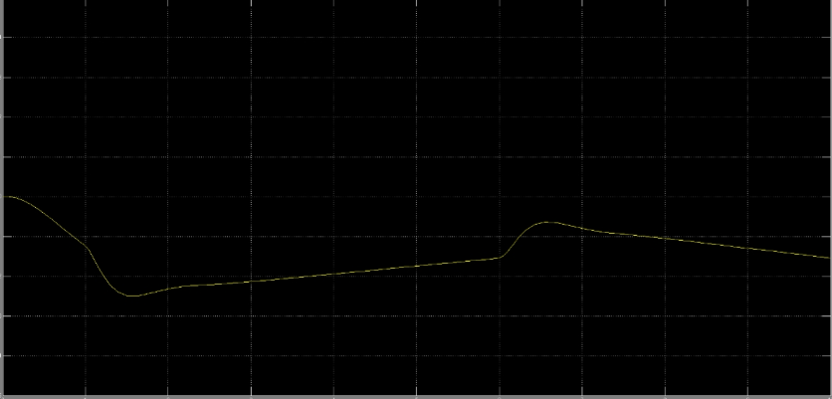

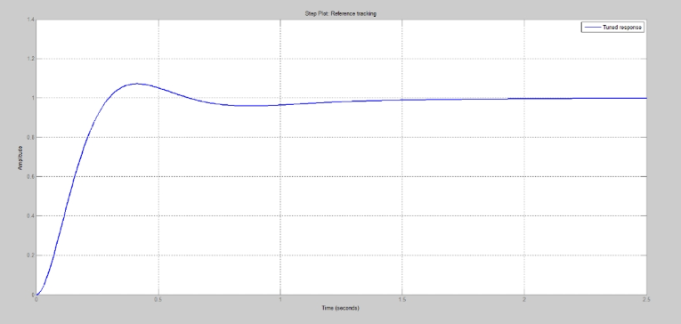

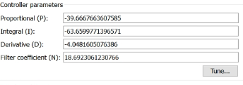

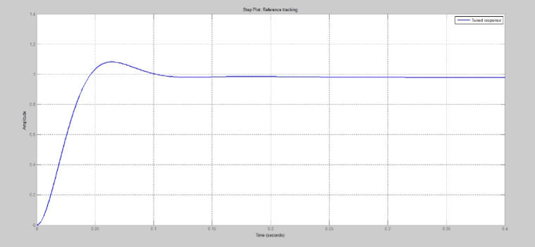

From the Above figures of response of system obtained on updating PID coeffeffient using PIDtuning feature of controller along with hit and trail method for error the following observations can be summed up in table given below:
