EEE302 Control Systems
Pre-laboratory Report

Name And Number : TURHAN CAN KARGIN - 150403005
Assignment Number : 4

Objectıves of the Laboratory Assignment:

Objectives of this lab are learning to draw root locus on MATLAB and observing Kp range change in Simulink.

Question-1 (On Paper)

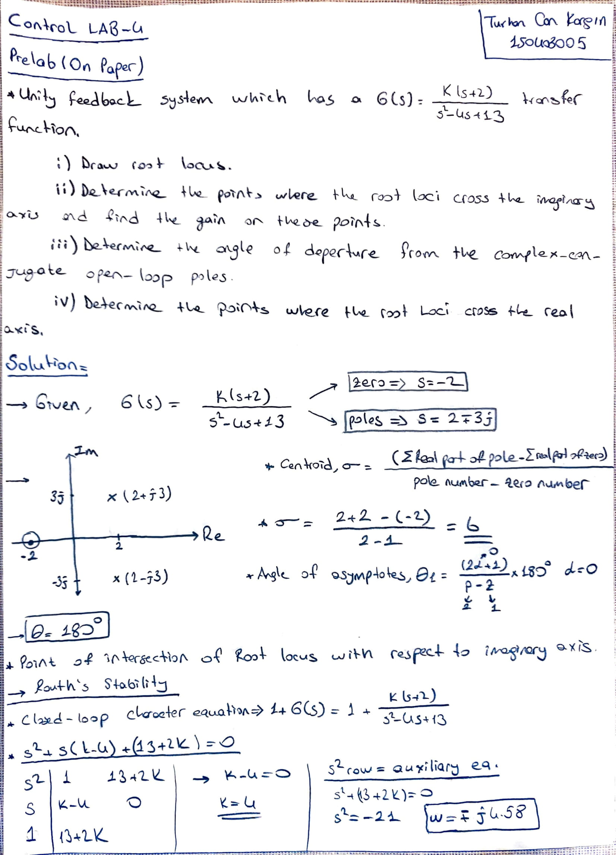
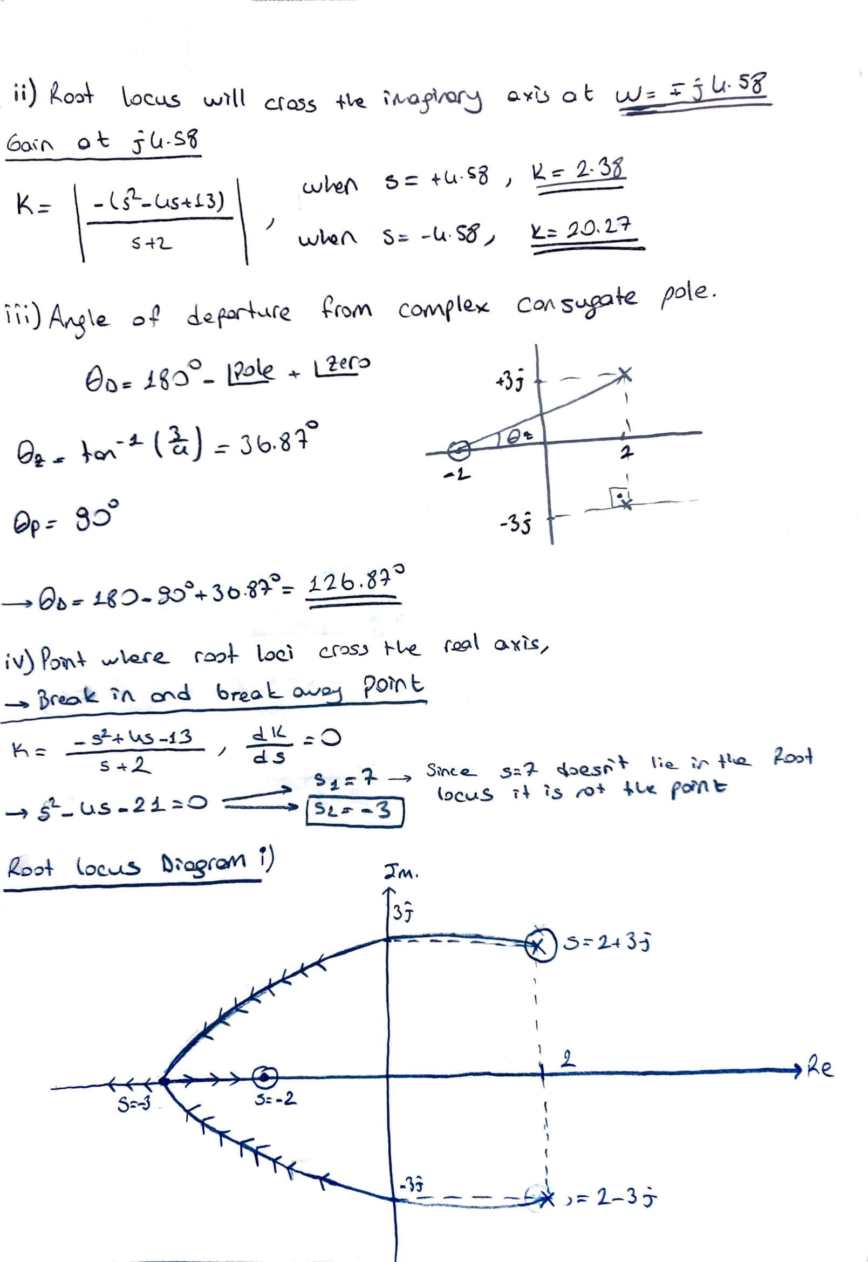
question-2 (On Paper)

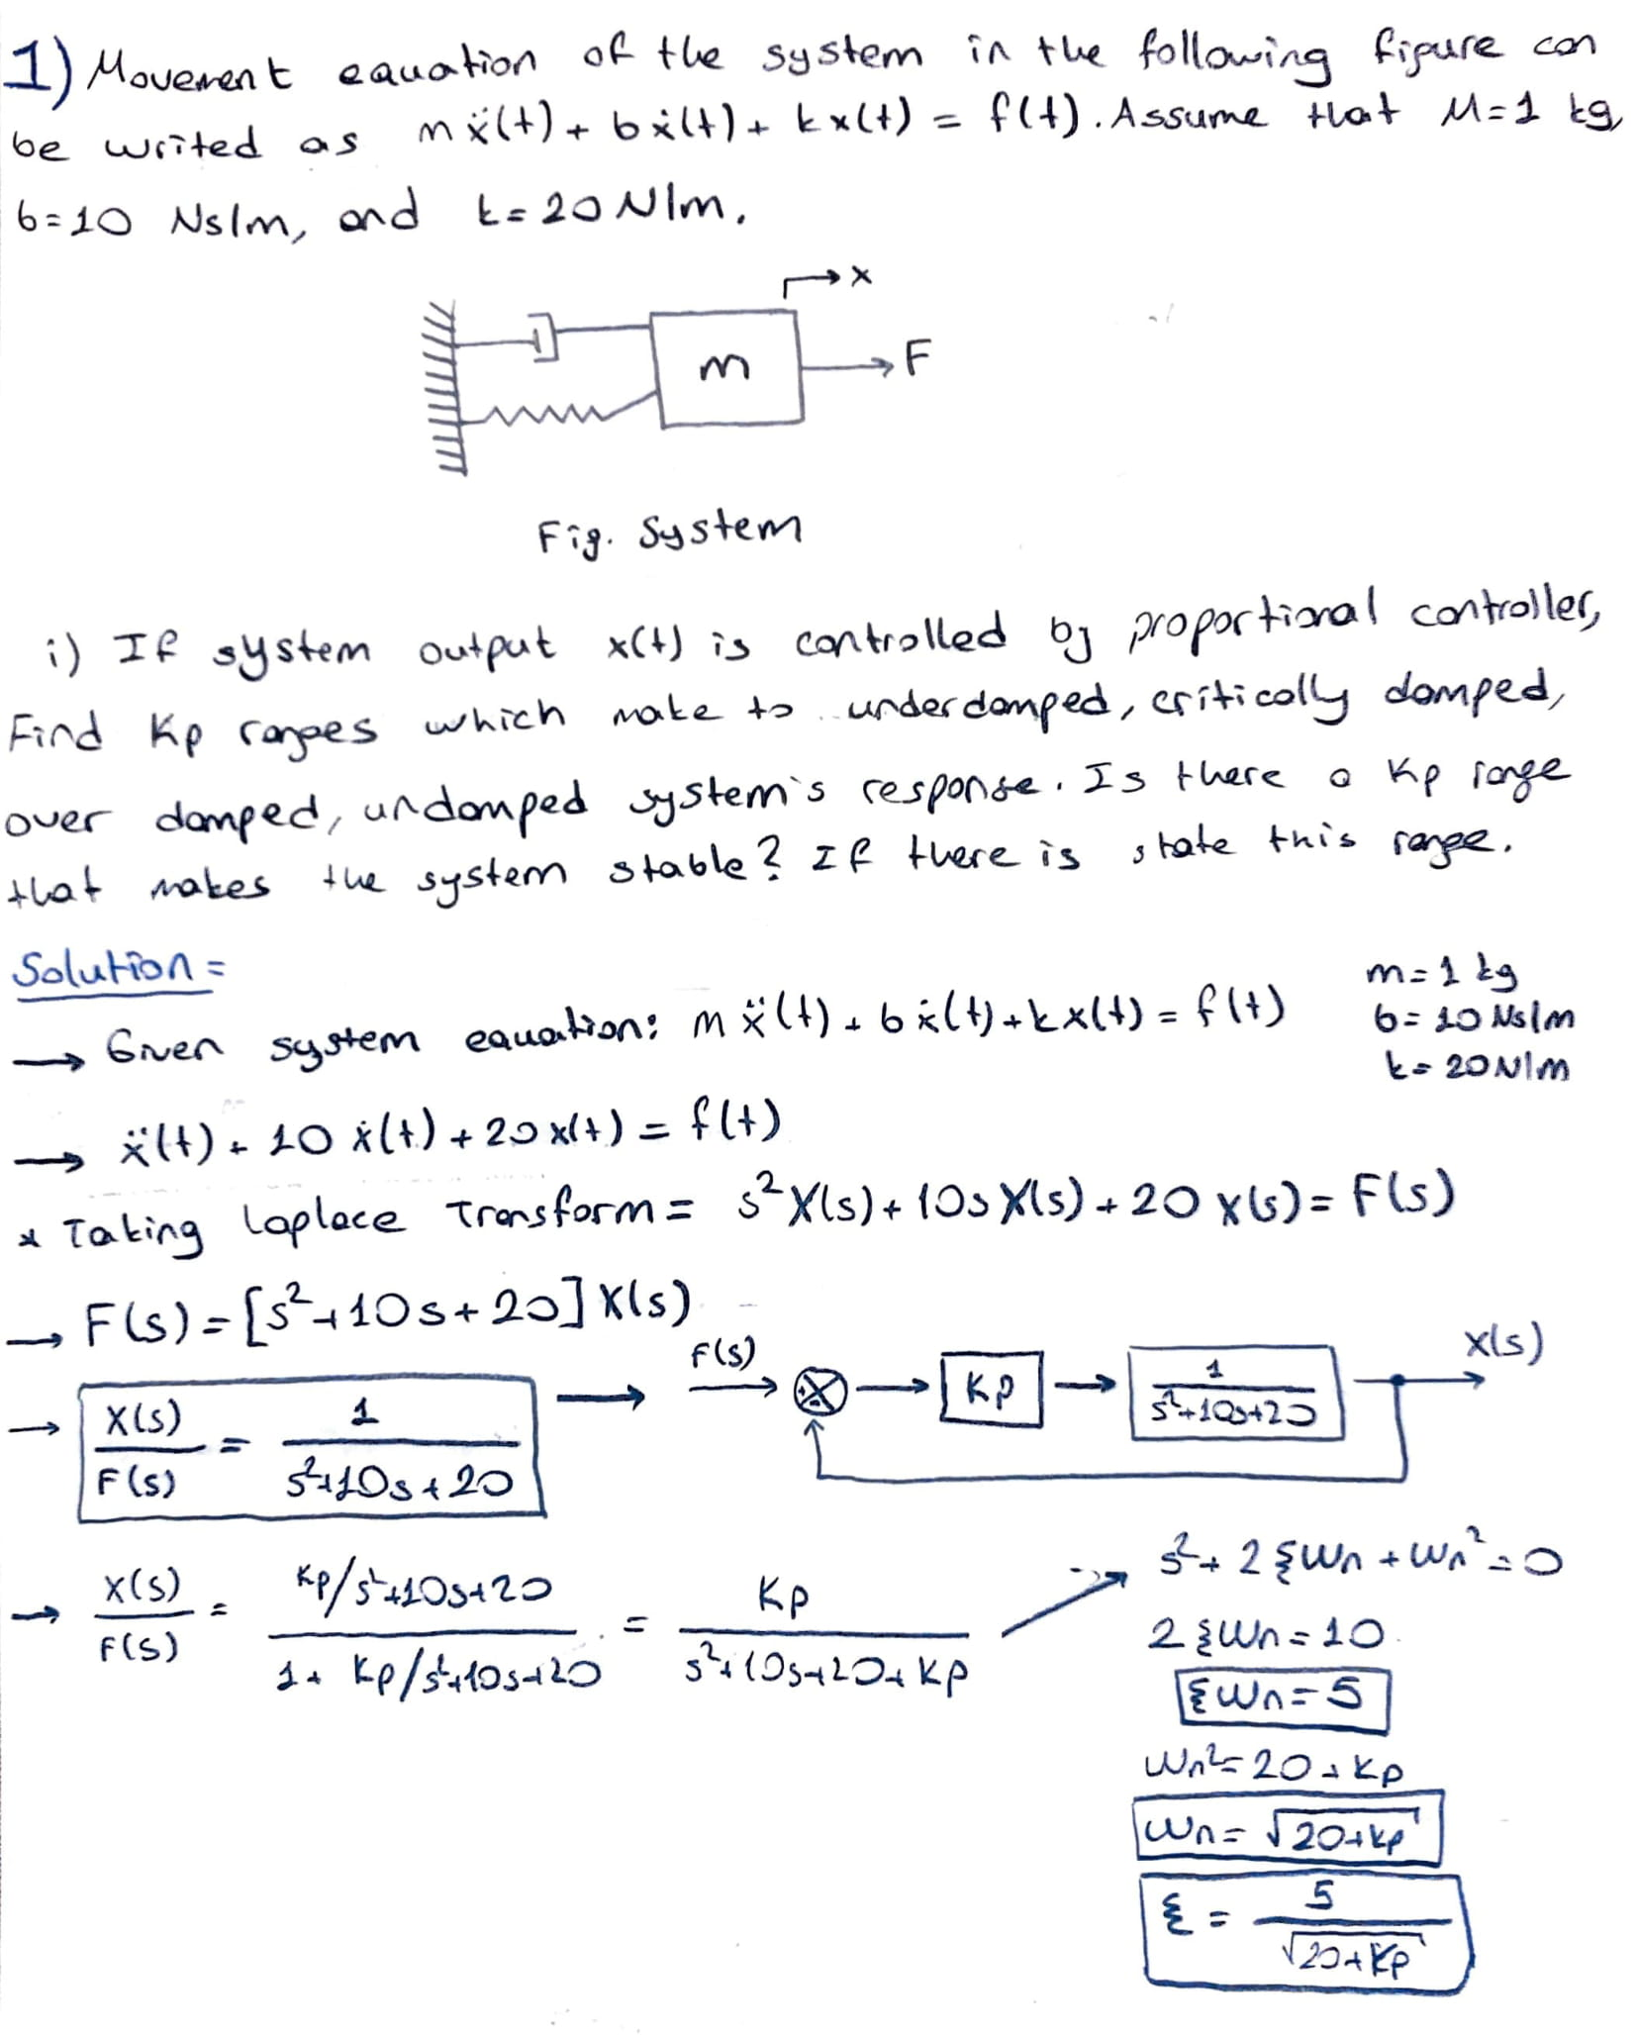

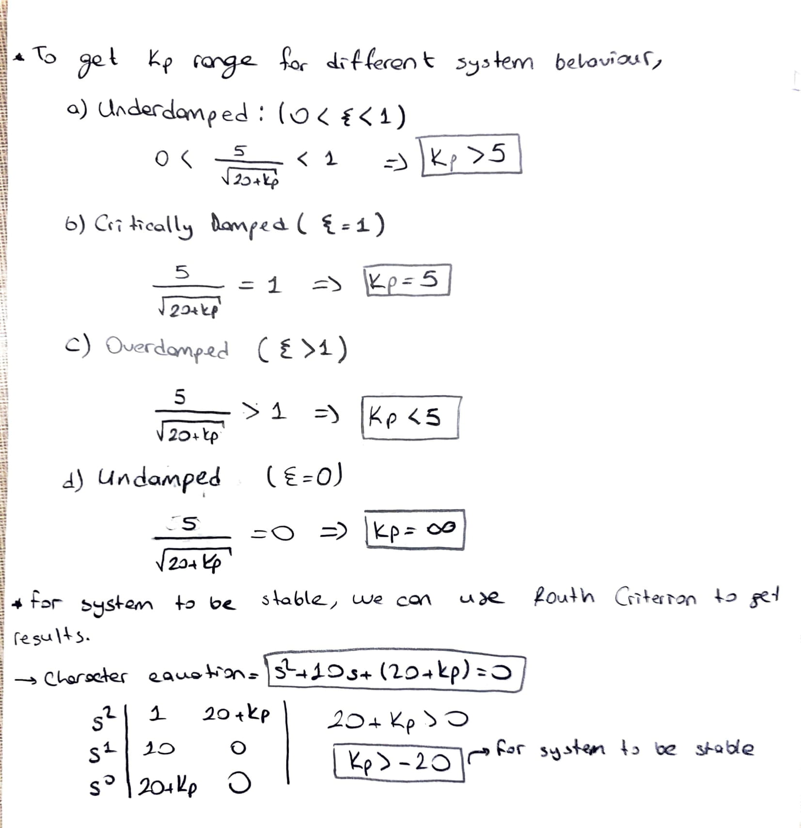

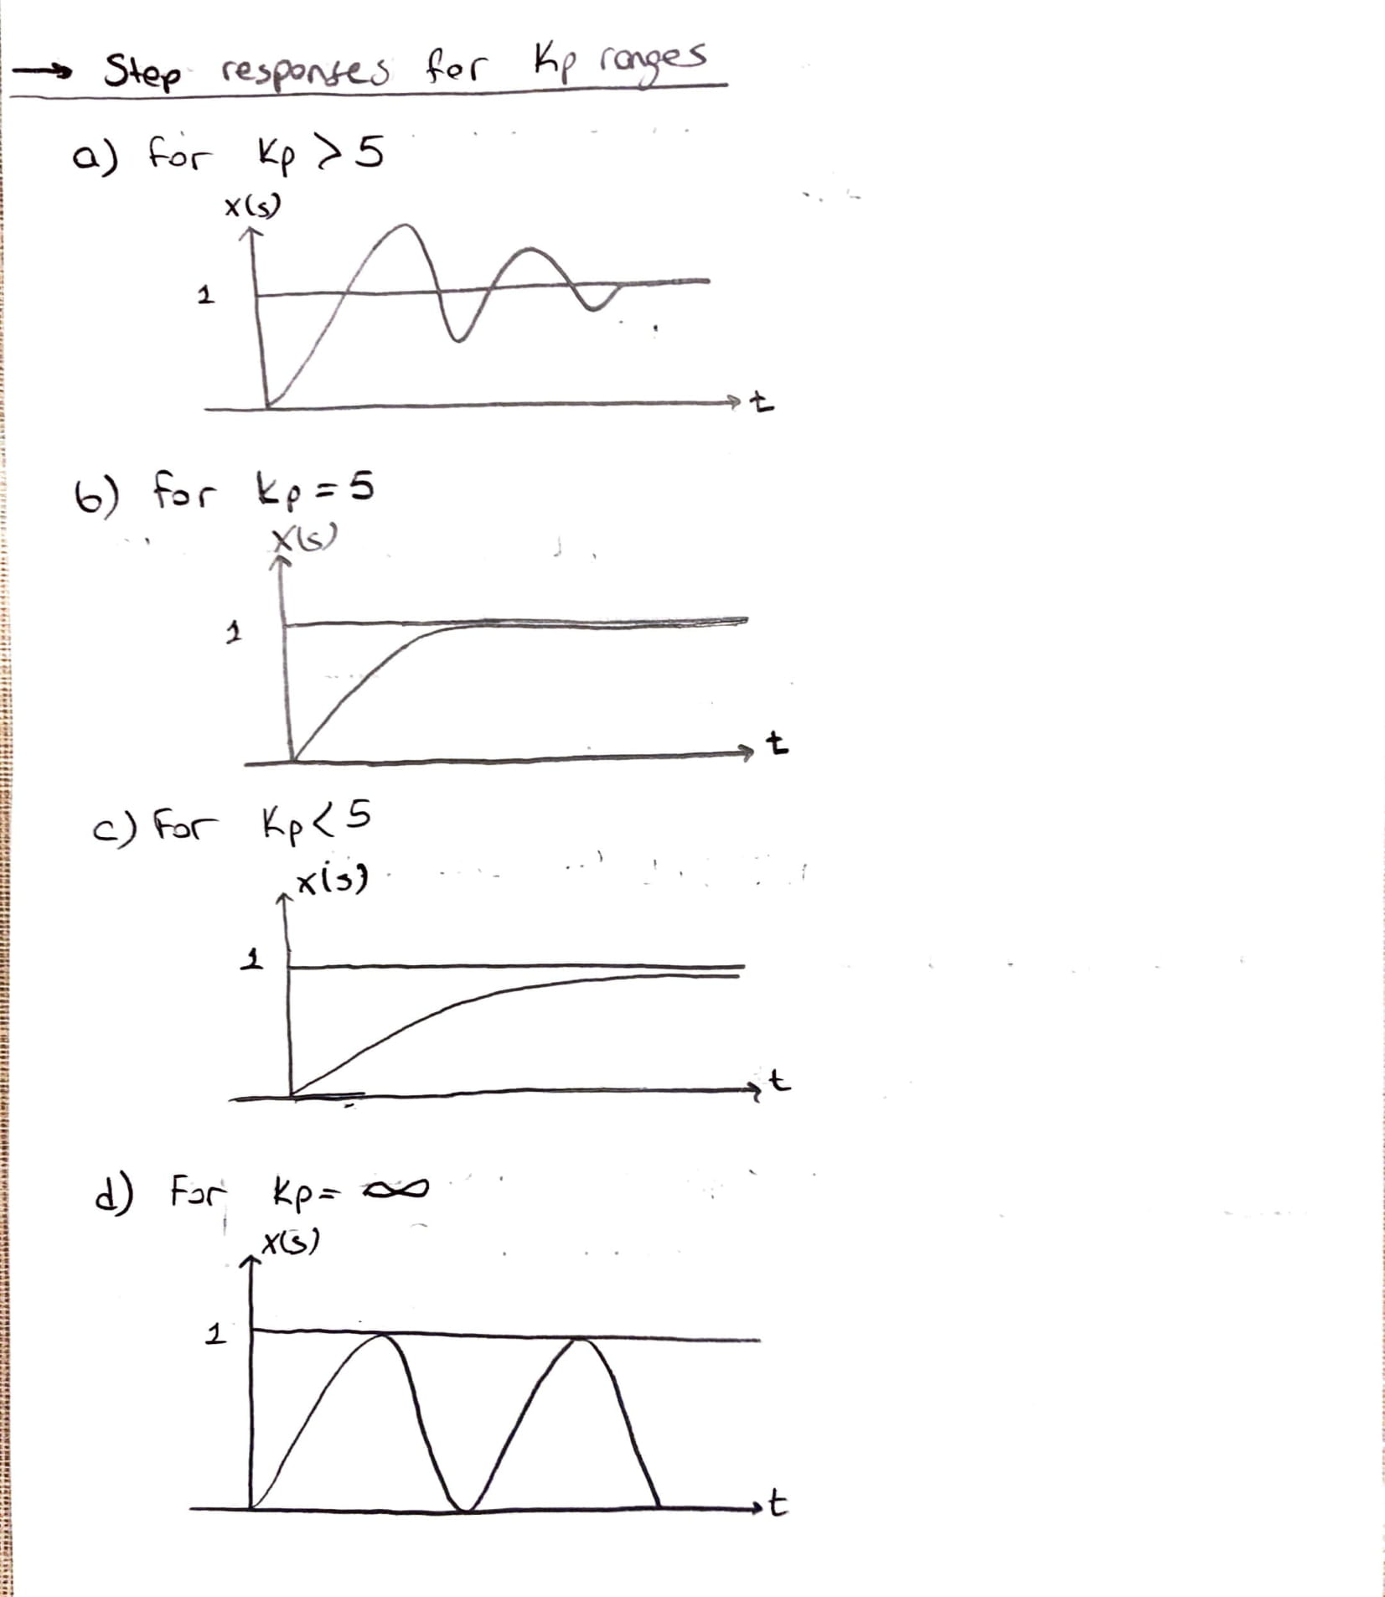

Question-2 (Simulink)

Kp = 1, 5, 100, and very high respectively.

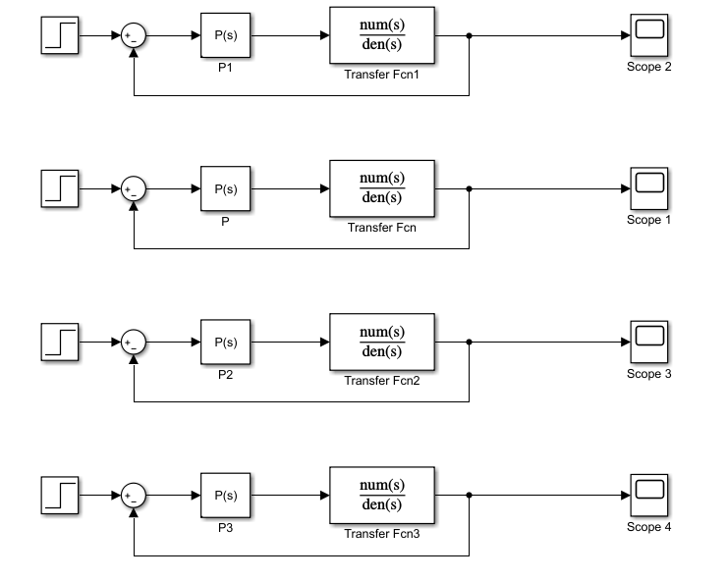

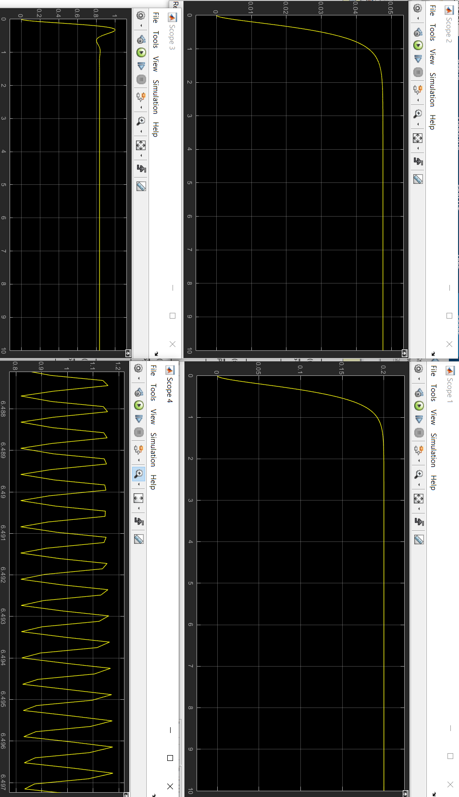

Question-2 (M-file)

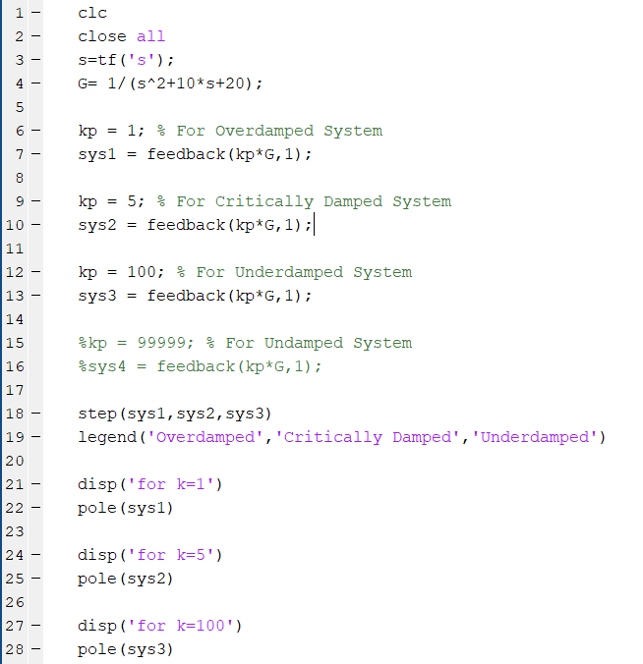

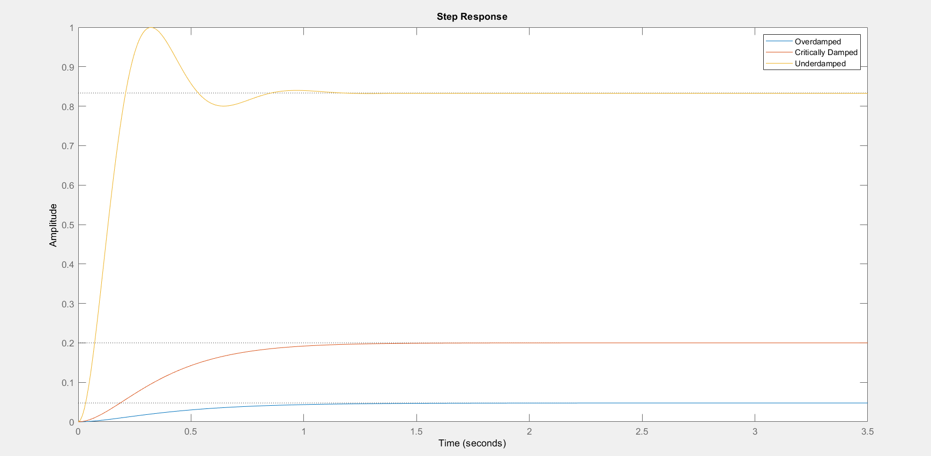

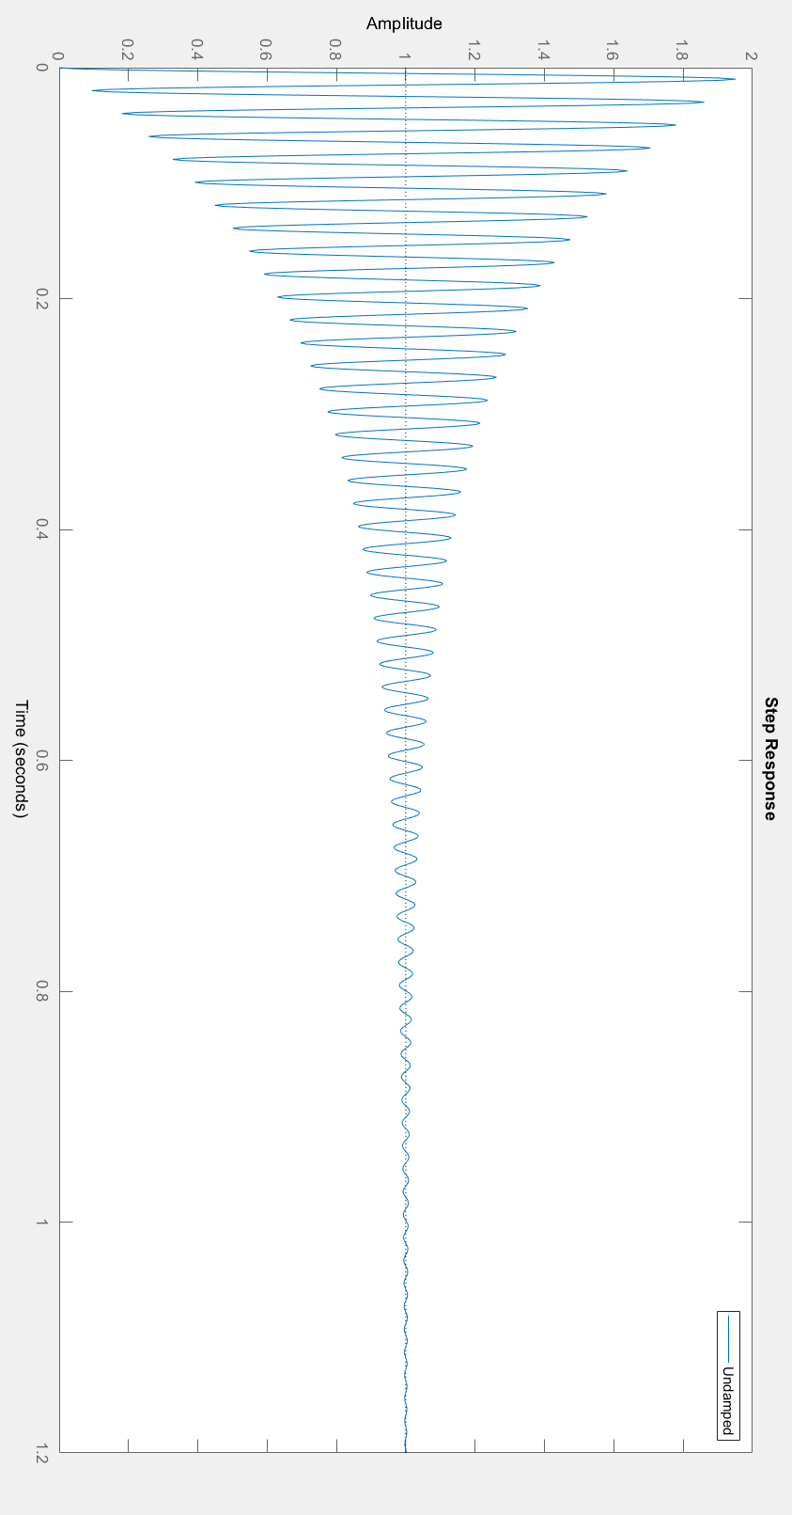

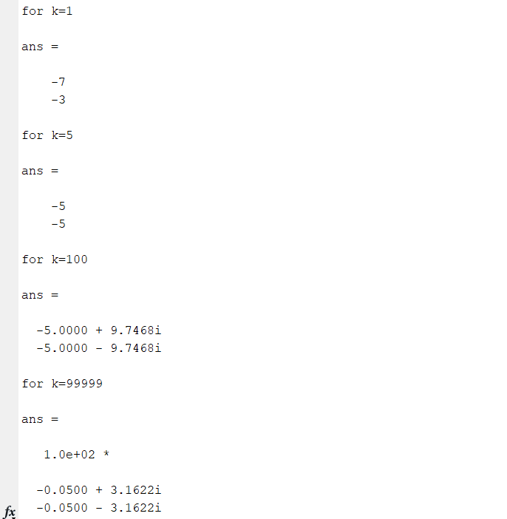

Question-3 (M-file)

A-
clc;

% Question A
num=[1]; % Numerator
denum=[1 1]; % Denominator
sys=tf(num,denum) % Transfer Function
rlocus(sys) % Root Locus

% i
num=[1];
denum2=[1 3 2];
sys2=tf(num,denum2)
rlocus(sys2)

% ii
num=[1];
denum3=[1 5 4];
sys3=tf(num,denum3)
rlocus(sys3)

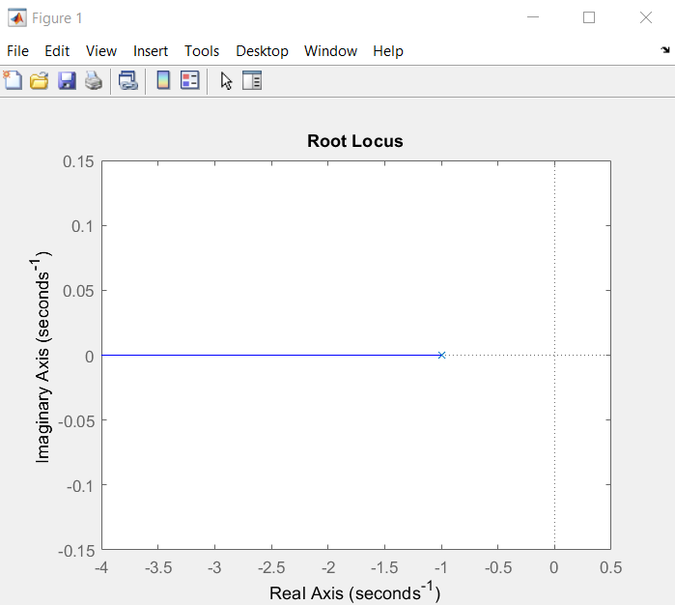

I)

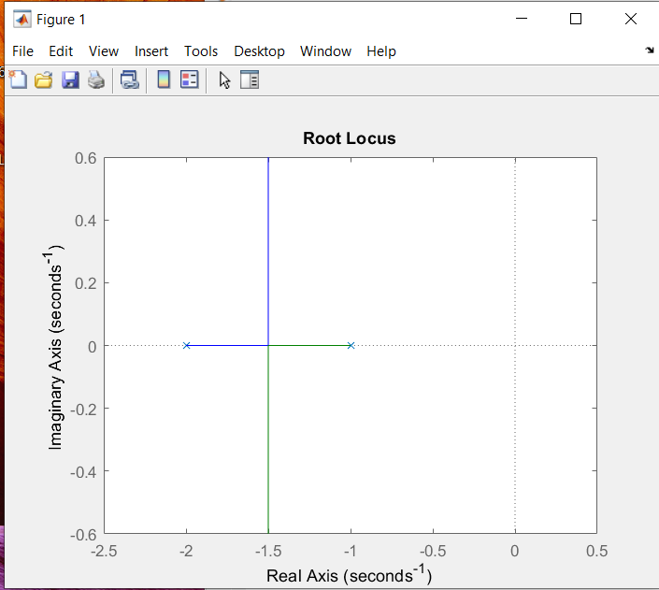

II)

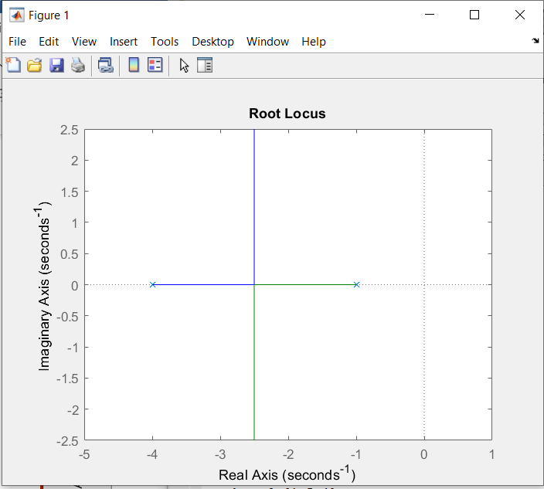

B-
clc;

% Question B
num=[1]; % Numerator
denum=[1 5 4 0]; % Denominator
sys=tf(num,denum) % Transfer Function
rlocus(sys) % Root Locus

% i
num=[1 5];
denum2=[1 5 4 0];
sys2=tf(num,denum2)
rlocus(sys2)

% ii
num=[1 2];
denum3=[1 5 4 0];
sys3=tf(num,denum3)
rlocus(sys3)

% iii
num=[1 0.5];
denum4=[1 5 4 0];
sys4=tf(num,denum4)
rlocus(sys4)

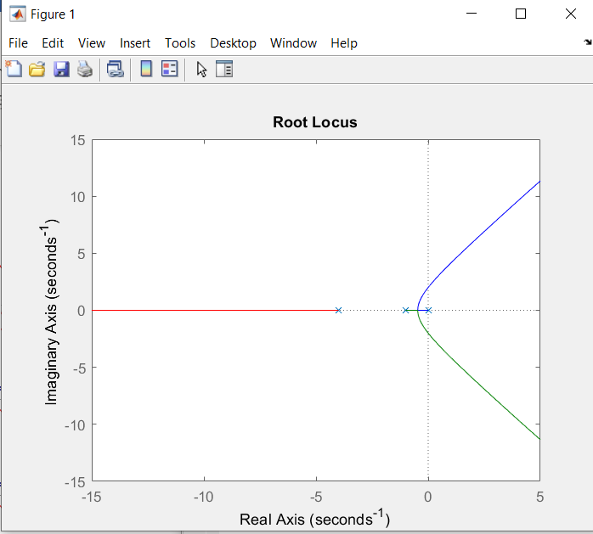

I)

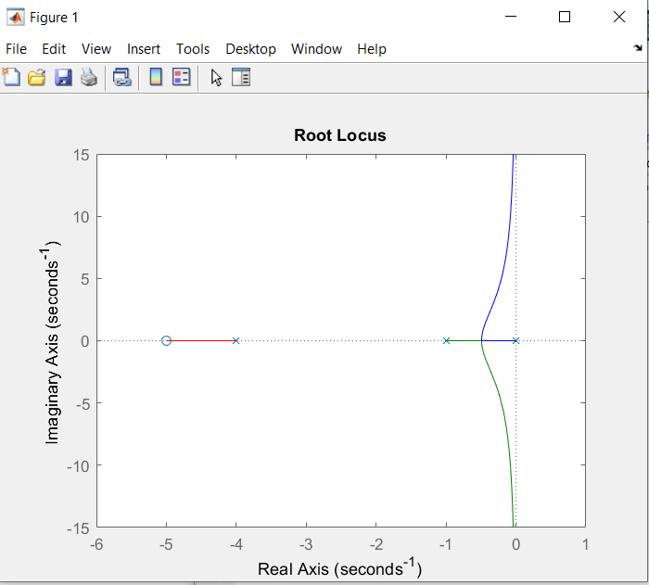

II)

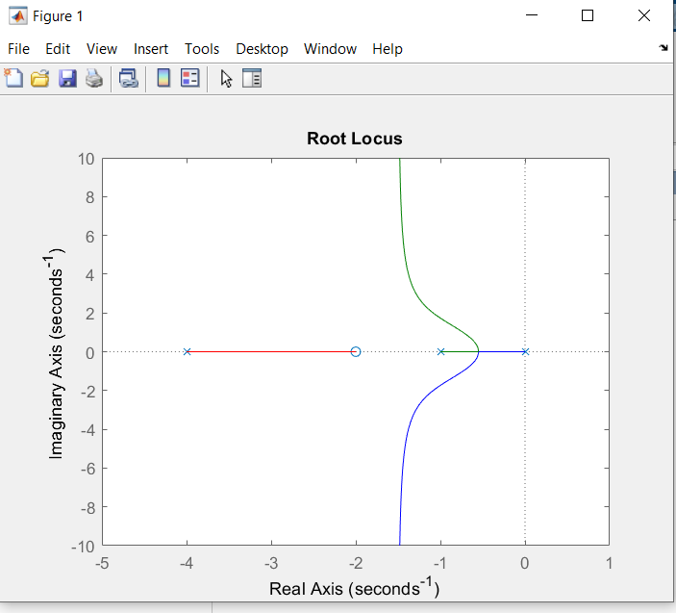
III)

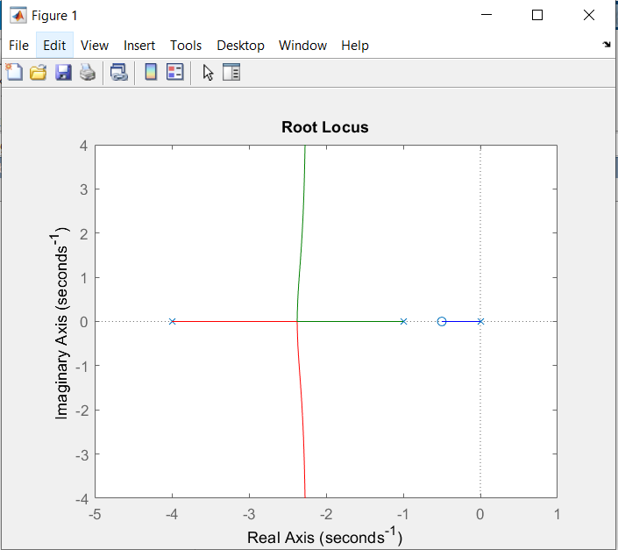

C-
clc;
num=[1 2]; % numerator
den=[1 -4 13]; % Denominator
G_s=tf(num,den) % Transfer function
rlocus(G_s) % Root locus

K=6.04; % DC gain
G_s=tf(K.*num,den) % Transfer function

H_s=feedback(G_s,1) % Closed Loop Transfer function with Unit Negative feedback
step(H_s) % Unit Step Response

% Command Window
G_s =

6.04 s + 12.08
--------------
s^2 - 4 s + 13

H_s =

6.04 s + 12.08
--------------------
s^2 + 2.04 s + 25.08
Root-Locus
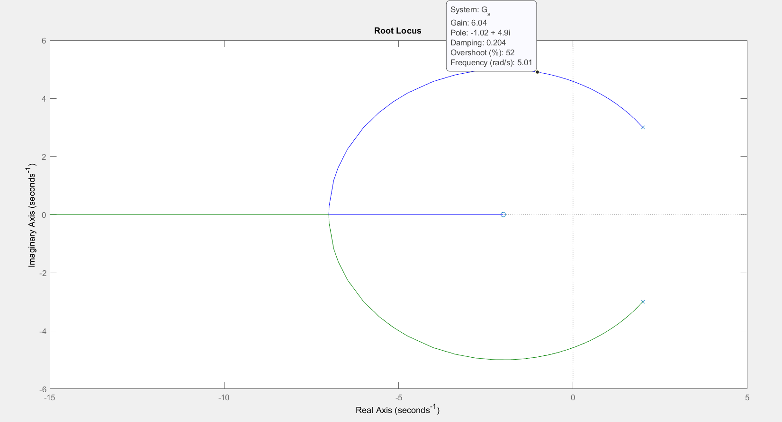

Here at 52 % Overshoot ,gain is 6.04
