**System Diagrams for**

**Trainee Management System**

**(TMS)**

**Prepared By: Md Habibullah Howlader Suman**

**Trainee Software Engineer at BJIT Academy**

**ID: 30058**

**List of Figures**

|  |  |  |
| --- | --- | --- |
| Serial Number | Diagram Name | Feature/Functionality |
| 1 | Use Case | For TMS System |
| 2 | Use Case | For Admin Functionality |
| 3 | Activity | For TMS System |
| 4 | Activity | For Classroom feature |
| 5 | Context | For TMS System |
| 6 | DFD | For TMS System |
| 7 | Sequence | For Classroom Feature |
| 8 | Entity Relationship (From MySQL) | For TMS System |
| 9 | Entity Relationship | For TMS System |

**Use Case Diagram**

Use Case diagram visually represents the interactions between system actors and the system itself, providing an overview of user-system interactions.

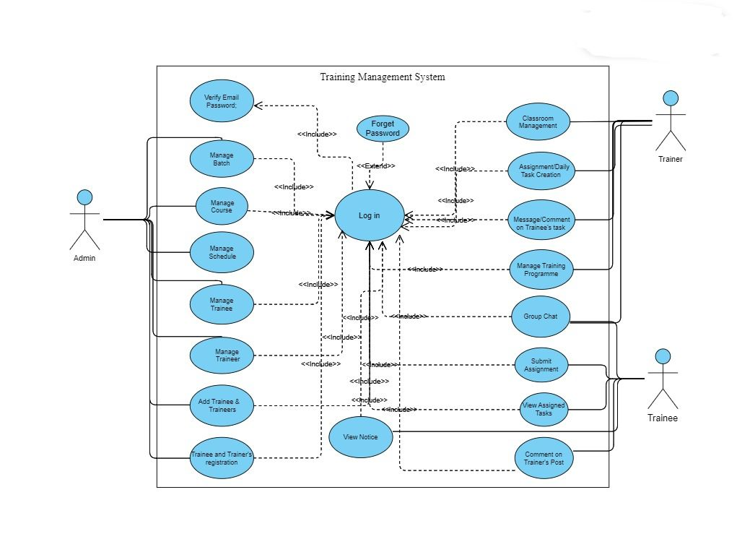The activity diagram for the TMS project illustrates the different activities and workflows within the system, such as creating and managing training programs, scheduling sessions, assigning trainers, and monitoring trainee progress.

**Figure 1: Use Case Diagram for TMS**

In the above Figure Use Case Diagram describe all the actor with their dependencies in a nutshell. It gives a simple understanding for the whole project. I also make another Use Case diagram for Admin Actor that describe all the functionality for admin.

In this Figure - - - - - - -> describe a include relationship. Here we can see details work functionality of the Admin.

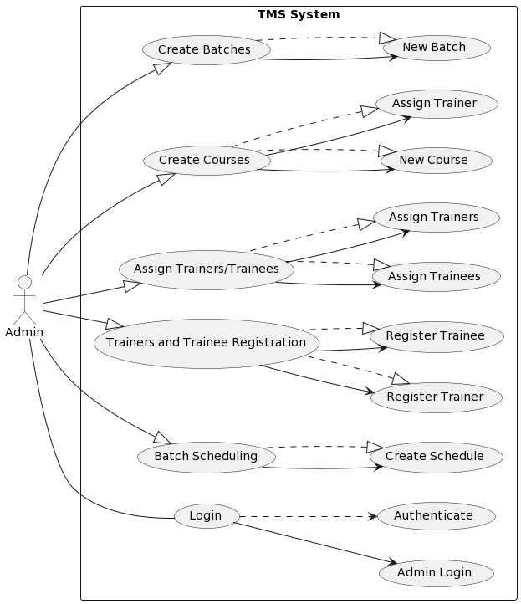

**. Figure 2: Use Case Diagram for Admin Functionality**

**Activity Diagram**

Activity diagram illustrates the flow of activities or processes within a system, highlighting the sequence of actions and decision points in a clear and visual manner.

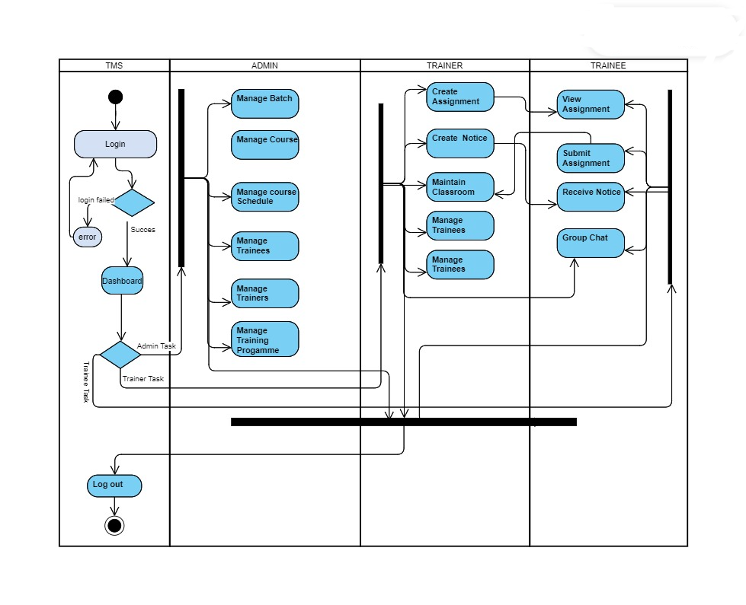

**Figure 3: Activity Diagram for TMS**

The activity diagram for the TMS project depicts the sequential flow of activities involved in managing training programs, including creating courses, scheduling sessions, assigning trainers, and evaluating trainee performance. It provides a visual representation of the steps and decisions involved in the training management process.

In below I draw a diagram for Trainer Classroom Feature that clearly describe how trainer will go through each step of the classroom functionality.

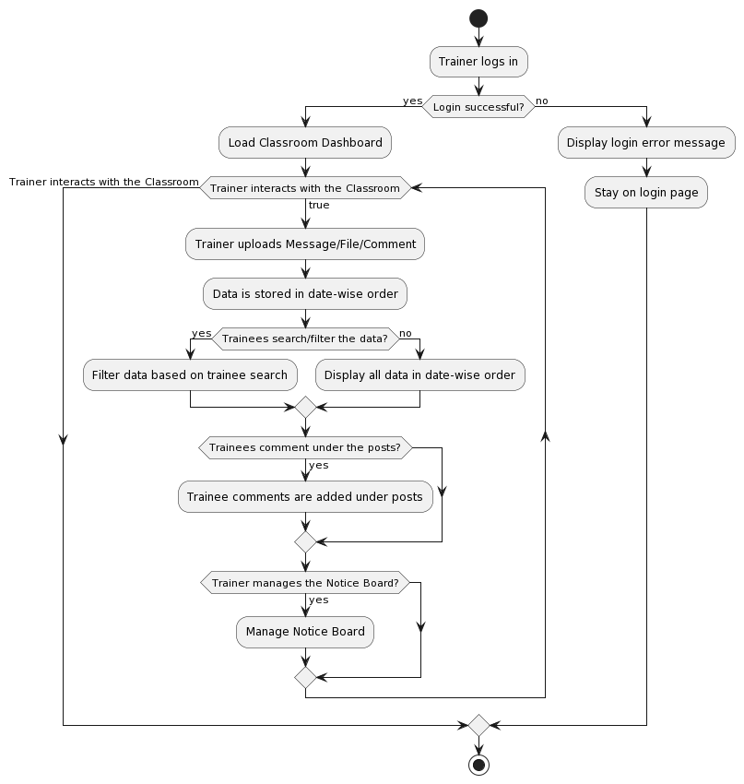

**Figure 4: Activity Diagram for Classroom Feature**

**DFD Diagram**

The DFD-0 or Context Diagram for the TMS project provides an overview of the system's boundaries and external entities. It depicts the high-level interactions between the TMS system and external entities such as trainers, trainees, administrators, and external systems. It helps to understand the scope of the system and its relationships with external entities without going into the detailed internal processes.

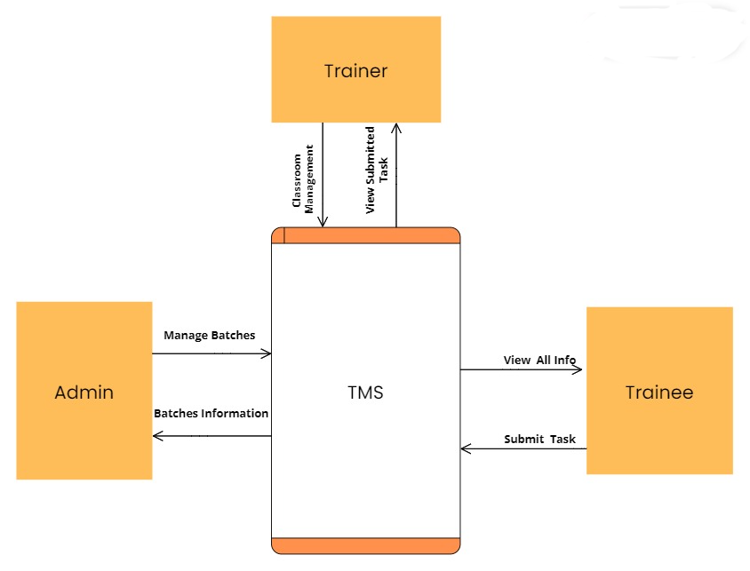

**Figure 5: DFD-0 or Context Diagram for TMS**

The Data Flow Diagram (DFD) for the TMS project illustrates the flow of data within the system, including inputs, outputs, and data transformations. It provides a visual representation of how information moves through different processes and entities, helping to identify data sources, data stores, and data flows within the TMS system.

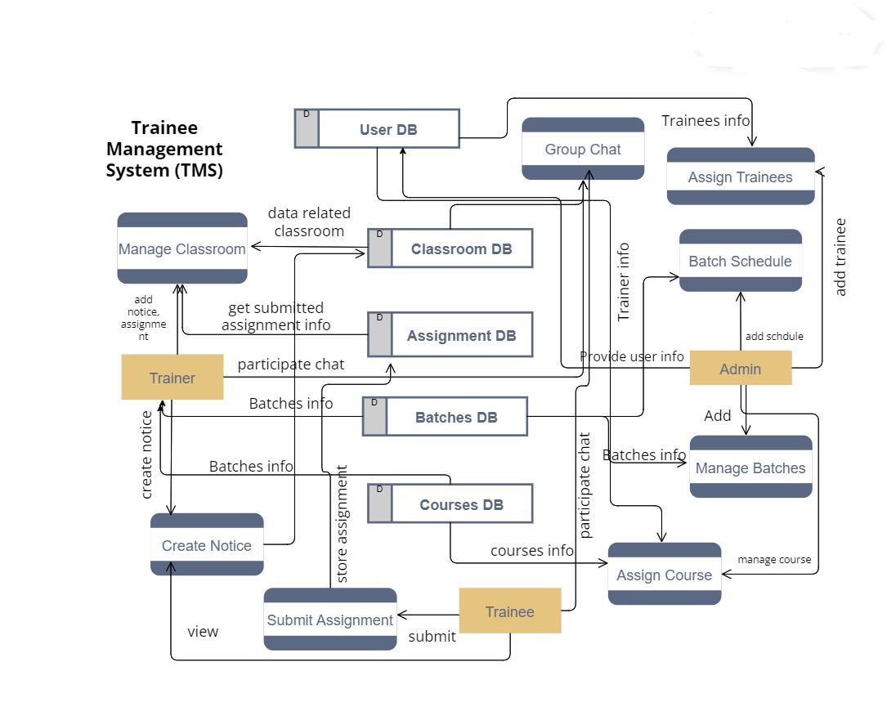

**Figure 6: DFD Diagram for TMS**

**Sequence Diagram**

The Sequence Diagram for the TMS project illustrates the chronological sequence of interactions between different objects or components within the system. It showcases the order in which messages are exchanged and the flow of control between objects, capturing the dynamic behavior of the system.

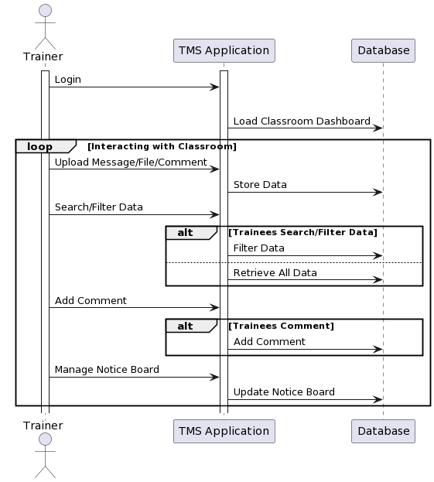

**Figure 7: Sequence Diagram for Classroom Feature.**

This diagram helps to visualize the interaction between different components and understand the sequence of events in a particular scenario of Classroom for Trainer and Trainee.

**ER Diagram**

The ER Diagram (Entity-Relationship Diagram) for the TMS project represents the logical structure of the database schema. It illustrates the entities, attributes, and relationships between them in the system. 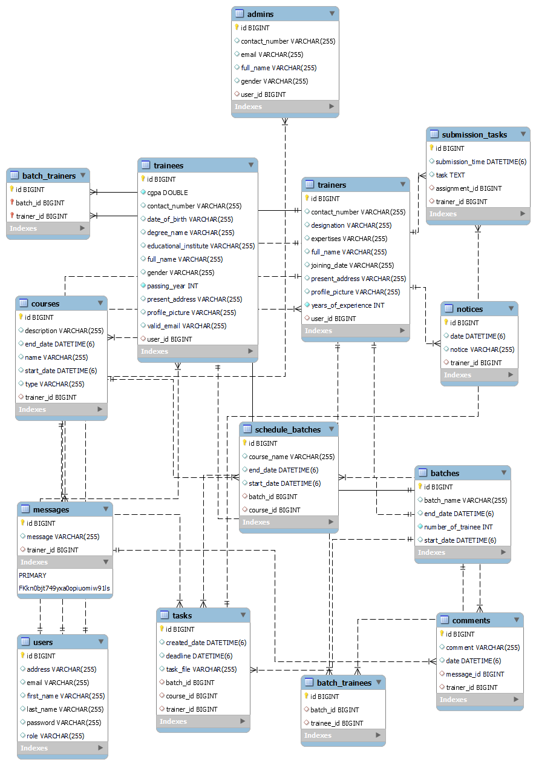

**Figure 8: ER Diagram for TMS project**

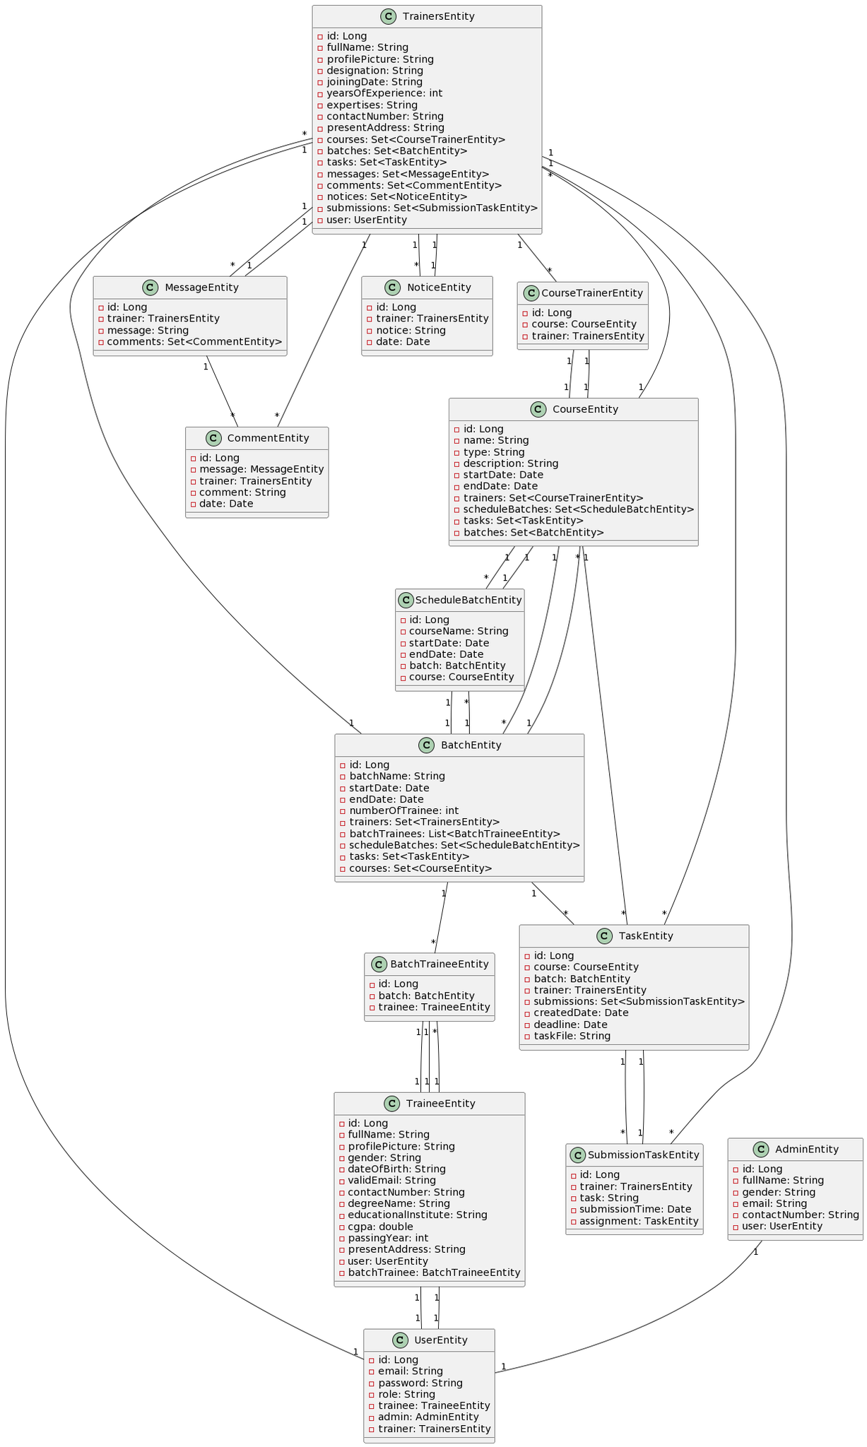

**Figure 9: ER Diagram for TMS**