Ex 1;

import java.util.Scanner;

public class ProblemaUnu

{

public static void main(String[] args) {

double sum = 0 ;

Scanner numere = new Scanner (System.in);

Scanner caractere = new Scanner (System.in);

System.out.println("Valoarea numerelor:");

int socoteala = numere.nextInt();

System.out.println("Indroduceti " + socoteala + " numerele:");

for(int a=1; a<=socoteala ; a++){

double introducerea = numere.nextInt();

sum = sum + introducerea;

System.out.println();

}

if (sum <= 1000){

double media = sum / socoteala;

System.out.println ("Media aritmetica este :" + media);

} else{

System.out.println ("Suma numerelor nu trebuie sa depaseasca 1000");

}

}

}

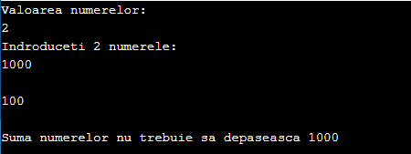

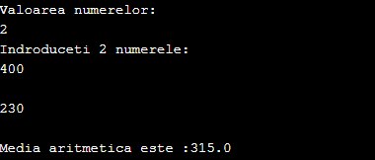

Ex 2 ; (nu vad in conditie eliminarea metodei de a mixa cele 3 loop-uri)

public class ProblemaDoi

{

public static void main(String[] args) {

int r = 5;

while(r >= 1) {

for(int c=1;c<=r;c++) {

System.out.print(r);

}

System.out.println();

r--;

}

}

}

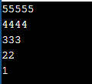

Ex 3;

import java.util.Scanner;

import static java.lang.Math.sqrt;

public class Main

{

public static void main(String[] args) {

Scanner numere = new Scanner (System.in);

System.out.println("Introduceti n");

int n = numere.nextInt();

int sum1 = 0 ;

int sum2 = 0 ;

int nr1 = 1 ;

int nr2 = 1 ;

//Aflam Suma1

do { sum1 = sum1 + (int) Math.pow(nr1, 3.0) ;

nr1++ ;

} while (nr1<=n) ;

System.out.println("Suma1 este "+ sum1);

//Aflam Suma2

do { sum2 = sum2 + nr2 ;

nr2++;

} while (nr2<=n) ;

sum2 =(int) Math.pow(sum2, 2.0) ;

System.out.println("Suma2 este "+sum2);

if (sum1 < sum2){

System.out.println("Suma 1("+sum1+") este mai mica ca Suma 2("+sum2+")");

}else if(sum1 > sum2){

System.out.println("Suma 1("+sum1+") este mai mare ca Suma 2("+sum2+")");

}else{

System.out.println("Suma 1("+sum1+") este egala cu Suma 2("+sum2+")");

}

}

}

