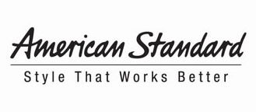
For more information:
Nora DePalma
O’Reilly/DePalma for American Standard
(770) 772-4726
nora.depalma@oreilly-depalma.com

FOR IMMEDIATE RELEASE

The American Standard® Responsible Bathroom Tour
Rolling to 300 Locations, Now Through November

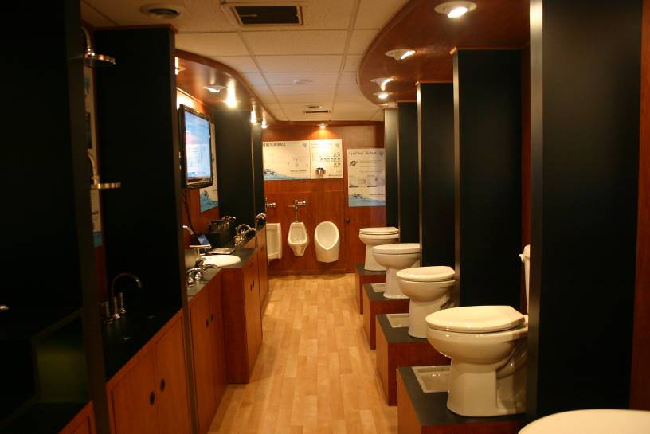
PISCATAWAY, N.J. (April 8, 2010) – With a goal of saving two billion gallons of water this year, the American Standard Responsible Bathroom Tour kicks off this week with visits to more than 300 plumbing wholesale locations in the United States, Canada and Mexico through November.
Open to the public, the warm-paneled walk-through mobile plumbing showrooms are expected to attract plumbers, specifiers and other construction professionals, along with environmentalists, researchers, housing authority and utility personnel. Visitors will experience product demonstrations, giveaways and water conservation education.
Inside one of the American Standard Responsible Bathroom Tour mobile showrooms, equipped with a wide variety of water-conserving plumbing products for viewing and hands-on learning
American Standard Brands expects the Responsible Bathroom Tour to contribute two billion gallons of water savings over the next seven months simply by convincing attendees to adopt new water conserving behaviors and replace old leaky fixtures with top-rated WaterSense® toilets, faucets and showerheads. Water savings progress will be tracked on the Responsible Bathroom Tour microsite, TheResponsibleBathroomTour.com, which also has the tour schedule.

- more -

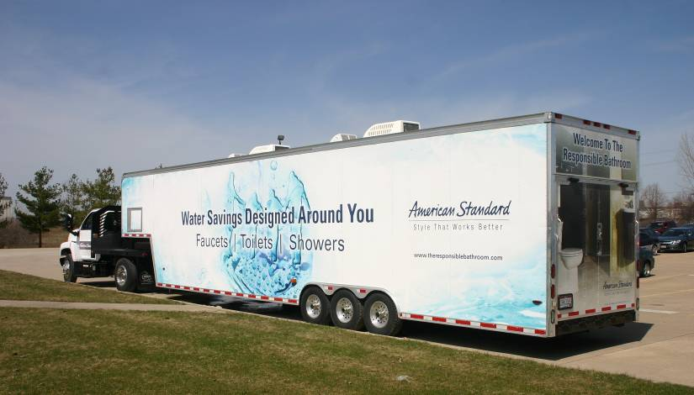
The American Standard® Responsible Bathroom Tour Rolling to 300 Locations, Now Through November 2-2-2
In total, American Standard expects to help the United States save a total of 18 billion gallons of water this year. The Responsible Bathroom Tour microsite links to the recently launched TheResponsibleBathroom.com, a fun, interactive educational website. Points earned for pledging different water conservation behaviors can be used to enter sweepstakes for prizes ranging from free products to a luxury eco-friendly vacation.
American Standard officials expect the 2010 Responsible Bathroom Tour to contribute two billion gallons in water savings by persuading showroom visitors to adopt water-saving behaviors and to replace their current leaky fixtures with WaterSense models.
The Responsible Bathroom website is the latest in a series of initiatives by American Standard Brands to raise awareness of practical water conservation solutions, including a two-year $1 million commitment to support the Nature Conservancy.
For more information or find out when the tour is visiting your area, visit TheResponsibleBathroomTour.com,

ABOUT AMERICAN STANDARD BRANDS
American Standard Brands is a leading North American manufacturer of a wide range of high-quality kitchen and bath products, including faucets, fixtures, furniture, vitreous china fixtures, cast iron sinks, whirlpool tubs and other related products. The company currently serves both the residential and commercial markets; employs more than 5,000 people in the United States, Canada and Mexico; and markets products under the American Standard®, Crane®, Eljer®, Porcher®, JADO®, and Fiat® brands. American Standard Brands is an affiliated portfolio company of Sun Capital Partners with a minority interest held by Bain Capital Partners, Inc.

###

