Question 2.3

Autoplot  
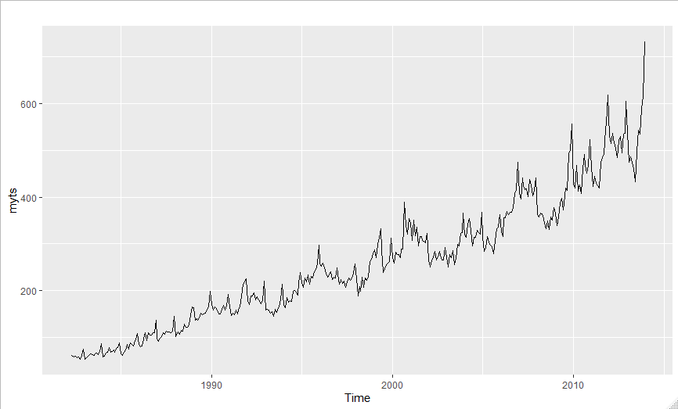

ACF  
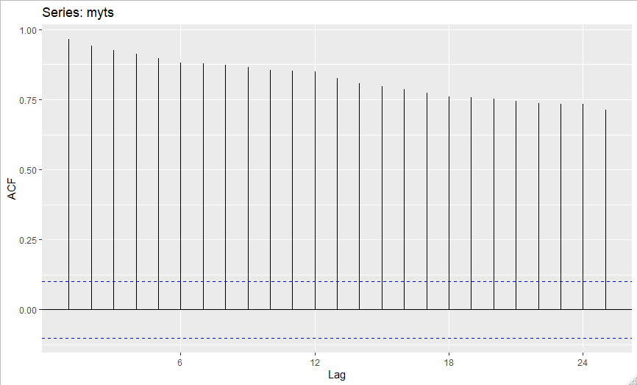

Seasonal Subseries  
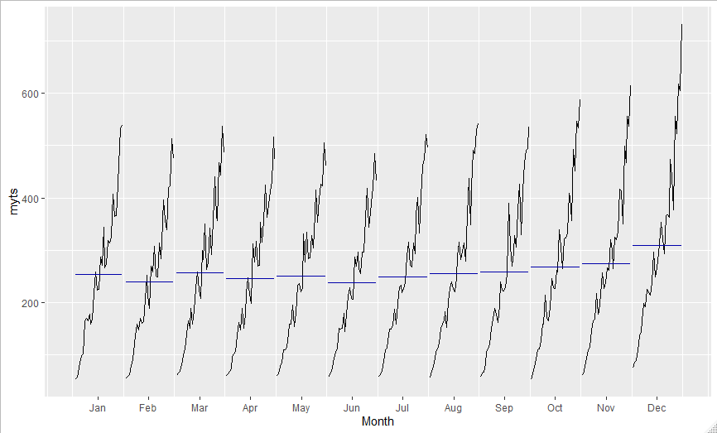

Lag Plot  
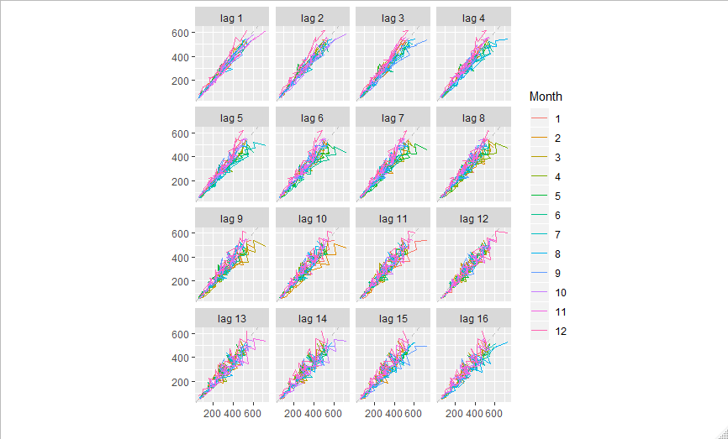

From the seasonal subseries of A3349709X, we can see that there is some for of seasonal trend. From January to June there isn’t much change in the mean of each subseries, but from June till December we see a steady increase. From the autoplot and the ACF we see that there is a clear upward trend. This is seen by the steady decrease of the ACF graph.  
From what can be seen from the graphs, the earliest data shows that there was a low level of turnover with the greatest amount being at the end of the year from June till December, but as the years continued there became higher counts of turnovers and this trend continues.

Question 3.8

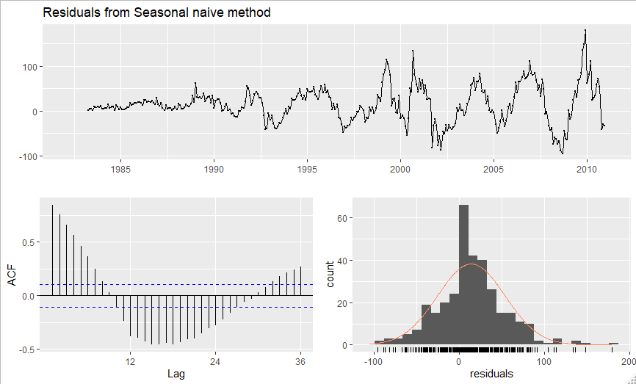

When we check the residuals, we see that they have a significant correlation with each other, and this shows in the histogram where it can almost be a normal distribution if not for slightly long right tail.

From the accuracy test, we see that the training set tested lower for many of the error forecasts.