Installing Python:

**HelloWorld portion:**

Added input.txt to hadoop-1.2.1

CD into directory

Modify input.txt to add a couple lines

Attempted to run wordcount jar

Received error of JAVA_HOEM is not set

Followed instructions for linux on this website: <https://docs.opsgenie.com/docs/setting-java_home>

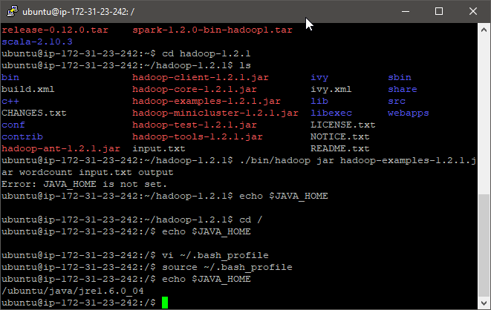

Reran the wordcount jar in the Hadoop directory

New error reporting that the bin/java directory does not exist

Both cd ~ and cd / indicate that the java directory is set up correctly, so not sure why this error appears

Reran source env.sh

CD back into Hadoop-1.2.1

Reran wordcount jar

Output of command:

Use vi to look at output:

CD into output

LS to see files

Use vi to read part-r-00000:

Appears to have counted each word correctly

**Streaming I/O portion:**

Copied files using WinSCP to the ubuntu directory

Used dos2unix on most files:

Used chmod 777 *.py

Ran ubuntu@ip-172-31-23-242:~$ echo "one two three testing the program hello world" | ./m.py

Ran command with reducer, mapper, and input output

Output of command:

No output3 file as the command failed:

Saw that I had run the wrong files for mapper and reducer and removed all python files, imported them again, and then reran dos2unix on the .py files

Reran the function as such:

Used vi to view output:

