Start Grunt.

Load baseball.txt from Blackboard.

Prepare pos1.

Dump pos1:

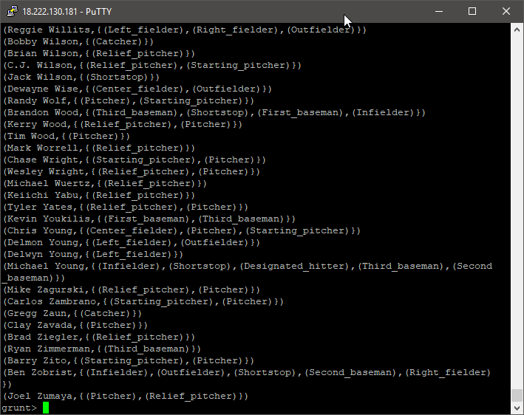

Reload baseball and prepare pos.

Dump pos:

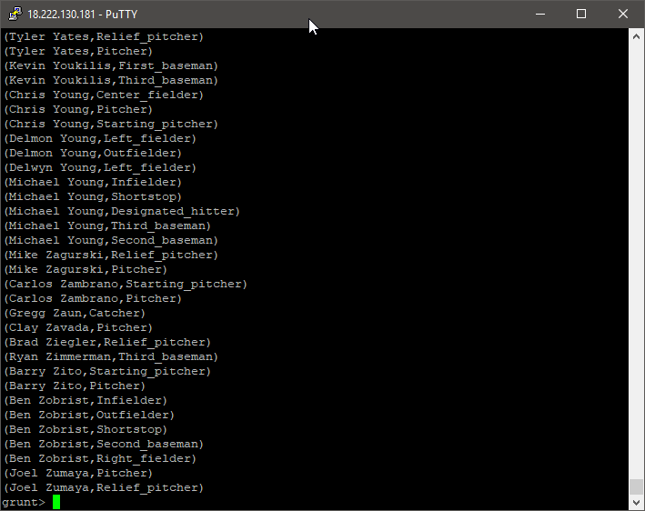

Reload data, prepare noempty and pos, dump pos:

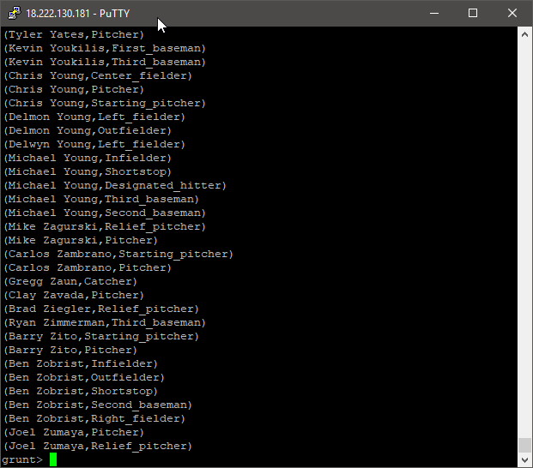

Dump bypos:

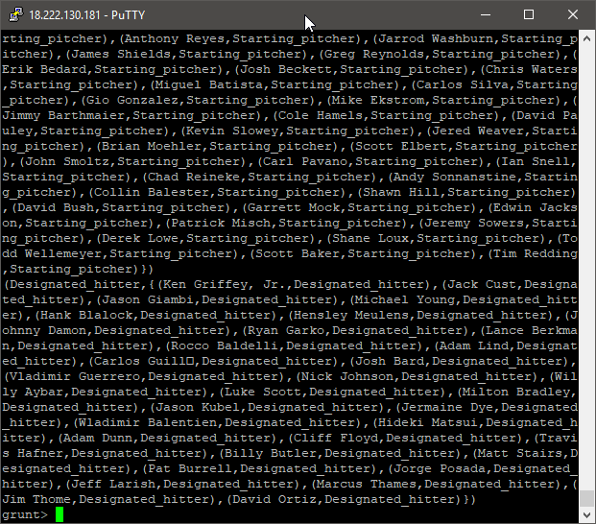

Load NYSE, group, and dump grpd:

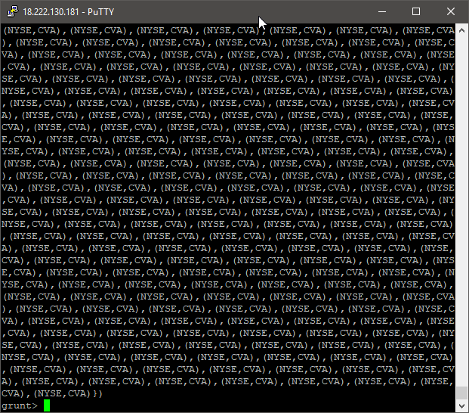

Load NYSE, and prepare uniqcnt:

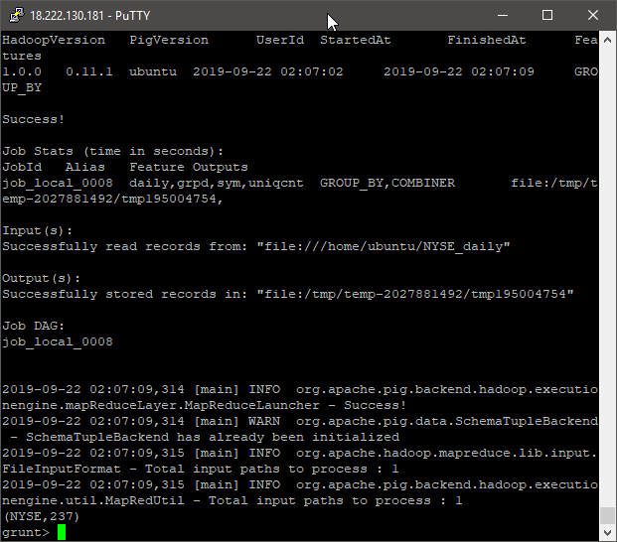

Load dividends, prepare grpd, and dump:

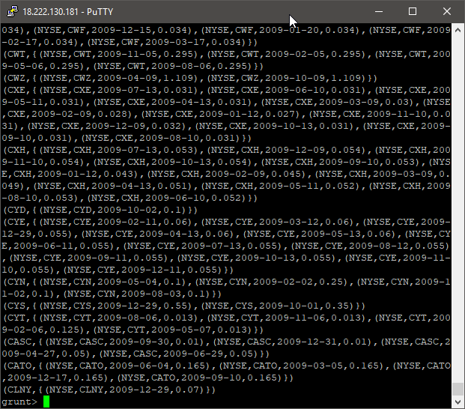

Load dividends and dump the uniq:

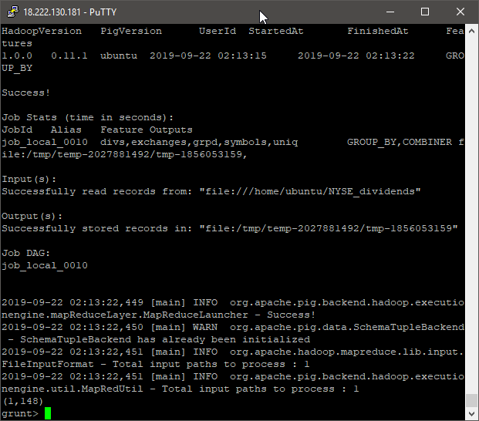

Load the two NYSE datasets and prep lines.

Dump daily:

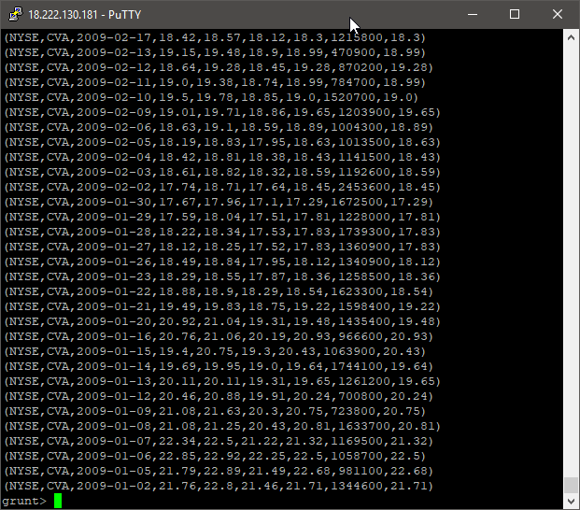

Dump divs:

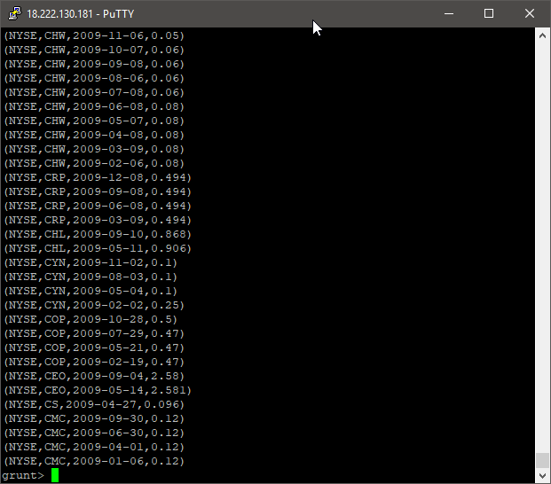

Dump jnd:

