Homework 6

Using the same shell as homework 5, so result set number is higher than example Powerpoint:

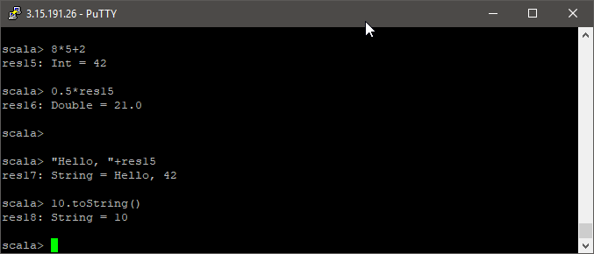

a.+(b) was unable to recognize values for a and b, but variable assignment worked as expected:

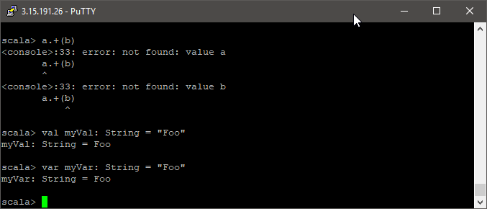

Tried to run the if but no matter the variation it always returns the same error, until I wrapped the whole statement in {}:

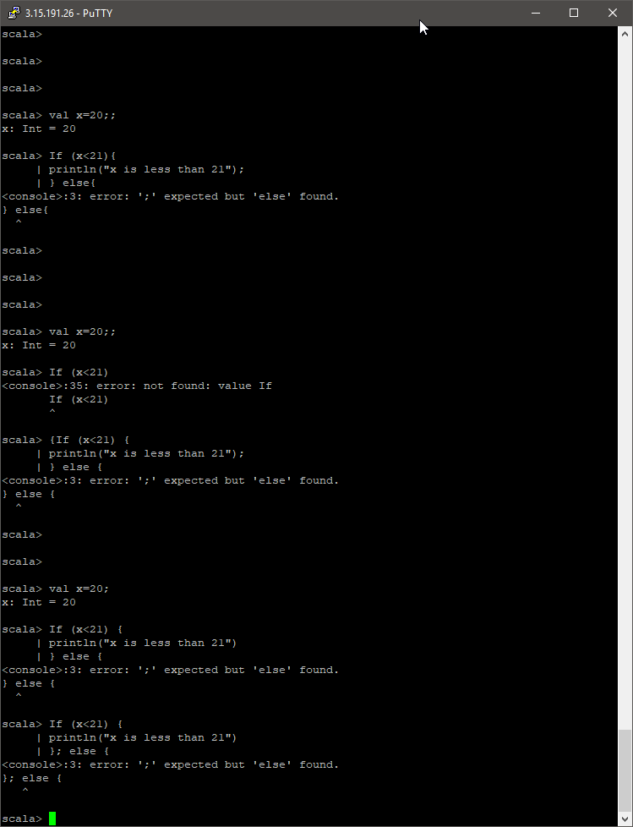

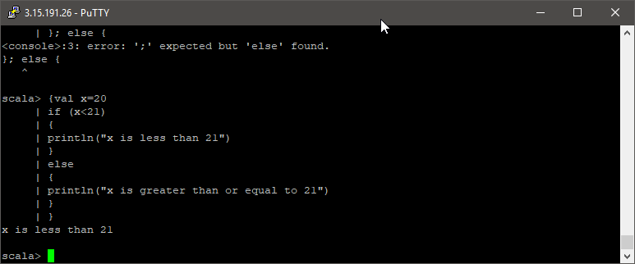

Iteration:

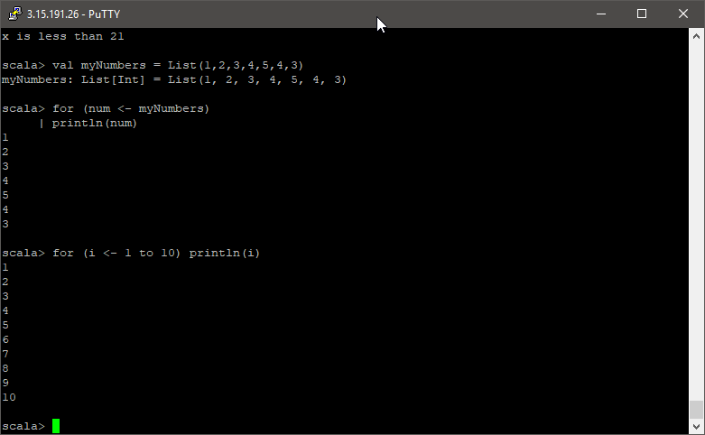

Count:

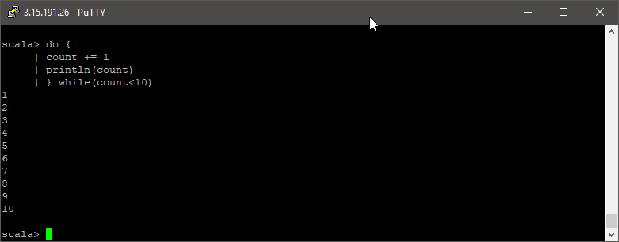

Concise methods:

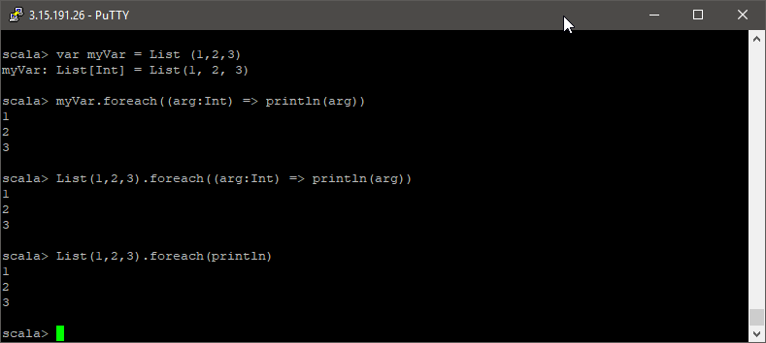

Cube:

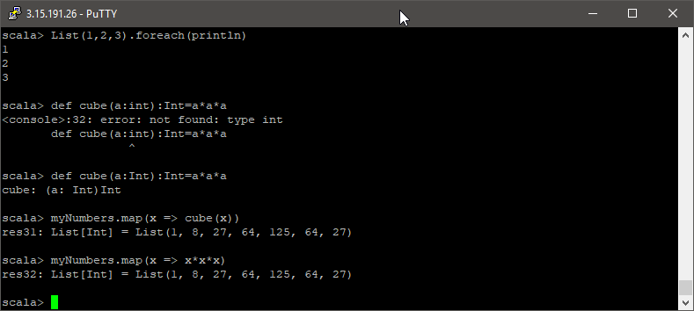

Factorial:

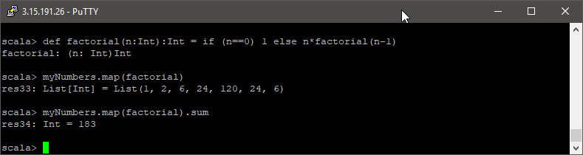

Factor multiplication:

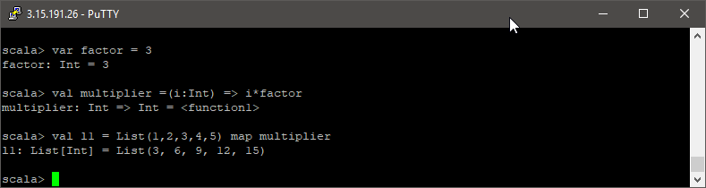

Add all:

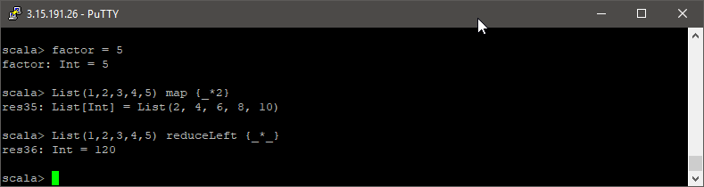

Had an error on newValue then machine crashed. Rebooted in AWS Console and tried again:

Insufficient memory error blocks Spark Shell from starting:

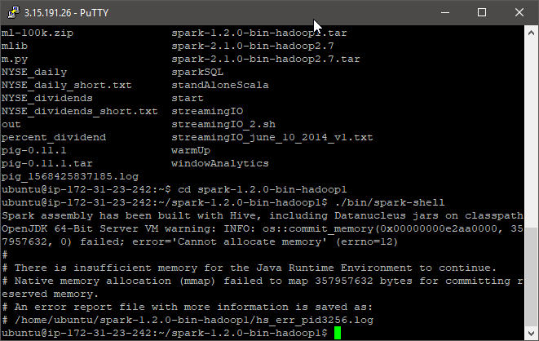

Ran top to see memory:

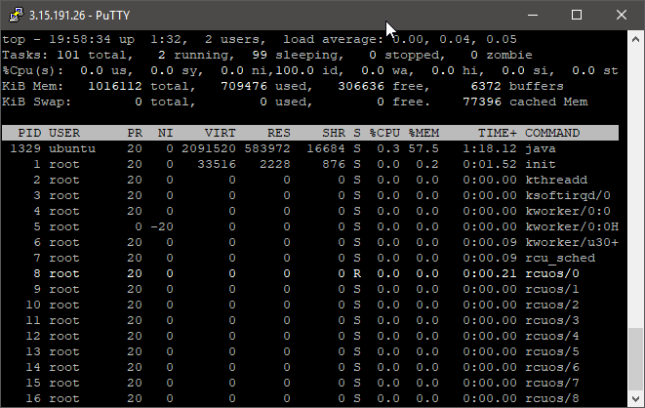

Killed the highest memory using process (1329)

Spark started up

Able to run another attempt:

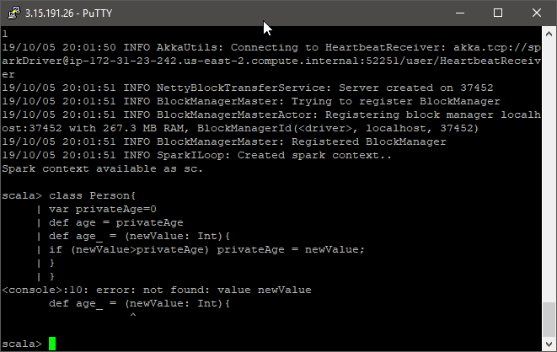

Looked at class creation in Scala docs and not sure what I am missing. Perhaps a unit = would be useful?

<https://docs.scala-lang.org/tutorials/tour/classes.html.html>