The ESP32 Superexpander
The ESP32 has 40 GPIO pins. If all you want to do is build a rover like the Forthmobile, that seems like a lot of pins, until you consider that 6 of them are used for the internal flash, one is used for debug, another is connected to the on-board LED, one will make the system fail if pulled high during boot, 4 are input only, and 4 of them produce a PWM signal at boot which might disturb your connected logic.
Only 14 pins don’t have any notes attached.
Out of these, you’ll need 2 for I2C clock and data, and if you’re planning to make use of the Forthmobile’s 3 VL53L0X laser distance sensors, you’re left with 9.
7 if you plan to use a GPS module. Perhaps you want two collision sensors at the front and two at the back? Now, you’ve got three pins left out of 40.
If you’re anything like me, you have a box full of cool sensors that you want to add: Movement detectors, sound, shock, and tilt detectors … temperature readers, line followers, buzzer and if you’re going to get anywhere at all, you need a motor controller, requiring an IN1, IN2, IN3, IN4 and two pwm pins.
A headlight switch would be nice to have as well, but you ran out of pins a couple of sensors ago.
Luckily, we can send data over a serial line to read to or write from an 8 bit register giving us 8 more pins minus the pins used for transmission, and if we cascade these registers, we get 16 extra pins instead of 8.
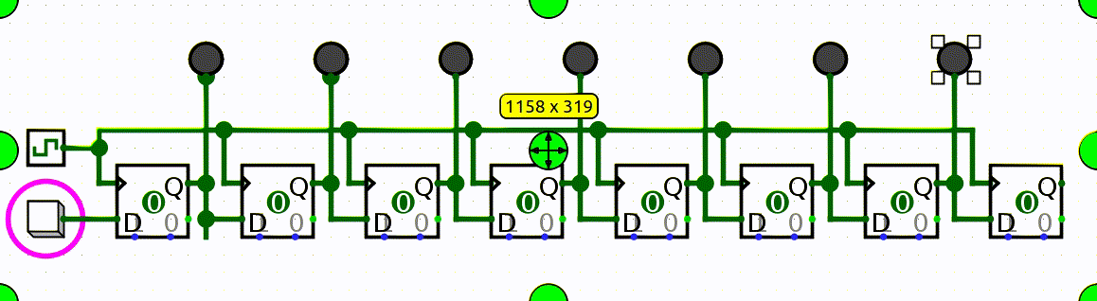
In the image above, when the square button in the lower left corner is pressed, a 1 is shifted in fron the left. When it’s released, a 0 is shifted in.
The ESP32 Superexpander uses five such registers, three 74LS165 for input and two 75LS595 for output.

Afferent flows
Two of the three 74165 input registers are connected to 4060 pulse counters.
Since the Superexpander is intended to be used as a main plate for a Forthmobile rover, the idea behind the counter registers is to let you keep track of your travel distance without using up two precious ESP32 interrupts.
The pulses are counted and stored in the 4060.

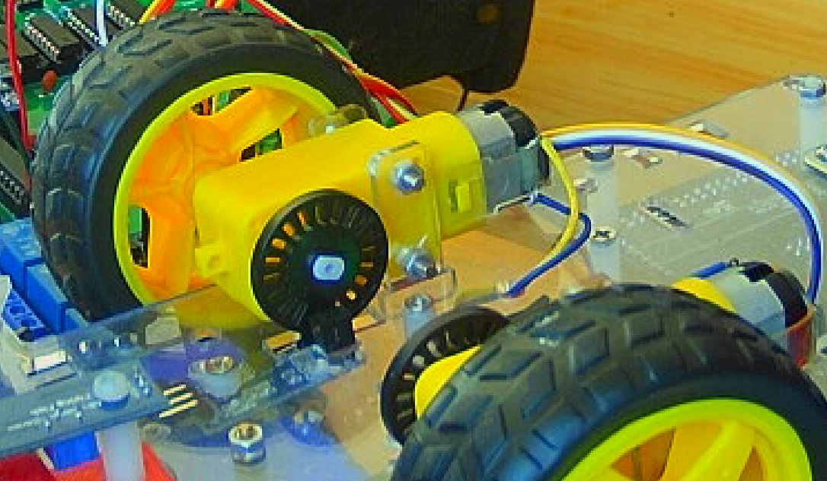Figure 1: Mounted on the inside of the wheel is a disk with 24 slits in it. On the other side of the chassis there’s a pulse counter consisting of an LED and a photo transistor. Each time a slit passes over the LED, a pulse is generated.
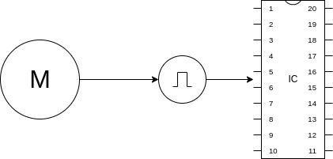
Whenever you want to read the value, you transfer the count from the 4060 to the 74165 using a LOAD signal (shown below as SH_LD) then read it serially into a variable inside the ESP32 using CLOCK and DATA signals, shown as SCK and HOST_OUT below.

Modules like the one above can be daisy-chained.
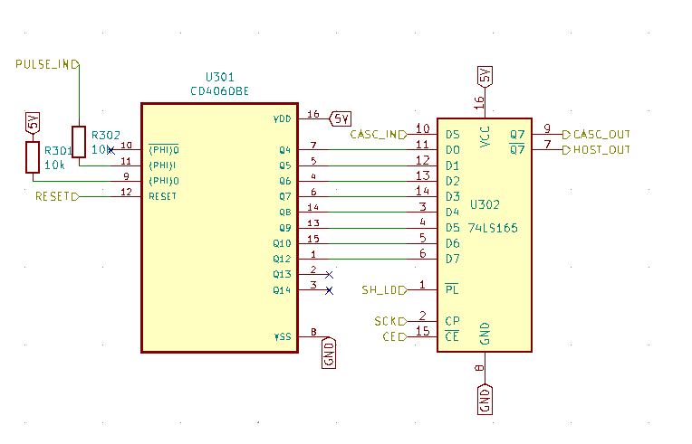Figure 2: Counter module. When SH_LD is pulled LOW, data is transferred from the 4060 counter to the 74LS165 PISO register
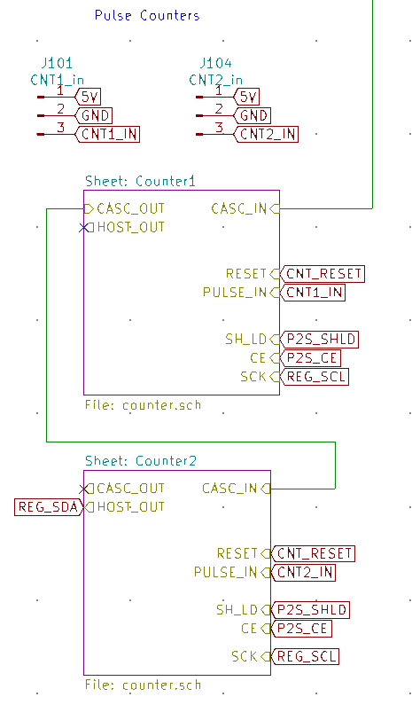Figure 3: When daisy-chaining registers, serial output from one register is fed to the input of the next
The connectors J101 and J104 are meant for a pulse counter like the one below. The connections are as follows: VCC on the sensor to 5V on the module, GND to GND, and D0 CNT1_IN or CNT2_IN.
The A0 line is not used.
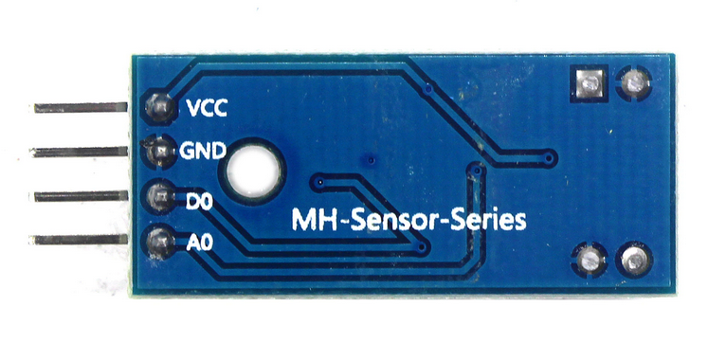
The CASC_IN line at the top of the counter module schematic comes from a sensor reading module.
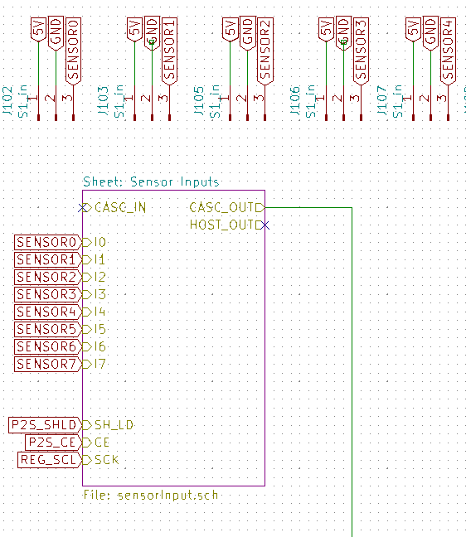Figure 4: Here, you see the line CASC_OUT leaving the sensor schematic to enter as CASC_IN in the first counter module. The sensors are connected in the same way. Sensor VCC to 5V, GND to GND and the sensor output to one of the terminals labeled SENSOR0 through SENSOR7.
The inside of the module should be unsurprising. Instead of reading counter values, the 74165 reads the state of 8 input terminals, each corresponding to the output of one sensor.
The module also contains 8 LEDs that will light up on the board as soon as an input is activated.
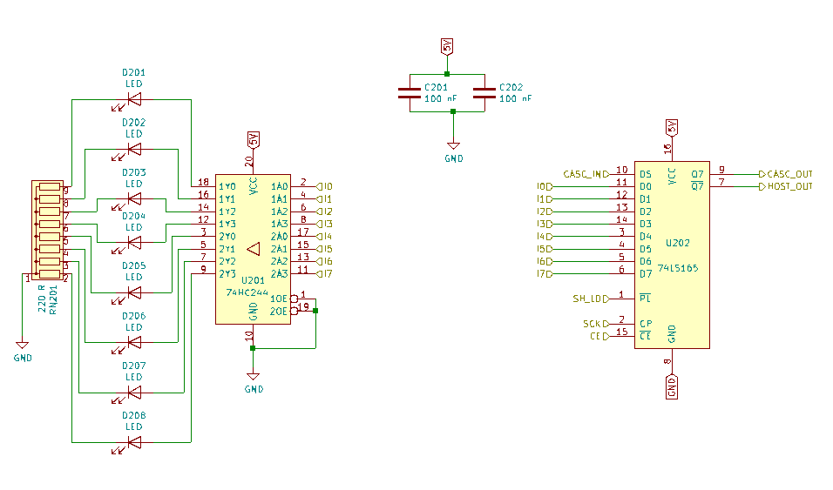Figure 5: Sensor reading module. Data coming in on lines I0-I7 are split between the 74LS165 PISO register and an output buffer driving 7 LEDs.

Efferent flows
The output side consists of two output modules, cascaded in the same way as the input modules.
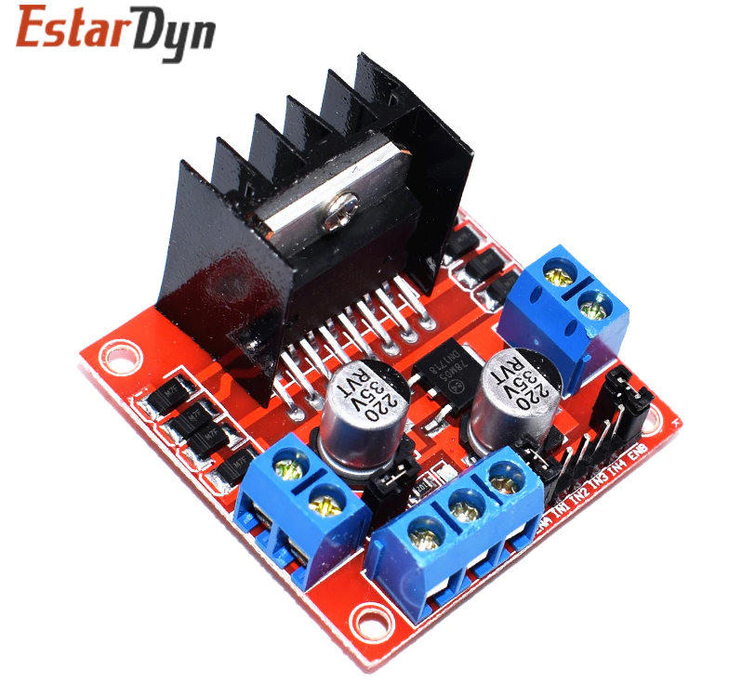
The connectors J120 and J121 give a total of 12 general purpose outputs plus 4x5V outputs.
The connector J119 is intended for an L298 motor driver shield, or any other shield with the same interface.
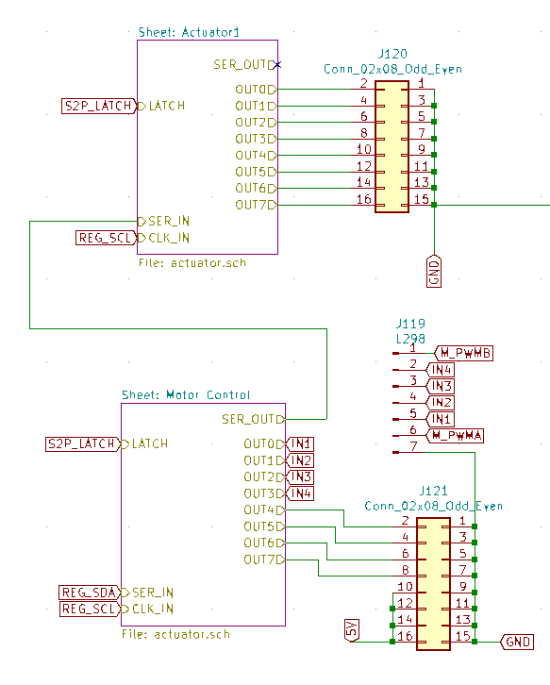
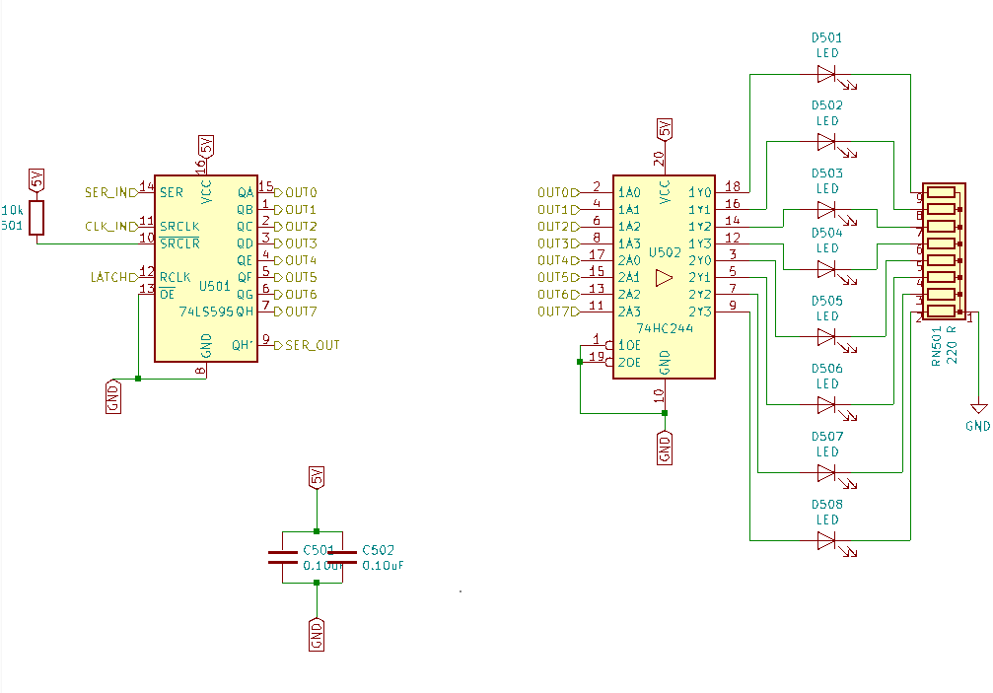
The outputs IN1 through IN4 get connected to IN1-IN4 on the shield, M_PWMA goes to ENA, and M_PWMB goes to ENB.
The inside of an actuator module is similar to that of the sensor module, with one LED per output for visual feedback.

Transformations
Last but not least, the star of the show: The ESP32 Devkit V1,
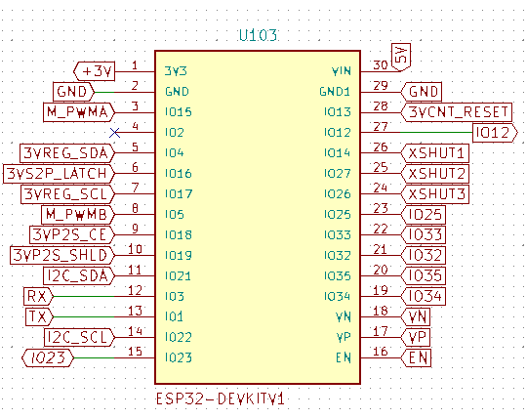
supported by two BOB-12009 level shifter modules to enable working with the more common 5V modules.
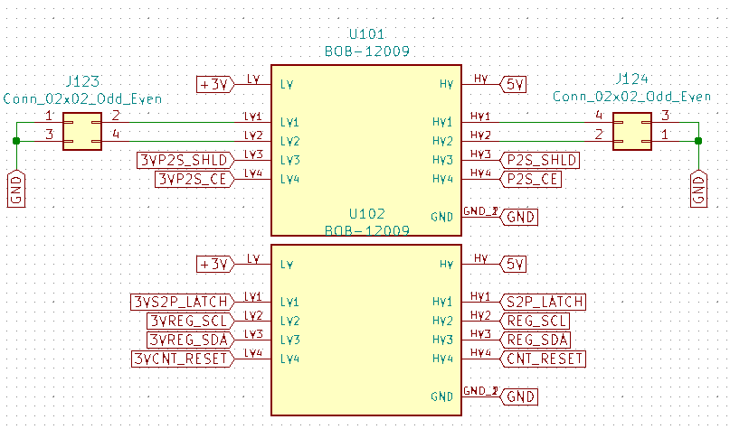
Figure 6: All the labels prefixed with 3V are connected to the ESP32 and the 3V side of the level shifters,
and the corresponding 5V side of the level shifter is connected to the register.
This is how the 3.3V ESP32 can drive 5V registers.
In addition to the connectors used for SIPO (serial-in, parallel out) and PISO registers, there are seven connectors giving access to the I2C bus. Three of them are intended for the LV53L0X laser distance sensor.
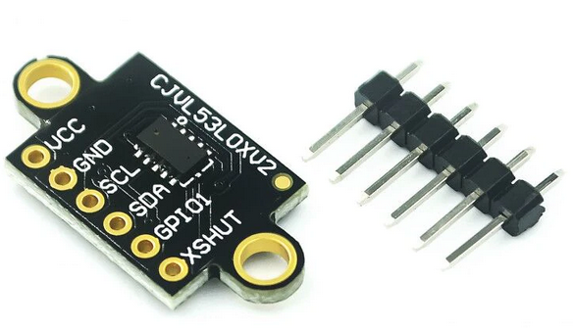
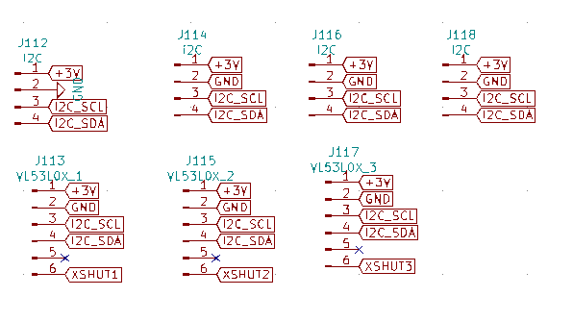

Putting it all together, the result becomes something like this:

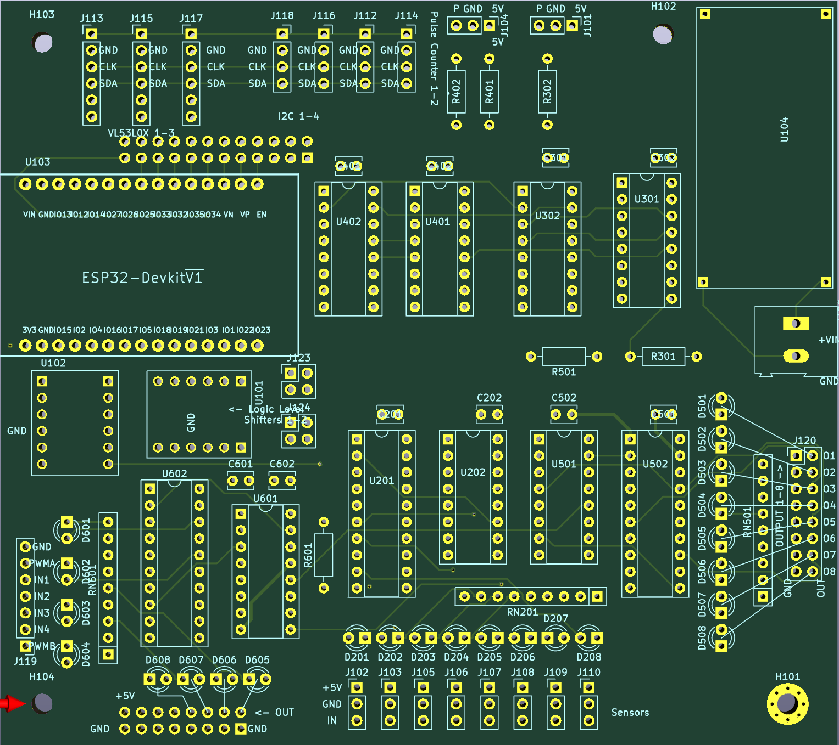
Directly above the ESP32 Devkit V1 module you find J111, a breakout of all the unused pins on the ESP32, 12 in all.

Programming

Constants
2 constant LED_BUILTIN

\ 74165 Parallel to serial
18 constant P2S_CE \ set high when P2S_SCK is HIGH to disable clock
19 constant P2S_SHLD \ Shift=1, load=0
17 constant P2S_SCK
23 constant P2S_SDA

\ 74595 Serial to parallel
4 constant S2P_SDA
16 constant S2P_LATCH \ aka RCLK
17 constant S2P_SCL

\ Motor control
15 constant M_PWMA
5 constant M_PWMB
\ LSB 0-3 of S2P give IN1-IN4 on the L298 motor controller connected to J15

21 constant I2C_SDA
22 constant I2C_SCL

13 constant CNT_RESET \ Reset the pulse counters on J21 and J22

\ VL53L0X uses I2C. To initialize, only keep one of these high and the
\ others LOW until the addresses are set. When the I2C address is set, all of these should be HIGH
14 constant XSHUT1
27 constant XSHUT2
26 constant XSHUT3

Setup
\ PISO REGISTERS
P2S_SHLD output pinMode
P2S_CE output pinMode
P2S_SCK output pinMode
P2S_SDA input pinMode

CNT_RESET output pinMode
CNT_RESET 0 digitalWrite 0 ms
CNT_RESET 1 digitalWrite 0 ms
CNT_RESET 0 digitalWrite

LED_BUILTIN output pinMode

P2S_SHLD output pinMode
P2S_CE output pinMode
P2S_SCK output pinMode
P2S_SDA input pinMode

Reading the PISO registers

: readP2S ( - n n n )
P2S_SHLD 0 digitalWrite 0 ms \ load data
P2S_SHLD 1 digitalWrite 0 ms \ prepare to shift
P2S_SCK 1 digitalWrite
P2S_CE 0 digitalWrite
P2S_SCK 0 digitalWrite

0
8 0 DO
1 LSHIFT
P2S_SCK 0 digitalWrite
P2S_SDA digitalRead OR
P2S_SCK 1 digitalWrite
LOOP
0
8 0 DO
1 LSHIFT
P2S_SCK 0 digitalWrite
P2S_SDA digitalRead OR
P2S_SCK 1 digitalWrite
LOOP

0
8 0 DO
1 LSHIFT
P2S_SCK 0 digitalWrite
P2S_SDA digitalRead OR
P2S_SCK 1 digitalWrite
LOOP
;

binary readp2s . . . decimal
11101011 11111011 11101111 ok
binary readp2s . . . decimal
11111011 11111011 11101111 ok
binary readp2s . . . decimal
11111111 11111011 11101111 ok
readp2s binary . decimal . . cr
11101011 251 239
ok
readp2s binary . decimal . . cr
11101011 249 239
ok
readp2s binary . decimal . . cr
11101011 249 239
ok
readp2s binary . decimal . . cr
11101011 247 239
Ok

Writing the SIPO registers
: writeS2P ( u u --)
S2P_LATCH 0 digitalWrite
8 0 DO
dup 1 and
S2P_SCL 0 digitalWrite
S2P_SDA swap digitalWrite
S2P_SCL 1 digitalWrite
1 RSHIFT
LOOP
drop
8 0 DO
dup 1 and
S2P_SCL 0 digitalWrite
S2P_SDA swap digitalWrite
S2P_SCL 1 digitalWrite
1 RSHIFT
LOOP
drop
S2P_LATCH 1 digitalWrite
;

Testing the SIPO registers (video)

