**Contents**

Underwriting 2

Medicals screen 2

Medical screen Terminologies 3

Medical process 4

Cases with Decisions affecting SA/Premium 4

Underwriting Decisions 6

Decision Types 7

Underwriting Decision Types 7

Cases with Decisions not affecting SA/prem 16

+

# Underwriting

The user can:

1. View members going for medicals
2. Send the SHQ (Standard Health Questionnaire) by clicking button on the medicals tab
3. Authorize the policy, after which they send the member for medicals

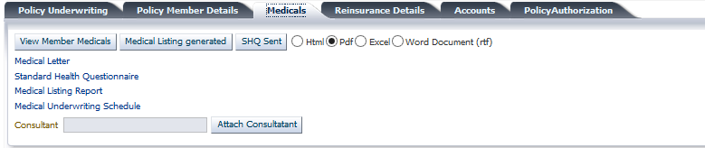

# Medicals screen

Having authorized a policy, click on underwriting>>Policy Medicals.

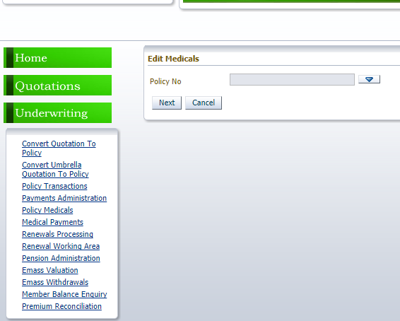

Select the policy

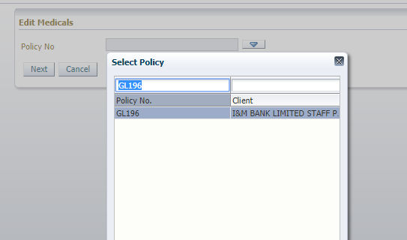

## Medical screen Terminologies

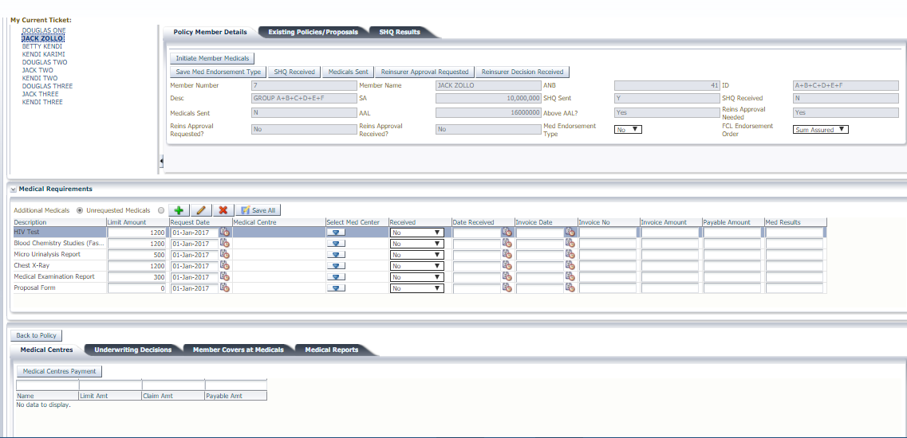

- This is the button that starts the medical process. This button populates the member covers and allows underwrite the member.

- Medical decisions except “Accept member at Normal Rates” require a medical endorsement (FCL endorsement) to take effect. Setting the field as Yes takes the user to the endorsement screen. Setting as No, allows te user to complete the medical process on this screen

- This allows a user to capture in the system that SHQ (Standard Health Questionnaire) has been received

- This allows a user to send the medicals for a member and update them in the system once received. The field is updated to Y once medicals are sent and the button is clicked.

-For cases whose main cover SA is greater than AAL, the insurance company seeks reinsurance approval in accepting the customer to the policy. This field is automatically Y else N.

- Once the reinsurance decidion is received, this button is clicked upon which the field is updated to Y.

- This is a tab for capturing the member’s results as is in the SHQ (Standard Health Questionnaire)

- These are medicals that the member ought to take before being accepted to the policy. These are set up based.

- This is a tab for capturing the members decisions based on the customer’s health condition

- These are the member’s covers which are automatically updated based on the final decision made.

- This is a tab that has the medical reports as requested by the insurance company

# Medical process

# Cases with Decisions affecting SA/Premium

1. Select the member to underwrite.

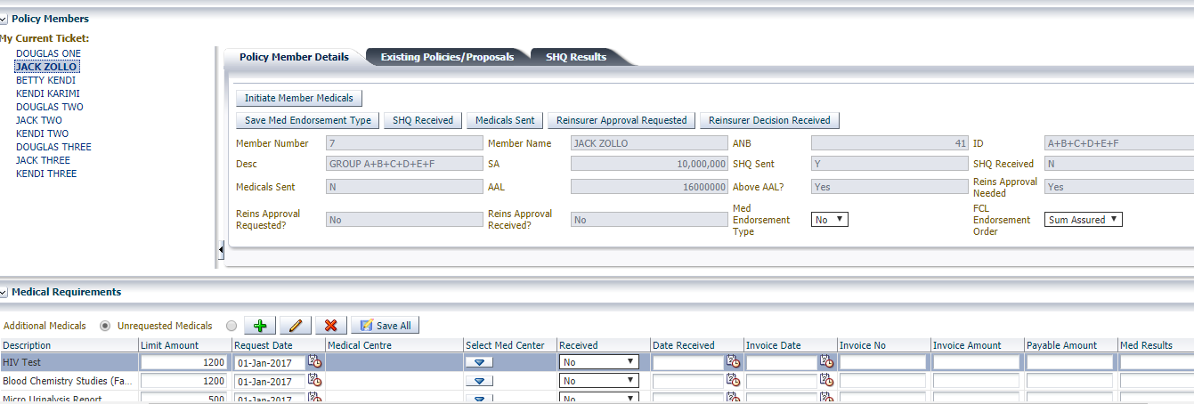

1. Click on . The ticket Process Medicals is appended on the specific member. At the  tab, the initial premiums of the member being underwritten are displayed

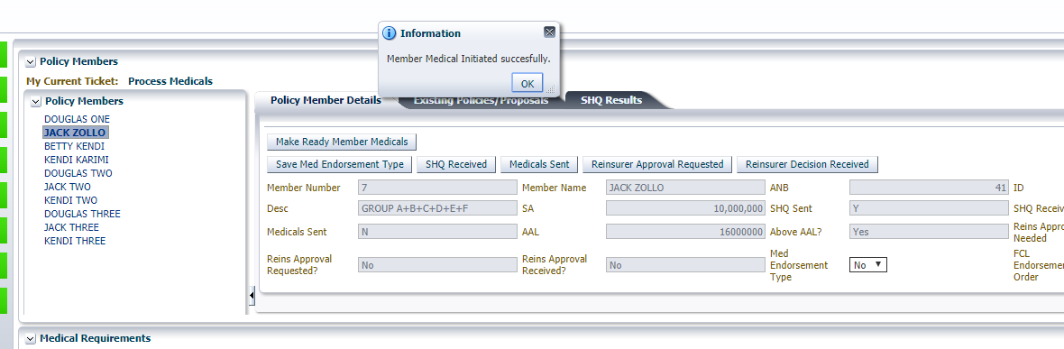

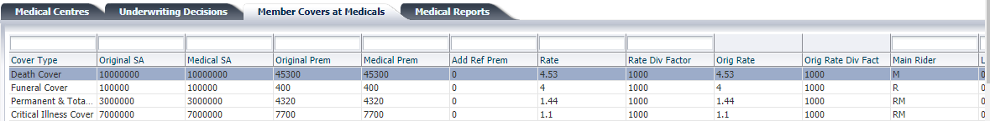

1. Click on  button

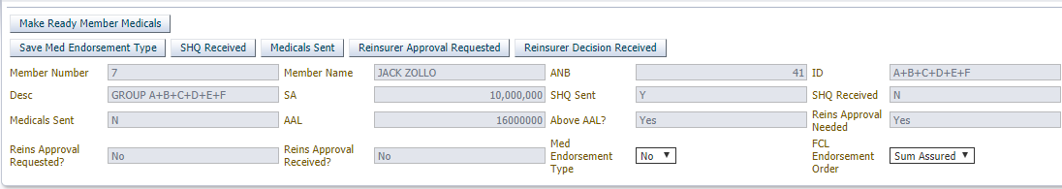

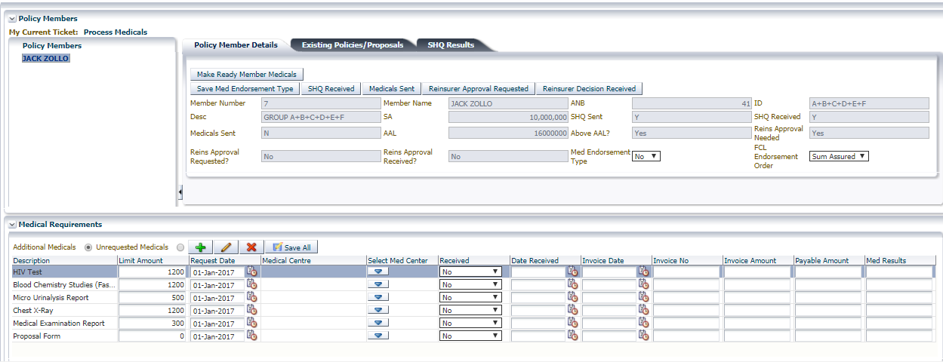

1. Click on  tab
2. Capture the SHQ results and save

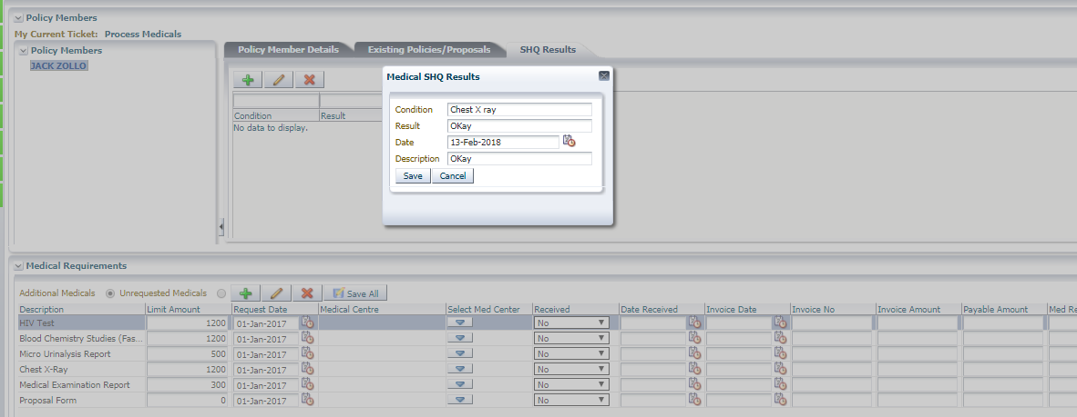

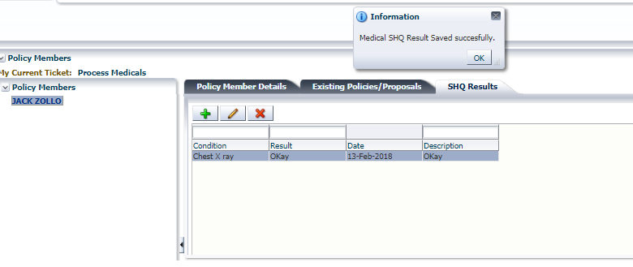

1. Click on 

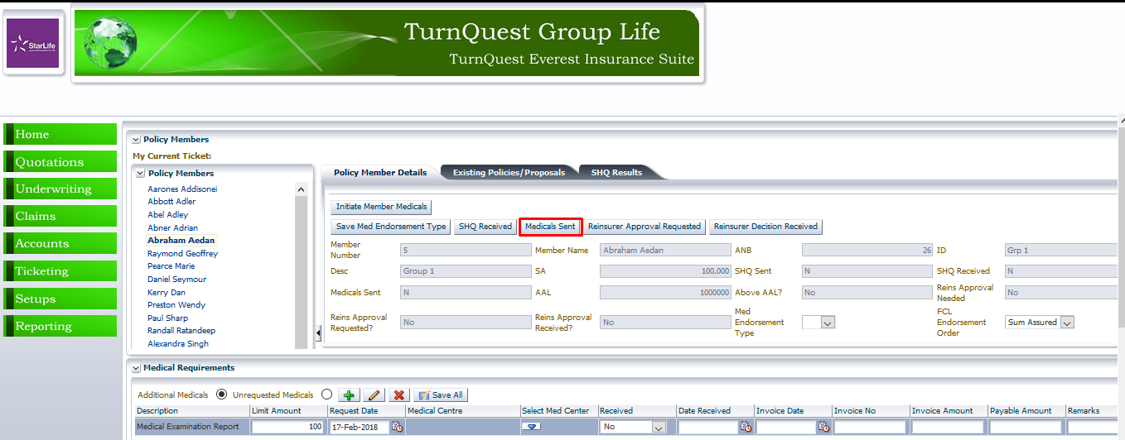

1. Capture the medicals received by selecting the medical centre, date the medicals were done and invoice details.
2. Click on **Save All**.

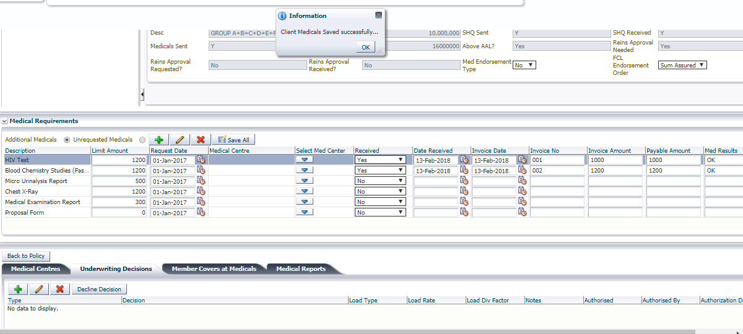

## Underwriting Decisions

* Click on 

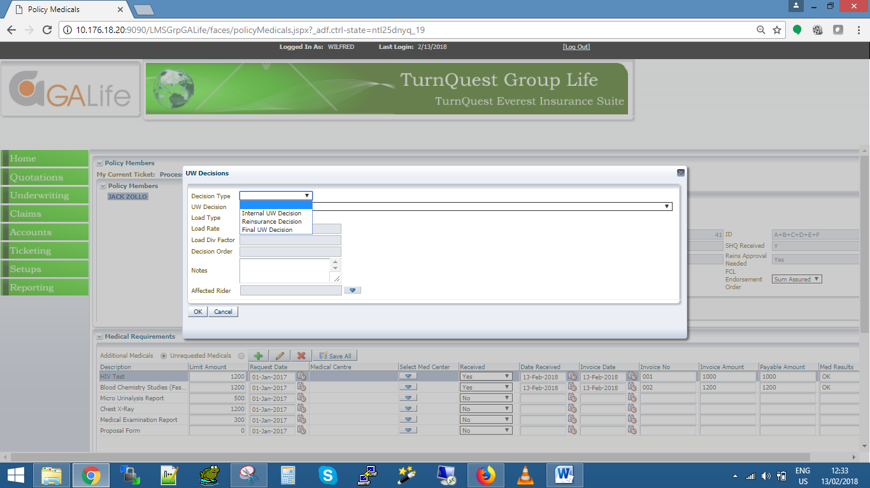

## Decision Types

* Internal Decision: - These are decisions made internally by the insurance company with regard to the customer’s health condition after having received the SHQ results. This does not affect the premium of the customer
* Reinsurance Decision: - This decision is sought by the insurance company to the reinsurer with regard to the customer’s health condition after having received the SHQ results. This does not affect the premium of the customer as well
* Final Underwriting Decision: - This is the final decision made by the insurance company having taken into consideration the Internal Decision, Reinsurance Decision and the customer’s health condition after having received the SHQ results

## Underwriting Decision Types

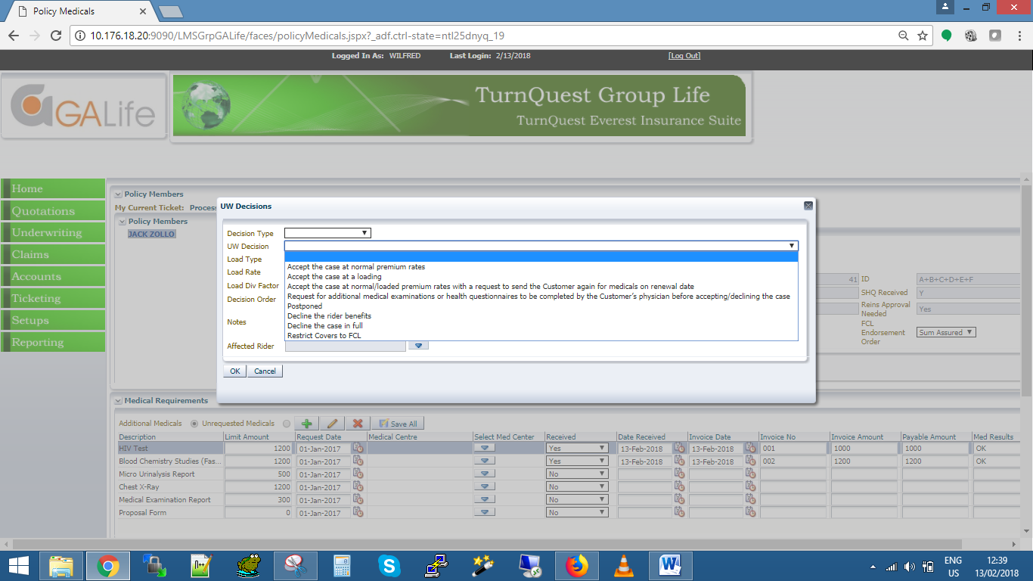

* **Accept the case at normal premium rates**: - Under this decision type, the customer is accepted without having to load their premium
* **Accept the case at a loading**: - This decision type caters for accepting a customer to a policy but loading their premium or rates
* Accept the case at normal/loaded premium rates with a request to send the Customer again for medicals on renewal date
* Request for additional medical examinations or health questionnaires to be completed by the Customer’s physician before accepting/declining the case
* **Decline the rider benefits**: - This decision allows decline some of the cover types attached to a customer
* **Decline the case in full**: - This decision type allows for declining a customer to a policy

Making an Internal Decision

1. Click on 



1. Select Internal decision

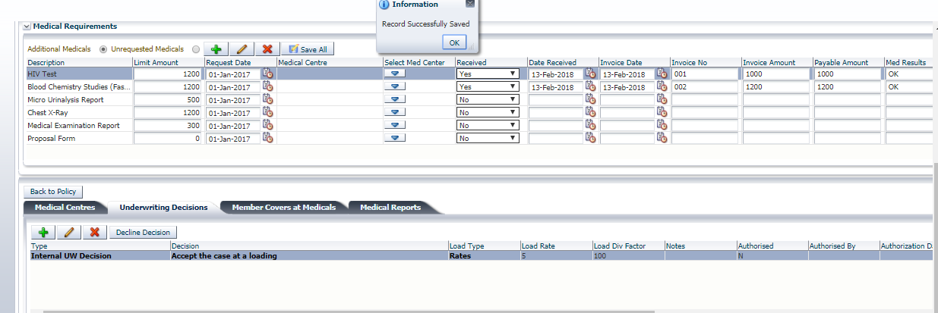

1. Confirm that the decision does not affect the premium of the member at  tab

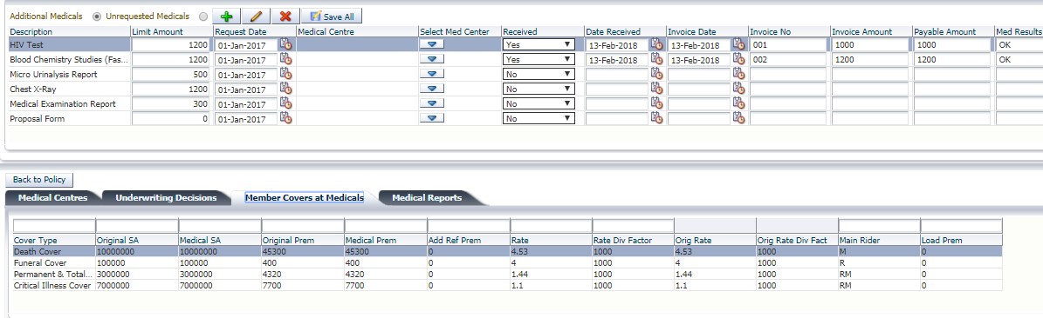

Making a Reinsurance Decision

1. Click on 



1. Select Reinsurance decision

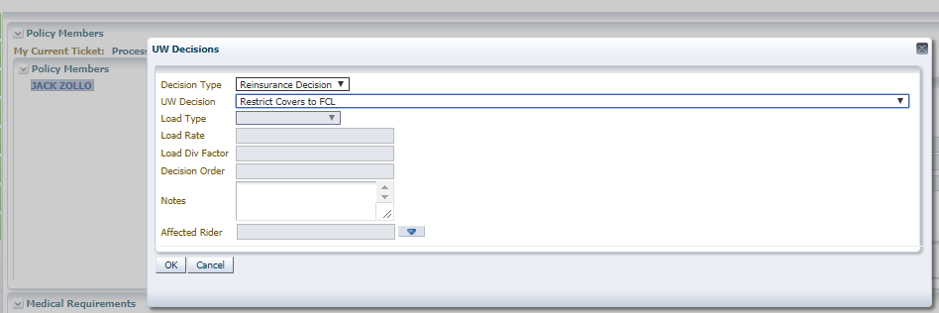

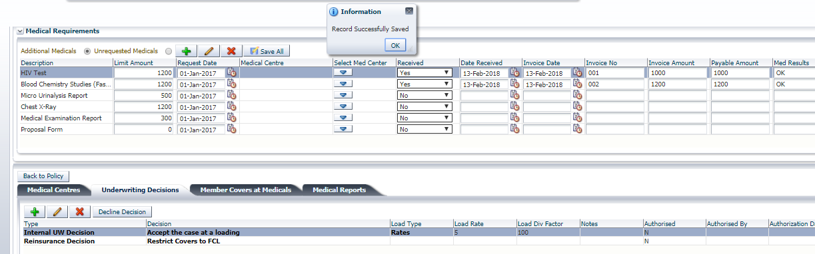

1. Confirm that the decision does not affect the premium of the member at  tab



Making a Final Underwriting Decision

1. Click on 



1. Select final decision

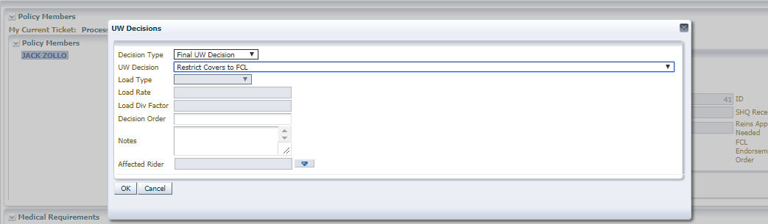

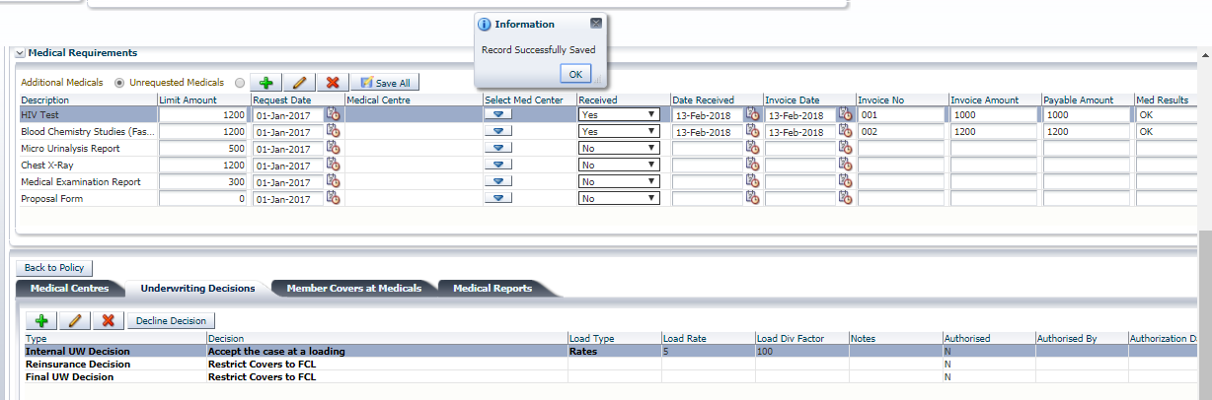

1. Confirm that the decision affects the premium/Sum assureds of the member at  tab

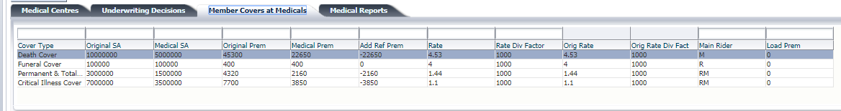

1. Another final decision can be made

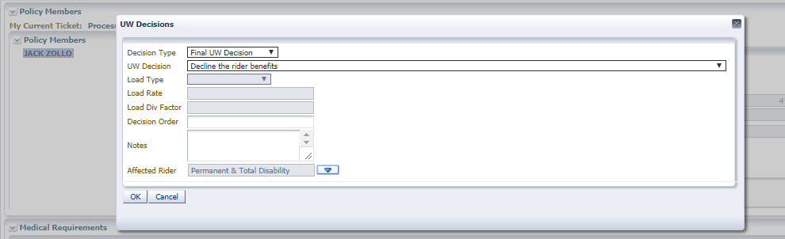

1. Confirm that the decision affects the premium/Sum assureds of the member at  tab

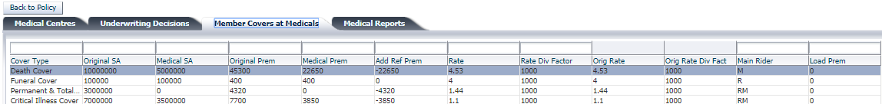

1. At the med endorsement type field, save the endorsement type as Yes. Since the decisions made require an endorsement to take effect.

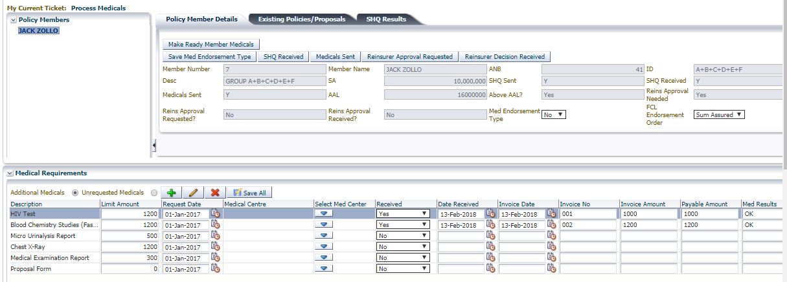

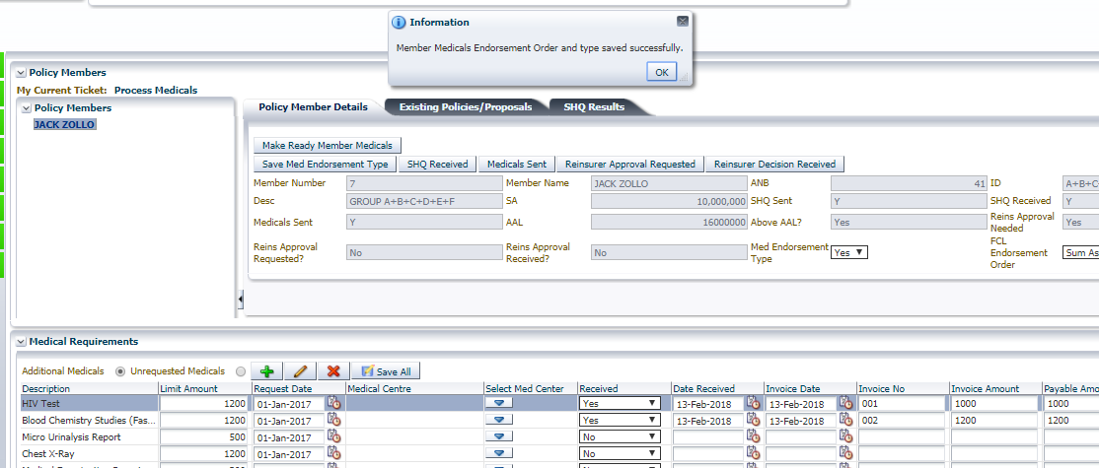

1. Proceed to make ready to authorize the transaction

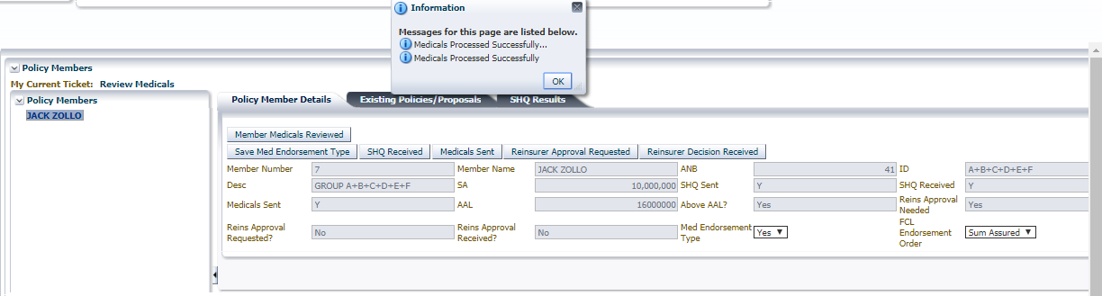

1. Review the endorsement

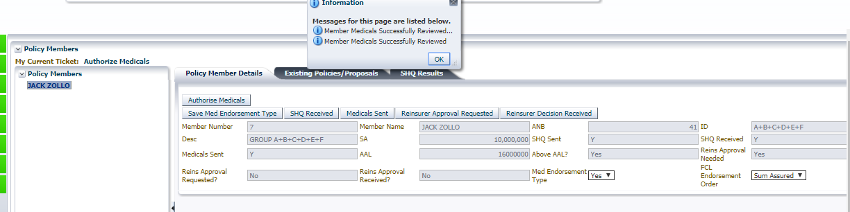

1. Re assign the ticket to the approver to authorize the medical underwriting
2. Proceed to perform the FCL endorsement by clicking the perform endorsement button

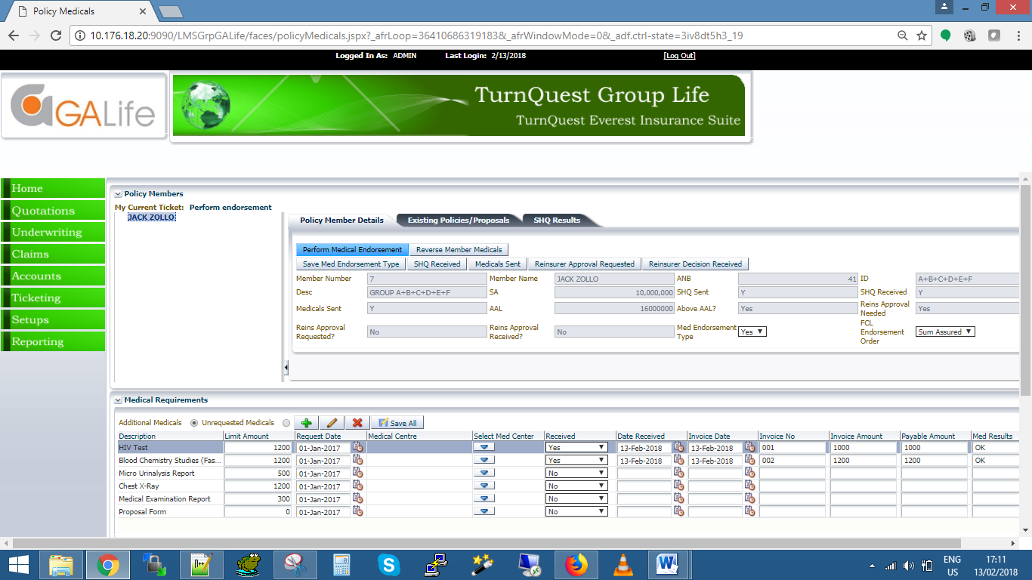

1. Capture the effective date of the endorsement

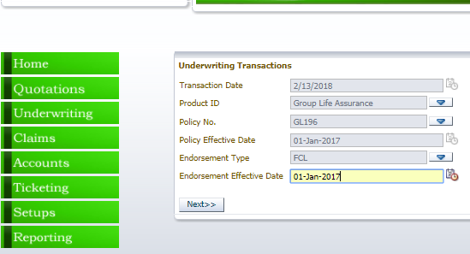

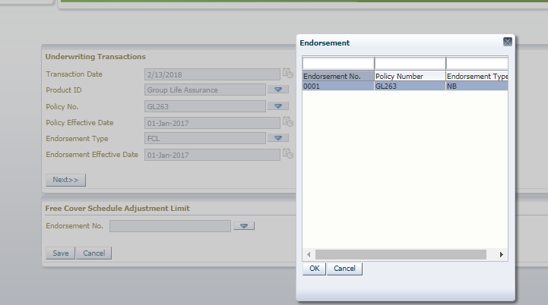

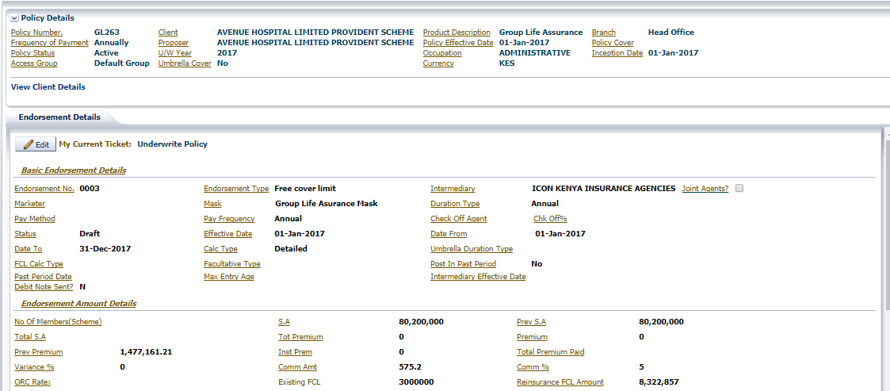

1. Compute premium

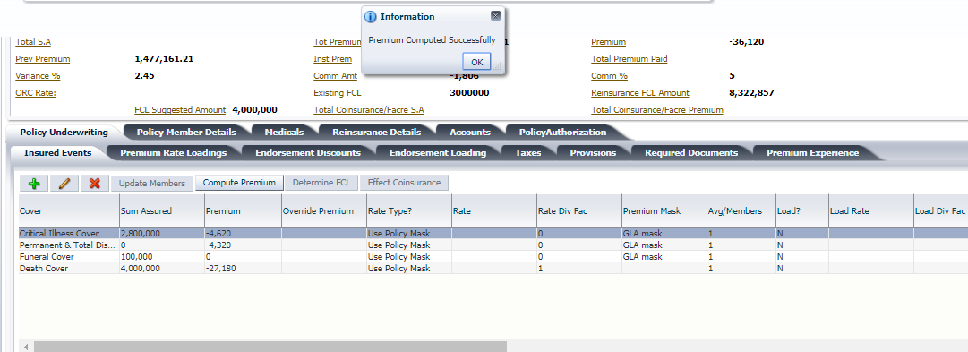

1. Make ready

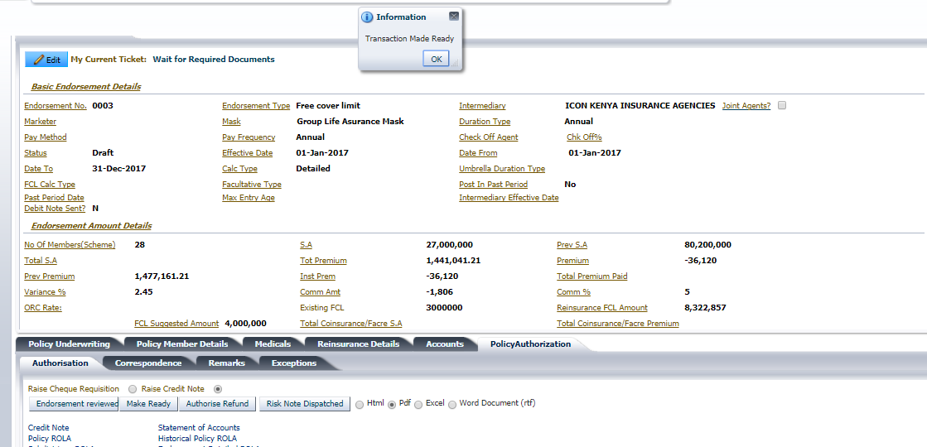

1. Receive required documents

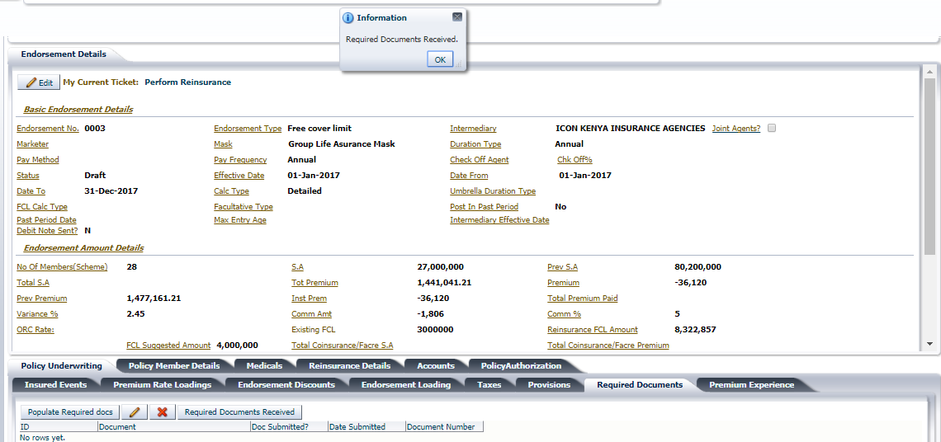

1. Populate treaties then reinsure

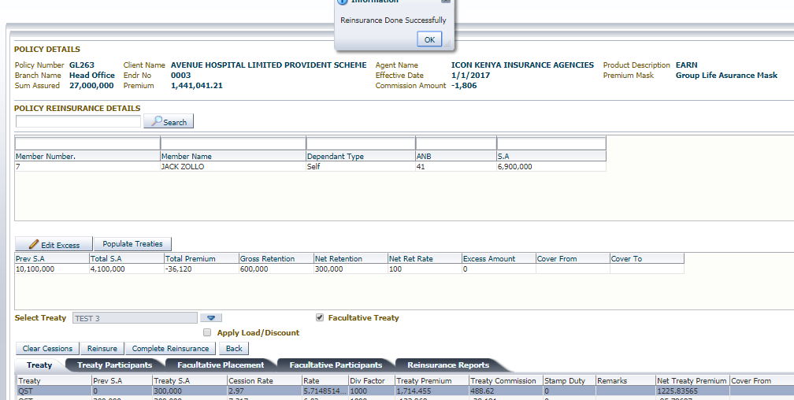

1. Complete Reinsurance

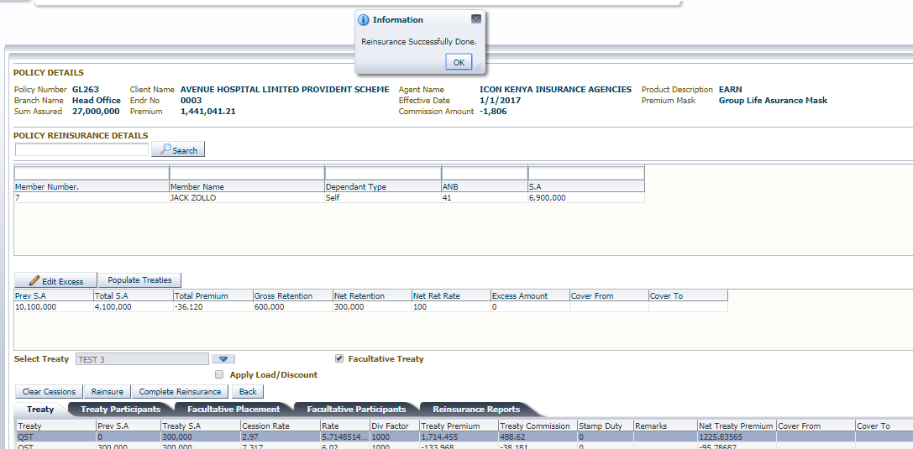

1. Authorise policy

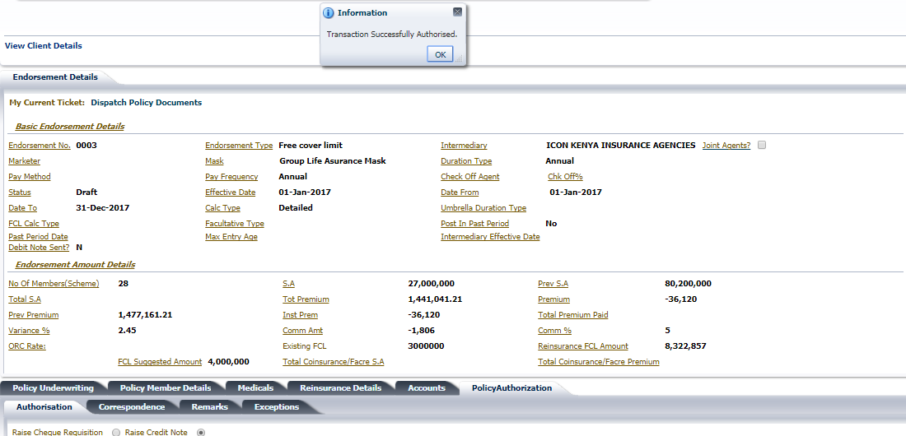

# Cases with Decisions not affecting SA/prem

Process as above:

1. Select the member to underwrite.
2. Initiate member medicals
3. Make ready
4. Review Medicals
5. Authorise medicals
6. Complete Medical U/W

Or

1. Select the member to underwrite.
2. Initiate member medicals
3. Make decision accept at Normal Rates
4. Make ready
5. Review Medicals
6. Authorise medicals
7. Complete Medical U/W