**Testing**

Database at start-

Seat Table:

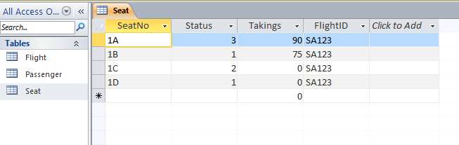

Passenger Table:

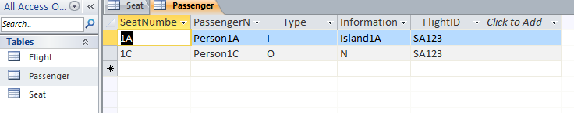

Flight Table:

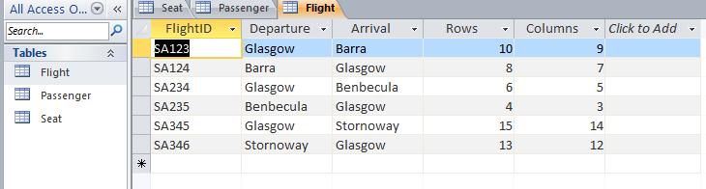

|  |  |  |  |  |  |
| --- | --- | --- | --- | --- | --- |
| **Test No** | **Test Case** | **Input** | **Expected Output** | **Actual Output** | **Screenshots** |
| 1. | Testing the applications main menu appears when the app is first run | Compiling and running the application | Windows displaying main menu (Flight Admin, Bookings Menu, View Flight Details, View Seat Details, Quit) | As expected | Pic 1 |
| 2. | Testing the flight details are read from database and shown to user after pressing View Flight Details button | Click ‘View Flight Details’ then click on flight on select flight screen | Generic output displaying flight details | As expected | Pic 2 |
| 3. | Testing to see if a free seat’s details are shown when View Seat details is pressed | Click View Seat Details, select flight SA364, enter seat number 1A. | Generic output displaying seat details showing seat is free | As expected | Pic 3 |
| 4. | Testing to see if a reserved seat’s details are shown when View Seat details is pressed | Click View Seat, Select Flight SA123, Select Seat 1C | Generic output displaying seat details showing seat is reserved | As expected | Pic 4 |
| 5. | Testing to see if a booked seat’s details are shown when View Seat details is pressed | Click View Seat, Select Flight SA123, Select Seat 1A | Generic output displaying seat details showing seat is booked | As expected | Pic 5 |
| 6.1 | Testing if Cancelling a free seat displays appropriate message. | Click Booking menu, select flight SA364, Click cancel booking, enter seat number 1A | Generic output showing that a free seat cannot be cancelled | As expected | Pic 6.1 |
| 6.2 | Testing if Cancelling a free seat updates the flight counters (on View Flight Details) correctly. | View click on view flight details, select flight SA236 | Generic output showing flight details displayed, flight counters remain unchanged | As expected | Pic 6.2 |
| 7.1 | Testing if Cancelling a reserved seat displays appropriate message. | Click Booking menu, select flight SA123, Click cancel booking, enter seat number 1C | Generic output showing that seat has been cancelled | As expected | Pic 7.1 |
| 7.2 | Testing if Cancelling a reserved seat updates the flight counters (on View Flight Details) correctly. | Click view flight details, select flight SA123 | Generic output showing updated counters | As expected | Pic 7.2 |
| 8.1 | Testing if Cancelling a booked seat displays appropriate message. | Click Booking menu, select flight SA123, Click cancel booking, enter seat number 1A | Generic output showing cancellation message | As expected | Pic 8.1 |
| 8.2 | Testing if Cancelling a booked seat updates the flight counters (on View Flight Details) correctly. | View click on view flight details, select flight SA123 | Generic output showing booked seats down by 1 and takings unchanged | As expected | Pic 8.2 |
| 9.1 | Testing if reserving a free seat as an Island Passenger displays an appropriate message. | Booking menu, select flight, make reservation, seat number 1A, name john click local, enter barra as island click submit | Generic output showing seat 1A reserved by john | As expected | Pic 9.1 |
| 9.2 | Testing if reserving a free seat as an Island Passenger updates the flight counters (on View Flight Details) correctly. | View flight details, flight SA236 | Generic output showing reserved seats up by 1 | As expected | Pic 9.2 |
| 10.1 | Testing if reserving a free seat as a Business Passenger displays an appropriate message. | Booking menu, select flight SA236, make reservation, seat number 1B, name jim click business, enter comp1 as business click submit | Generic output showing seat 1B reserved by jim | As expected | Pic 10.1 |
| 10.2 | Testing if reserving a free seat as a Business Passenger updates the flight counters (on View Flight Details) correctly. | View flight details, flight SA236 | Generic output showing reserved seats up by 1 | As expected | Pic 10.2 |
| 11.1 | Testing if reserving a free seat as an Ordinary Passenger displays an appropriate message. | Booking menu, select flight, make reservation, seat number 1c, name dave click Ordinary, enter N as promo click submit | Generic output showing seat 1c reserved by dave | As expected | Pic 11.1 |
| 11.2 | Testing if reserving a free seat as an Ordinary Passenger updates the flight counters (on View Flight Details) correctly. | View flight details, flight SA236 | Generic output showing reserved seats up by 1 | As expected | Pic 11.2 |
| 12.1 | Testing if booking a free seat as an Island Passenger displays an appropriate message | Booking menu, select flight SA235, make reservation, seat number 1A, name john click local, enter barra as island click submit | Generic output showing seat 1A reserved by john | As expected | Pic 12.1 |
| 12.2 | Testing if booking a free seat as an Island Passenger updates the flight counters (on View Flight Details) correctly. | View flight details View flight details SA235 | Generic output showing booked seats up by 1 | As expected | Pic 12.2 |
| 12.3 | Testing if booking a free seat as an Island Passenger updates the total flight takings correctly (with the Island Passengers discount). | View flight details SA235 | Takings up to 90 | As expected | Pic 12.2 |
| 13.1 | Testing if booking a free seat as a Business Passenger displays an appropriate message | Booking menu, select flight SA235, make reservation, seat number 1B, name jim click Business, enter comp1 as business click submit | Generic output showing seat 1B reserved by jim | As expected | Pic 13.1 |
| 13.2 | Testing if booking a free seat as a Business Passenger updates the flight counters (on View Flight Details) correctly. | View flight details SA235 | Generic output showing booked seats up by 1 | As expected | Pic 13.2 |
| 13.3 | Testing if booking a free seat as a Business Passenger updates the total flight takings correctly (with the Island Passengers discount). | View flight details SA235 | Takings up to 90 | As expected | Pic 13.2 |
| 14.1 | Testing if booking a free seat as an Ordinary Passenger (no promo) displays an appropriate message | Booking menu, select flight SA235, make reservation, seat number 1C, name dave click local, enter N as promo click submit | Generic output showing seat 1C reserved by Dave | As expected | Pic 14.1 |
| 14.2 | Testing if booking a free seat as an Ordinary Passenger (no promo) updates the flight counters (on View Flight Details) correctly. | View flight details SA235 | Generic output showing booked seats up by 1 | As expected | Pic 14.2 |
| 14.3 | Testing if booking a free seat as an Ordinary Passenger updates the total flight takings correctly (with no discount). | View flight details SA235 | Takings up to 90 | As expected | Pic 14.2 |
| 15.1 | Testing if booking a free seat as an Ordinary Passenger (promo included) displays an appropriate message | Seat number 1D booked by jack | Message displaying that jack has now booked 1D | As expected | Pic 15.1 |
| 15.2 | Testing if booking a free seat as an Ordinary Passenger (promo included) updates the flight counters (on View Flight Details) correctly. | View flight details on flight SA235. | Booked seats up to 4, free seats down to 9 | As expected | Pic 15.2 |
| 15.3 | Testing if booking a free seat as an Ordinary Passenger updates the total flight takings correctly (with promo discount). | View flight details on flight SA235. | £95 added to total takings | As expected | Pic 15.2 |
| 16.1 | Testing if booking a reserved seat as an Island Passenger (from Test 9) displays an appropriate message – name is different | Attempt to book seat 1A with name Jim on flight SA346 | Display error message | As expected | Pic 16.1 |
| 16.2 | Testing if booking a reserved seat as an Island Passenger (from Test 9) updates the flight counters (on View Flight Details) correctly – name is different | Attempt to book seat 1A with name Jim on flight SA346 | Reserved seats 3, booked seats 0 | As expected | Pic 16.2 |
| 16.3 | Testing if booking a reserved seat as an Island Passenger (from Test 9) updates the total flight takings correctly – name is different | Attempt to book seat 1A with name Jim on flight SA346 | Flight takings 0.0 | As expected | Pic 16.2 |
| 17.1 | Testing if booking a reserved seat as an Island Passenger (from Test 9) displays an appropriate message – name is the same | Enter seat 1A on SA346. Book as John | Seat booked by John | As expected | Pic 17.1 |
| 17.2 | Testing if booking a reserved seat as an Island Passenger (from Test 9) updates the flight counters (on View Flight Details) correctly – name is the same | View flight details SA346 | Booked Seats 1  Takings 90 | As expected | Pic 17.2 |
| 17.3 | Testing if booking a reserved seat as an Island Passenger (from Test 9) updates the total flight takings correctly – name is the same | View flight details SA346 | Booked Seats 1  Takings 90 | As expected | Pic 17.2 |
| 18.1 | Testing if booking a reserved seat as a Business Passenger (from Test 10) displays an appropriate message – name is different | Attempt to book seat 1A with name dave on flight SA346 | Display error message | As expected | Pic 18.1 |
| 18.2 | Testing if booking a reserved seat as a Business Passenger (from Test 10) updates the flight counters (on View Flight Details) correctly – name is different | View flight details SA346 | No change | As expected | Pic 18.2 |
| 18.3 | Testing if booking a reserved seat as a Business Passenger (from Test 10) updates the total flight takings correctly – name is different | View flight details SA346 | No change | As expected | Pic 18.2 |
| 19.1 | Testing if booking a reserved seat as a Business Passenger (from Test 10) displays an appropriate message – name is the same | Enter seat 1B on SA346. Book as Jim | Seat booked by Jim | As expected | Pic 19.1 |
| 19.2 | Testing if booking a reserved seat as a Business Passenger (from Test 10) updates the flight counters (on View Flight Details) correctly – name is the same | View flight details SA346 | Booked seats 2, reserved seats down by 1 | As expected | Pic 19.2 |
| 19.3 | Testing if booking a reserved seat as an Business Passenger (from Test 10) updates the total flight takings correctly – name is the same | View flight details SA346 | Takings up by £75 | As expected | Pic 19.2 |
| 20.1 | Testing if booking a reserved seat as an Ordinary Passenger (from Test 11) displays an appropriate message – name is different | Enter seat 1C on SA346. Book as ordinary passenger named Jim | Display error message | As expected | Pic 20.1 |
| 20.2 | Testing if booking a reserved seat as an Ordinary Passenger (from Test 11) updates the flight counters (on View Flight Details) correctly – name is different | View flight details SA346 | No change | As expected | Pic 20.2 |
| 20.3 | Testing if booking a reserved seat as an Ordinary Passenger (from Test 11) updates the total flight takings correctly – name is different | View flight details SA346 | No change | As expected | Pic 20.2 |
| 21.1 | Testing if booking a reserved seat as an Ordinary Passenger (from Test 11) displays an appropriate message – name is the same | Enter seat 1C on SA346. Book as ordinary passenger named Dave | Seat booked by Dave | As expected | Pic 21.1 |
| 21.2 | Testing if booking a reserved seat as an Ordinary Passenger (from Test 11) updates the flight counters (on View Flight Details) correctly – name is the same | View flight details SA346 | Booked seats 3, reserved seats 0 | As expected | Pic 21.2 |
| 21.3 | Testing if booking a reserved seat as an Ordinary Passenger (from Test 11) updates the total flight takings correctly – name is the same | View flight details SA346 | Takings up to £265 | As expected | Pic 21.2 |
| For test 22 you will need to create a new Island Passenger and give them a reservation | | | | | |
| 22.1 | Testing if reserving a reserved seat as an Island Passenger displays an appropriate message. | Attempt to reserve 1A on SA123 as Island passenger named Jack | Display error message | As expected | Pic 22.1 |
| 22.2 | Testing if reserving a reserved seat as an Island Passenger updates the flight counters (on View Flight Details) correctly. | View flight details SA123 | No change | As expected | Pic 22.2 |
| For test 23 you will need to create a new Business Passenger and give them a reservation | | | | | |
| 23.1 | Testing if reserving a reserved seat as a Business Passenger displays an appropriate message. | 1A on SA123 as Business passenger named Jack | Display error message | As expected | Pic 23.1 |
| 23.2 | Testing if reserving a reserved seat as a Business Passenger updates the flight counters (on View Flight Details) correctly. | View flight details SA123 | No change | As expected | Pic 23.2 |
| For test 24 you will need to create a new Ordinary Passenger and give them a reservation | | | | | |
| 24.1 | Testing if reserving a reserved seat as an Ordinary Passenger displays an appropriate message. | 1A on SA123 as Business passenger named Jack | Display error message | As expected | Pic 24.1 |
| 24.2 | Testing if reserving a reserved seat as an Ordinary Passenger updates the flight counters (on View Flight Details) correctly. | View flight details SA123 | No change | As expected | Pic 24.2 |
| 25.1 | Testing if reserving a booked seat as an Island Passenger displays an appropriate message. | Attempt to reserve 1A on SA235 as Island passenger named Jack | Display error message | As expected | Pic 25.1 |
| 25.2 | Testing if reserving a booked seat as an Island Passenger updates the flight counters (on View Flight Details) correctly. | View flight details SA235 | No change | As expected | Pic 25.2 |
| 26.1 | Testing if reserving a booked seat as a Business Passenger displays an appropriate message. | Attempt to book 1A on SA235 as Business passenger named Jack | Display error message | As expected | Pic 26.1 |
| 26.2 | Testing if reserving a booked seat as a Business Passenger updates the flight counters (on View Flight Details) correctly. | View flight details SA235 | No change | As expected | Pic 26.2 |
| 27.1 | Testing if reserving a booked seat as an Ordinary Passenger displays an appropriate message. | Attempt to book 1A on SA235 as Ordinary passenger named Jack | Display error message | As expected | Pic 27.1 |
| 27.2 | Testing if reserving a booked seat as an Ordinary Passenger updates the flight counters (on View Flight Details) correctly. | View flight details SA235 | No change | As expected | Pic 27.2 |
| 28.1 | Testing if booking a booked seat as an Island Passenger displays an appropriate message. | Attempt to book 1A on SA235 as Island passenger named Jack | Display error message | As expected | Pic 28.1 |
| 28.2 | Testing if booking a booked seat as an Island Passenger updates the flight counters (on View Flight Details) correctly. | View flight details SA235 | No change | As expected | Pic 28.2 |
| 28.3 | Testing if booking a booked seat as an Island Passenger updates the total flight takings correctly. | View flight details SA235 | No change | As expected | Pic 28.2 |
| 29.1 | Testing if booking a booked seat as a Business Passenger displays an appropriate message. | Attempt to book 1A on SA235 as Business passenger named Jack | Display error message | As expected | Pic 29.1 |
| 29.2 | Testing if booking a booked seat as a Business Passenger updates the flight counters (on View Flight Details) correctly. | View flight details SA235 | No change | As expected | Pic 29.2 |
| 29.3 | Testing if booking a booked seat as a Business Passenger updates the total flight takings correctly. | View flight details SA235 | No change | As expected | Pic 29.2 |
| 30.1 | Testing if booking a booked seat as an Ordinary Passenger displays an appropriate message. | Attempt to book 1A on SA235 as ordinary passenger named Jack | Display error message | As expected | Pic 30.1 |
| 30.2 | Testing if booking a booked seat as an Ordinary Passenger updates the flight counters (on As expected View Flight Details) correctly. | View flight details SA235 | No change | As expected | Pic 30.2 |
| 30.3 | Testing if booking a booked seat as an Ordinary Passenger updates the total flight takings correctly. | View flight details SA235 | No change | As expected | Pic 30.2 |
| 31.1 | Testing Adding a Flight Displays new flight in All Flights menu | View flight details, check list | Flight SA111 displayed in list | As expected | Pic 31.1 |
| 31.2 | Testing Adding a Flight Displays new flight data in Database | View DB flight table | Flight SA111 added to db | As expected | Pic 31.2 |
| 32.1 | Testing changing flight status to Seats Available modifies the View Flight Details page view | Change flight status SA 346 to seats available. View flight status SA346 | Status is seats available | As expected | Pic 32.1 |
| 32.2 | Testing changing flight status to Checking In modifies the View Flight Details page view | Change flight status SA 346 to checking in. View flight status SA346 | Status is checking in | As expected | Pic 32.2 |
| 32.3 | Testing changing flight status to Boarding modifies the View Flight Details page view | Change flight status SA 346 to boarding. View flight status SA346 | Status is boarding | As expected | Pic 32.3 |
| 32.4 | Testing changing flight status to Flight Closed modifies the View Flight Details page view | Change flight status SA 346 to closed. View flight status SA346 | Status is closed | As expected | Pic 32.4 |
| 33. | Testing to make sure the Flight Details are written to the Seats Table | View DB | Flight details in seats table | As expected | Print screen of “View Flight Details” screen + Seats table (on DB) |
| 34. | Testing to make sure a Reserved seat is correctly written to the Passenger table | View DB | Reserved seat in passenger table (SA123, 1D & 1C) | As expected | Print screen of “View Seat Details” screen + Passenger table (on DB) |
| 35. | Testing to make sure a Booked seat is correctly written to the Passenger table | View DB | Booked seat in passenger table (SA235, 1A, 1B, 1C) | As expected | Print screen of “View Seat Details” screen + Passenger table (on DB) |

**Appendix**

Pic 1

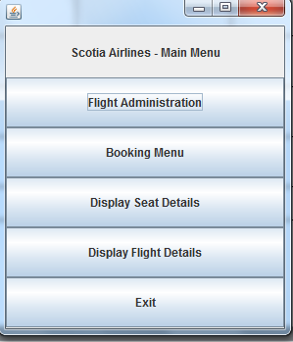

Pic 2

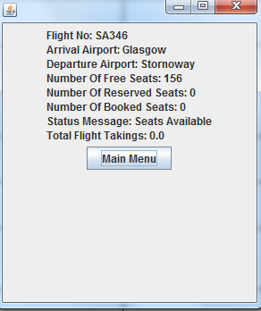

Pic 3

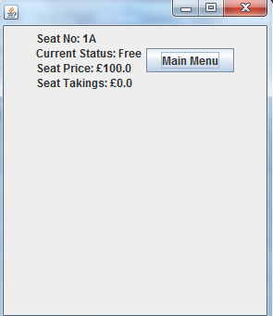

Pic 4

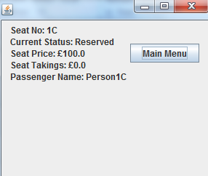

Pic 5

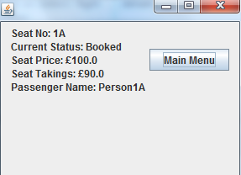

Pic 6.1

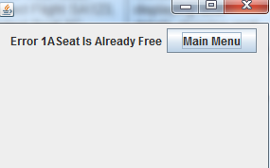

Pic 6.2

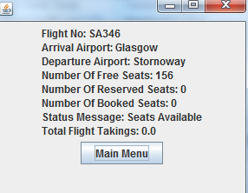

Pic 7.1

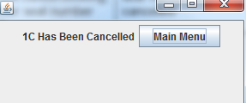

Pic 7.2

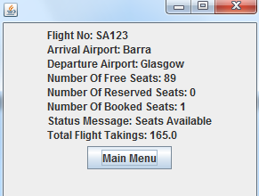

Pic 8.1

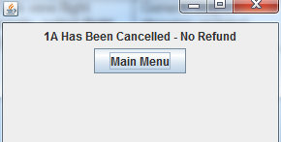

Pic 8.2

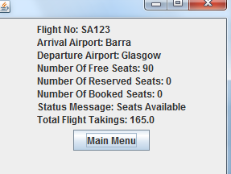

Pic 9.1

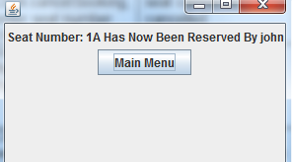

Pic 9.2

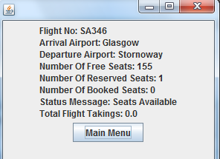

10.1

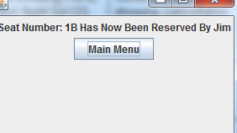

10.2

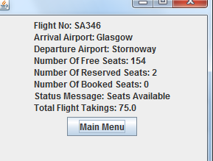

11.1

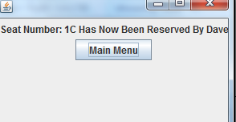

11.2

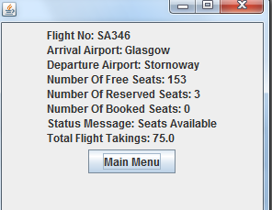

12.1

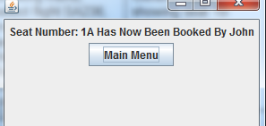

12.2

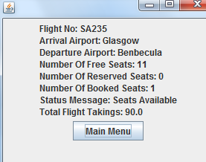

12.3



13.1

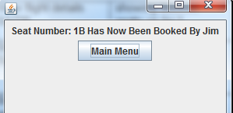

13.2

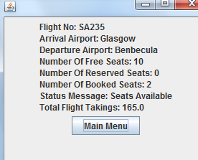

13.3



14.1

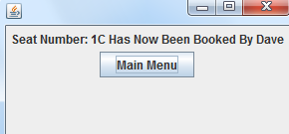

14.2

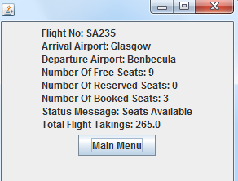

14.3



15.1

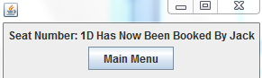

15.2

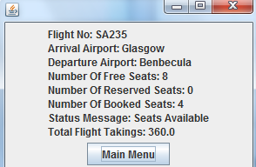

15.3



16.1

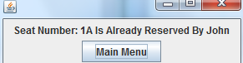

16.2

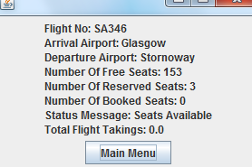

16.3



17.1

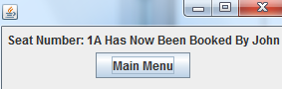

17.2

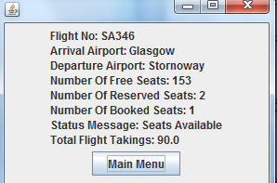

17.3



18.1



18.2



18.3



19.1

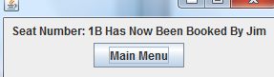

19.2

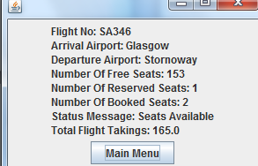

19.3



20.1

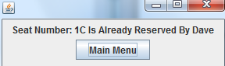

20.2

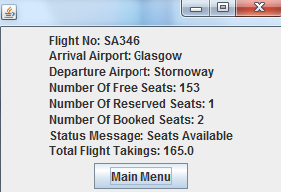

20.3



21.1

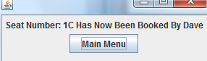

21.2

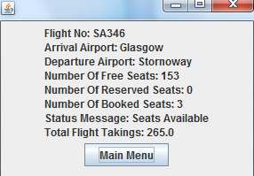

21.3



22.1

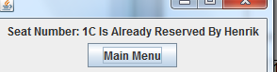

22.2

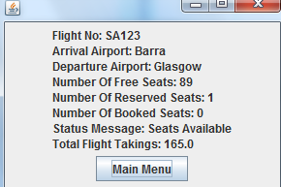

23.1

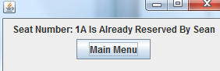

23.2



24.1

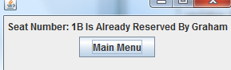

24,2

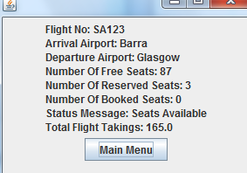

25.1

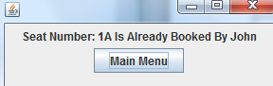

25.2

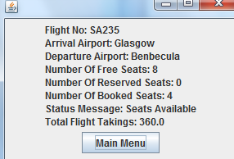

26.1

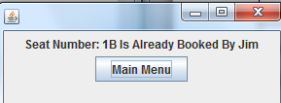

26.2

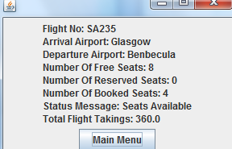

27.1

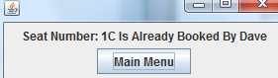

27.2

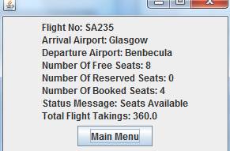

28.1

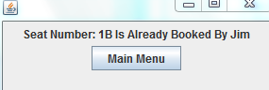

28.2

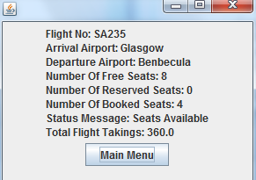

28.3



29.1

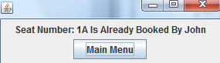

29.2

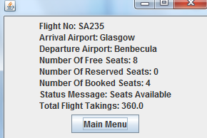

29.3



30.1

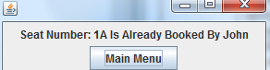

30.2

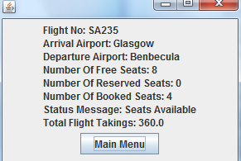

30.3



31.1

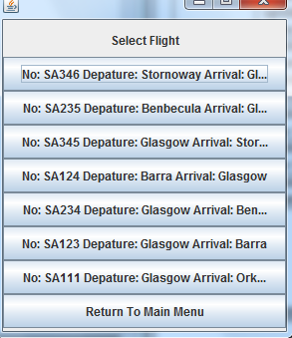

31.2

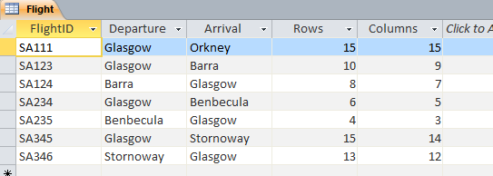

32.1

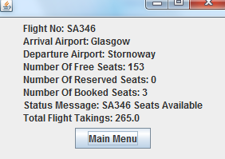

32.3

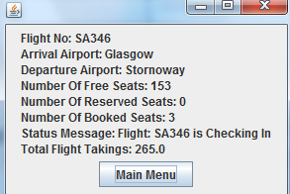

32.3

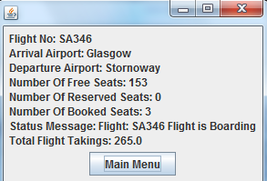

32.4

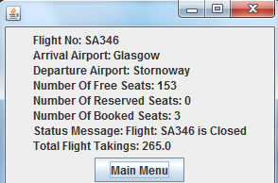

33.

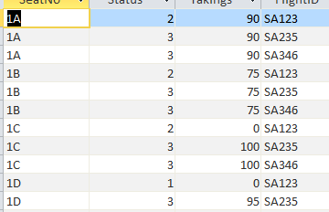

34

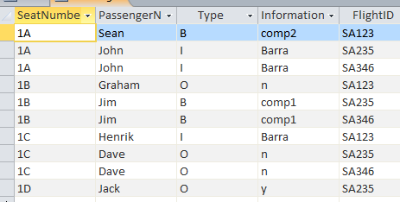

35

