**Exercise_1&2**

Hosting a Basic Website with Docker Desktop:

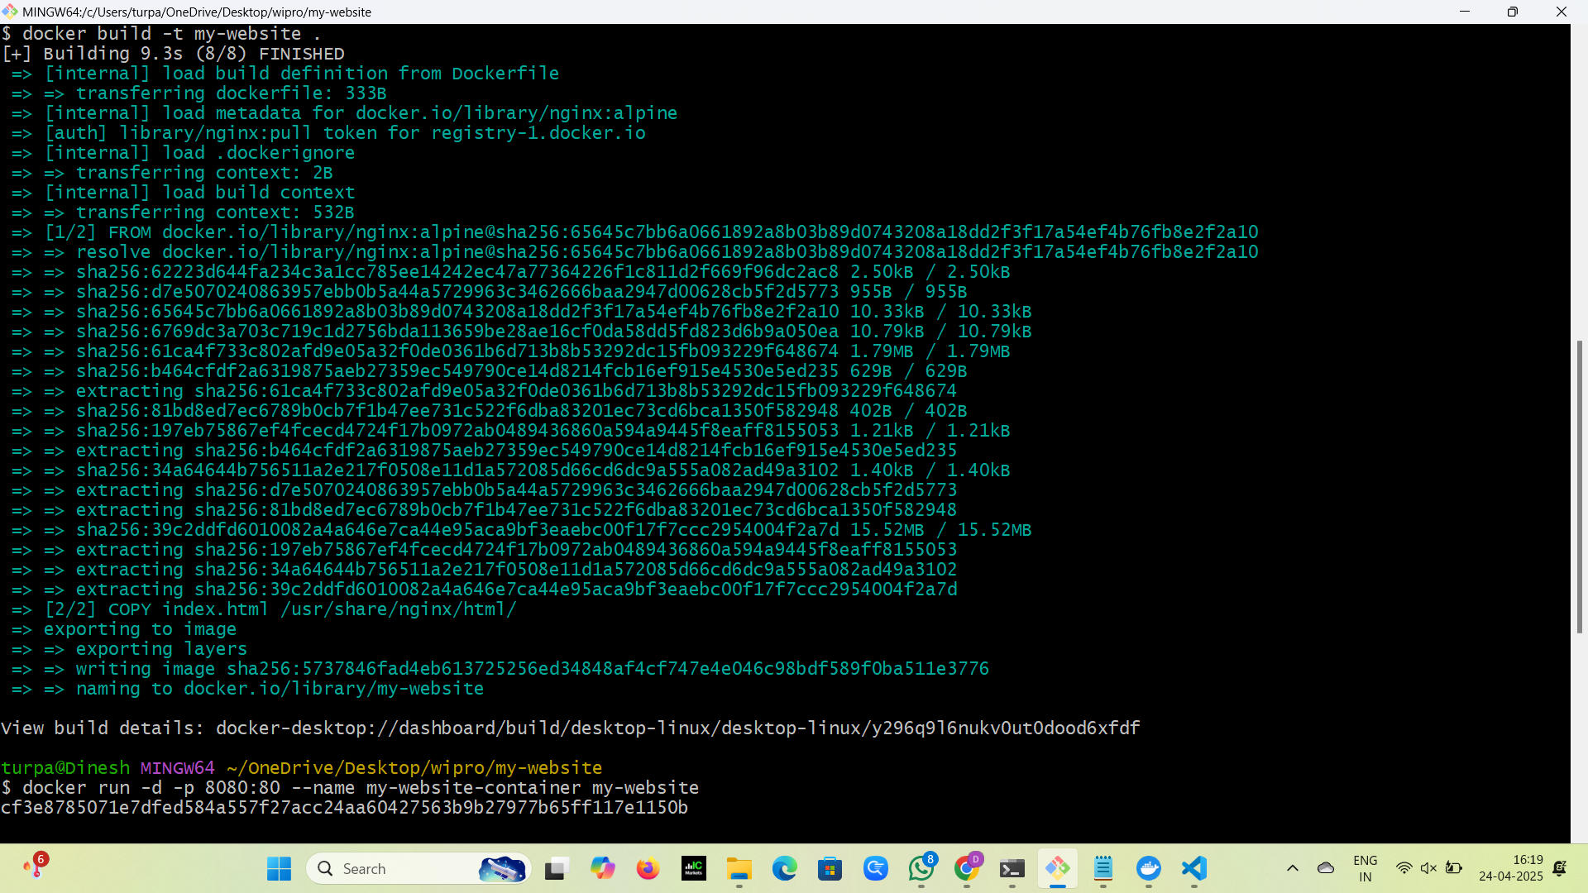

**Docker desktop container:**

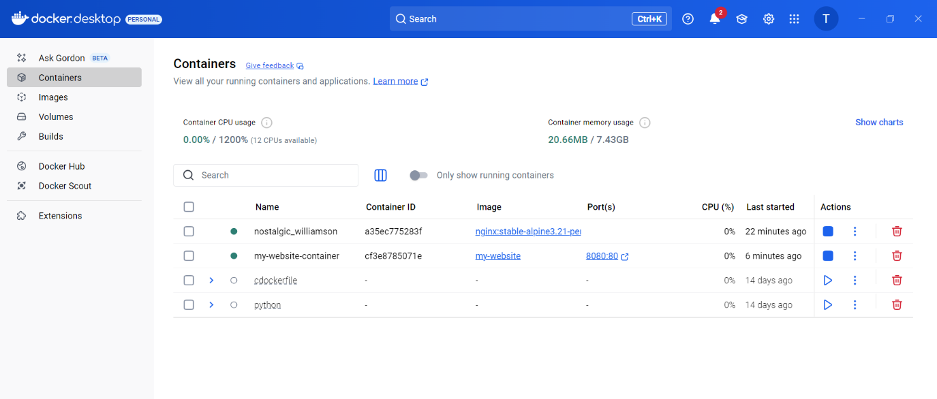

**Output:**

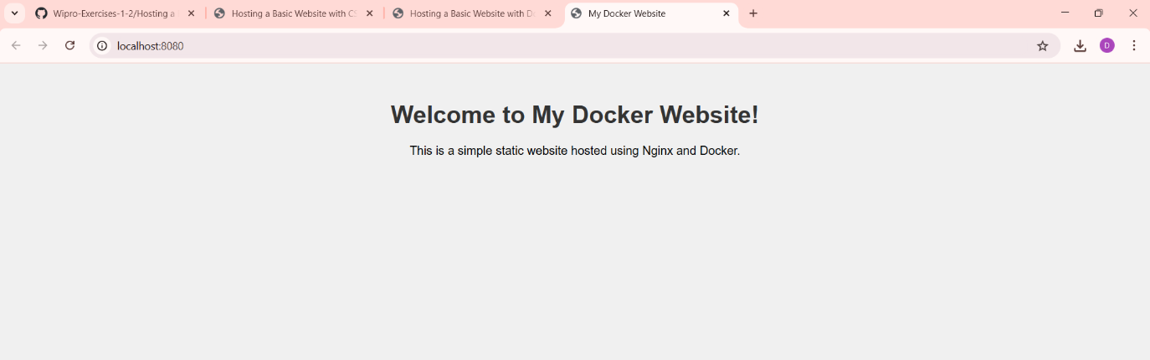

Hosting a Basic Wedsite with CSS, JS, BOOTSTRAP: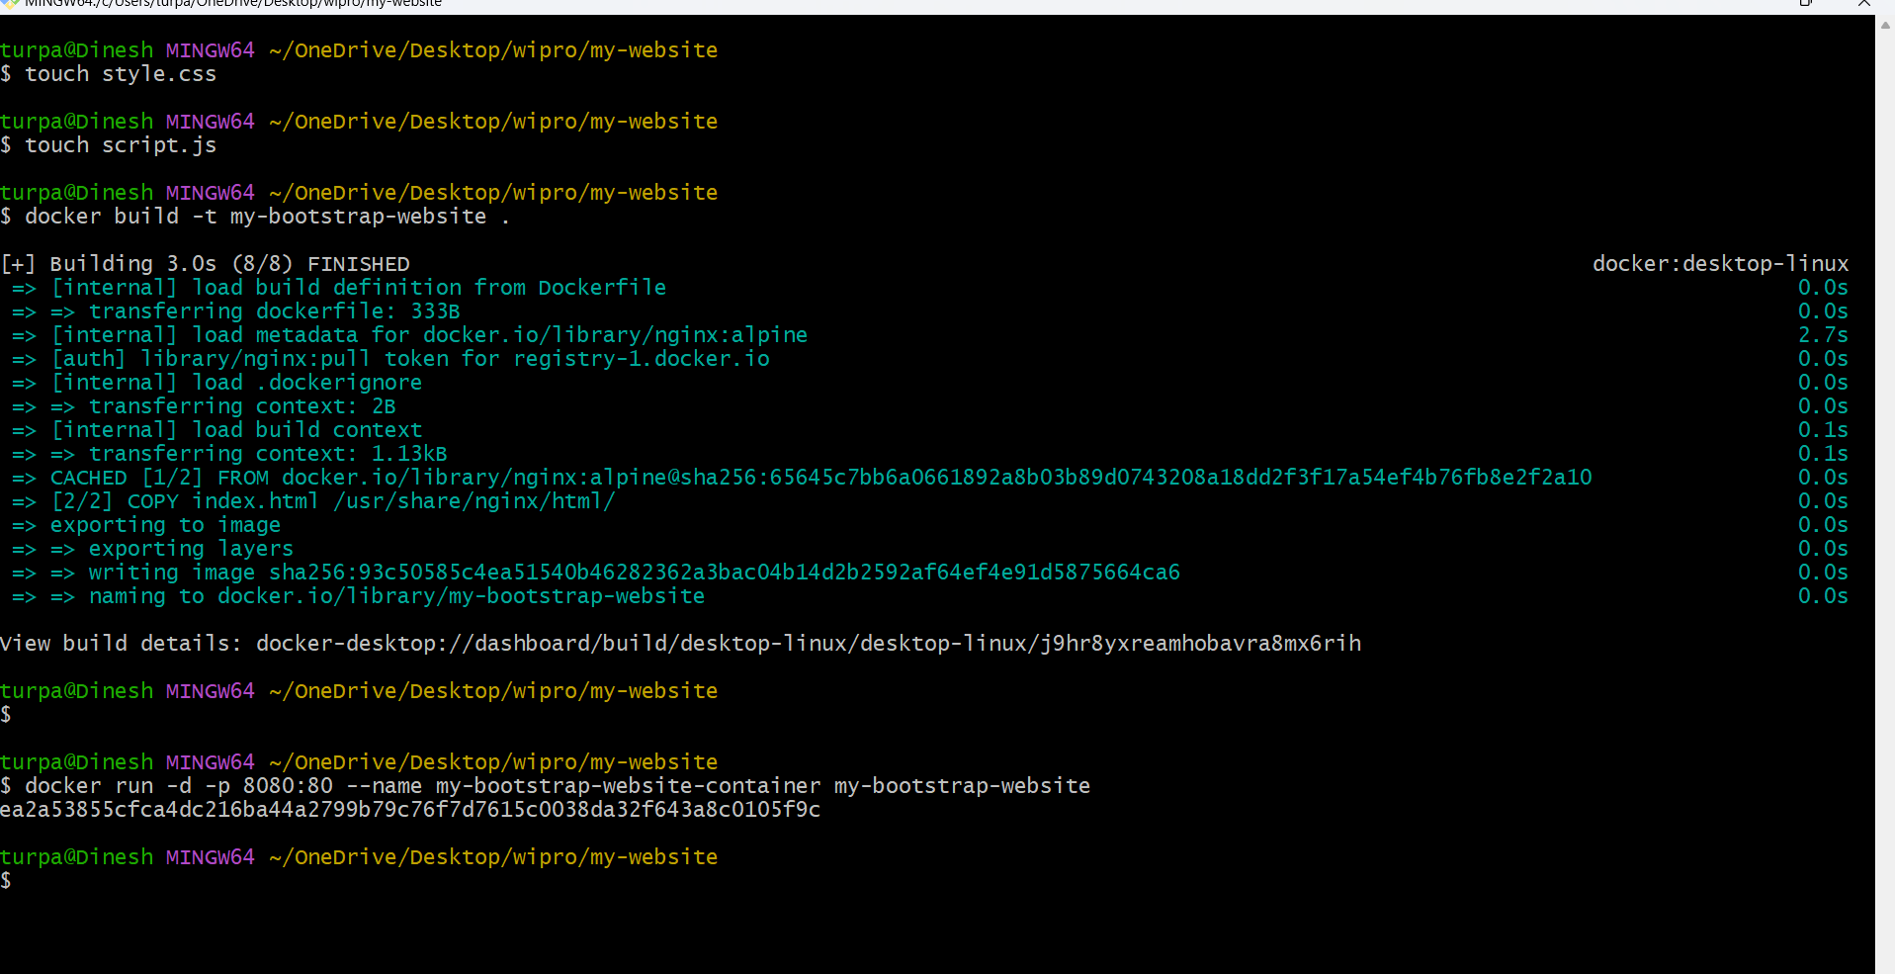

**Docker Desktop Containers:**

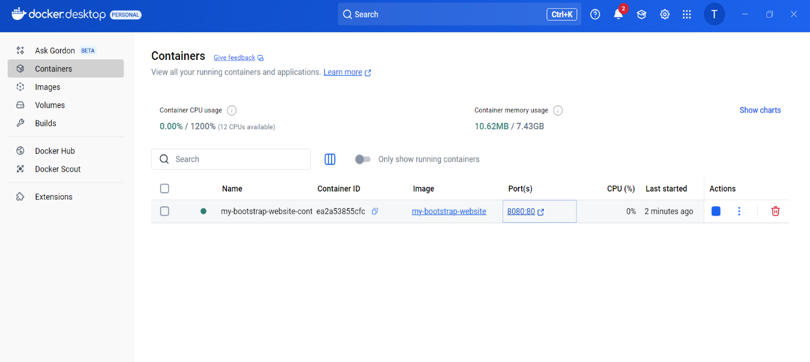

**Output:**

