**Installing : CUDA, Cudnn, Anaconda, GIT**

**Anaconda and Python:**

Some steps of this document come from here: <https://nitishmutha.github.io/tensorflow/2017/01/22/TensorFlow-with-gpu-for-windows.html>

Download anaconda : <https://www.continuum.io/downloads>

Install it

**Install GIT :**

Download and install git for windows from the following link:

<http://msysgit.github.io>

During the installation, in the configs, use the git bash and let other by default if you want

Then launch the git bash you just installed, go on the folder you want to put the project on and run:

* git clone <https://github.com/turpaultn/Text_classification> (public)
* git clone <https://github.com/turpaultn/CnafSAXO.git> (private)

**If you are using a GPU:**

If you have multiple machines

**CUDA (+Visual studio)**

You will need some dll files from visual studio. For dependencies (you can check on internet for the last updates <http://docs.nvidia.com/cuda/cuda-installation-guide-microsoft-windows/index.html#axzz4m40MXjmr> ) you need visual studio, at my time, it is VS 2015: <http://www.kunal-chowdhury.com/2015/07/download-visualstudio-2015.html#D0ADxefmaYEYWRmM.97>

You can choose web installer.

Once Visual studio is installed, you need CUDA:

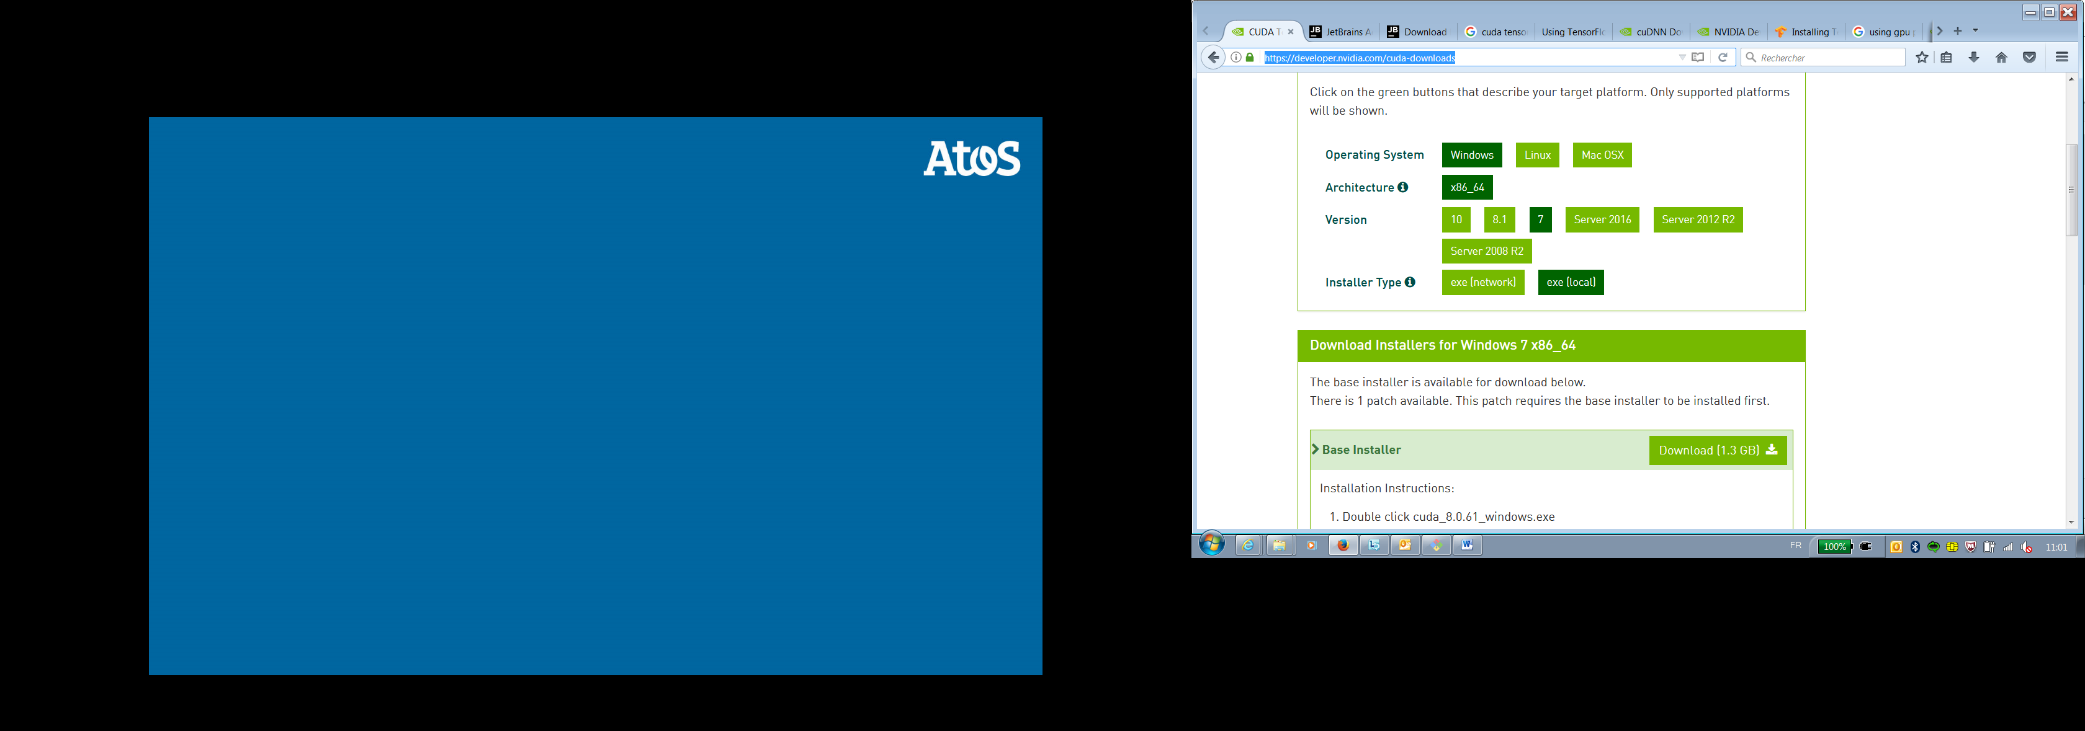

<https://developer.nvidia.com/cuda-downloads>

And the default installation is fine.

Add environment variable CUDA_HOME if it does not exist with the value of CUDA_PATH (for me it is C:\...\CUDA\v8.0)

**Cudnn**

Now we need Cudnn to run Tensorflow or others neural networks library in our GPU:

<https://developer.nvidia.com/rdp/cudnn-download> (you will need an account)

I chose [Download cuDNN v5.1 (Jan 20, 2017), for CUDA 8.0](https://developer.nvidia.com/rdp/cudnn-download#a-collapseTwo) because it is the most stable and best for my GPU

And [cuDNN v5.1 Library for Windows 7](https://developer.nvidia.com/compute/machine-learning/cudnn/secure/v5.1/prod_20161129/8.0/cudnn-8.0-windows7-x64-v5.1-zip) because of my laptop configuration.

Extract the files from the zip into the CUDA folder to merge directories: 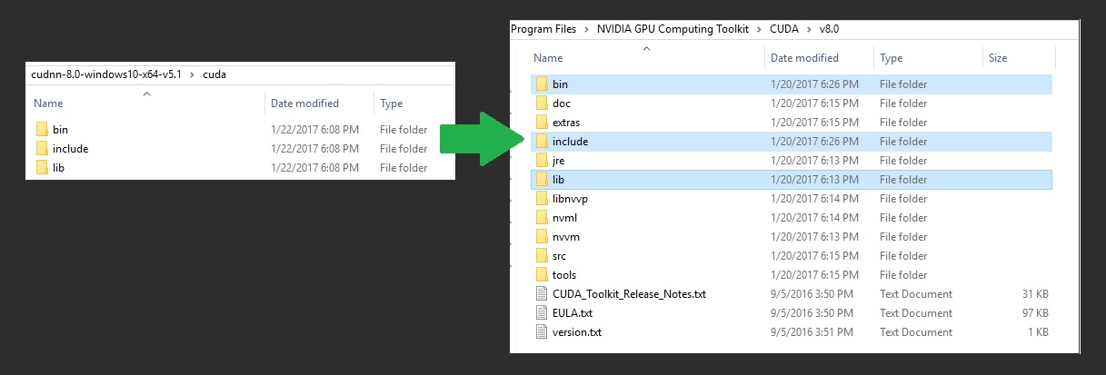

####

I had a problem written “CUDA_ERROR_NO_DEVICE” or a window appearing saying “nvidia device is not removable and cannot be ejected or unplugged”. Problem solved downloading the driver on the page: <http://www.nvidia.com/download/driverResults.aspx/96383/en-us> and install it.

####

**Requirements and advices to use the project:**

On the anaconda prompt:

Create an environment named saxo:

*(if you’re not familiar with environments, it allows you to create different session of python with different configs. For example, if you have a project in python 3.5 and another in python 3.6, some packages will have conflict on your computer. To avoid that, you make an environment for each of your project and it is like having only python 3.5 or only python 3.6)*

* conda create –n saxo python=3.5
* activate saxo
* conda install numpy scipy pandas scikit-learn jupyter h5py matplotlib seaborn cython
* pip install keras treetaggerwrapper xlrd
* conda install mingw libpython gensim
* pip install --ignore-installed --upgrade <https://storage.googleapis.com/tensorflow/windows/gpu/tensorflow_gpu-1.2.1-cp35-cp35m-win_amd64.whl> (for gpu usage)
* pip install --ignore-installed --upgrade <https://storage.googleapis.com/tensorflow/windows/cpu/tensorflow-1.2.1-cp35-cp35m-win_amd64.whl> (for cpu only)

#### TreeTagger

Go to <http://www.cis.uni-muenchen.de/~schmid/tools/TreeTagger/#Windows>

Download it, unzip it and follow the instructions in the INSTALL.txt

*(I downloaded this windows version link on the website:* [*http://www.cis.uni-muenchen.de/~schmid/tools/TreeTagger/data/tree-tagger-windows-3.2.zip*](http://www.cis.uni-muenchen.de/~schmid/tools/TreeTagger/data/tree-tagger-windows-3.2.zip)

*And the French lib I used has been download with this link:* [*http://www.cis.uni-muenchen.de/~schmid/tools/TreeTagger/data/french-par-linux-3.2-utf8.bin.gz*](http://www.cis.uni-muenchen.de/~schmid/tools/TreeTagger/data/french-par-linux-3.2-utf8.bin.gz) *)*

I needed to install activeperl to make it work. (download and install it from their website: <https://www.activestate.com/activeperl> and the community edition)

“”” Installation steps I followed for the TreeTagger:

Download and unzip the windows version link. Put it in the C:\ folder.

Add the bin directory to my system path.

Download French lib link. Unzip it and put it in the lib folder.

Download and install activeperl

It is working.”””

To use a notebook for example:

Launch the anaconda prompt:

* activate saxo
* jupyter notebook

It will launch a window in a browser, just navigate to the notebook folders and open one of them.

All the scripts of the projects in the other way is a classical python project you can use with your favorite python IDE, I personally used Pycharm. 🡪 Just be sure that your python interpreter is the one in your conda folder: <conda_folder>/conda/envs/saxo/python.exe

**If you have a Proxy:**

I use CNTLM to make it possible to pass the proxy with multiple applications.

In CNTLM directory:

Configure cntlm.ini file as below:

Username A645951

Domain WW930

Password 64265278Mn!

Proxy proxy-fr.glb.my-it-solutions.net:84

NoProxy localhost, 127.0.0.*, 172.23.152.*

Listen 3128

Then go in your configuration: Panneau de configuration > Options Internet > Connexions > Paramètres réseau

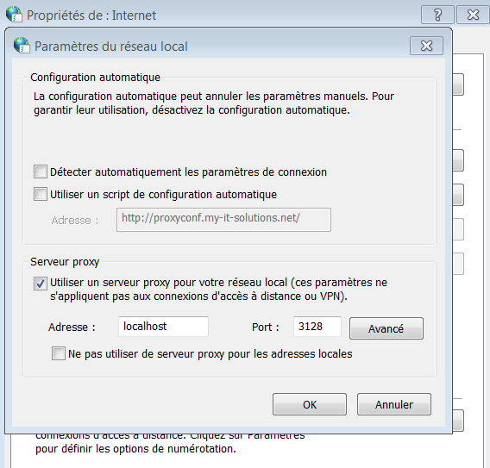

Then launch cntlm.exe.

It should work.

## if it doesn’t work

Launch the Anaconda prompt, write:

conda config --add channels r

It creates the .condarc file in your home directory

Open .condarc file and delete lines written in it.

Write in .condarc:

proxy_servers:

http: http://localhost:3128

https: http://localhost:3128

##

**END Proxy**