Super Space Acer for the TI-99/4A is both a new game and an old game at the same time! The original game was started in 1989 and released in 1992 on diskette. Now in 2024, it’s released on an UberGROM cartridge as a much more complete title. The game contains 256KB of ROM and optionally supports joysticks, F18A, ForTI, and SID Blaster. The 128KB of GROM stores the original 1992 game release, as well as stories and the unreleased sequel’s title sequence.
Super Space Acer is © 2024 by Mike Brent,
dba HarmlessLion.

Requirements:
- Designed for the TI-99/4A home computer. Both the 1981 and 1983 v2.2 console is supported.
- 32KB or compatible memory expansion is required
- Joysticks are Optional
- F18A Graphics is Optional
- ForTI Sound Card is Optional
- SID Blaster Sound Card is Optional

To Play:
- Ensure your TI-99/4A is powered OFF when inserting or removing the cartridge.
- On the Master Selection Screen you will have the option of Super Space Acer, or Library
- Library gives you the option to try the original 1992 release, read the stories, or see the intro for the unfinished sequel.

Library:
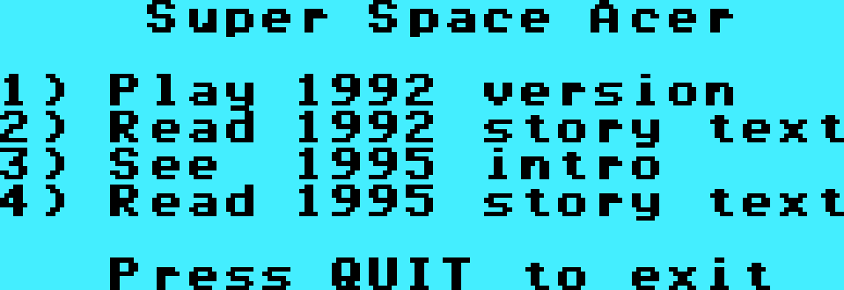

If you select 1, the original 1992 version of the game will load. Press Fire on either joystick to begin. This version does not support keyboard play.

The game will start immediately with the ‘Snowball’ ship. Shoot enemies and avoid contact with enemies and their shots. Occasionally a destroyed enemy will drop a powerup. ‘S’ will add to a time limited shield that protects your ship from all impacts. ‘P’ will increase weapon power – first with a spread shot, then with a powerful pulse shot.

To defeat the large boss ships, destroy their engines with repeated shots.

After five stages are defeated, you will be presented with a credits scroll.

Use QUIT (Fctn-=) to exit the game.

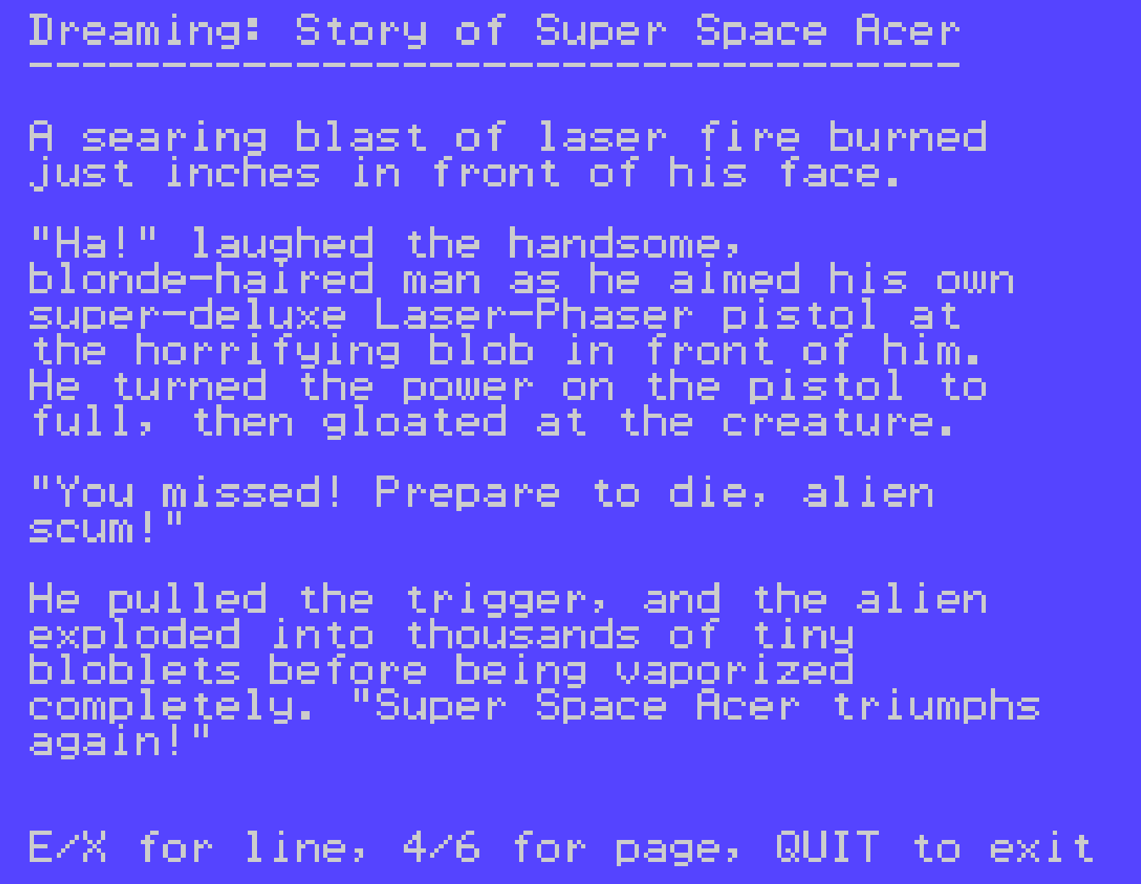

Either story text will bring up a text viewer. Use E or X to scroll one line, or 4 and 6 to scroll an entire page. Use QUIT to exit.

Finally, See 1995 Intro will load and run the intro animation and scroll text for the sequel, which never made it past this intro sequence. It is not playable. Press QUIT to exit.

Super Space Acer

When you enter the main game, you will first see the HarmlessLion logo, then the game title page will appear. If the F18A is detected, the lower left corner of the image will say F18A. The attract mode will cycle through the title page, high score table, enemy description, and example gameplay. Press fire to return to the title page, and 1, 2 or 3 to start the game.

To prevent the F18A detection, hold ‘0’ on the HarmlessLion screen until the title screen appears. You can also disable it in the config menu described below.

Hint: on many of these screens, pressing ‘0’ will also advance to the next sequence.

Keys:

ESDX – move ship
Period (.) or Q – Fire
You may also use either Joystick.

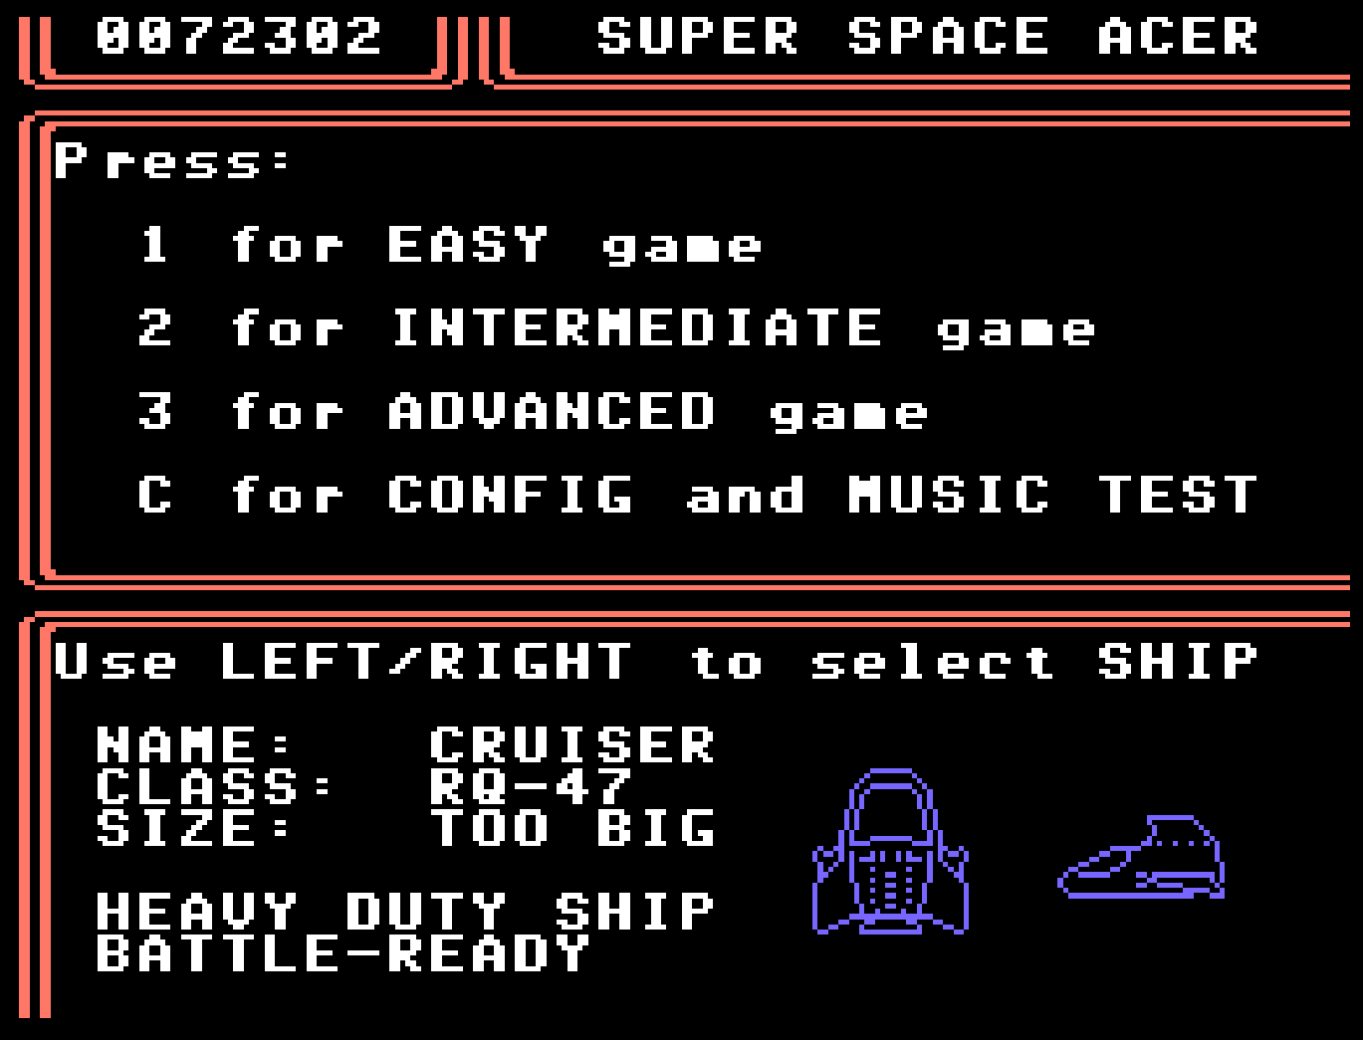

After leaving the title page, you will get the above menu screen.

At the bottom is your ship select. Use left and right to select your vehicle. Each ship has a different play style:

Cruiser: slower but has a persistent shield that can withstand 3 hits. The shield can be recharged by collecting a powerup icon while it displays ‘S’. If you are hit without any shield remaining, it is Game Over.

Snowball: quicker ship. Shields must be collected via powerup icon while it displays ‘S’ and are time limited. If you are hit without a shield you will lose one ship, with remaining stock displayed at bottom left. When all ships are destroyed, it is Game Over.

Ladybird: average ship. Shields are offensive and can be used as an additional weapon, once collected. Shields are time limited otherwise.

There are two additional ships, if you can work out how to select them!

Press the numbers 1-3 to select an Easy, Intermediate, or Advanced game. Note the full ending is only available to the Advanced game mode. The difficulty mode affects the number of enemies onscreen, and how aggressive they are towards you.

Note: The letters Q, W, E also select Easy, Intermediate or Advanced. Be careful if you are using ‘Q’ for Fire.

Finally, ‘C’ enters the config menu, described next…

Config Menu

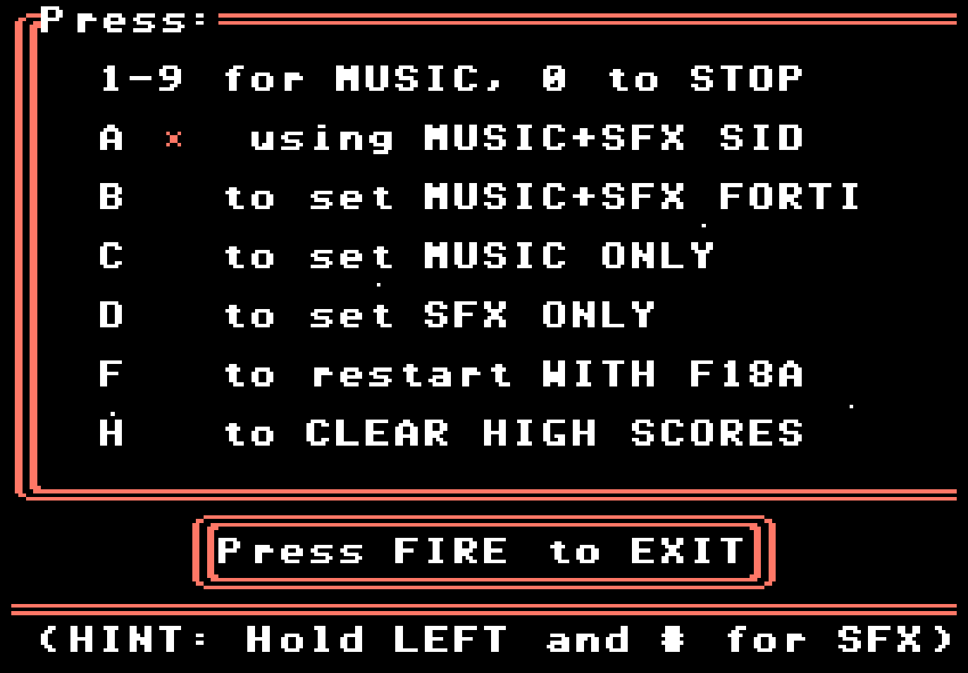

The default setup is fine for most systems, but you can set various options here.

If you press 1 through 9, this will play the music associated with that key. Press 0 to stop the music.

If you hold LEFT while pressing the digit, you will get the associated sound effect instead. In this case 0 is also a sound effect.

Sound Effects can only be heard if you have the appropriate hardware setting, as follows.

The default is A – Music + SFX SID. This plays music on the internal sound chip, and sound effects via SID Blaster. If no SID is available, this should still play the music without any ill effect, but no sound effects.

Select B – Music + SFX FORTI if you have a FORTI card. Music will be played on the first chip and sound effects on the second. If you select this option on a stock machine, your music and sound effects will sound truncated and broken.

Select C – Music Only will not attempt sound effects at all. This is only useful if the SID Blaster in your system responds poorly to the given effects (some clone SIDs may).

Select D – SFX only if you don’t want the music and want to play the SFX, but you only have the stock sound chip.

Option F, if you have an F18A installed, allows you to restart the game with the F18A enhanced graphics disabled. If already disabled, this will re-enable F18A support.

Super Space Acer uses the F18A to provide enhanced sprites, enhanced bosses via the bitmap layer, and GPU support for the boss damage.

Option H to clear High Scores will reset the non-volatile high score data to default values.

Note that the cartridge will save high scores as well as the audio selection.

Gameplay

Your selected ship will fly up from the bottom of the screen, and then enemies will start to attack from the top. You will also see your current score at the top center. If your selected ship has lives, the lives remaining will be at bottom left.

All three main ships have two weapon systems – a wide shot and a pulse shot. The pulse shot is more powerful but fires only straight ahead while the wide shot fires multiple bullets at once that spread out. Each weapon system can be powered up twice.

To powerup or change weapon systems, destroy enemies until one drops a powerup pod. This pod will cycle through three letters:

- S – shields
- P – increase pulse shot power
- W – increase wide shot power

If you collect P or W while on the other weapon, you will be switched. The previous power level for that weapon is retained but a switch does not raise the power level.

If your ship is destroyed and you have lives remaining, both weapons are returned to the base level.

When you reach the boss, the objective is to destroy all engines on the boss. Your shots will be blocked by the boss’ body until you do enough damage to reach the engines.

After destroying the boss, bonus points are awarded, and then you are off to the next stage! After five bosses are complete, if you selected Advanced mode, you will see an end sequence specific to the ship you selected, followed by the game credits. In Intermediate you will get only the credits, and in Easy you will get encouragement to play a harder difficulty.

High Scores

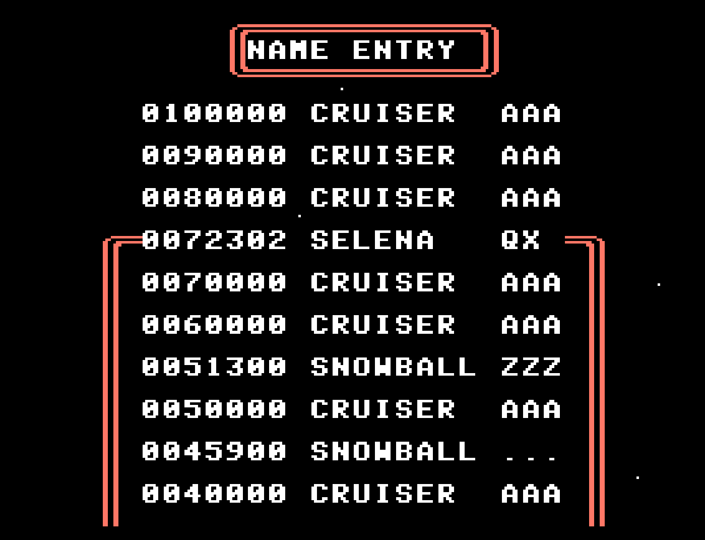

If you get a high score, your position will be indicated as shown. Use left and right to choose your letter, and ‘fire’ to enter it. Your ship will be registered along with the score. If you make a mistake, select ‘<’ to back up.

Upon entering the third initial, the high score table will be saved to the cartridge and re-displayed.

