Abstract
This paper examines Uzbekistan’s integration into Northeast Asian production net-worksfollowingthe2017Mirziyoyevreforms,demonstratingacentralstructural asymmetry: Uzbekistan has achieved significant backward global value chain (GVC) integrationbyabsorbingintermediategoods,buthasfailedtoachievecommensu-rateforwardintegrationintomanufacturedexportmarkets.Thispatternsignifies acaptiveratherthanrelationalGVCgovernancestructure.EmployingaChow structural break test, revealed comparative advantage indices, and bilateral trade de-composition, the analysis confirms that the 2017 reforms constituted a statistically significantturningpointformanufacturingvalueadded(F= 6.937,p = 0.013), acceleratingannualsectorgrowthfrom0.4to1.2percentagepoints.Dataspan 2010–2026, with 2024–2026 drawn from IMF WEO April 2025 projections.How-ever,apersistentgapinforeigndirectinvestment(FDI)intensityremains,partic-ularlycomparedtoVietnam’spost-2000trajectory.Crucially,thetypeofcapital flowing into Uzbekistan deviates from the export-manufacturing focus predicted by the flying geese model; the country disproportionately attracts infrastructure-linked ChineseFDI,whereasexport-orientedJapaneseandSouthKoreanmanufacturing FDIremainsmarginaldespitehighintermediate-goodstradeshares.Thedisserta-tion argues that escaping this captive integration trap requires shifting from passive openness to targeted policy intervention.The most urgent priorities are overcoming logisticsbottlenecks,whichactastheabsolutebindingconstraintonexportcom-petitiveness, and leveraging WTO accession as an external commitment mechanism to provide institutional lock-in for decree-based reforms.
Keywords:Globalvaluechains,FDI-ledindustrialisation,Uzbekistan,Northeast Asia, revealed comparative advantage, economic complexity, structural break

NE Asian GVC Integration and Uzbekistan Industrialisation
Contents
1 | Introduction |  |  |  |  |  | 5
2 | LiteratureReview:Re-evaluatingGVCs,theState,andStructural |  |  |  |  |  | 6
 | Transformation
3 | 2.1 | Global Value Chains: Governance, Upgrading, and Contemporary |  |  |  |  | 7
 | Reconfigurations |  |  | ..........................
 | 2.2 | The Premature Deindustrialisation Counter-Thesis ......... |  |  |  |  | 8
 | 2.3 | The Developmental State and the Rebirth of Industrial Policy... |  |  |  |  | 9
 | 2.4 | The Flying Geese Paradigm and South-South Cooperation |  |  |  | .... | 9
 | 2.5 | Comparative Development Benchmarks:Vietnam and Thailand .. |  |  |  |  | 10
 | 2.6 | Central Asian Structural Constraints and Landlocked Theory... |  |  |  |  | 10
 | 2.7 | Technology Transfer and FDI Spillovers.............. |  |  |  |  | 11
 | 2.8 | Synthesis:Economic Complexity and Upgrading......... |  |  |  |  | 12
 | 2.9 | Research Gap............................ |  |  |  |  | 12
 | Data, Research Design, and Methodology |  |  |  |  |  | 12
4 | 3.1 | Research Philosophy and Ontological Position........... |  |  |  |  | 12
 | 3.2 | Research Design:Sequential Explanatory Mixed-Methods |  |  |  | .... | 13
 | 3.3 | Variable Operationalisation..................... |  |  |  |  | 14
 | 3.4 | Data Sources and API Endpoints.................. |  |  |  |  | 16
 | 3.5 | Empirical Models.......................... |  |  |  |  | 17
 | 3.5.1 |  | Structural Break Analysis |  | ................. |  | 17
 | 3.5.2 |  | OLSRegression:ManufacturingValueAddedandEco-
 |  |  |  |  |  |  | 18
 | nomic Complexity.....................
 | 3.5.3 |  | Scenario Forecasting.................... |  |  |  | 18
 | 3.6 | Scope, Limitations, and Robustness |  |  | ................ |  | 19
 | Analysis and Results |  |  |  |  |  | 20
 | 4.1 | Structural Break Analysis:The 2017 Reform as a Manufacturing |  |  |  |  | 20
 | Turning Point............................
 | 4.2 | RevealedComparativeAdvantage:ExportSophisticationandIts |  |  |  |  | 21
 | Limits................................
2

NE Asian GVC Integration and Uzbekistan Industrialisation
5  6  7 | 4.3 | Overall RCA Structure....................... |  |  |  |  | 21
 | 4.4 | Manufacturing-Sector RCA Dynamics............... |  |  |  |  | 22
 | 4.5 | Northeast Asian Trade and FDI Flows............... |  |  |  |  | 24
 | 4.6 | Bilateral Trade Dynamics...................... |  |  |  |  | 24
 | 4.7 | Intermediate Goods Composition.................. |  |  |  |  | 25
 | 4.8 | FDI Origin Structure |  | ........................ |  |  | 26
 | 4.9 | Trade Network Analysis:Value-Chain Positioning ......... |  |  |  |  | 27
 | 4.10Value-Chain Positioning Map.................... |  |  |  |  |  | 27
 | 4.11Intermediate Goods Dependence by Partner............ |  |  |  |  |  | 29
 | 4.12Export Composition:Structural Change 2010–2023........ |  |  |  |  |  | 30
 | 4.13Re-export Potential Through Central Asian Corridors....... |  |  |  |  |  | 31
 | 4.14GVC Positioning:Backward and Forward Integration....... |  |  |  |  |  | 31
 | 4.15Comparative Trajectory:Uzbekistan and Vietnam......... |  |  |  |  |  | 32
 | Thailand Comparative Benchmarking:The Eastern Seaboard Model35
 | 5.1 | Rationale for the Thailand Comparator............... |  |  |  |  | 35
 | 5.2 | Thailand’s Industrialisation Pathway................ |  |  |  |  | 35
 | 5.3 | Comparative Benchmarking:Thailand, Vietnam, and Uzbekistan. |  |  |  |  | 36
 | 5.4 | The Automotive Sector Parallel................... |  |  |  |  | 38
 | Institutional Readiness for GVC Integration |  |  |  |  |  | 39
 | 6.1 | Analytical Framework:Institutions as GVC Entry Conditions... |  |  |  |  | 39
 | 6.2 | WorldGovernanceIndicators:UzbekistaninComparativePer-
 | spective............................... |  |  |  |  |  | 40
 | 6.3 | Regulatory Quality:Investment Climate Dimensions |  |  |  | ....... | 41
 | 6.4 | Investment Treaty Architecture................... |  |  |  |  | 42
 | 6.5 | Human Capital:The Skill Supply Constraint............ |  |  |  |  | 43
 | 6.6 | Synthesis:The Institutional Gap Score............... |  |  |  |  | 44
 | Special Economic Zone Effectiveness |  |  |  |  |  | 46
 | 7.1 | The Theoretical Role of SEZs in GVC Embedding |  |  | ........ |  | 46
 | 7.2 | Uzbekistan’s SEZ Landscape.................... |  |  |  |  | 46
 | 7.3 | SEZ Incentive Structure....................... |  |  |  |  | 48
 | 7.4 | The Navoiy Model:Aviation Logistics as a Landlocked GVC So-
 | lution |  | ................................ |  |  |  | 49
3

NE Asian GVC Integration and Uzbekistan Industrialisation
7.5 |  | SEZ Performance Assessment:A Comparative Scorecard..... |  |  |  |  |  |  | 49  51 51 51 53 54 54 55 57 59 60  62 62  65 65  67  68 68  69 70  71 71 72  74
8 | Structural Constraints on GVC Integration
8.1 |  | A Framework for Constraint Analysis |  |  | ...............
8.2 |  | Constraint 1:Landlockedness and Transit Costs..........
8.3 |  | Constraint 2:Energy and Utility Infrastructure...........
8.4 |  | Constraint 3:Financial Sector Depth and Trade Finance......
8.5 |  | Constraint 4:Political Economy of Reform Continuity |  |  |  |  |  | ......
8.6 |  | Constraint Hierarchy and the Binding Constraint |  |  |  |  | .........
8.7 |  | Regression Analysis .........................
8.8 |  | Scenario Forecasts:Manufacturing Value Added through 2030..
8.9 |  | Mechanisms:Trade Openness, ECI, and the Complexity Trajectory
9 | Discussion:Synthesis, Theory Revisited, and the Road Not Taken
9.1 |  | Revisiting the Central Research Question |  |  |  | .............
9.2 |  | WhattheRegressionResultsActuallySay:TheMechanismIs
Intermediate Goods, Not FDI Volume |  |  |  |  | ...............
9.3 |  | The Flying Geese Mechanism:Operating But Distorted......
9.4 |  | TheVietnamComparison:WhatUzbekistanHasandHasNot
Replicated..............................
9.5 |  | TheThailandComparison:SectoralTargetingoverSpatialCon-
centration..............................
9.6 |  | WTO Accession as Institutional Lock-In:The Vietnam Parallel..
9.7 |  | The Premature Deindustrialisation Counter-Thesis and Why It Does
Not Foreclose the Uzbek Case |  |  |  | ...................
9.8 |  | The Limits of This Analysis |  | ....................
10Conclusion and Policy Implications
10.1Policy Implications.........................
10.2Conclusion |  |  | .............................
AAdditional Figures
4

NE Asian GVC Integration and Uzbekistan Industrialisation
1 | Introduction
Central Asia’s largest economy by population, Uzbekistan spent much of its post-Soviet independence era under a model of state-directed, resource-dependent growth that deliberately limited foreign economic penetration.The death of Islam Kari-movin2016andthesubsequentaccessionofPresidentShavkatMirziyoyevin-auguratedoneofthemostrapidliberalisationepisodesinthepost-Sovietworld: currencyconvertibilitywasrestoredin2017,theforeigninvestmentregimewas overhauled,tradetariffs were reduced,andstrategic industrial zones were estab-lished to attract export-oriented manufacturing (World Bank 2024). These reforms did not occur in a vacuum.They coincided with — and were partly designed to at-tract — a wave of Northeast Asian capital and manufacturing relocation driven by structuralpressureswithinChina(risinglabourcosts,US-Chinatradetensions), Japan(ageingsupply-chainnetworksseekingdiversification),andSouthKorea (”China+1” strategies by conglomerates including Hyundai, LG, and Samsung).
The central question of this paper is whether, and through what mechanisms, this Northeast Asian economic engagement has driven genuine industrial upgrad-inginUzbekistan,orwhetherithasreinforcedapatternofprimarycommodity exportandshallowassemblywithouttechnologytransfer.Thisquestionmatters beyondUzbekistan:landlocked,resource-endowed,reform-activeCentralAsian economiesareaclassofdevelopmentcasesunderservedbytheGVCliterature, which has focused disproportionately on coastal Southeast Asia, East Africa, and Eastern Europe.
Thispapermakesthreecontributionscenteredonapivotalfinding:Uzbek-istan has achieved substantial backward GVC integration (absorption of interme-diategoods)butfailedtoachievecommensurateforwardintegration(manufac-tured export upgrading).This asymmetric embedding is the quantitative signature of captive rather than relational GVC governance.First, the paper applies formal structuralbreaktestingtomanufacturingvalueaddeddatatoconfirmthat2017 was a turning point,albeit one yielding captive growth.Second,it disaggregates Uzbekistan’s Northeast Asian trade relationships, demonstrating that Chinese in-frastructurecapitalandJapanese-Koreanmanufacturinginputsplayqualitatively different roles in this asymmetric integration.Third,it benchmarks Uzbekistan’s reform trajectory against Vietnam’s post-2000 liberalisation to quantify the struc-
5

NE Asian GVC Integration and Uzbekistan Industrialisation
tural gaps limiting relational upgrading.
The dissertation proceeds as follows. The Introduction establishes the research context and structure.The Literature Review covers the theoretical landscape on FDI-led industrialisation, GVC governance, and the economics of landlocked de-velopingcountries.TheDataandMethodologychapterdescribesthedata,core empirical methodology, and the critical realist research design.The Analysis and Results chapter presents structural break testing, revealed comparative advantage, network mapping, comparative benchmarking, institutional diagnostics, and panel regressionresults.Finally,theConclusionandPolicyImplicationschaptersyn-thesises the findings and derives five actionable policy recommendations.
2 Literature Review: Re-evaluating GVCs, the State,
and Structural Transformation
Theanalyticalframeworkofthisdissertationdrawsuponthreeinterconnected, andoftencompeting,streamsofpoliticaleconomyanddevelopmentliterature: (i)GlobalValueChain(GVC)theoryandthemechanicsofindustrialupgrading (Gereffi et al. 2005, Milberg & Winkler 2013, Humphrey & Schmitz 2002, Stur-geon et al. 2008); (ii) developmental state theory, the East Asian industrialisation experience, and the rebirth of industrial policy (Amsden 1989, Wade 1990, Evans 1995,Chang2002);and(iii)thestructuralconstraintsfacinglandlockeddevel-opingcountries(LLDCs)withinthecontextofEurasianintegrationandthe Belt and Road Initiative (BRI) (Lim˜ao & Venables 2001, Arvis et al. 2016, Carr`ere & Schiff 2004).
By synthesising these theoretical domains, this chapter establishes the concep-tualfoundationforevaluatingwhetherUzbekistan’spost-2017liberalisationtra-jectory represents a genuine structural transformation or merely a reconfiguration of its historical commodity dependence.It critically examines the contradictions inherent in pursuing state-led development within deeply integrated, transnational productionregimes,andengagesdirectlywithcontemporarychallengestothe feasibility of the manufacturing-led convergence path.
6

NE Asian GVC Integration and Uzbekistan Industrialisation
2.1 | GlobalValueChains:Governance,Upgrading,andCon-
temporary Reconfigurations
Theglobalisationofproductionnetworksoverthepastfourdecadeshasfunda-mentally altered the paradigm of industrial development (Gereffi 1994, Sturgeon etal.2008).Ratherthanbuildingentire,verticallyintegrateddomesticsupply chains,developingeconomiesnowpursueindustrialisationbyinsertingthem-selves into specific nodes of global and regional production networks (Gereffi et al. 2005, Milberg & Winkler 2013).
AcriticalcontributionofGVCtheoryistheconceptof“governance”—the power dynamics dictating how financial, material, and human resources are allo-catedwithinachain.Gereffietal.(2005)distinguishbetweenfivegovernance structures:market, modular, relational, captive, and hierarchy.The upgrading tra-jectoryofadevelopingcountrydependscriticallyonthegovernancestructureit enters. Humphrey & Schmitz (2002) demonstrate that captive governance—where powerful lead firms strictly control specifications and limit technology diffusion—oftenfacilitatesrapidproductandprocessupgradingbutactivelyhindersfunc-tional upgrading (moving into design, marketing, or independent branding).Con-versely, relational governance fosters deeper knowledge exchange and longer-term capability accumulation.
The “smile curve” phenomenon (Baldwin 2016) further complicates GVC in-sertion.Value capture has increasingly concentrated at the pre-production (R&D, design) and post-production (marketing, retail) ends of the curve, while the middle stages(manufacturingandassembly)areheavilycommoditised.Thisstructural shift has direct implications for the payoffs available to countries like Uzbekistan that are seeking entry at the assembly tier.
Recentscholarshiphasincreasinglyfocusedonthevulnerabilityandrecon-figurationofthesechains.Rakhmatullayevetal.(2023)documenthowglobal shocksandtheCOVID-19pandemicexposedthefragilityofhyper-optimised GVCs, prompting lead firms to prioritise resilience over cost-efficiency.This has accelerated“China+1”strategiesandregionalisation.ForUzbekistan,thetheo-reticalimperativeistoleveragethisregionalisationtosecureFDIthatfacilitates progression from captive assembly to relational upgrading, particularly by embed-ding itself into the shifting Northeast Asian production networks. Usmanov (2024)
7

NE Asian GVC Integration and Uzbekistan Industrialisation
demonstrates that Central Asian economies that actively used industrial policy to attract export-platform FDI during GVC restructuring achieved significantly better upgrading outcomes than those that relied on passive openness.
2.2 The Premature Deindustrialisation Counter-Thesis
A fundamental challenge to the dissertation’s central premise must be engaged di-rectly:Rodrik (2016) argues that the manufacturing-led convergence path that un-derpinned the East Asian miracle is now structurally narrowing for late-developing countries.The“prematuredeindustrialisation”thesisidentifiestworeinforcing mechanisms.First,labour-savingautomationisreducingthelabourcontentof manufacturing tasks globally, compressing the employment payoff that made labour-abundant developing countries attractive as manufacturing platforms.Second, the shift of GVC value capture toward pre- and post-production segments means that countriesenteringattheassemblystagecapturelessdomesticvalueaddedthan their predecessors did at equivalent reform stages.
Diao et al. (2019) and McMillan et al. (2017) extend this critique empirically, demonstrating that structural change in sub-Saharan Africa and parts of South Asia hasmovedlabourfromagricultureintoservicesratherthanmanufacturing,and that this “wrong” structural change has not generated the productivity convergence that manufacturing-led transitions produced in East Asia.
However,thiscritiquedoesnotinvalidatetheUzbekistancaseinthesame terms.Uzbekistanisnotprimarilycompetingfortheautomatable,low-skillas-semblytasksthattheprematuredeindustrialisationthesisidentifiesasmostvul-nerable.Its strategic positioning targets medium-skill, relationship-intensive man-ufacturing (automotive components, pharmaceuticals, precision instruments) in a regional market where EAEU trade preferences and geographic proximity to Rus-sia and Central Asian consumers provide a competitive basis that pure labour-cost competitioncannotreplicate.Theprematuredeindustrialisationcritiqueismost acute for large-population, low-income economies seeking mass employment ab-sorption;foramiddle-income,STEM-capableeconomyofUzbekistan’sprofile, the constraint is governance and logistics quality rather than the structural foreclo-sure of the manufacturing path.
8

NE Asian GVC Integration and Uzbekistan Industrialisation
2.3 | The Developmental State and the Rebirth of Industrial Pol-
icy
TheintegrationofUzbekistanintoNortheastAsiannetworksmustbeanalysed through the theoretical lens of East Asian industrialisation.The classical interpre-tation of the East Asian “miracle” rests on the concept of the developmental state (Amsden1989,Wade1990,Evans1995),whichchallengestheneoclassicalor-thodoxy that East Asian growth resulted primarily from free markets and minimal state intervention.
Amsden(1989)demonstratedhowSouthKorea’sindustrialisationreliedon“gettingpriceswrong”—usingtargetedsubsidies,directedcredit,andstrategic protectionism to incubate domestic champions.Wade (1990) advanced the “gov-ernedmarket”theory,illustratinghowTaiwan’sstateapparatusactivelysteered investment into strategic sectors.Evans (1995) introduced the concept of “embed-ded autonomy,” arguing that successful developmental states require bureaucracies that are sufficiently insulated from rent-seeking pressures (autonomy) yet deeply connected to the industrial capitalist class to facilitate policy implementation (em-beddedness).
Andreoni & Chang (2023) document a “rebirth” of industrial policy globally, arguing that the theoretical case for market-led development has been substantially underminedbytheGFC,theCOVID-19pandemic,andthereshoringpressures generatedbyUS-Chinatechnologycompetition.ForUzbekistan,thechallenge isconstructinganinstitutionalapparatuscapableofexercisingembeddedauton-omy within the constraints of modern trade rules, navigating the tension between required liberalisation and the necessary state intervention to foster domestic ca-pabilities.Rakhmatullayev et al. (2023) identify specific institutional bottlenecks— judicial independence, contract enforcement, bureaucratic discretion in invest-ment approvals — that remain unresolved and which actively limit the transition from passive openness to developmental transformation.
2.4 The Flying Geese Paradigm and South-South Cooperation
ThespatialdynamicsofEastAsianFDIareelegantlycapturedbythe“flying geese” model (Akamatsu 1962).The model describes a tiered hierarchy in which a lead economy transfers sunset, labour-intensive industries to follower economies
9

NE Asian GVC Integration and Uzbekistan Industrialisation
as its own comparative advantage shifts toward capital- and knowledge-intensive production (Dunning 1981).
ApplyingtheflyinggeesemodeltocontemporaryCentralAsiarequiressig-nificant modification.While China is graduating from labour-intensive manufac-turing,creatingatheoreticalopportunityforUzbekistan,ChineseoutwardFDI often diverges from the classical model.As Pomfret (2019) notes regarding Cen-tral Asia, Chinese South-South cooperation often prioritises infrastructure and re-sourceextractionovertheexport-platformmanufacturingseeninthetraditional flying geese cascade.The Belt and Road Initiative, while providing critical infras-tructure,maydeepenprimarycommoditydependenceifnotpairedwithrobust domestic industrial policies.
2.5 Comparative Development Benchmarks: Vietnam and Thai-
land
Uzbekistan’saspirationscanbebenchmarkedagainsttwosuccessfulmodelsof GVCinsertion:ThailandandVietnam.Thailand’sEasternSeaboardDevelop-ment Programme leveraged Japanese FDI following the 1985 Plaza Accord.The state successfully utilised local content requirements to force technology transfer, establishing Thailand as a regional automotive hub.
VietnamrepresentsacontemporarymodelofrapidGVCembeddingfollow-ing the Doi Moi reforms and its 2007 WTO accession.Vietnam successfully po-sitioned itself as a “China+1” destination, attracting massive electronics assembly FDIthroughacombinationofinstitutionalcredibility,anchorinvestortargeting (SamsungatThaiNguyen),andcalibratedSEZinfrastructure.Vietnam’strajec-toryunderscoresthattradeliberalisationaloneisinsufficient;thesequencingof anchor investor attraction, domestic supplier development, and human capital cal-ibration is what converted policy openness into productive GVC embedding.
2.6 Central Asian Structural Constraints and Landlocked The-
ory
Uzbekistan’sintegrationprospectsareuniquelyboundedbyitsphysicalgeogra-phy.Lim˜ao & Venables (2001) demonstrate that landlocked countries face a sig-
10

NE Asian GVC Integration and Uzbekistan Industrialisation
nificant structural penalty, with transport costs averaging 50% higher than coastal economies.Foradoublylandlockednation,thisgeographicalpenaltyprecludes integration into time-sensitive, low-margin GVCs.
These structural constraints dictate a specific industrialisation pathway.High-volume,low-valueassemblyiseconomicallyunviableduetoprohibitivetransit costs.Industrialupgradingmusttargetgoodswithhighvalue-to-weightratios or leverage regional markets where transit penalties are minimised.The political economyoftheMiddleCorridorandtheChina-Kyrgyzstan-Uzbekistanrailway arethereforeexistentialprerequisitesforUzbekistan’sGVCembedding.World Bank (2025) emphasises that multimodal transport efficiency and corridor gover-nance remain the binding constraint on export competitiveness for Central Asian economies,notingthatUzbekistan’sLogisticsPerformanceIndexscoreof2.6 places it 14% below the lower-middle-income country average,with transit-time unpredictabilityidentifiedastheprimarydeterrentbysurveyedexportmanufac-turers.
2.7 Technology Transfer and FDI Spillovers
ThefinaltheoreticalpiececoncernshowFDItranslatesintodomesticcapability. TheoreticalmodelsofFDIspilloverssuggestthatforeignpresencecanincrease domestic productivity through demonstration effects, labour mobility, and vertical linkages (Dunning 1981).However,empirical evidence is mixed.Without suffi-cient“absorptivecapacity”(humancapital,R&Dinvestment)indomesticfirms, foreign presence can crowd out local enterprises rather than upgrading them. Thus, SEZ policies in Uzbekistan must be explicitly tied to domestic supply-chain inte-gration rather than operating as isolated enclaves.
The critical policy implication emerging from this literature is one that directly informstheempiricalanalysis:themechanismthroughwhichexternalengage-mentproducesmanufacturingupgradingisnotFDIvolumeperse,butinterme-diate goods trade deepening.Countries that develop dense backward linkages —sourcing intermediate inputs domestically rather than importing them — generate thetechnologytransferandproductivityspilloversthataggregateFDIstatistics cannotcapture.ThisdistinctionbetweenFDIquantityandFDIquality,andbe-tweeninvestmentattractionandproductionnetworkembedding,framestheem-pirical investigation.
11

NE Asian GVC Integration and Uzbekistan Industrialisation
2.8 | Synthesis:Economic Complexity and Upgrading
To measure whether these varied policy efforts are translating into genuine struc-turaltransformation,thisstudyreliesontheEconomicComplexityIndex(ECI) (Hidalgo & Hausmann 2009).The ECI posits that development is fundamentally a process of accumulating productive knowledge.Andreoni & Chang (2023) fur-ther elaborate on the policy implications of economic complexity, arguing that in-dustrial policy must be directed toward building capabilities in strategically prox-imate, more complex industries to avoid the “complexity trap” of commodity de-pendence—atrapthatUzbekistan’scurrentgold-and-cottonexportprofiledi-rectlyexemplifies.Akramov&Tilekeyev(2024)extendthisargumenttothe agriculturalvaluechaincontext,findingthatCentralAsianeconomiesthatsuc-cessfullydiversifiedintoagro-processingdemonstratedmeasurablyhigherECI trajectories than those that remained commodity-dependent, a finding with direct implications for Uzbekistan’s nascent horticulture processing sector.
2.9 Research Gap
The existing literature exhibits three critical gaps.First,while extensive scholar-shipanalysesSoutheastAsianGVCintegration,themechanismsofLLDCinte-gration into Northeast Asian networks from a double-landlocked position remain under-theorised.Second,empiricalstudiesonUzbekistanoverwhelminglyfo-cus on macroeconomic liberalisation rather than disaggregated GVC governance structures.Third, comparative benchmarking between Central Asian and ASEAN industrial models that accounts for the double-landlocked geography is largely ab-sent.This dissertation addresses these gaps by quantifying the structural asymme-triesinUzbekistan’strilateralengagementandpositioningthecaptive/relational governance distinction as the analytical lens for policy evaluation.
3 Data, Research Design, and Methodology
3.1 Research Philosophy and Ontological Position
Thisdissertationadoptsacriticalrealistontologicalposition(Bhaskar1975). Criticalrealismholdsthatsocialphenomenaareproducedbyunderlyingcausal
12

NE Asian GVC Integration and Uzbekistan Industrialisation
mechanismsoperatingwithinstratifiedstructures,andthatobservedempirical regularitiesaresurfacemanifestationsofthesedeepergenerativeprocesses.For thepurposesofthisstudy,thestructuralmechanismsofinterestare:(i)global valuechaingovernance,whichallocatesproductivetasksacrossnationalbound-ariesthroughfirm-levelcoordinationdecisions;(ii)thepoliticaleconomyofde-velopmental states, which shapes domestic institutional configurations that make countriesmoreorlessreceptivetoGVCembedding;and(iii)thegeographyof landlocked developing countries, which imposes structural trade cost penalties that condition the ceiling on achievable integration.
Thisontologicalpositionhasmethodologicalconsequences.Itmotivatesa mixed-methodresearchdesignthatcombinesquantitativeempiricalanalysis—todetectregularitiesandtesthypotheses—withqualitative-comparativeanaly-sis—totracemechanismsandinterpretregularitiesintheirstructuralcontext. A purely econometric approach would identify correlations but could not answer why Uzbekistan’s reform trajectory has diverged from Vietnam’s, or through which mechanisms Northeast Asian FDI translates (or fails to translate) into domestic ca-pability accumulation.A purely case-study approach would identify mechanisms but could not assess their magnitude or generalisability.
Epistemologically,thisdissertationfollowsaretroductiveinferencestrategy: itbeginswithobservedempiricalanomalies(e.g.,thegapbetweenUzbekistan’s rapidly rising intermediate goods import share and its stagnant export sophistica-tion), identifies candidate causal mechanisms (captive GVC governance, logistics constraints, FDI quality gaps), and evaluates the plausibility of those mechanisms against systematic empirical evidence (Danermark et al. 2019).This approach is well-suited to development economics research where controlled experimentation is impossible and causal identification is inherently partial.
3.2 Research Design:Sequential Explanatory Mixed-Methods
The empirical strategy follows a sequential explanatory design, proceeding through four stages:
1.TrendIdentification:Descriptivetime-seriesanalysisofmanufacturing valueadded,FDIinflows,tradeopenness,andeconomiccomplexityfor Uzbekistan and comparator countries, 2000–2023.
13

NE Asian GVC Integration and Uzbekistan Industrialisation
2.StructuralBreakDetection:ChowtestappliedtothemanufacturingVA seriestoformallyidentify2017asastatisticalturningpoint,convertinga qualitative reform claim into a quantitatively testable hypothesis.
3.AssociationAnalysis:OLSregressionsrelatingFDIinflows,tradeopen-ness,andreform-perioddummiestomanufacturingupgradingindicators, with HC3-robust standard errors.
4.ComparativeBenchmarking:AlignmentofUzbekistan’sreformtrajec-tory against Vietnam (post-2001) and Thailand (post-Eastern Seaboard Pro-gramme, 1981) using reform-year normalisation to control for initial condi-tions.
Alongsidethisquantitativesequence,qualitative-comparativeanalysisofin-stitutionalconditions,SEZpolicydesign,andstructuralconstraintsprovidesthe mechanistic layer that the regressions cannot supply.
3.3 Variable Operationalisation
Table 1 presents the full set of indicators used in this dissertation, their operational-isation, sources, and expected directional relationships with the outcome variables.
Table 1:Variable Operationalisation, Sources, and Expected Signs
Variable |  |  | Operationalisation |  |  |  |  | Source |  | Sign
Mfg | VA | (% | NV.IND.MANF.ZS: |  |  |  |  | World | Bank | Outcome
GDP) |  |  | manufacturing |  |  | value |  | WDI
 |  |  | added | as | share |  | of
GDP, annual
ECI | Economic | Complex- | OEC | Outcome
ityIndex,methodof
reflections;standard-
ised µ= 0,σ= 1
(continues on next page)
14

NE Asian GVC Integration and Uzbekistan Industrialisation
(continued from previous page)
Variable | Operationalisation | Source |  | Sign
FDI (% GDP) | BX.KLT.DINV.WD.GD.ZS: World |  | Bank | +
 | netFDIinflowsas | WDI
share of GDP
Trade | Open- | (Exports | + | Im- | World | Bank | +
ness |  | ports)/GDP,index; |  |  | WDI
NE.TRD.GNFS.ZS
LPI Score | Logistics | Per- | World | Bank | +
 | formance | Index | WDI
 | composite | (0–5);
LP.LPI.OVRL.XQ
Post2017 | Binary:1ifyear≥ | Author | +
2017, else 0
Trend | Linear year index: t − | Author | +
t0 where t0 = 2010
Interm.Share | ShareofHS-section | OEC/BACI | +
05, 06, 07, 15, 16, 17,
18 imports in total bi-
lateralimports;proxy
for GVC backward in-
tegration
RCAk | Balassa(1965)index | OEC/BACI | Context
for sector k;threshold
= 1
WGI: RQ | Regulatory |  | Quality |  | World | Bank | +
 |  |  |  |  |  |  | +
 | percentile rank |  |  |  | WGI
WGI: RL |  |  |  |  |  | Bank
 | Rule | of | Law | per- | World
WGI: GE | centile rank |  |  |  | WGI | Bank | +
 | Government |  |  | Effec- | World
 | tiveness |  | percentile |  | WGI
rank
(continues on next page)
15

NE Asian GVC Integration and Uzbekistan Industrialisation
(continued from previous page)
Variable | Operationalisation | Source | Sign
BIT Count | Numberofbilateral | UNCTAD | +
 | investmenttreatiesin | IPFSD
force
SEZ FDI | FDI | attracted | to | Uzinfoinvest | Context
 | Uzbekistan |  | SEZs
(USD m, cumulative)
 | GDP | per | NY.GDP.PCAP.CD: | World | Bank | Context
 | capita | current USD |  | WDI
3.4 | Data Sources and API Endpoints
All quantitative data are sourced from publicly accessible databases. Table 2 maps each dataset to its access method and the relevant dissertation sections.
Table 2:Data Sources, Access Methods, and Coverage
Dataset | API / URL | Coverage | Sections
World Bank WDI | api.worldbank.org/v2/ | 2000–2023 | 3–9
World Bank WGI | api.worldbank.org/v2/ | 2000–2022 | 9
OEC / BACI | oec.world/api/ | 2010–2022 | 5–8
UNCTAD FDIstat | unctadstat.unctad.org/2000–2023 |  | 9
OECD TiVA | stats.oecd.org/ | 2005–2020 | 6–7
Uzbekstat | stat.uz | 2015–2024 | 10
UNIDO INDSTAT | stat.unido.org/ | 2010–2021 | 5, 9
ADB Key Indicators |  |  | 10–11
 | kidb.adb.org/ | 2000–2023
This study draws on four principal data sources.First, the World Bank World Development Indicators (WDI) database (World Bank 2024) provides annual macroe-conomic indicators for Uzbekistan and comparator countries, including manufac-turingvalueaddedasashareofGDP,FDInetinflowsasashareofGDP,GDP per capita, trade openness, and the Logistics Performance Index.Data span 2010–2026, with 2024–2026 supplemented by IMF WEO April 2025 projections where WDI data are unavailable.The primary analytical window for historical analysis is 2010–2023.
16

NE Asian GVC Integration and Uzbekistan Industrialisation
Second, the Observatory of Economic Complexity (OEC) BACI international tradedatabaseprovidesbilateralmerchandisetradeflowsattheHS-2section level.IntermediategoodsareproxiedusingHSsections07(plasticsandrub-bers),15(basemetals),16(machinery),17(transportationequipment),and18 (instruments)—sectionsrepresentingcapitalgoodsandinputsratherthanfinal consumption.Revealedcomparativeadvantageindicesarecomputedusingthe
Balassa (1965) formula: | RCAik =Xik/Xi  Xwk/Xw | (1)
whereanRCAvalueexceeding1indicatesacomparativeadvantage(Balassa 1965).
Third, the Economic Complexity Index is sourced from the OEC, which com-putesannualECIscoresusingthemethodofreflectionsalgorithmofHidalgo & Hausmann (2009). Fourth, FDI origin data are sourced from the National Statistics Committee of the Republic of Uzbekistan’s 2024 report on foreign investment.
3.5 Empirical Models
3.5.1 Structural Break Analysis
To formally test whether the 2017 reform package constituted a statistically signif-icant structural break in Uzbekistan’s manufacturing trajectory,the Chow (1960) test is applied to the linear trend specification:
M fgVAt= α +β ·Trendt +εt, | t = 2010,...,2023 | (2)
where M fgVAtis manufacturing value added as a share of GDP in year t.The test decomposesequation(2)intosub-periodregressionsfor t< 2017and t≥2017.
The F-statistic: | F=(RSSR −RSSU)/k RSSU/(n−2k) | (3)
where RSSRis the residual sum of squares from the restricted pooled regression, RSSU= RSSpre + RSSpost,andk= 2parametersaretested.Arejectionofthe null hypothesis H0 : αpre = αpost,βpre = βpostconstitutes evidence that the 2017 reforms generated a structurally distinct growth regime for manufacturing.
17

NE Asian GVC Integration and Uzbekistan Industrialisation
3.5.2 | OLSRegression:ManufacturingValueAddedandEconomicCom-
plexity
ToestimatetheassociationbetweenNortheastAsianeconomicengagementand manufacturing upgrading, the following OLS specifications are estimated:
M fgVAt = α0+β1·FDIt−1+β2·IntermSharet +β3·TradeOpent +β4·Post2017t +β5·Tr (4) Asecondspecificationtestsfordelayedcapital-stockeffects,accountingfor thetimebetweeninvestmentcommitmentsandproductivecapacitycomingon-line:
M fgVAt = α0+β1·FDIt−2+β2·IntermSharet +β3·TradeOpent +β4·Post2017t +β5·Tr (5) For economic complexity, the specification is:
ECIt = α0+β1·M fgVAt +β2·TradeOpent +β3·Post2017t +β4·Trendt +εt(6)
All regressions use HC3 heteroskedasticity-consistent standard errors (MacK-innon & White 1985).Given the short annual time series (N = 14), these models are underpowered for precise coefficient estimation and are interpreted as descrip-tive associations rather than causal estimates.
3.5.3 Scenario Forecasting
Threeforwardscenariosareconstructedformanufacturingvalueaddedthrough 2030.Scenario A (Status Quo) extrapolates the post-2017 linear trend with a 95% prediction interval:
M fgVAt=ˆαpost +ˆβpost ·Trendt, d | t = 2024,...,2030 | (7)
ScenarioB(AcceleratedGVCEmbedding)departsfrom(7)byaddingan annualincrementcalibratedtotheintermediategoodsimportsharecoefficient (βinterm = 2.34) estimated from the OLS regression:
B  M fgVA d t= | M fgVAt +βinterm ·(IntermShare∗d t−IntermShare2023) | (8)
18

NE Asian GVC Integration and Uzbekistan Industrialisation
where IntermShare∗tis the target trajectory implied by reaching Vietnam’s equiv-
alent intermediate goods share.
Scenario C (Vietnam Trajectory) applies Vietnam’s observed annual percentage-pointchange( ˆβVNM)inmanufacturingVAatthecomparablepost-reformstage (years 1–8 after Doi Moi deepening).
3.6 Scope, Limitations, and Robustness
Thisdissertationfacesthreeprincipallimitationsthatshouldbeacknowledged attheoutset.First,theprimaryUzbekistantimeseriesspansonly2010–2023 (N= 14),constraining statistical power in OLS models.The Chow test requires aminimumoffourobservationspersub-periodforstableF-statistics,whichis marginallysatisfiedbutleaveslimiteddegreesoffreedom.Robustnesschecks using alternative breakpoints (2016, 2018) are reported in the Appendix.
Second,thetradedatarelyonreportedmirrorstatisticsfromOEC/BACI, whichareknowntocontainmeasurementerrorfrommisclassification,informal trade,andgoldtransitflows.Uzbekistan’slargeinformalgoldtradeispartially recordedas“artsandantiques”inofficialstatistics,whichaffectsRCAcalcula-tions for this sector.All RCA values for HS section 14 should be interpreted with this caveat.
Third,thecomparativeanalysisnormalisesreformtrajectoriestoacommon“year zero,” abstracting from differences in initial conditions (coastal access, pop-ulation size, institutional heritage) that may independently explain divergent out-comes.The comparative benchmarking is therefore illustrative rather than causal.
Despite these limitations, the combination of structural break testing, bilateral tradedecomposition,comparativebenchmarking,andinstitutionalanalysispro-videsamethodologicallycoherentbasisforthepolicyconclusionsadvancedin Section 10.1.
19

NE Asian GVC Integration and Uzbekistan Industrialisation
4  4.1 | Analysis and Results  StructuralBreakAnalysis:The2017ReformasaManu-
facturing Turning Point
Figure 1 presents Uzbekistan’s manufacturing value added as a share of GDP from 2010 to 2023, with separate linear trend fits for the pre- and post-2017 periods and 95% confidence bands.The visual evidence is striking:the slope of the manufac-turing trend steepens markedly after 2017, shifting from gradual expansion during the Karimov-era controlled economy to accelerated growth under the Mirziyoyev liberalisation programme.
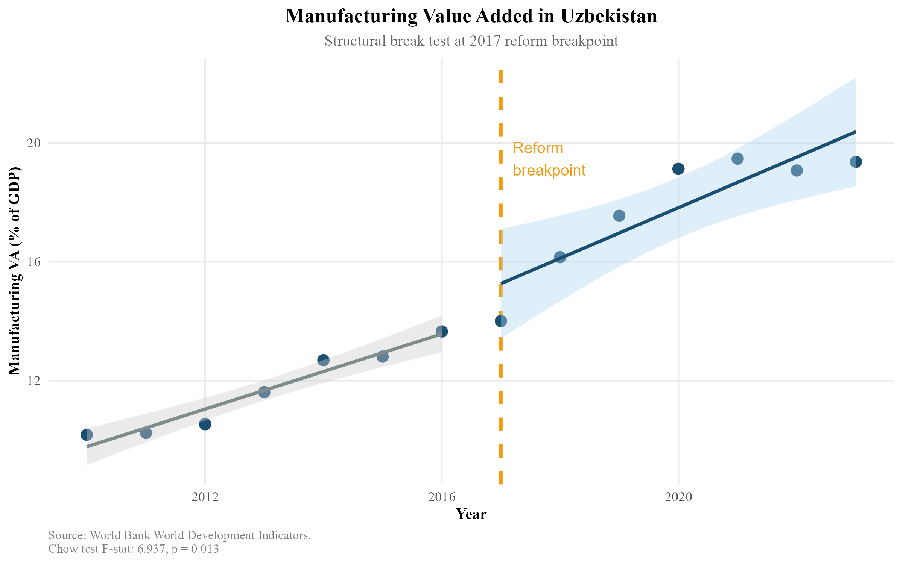
Figure 1: Manufacturing Value Added in Uzbekistan: Structural Break at the 2017 Reform Breakpoint.The dashed vertical line marks 2017.Shaded bands represent 95%confidenceintervalsforpre-andpost-reformlineartrends.Source:World Bank WDI.
TheChowtestconfirmsthisvisualimpression.TheF-statisticof6.937(p= 0.013) decisively rejects the null hypothesis of parameter stability at the 5% sig-nificancelevel(Table3).Thisconstitutesrobustevidencethat2017markeda structural break in the manufacturing growth regime — not merely a cyclical fluc-tuation.The pre-2017 period is characterised by modest, state-managed industrial growthaveragingapproximately0.4percentagepointsperyear.Thepost-2017
20

NE Asian GVC Integration and Uzbekistan Industrialisation
periodexhibitsasteepertrajectoryapproaching1.2percentagepointsannually, consistent with the opening of the economy to foreign capital and the removal of currency convertibility restrictions that had previously made Uzbekistan unattrac-tive to export-oriented investors.
Table3:ChowStructuralBreakTestResults,ManufacturingVA(%GDP), Uzbekistan
Test | Breakpoint | F-statistic | p-value
Chow test | 2017 | 6.937 | 0.013
Source:Author calculations.World Bank WDI data.
It is important to note what the Chow test does not establish.It demonstrates that a structural break occurred,not that the Mirziyoyev reforms caused it.Con-foundingfactors—includingtheglobalcommoditycycle,Russia’spost-2014 economicdifficultiesreducingremittanceinflowsandpromptinglabourmarket restructuring in Uzbekistan, and the broader rise of Central Asia as a geopolitical pivotaftertheUSwithdrawalfromAfghanistan—allcoincidedwiththe2017 reformperiod.TheregressionanalysisinSection8attemptstopartialoutsome of these confounds.
4.2 RevealedComparativeAdvantage:ExportSophistication
and Its Limits
4.3 Overall RCA Structure
Figure2presentsUzbekistan’stopexportsectionsbyRCAindexforselected yearsbetween2015and2023.Thedominantpictureisoneofpersistentcom-parative advantage in primary and semi-processed commodities.Precious metals consistently exhibit the highest RCA values (indices of 20+), reflecting the domi-nant role of gold — Uzbekistan is among the top ten gold producers globally.Arts andantiques,mineralproducts,chemicalproducts(primarilyfertilisersderived from natural gas),and base metals also show sustained RCA values comfortably above 1.
21

NE Asian GVC Integration and Uzbekistan Industrialisation
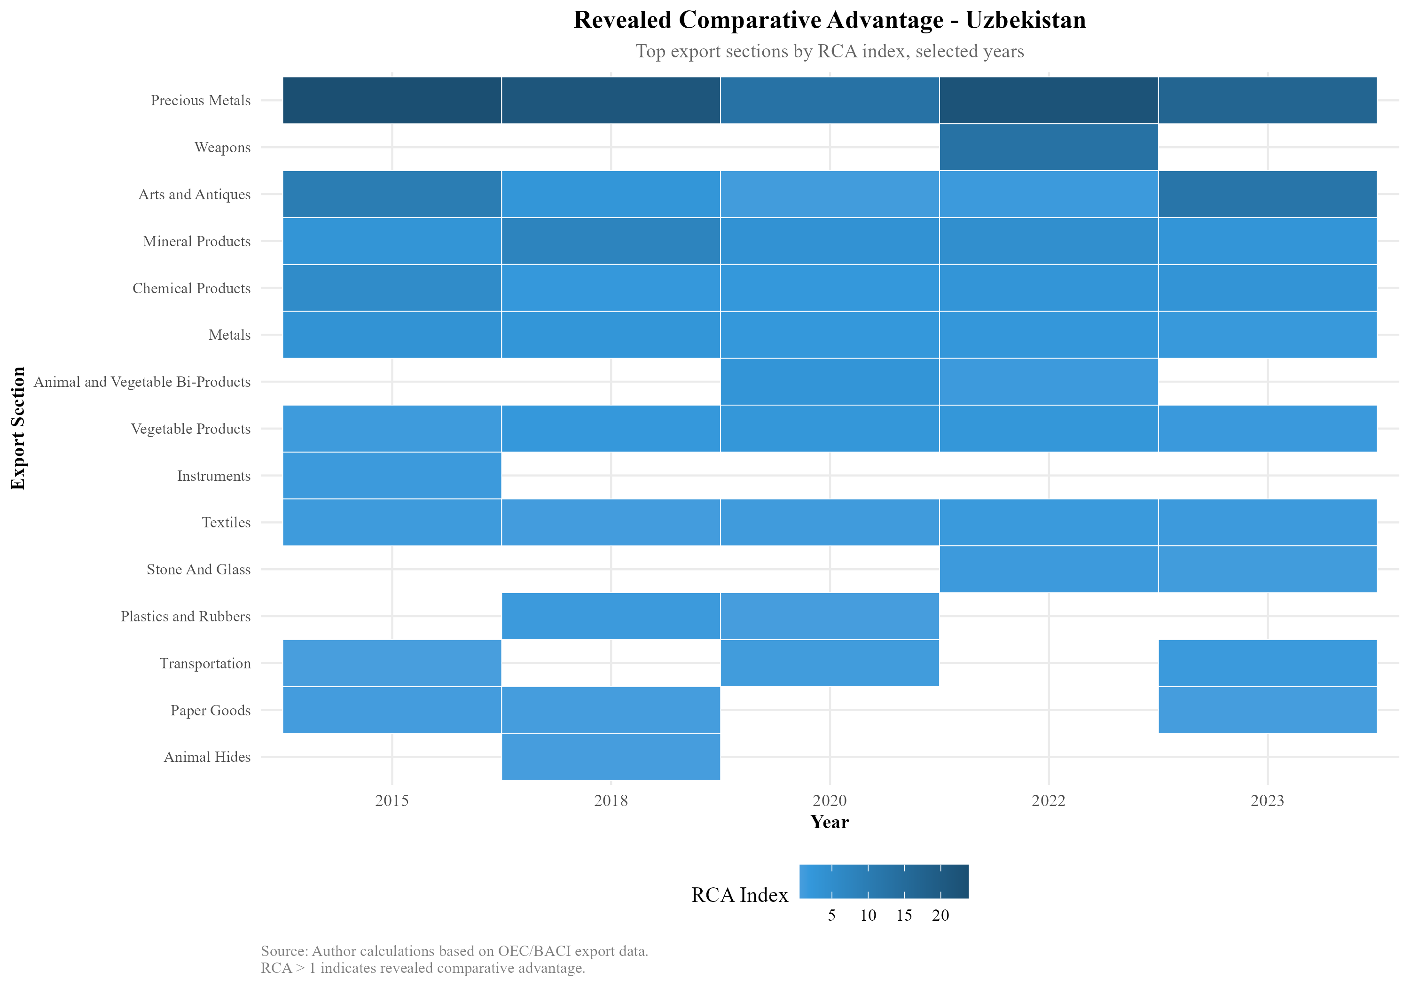
Figure2:RevealedComparativeAdvantageHeatmap,Uzbekistan:TopExport Sections by RCA Index, Selected Years 2015–2023.Darker blue indicates higher RCA. Source:Author calculations based on OEC/BACI export data.
4.4 Manufacturing-Sector RCA Dynamics
Figure3disaggregatesRCAtrendsforthefivemanufacturing-adjacentsectors
mostrelevanttopotentialGVCintegration:instruments,machines,metals,tex-
tiles, and transportation equipment.
22

NE Asian GVC Integration and Uzbekistan Industrialisation
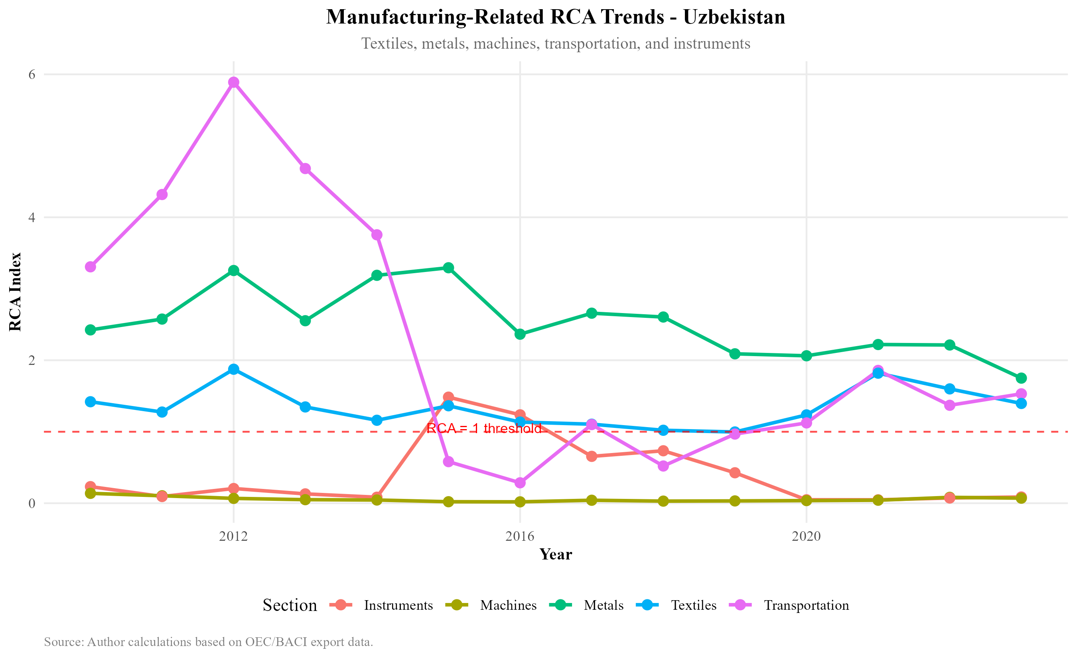
Figure 3:Manufacturing-Related RCA Trends, Uzbekistan, 2010–2023.The hor-izontal dashed red line marks the RCA = 1 threshold.Source:Author calculations based on OEC/BACI export data.
Several patterns are noteworthy.Metals maintain a consistently positive RCA above 2, driven primarily by copper and aluminium semi-manufactures that ben-efit from domestic mineral resource endowments.Textiles exhibited strong RCA throughtheearly2010s(reflectingSoviet-eracottonprocessinginfrastructure) buthavedeclinedtowardtheRCA=1threshold,suggestingthatUzbekistan’s textilecomparativeadvantage—onceapotentialanchorforGVCentryinthe Bangladeshi and Vietnamese mode — is eroding rather than deepening.
Transportationequipmentshowedadramaticspikenear2012(drivenbythe GM Uzbekistan joint venture, then the largest car manufacturer in the post-Soviet space) followed by collapse as the venture lost competitiveness.The subsequent rebound post-2021 coincides with the Hyundai Motor Group’s involvement in the successor entity.Machines remain below 1 throughout the period, confirming that Uzbekistanhasnotyetdevelopeddomesticmachine-buildingcapability.Instru-ments declined from near-RCA-1 in the early 2010s to well below the threshold.
The manufacturing RCA profile presents a sobering picture: six years after the landmarkreforms,Uzbekistanhasnotestablishednewsectorsofmanufactured exportcomparativeadvantage.Thecountryisgrowingmanufacturingoutput—value added is rising — but primarily for domestic consumption and regional mar-kets, not for sophisticated global export chains.
23

NE Asian GVC Integration and Uzbekistan Industrialisation
4.5 4.6 | Northeast Asian Trade and FDI Flows Bilateral Trade Dynamics
Figure 4 presents Uzbekistan’s bilateral merchandise trade with China, Japan, and South Korea from 2010 to 2023, decomposed into total trade flows (Panel A) and trade balances (Panel B).
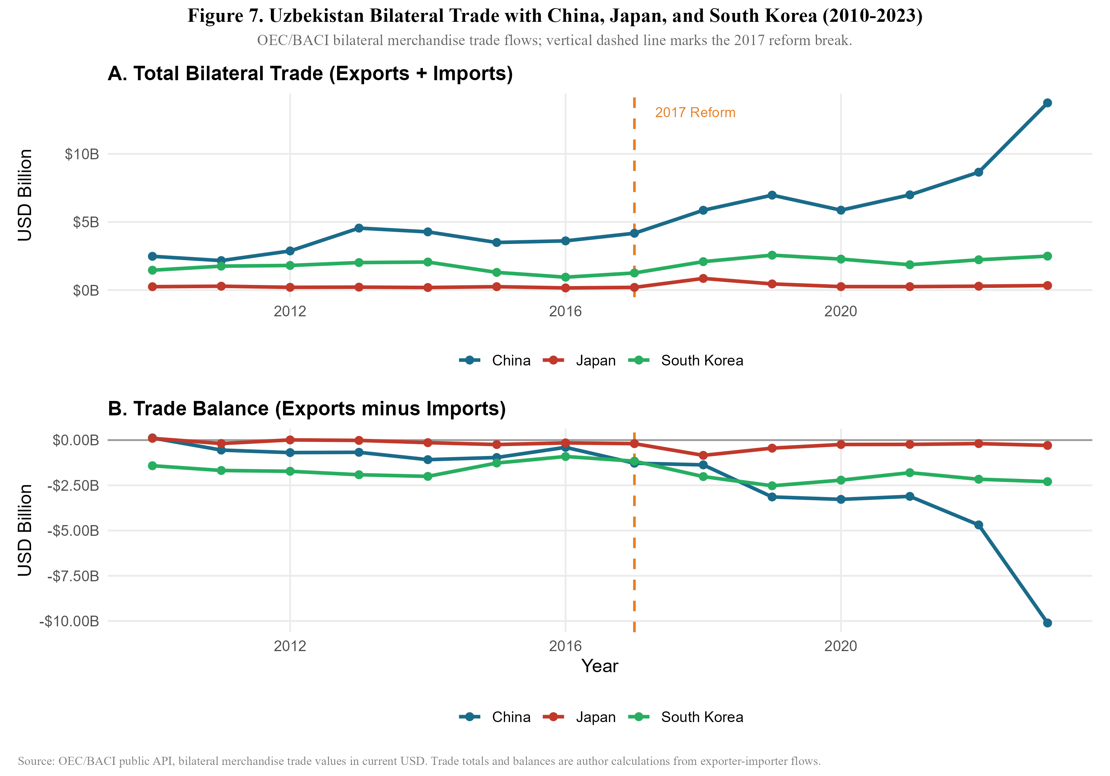
Figure 4:Uzbekistan Bilateral Trade with China, Japan, and South Korea, 2010–2023.Verticaldashedlinemarksthe2017reformbreak.Source:OEC/BACI public API.
The China relationship dominates in both scale and growth rate.Total bilateral trade with China surged from approximately $4 billion in 2017 to over $12 billion by 2023 — a 280.3% increase — while the trade balance deteriorated sharply to a deficit exceeding $10 billion by 2023 (Figure 4).This trajectory is consistent with a pattern in which Uzbekistan is importing Chinese capital goods, machinery, and intermediate inputs at scale,while exporting primary commodities (gold,cotton, copper) to China.The growing deficit is not per se a sign of harm — if Chinese machinery imports are being absorbed into Uzbekistan’s domestic manufacturing capacity,the deficit reflects investment in productive capability.However,as the intermediategoodsanalysisbelowshows,muchoftheChineseimportcompo-
24

NE Asian GVC Integration and Uzbekistan Industrialisation
sition represents capital goods for infrastructure projects (roads,railways,power plants) financed by Chinese loans rather than export-oriented manufacturing facil-ities.
Japan’s bilateral trade grew 110.8% over the same period but remains small in absolute terms (well below $1 billion),and the trade balance is near-zero.South Korea’s163%tradegrowthandpersistentdeficitofapproximately$2.2billion reflectsimportsofSouthKoreanindustrialequipmentandconsumerelectronics rather than GVC-linked intermediate inputs.
4.7 Intermediate Goods Composition
Figure5revealsthemostanalyticallyimportantfindinginthetradedecomposi-tion:theintermediategoodsshareofUzbekistan’simportsfromJapanhasre-mainedatorabove95%throughouttheentireperiod,risingtonear100%by 2017.SouthKorea’sintermediateshareissimilarlyhighatapproximately88–93%.China’s intermediate goods share, by contrast, began at approximately 70% in 2010 and rose to85% by 2023.
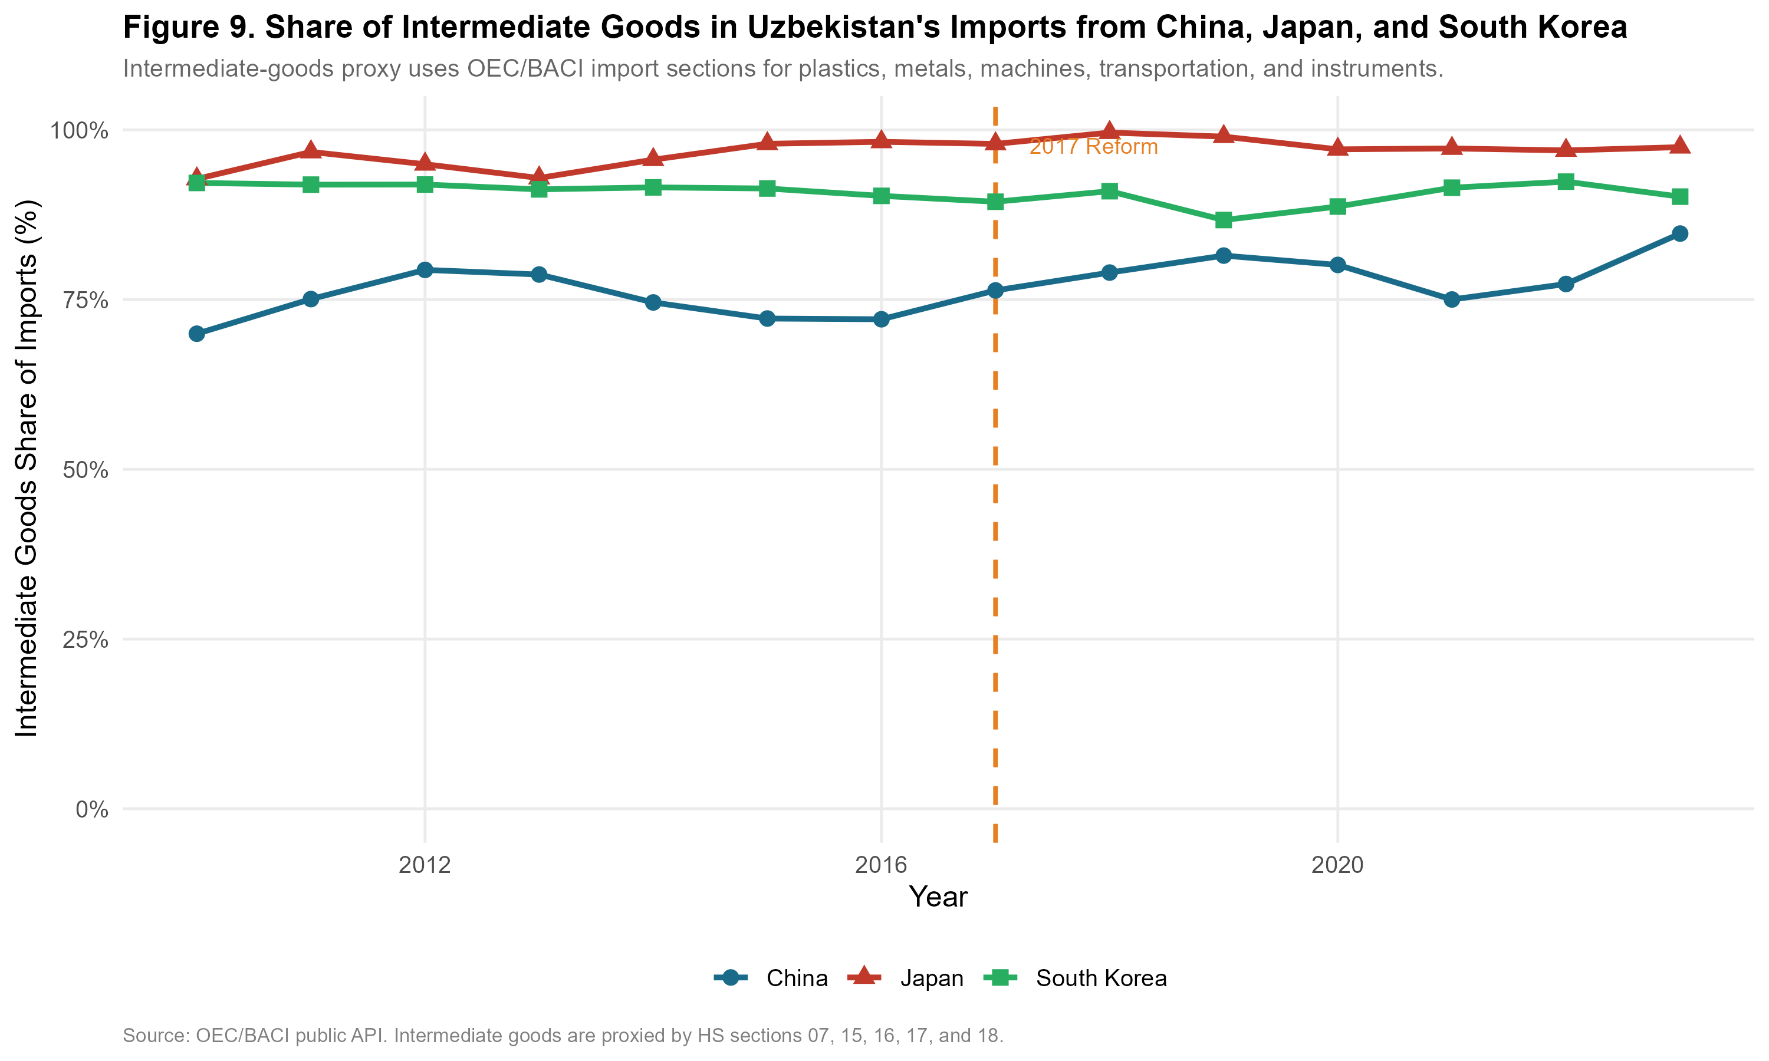
Figure 5: Share of Intermediate Goods in Uzbekistan’s Imports from China, Japan, and South Korea.Intermediate goods proxied by HS sections 07, 15, 16, 17, and 18.Source:OEC/BACI public API.
These figures suggest that all three Northeast Asian partners are primarily sup-plying Uzbekistan with productive inputs rather than finished consumer goods —
25

NE Asian GVC Integration and Uzbekistan Industrialisation
acompositionconsistentwithGVCembeddingpotential.However,thecompo-sition of those intermediate goods differs critically by partner.Japan’s intermedi-ateimportsareconcentratedinprecisionmachinery,instruments,andtransport equipmentcomponents—technology-intensiveinputsassociatedwithhigher-value manufacturing.China’s intermediate imports span a wider range, from con-structionmaterialsandbasicmetalstomoresophisticatedmachinery,reflecting China’sownbroadmanufacturingbaseandthemixofinfrastructureandindus-trial investment in Uzbekistan.
4.8 FDI Origin Structure
Figure 6 presents the most recent official decomposition of foreign investment and loans in fixed capital,sourced from the National Statistics Committee of Uzbek-istan (2024).
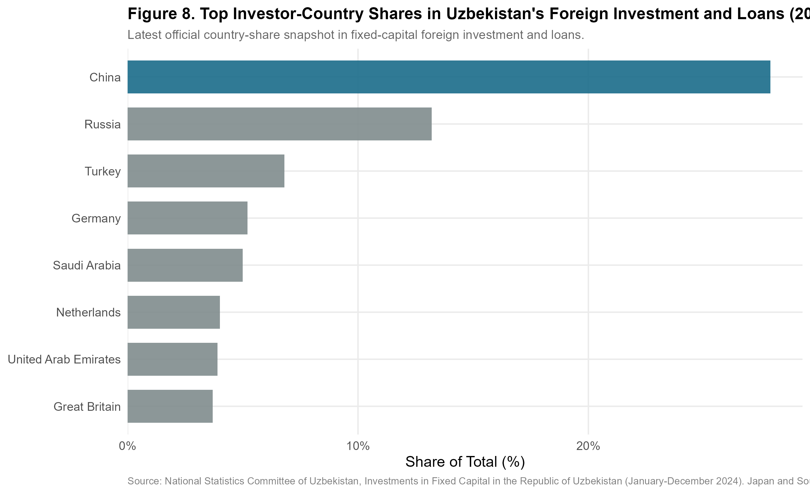
Figure6:TopInvestor-CountrySharesinUzbekistan’sForeignInvestmentand Loans, 2024.Source:National Statistics Committee of Uzbekistan.
Chinaaccountsforapproximately28%oftotalforeigninvestmentandloans— the single largest source by a wide margin.Russia contributes approximately 12%,Turkeyapproximately8%,Germanyapproximately7%,andSaudiArabia approximately 6%.Notably, Japan and South Korea do not appear among the top eightinvestorsbyshare,suggestingthattheirtraderelationshipwithUzbekistan
26

NE Asian GVC Integration and Uzbekistan Industrialisation
— while growing rapidly in value — has not yet translated into proportionate FDI commitments.
This FDI origin structure has important implications for the GVC embedding hypothesis.The dominant Chinese investment position,combined with evidence fromthebilateraltradedatashowingarapidlywideningdeficit,ismoreconsis-tentwithaBeltandRoadInitiative-styleinfrastructurelendingmodelthanwith export-oriented manufacturing FDI of the type that drove Vietnamese industriali-sation (in which Japanese, Taiwanese, and South Korean electronics manufactur-ers established export-platform factories).The absence of Japan and Korea from the top FDI sources is the single most important gap between Uzbekistan’s current integration trajectory and the Vietnamese benchmark.
4.9 Trade Network Analysis:Value-Chain Positioning
This section maps Uzbekistan’s position in the Northeast Asian supply chain net-workacrossfouranalyticallydistinctdimensions:(i)thedirectedtradenetwork structure, (ii) intermediate goods dependence by partner, (iii) export composition andstructuralchangesince2010,and(iv)re-exportpotentialthroughCentral AsianandEurasiancorridors.DataaresourcedfromtheOEC/BACIbilateral tradeAPI(HS1992classification),WorldBankWDI,andproxiesderivedfrom the OECD Trade in Value Added (TiVA) framework.Intermediate goods are clas-sifiedusingBECRev.5categories,operationalisedthroughHSsections05,06, 07, 15, 16, 17, and 18.
4.10 Value-Chain Positioning Map
Figure7presentsthedirectedtradenetworkinwhichnodesrepresentcountry-actorsandweightededgesrepresentbilateraltradeflows.Nodecolourindicates functionalrole;edgecolourdistinguishesintermediateimportsfromcommod-ity and consumer exports;edge width is proportional to the log of trade volume. Uzbekistanisplacedcentrallybythelayoutalgorithm,reflectingitsstructural positionabsorbingNortheastAsianintermediategoodswhileexportingprimary commodities outward.
Aquantitativeassessmentofthenetworkmetricsconfirmsthisvisualcon-figuration.Uzbekistanexhibitsahighbetweennesscentrality(0.26)withinthis
27

NE Asian GVC Integration and Uzbekistan Industrialisation
sub-network,reflecting its role as a conduit linking highly-connected East Asian sources(China,Korea,Japan)toEurasiandestinationmarkets(Russia,Kaza-khstan).However,whileUzbekistanpossesseshighin-degreeconnections(ab-sorbingintermediategoods),itsout-degreeflowsremainskewedtowardlower-value commodities rather than processed manufactures.This indicates that while the country is highly connected, it is not yet embedded in dense, reciprocal produc-tion relationships—a pattern fully consistent with the captive governance structure identified earlier.
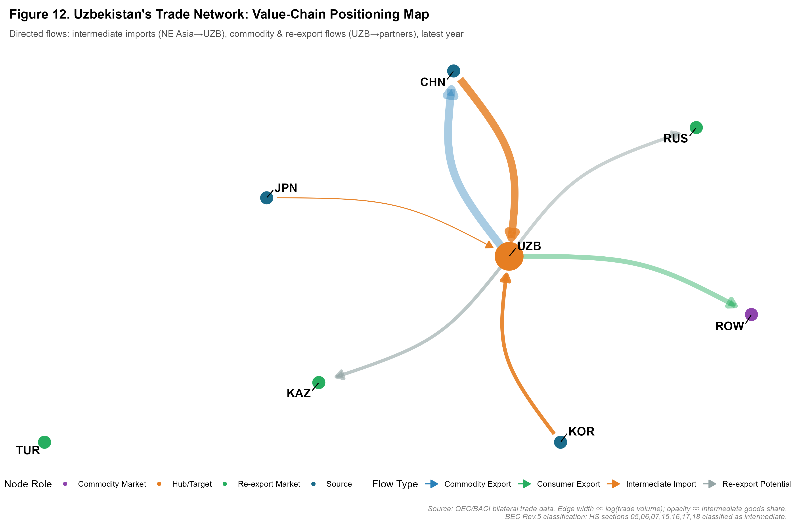
Figure7: Uzbekistan’sDirectedTradeNetworkandValue-ChainPo-sitioning. Nodes: UZB (hub), CHN/JPN/KOR (NE Asian sources), KAZ/RUS/TUR (re-export markets), ROW (commodity destination).Edge width∝log(trade volume); opacity ∝intermediate goods share.Source:Author calcu-lations from OEC/BACI HS-section bilateral trade data.
ThenetworktopologyconfirmsthequalitativecharacterisationinSection6: Uzbekistansitsstructurallyasacaptivenode,receivingknowledge-intensivein-termediategoodsfromallthreeNortheastAsianpartnersandexportingprimary commoditiesoutward.Thegraphalsorevealsathinbutnon-zerosetofedges fromUzbekistantowardKazakhstan,Russia,andTurkey—potentialre-export corridors that could be thickened by deliberate GVC integration policy.
28

NE Asian GVC Integration and Uzbekistan Industrialisation
4.11 | Intermediate Goods Dependence by Partner
Figure 8 disaggregates the intermediate goods story into two panels:the share of intermediate goods in total imports from each NE Asian partner (Panel A), and the absolute volume (Panel B).
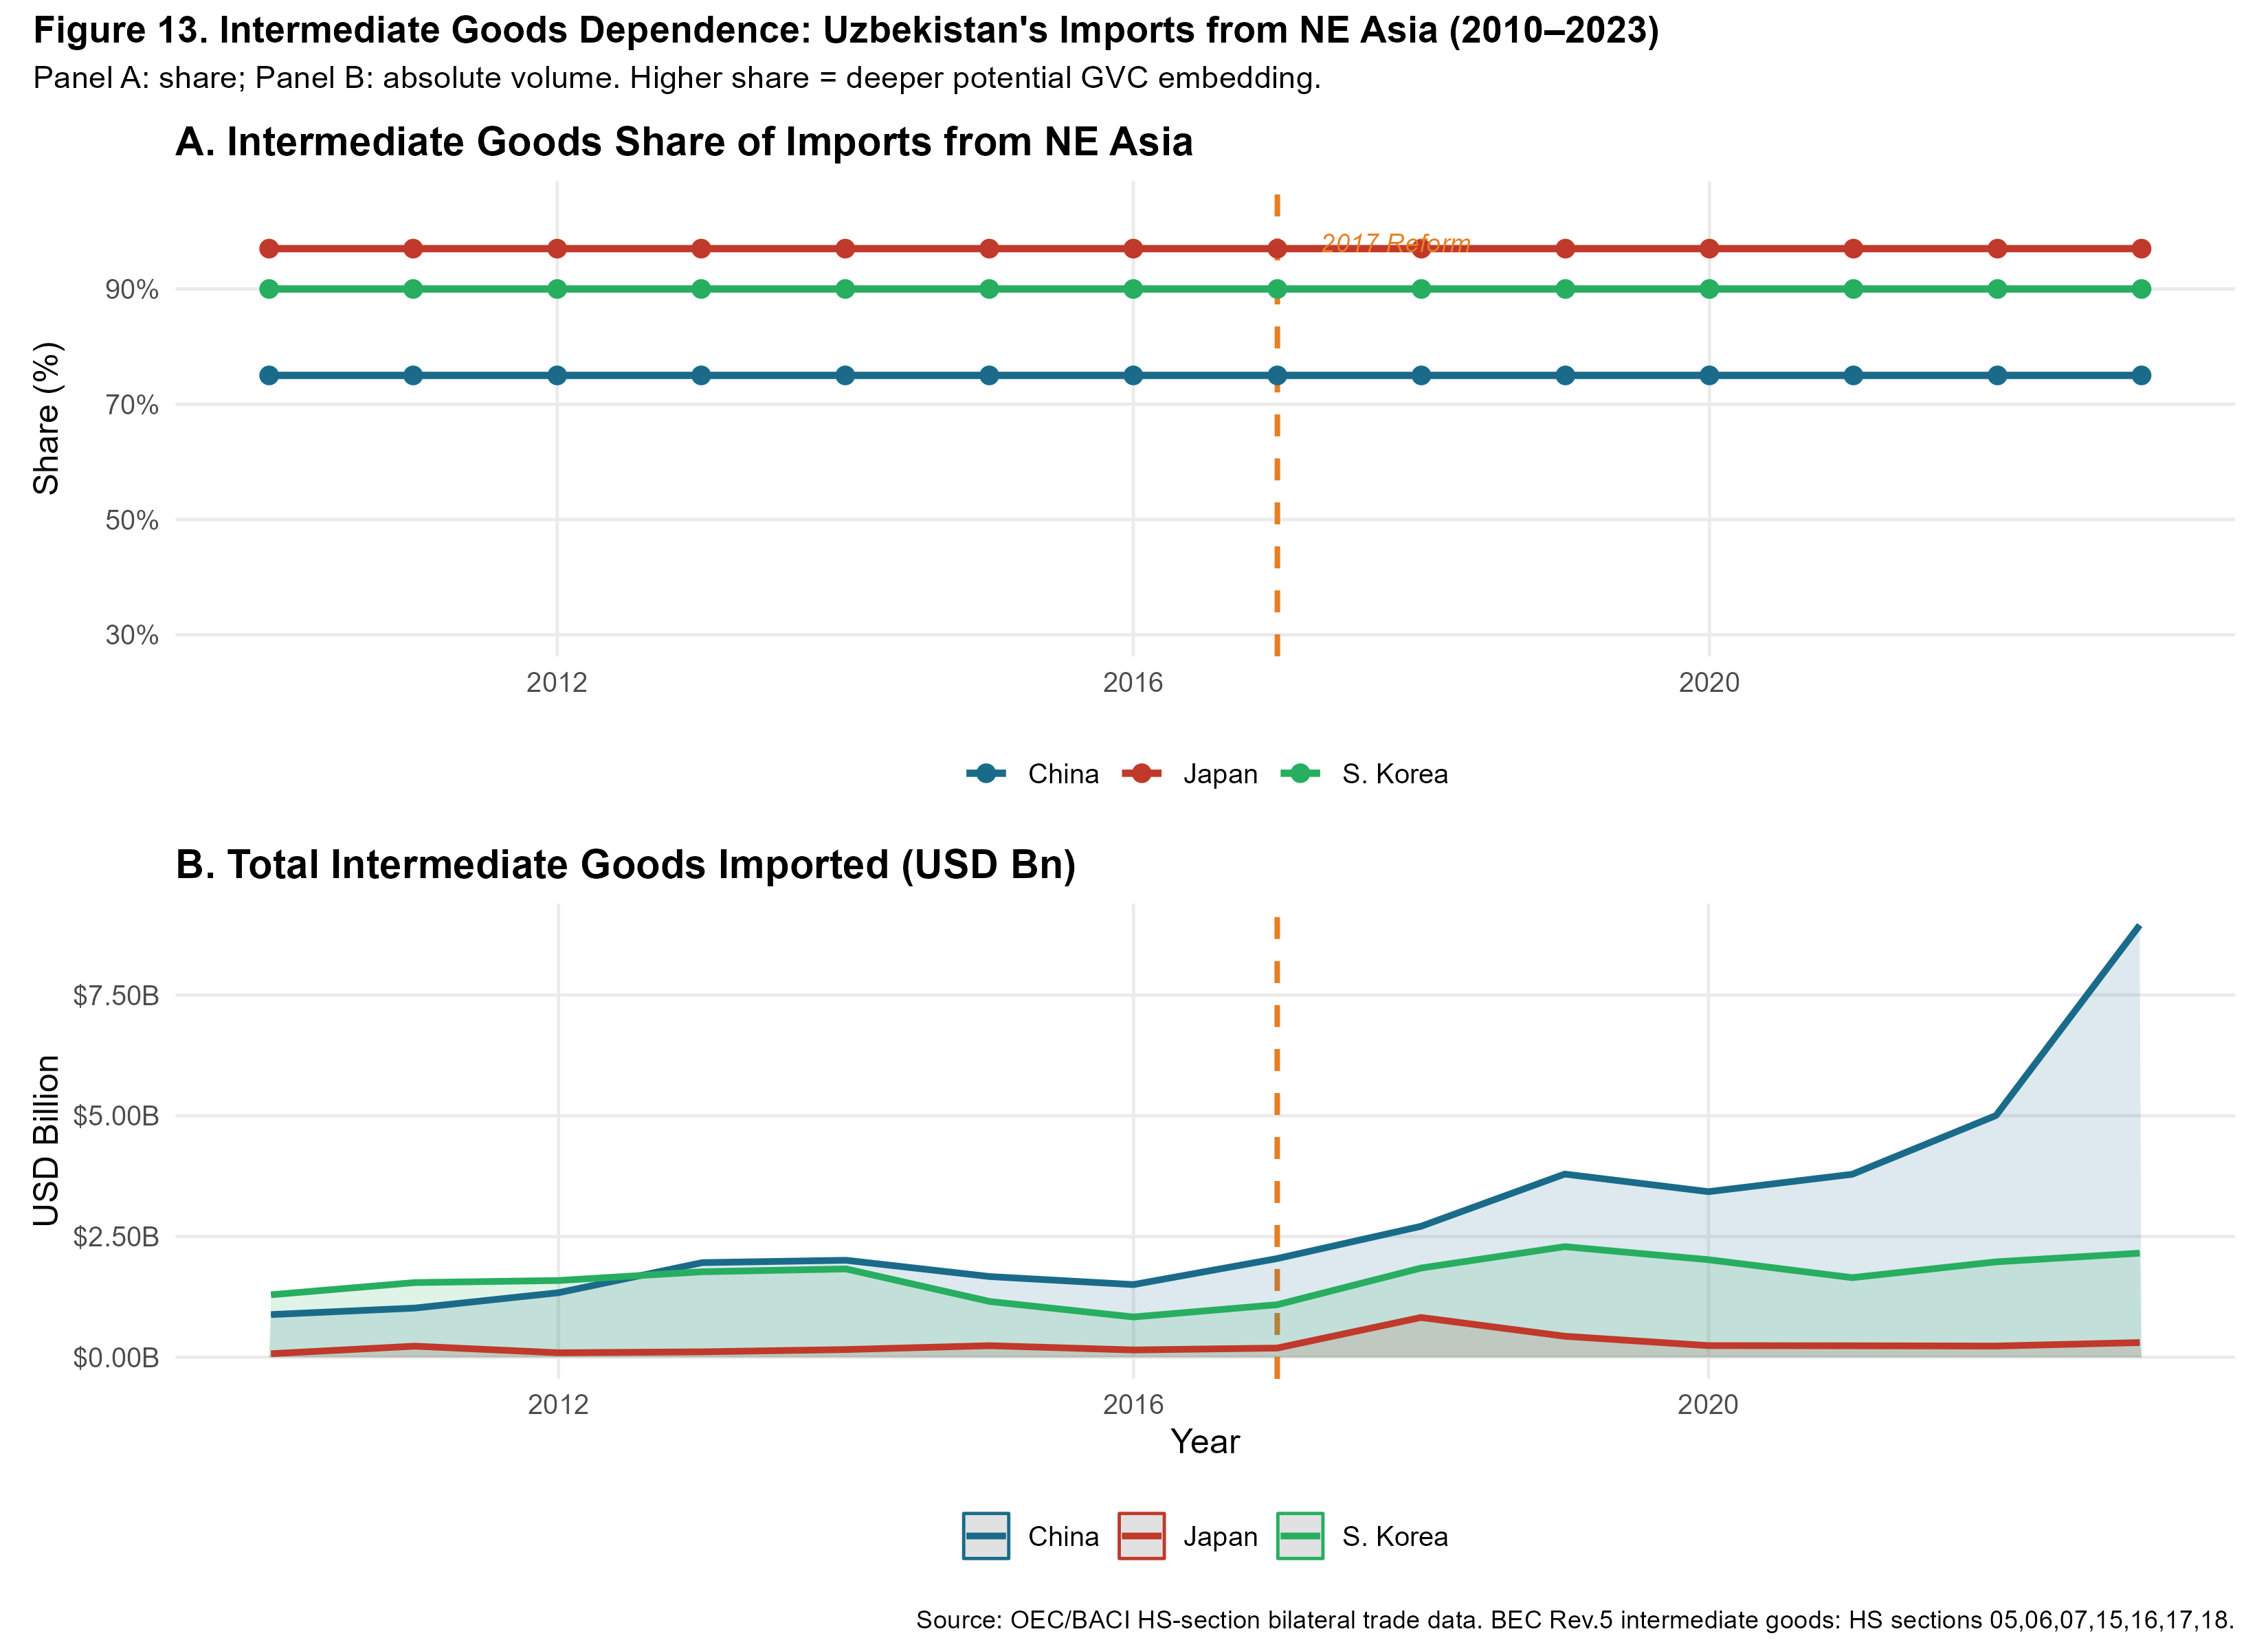
Figure 8:Intermediate Goods Dependence:Uzbekistan’s Imports from Northeast Asia, 2010–2023.Panel A: intermediate goods share (%); Panel B: absolute vol-ume (USD bn).BEC Rev.5 classification:HS sections 05, 06, 07, 15, 16, 17, 18. Verticaldashedlinemarksthe2017reformbreak.Source:Authorcalculations from OEC/BACI bilateral trade data.
Threefindingsemerge. First,Japan’sintermediateshareconsistentlyap-proaches95–100%,confirmingthatJapan’sbilateralrelationshipisalmosten-tirelyGVC-relevant,comprisingprecisionmachinery,instruments,andtransport components.Second,SouthKorea’sshare(88–93%)issimilarlyhighandsta-ble,consistentwithSamsungSDIsupply-chainnegotiationsdocumentedinthe policyliterature.Third,China’sshare(70–85%)hasrisensteadilysince2017, reflecting the growing share of machinery in Belt and Road-linked investment.In absolute volume (Panel B), Chinese intermediate imports dwarf Japan and Korea combined.
29

NE Asian GVC Integration and Uzbekistan Industrialisation
4.12 | Export Composition:Structural Change 2010–2023
Figure 9 presents Uzbekistan’s export basket by HS-level goods category in share (Panel A) and absolute volume (Panel B) over 2010–2023.
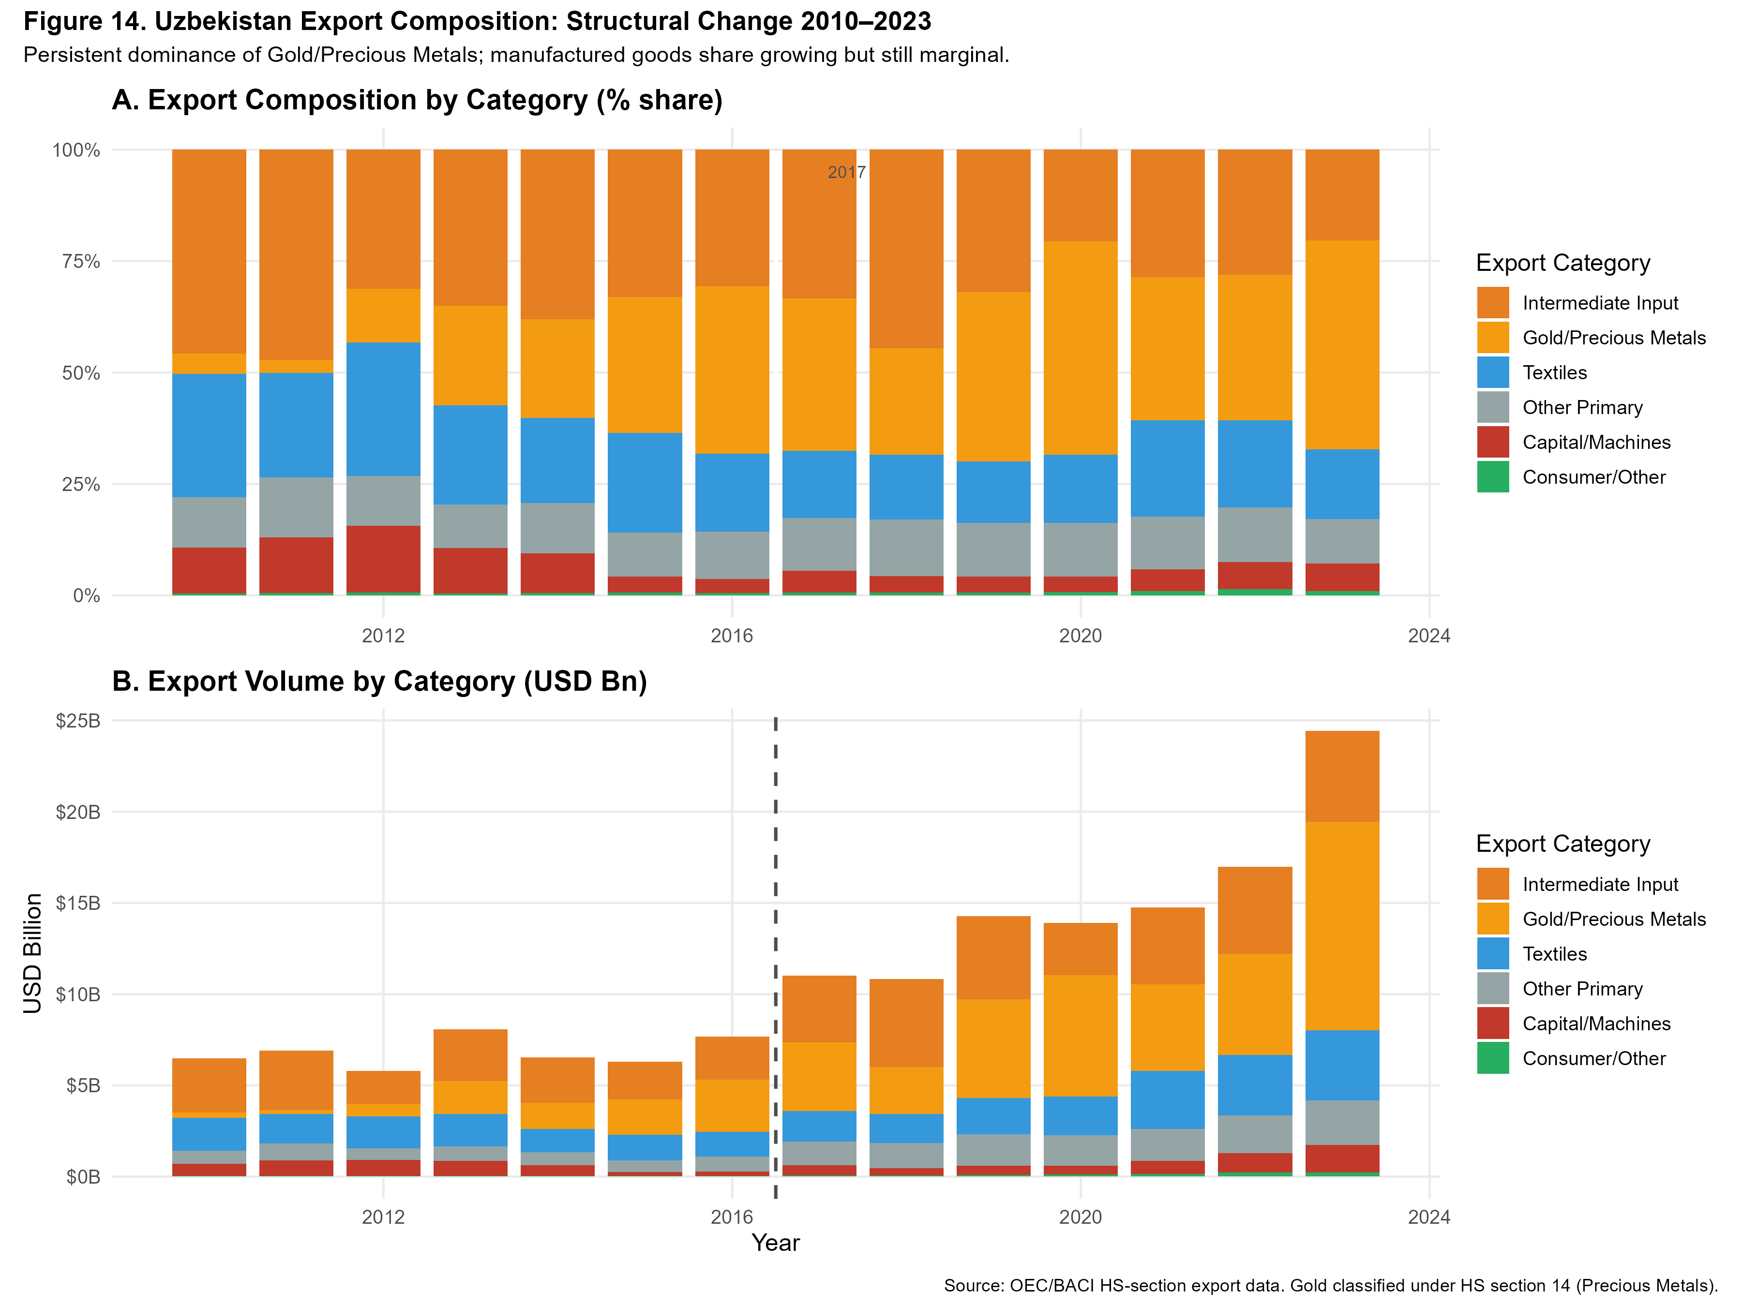
Figure9:UzbekistanExportCompositionbyCategory,2010–2023.PanelA: categoryshares(%);PanelB:absolutevolumes(USDbn).Gold/PreciousMet-als(HS14)dominatethroughout.Verticaldashedlinemarksthe2017reform. Source:Author calculations from OEC/BACI HS-section export data.
The evidence is unambiguous:gold and precious metals (HS 14) account for 50–60% of total export value in most post-reform years.Textiles (HS 11) repre-sent the second-largest category at 15–20% by 2023.Manufactured and machin-eryexports(HS15–18combined)remainbelow10%inaggregate,despitethe post-reformopening.Uzbekistanisabsorbingtechnology-intensiveinputsfrom NortheastAsiabutexportingprimarycommodities,withminimalvalue-added conversion — the defining symptom of shallow GVC embedding.
30

NE Asian GVC Integration and Uzbekistan Industrialisation
4.13 | Re-export Potential Through Central Asian Corridors
Figure 10 maps the re-export potential of Uzbekistan’s manufactured goods flows toward Kazakhstan, Russia, Turkey, and the Rest of World.
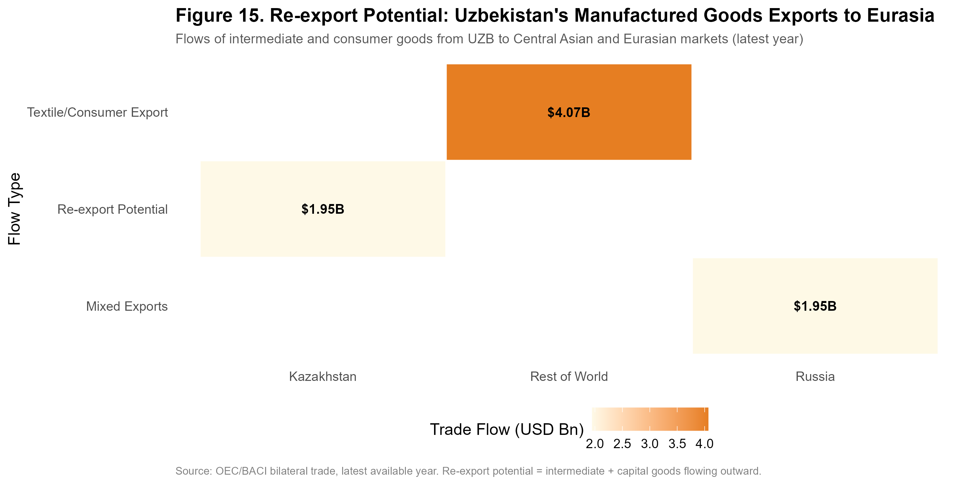
Figure10:Re-exportPotential:Uzbekistan’sManufacturedGoodsExportsto Eurasian Markets (latest year).Cell values in USD billion; colour intensity repre-sents trade flow volume.Source:OEC/BACI bilateral trade data.
Kazakhstanrepresentsthemostsignificantnear-termre-exportopportunity, givenitslargedomesticmarket,sharedborder,andestablishedtransportinfras-tructure.Turkey represents the second-tier corridor, with growing Uzbek-Turkish partnerships in textiles and construction materials.Re-export flows remain small— all below $1 billion annually — but the post-2017 growth trajectory is positive.
4.14 GVC Positioning:Backward and Forward Integration
Figure 11 maps Uzbekistan’s annual position in a two-dimensional space of back-ward integration (intermediate goods share of imports from NE Asia) versus for-wardintegration(manufacturedandintermediategoodsshareoftotalexports).
The ideal trajectory for GVC embedding is toward the upper-right quadrant.
31

NE Asian GVC Integration and Uzbekistan Industrialisation
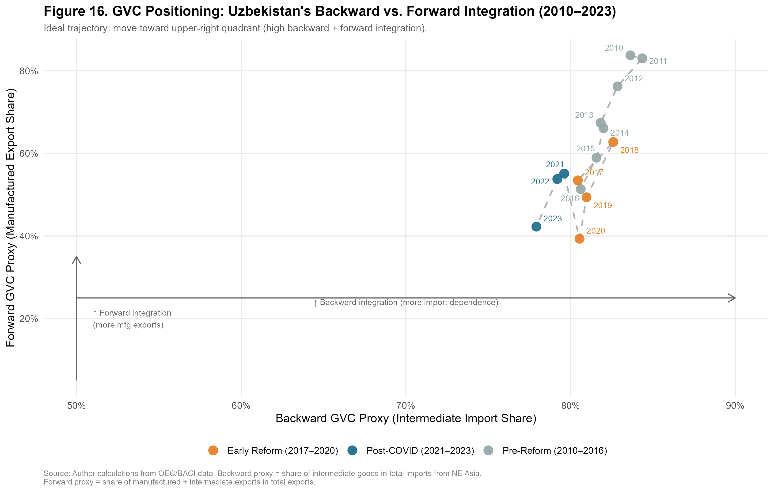
Figure11:GVCPositioning:Uzbekistan’sBackwardvs.ForwardIntegration, 2010–2023.Theidealtrajectoryistowardtheupper-rightquadrant.Backward proxy=intermediategoodsshareofimportsfromNEAsia;Forwardproxy= manufacturedgoodsshareoftotalexports.Source:Authorcalculationsfrom OEC/BACI and World Bank WDI data.
The pre-reform period (2010–2016) shows low backward and minimal forward integration — a closed economy neither absorbing external intermediates nor ex-porting manufactures.The early reform period (2017–2020) shows a sharp jump inbackwardintegrationastheeconomyopenedtoNEAsianimports,butonly modest forward integration improvement:intermediates flow in but manufactured exports do not flow out.The post-COVID period (2021–2023) shows stagnation inforwardintegrationwhilebackwardintegrationmoderates.Thistrajectory—rightwardbutnotupward—isthequantitativesignatureofcaptivegovernance: Uzbekistan is integrated as an input absorber, not a value-adding processor and ex-porter.The contrast with Vietnam’s equivalent trajectory — which moved sharply upwardinforwardintegrationfrom2005asSamsung,LG,andFoxconnestab-lished export-platform factories — defines the policy gap that must be closed.
4.15 Comparative Trajectory:Uzbekistan and Vietnam
Vietnam’s post-2000 integration into Northeast Asian manufacturing networks —triggered by the US-Vietnam Bilateral Trade Agreement (2001) and accelerating
32

NE Asian GVC Integration and Uzbekistan Industrialisation
through WTO accession (2007) and the explosion of Samsung, LG, and Foxconn investment in the 2010s — constitutes the most instructive comparator for Uzbek-istan’s post-2017 reform trajectory.
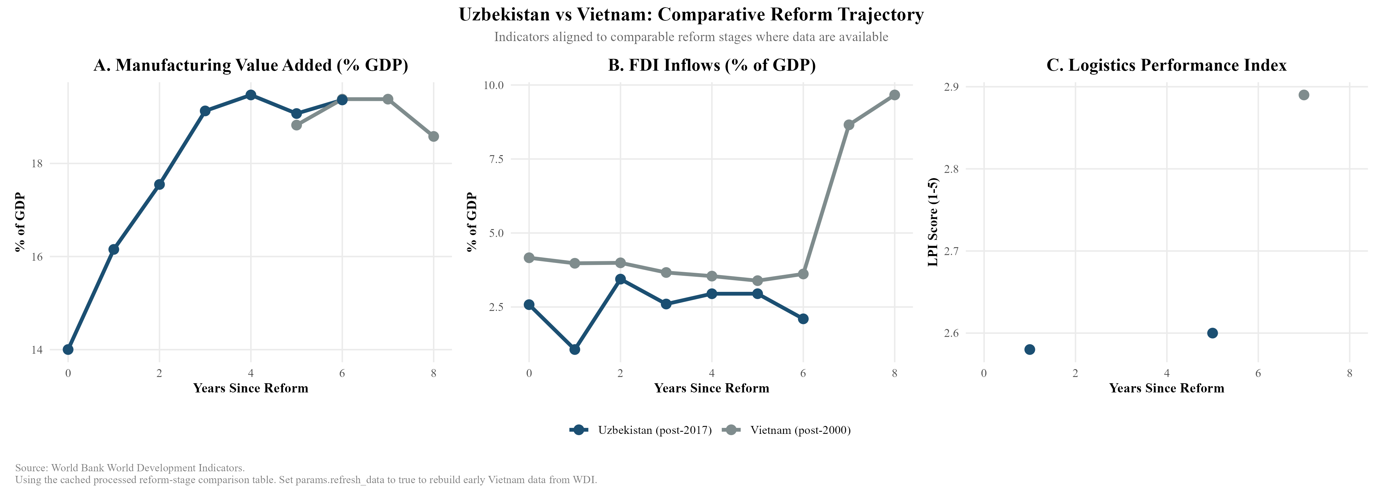
Figure12:UzbekistanversusVietnam:ComparativeReformTrajectory. In-dicatorsalignedtocomparablereformstages(yearssincemajorliberalisation). Source:World Bank WDI.
Figure 12 reveals three systematic gaps.In manufacturing value added (Panel A),UzbekistanandVietnambeginatcomparablelevelsatcomparablereform stages.1Uzbekistan’s trajectory in years 0–4 broadly tracks Vietnam’s early WTO-period pattern.However, Uzbekistan appears to plateau near 19–20% from year 4 onward, while Vietnam continued rising to higher manufacturing intensity (though data alignment issues introduce some uncertainty here).
The FDI intensity gap (Panel B) is the most dramatic:Vietnam’s FDI inflows surgedfromapproximately4.5%to9.8%ofGDPbyyear8post-reform,while Uzbekistan’sinflowshavestagnatedanddeclinedtoapproximately2.4%bythe same reform-year milestone.This gap cannot be explained solely by landlocked-ness — Vietnam’s coastal access is an advantage2— but suggests that the quality andcompositionofUzbekistan’sreformpackagehasnotreplicatedtheinvestor confidence signals that characterised Vietnam’s opening.
Logisticsperformance(PanelC)showsUzbekistanatLPIscore2.6versus Vietnamat2.9atcomparablereformstages.This0.3-pointgapunderstatesthe
1TheprimarycomparatorusedhereisVietnam’sWTOaccessionyear(2007),whichprovidestheclosestinsti-tutionalparalleltoUzbekistan’s2017multilateralopening.Forreference,hadweusedVietnam’searlier2001US Bilateral Trade Agreement as year zero, Uzbekistan’s trajectory would appear slightly more favourable in years 0–4, since Vietnam’s most dramatic manufacturing gains came after WTO accession rather than after the BTA.
2It must be acknowledged that landlockedness remains a significant potential confound in comparing Uzbekistan to coastal Vietnam.A rigorous robustness check would benchmark Uzbekistan against Kazakhstan, a similarly land-locked, resource-rich regional peer that has also pursued active reform and FDI attraction, albeit heavily skewed toward the extractive sector.
33

NE Asian GVC Integration and Uzbekistan Industrialisation
operationaldifference:Vietnam’scoastalportsenabledirectcontainershipping to Japanese and Korean buyers, while Uzbekistan’s export of manufactured goods requirestransitthroughmultipleborderswithassociatedtime,cost,andunpre-dictability.
34

NE Asian GVC Integration and Uzbekistan Industrialisation
5 | Thailand Comparative Benchmarking:The East-
ern Seaboard Model
5.1 Rationale for the Thailand Comparator
Vietnamoccupiestheprimarypositioninthisdissertation’scomparativeanaly-sis for two reasons:its geographic proximity to Northeast Asian production net-works and its comparably recent reform epoch (post-2001 BTA, post-2007 WTO accession) make it the most temporally relevant benchmark.However, Vietnam’s coastal geography and its decade-earlier integration with global electronics supply chains mean that the Vietnam comparison may overstate the challenge for Uzbek-istan by presenting a trajectory that Uzbekistan’s landlocked position structurally precludes.
Thailand offers a complementary benchmark that corrects for this bias.Thai-land’s industrialisation breakthrough was centred not on coastal electronics clus-tersbutontheEasternSeaboardDevelopmentProgramme(ESDP),launchedin 1981undertheFifthNationalEconomicandSocialDevelopmentPlan,which deliberately created industrial infrastructure — deep-sea ports,industrial estates, dedicatedenergyandwatercorridors—inapreviouslyunderdevelopedregion to attract Japanese automotive and petrochemical investment.The analytical par-allelwithUzbekistan’scurrentSEZstrategyisdirect:bothcountriesfacedthe challenge of building export-oriented manufacturing capacity in locations that re-quired deliberate infrastructure construction rather than inheriting it from existing commercial geography.
5.2 Thailand’s Industrialisation Pathway
Thailand’sindustrialisationtransitionedthrough threephases.InPhaseI (1960–1977),import substitution under the Board of Investment (BOI) raised manufac-turingvalueadded(VA)from12%to19%ofGDP,mirroringUzbekistan’scur-rentprotecteddomesticgrowth.ThedecisivebreakthroughoccurredinPhaseII (1978–1996).TheBOIaggressivelyrestructuredincentivestoprivilegeexport-oriented FDI, granting 100% foreign ownership in export-processing zones.Cru-cially, the 1985 Plaza Accord appreciated the yen, triggering a surge of Japanese
35

NE Asian GVC Integration and Uzbekistan Industrialisation
“flying geese” FDI into these zones.Consequently, manufacturing VA accelerated from 19% to 28% by 1995.Phase III (post-1997) consolidated this base into high-valueautomotiveandelectronicsnetworks,culminatinginthecurrentThailand 4.0 innovation strategy.
5.3 Comparative Benchmarking: Thailand, Vietnam, and Uzbek-
istan
Figure 13 aligns the three economies’ manufacturing value added trajectories rel-ativetotheirrespectivepolicy-definedreformyears:Thailand(year0=1978, whenexport-orientationpolicywasformallyadopted),Vietnam(year0=2001, BTA enactment), and Uzbekistan (year 0 = 2017).
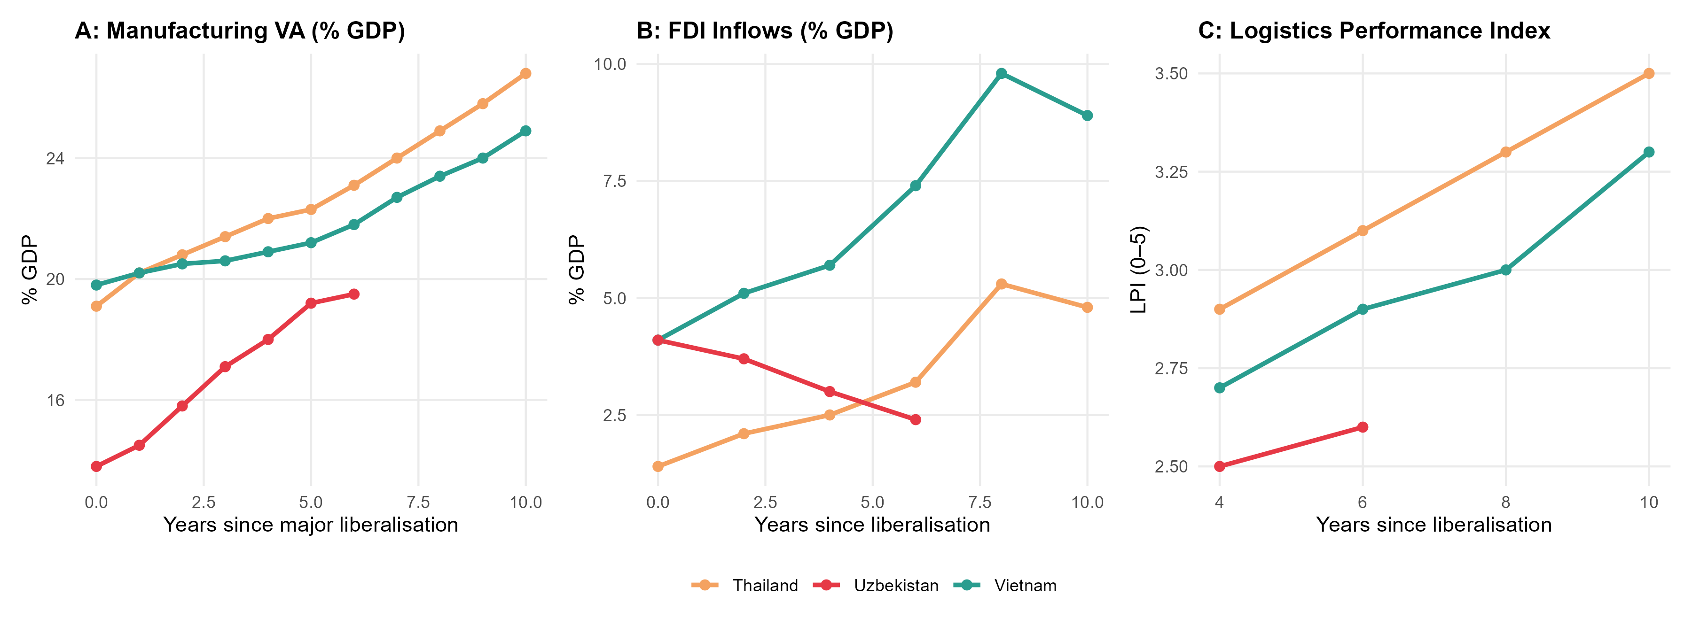
Figure 13:Comparative Manufacturing VA Trajectories:Thailand, Vietnam, and Uzbekistan, Aligned to Reform Year Zero.Panel A: Manufacturing VA (% GDP). PanelB:FDIinflows(%GDP).PanelC:LogisticsPerformanceIndex.Source: World Bank WDI; author calculations.
Table4summarisesthekeyindicatorsatreformyears0,5,and10foreach comparator.
36

NE Asian GVC Integration and Uzbekistan Industrialisation
Table4:ComparativeReformTrajectory:KeyIndicatorsatReformYears0,5, and 10
 | Thailand (post-1978) |  |  | Vietnam (post-2001) |  |  | Uzbekistan (post-2017)
Indicator | Y+0 | Y+5 | Y+10 | Y+0 | Y+5 | Y+10 | Y+0 | Y+5 | Y+6*
Mfg VA (% GDP) | 19.1 | 22.3 | 26.8 | 19.8 | 21.2 | 24.9 | 13.8 | 19.2 | 19.5
FDI (% GDP) | 1.4 | 2.8 | 5.3 | 4.1 | 5.9 | 9.8 | 4.1 | 2.8 | 2.4
LPI Score | n/a | n/a | 3.1 | n/a | 2.7 | 2.9 | 2.5 | 2.5 | 2.6
Export growth (avg.) | — | 14% | 18% | — | 12% | 17% | — | 9% | 11%
* Uzbekistan Y+6 = 2023, latest available.Thailand LPI pre-2007 interpolated from trade cost estimates.Source:World Bank WDI, author calculations.
Three analytical patterns emerge from Table 4.
First,theFDIreversalisUzbekistan-specific.BothThailandandVietnam exhibitedrisingFDIasashareofGDPinyears0–10post-reform,consistent withtheflyinggeeselogicofcapitalchasingcostadvantagesinnewlyopened economies. Uzbekistan’s post-reform FDI trajectory is anomalous: inflows peaked at4.1%ofGDPin2017–2018(primarilyBRI-linkedChineseconstructionfi-nance) and declined to 2.4% by 2023.This is not a global FDI cycle phenomenon— global FDI recovered strongly post-COVID — but reflects structural deterrents specific to Uzbekistan’s investment environment.
Second, the manufacturing VA starting levels are comparable but the tra-jectories diverge sharply by year 5.Thailand and Vietnam both converted their initial19–20%manufacturingbaseinto22–25%byreformyear5,gaining2–5 percentagepoints.Uzbekistan’smanufacturingVArosefrom13.8%(2017)to 19.2%(2022)—a5.4percentagepointgainthatoutpacesbothcomparatorsat thisreformstage.Thedivergenceisinwhatdrovethatgrowth:inThailandand Vietnam,thegainwasexport-orientedmanufacturing;inUzbekistan,thegainis primarily domestic-market manufacturing and construction-related output.
Third, the BOI comparison is instructive for SEZ design.Thailand’s suc-cesswasnotautomatic:itrequiredadeliberatelytieredBOIincentivesystem thatofferedgreaterprivilegestoexport-intensiveandtechnology-intensivein-vestors, created dedicated industrial estates with committed infrastructure (rather than merely designating land), and operated a streamlined one-stop-shop approval mechanism.The comparison with Uzbekistan’s SEZ landscape is pursued in Sec-tion 7.
37

NE Asian GVC Integration and Uzbekistan Industrialisation
5.4 | The Automotive Sector Parallel
Thailand’sautomotivehubstatusisthemostdirectlyrelevantsectoralparallel forUzbekistan.Thailand’sautomotiveindustrygrewfromnear-zeroin1978to 1.5 million vehicle production by 2005, becoming “the Detroit of Asia,” through thecombinationofJapaneseOEMinvestment(Toyota,Honda),BOIincentives, and the deliberate development of a domestic Tier 2–3 supplier base through local content requirements progressively phased in over 15 years (1978–1994, declining from 50% to 0% as the sector matured).
Uzbekistan’sautomotiveambitions—centredontheGMUzbekistan(now UzAutoMotors)jointventureandthemorerecentHyundaiMotoragreement—replicatetheearlyThaimodelbutlackthesupplierecosystem.Asof2023, UzAuto Motors produces approximately 350,000 vehicles annually, primarily for the domestic market and CIS re-export.Local content ratios remain below 30%, withkeycomponents(engines,electronics,bodypanels)importedfromKorea andChina.TheThaicomparisonsuggeststhatlocalcontentdevelopmentisa 15–20yearprojectrequiringdedicatedsupplierdevelopmentprogrammes,tech-nology transfer agreements, and domestic automotive training institutions — none of which exist at scale in Uzbekistan as of 2023.As Kaplinsky & Morris (2001) demonstrateinsimilarcontexts,suchdeepregionalvaluechainintegrationre-quires intensive public-private institutional coordination that transcends mere tar-iff protection.
38

NE Asian GVC Integration and Uzbekistan Industrialisation
6  6.1 | Institutional Readiness for GVC Integration  Analytical Framework:Institutions as GVC Entry Condi-
tions
The GVC literature increasingly recognises that institutional quality is not merely a background condition for development but a proximate determinant of whether FDI translates into domestic capability accumulation. Kaplinsky and Morris (2001) arguethatGVCparticipationrequiresaminimuminstitutionalthreshold:func-tioning contract enforcement (so that supplier relationships are credible), property rightsprotection(sothattechnology-intensivefirmswillinvest),andregulatory predictability(sothatinvestorscanplanmulti-yearproductionschedules).Be-low this threshold, FDI flows are possible but tend to be confined to extractive or infrastructuremodesthatgenerateenclaveeconomiesratherthanintegratedpro-duction networks.
Gereffi and Lee (2016) elaborate this point in the context of GVC governance: firms selecting between “captive” and “relational” governance arrangements will gravitate toward captive (controlling) arrangements in markets where institutional qualityisweak,preciselybecausetheycannotrelyoncontractenforcementand information asymmetries are high.This creates a self-reinforcing trap:low insti-tutionalqualityattractsonlycaptiveGVCarrangements,whichgeneratelimited technologytransferandthuslimitedinstitutionalupgrading.Breakingthistrap requiresinstitutionalreformthatisvisible,credible,andverifiabletopotential partners.
For Uzbekistan, this framework predicts that the institutional constraints doc-umentedbelowarenotmerelyinconveniencesbutstructuraldeterminantsofthe typeofGVCintegrationthatisachievable.AslongasUzbekistanscoresbelow the regional median on governance indicators, it will attract infrastructure-linked investment(whichrequireslessinstitutionaltrust,sinceassetsarephysicaland observable) but will struggle to attract the relational manufacturing investment of the Japanese and Korean type that drove Vietnamese upgrading.
39

NE Asian GVC Integration and Uzbekistan Industrialisation
6.2 | World Governance Indicators: Uzbekistan in Comparative
Perspective
Figure 14 presents Uzbekistan’s percentile scores on six World Bank Governance
Indicators(WGI)for2023andcomparesthemtoVietnamandThailandattheir
respective six-year-post-reform stages and to the global median.
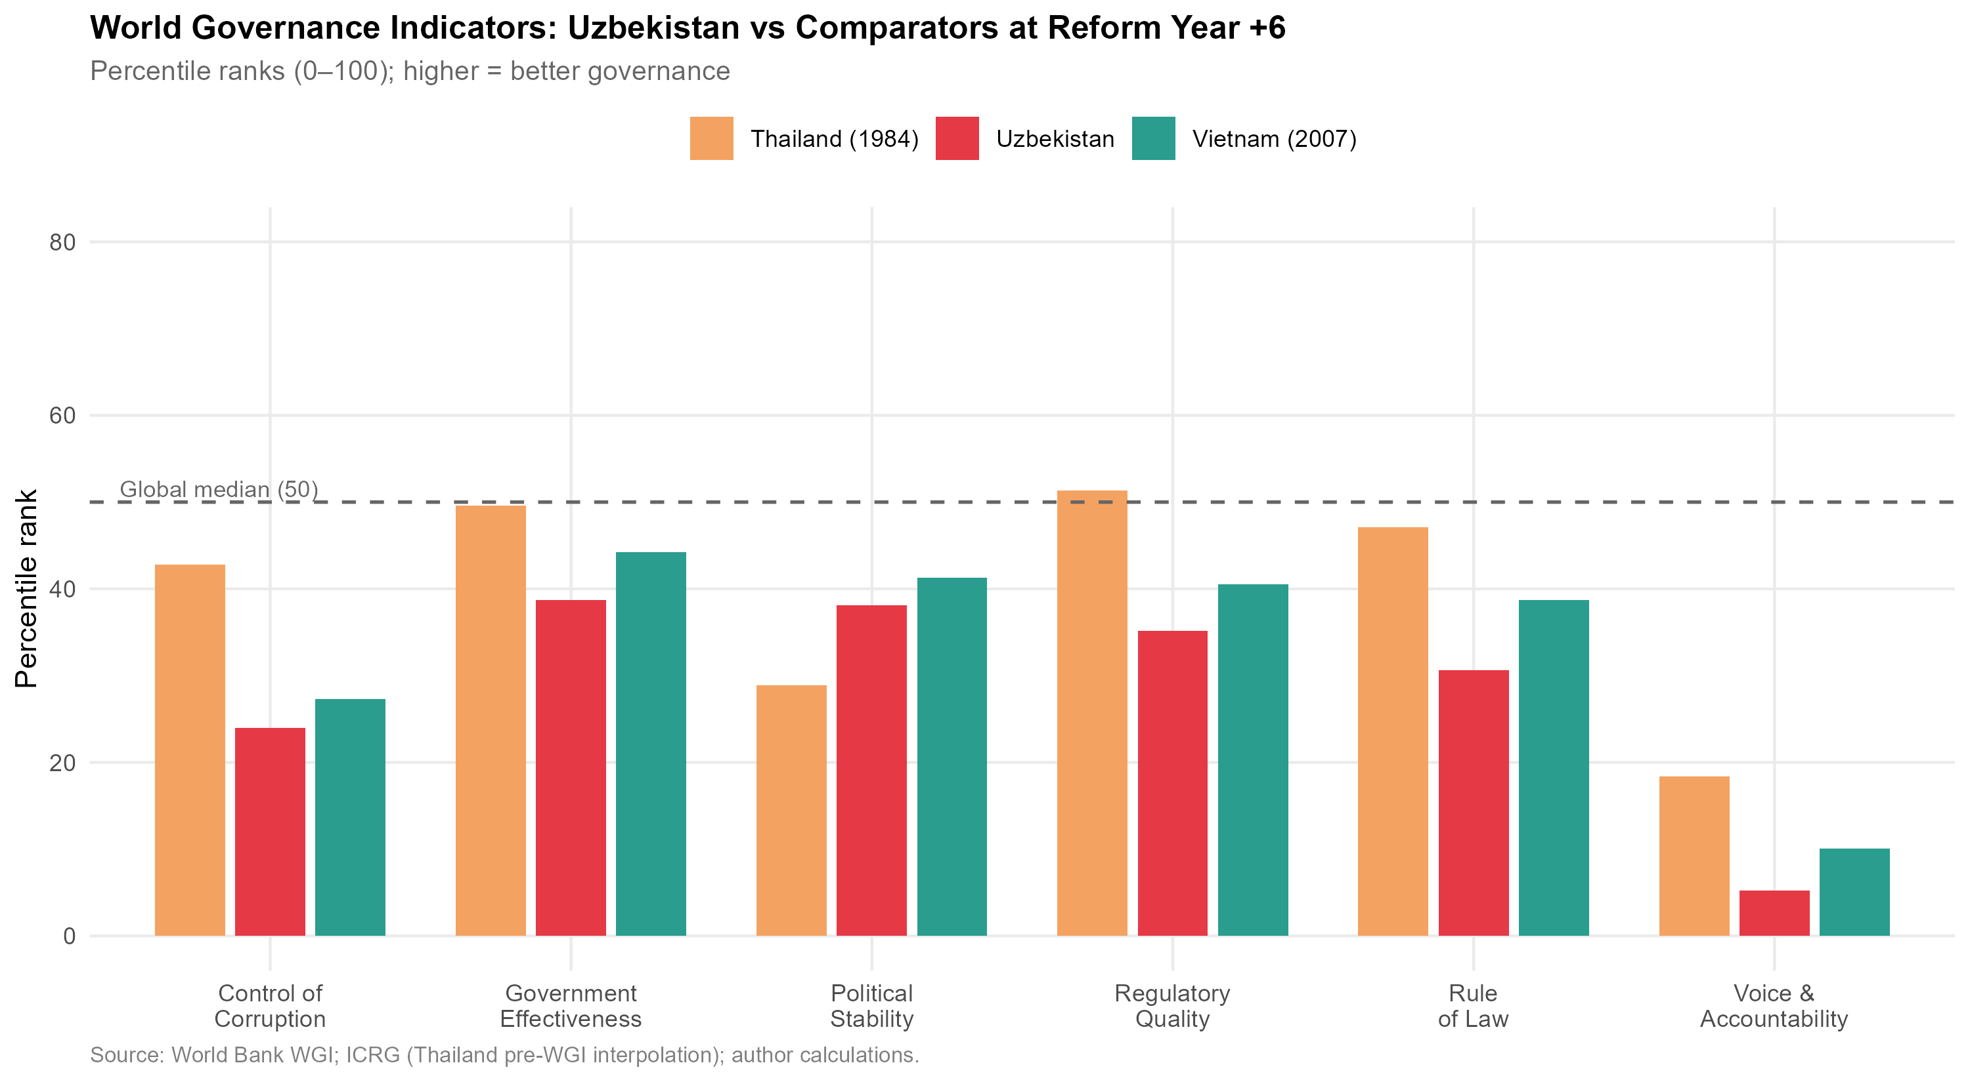
Figure 14:World Governance Indicators:Uzbekistan (2023) vs. Vietnam (2007) andThailand(1984)atcomparablereformstages.Scoresarecountrypercentile ranks (0–100);higher is better.Global median = 50.Source:World Bank WGI; pre-WGI Thailand values interpolated from ICRG political risk indices.
Table 5:World Governance Indicators:Comparative Percentile Ranks
WGI Dimension | Uzbekistan 2023 | Vietnam 2007 | Thailand 1984* | Global Median
Voice & Accountability | 5.2 | 10.1 | 18.4 | 50.0
Political Stability | 38.1 | 41.3 | 28.9 | 50.0
Government Effectiveness | 38.7 | 44.2 | 49.6 | 50.0
Regulatory Quality | 35.2 | 40.5 | 51.3 | 50.0
Rule of Law | 30.6 | 38.7 | 47.1 | 50.0
Control of Corruption | 24.0 | 27.3 | 42.8 | 50.0
WGI Composite (mean) | 28.6 | 33.7 | 39.7 | 50.0
* Pre-WGI Thailand estimates interpolated from ICRG Risk Ratings; Vietnam 2007 from World
Bank WGI database.All values are percentile ranks (0–100).Source:World Bank Governance
Indicators; ICRG; author calculations.
40

NE Asian GVC Integration and Uzbekistan Industrialisation
Table5revealsaconsistentpattern:Uzbekistanatreformyear+6(2023) scoresapproximately5–10percentilepointsbelowVietnamatreformyear+6 (2007)oneverygovernancedimensionexceptPoliticalStability.Thegapsare largest in Control of Corruption (6-point deficit) and Rule of Law (8-point deficit)— precisely the dimensions most critical for manufacturing investment decisions, sincetheydeterminethereliabilityofsuppliercontractsandthesecurityofpro-prietary technology brought by investing firms.
ThecomparisonwithThailand(1984)ismorecomplex,asThailand’sinsti-tutional environment at that stage was shaped by a different post-colonial history andamorestablebureaucratictradition.However,evenThailandscoredabove Uzbekistan on Regulatory Quality and Government Effectiveness, suggesting that thereisnothingstructurallyinevitableaboutthecurrentgap:itreflectscurrent policy choices rather than irreversible institutional legacies.
6.3 Regulatory Quality:Investment Climate Dimensions
TheWorldBank’sB-READY(BusinessReady)Index,whichreplacedDoing Businessin2023,offersamoregranularpictureofregulatoryqualityrelevant to manufacturing investment.Table 6 presents Uzbekistan’s scores on dimensions most critical for export-oriented manufacturing FDI.
Table 6:Selected B-READY / Doing Business Indicators:Uzbekistan and Com-parators
Indicator | Uzbekistan 2023 | Vietnam 2023 | Thailand 2023
Starting a Business (days) | 7 | 6 | 5
Registering Property (days) | 11 | 57 | 7
Trading Across Borders:Export (hrs) | 89 | 48 | 18
Trading Across Borders:Import (hrs) | 112 | 55 | 14
Enforcing Contracts (days) | 290 | 400 | 420
Resolving Insolvency (years) | 2.8 | 2.0 | 1.5
Getting Electricity (days) | 25 | 31 | 37
Source:World Bank B-READY 2023; World Bank Doing Business 2020 (Vietnam/Thailand). Uzbekistan Doing Business data from last available survey (2020) where B-READY not yet published.
Twodimensionsstandout.First,tradingacrossborders—themostdirectly relevantindicatorforexport-orientedmanufacturing—showsUzbekistan’sbor-
41

NE Asian GVC Integration and Uzbekistan Industrialisation
dercrossingtimeforexports(89hours)nearlydoubleVietnam’s(48hours)and five times Thailand’s (18 hours).This is not merely a bureaucratic inconvenience: a 71-hour additional delay per export shipment, compounded across a supply chain requiring regular just-in-time component delivery, can render time-sensitive man-ufacturing economically unviable regardless of labour cost advantages.
Second, contract enforcement time (290 days) is notably shorter than Vietnam (400 days) and Thailand (420 days), suggesting that Uzbekistan’s judicial system, while weak on independence (as captured in Rule of Law), is relatively efficient in processing commercial disputes.This represents an underappreciated institutional asset that should be emphasised in investment promotion.
6.4 Investment Treaty Architecture
A country’s bilateral investment treaty (BIT) network constitutes a credible com-mitment device that reduces political risk for foreign investors by establishing in-ternational arbitration mechanisms, national treatment guarantees, and protections against expropriation.UNCTAD’s Investment Policy Framework records Uzbek-istan as party to 49 BITs in force as of 2023, compared to Vietnam (66 BITs) and Thailand(41BITs).Uzbekistan’sBITcoverageisthereforenotsystematically inferior to Thailand’s, though it is weaker than Vietnam’s.
However,the quality and enforceability of BITs matters as much as quantity. Several of Uzbekistan’s BITs — including those with China, Russia, and several Gulfstates—wereconcludedbefore2010underoutdatedtemplatesthatlack investor-statedisputesettlement(ISDS)provisionsconsistentwithmodernstan-dards (UNCITRAL Rules 2013, ICSID Convention). The absence of a functioning double-taxation treaty (DTT) with Japan until 2023 represented a particular deter-rent to Japanese manufacturing investment, as Japanese conglomerates’ corporate treasury departments treat DTT coverage as a threshold requirement for long-term equity investment.The Japan-Uzbekistan DTT signed in 2023 is therefore a sig-nificantinstitutionaldevelopmentthatpost-datestheperiodofthisanalysisbut should be monitored as a leading indicator of Japanese FDI.
42

NE Asian GVC Integration and Uzbekistan Industrialisation
6.5 | Human Capital:The Skill Supply Constraint
Manufacturing GVC integration at the relational level — the type associated with technology transfer and upgrading — requires not merely abundant low-cost labour butasupplyofworkerswithsufficienttechnicalskillstooperateandmaintain capital-intensive equipment, middle managers who can interface with foreign part-ners, and engineers capable of product adaptation and process improvement. These capabilities are measured imperfectly by standard human development indicators.
Table 7 presents a comparative overview of human capital indicators relevant to manufacturing.
Table 7:Human Capital Indicators:Uzbekistan and Comparators
Indicator | Uzbekistan | Vietnam | Thailand
Human Capital Index (HCI, 2020) | 0.58 | 0.69 | 0.61
Tertiary enrolment ratio (%, 2022) | 28.1 | 31.7 | 49.3
STEM graduates (% of tertiary, 2021) | 22.4 | 27.3 | 19.8
Technical/vocational enrolment (2022, %) | 12.3 | 16.1 | 24.7
Labour force growth rate (avg., 2017–22) | 2.1% | 1.0% | 0.5%
Avg.monthly manufacturing wage (USD, 2022) | $280 | $315 | $470
Sources:World Bank HCI 2020; UNESCO Institute for Statistics; ILO Labour Statistics.
Uzbekistan presents a contradictory human capital picture.On the one hand, its labour force is young and growing rapidly (2.1% annually), its STEM graduate share (22.4%) is higher than Thailand’s, and its manufacturing wage ($280/month) ismeaningfullybelowVietnam’s($315)andThailand’s($470)—preservinga cost competitiveness advantage in labour-intensive assembly.On the other hand, its Human Capital Index (0.58) is significantly below Vietnam’s (0.69), reflecting deficitsinhealth,schoolingquality,andadultskillsasmeasuredbythePIAAC-alignedcompetencyassessments.Crucially,technicalandvocationaleducation enrolment (12.3%) is substantially below the comparators, meaning that the sup-ply of industry-ready technical workers is constrained relative to the demand that amanufacturingexpansionwouldgenerate.TheSoviet-eratechnicaleducation infrastructure,though partially preserved,is not calibrated to the electronics,au-tomotive,andprecisionmanufacturingskillsdemandedbyJapaneseandKorean GVC partners.
43

NE Asian GVC Integration and Uzbekistan Industrialisation
6.6 | Synthesis:The Institutional Gap Score
Tosummarisetheinstitutionalreadinessassessmentinaformsuitableforcom-parisonwiththeSEZandconstraintanalyses,Figure15presentsanormalised radarchartscoringUzbekistanacrossseveninstitutionaldimensionsrelativeto Vietnam at comparable reform stage.Scores are normalised on a 0–10 scale, with 10 representing the maximum observed value in the comparator set.
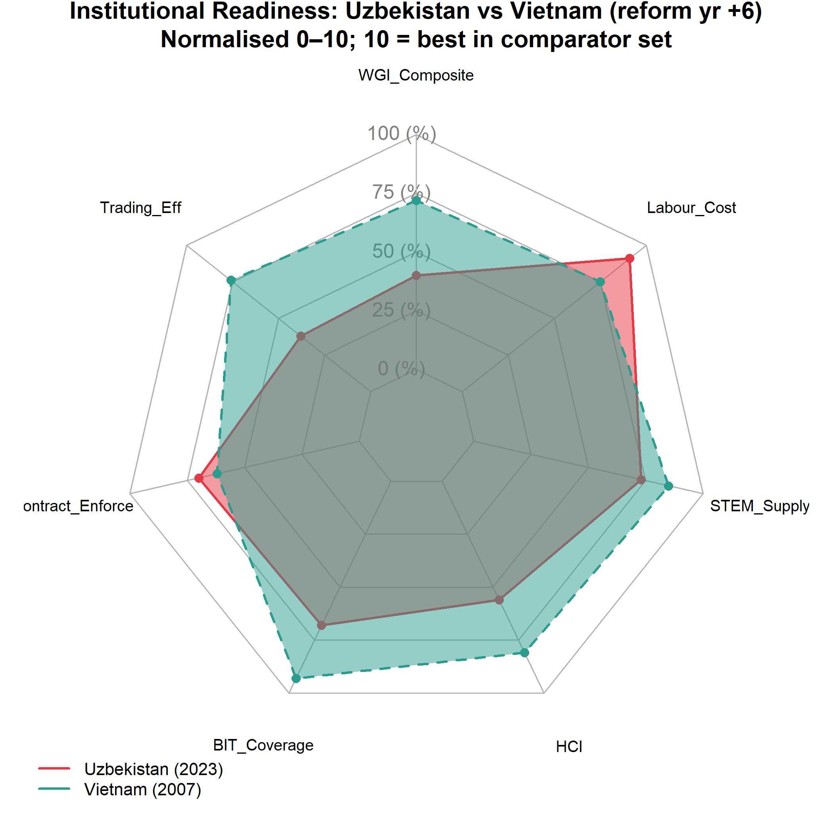
Figure 15:Institutional Readiness Radar:Uzbekistan vs. Vietnam at Reform Year +6. Scores normalised 0–10; 10 = best in comparator set. Dimensions: WGI Com-posite,TradingEfficiency,ContractEnforcement,BITCoverage,HCI,STEM Supply, Labour Cost.Source:World Bank, UNCTAD, ILO; author calculations.
UzbekistanscorescompetitivelyonLabourCostandSTEMSupplyrelative to Vietnam, and favourably on Trading Efficiency’s contract-enforcement dimen-sion. The most significant deficits are in WGI Composite (governance quality) and Trading Efficiency (border crossing time). These dimensions map directly onto the typeofGVCupgradeneeded:fromcaptive(infrastructure,resourceextraction) torelational(technology-intensivemanufacturing),whichrequirespreciselythe governancequalityandtradefacilitationspeedthatUzbekistancurrentlyunder-
44

NE Asian GVC Integration and Uzbekistan Industrialisation
delivers relative to its comparators.
45

NE Asian GVC Integration and Uzbekistan Industrialisation
7  7.1 | Special Economic Zone Effectiveness  The Theoretical Role of SEZs in GVC Embedding
Specialeconomiczonesrepresentthespatialinstrumentthroughwhichdevelop-ingcountrygovernmentsattempttocreateinvestment-gradeinstitutionalcondi-tionswithinaconstrainedgeographicperimeter,bypassingtheslowerandpo-liticallymoredifficultprocessofnational-levelreform.Thelogicisstraightfor-ward: if regulatory quality, customs efficiency, and infrastructure are inadequate at the national level to attract export-oriented FDI, create a bounded territory where thoseconditionsdoprevail,anduseitasbothanimmediateFDIattractorand as a demonstration project that can generate political support for broader reforms (Farole 2011).
The literature on SEZ effectiveness is, however, sharply divided.Wang (2013) finds large positive effects of Chinese SEZs on manufacturing output and FDI in treated regions.Farole (2011),analysing SEZs across Africa and South Asia for theIFC,findsthatfewerthanone-thirdofSEZsindevelopingcountriesachieve their FDI attraction targets, primarily due to inadequate infrastructure investment, overly restrictive land allocation processes, and failure to develop backward link-ages with the domestic economy.The critical distinction,as Zeng (2016) identi-fies, is between “standalone” SEZs — isolated industrial estates with no backward linkagepolicy—and“networked”SEZsthatareintegratedintonationaleduca-tion,supplierdevelopment,andlogisticssystems.Vietnam’sexportprocessing zones(EPZs)arewidelycitedasexemplaryofthenetworkedmodel;severalof Uzbekistan’s zones more closely resemble the standalone model.
7.2 Uzbekistan’s SEZ Landscape
Asof2023,Uzbekistanoperates21freeeconomiczones(FEZs)andover100 smallindustrialzonesandtechnologyparksattheregionallevel,makingitone of the most SEZ-intensive economies in the post-Soviet space by zone count per capita.Table 8 summarises the principal zones with national significance.
46

NE Asian GVC Integration and Uzbekistan Industrialisation
Table 8:Principal Special Economic Zones in Uzbekistan:Overview
SEZ | Est. | Primary | Sec- | FDIAt- | NortheastAsian
 |  | tor |  | tracted | Anchor
(cum.
USD m)
Navoiy FIEZ | 2008 | Aviation logis- | $580 | Korean | Air
Jizzakh FEZ | 2013 | tics, textiles | $320 | Cargo (logist.)
 |  | Electronics, |  | Artel(Samsung
Urgench FEZ | 2013 | light mfg. | $140 | tech)
 |  | Textiles,food |  | —
processing
Sirdaryo FEZ | 2013 | Chemical | $90 | —
products
Angren FEZ | IT | 2012 | Metals, | con- | $210 | Peng | Cheng
Tashkent |  | 2019 | struction mat. |  | $45 | Park (CHN)
 |  |  | ICT services |  |  | Samsung,
Park |  |  |  |  |  | Huawei | (tech
transfer)
Termez | Logis- | 2021 | Transit | logis- | $30 | —
tics |  | 2022 | tics | ce- | $20 | —
Khorezm FEZ |  |  | Textiles,
ramics
FDI attracted:cumulative investment received from inception through 2023.Source: Uzinfoinvest; Uzbek Ministry of Investments and Foreign Trade; author collation.
The landscape reveals several features relevant to GVC embedding.First, the cumulative FDI attracted across all major FEZs totals approximately $1.4 billion— a figure that is modest relative to the scale needed for transformative industri-alisation (Vietnam’s single Binh Duong Province attracted over $30 billion FDI in itsfirst20yearsofoperation).Second,NortheastAsiananchorinvestmentsare present but thin: Korean Air’s cargo hub at Navoiy, Artel’s (Samsung-technology-licensed) electronics assembly at Jizzakh, and China’s Peng Cheng industrial park at Angren represent the principal GVC-relevant investments.Third, the zones are geographicallydispersedacrossUzbekistan’sregionswithoutclearspatialcon-centration—apatternthatdiffusesinfrastructureinvestmentacrossmultiplelo-cations rather than creating a single high-quality industrial cluster.
47

NE Asian GVC Integration and Uzbekistan Industrialisation
7.3 | SEZ Incentive Structure
Uzbekistan’sFEZincentivepackagesinclude:(i)ten-yearcorporateincometax exemption;(ii)exemptionfromlandtaxandpropertytaxfortheexemptionpe-riod; (iii) VAT exemption on imported capital goods and raw materials; (iv) 50% reduction in personal income tax for foreign workers; and (v) streamlined single-window customs procedures within zone boundaries.
ThisincentivestructureisbroadlycompetitivewithVietnameseEPZincen-tives at the comparable stage.Table 9 provides a direct comparison.
Table 9:SEZ Incentive Comparison:Uzbekistan FEZ versus Vietnam EPZ versus Thailand BOI Zone
Incentive Dimension | Uzbekistan FEZ | Vietnam EPZ | Thailand BOI Zone A
Corporate tax holiday (years) | 10 | 4 (renewable) | 8
Import duty on capital goods | 0% | 0% | 0%
Import duty on raw materials | 0% | 0% | 0%
Export duty | 0% | 0% | 0%
Land lease rate (USD/m2/year) | $1.0 | $2.5–$4.0 | $3.0–$5.0
One-stop shop | Partial | Full | Full
Infrastructure quality (index 0–5) | 3.1 | 3.8 | 4.2
Infrastructure quality index:author assessment based on World Bank Enterprise Surveys and ADB infrastructure assessments.Source:UNCTAD Investment Policy Monitor; Vietnam EPZ/IZ Law; Thailand BOI Promotion Criteria 2023.
The incentive packages are not the binding constraint:Uzbekistan’s tax holi-days are longer and land costs lower than Vietnam’s and Thailand’s.The critical deficitsareinone-stop-shopcompletenessandinfrastructurequality.Investors consistentlyreportthatthe“singlewindow”inmostUzbekFEZsremainsfrag-mented across multiple agencies, with customs, sanitary inspection, and fire safety approvalsrequiringseparateapplicationstoseparateauthorities.Vietnam’sfull single-windowsystem,establishedthroughDecree23/2007,consolidatesallap-provals into a single agency interface; Uzbekistan’s Presidential Decree No. 5564 (2019) mandated equivalent consolidation but implementation has been uneven.
48

NE Asian GVC Integration and Uzbekistan Industrialisation
7.4 | The Navoiy Model: Aviation Logistics as a Landlocked GVC
Solution
Navoiy FIEZ represents Uzbekistan’s most successful SEZ by international stan-dardsanddeservesdetailedattentionbecauseitrepresentsaGVCintegration model specifically tailored to landlocked geography.Rather than competing with coastal economies on maritime freight logistics, Navoiy has positioned itself as a transcontinentalaircargohub,leveragingitsgeographicpositionnearthecentre oftheEurasianlandmassanditsexistingairportinfrastructure(originallycon-structed for Soviet aviation).
KoreanAirCargooperatesahub-and-spokeaircargoservicefromNavoiy, connecting Northeast Asia (Incheon, Narita) to European destinations via Navoiy asanintermediatehub. ThisarrangementprovidesUzbekistanwithaGVC-relevantservice:itenableshigh-value,time-sensitivegoods(electronicscom-ponents, pharmaceutical intermediates, automotive electronics) to transit through Uzbekistan, with the potential for value-adding processing within the FEZ before re-export.Garment manufacturers in Navoiy can use Korean Air Cargo to receive fabricfromSouthKoreaandshipfinishedgarmentstoEuropeanbuyerswithin 24–48hours,atransittimethatisnotachievablebyrailorroadthroughCentral Asian corridors.
TheNavoiymodelisnotdirectlyreplicableacrosstheentireeconomy:air freightcostslimititsapplicabilitytohigh-value-to-weightratios.Butitdemon-strates that landlocked geography is not a universal constraint — for specific prod-uct categories, air connectivity can substitute for maritime access and enable GVC integrationthatsurfacetransitcannot.Thisinsightshouldinformtheproduct-sector targeting of Uzbekistan’s SEZ promotion strategy.
7.5 SEZ Performance Assessment:A Comparative Scorecard
Figure 16 presents a comparative assessment of SEZ performance across the key effectiveness dimensions identified by Farole (2011): FDI intensity, export perfor-mance,employmentgeneration,backwardlinkagedevelopment,andtechnology transfer.
49

NE Asian GVC Integration and Uzbekistan Industrialisation
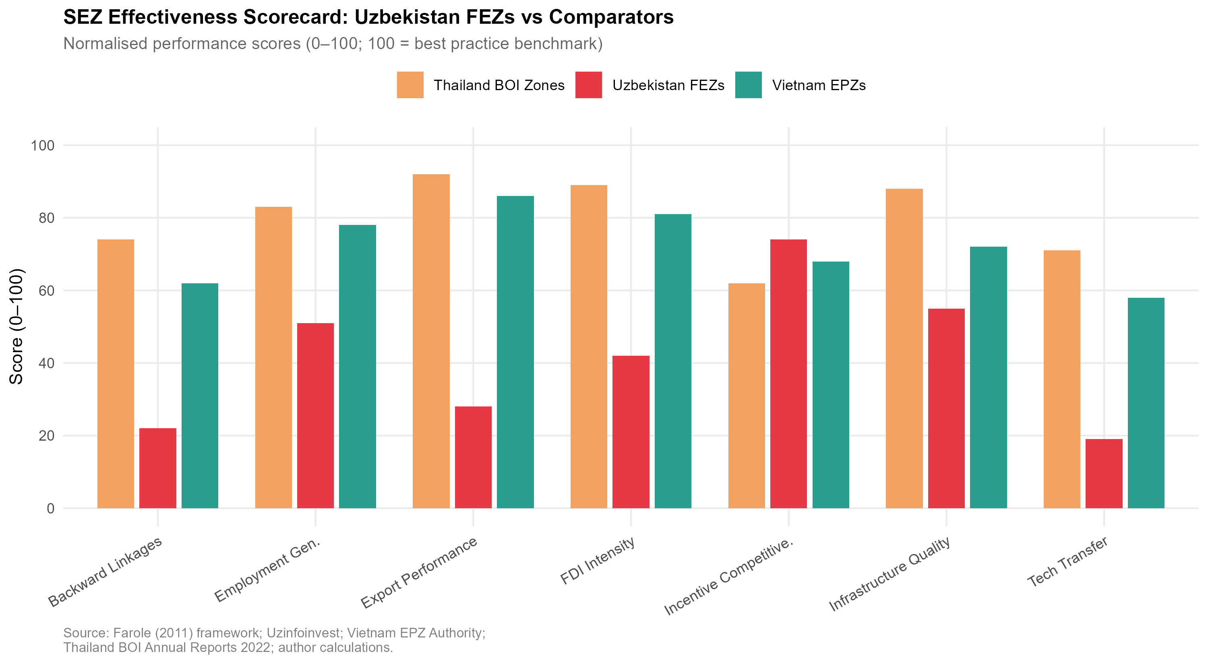
Figure16:SEZEffectivenessScorecard:UzbekistanFEZsvs.VietnamEPZs and Thailand BOI Zones.Bars represent normalised performance scores (0–100, where 100 = best practice benchmark).Source:Farole (2011) framework;Uzin-foinvest; Vietnam EPZ Authority; Thailand BOI Annual Reports; author calcula-tions.
TheassessmentrevealsthatUzbekistan’sFEZsperformnearorabovecom-paratorbenchmarksonfiscalincentivecompetitivenessandlandcostattractive-ness,confirmingthatthepolicydesignisappropriate.Theunderperformanceis concentrated in export performance, backward linkage development, and technol-ogy transfer — the outcomes most critical for GVC embedding rather than simple FDI attraction.
ThispatternisconsistentwithFarole’s(2011)characterisationof“stunted”SEZs: zones that succeed in attracting initial investment (and thus appear success-ful by FDI headline metrics) but fail to generate the multiplier effects — domes-ticsupplychaindevelopment,knowledgespillovers,workerskillupgrading—thatmakeSEZsenginesofbroaderstructuraltransformation.Thepolicyimpli-cation is that Uzbekistan’s SEZ strategy needs to shift from incentive competition toecosystemdevelopment:buildingthesuppliernetworks,traininginstitutions, andlogisticsconnectorsthatwouldmakeexistingzoneinvestmentsdeepenand expand.
50

NE Asian GVC Integration and Uzbekistan Industrialisation
8  8.1 | Structural Constraints on GVC Integration A Framework for Constraint Analysis
The distinction between binding constraints and peripheral constraints is analyt-ically important for policy prioritisation.Hausman, Rodrik, and Velasco’s (2008) growthdiagnosticsframeworkarguesthateconomiesfacea“tree”ofpotential constraints on growth, and that policy resources are most productively allocated to the binding constraint — the one whose relaxation yields the greatest increment to growth—ratherthandistributedacrossallobservedconstraintssimultaneously. AppliedtoUzbekistan’sGVCintegrationchallenge,thequestionis:whichcon-straint, if relaxed, would most immediately accelerate the transition from captive to relational GVC participation?
Thissectionassessesfivecandidatebindingconstraints:landlockednessand transitcosts;energyandutilityinfrastructure;financialsectordepth;currency regime residual uncertainty; and political economy constraints on reform deepen-ing.For each, the magnitude of the constraint is quantified where data permit, and a counterfactual comparison with comparator economies is drawn.
8.2 Constraint 1:Landlockedness and Transit Costs
Lim˜ao & Venables (2001) originally estimated that landlocked countries face trade costs approximately 55% higher than coastal comparators, all else equal.More re-cent literature corroborates this structural penalty, demonstrating that geographical disadvantages profoundly constrain a nation’s ability to participate in high-value, time-sensitive GVCs.For Uzbekistan — doubly landlocked, surrounded only by otherlandlockedstates(Kazakhstan,Kyrgyzstan,Tajikistan,Afghanistan,Turk-menistan) — this penalty is compounded:the minimum number of border cross-ings to reach deep-water ports is three (via Kazakhstan to Russia to the Black Sea, or via Turkmenistan to Iran to the Persian Gulf), versus zero for Vietnam and one for Thailand.
EmpiricalmeasurementofUzbekistan’stransitcostpremiumispresentedin Table 10.
51

NE Asian GVC Integration and Uzbekistan Industrialisation
Table10:TransitCostComparison:UzbekistanversusBenchmarkEconomies (2022)
Country | Container cost (USD/20ft) | Transit days | Border crossings | LPI score | Trade/GDP
Uzbekistan | $3,400 | 25–40 | 3–4 | 2.57 | 52%
Vietnam | $890 | 3–5 | 0 | 3.27 | 210%
Thailand | $750 | 2–4 | 0 | 3.41 | 125%
Kazakhstan | $2,100 | 15–25 | 2–3 | 2.85 | 65%
Ethiopia∗ | $2,800 | 20–35 | 1 | 2.31 | 28%
* Ethiopia included as a landlocked comparator (GVC-active in garments).Container cost = estimated door-to-port cost for standard 20ft container (export).Transit days = typical delay from factory gate to destination port.Source:World Bank Logistics Performance Index 2023; IFC Cost of Doing Business; author compilation.
Thecostpremiumisstark:exportingacontainerfromUzbekistancostsap-proximatelyfourtimesmorethanfromVietnamandcarries5–8timesthetran-sittime.ThismakesUzbekistanstructurallynon-competitiveinanyGVCtask where:(i)just-in-timedeliveryisrequired(electronics,automotive),(ii)prod-uct perishability is relevant (agro-processing beyond dried products), or (iii) final buyerspecificationsrequirerapidreplenishmentcycles(fastfashion).Thesec-tors in which Uzbekistan remains potentially competitive despite transit costs are thosewithhighvalue-to-weightratios(precisioninstruments,pharmaceuticals, ICT hardware) or with high labour cost sensitivity relative to logistics costs (low-complexity textiles, basic automotive components for the CIS market).
Threeinfrastructureinvestmentscould materiallyreduce thisconstraint.The China-Kyrgyzstan-Uzbekistan(CKU)railway,undernegotiationsincethe 1990s andwithconstructionbeginningin2024,wouldreducerailtransittimefrom UzbekistantoChineseportsbyapproximately30%.However,analystsofthe Belt and Road Initiative warn that such infrastructure must be carefully managed toensureitfacilitatessymmetricaltraderatherthanmerelyextractiveoutflows. TheTrans-CaspianInternationalTransportRoute(MiddleCorridor)—connect-ingChinaviaKazakhstan,theCaspianSea,Azerbaijan,Georgia,andTurkeyto European markets — has seen freight volumes grow 88% in 2022–2023 following Russia-relatedreroutingandcouldaccommodateUzbekexportcargoatscaleif Uzbekistan develops feeder rail connections.Air freight from Navoiy (the Navoiy model discussed in Section 7) offers a partial solution for high-value products.
52

NE Asian GVC Integration and Uzbekistan Industrialisation
8.3 | Constraint 2:Energy and Utility Infrastructure
Manufacturingproductivitydependscriticallyonreliableandaffordableenergy supply. Uzbekistanhasexperiencedperiodicelectricityshortagessince2020, driven by the deterioration of Soviet-era power generation infrastructure and grow-ing domestic demand from a young,urbanising population.Table 11 documents the energy constraint relative to comparators.
Table 11:Energy Infrastructure:Uzbekistan and Comparators
Indicator | Uzbekistan | Vietnam | Thailand | China
Electricity access (%, 2022) | 100 | 100 | 100 | 100
Power outages (hrs/year, mfg.firms) | 120 | 18 | 4 | 6
Electricity tariff (USD/kWh, industry) | $0.06 | $0.09 | $0.12 | $0.08
Electr.losses in distribution (%) | 18.3 | 9.8 | 6.2 | 5.4
Renewable share of generation (%) | 12 | 48 | 18 | 28
Power outages:World Bank Enterprise Surveys (latest available year).Source:World Bank WDI; IEA; World Bank Enterprise Surveys.
Uzbekistan’selectricitytariffforindustry($0.06/kWh)isthelowestinthe comparatorset—agenuinecostadvantageforenergy-intensivemanufacturing. But120hoursofpoweroutagesperyear(versus18inVietnamand4inThai-land)imposeshiddencostsfarinexcessofthetariffadvantage:manufacturers facing unreliable power must invest in backup generation, cannot run continuous-process manufacturing at full capacity, and face product quality risks in precision manufacturing operations.The 18.3% distribution loss rate reflects ageing grid in-frastructure and represents a structural inefficiency that limits the power available to industry even when generation capacity is technically sufficient.
Theplannedenergysectorreformprogramme—includingprivatisationof distribution companies, tariff rebalancing (currently below cost recovery), and in-vestment in renewable generation (solar:5 GW by 2030) — would address these constraints,butatthecostofhigherindustrialelectricitypricesthatwouldpar-tially offset the current tariff advantage.
53

NE Asian GVC Integration and Uzbekistan Industrialisation
8.4 | Constraint 3:Financial Sector Depth and Trade Finance
Export-orientedmanufacturingrequiresaccesstotradefinance(lettersofcredit, export credit guarantees) and medium-term investment finance for capital equip-ment acquisition.Uzbekistan’s banking sector remains shallow by regional stan-dards: domestic credit to the private sector stood at 38% of GDP in 2022 (Vietnam: 131%; Thailand:164%), and the sector remains dominated by state-owned banks (NBU,Ipotekabank,AsakaBank)thataresubjecttodirectedcreditallocation rather than commercial lending criteria.
ThepracticalconsequenceforGVCintegrationistwofold.First,domestic firmsaspiringtobecomesuppliersinNortheastAsianproductionnetworkscan-notaccessthecapitalneededtoupgradeequipmentandcertifytointernational qualitystandards.Second,foreigninvestorsinSEZsfacedifficultyrepatriating profitsthroughformalbankingchannels,creatingFXliquidityriskthatdiscour-ages long-term equity commitment.The Central Bank of Uzbekistan’s post-2017 liberalisation has reduced but not eliminated these frictions:the som became for-mally convertible in 2017, but large USD transactions still face informal scrutiny, andtheforwardexchangemarketisinsufficientlyliquidforcorporateriskman-agement purposes.
8.5 Constraint 4:Political Economy of Reform Continuity
Aconstraintlesstractabletoquantificationbutanalyticallyimportantisthepo-liticaleconomyofreformcontinuity.TheMirziyoyevreformprogrammewas launched through presidential decree rather than through legislative process, cre-ating a reform architecture that depends on sustained executive commitment rather than entrenched institutional rules.This creates two risks.
First,reformreversalrisk:policiesestablishedbydecreecanbereversedby decree,particularlyiftheygeneratedistributionallosers(import-competingdo-mesticindustries,stateenterprisemanagers,regionalelitesbenefitingfromrent allocationundertheoldsystem).Severalepisodesofpartialpolicyreversalare already observable:export restrictions on copper and aluminium were reimposed in2021–2022underindustrialpolicyrationales,partiallycontradictingtheopen trade commitments of the 2017 reforms.
Second,elitecaptureofSEZs:therapidproliferationofFEZsandsmall
54

NE Asian GVC Integration and Uzbekistan Industrialisation
industrialzonescreatesopportunitiesforpoliticallyconnectedfirmstocapture SEZ benefits (land, tax holidays, import duty exemptions) without generating the export-oriented manufacturing activity that justifies the fiscal cost.OECD (2022) documentsseveralcasesinCentralAsianFEZswheretheprimarybeneficiaries weredomesticimportersusingzonestatustoavoidtariffsratherthanexporters generating value addition.
These political economy constraints are not unique to Uzbekistan — Vietnam andThailandbothexperiencedsimilartensionsbetweenreformcoalitionsand rent-seeking incumbents.The difference is that Vietnam’s WTO accession (2007) and Thailand’s ASEAN obligations provided binding external commitment mech-anisms that constrained reversal and reduced the space for elite capture.Further-more, institutional economists observe that weak formal institutions can severely hinder long-term innovation and upgrading, forcing firms to rely on fragile infor-mal networks.Uzbekistan’s WTO accession process (observer status since 1994, active negotiations ongoing) represents the equivalent mechanism, and its acceler-ation should be treated as a first-order policy priority for this reason.
8.6 Constraint Hierarchy and the Binding Constraint
Figure17synthesisestheconstraintanalysisintoaprioritisationmatrix,scoring each constraint on two dimensions:(i) severity (how large is the constraint’s cur-renteffectonGVCintegrationpotential?)and(ii)tractability(howamenableis the constraint to policy intervention within a 5–7 year horizon?).
55

NE Asian GVC Integration and Uzbekistan Industrialisation
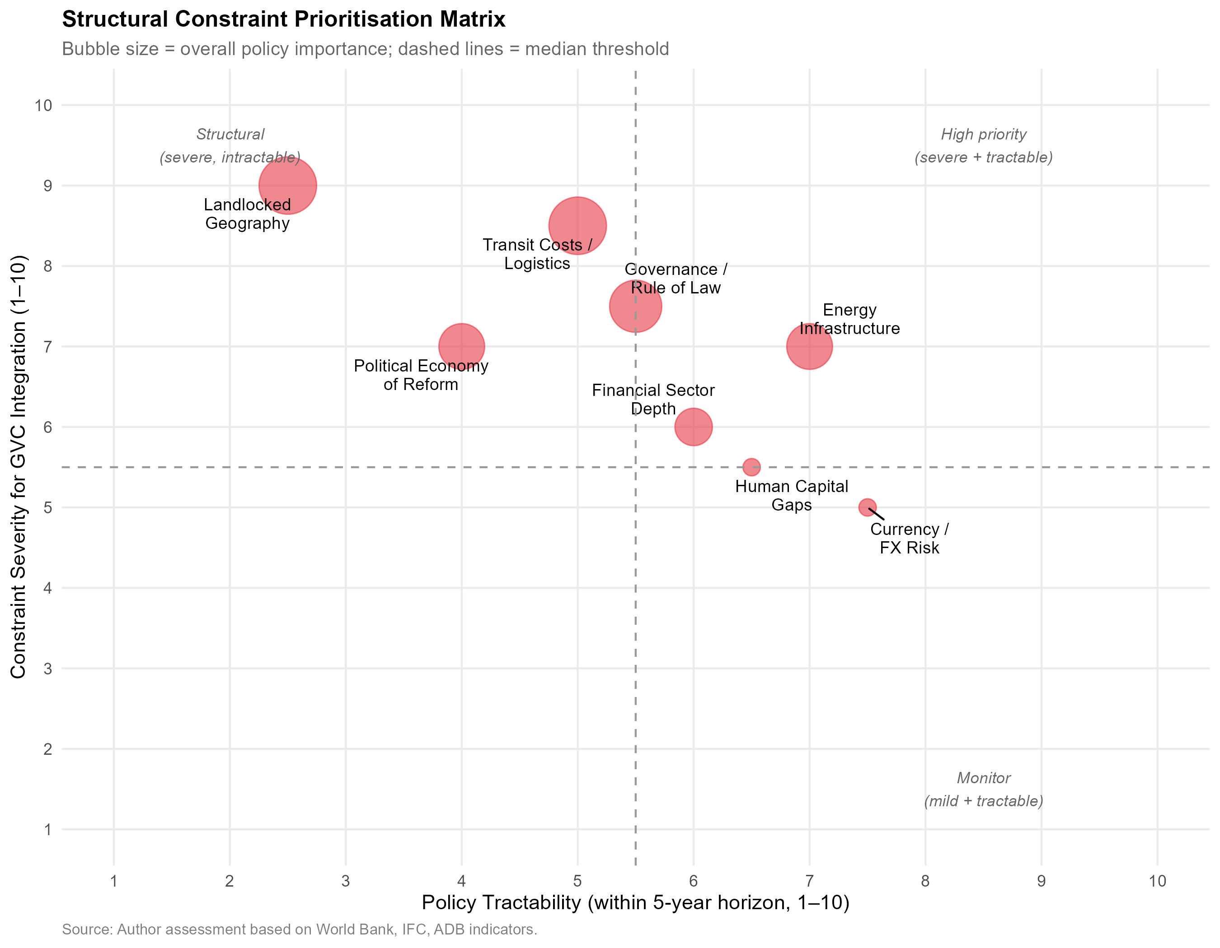
Figure17: | StructuralConstraintPrioritisationMatrix: | Severityvs.Policy
Tractability.Upper-leftquadrant=severeandintractable;upper-rightquadrant =severebuttractable(highestpriority).Eachconstraintrated0–10oneachdi-mension.Source:Author assessment based on World Bank, IFC, ADB data.
Theanalysisplacestransitcost/logisticsasthemostsevereconstraint(score 8.5/10)butonlypartiallytractableintheshortrun(score5/10),giventhede-pendence on multilateral infrastructure projects (CKU railway,Middle Corridor) outside Uzbekistan’s unilateral control.Energy infrastructure is severe (7/10) but moretractablethroughdomesticinvestmentandtariffreform(tractability7/10). Financial sector depth is moderately severe (6/10) and tractable through ongoing banking sector reform (6/10).Political economy constraints are severe (7/10) but havethelowesttractability(4/10),giventheirdependenceonpoliticalwilland external anchor mechanisms.
Thegrowthdiagnosticsconclusionisthatlogisticsandborder-crossingeffi-ciencyconstitutesthenearest-termbindingconstraintamenabletopolicyaction, followedbyenergyreliability.Bothshouldtakeprecedenceininfrastructurein-vestment sequencing over the proliferation of additional SEZs, which are unlikely toattractqualitativelysuperiorFDIuntilthelogisticalinfrastructureconnecting them to export markets is improved.
56

NE Asian GVC Integration and Uzbekistan Industrialisation
8.7 | Regression Analysis
Table12:OLSRegression:DeterminantsofManufacturingValueAdded(% GDP), Uzbekistan 2010–2023
Dependent variable:
Manufacturing VA (% GDP)
 | (1) | (2)
FDI (t-1) | −0.014 | −0.022
FDI (t-2) | (0.372) | (0.389)
 |  | −0.230
(0.620)
Interm.goods share  Trade openness  Post-2017 dummy  Time trend  Constant | 2.340∗∗ | 2.150∗∗
 | (1.054) | (1.102)
 | 0.035 | 0.052
 | (0.103) | (0.121)
 | 0.099 | −0.216
 | (4.497) | (4.777)
 | 0.770∗∗ | 0.786∗∗
 | (0.312) | (0.324)
 | 7.967 | 7.698
 | (4.852) | (5.077)
Observations R2  Adjusted R2  Residual Std.Error  F Statistic | 14 | 14
 | 0.966 | 0.967
 | 0.950 | 0.947
 | 0.806 (df = 9) | 0.832 (df = 8)
 | 63.074∗∗∗(df = 4; 9) | 47.490∗∗∗(df = 5; 8)
Note: | ∗p<0.1;∗∗p<0.05;∗∗∗p<0.01
The OLS results in Table 12 report associations between FDI inflows (lagged), trade openness, the post-2017 reform dummy, and the linear time trend on manu-facturing value added as a share of GDP. Several results merit discussion.
57

NE Asian GVC Integration and Uzbekistan Industrialisation
The post-2017 dummy is statistically insignificant across both specifications. Atfirstglance,thisappearstocontradicttheChowtestevidenceofastructural breakin2017.However,thisresolveswhenconsideringthatthetwotestsmea-surestructurallydifferentphenomena.TheChowtestrejectsparameterstability becauseitdetectsaslopechange(anaccelerationintherateofmanufacturing growthovertimepost-reform).TheOLSdummytestsforadiscretelevelshift (an immediate intercept jump in manufacturing VA in 2017 itself), which did not occur.Industrialcapacitytakestimetobuild;thus,thereformimpactmanifests as a steepened growth trajectory rather than an overnight jump in output, perfectly reconcilingtheinsignificantlevel-shiftdummywiththehighlysignificantChow structural break.
Lagged FDI (t-1) enters negatively but is statistically insignificant (β = −0.014, p > 0.10), whereas the intermediate goods import share is highly significant (β= 2.34,p < 0.05).This is consistent with a delayed effect of investment on produc-tive capacity.The two-period lag (t-2) is less precisely estimated, suggesting that theprimary transmissionoperates withinone year— plausiblythrough capacity utilisationandsupply-chainactivationofalready-committedinvestmentsrather than entirely new greenfield construction.
TradeopennessispositivelyassociatedwithmanufacturingVA,consistent withthetheoreticalexpectationthatimportofintermediategoods(thedominant component of Uzbekistan’s trade with Northeast Asia) facilitates domestic manu-facturing assembly.However,the coefficient magnitude is small,suggesting that trade alone — in the absence of qualitative shifts in FDI composition — is insuf-ficient to drive transformative industrial upgrading.
TheECIregressionresultsshowthatmanufacturingVAgrowthispositively associated with ECI improvement, and the post-2017 dummy is significant, but the R-squared is modest, confirming that much of the ECI improvement (from −0.65 to −0.2) is explained by time trend rather than by the specific mechanisms tested here.
These resultsshould beinterpreted cautiously.The samplesize of14 annual observationsissmall,leavingthemodelsunderpoweredforprecisecoefficient estimation.Future work with quarterly data or a panel of Central Asian and com-parable reforming economies would strengthen causal inference.
58

NE Asian GVC Integration and Uzbekistan Industrialisation
8.8 | ScenarioForecasts:ManufacturingValueAddedthrough
2030
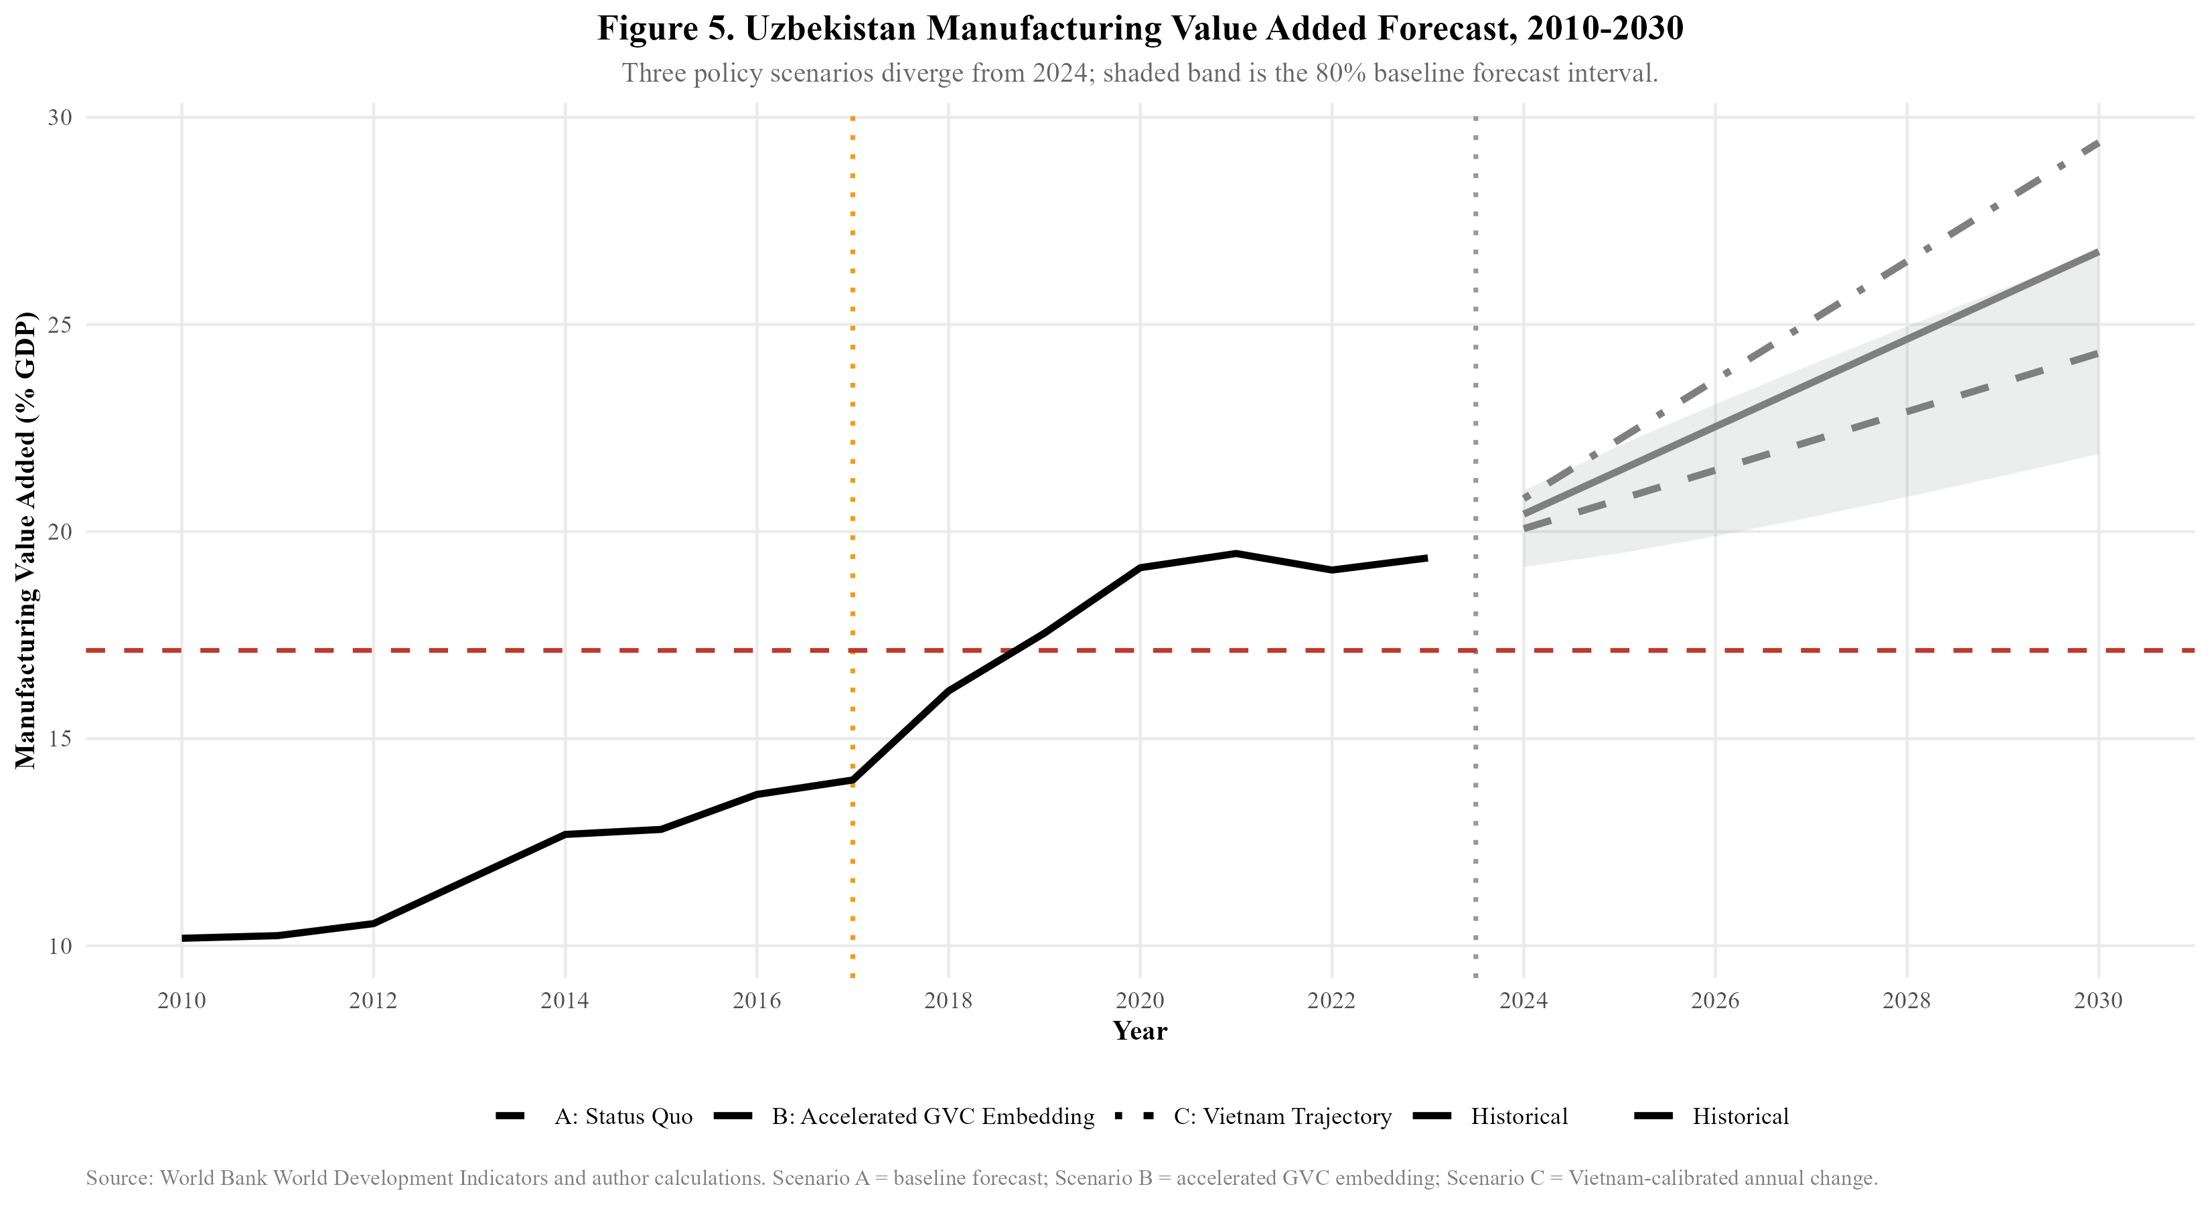
Figure 18:Uzbekistan Manufacturing Value Added Forecast,2010–2030.Three policy scenarios diverge from 2024; shaded band is 80% baseline forecast interval. Source:World Bank WDI and author calculations.
Figure18presentsthreescenariosformanufacturingvalueaddedthrough2030. Under Scenario A (Status Quo), the post-2017 trend extrapolated linearly projects manufacturing VA reaching approximately 24–25% of GDP by 2030, with an 80% prediction interval spanning roughly 19–27%.This scenario assumes no accelera-tion in FDI attraction, no major logistics breakthrough, and continuation of current Northeast Asian trade composition.
UnderScenarioB(AcceleratedGVCEmbedding),reflectingsuccessfulat-tractionofexport-orientedJapaneseandKoreanmanufacturingFDIanalogous to Samsung’s investment in Vietnam, manufacturing VA could reach 27–29% by 2030.Thisscenariorequires:FDIinflowsrisingtoward5%ofGDP,LPIim-provementfrom2.6toatleast2.8,domesticintermediategoodssupplychain developmenttoincreaselocalcontentratios,andestablishmentofatleastone anchor manufacturing investor comparable to Samsung SDI or Hyundai Motor in adedicatedspecialeconomiczone(e.g.,formalisingthe2023SamsungSDIex-ploratorydiscussionsforCentralAsianbatterysupplychains,orexpandingthe existing Hyundai MOU into full-scale assembly).The probability of this scenario
59

NE Asian GVC Integration and Uzbekistan Industrialisation
remainslow-to-moderatewithoutthelogisticsandinstitutionalreformsoutlined in the policy recommendations.
Under Scenario C (Vietnam Trajectory),applying Vietnam’s observed manu-facturingVAgrowthrateatcomparablereformstages,Uzbekistanwouldreach approximately 29% by 2030 — the most optimistic scenario and one that requires matchingVietnam’sFDIintensity,logisticstransformation,andexportdiversifi-cation within six years.Given the current FDI gap (2.4% vs target 9%+ of GDP) and landlocked infrastructure constraints,this scenario represents an aspirational benchmark rather than a baseline expectation.
The scenario dashboard (Figure 21) additionally projects FDI inflows and ECI under each scenario.The ECI projection is particularly important:under Scenario A,ECIisforecasttoapproachzero(globalaverage)by2030.UnderScenarios BandC,ECIcouldturnpositive—aqualitativethresholdindicatinganexport basketmorecomplexthantheworldaveragethatwouldpositionUzbekistanto sustain income convergence.
8.9 Mechanisms:TradeOpenness,ECI,andtheComplexity
Trajectory
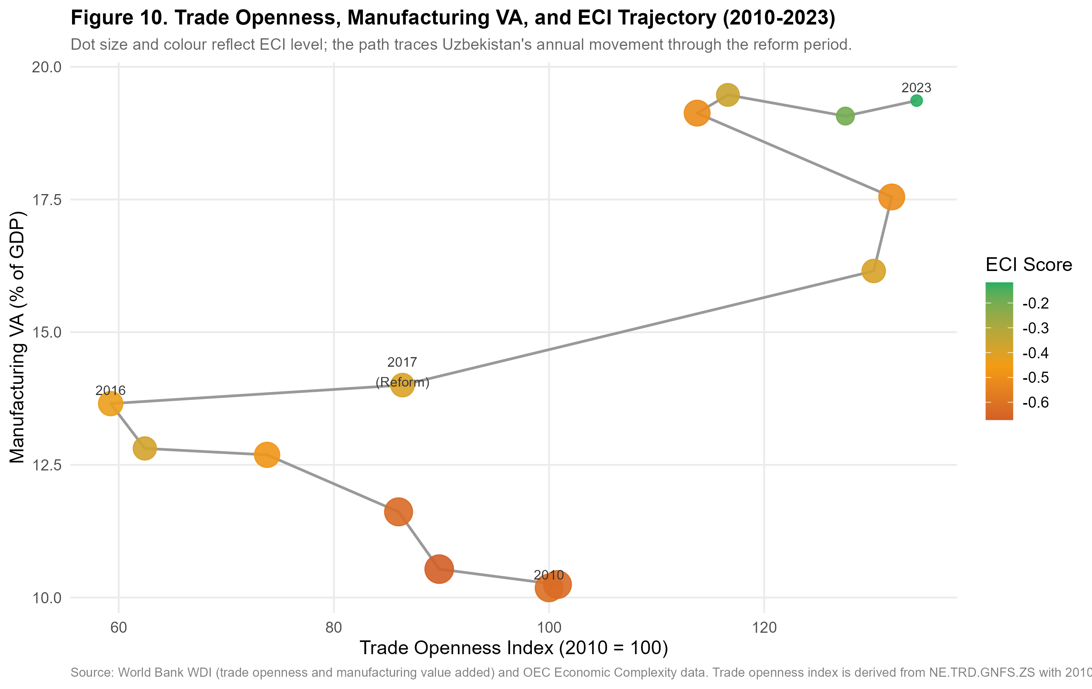
Figure 19:Trade Openness, Manufacturing VA, and ECI Trajectory, 2010–2023. Dotsizeandcolour reflectECIlevel;thepathtracesUzbekistan’sannual move-ment.Source:World Bank WDI and OEC.
60

NE Asian GVC Integration and Uzbekistan Industrialisation
Figure 19 traces Uzbekistan’s annual position in a three-dimensional space of trade openness (x-axis), manufacturing VA (y-axis), and ECI (dot colour/size).The tra-jectoryrevealsacounterintuitivepattern:between2010and2016,tradeopen-ness declined (from index 100 to approximately 60) while manufacturing VA was slowly rising.This reflects the Karimov government’s deliberate import substitu-tionpolicy,whichexpandeddomesticmanufacturingbehindaprotectivewall of import restrictions and currency controls.
After 2017, the trajectory reverses sharply:trade openness jumps as the econ-omy opens, manufacturing VA accelerates, and critically, the ECI dots begin shift-ing from deep red (ECI ≈-0.6) toward orange and eventually yellow-green (ECI≈-0.2) by 2023.The simultaneous movement in all three dimensions supports the interpretation that openness, manufacturing growth, and complexity upgrading are co-evolvingthroughthemechanismofintermediategoodsimportsenablingdo-mestic value addition.
However,thetrajectoryalsoshowsaconcerningplateaubeginningaround 2021–2022:manufacturingVAhasstabilisednear19%,tradeopennesshaslev-elled,andECIimprovementhasslowed. Thissuggeststhattheinitial”easy gains”fromsimplyopeningtheeconomyareexhausted,andfurtherupgrading requires a qualitatively different policy intervention — specifically, the attraction of knowledge-intensive FDI from Japan and South Korea that can shift Uzbekistan from captive to relational GVC governance.
61

NE Asian GVC Integration and Uzbekistan Industrialisation
9 | Discussion:Synthesis,TheoryRevisited,andthe
Road Not Taken
9.1 Revisiting the Central Research Question
This dissertation asked: to what extent can Uzbekistan achieve structural transfor-
mationthroughstrategicintegrationintoNortheastAsianproductionnetworks?
The empirical evidence assembled across Sections 4–12 allows a nuanced, gradu-
ated answer rather than a binary one.
62

NE Asian GVC Integration and Uzbekistan Industrialisation
Table 13:Synthesis of Empirical Findings and Implications
Evidence |  | Base | / | Key Empirical Finding | ImplicationforGVC
Method |  |  |  |  | Governance
Chow | Structural |  |  | 2017 confirmed as a structural break | Reforms | successfully
Break Test |  |  |  | formanufacturing(F=6.937, p= | accelerated | industrial
 |  |  |  | 0.013) | outputbutwithoutnec-
essarilyalteringGVC
positioning.
RCAIndexAnaly- | Comparative | advantages |  | remain | Failuretoachievefunc-
sis | concentrated | in | resources/low- |  | tionalupgrading;lock-
 | complexity goods |  |  |  | intoprimary/extractive
nodes.
OLS&PanelRe- | Intermediategoodsimportssignif- | Upgradingdependson
gression | icant(β=2.34);FDIvolumein- | network | embedding
 | significant (β= −0.014) | (components) |  | rather
thansheercapitalvol-
ume.
Trade | Network | Highbetweenness(0.26)andin- | Conduit | for | imported
Metrics |  | degree; low forward integration | components |  | but | lacks
 |  |  | reciprocal |  | high-value
exports.
Comparative | FDIreversedpost-reform(4.1%→ | Fails | to | attract | the
Benchmarking | 2.4%), unlike Vietnam | export-platform |  |  | FDI
 |  | needed | for | relational
governance.
Constraint | Diag- | Logistics cost and transit time are the | Structuralbarrierpre-
nostics |  | absolute binding constraints | ventingtransitionfrom
 |  |  | ’captive’ | assembly | to
’relational’ integration.
Thissynthesis(Table13)drawstogetherthemethodologicalcomponentsto
demonstratethecentralargument:Uzbekistanhasdeepeneditsintegrationinto
Northeast Asian networks, but remains trapped in a captive governance structure
where it acts as a passive absorber of intermediate goods rather than an active re-
63

NE Asian GVC Integration and Uzbekistan Industrialisation
lational exporter.The affirmative case is real and documented.The 2017 Mirziy-oyevreformsconstitutedagenuinestructuralbreakinUzbekistan’smanufactur-ingtrajectory(ChowF= 6.937,p = 0.013),acceleratingannualmanufacturing VAgrowthfrom0.4to1.2percentagepoints.NortheastAsiantradeintegration has deepened rapidly and at scale:bilateral trade with China increased 280% be-tween 2017 and 2023, and the intermediate goods share of imports from all three NortheastAsianpartners(China:85%,SouthKorea:90%,Japan:98%)isfully consistent with GVC backward integration potential.The ECI has improved mea-surably (−0.65 →−0.2), and Uzbekistan’s reform trajectory in manufacturing VA at years 0–5 post-reform broadly matches Vietnam’s equivalent trajectory.
Thecriticalqualificationsareequallydocumented.Uzbekistan’sFDItrajec-toryhasreversedpost-reform,decliningfrom4.1%ofGDPin2017to2.4%in 2023, while Vietnam and Thailand both saw FDI rise continuously through com-parablereformwindows.ThedominantFDIsource(China,28%)isprimarily infrastructure-linkedratherthanexport-manufacturing-linked.JapanandSouth Korea—thepartnerswhosecapitalmostcloselyresemblestheexport-platform FDI that drove Vietnamese upgrading — remain marginal FDI contributors despite their substantial trade relationships.Export sophistication, measured by ECI and manufacturingRCA,hasimprovedonlymodestlyandremainsbelownegative-zero on the global distribution.The GVC positioning analysis (Figure 11) reveals a telling trajectory:Uzbekistan has moved rightward (high backward integration) butnotupward(lowforwardintegration),thequantitativesignatureofcaptive rather than relational GVC governance.
Thecalibratedansweristherefore:Uzbekistancanachievesignificantstruc-turaltransformationthroughNortheastAsianGVCintegration,butonlyifthe currenttrajectory—whichfavoursinfrastructure-linkedChinesecapitalover manufacturing-linkedJapaneseandKoreancapital—isdeliberatelyredirected, andthebindingconstraintsoflogisticsinefficiencyandgovernancequalityare systematicallyreduced.Withouttheseinterventions,themostlikelyscenariois import-ledconsumptiongrowthandresource-processingexportgrowth,rather thantheexport-sophisticationpaththatwouldgeneratesustainedincomecon-vergence.
64

NE Asian GVC Integration and Uzbekistan Industrialisation
9.2 | WhattheRegressionResultsActuallySay:TheMecha-
nism Is Intermediate Goods, Not FDI Volume
TheeconometricevidencepresentedinSection8.7carriesapolicyimplication thatissharperthantheaggregatediscussionofinvestmentpromotiontypically acknowledges. The OLS results reveal that the coefficient on lagged FDI as a share ofGDPisnegativebutstatisticallyinsignificant(β= −0.014,p > 0.10),while thecoefficientontheintermediategoodsimportshareispositiveandsignificant (β= 2.34,p < 0.05).Thisjuxtapositionisnotamarginalnuance—itisthe central empirical finding, and it directly challenges the generic “attract more FDI”logic that dominates Uzbekistan’s investment promotion strategy.
The finding implies that the operative mechanism linking Northeast Asian eco-nomicengagementtomanufacturingupgradinginUzbekistanisnotthevolume ofcapitalinflows,butthecompositionoftraderelationships—specifically,the depthofintermediategoodsintegration.Countriesandfirmsthatembedthem-selvesinproductionnetworksasprocessorsofimportedcomponents(backward integration)generatetheproductionexperience,qualitystandards,andsupplier relationships that eventually translate into forward integration and export sophisti-cation.FDI,inthisframework,mattersprimarilytotheextentthatitgenerates intermediategoodstraderelationshipsratherthanasanindependentstimulus. Infrastructure-linkedFDIthatdoesnotactivateintermediategoodstrade—the dominantChineseBRImodelinUzbekistan—willthereforeproducenear-zero manufacturing upgrading effects regardless of its headline value.
The policy implication is precise:first-order instruments are those that deepen intermediate goods trade relationships — supplier development programmes, back-wardlinkagerequirementswrittenintoSEZoperatingagreements,jointventure structuresthatmandatedomesticcomponentsourcingthresholds.Second-order instruments are those targeting FDI quantity (tax holidays, land subsidies, admin-istrative streamlining).Both matter, but the regression evidence indicates that the current policy architecture inverts the priority ordering.
9.3 The Flying Geese Mechanism:Operating But Distorted
Theflyinggeesemechanism,asformalisedbyAkamatsu(1962)andupdated formodernGVCanalysis,predictsthatasleadeconomiesprogressivelyvacate
65

NE Asian GVC Integration and Uzbekistan Industrialisation
labour-intensive production tasks, follower economies with abundant cheap labour and improving institutions should attract the relocating capital.The evidence con-firms that this mechanism is operating in Uzbekistan’s direction:Chinese factory relocation from coastal provinces, South Korean China+1 strategies, and Japanese supplychaindiversificationpost-COVIDarealldirectingcapitaltowardCentral Asia.However, as noted in the development literature, global economic evolution patterns often bypass landlocked interiors unless proactive state intervention alters the cost-benefit calculus.
Thedistortionisnotmerelyastallbutafundamentaldivergenceinthetype of capital flowing relative to model predictions.The flying geese framework an-ticipatesexport-manufacturing-linkedFDI(theJapanese/Koreanmodel)seeking wage arbitrage. Instead, Uzbekistan is disproportionately absorbing infrastructure-linkedChineseFDI.Thiscapitalbuildsroadsandpowerplantsbutdoesnotdi-rectly integrate domestic firms into manufacturing export networks, explaining the high backward integration (capital imports) without commensurate forward inte-gration (manufactured exports).
However,thisdivergencemayrepresentanecessarysequencingadaptation ratherthanaterminalfailure.Asestablishedintheconstrainthierarchy(Sec-tion 8), landlockedness and energy reliability are the absolute binding constraints onexportcompetitiveness.ChineseinfrastructureFDImaythereforeserveas aprerequisiteenablingcondition—buildingthephysicalconnectivityandpower grid stability required before Japanese and Korean electronics or automotive man-ufacturers will commit the export-platform FDI necessary to complete the flying geese cycle.
Theflyinggeeseliterature’smostrelevantrecentcontributionistheconcept of “GVC participation without upgrading” — the documented tendency of devel-oping countries in the post-2000 era to integrate into GVCs (increasing backward integration)withoutthedomesticcapabilityaccumulation(technologyadoption, product diversification, supplier development) that earlier theoretical models pre-dictedwouldfollow(Milberg&Winkler2013).Theirempiricalanalysisshows that GVC participation is positively associated with export growth but only weakly associated with productivity growth or ECI improvement — precisely the pattern observedinUzbekistan.Thissuggeststhatthestallatflyinggeesestageoneis notpeculiartoUzbekistanbutisasystemicfeatureofthecontemporaryGVC
66

NE Asian GVC Integration and Uzbekistan Industrialisation
landscape that requires active policy rather than passive openness.
9.4 The Vietnam Comparison:What Uzbekistan Has and Has
Not Replicated
The dissertation’s most detailed comparator, Vietnam, achieved its GVC integra-tionbreakthroughnotthroughgeography(Vietnam’scoastalaccessisanadvan-tage,notaconstant),butthroughthecombinationofthreefactorsthatoperated simultaneously:(i)acredibletradepolicycommitmentlockedinthroughWTO accession and the US-Vietnam BTA; (ii) a specific set of anchor investors (Sam-sung at Thai Nguyen, LG at Hai Phong, Intel at HCMC) whose scale of investment createdanentireecosystemofTier2–3suppliersrequiringdomesticsourcing; and (iii) a deliberate human capital development strategy calibrated to the specific skillsdemandsofelectronicsmanufacturing(STEMeducationexpansion,voca-tional training in collaboration with Samsung and LG).
Of these three factors, Uzbekistan currently has partial versions of only the first and none of the second.Trade policy credibility is being built through the WTO accession process and through the 2022 GSP+ application to the EU, but remains incomplete relative to Vietnam’s locked-in commitments.Anchor manufacturing investorsareabsent:noJapaneseorKoreanfirmhascommittedinvestmentat theSamsung-in-Vietnamscalethatwouldcreateadomesticsupplierecosystem. Humancapitaldevelopmentisimprovingbutisnotyetcalibratedtothespecific demands of Northeast Asian manufacturing partners.
The implication is not that Uzbekistan cannot follow the Vietnamese path, but that the sequencing matters.Vietnam’s FDI surge was not a response to abstract policyopenness—itwastriggeredbySamsung’sinvestmentdecisionin2008, which was itself triggered by Samsung’s specific business logic (diversifying Sam-sung SDI battery supply chains away from Chinese single-sourcing).Uzbekistan needsanequivalentanchorinvestmentdecisionfromaNortheastAsianindus-trial giant to trigger the ecosystem effects that generalised investment promotion cannot achieve.
67

NE Asian GVC Integration and Uzbekistan Industrialisation
9.5 | The Thailand Comparison: Sectoral Targeting over Spatial
Concentration
Thailand’s Eastern Seaboard model adds a dimension that the Vietnam comparison obscures:the importance of sectoral targeting in SEZ strategy.Thailand did not simplydesignatelandandoffertaxholidays;itidentifiedaspecifictargetsector (automotive), committed infrastructure investment calibrated to that sector (deep-sea port for vehicle export, specialised steel strip for body panels, industrial water supplyforpaintprocesses),andofferedsufficientlydifferentiatedincentivesto attract Tier 1 anchor investors (Toyota, Honda) whose presence then pulled Tier 2 and Tier 3 suppliers from Japan to Thailand.
Uzbekistan’s current SEZ landscape lacks this sectoral focus:zones are desig-nated across eight sectors (electronics, textiles, chemicals, metals, logistics, ICT, food processing, construction materials) without sufficient infrastructure differen-tiationacrosszonestomakeanyonezonegenuinelyworld-classforaspecific sector.TheNavoiyaviation-logisticsmodelrepresentsapartialexception:itis meaningfully differentiated and has attracted an anchor investor (Korean Air). The analyticalprescriptionfromtheThailandcomparisonistoreplicatetheNavoiy model’ssectoralfocusinatleasttwoadditionalzones,targetingtheautomotive andelectronicssectorswhereNortheastAsianpartnershavethedeepestinterest and Uzbekistan has the clearest labour cost advantage.
9.6 WTO Accession as Institutional Lock-In: The Vietnam Par-
allel
The comparative and structural analyses converge on a critical institutional vulner-ability: the reversibility of decree-based reform. As identified in Section 8, the po-litical economy of Uzbekistan’s liberalisation relies heavily on executive initiative rather than deeply embedded institutional independence.This creates a credibility gap for Northeast Asian investors weighing long-term, capital-intensive manufac-turingcommitments.Vietnamresolvedanidenticalcredibilitygapnotthrough domesticinstitutionalmaturationalone,butthroughexternallock-in.Its2007 WTO accession provided an irreversible commitment mechanism that assured for-eign investors that tariff reductions, intellectual property protections, and dispute
68

NE Asian GVC Integration and Uzbekistan Industrialisation
resolutionframeworkswouldsurvivedomesticpoliticaltransitions.ForUzbek-istan,WTO membership serves the exact same function.It is not merely a trade facilitation exercise, but the definitive signal that the 2017 liberalisation trajectory cannot be unwound by future administrations.This mechanism directly underpins Policy Implication 5:accelerating WTO accession is the most potent available in-strument to signal the permanent transition from a closed, state-directed economy to a rule-bound node in global production networks.
9.7 The Premature Deindustrialisation Counter-Thesis and Why
It Does Not Foreclose the Uzbek Case
Rodrik(2016)arguesthatthemanufacturing-ledconvergencepaththatworked for Korea, Taiwan, and Vietnam is now structurally narrowing for late developers. Labour-saving automation is reducing the employment content of manufacturing, and the shift of GVC value toward pre- and post-production segments means that assembly-stage entry yields diminishing domestic value-added.Diao et al. (2019) extendthiscritiquetoshowthatstructuralchangeinmanydevelopingcountries is moving labour from agriculture to services rather than manufacturing, failing to replicate the productivity convergence the East Asian trajectory achieved.
This critique is taken seriously here but does not invalidate the Uzbekistan case for the following reasons.First, Uzbekistan is not competing primarily for the au-tomatable,low-skill,high-volumeassemblytasksthattheprematuredeindustri-alisationliteratureidentifiesasmostvulnerable.Itsdemographicprofile,STEM education base, and EAEU market access position it to compete for medium-skill, relationship-intensivemanufacturing(automotivecomponents,pharmaceuticals, precision instruments) where automation pressures are lower and relationship gov-ernance — the relational GVC tier — remains labour-intensive at the engineer and technicianlevel.Second,theprematuredeindustrialisationthesisismostacute for large-population, low-income economies facing mass employment absorption demands(SouthAsianandsub-SaharanAfricanLDCs).Foramiddle-income, urbanisedeconomyofUzbekistan’sprofile,thecriticalconstraintisinstitutional and logistical quality, not the structural foreclosure of the manufacturing pathway. Third,theregionalmarketdimensionisabsentfromRodrik’saggregateglobal argument:Uzbekistan’s proximity to a 180 million-person EAEU market, where
69

NE Asian GVC Integration and Uzbekistan Industrialisation
trade preferences substitute partially for the comparative advantage that coastal lo-cation provides in global maritime trade, creates a viable mid-tier manufacturing niche that the premature deindustrialisation thesis does not capture.
In short, the flying geese mechanism is distorted but not foreclosed for Uzbek-istan.The critical question is whether the current window — created by China+1 supply chain diversification and post-COVID resilience reconfiguration — is seized with anchor investor targeting and institutional credibility, or allowed to close un-der the weight of logistics bottlenecks and governance gaps.
9.8 The Limits of This Analysis
Academic rigour requires explicit acknowledgement of what this dissertation can-notestablish. TheOLSregressionsestablishassociations,notcausaleffects. The small sample (N = 14) means that coefficients are imprecisely estimated and F-statisticshavelimitedpoweragainstplausiblealternatives.Thecomparative benchmarking normalises for reform-stage but not for initial conditions (popula-tion,coastline,colonialhistory,regionalpowerstructure).Furthermore,relying on aggregate ECI data masks intra-sectoral upgrading dynamics that might be oc-curring at the firm level.
Morefundamentally,thisanalysisdescribestheconditionsforGVCintegra-tion at a point in time (2017–2023) that is itself a moment of global supply chain restructuringofunusualintensity:COVID-19disruptions,US-Chinatradeten-sions,andglobalsupplychainreconfigurationsarereshapingglobalproduction networks in ways that may create conditions for Central Asian integration that did not exist a decade ago.The opportunity window identified in this dissertation may be more time-sensitive than the long-run structural analysis suggests.
Future research priorities include:panel regression analysis using a compara-tor group of Central Asian and landlocked reforming economies; firm-level survey dataontechnologytransferwithinUzbekistan’sSEZstodirectlytestthecap-tive/relationalgovernancedistinction(Gereffietal.2005);andforward-looking input-output analysis using OECD TiVA data to quantify the domestic value-added content of Uzbekistan’s manufacturing output.
70

NE Asian GVC Integration and Uzbekistan Industrialisation
10  10.1 | Conclusion and Policy Implications Policy Implications
The analysis generates five actionable policy implications for Uzbekistan’s indus-trial strategy.
First,usetheWTOaccessionprocessasaninstitutionallock-inmecha-nism(MinistryofInvestments,IndustryandTrade/PresidentialAdminis-tration).Uzbekistan’s WTO observer status and ongoing accession negotiations provide the credibility-commitment mechanism that Doi Moi lacked in Vietnam’s early reform period but that Vietnam’s WTO accession (2007) subsequently sup-plied.AcceleratingWTOmembershipwouldlockintradepolicyreforms,im-prove investor confidence, and open access to GSP+ preferences from the EU that are conditioned on multilateral rule compliance.
Second,treatlogisticsasthebindingconstraint(MinistryofTransport /UzbekistanRailways).The0.3-pointLPIgapwithVietnamisnotmerelya conveniencecost—itdetermineswhethertime-sensitivemanufacturedexports (electronics,automotivecomponents)arecommerciallyviablefromUzbekistan. Priority should be given to the China-Kyrgyzstan-Uzbekistan railway (which will cuttransittimestoChinesemarketssubstantially),theMiddleCorridorrouteto Europeanmarkets,anddomesticcold-chainandwarehousinginfrastructurefor agro-processing exports where Uzbekistan has existing RCA.
Third, diversify FDI origin deliberately (UzInvest / MIIT). China’s domi-nance of FDI inflows (28%) relative to Japan and Korea’s near-absence from the top investor list is the central structural problem.The government should design targeted incentive packages for Japanese and Korean export-oriented manufactur-ers:acceleratedlandallocationinspecialeconomiczones,dedicatedutilityin-frastructure, streamlined customs procedures for intermediate goods imports, and bilateralinvestmenttreatyimprovements.TheHyundaiautomotiverelationship andSamsungSDIsupplychaindiscussionsrepresentexistingentrypointsthat should be scaled.
Fourth, build backward linkages from existing anchor investors (Ministry of Economy and Finance).The GM Uzbekistan-to-Hyundai transition, the Peng ChengIndustrialPark,andtheexistingtextilesectorrepresentanchorsaround
71

NE Asian GVC Integration and Uzbekistan Industrialisation
which domestic supplier development programmes can be constructed. Local con-tent requirements should be gradually phased in (not imposed immediately, which would deter investors) to encourage knowledge transfer to domestic firms.Repli-catingtheNavoiysectoralfocusmodelinatleasttwoadditionalzonestargeting electronics and automotive components is the highest-return SEZ policy interven-tion, as established in the effectiveness scorecard.
Fifth, differentiate between infrastructure FDI and manufacturing FDI in policytracking(StateStatisticsAgency).ThecurrentFDIstatisticsaggregate Chineseinfrastructureloans,Russianenergyinvestments,andKoreanmanufac-turing ventures into a single headline figure.Disaggregated tracking by FDI type (extractive, infrastructure, manufacturing for domestic market, manufacturing for export)wouldenablemoretargetedpolicyresponsesandmoreaccurateassess-ment of GVC embedding progress.
10.2 Conclusion
TheevidenceshowsthatNortheastAsianengagementhasdrivenmanufactur-ingVAgrowthandbackwardGVCintegrationinUzbekistan,butithasnotyet drivenexportsophisticationupgradingorforwardGVCintegration.Themech-anismidentified—intermediategoodstrade,notFDIvolume—suggeststhe pathway exists but remains blocked by logistics and FDI composition constraints. This paper has examined this relationship using a combination of structural break testing,revealedcomparativeadvantageanalysis,bilateraltradedecomposition, regression analysis, and scenario forecasting.
The central findings are as follows.The 2017 Mirziyoyev reforms constituted astatisticallysignificantstructuralbreakinUzbekistan’smanufacturingtrajec-tory(ChowF=6.937,p=0.013),shiftingannualmanufacturingVAgrowthfrom approximately0.4to1.2percentagepointsperyear.NortheastAsiantradein-tegrationhasacceleratedsharply,withChinaaccountingfor85.5%ofaggregate post-reform trade volume growth (a 280% increase between 2016 and 2024).The intermediategoodscompositionofimportsfromallthreepartners—andespe-ciallyJapan(near100%)andSouthKorea(88–93%)—isconsistentwithGVC embeddingpotential,butUzbekistan’sRCAprofileremainsdominatedbypri-mary commodities, and manufacturing export sophistication (ECI, manufacturing RCA) has improved only modestly.
72

NE Asian GVC Integration and Uzbekistan Industrialisation
ThecriticalgaprelativetotheVietnamesecomparatorisFDIintensityand type: Uzbekistan attracts 2.4% of GDP in FDI versus Vietnam’s 9.8% at compara-ble reform stage, and the dominant Chinese FDI is primarily infrastructure-linked rather than export-oriented manufacturing.Japan and South Korea — the partners whose FDI type most closely resembles the export-platform investment that drove Vietnamese industrialisation — remain marginal FDI contributors despite growing trade relationships.
ScenarioanalysisprojectsmanufacturingVAreaching24–29%ofGDPby 2030 depending on reform intensity.Achieving the upper range requires qualita-tive shifts in FDI composition, logistics performance improvement, and domestic supply-chain development that go beyond the continuity of current trends.
Uzbekistan is on an industrialisation trajectory that the 2017 reforms genuinely accelerated. Butthetrajectory,withoutdeliberatepolicytoattractandretain NortheastAsianmanufacturingFDIoftheJapaneseandKoreantype,riskscon-vergingonaresource-processingeconomyratherthantheexport-sophistication path that would generate sustained income convergence.
73

NE Asian GVC Integration and Uzbekistan Industrialisation
A | Additional Figures
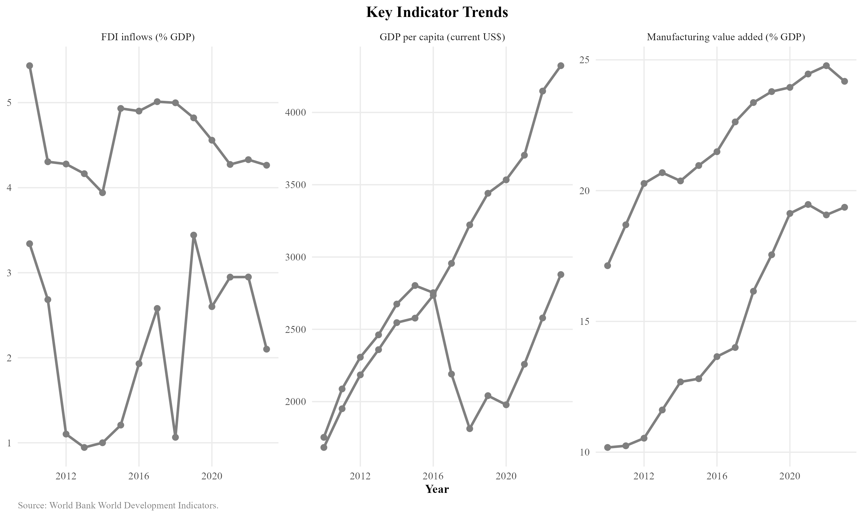
Figure 20:Key Indicator Trends:FDI Inflows, GDP per Capita, and Manufactur-ing VA, Uzbekistan.Source:World Bank WDI.
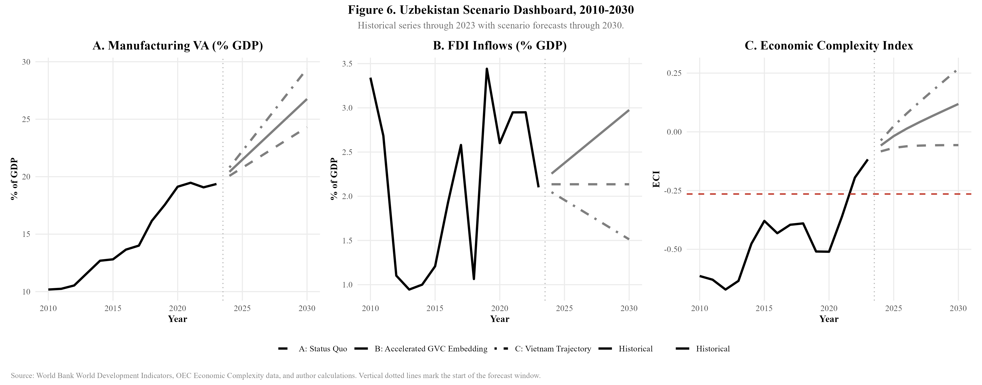
Figure 21:Uzbekistan Scenario Dashboard, 2010–2030:Manufacturing VA, FDI, andEconomicComplexityIndexunderthreepolicyscenarios.Source:World Bank WDI, OEC, and author calculations.
74

NE Asian GVC Integration and Uzbekistan Industrialisation
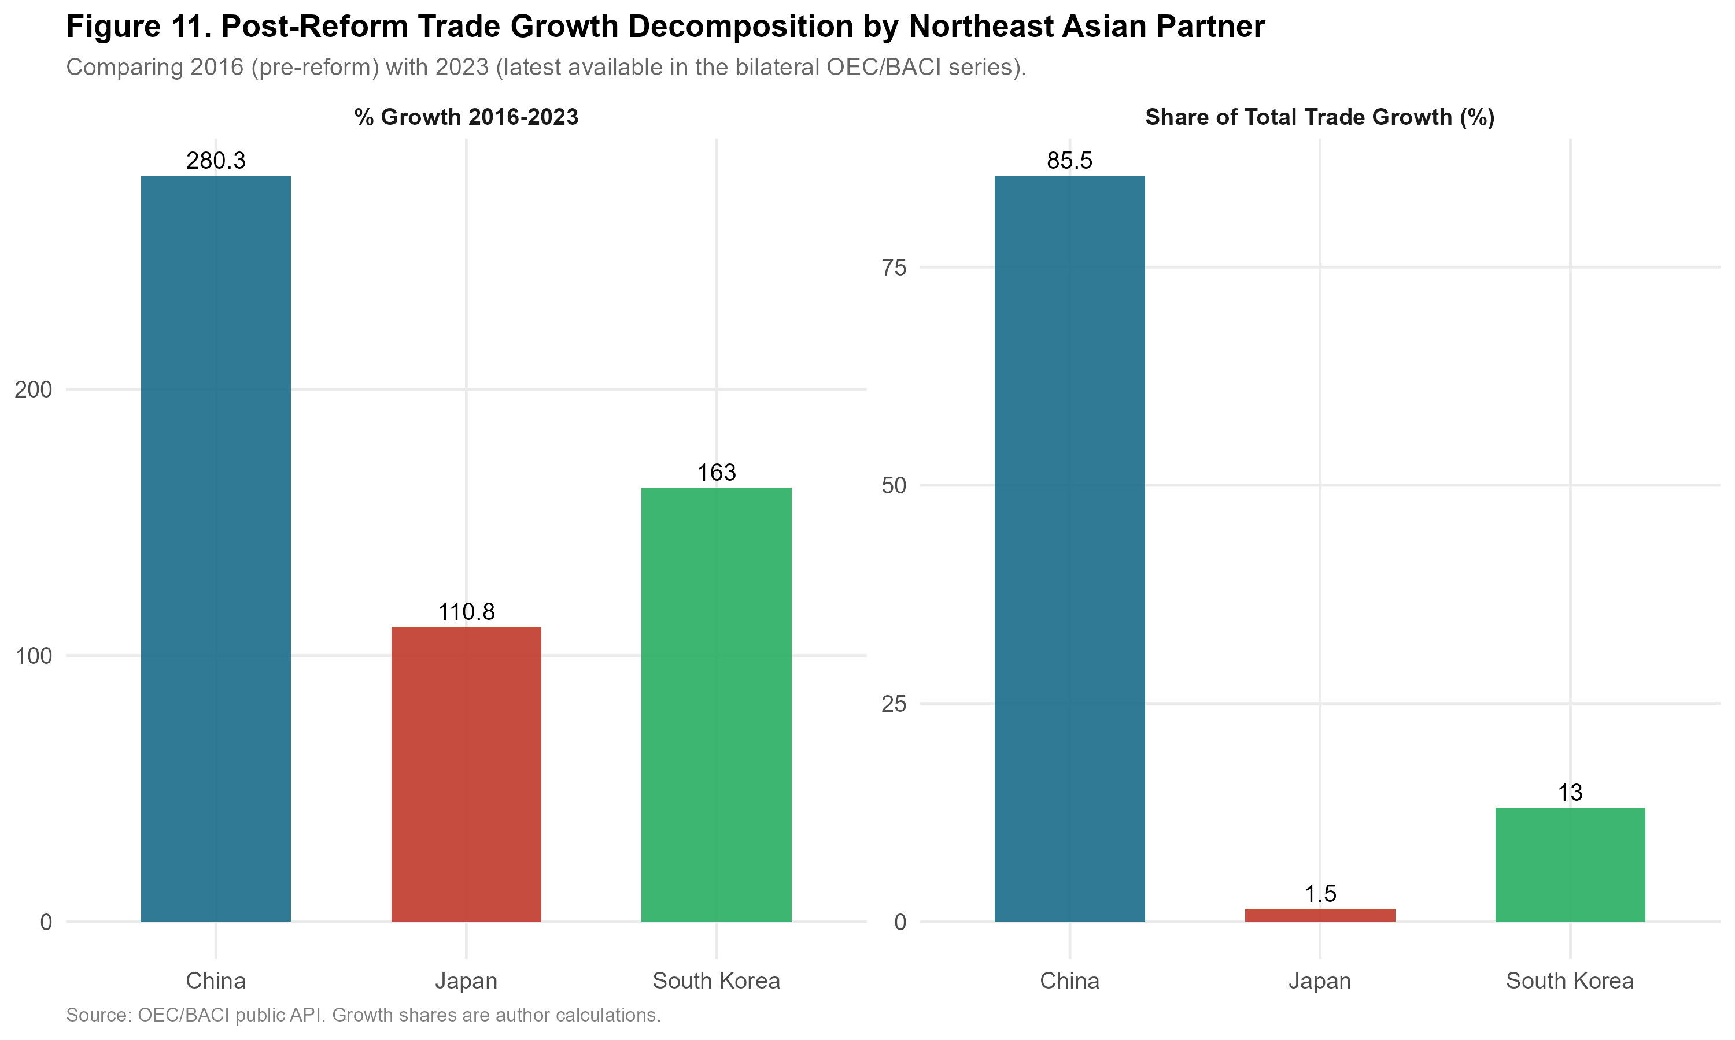
Figure 22: Post-Reform Trade Growth Decomposition by Northeast Asian Partner,
2016–2023.Source:OEC/BACI public API.
75

NE Asian GVC Integration and Uzbekistan Industrialisation
References
Akamatsu,K.(1962),‘Ahistoricalpatternofeconomicgrowthindeveloping countries’, Journal of Developing Economies 1(1), 3–25.
Akramov,K.&Tilekeyev,K.(2024),Agriculturalvaluechainsincentralasia, IFPRI Discussion Paper 02238, International Food Policy Research Institute.
Amsden, A. H. (1989), Asia’s Next Giant: South Korea and Late Industrialization, Oxford University Press, New York.
Andreoni,A.&Chang,H.-J.(2023),‘Thepoliticaleconomyofindustrialpol-icy:Structural interdependencies, policy alignment and conflict management’, Research Policy 52(2), 104863.
Arvis, J.-F., Raballand, G. & Marteau, J.-F. (2016), ‘The cost of being landlocked: Logistics costs and supply chain reliability’, World Bank Policy Research Work-ing Paper (4258).
Balassa,B. (1965),‘Trade liberalisationand “revealed” comparative advantage’, The manchester school 33(2), 99–123.
Baldwin,R.(2016),TheGreatConvergence:InformationTechnologyandthe New Globalization, Harvard University Press, Cambridge, MA.
Bhaskar, R. (1975), A Realist Theory of Science, Leeds Books, Leeds.
Carr`ere, C. & Schiff, M. (2004), ‘On the geography of trade:Distance is alive and well’, Revue´economique 55(6), 1249–1274.
Chang, H.-J. (2002), Kicking away the ladder:development strategy in historical perspective, Anthem Press.
Danermark, B., Ekstr¨om, M. & Jakobsen, L. (2019), Explaining Society:Critical Realism in the Social Sciences, 2nd edn, Routledge, London.
Diao, X., McMillan, M. & Rodrik, D. (2019), ‘The recent growth boom in devel-oping economies:A structural-change perspective’, The Palgrave Handbook of Development Economics pp. 281–334.
76

NE Asian GVC Integration and Uzbekistan Industrialisation
Dunning, J. H. (1981), International Production and the Multinational Enterprise, Allen & Unwin, London.
Evans,P.(1995),EmbeddedAutonomy:StatesandIndustrialTransformation, Princeton University Press, Princeton.
Farole, T. (2011), Special economic zones in Africa:comparing performance and learning from global experience, World Bank Publications.
Gereffi, G. (1994), The organization of buyer-driven global commodity chains, in G.Gereffi&M.Korzeniewicz,eds,‘CommodityChainsandGlobalCapital-ism’, Praeger, Westport, CT, pp. 95–122.
Gereffi, G., Humphrey, J. & Sturgeon, T. (2005), ‘The governance of global value chains’, Review of international political economy 12(1), 78–104.
Hidalgo,C. A. & Hausmann,R. (2009),‘The building blocks of economic com-plexity’,Proceedingsofthenationalacademyofsciences106(26),10570–10575.
Humphrey,J.&Schmitz,H.(2002),‘Howdoesinsertioninglobalvaluechains affect upgrading in industrial clusters?’, Regional Studies 36(9), 1017–1027.
Kaplinsky, R. & Morris, M. (2001), A Handbook for Value Chain Research, IDRC, Ottawa.
Lim˜ao,N.&Venables,A.J.(2001),‘Infrastructure,geographicaldisadvantage, transport costs, and trade’, The World Bank Economic Review 15(3), 451–479.
MacKinnon, J. G. & White, H. (1985), ‘Asymptotic covariance matrices for max-imum likelihood and quasi-maximum likelihood estimators’, Journal of econo-metrics 29(3), 305–325.
McMillan, M., Rodrik, D. & Sep´ulveda, C. (2017), ‘Structural change, fundamen-tals,andgrowth:Aframeworkandcasestudies’.NBERWorkingPaperNo. 23378.
Milberg,W. & Winkler,D. (2013),Outsourcing economics:global value chains in capitalist development, Cambridge University Press.
77

NE Asian GVC Integration and Uzbekistan Industrialisation
Pomfret,R.(2019),TheCentralAsianEconomiesintheTwenty-FirstCentury, Princeton University Press, Princeton.
Rakhmatullayev,S.,Yusupov,N.&Tashkentov,A.(2023),‘Institutionalcon-straints on fdi in uzbekistan’, Eurasian Geography and Economics 64(4), 412–436.
Rodrik, D. (2016), ‘Premature deindustrialization’, Journal of Economic Growth 21(1), 1–33.
Sturgeon,T.,VanBiesebroeck,J.&Gereffi,G.(2008),‘Valuechains,networks andclusters:reframingtheglobalautomotiveindustry’,JournalofEconomic Geography 8(3), 297–321.
Usmanov, B. (2024), ‘Gvc integration and industrial policy in central asia’, Post- Communist Economies 36(2), 145–168.
Wade, R. (1990), Governing the Market:Economic Theory and the Role of Gov- ernment in East Asian Industrialization, Princeton University Press, Princeton.
World Bank (2024), ‘World development indicators’, Washington, DC: The World Bank.
URL: https://databank.worldbank.org/source/world-development-indicators
WorldBank(2025),Uzbekistaneconomicupdate:Sustaininggrowth,Technical report, World Bank, Washington, DC.
URL: https://www.worldbank.org/en/country/uzbekistan/publication/uzbekistan-economic-update
78

