Use of Iron Oxide and Borax/Boron Additives as Graphitization Catalysts in Natural Graphite Electrodes
Detailed technical explanation with experimental data, mechanisms, formulas, and proposed optimization plan
Prepared: June 2026

Abstract
This report answers whether iron oxide and borax can be used as graphitization catalysts/additives in natural graphite electrode manufacturing. The short answer is yes for iron oxide and conditionally yes for borax, but their functions and risks are different. Iron oxide is a strong catalyst precursor because it can be reduced during carbon-rich baking/graphitization to Fe and Fe3C, which promote graphitic ordering of amorphous or pitch-derived carbon. Borax can supply boron/borate species and flux oxide impurities, but it also adds sodium-containing ash and water of hydration, so boric acid, B2O3, B4C, or elemental boron are usually cleaner boron sources for electrode-grade material. For a natural graphite electrode, catalysts will mainly improve the binder coke, pitch-carbon matrix, petroleum/needle coke fraction, and interparticle carbon bridges, not the already-crystalline natural graphite particles.

Direct answer
- Iron oxide: suitable as a graphitization catalyst precursor. It is more useful when finely dispersed or introduced by impregnation as an iron salt that converts to iron oxide and then Fe/Fe3C during heating.
- Borax: possible as a boron/borate additive, but not the preferred source for high-purity electrodes because it introduces Na-containing ash and can create porosity from dehydration. Use anhydrous borax only if borax must be studied; otherwise use boric acid, B2O3, B4C, or elemental boron.
- Best solution: use a low-dose Fe + boron co-additive strategy, with careful dispersion, slow baking, inert/reducing atmosphere, and high-temperature graphitization. Optimize against graphitization degree, electrical resistivity, flexural strength, porosity, and ash, not graphitization alone.
- Iron species during baking: FeOOH/hydrated iron oxides, Fe2O3, Fe3O4, FeO, metallic Fe, Fe3C, and, with boron, possible Fe-B/Fe-B-C phases. The exact species depend on oxygen potential, CO/CO2 ratio, carbon activity, additive particle size, and temperature.

1. Why this matters for natural graphite electrodes
A natural graphite electrode is a composite. It may contain natural graphite particles, coke or carbon filler, pitch binder, and ash-forming mineral impurities. The natural graphite fraction already has a layered graphitic structure. Therefore, catalyst addition mainly targets less-ordered carbon: pitch-derived binder coke, amorphous carbon bridges, coke edges, and defective carbon around pores. Improvement in these regions can reduce electrical resistivity and improve thermal stability, but excessive catalyst can increase ash, gas evolution, and flaw density, reducing flexural strength.
Commercial graphite electrodes normally involve mixing coke/filler with pitch, forming, baking around 900 C to carbonize pitch, pitch impregnation/rebaking, and graphitization near 2500-3000 C. Literature on bulk graphite notes that artificial bulk graphite is made from carbon filler plus binder followed by high-temperature treatment, commonly 2500-3000 C, while a Nippon Steel report describes graphite-electrode bodies being baked at about 900 C and graphitized at approximately 3000 C. [8,9]

2. Iron oxide as a graphitization catalyst precursor
Iron oxide itself is normally not the final active catalytic phase. In a carbon-rich baking/graphitization environment, Fe2O3 and Fe3O4 can be reduced by CO and solid carbon. The active graphitization phases are often metallic Fe and/or iron carbide Fe3C. A review of iron-catalyzed graphitization describes iron precursors decomposing first to iron oxide nanoparticles, followed by carbothermal reduction to Fe or Fe3C; these particles then drive graphitization by dissolution/reprecipitation of carbon and/or carbide-related mechanisms. [1]
Simplified reduction pathway: Fe2O3 -> Fe3O4 -> FeO -> Fe -> Fe3C
Example reactions: 3Fe2O3 + C -> 2Fe3O4 + CO; FeO + CO -> Fe + CO2; 3Fe + C -> Fe3C
The catalyst effect is strongly dependent on particle size and dispersion. Fine Fe/Fe3C particles give many reaction fronts. Large agglomerates can become inactive inclusions or crack initiators. For this reason, impregnation with soluble iron salts or very fine Fe2O3 is generally better than dry blending coarse red iron oxide.

Real experimental data: Fe2O3 graphitization effect
The following data are from a published patent example using Chinese fir wood powder (<38 um) mixed with nano red iron oxide under nitrogen, heated to 1600 C for 2 h at 3 C/min. This is not a graphite electrode sample, but it is useful as real experimental evidence that Fe2O3 can strongly reduce d002 spacing and increase XRD graphitization in carbon. [6]
Fe2O3 addition (wt%) | 2theta of (002) (deg) | d002 (nm) | G_app (%) | G capped (%)
0 | 26.04 | 0.3419 | 24.4 | 24.4
3 | 26.34 | 0.3381 | 68.6 | 68.6
6 | 26.51 | 0.3354 | 100.0 | 100.0
10 | 26.50 | 0.3361 | 91.9 | 91.9
15 | 26.56 | 0.3353 | 101.2 | 100.0

The calculated graphitization degree uses the common empirical equation G = (0.3440 - d002)/(0.3440 - 0.3354) x 100. Values slightly above 100% are possible from rounding or measurement uncertainty and are capped at 100% for interpretation.
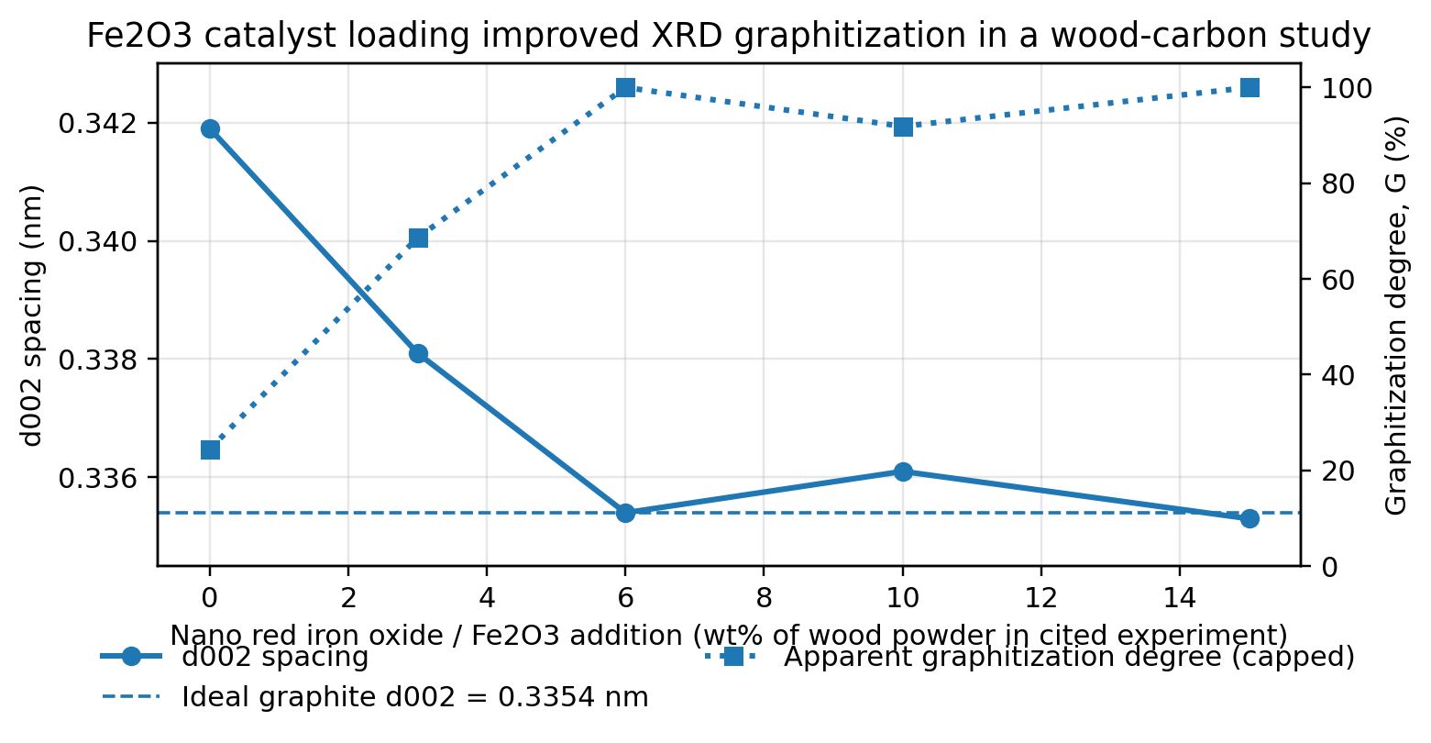
Figure 1. Fe2O3 loading versus d002 spacing and apparent graphitization degree, calculated from the cited 1600 C wood-carbon experiment. Data source: CN102502598A. [6]

3. Borax and boron additives
Borax can contribute boron/borate chemistry, but it should not be treated as equivalent to pure boron or B4C. Borax decahydrate is hydrated sodium tetraborate. It loses water at relatively low temperature and becomes sodium borate/borate glass on heating. NCBI/ATSDR data list borax as decomposing around 75 C and sodium tetraborate melting at about 743 C; boron oxide melts around 450 C and boric acid melts around 170.9 C. [5]
Borax dehydration/oxide route: Na2B4O7.10H2O -> Na2B4O7 + 10H2O(g)
Boric acid route: 2H3BO3 -> B2O3 + 3H2O(g)
The benefit of borax is that it can form a liquid/glassy borate phase, which may wet carbon and flux oxide impurities. The problem is that sodium remains as Na-containing ash, while water release can create pores during baking. For electrode applications where low ash and high strength are required, boric acid, B2O3, B4C, or elemental boron are cleaner sources. Borax can be studied scientifically, but it is not the first recommendation for a high-purity product.

Real experimental data: boric acid / boron effect
Boric-acid-treated cellulose-based carbon fibers provide a clear experimental example of boron-assisted graphitization. In this study, boron improved carbon yield, reduced d002 spacing, increased crystallite size, increased modulus and conductivity, but decreased tensile strength. This strength decrease is important for natural graphite electrodes because excessive additive-derived secondary phases can become flaws. [2]

Property at 2000 C | Reference carbon fiber | Boric-acid modified fiber | Effect
Carbon yield | 30% | 51% | +71% relative increase
d002 spacing | 0.351 nm | 0.3405 nm | Closer to graphite
Crystallite size Lc | 1.2 nm | 4.4 nm | ~3.7x higher
Crystallite size La | 3.3 nm | 8.8 nm | ~2.7x higher
Electrical resistivity | 19.8 uohm m | 7.4 uohm m | -63%
Young modulus | 108 GPa | 137 GPa | +27%
Tensile strength | ~1000 MPa | ~750 MPa | -25%

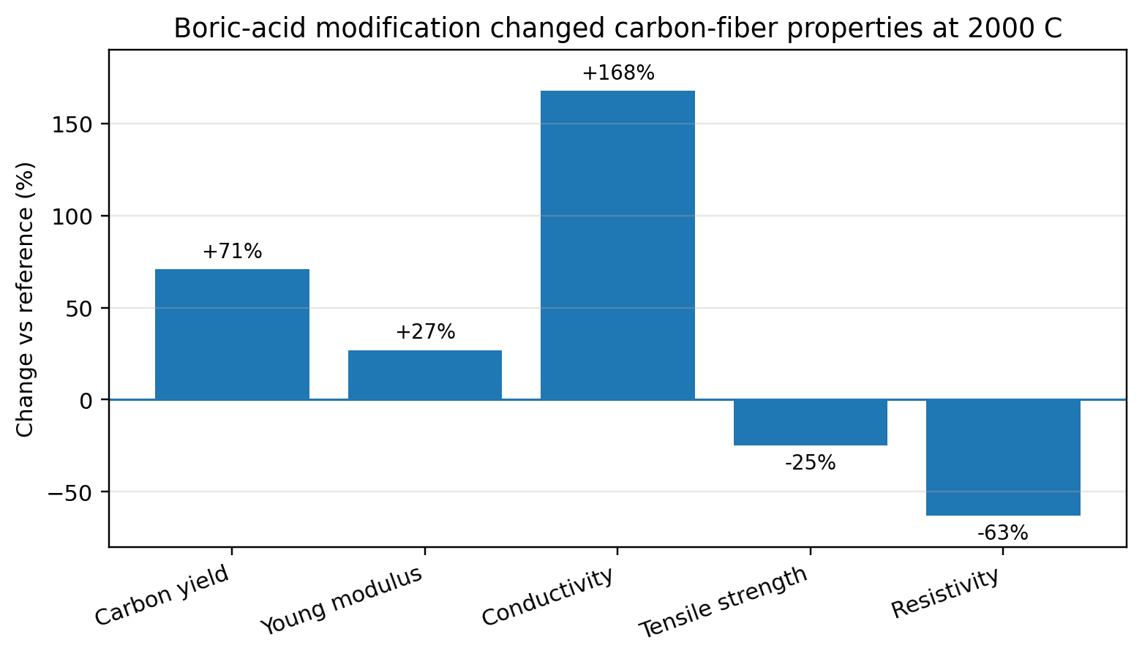
Figure 2. Selected property changes caused by boric-acid modification in cellulose-based carbon fibers at 2000 C. Data summarized from Hückstaedt et al. [2]
Older boron-catalysis work also shows that boron can accelerate graphitization over a wide temperature range. Yamashita, Otani, and Oya reported that 1 wt% boron accelerated homogeneous graphitization in non-graphitizing phenol-formaldehyde resin carbon from 1800 to 2600 C. At 5-10 wt% boron, turbostratic carbon with d002 about 3.38 A and Lc about 200 A was observed at 2200 C, and graphitic carbon with d002 about 3.36 A and Lc about 1000 A above 2400 C. [3]

4. Fe + B synergy
The most promising approach is not borax alone or iron oxide alone, but a controlled Fe + B system. A 2025 PAN-derived carbon study found that boronated PAN containing 5% iron salt was more graphitized than other iron concentrations; the authors attributed this to optimized metallic iron activity and in-situ iron-boron-carbide acting as a nucleation/stabilization phase. [4] Although PAN carbon is not a graphite electrode, it supports the concept that Fe and B can work together if the concentration is optimized.
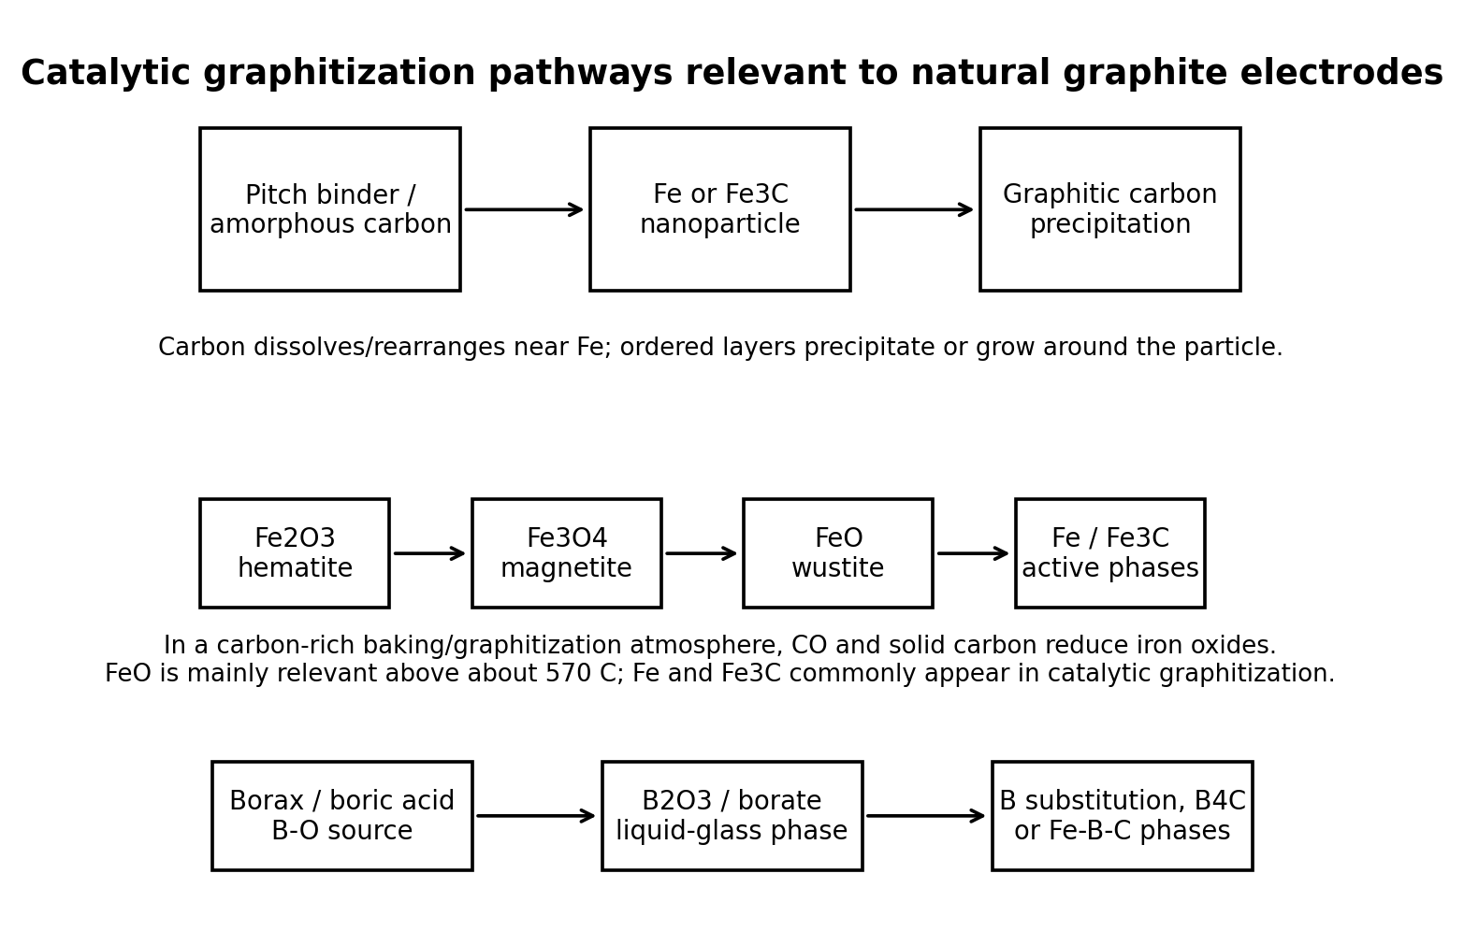
Figure 3. Mechanism schematic for Fe, boron, and borax-related pathways in a natural graphite electrode matrix.

5. What iron oxide species can exist during baking?
In an electrode baking process, the iron phase is not fixed. It evolves with temperature and atmosphere. Under oxidizing conditions, Fe2O3 is stable. Under inert but carbon-rich conditions, pitch volatiles, CO, and solid carbon lower oxygen potential and reduce iron oxide. General iron-oxide reduction literature describes hematite reduction through magnetite; above about 570 C, wustite is also part of the route before metallic iron forms. [10]
Temperature/process zone | Likely iron-containing species | Meaning for electrode processing
Raw batch / wet mixing | FeOOH, hydrated Fe oxides, Fe2O3, Fe3O4 | Depends on additive source, moisture, and surface oxidation. Hydrated phases release water during heating.
100-350 C | FeOOH -> Fe2O3; hydrated oxides dehydrate | Water removal can generate microvoids if heating is too fast.
350-600 C | Fe2O3 and Fe3O4 | Pitch volatiles and CO begin reducing Fe3+ to mixed Fe2+/Fe3+ magnetite.
>570 C in reducing/carbon-rich atmosphere | Fe3O4 -> FeO -> Fe | Wustite FeO is relevant mainly above about 570 C; metallic Fe can begin to form.
800-1200 C baking/carbonization | Fe, Fe3C, residual FeO/Fe3O4 | Fe/Fe3C can start catalyzing local ordering of binder coke and defective carbon.
>1600 C graphitization zone | Fe, Fe3C, Fe-B/Fe-B-C phases possible | Catalyst-assisted ordering becomes stronger; Fe can migrate/agglomerate if not controlled.
Cooling and air exposure | Fe, Fe3C with surface Fe3O4/Fe2O3 | Post-process XRD can show phases different from in-situ high-temperature phases.

6. Formulas for analysis
Use the following formulas to quantify graphitization and electrode properties in the paper.
Bragg law: n lambda = 2 d sin(theta) -> d002 = lambda / (2 sin theta)
Scherrer equation: Lc = K lambda / (beta cos theta)
Graphitization degree: G(%) = [(0.3440 - d002) / (0.3440 - 0.3354)] x 100
Raman disorder ratio: R = ID / IG (lower ID/IG generally means fewer defects)
Electrical resistivity: rho = R_elec A / L
Three-point flexural strength, rectangular bar: sigma_f = 3 Fmax L / (2 b h^2)
Three-point flexural strength, circular rod: sigma_f = 8 Fmax L / (pi D^3)
For a natural graphite electrode, graphitization degree alone is insufficient. A catalyst may improve d002 and Raman ID/IG while damaging flexural strength by increasing ash, pores, or brittle secondary phases. Therefore, use a multi-objective index such as:
Performance objective = high G + low resistivity + high flexural strength + low ash + low open porosity

7. Solution to maximize graphitization without destroying strength
The following strategy is recommended for a scientific paper and pilot experiment.
- Use iron oxide mainly as a precursor to Fe/Fe3C. Start with 0.5-2.0 wt% Fe2O3 relative to total dry solid, or lower if ash specification is strict. Avoid jumping to 10-15 wt% in electrode bodies unless the purpose is only mechanism research, because high Fe loading can increase ash and create inclusions.
- Use boric acid, B2O3, B4C, or elemental boron instead of borax for cleaner graphitization. If borax must be tested, use pre-dehydrated/anhydrous sodium tetraborate and keep the loading low, around 0.2-0.8 wt% of total dry solids in first screening experiments.
- Introduce catalysts by impregnation or fine wet dispersion. Iron salt impregnation of coke/filler, followed by controlled calcination, usually gives better distribution than dry-blended coarse oxide powder.
- Use a slow baking program through dehydration and pitch devolatilization. Water and volatile release below 600 C must be slow enough to avoid internal pressure, pores, cracks, and lower flexural strength.
- Use inert or mildly reducing atmosphere. In air, iron remains oxidized and carbon oxidizes. In inert carbon-rich atmosphere, CO and carbon reduce iron oxide to active Fe/Fe3C phases.
- Do not expect baking alone at 900-1100 C to fully graphitize a bulk natural graphite electrode. Baking can activate the catalyst and improve binder-coke ordering, but full electrode-grade graphitization normally requires high-temperature treatment, commonly above 2500 C.
- Optimize by design of experiments. Measure XRD d002/G, Raman ID/IG, resistivity, flexural strength, density, open porosity, ash, and SEM/EDS distribution of Fe/B/Na before selecting the best formulation.
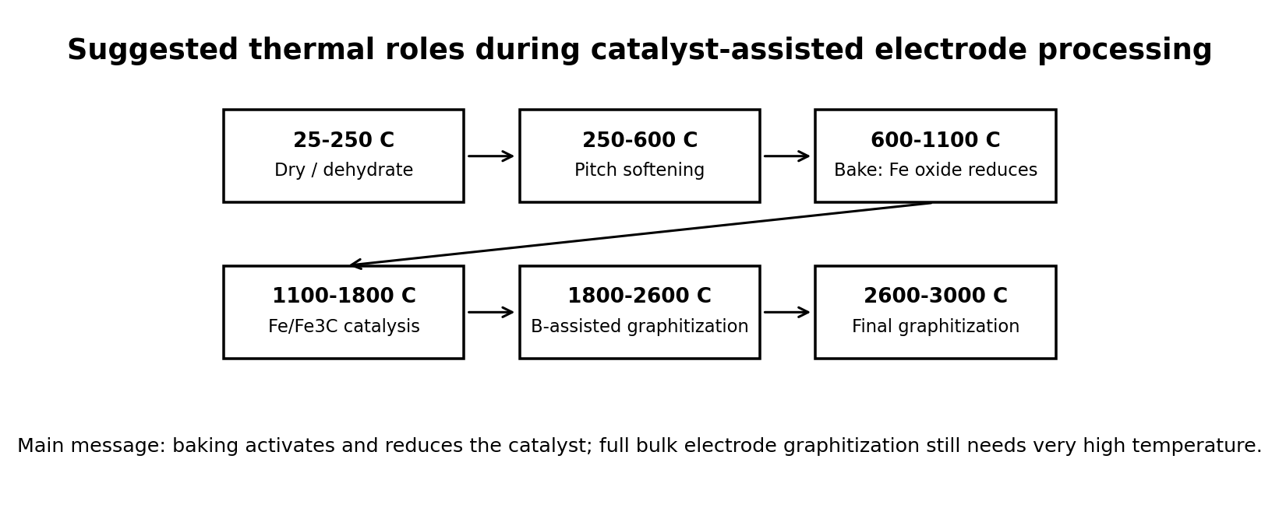
Figure 4. Temperature windows relevant to catalyst-assisted processing. Exact temperatures must be adjusted to the pitch, filler, electrode size, and furnace atmosphere.

Recommended first experiment matrix
Sample ID | Fe2O3 loading | Boron source/loading | Purpose
C0 | 0 | 0 | Baseline natural graphite electrode composition
Fe0.5 | 0.5 wt% | 0 | Low iron catalyst screening
Fe1.0 | 1.0 wt% | 0 | Practical iron catalyst candidate
Fe2.0 | 2.0 wt% | 0 | High iron limit before ash/porosity risk
B0.5 | 0 | 0.5 wt% B equivalent from H3BO3 or B2O3 | Boron-only comparison
B1.0 | 0 | 1.0 wt% B equivalent | Higher boron graphitization test
Fe1+B0.5 | 1.0 wt% | 0.5 wt% B equivalent | Recommended synergy candidate
Fe1+Borax0.5 | 1.0 wt% | 0.5 wt% anhydrous borax | Borax-specific comparison; monitor Na ash and porosity
Fe2+B1 | 2.0 wt% | 1.0 wt% B equivalent | Aggressive graphitization; likely higher risk of strength loss

8. Expected phenomena in the electrode
Observation | Cause | Good or bad?
Lower d002 and sharper XRD (002) peak | Growth and stacking improvement of graphitic layers | Good for graphitization and conductivity
Lower Raman ID/IG | Reduced defects or larger ordered domains | Usually good, but check if surface graphitization hides bulk flaws
Lower resistivity | Better graphitic binder bridges and particle contacts | Good
Higher density after impregnation/rebaking | Pitch fills pores; carbon yield improves | Good if not accompanied by closed gas pores
Lower flexural strength despite better XRD | Brittle catalyst agglomerates, boron carbide/iron carbide inclusions, pores, sodium borate glass | Bad; indicates over-doping or poor dispersion
Higher ash | Residual Fe, Na, B-containing phases | Bad for high-purity electrodes; sometimes acceptable for low-cost industrial materials
CNT/filament-like carbon around Fe particles | Iron-catalyzed carbon precipitation | Evidence of catalytic activity; may or may not improve bulk properties

9. Recommended conclusion for the scientific paper
Iron oxide can be used as a graphitization catalyst precursor in natural graphite electrode manufacturing, but its function is mainly to graphitize amorphous/binder-derived carbon rather than the already-crystalline natural graphite filler. Borax can be used as a boron/borate additive, but it is less suitable than cleaner boron sources because sodium-containing ash and dehydration can compromise electrode strength and purity. The highest-potential solution is a controlled Fe + B catalyst system, for example low-dose Fe2O3 combined with boric acid/B2O3/B4C, dispersed uniformly and processed through slow baking, inert/reducing atmosphere, and high-temperature graphitization. Optimization must target a balance between graphitization degree, electrical resistivity, flexural strength, porosity, and ash.

10. Evidence limitations
Public literature contains strong evidence for Fe- and B-assisted graphitization in biomass carbons, polymer-derived carbons, carbon fibers, and electrode-related coke processing. However, directly comparable experiments on natural graphite electrode bodies with controlled ash, Fe2O3, borax, baking temperature, and flexural strength are limited. Therefore, this report uses literature data as mechanistic and design evidence, not as a final production specification. A paper should present a dedicated experiment matrix for the target natural graphite electrode formulation.

