Effect of Ash Content on the Flexural Strength of Natural Graphite Electrodes
Short scientific-paper style report with literature-backed explanation, real published data, equations, and experimental recommendations

Abstract
Answer in one sentence: when all other variables are controlled, increasing ash content in natural graphite generally lowers the flexural strength of a graphite electrode. The reason is not that ash simply dilutes carbon; ash is mainly inorganic mineral residue that creates weak interfaces, stress concentrators, pores, and oxidation-active sites in the graphite/binder network. Public electrode-grade datasets support the same practical trend: higher-ash regular-power electrodes show lower bending-strength ranges than lower-ash high-power and ultra-high-power electrodes. However, ash is not the only controlling variable. Bulk density, porosity, grain size, forming method, pitch impregnation, graphitization temperature, anisotropy, and testing direction can dominate the measured flexural strength, especially when ash is already at ppm levels.
Keywords: natural graphite, ash content, flexural strength, graphite electrode, bending strength, porosity, impurities, thermal shock

1. Research question and hypothesis
Research question: How does increasing ash content in graphite affect the flexural strength of a natural graphite electrode?
Hypothesis: At constant graphite particle size distribution, binder content, forming pressure, graphitization temperature, density, and porosity, higher ash content reduces flexural strength. A useful first-order empirical model is:
sigma_f = sigma_0 - kA, k > 0
where sigma_f is flexural strength in MPa, A is ash content in wt. %, sigma_0 is the extrapolated zero-ash strength for the same process route, and k is an empirical sensitivity coefficient. The value of k is not universal; it must be fitted for a specific electrode formulation and test method.

2. Background: what ash means in graphite
Ash content is the non-carbon residue remaining after graphite is oxidized/burned in a controlled test. In natural graphite, this residue commonly originates from mineral impurities such as quartz/silica, silicates, alumina-bearing minerals, iron oxides, calcium compounds, and other gangue minerals. In an electrode, those phases do not form the continuous graphitic load-bearing network.
The ash fraction can be expressed as:
Ash content, A (%) = (mash / mdry graphite) × 100
For high-purity graphite datasheets, ash is commonly reported in ppm; conversion is 10,000 ppm = 1 wt. %, so 200 ppm = 0.020 wt. % and 20 ppm = 0.002 wt. %.

3. Flexural strength formula and test interpretation
For a rectangular specimen in a three-point bending test, flexural strength is normally calculated as:
sigma_f = 3FL / (2bd^2)
where F is the fracture load, L is the support span, b is specimen width, and d is specimen thickness. For graphite, this value is sensitive to flaw population because graphite is a brittle, porous, anisotropic material. For this reason, test geometry, orientation with/against grain, and surface condition must be reported together with strength.
The POCO/Entegris graphite guide gives a sample flexural calculation using a 500 lb failure load, 3.0 in span, 0.75 in width, and 0.50 in thickness, giving 8000 psi or about 55 MPa. The same guide notes ASTM C651 for flexural testing of graphite and ASTM C561 for ash content determination. This is useful for methodology, although the example is not an ash-variable experiment.

4. Real published/industrial data relevant to ash versus bending strength
Important limitation: the public data below are not a perfectly controlled laboratory series where only ash content changes. They are real electrode/material property datasets in which ash co-varies with grade, raw material, density, impregnation, and microstructure. Therefore, the values should be used as evidence of the practical trend and as a basis for experiment planning, not as a universal law.

4.1 Electrode-grade data: Summit Steel / Linking Steel
The graphite-electrode technical specification from Summit Steel / Linking Steel reports typical EAF electrode properties. The lower-ash UHP/HP grades have higher bending-strength ranges than the higher-ash RP grade. For plotting, the midpoint of each reported range is used.
Grade | Ash limit (wt. %) | Reported bending strength (MPa) | Midpoint used (MPa) | Bulk density range (g/cm3) | Interpretation
UHP electrode | ≤0.20 | 10.0–14.0 | 12.0 | 1.68–1.74 / 1.70–1.74 | low ash, high strength
HP electrode | ≤0.30 | 10.0–13.0 | 11.5 | 1.62–1.66 | intermediate ash, slightly lower strength
RP electrode | ≤0.50 | 7.0–12.0 | 9.5 | 1.53–1.56 | highest ash, lowest strength range
Linear fit to the midpoint values:
sigma_f,mid ~ 13.86 -8.57A (R² = 0.98, A in wt. %)
This means that, within this product set, increasing the ash limit by 0.1 wt. % is associated with about 0.86 MPa lower midpoint bending strength. The slope should not be generalized beyond this product family because density also decreases from UHP/HP to RP.

4.2 Electrode-grade data: ANSSEN
ANSSEN reports graphite electrode technical parameters for regular-power, high-power, and ultra-high-power products. Considering the GE electrode values, the minimum bending strength increases as the maximum ash content decreases.
Grade | Ash max. (wt. %) | GE bending strength min. (MPa) | GE bulk density min. (g/cm3) | Trend
Regular Power GE | 0.30 | 9.8 | 1.56 | higher ash, lower strength
High Power GE | 0.25 | 12.0 | 1.65 | lower ash, higher strength
Ultra High Power GE | 0.20 | 14.0 | 1.68 | lowest ash, highest strength
Linear fit to these minimum values:
sigma_f,min ~ 22.43 -42.0A (R² = 0.999, A in wt. %)
This gives a steeper apparent sensitivity, about 4.2 MPa loss per 0.1 wt. % ash increase, because the grade shift also includes better density and lower resistivity for HP/UHP electrodes. Therefore, it is best interpreted as a product-grade correlation, not a pure ash-only coefficient.

4.3 High-purity graphite data: why ash alone cannot explain every strength value
SGL Carbon data show that two high-purity isostatic graphites can both be strong even when their ash values differ at ppm scale: SIGRAFINE R7550 reports flexural strength 60 MPa and ash 20 ppm, whereas SIGRAFINE R7650 reports flexural strength 65 MPa and ash 200 ppm. This does not contradict the ash hypothesis. It shows that at very low ash levels, microstructure variables such as grain size, density, porosity, forming method, and graphitization can dominate. In other words, low ash is necessary for clean, stable electrode performance, but not sufficient by itself to guarantee maximum flexural strength.
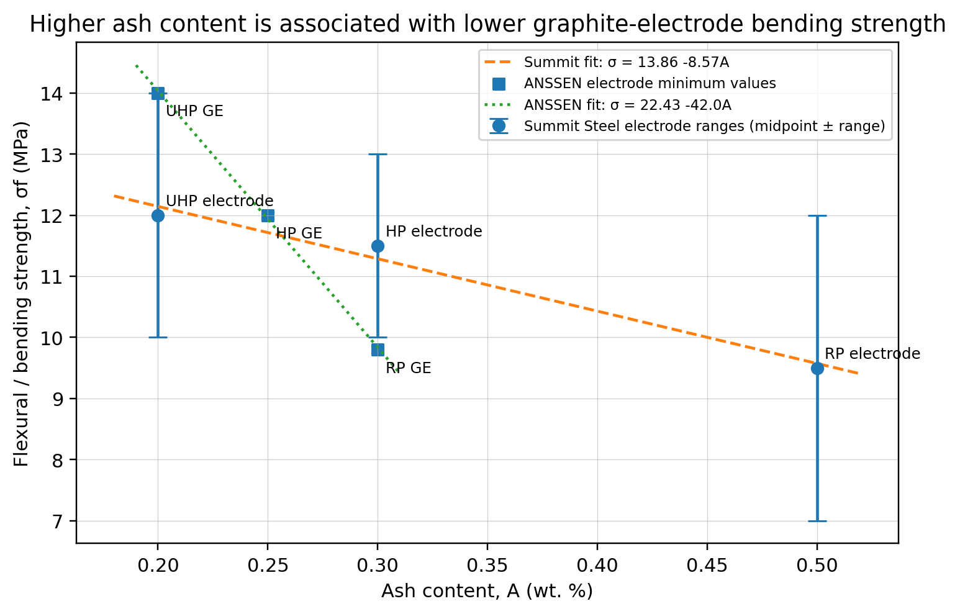
Figure 1. Real public electrode-grade data show an inverse ash-strength association. Summit Steel values are range midpoints with range bars; ANSSEN values are minimum GE electrode values. The datasets are not ash-only controlled experiments, but they are useful for engineering interpretation.

5. Phenomenon and microstructural mechanism
The flexural test puts one side of the specimen into tension. Because graphite is brittle, failure starts at flaws. Ash increases the probability and severity of such flaws through several mechanisms:
Weak interfaces: mineral particles bond poorly with graphitic carbon and pitch-derived binder, so cracks can initiate or deflect at ash-rich interfaces.
Stress concentration: hard oxide/silicate inclusions have different stiffness and thermal expansion from graphite, creating localized tensile stress under bending and thermal cycling.
Porosity and channels: ash-bearing gangue and poor purification can leave irregular pores or channels after processing. Strength falls rapidly with porosity.
Reduced effective graphite continuity: ash interrupts the graphitic load path and decreases the volume fraction of conductive/load-bearing carbon.
Oxidation catalysis: metals such as Fe, Ca, Na, and V can catalyze oxidation of carbon at high temperature, causing local burn-off and crack growth during electrode service.
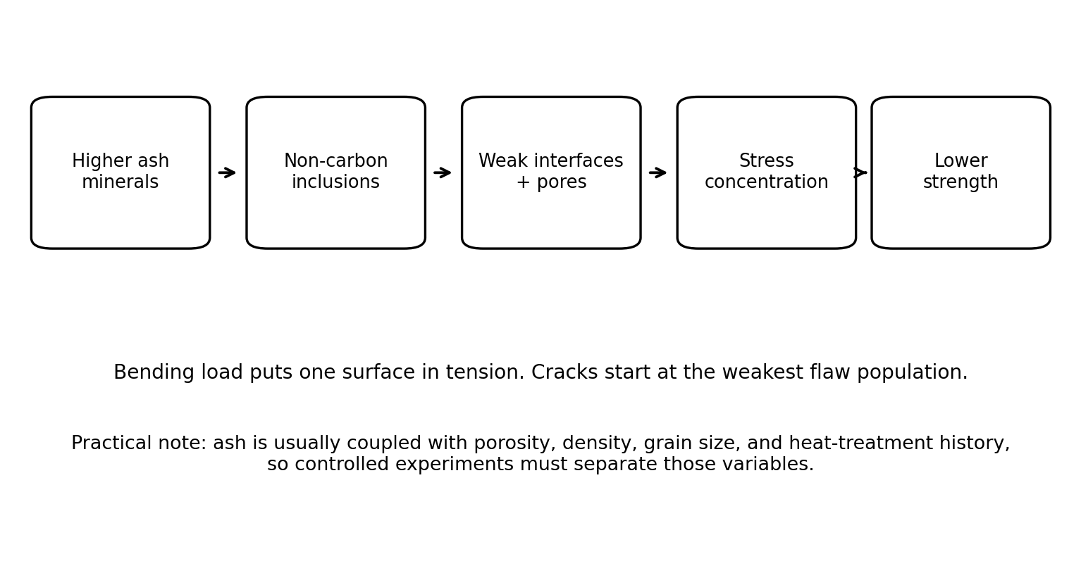
Figure 2. Mechanistic explanation for why ash tends to lower flexural strength in graphite electrodes.

6. Useful strength model including porosity
A more realistic model includes both ash and porosity/density. A common brittle porous-material expression is the Ryshkewitch-Duckworth type relationship:
sigma_f = sigma_dense exp(-bP)
where P is porosity fraction, b is a material constant, and sigma_dense is the strength of a hypothetical dense material. Because ash often increases defects and correlates with lower process quality, a practical regression for electrode research is:
sigma_f = beta_0 - beta_1 A + beta_2 rho_b - beta_3 P - beta_4 d_g + epsilon
where rho_b is bulk density, P is open porosity, dg is representative grain size, and epsilon is experimental error. In this form, beta_1 captures the ash penalty after density, porosity, and grain size are controlled.

7. Recommended controlled experiment for a scientific paper
To produce publishable data specifically for natural graphite electrodes, use a controlled design rather than comparing commercial grades. A suitable plan is:
1. Obtain one natural graphite source and split it into batches. Purify batches to different ash levels, for example 0.05, 0.10, 0.20, 0.50, 1.00 wt. %, while keeping particle-size distribution constant. Alternatively, intentionally add known SiO₂/Al₂O₃-rich ash to purified graphite as a controlled impurity phase.
2. Use one electrode recipe for every batch: same natural graphite/pitch ratio, same binder softening point, same mixing temperature, same forming pressure, and same baking/graphitization schedule.
3. Measure ash content by DIN 51903 or ASTM C561, bulk density, open porosity, electrical resistivity, Raman ID/IG, XRD d002/Lc, and SEM-EDS impurity distribution.
4. Cut at least five rectangular specimens per condition and test flexural strength by ASTM C651 or DIN IEC 60413/501. Report direction relative to forming/extrusion orientation.
5. Fit sigma_f versus ash first, then fit the multivariable model including density and porosity. Use ANOVA to check whether ash remains statistically significant after density/porosity correction.

8. Expected results and interpretation
For a controlled natural graphite electrode series, the expected curve is decreasing. At low ash content, the slope may be small because density, binder carbonization, and graphitization dominate. At moderate ash levels, the slope becomes more visible because inclusions and pores increasingly control crack initiation. At high ash levels, flexural strength can decrease sharply and scatter increases because failure becomes flaw-controlled.

9. Conclusion
Increasing ash content generally decreases the flexural strength of natural graphite electrodes when the processing route and microstructure are controlled. The practical reason is that ash introduces non-carbon inclusions, weak interfaces, porosity, and oxidation-active sites, all of which reduce the load-bearing continuity of the graphite network. Real electrode-grade specifications support this trend: higher-ash RP electrodes are reported with lower bending-strength ranges than lower-ash HP/UHP electrodes. Nevertheless, ash is not the only variable. A rigorous scientific paper should measure and control density, porosity, grain size, anisotropy, binder content, and graphitization temperature so the ash effect can be separated from general grade quality.

References / data sources
[1] Beijing Summit Steel Co., Ltd.; Linking Steel Hongkong Co., Limited. “Graphite Electrode Technical Specification.” Public technical specification, page 6: typical properties including bending strength, bulk density, CTE, and ash content. URL: https://www.gifa.de/vis-content/event-GMTN2019.metec/exh-GMTN2019.2618356/METEC-2019-BEIJING-SUMMIT-STEEL-CO.-LTD.-Product-GMTN2019.2618356-ZiIhiN5YTsW7PJM8lc1xzA.pdf
[2] ANSSEN Metallurgy. “Graphite Electrodes - Technical Parameter.” Public product data listing RP, HP, and UHP density, resistivity, bending strength, modulus, CTE, and ash limits. URL: https://www.anssen.com/Products_1/Graphite_Electrodes.html
[3] SGL Carbon. “SIGRAFINE R7550.” Technical datasheet TDS R7550.01, 2022: flexural strength 60 MPa and ash content 20 ppm. URL: https://www.sglcarbon.com/pdf/SGL-Datasheet-SIGRAFINE-R7550-EN.pdf
[4] SGL Carbon. “SIGRAFINE R7650.” Technical datasheet TDS R7650.00, 2019: flexural strength 65 MPa and ash content 200 ppm. URL: https://www.sglcarbon.com/pdf/SGL-Datasheet-SIGRAFINE-R7650-EN.pdf
[5] SGL Carbon. “SIGRAFINE ISO graphite for electronic applications.” Technical datasheet TDS EA.00, 2018: multi-grade isostatic graphite properties and purification purity levels. URL: https://www.sglcarbon.com/pdf/SGL-TDS-SIGRAFINE-ISO-for-Electronic-Applications-EN.pdf
[6] Entegris / POCO Graphite. “Graphite Properties and Characteristics.” Guide describing graphite flexural strength calculation and test-method references for flexural strength and ash content. URL: https://poco.entegris.com/content/dam/poco/resources/reference-materials/brochures/brochure-graphite-properties-and-characteristics-11043.pdf
[7] Dowell, M. B.; Howard, R. A. “Tensile and compressive properties of flexible graphite foils.” Carbon, 24, 311-323, 1986. Cited in reviews as reporting the negative influence of increasing ash content on strength-density enhancement.
[8] Savchenko, D. V. et al. Studies on flexible/expanded graphite mechanical properties. Cited in reviews as observing a linear relation between ash content and tensile strength in flexible graphite systems.

