Optimization of Raw-Material Ratios for Natural Graphite Electrodes
Natural graphite fraction, binder carbon, additives, particle-size packing, and process window
Direct answer: For an industrial-style natural graphite electrode, the most defensible starting ratio from public data is approximately 90.65 wt% natural flake graphite + 7.0 wt% carbon resin binder + 2.35 wt% additives (about 2.0 wt% Si powder, 0.20 wt% Fe2O3, and 0.15 wt% short carbon fiber). In the cited example, this formulation produced resistivity of 4.2 uohm m, flexural strength of 16.6 MPa, and bulk density of 1.99 g/cm3 after 1600 deg C firing and 300 MPa isostatic pressing [1].
Important limitation: This is not a universal optimum. The best ratio changes with natural graphite purity, particle-size distribution, binder type, binder carbon yield, compaction pressure, firing schedule, and whether the target is high strength, low resistivity, high oxidation resistance, or low cost. The report therefore gives both a recommended starting formulation and an experimental optimization plan.

Abstract
This paper-style note evaluates the raw-material ratio optimization of natural graphite electrodes. Publicly available data are limited, but two strong anchors are available: (i) a natural-graphite electrode process with formulation ranges and three measured examples, and (ii) a peer-reviewed bimodal natural graphite block study. The evidence indicates that natural graphite should normally remain the majority phase, while binder should be only high enough to create continuous carbon bridges after baking. Excess binder increases volatile evolution, shrinkage, and pore formation. Fine natural graphite improves packing by filling voids between coarse particles, while small amounts of carbon fiber, silicon powder, and iron oxide can improve strength, oxidation resistance, and binder-carbon graphitization. For a steelmaking-style natural graphite electrode, a recommended starting formulation is 89.5-91.0 wt% natural graphite, 6.5-7.5 wt% carbon binder, and 2.0-3.0 wt% additives. For a metal-additive-free natural graphite block, the best literature anchor is 70 wt% large natural graphite, 21 wt% small natural graphite, and 9 wt% pitch binder.

1. Research question and scope
Question: What is the optimized raw-material ratio for a natural graphite electrode?
Scope: The answer focuses on bulk natural graphite electrodes or graphite blocks made by mixing natural graphite, carbonaceous binder, and small additives, followed by molding/pressing, curing, baking, and sometimes graphitization. This is different from lithium-ion battery slurry electrodes, where PVDF, CMC/SBR, copper foil, and electrochemical utilization dominate the design.

2. Literature and experimental data basis
Two types of data were used: first, a natural-graphite electrode patent that reports raw mixture ranges and measured mechanical/electrical properties; second, a peer-reviewed natural-graphite block study showing the role of bimodal particle-size packing.

2.1 Natural graphite electrode formulation range
CN107311686B claims a formulation window of natural graphite 85-95 wt%, additive 0.05-5 wt%, and carbon resin binder 4-10 wt%. The additive system is carbon fiber or matrix fiber, silicon powder, and iron oxide, with a ratio of fiber:Si:Fe oxide = 2-5:80-90:7-12. The patent states that carbon fiber improves strength and thermal shock resistance, silicon improves oxidation resistance and hot strength, and iron oxide promotes graphitization of binder carbon, lowers resistivity, and improves conductivity and oxidation resistance [1].
Parameter | Reported range or role | Optimization meaning
Natural graphite | 85-95 wt%; carbon content >= 90%, preferably high-purity flake graphite | Main conductive skeleton. Too low increases binder/additive matrix; too high reduces bonding carbon.
Carbon resin binder | 4-10 wt%; modified asphalt, furan resin, phenolic resin, or mixture; carbon residue > 30% | Creates carbon bridges after baking. Too little weak bonding; too much volatile pores.
Additive total | 0.05-5 wt% | Small amount only; excess increases ash and non-carbon phases.
Additive internal ratio | fiber:Si:Fe oxide = 2-5:80-90:7-12 | Si dominates oxidation resistance; Fe oxide catalyzes binder-carbon ordering; fiber toughens/bridges cracks.
Compaction | >80 MPa; examples used 120, 250, 300 MPa | Higher density improves particle contacts and strength if cracking is avoided.
Firing | >1200 deg C; examples used 1200, 1400, 1600 deg C | Higher temperature improves binder carbonization and conductivity but increases cost.
Source: CN107311686B, Preparation process of graphite electrode, public patent text [1].

2.2 Reported example data from a natural graphite electrode process
Sample | NG (wt%) | Binder (wt%) | C fiber | Si | Fe2O3 | Additive total | Firing (deg C) | Pressure (MPa) | Strength (MPa) | Resistivity (uohm m) | Density (g/cm3)
E1 | 88.50 | 8.00 | 0.20 | 3.00 | 0.30 | 3.50 | 1200 | 120 | 12.3 | 6.4 | 1.85
E2 | 85.50 | 9.00 | 0.10 | 5.00 | 0.40 | 5.50 | 1400 | 250 | 15.3 | 5.5 | 1.95
E3 | 90.65 | 7.00 | 0.15 | 2.00 | 0.20 | 2.35 | 1600 | 300 | 16.6 | 4.2 | 1.99
Note: Example 1 reports breaking strength; Examples 2 and 3 report flexural strength. Data are process-coupled, not ratio-only. The best reported combined performance is Example 3: 90.65% NG, 7% binder, 2.35% additives, 1600 deg C firing, 300 MPa pressing [1].
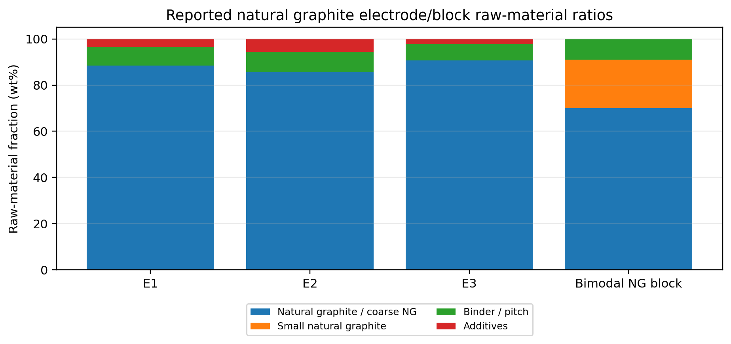
Figure 1. Raw-material compositions from reported natural graphite electrode examples and bimodal natural graphite block data.
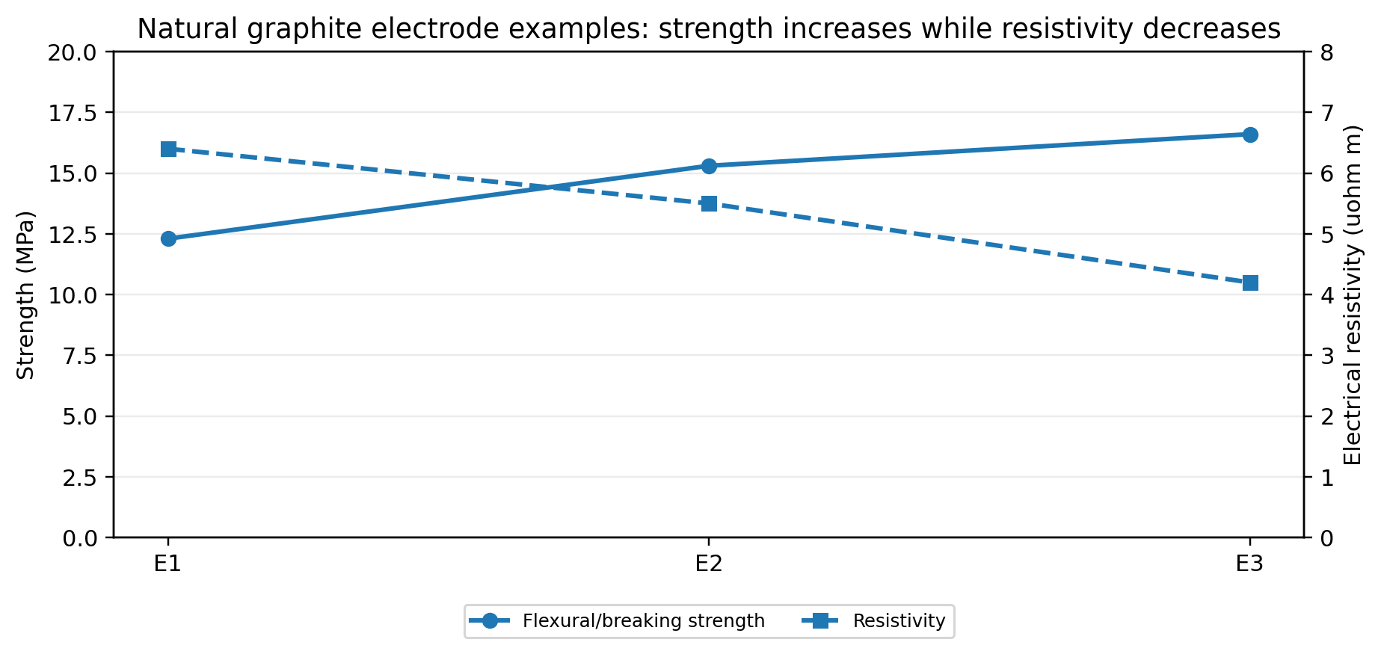
Figure 2. In reported natural graphite electrode examples, the highest strength and lowest resistivity occurred in Example 3. The trend is process-coupled because pressure and firing temperature also changed.
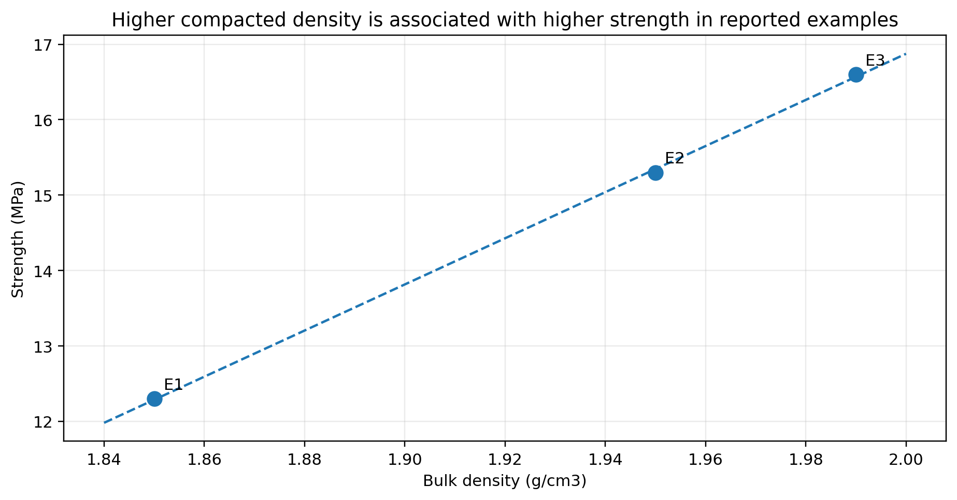
Figure 3. Bulk density and strength relationship in the three reported natural graphite electrode examples.

2.3 Bimodal natural graphite block data
Kim et al. reported a natural graphite block fabricated from a bimodal natural graphite system. Their best reported formulation contained 70 wt% large natural graphite particles, 21 wt% small natural graphite particles, and 9 wt% pitch binder. After pressure-mold heat treatment at 2600 deg C, this composition achieved 460 W/m K thermal conductivity and 14 MPa flexural strength [2].
Material function | Recommended ratio from Kim et al. | Interpretation
Large natural graphite | 70 wt% | Forms the high-conductivity skeleton and reduces binder demand.
Small natural graphite | 21 wt% | Fills voids between large particles and improves packing continuity.
Pitch binder | 9 wt% | Creates binder carbon after carbonization; too much can generate pores.
Reported performance | 460 W/m K and 14 MPa after 2600 deg C | Shows the value of bimodal packing when additives are not used.

3. Recommended optimized ratio
Recommended starting point for natural graphite electrode: Use the Example 3-style composition as the first experimental center point:
Raw material | Specific starting ratio | Recommended experimental window | Reason
Natural flake graphite | 90.65 wt% | 89.5-91.0 wt% | High-conductivity skeleton; high graphite fraction but enough binder/additive remains.
Modified liquid asphalt / pitch resin | 5.00 wt% | 4.5-5.5 wt% | Main graphitizable binder and coating carbon.
Phenolic or furan resin | 2.00 wt% | 1.5-2.5 wt% | Additional binding and green strength; carbon residue after curing/baking.
Total binder | 7.00 wt% | 6.5-7.5 wt% | Balances bonding strength and pore formation risk.
Silicon powder | 2.00 wt% | 1.8-2.5 wt% | Oxidation resistance and hot-strength support; avoid excessive ash.
Iron oxide powder | 0.20 wt% | 0.15-0.30 wt% | Catalyzes binder-carbon graphitization and lowers resistivity.
Short carbon fiber | 0.15 wt% | 0.10-0.20 wt% | Crack bridging and thermal shock resistance.
Total additives | 2.35 wt% | 2.0-3.0 wt% | Enough functional additive without excessive non-carbon phase.
Alternative additive-free block formulation: If the goal is a natural graphite block/electrode with no Si or Fe additives, use 70 wt% large NG + 21 wt% small NG + 9 wt% pitch binder as a strong literature-based starting point [2]. If only graphite powder and coal tar pitch are available, a broader practical window is 75-85 parts graphite powder and 15-25 parts coal tar pitch, but this higher pitch level may increase volatile loss and porosity unless impregnation and heat treatment are carefully controlled [3].
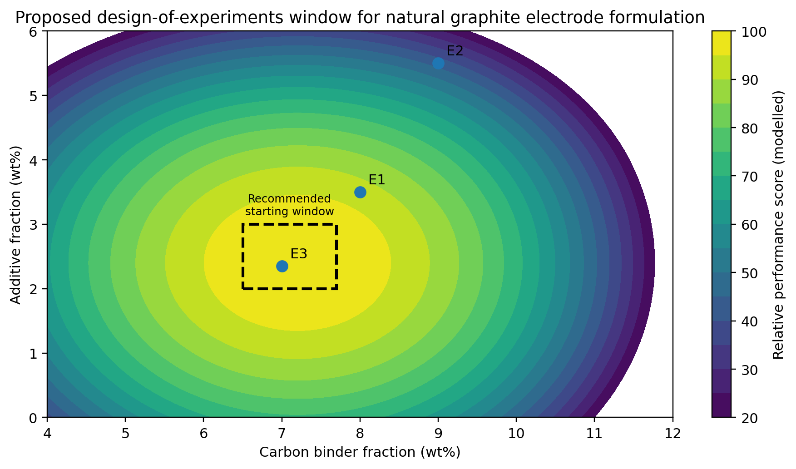
Figure 4. Proposed design-of-experiments window. This is a modelled guidance map, not a direct measurement. It is centered on the best reported natural graphite electrode example.

4. Why this ratio is optimized: mechanism
The optimum comes from three competing requirements:
- High natural graphite fraction is needed for conductivity, thermal conductivity, low shrinkage, and low electrical resistivity.
- Enough binder carbon is needed to create mechanical bridges between graphite particles after curing and carbonization.
- Enough fine particles/additives are needed to fill voids, improve crack resistance, and reduce oxidation/resistivity, but too much additive increases ash and non-carbon phases.
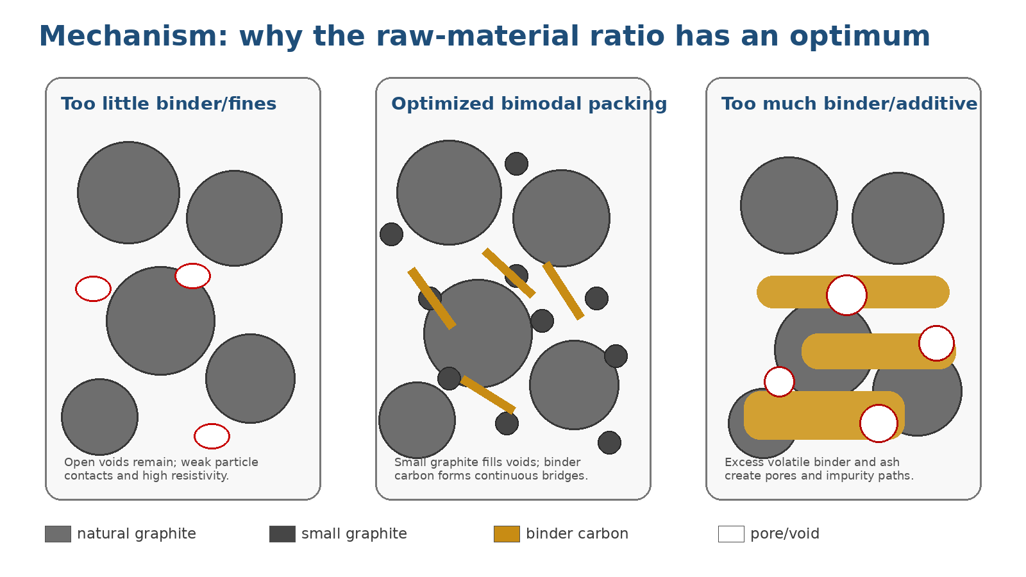
Figure 5. Mechanistic schematic for the optimum raw-material ratio.

5. Equations for formulation and evaluation
Purpose | Formula | Meaning
Mass balance | x_NG + x_binder + x_additive = 100 | The raw mixture must sum to 100 wt%.
Binder fixed carbon | C_fixed = x_binder * Y_c | Y_c is carbon yield of binder after baking. Low Y_c leaves pores.
Final carbon skeleton estimate | C_skeleton = x_NG + x_fiber + C_fixed | Useful for estimating remaining solid carbon after volatiles escape.
Open porosity estimate | P = 1 - rho_bulk / rho_true | Higher porosity usually lowers strength and raises resistivity.
Three-point flexural strength | sigma_f = 3 F L / (2 b d^2) | F is fracture load, L support span, b width, d thickness.
Electrical resistivity | rho_e = R A / L | R is resistance, A cross-section, L length.
Graphitization degree | G(%) = (0.3440 - d002) / (0.3440 - 0.3354) * 100 | XRD-based estimate of carbon ordering.
Composite objective | Score = w1*S_norm + w2*D_norm - w3*R_norm - w4*Ash_norm - w5*P_norm | Use weights based on target: strength, density, resistivity, ash, porosity.

6. Practical optimization method
Step 1 - Fix the graphite quality. Use high-purity flake natural graphite with controlled ash and moisture. Mixing different graphite purities makes the ratio optimization misleading.
Step 2 - Use bimodal particle packing. Prepare coarse and fine natural graphite fractions. For additive-free blocks, use a center point near 70:21:9 large NG:small NG:pitch. For electrode-style materials, keep the total natural graphite about 90 wt%, but make part of the graphite fine enough to fill coarse-particle voids.
Step 3 - Optimize binder at 6.5-7.5 wt% first. Below this range, interparticle bonding may be weak. Above this range, volatile release and coke shrinkage can increase pores. Kim (2023) also emphasized that binder pitch molecular-weight distribution, affinity, coking behavior, and viscosity control density and strength; high-viscosity or poorly compatible pitch can form many open pores and reduce strength [4].
Step 4 - Keep additive ash low. Use Si and Fe2O3 only if oxidation resistance and binder-carbon graphitization are important. For high-purity applications, avoid excessive Si/Fe because they remain as non-carbon phases unless post-treatment removes them.
Step 5 - Decouple formulation from processing. The reported patent examples improved from E1 to E3, but the process also changed from 120 to 300 MPa and from 1200 to 1600 deg C. Therefore, the true optimum should be confirmed using a factorial experimental matrix in which ratio, pressure, and firing temperature are varied independently.

7. Proposed experimental matrix
Factor | Low level | Center level | High level | Measurement response
Natural graphite total | 88.5 wt% | 90.65 wt% | 92.0 wt% | Resistivity, density, strength
Binder total | 6.5 wt% | 7.0 wt% | 8.0 wt% | Green strength, pore volume, flexural strength
Fine NG portion inside total NG | 15 wt% of NG | 20 wt% of NG | 25 wt% of NG | Packing density, thermal conductivity
Si powder | 1.5 wt% | 2.0 wt% | 2.5 wt% | Oxidation rate, hot strength, ash
Fe2O3 | 0.10 wt% | 0.20 wt% | 0.30 wt% | XRD d002, resistivity, residual Fe
Carbon fiber | 0.10 wt% | 0.15 wt% | 0.20 wt% | Flexural strength, thermal shock resistance
Isostatic pressure | 180 MPa | 250 MPa | 300 MPa | Density, anisotropy, cracking
Firing temperature | 1200 deg C | 1400 deg C | 1600 deg C | Resistivity, binder-carbon ordering
Recommended minimum sample set: Start with 9 formulations using a Taguchi L9 or response-surface design around the center point. Measure bulk density, open porosity, flexural strength, electrical resistivity, oxidation mass loss, XRD d002, Raman ID/IG, ash content, and microstructure by optical/SEM image analysis.

8. Expected phenomena when each ratio changes
Change in raw material | Expected positive effect | Expected negative effect if excessive
Increase natural graphite | Lower resistivity, higher thermal conductivity, lower shrinkage | Insufficient binder bridges, lower green strength and brittle interfaces
Increase binder | Better coating and bonding, higher green strength | More volatile loss, pores, shrinkage cracks, higher resistivity
Increase fine natural graphite | Better packing, lower pore volume, more contact points | Higher viscosity/mixing difficulty; more binder demand due to higher surface area
Increase Si powder | Better oxidation resistance and hot strength | Higher ash/non-carbon content; possible local hard inclusions
Increase Fe2O3 | More binder-carbon graphitization and lower resistivity | Residual Fe/oxide ash; possible catalytic oxidation risk if not controlled
Increase carbon fiber | Crack bridging and thermal shock resistance | Fiber agglomeration and anisotropy if poorly dispersed

9. Final recommendation
Best single starting ratio for experiments: 90.65 wt% natural flake graphite, 5.0 wt% modified pitch/asphalt resin, 2.0 wt% phenolic or furan resin, 2.0 wt% silicon powder, 0.20 wt% iron oxide, and 0.15 wt% short carbon fiber.
Best practical window: 89.5-91.0 wt% natural graphite, 6.5-7.5 wt% total carbon binder, and 2.0-3.0 wt% additives. Use 0.10-0.20 wt% short carbon fiber, 1.8-2.5 wt% Si powder, and 0.15-0.30 wt% Fe2O3 as the first additive window.
If the product must be low-ash or additive-free: Use a bimodal packing approach instead: about 70 wt% large natural graphite, 21 wt% small natural graphite, and 9 wt% pitch binder. This has published evidence for high thermal conductivity and 14 MPa flexural strength after graphitization at 2600 deg C [2].
Most important caution: Do not judge the optimum only by raw ratio. The same ratio can perform poorly if binder viscosity is too high, binder carbon yield is too low, mixing is non-uniform, or the pressure/firing schedule leaves large pores. The optimum is a coupled ratio-process window.

