Reducing the Unsaturation Degree of Oil Using Nanoparticle Catalysts
Paper-style technical note with mechanism, equations, literature data, graphs, and experimental plan
Prepared for: Scientific discussion and experimental planning
Scope: Vegetable/plant oils and similar triglyceride oils; the same principles also apply to fatty-acid methyl esters and many industrial bio-oils.

1. Direct Answer
Yes, nanoparticles can reduce the unsaturation degree of oil, but only when they act as hydrogenation catalysts in the presence of a hydrogen source. The nanoparticle itself is not consumed stoichiometrically. It provides active metal surface sites that dissociate H2 and transfer hydrogen atoms to carbon-carbon double bonds in fatty chains. The practical result is a lower iodine value, improved oxidative stability, and usually a higher melting/solid-fat tendency.
Most practical catalyst families: supported nickel nanoparticles such as Ni/SiO2, Ni/Al2O3 or Ni/kieselguhr for low-cost industrial hydrogenation; supported palladium nanoparticles such as Pd/C, Pd/bentonite, Pd/SBA-15 or Pd-B/Al2O3 for milder or more selective processes; and Pt/Ru systems for specialized high-activity research use.
Important limitation: if the target is edible oil, hydrogenation must be controlled to avoid trans-fat formation and excessive saturated-fat formation. If the target is industrial oil, lubricant oil, biodiesel or polymer/feedstock modification, a lower iodine value may be more important than food-nutrition constraints, but catalyst removal and metal residue still matter.

2. Chemistry and Key Equations
The main chemical transformation is hydrogen addition across a carbon-carbon double bond:
R-CH=CH-R + H2 -> R-CH2-CH2-R
For a triglyceride oil, this reaction reduces the number of olefinic bonds in oleic, linoleic, linolenic and other unsaturated fatty acyl chains. The usual analytical indicator is iodine value (IV), expressed as grams of I2 consumed per 100 g of oil.
Purpose | Formula | Meaning
Conversion based on IV | X_C=C (%) = [(IV0 - IVf) / IV0] x 100 | Fraction of double-bond capacity removed relative to the starting oil.
Theoretical hydrogen demand | n_H2 = [(IV0 - IVf) / 253.8] x (m_oil / 100) | Moles of H2 needed for a target IV decrease; 253.8 g/mol is molar mass of I2.
Mass of hydrogen | m_H2 = n_H2 x 2.016 | Theoretical H2 mass, not including losses or excess gas.
Selectivity warning | S_i = Delta(% trans fat) / Delta(% conversion) | Higher value means more trans isomerization per unit of hydrogenation.

Example calculation
If soybean oil starts at IV = 129 and is hydrogenated to IV = 71, then Delta IV = 58. For 100 g of oil:
n_H2 = 58 / 253.8 = 0.229 mol H2; m_H2 = 0.229 x 2.016 = 0.46 g H2
This is the theoretical stoichiometric hydrogen requirement. A real reactor uses excess hydrogen because of gas-liquid mass transfer, headspace, mixing, catalyst wetting and safety-control needs.

3. Nanoparticle Hydrogenation Mechanism
The reaction is heterogeneous. Oil molecules, hydrogen gas and catalyst particles must meet at the catalyst surface. A simplified mechanism is:
- H2 diffuses from the gas phase into the oil and reaches the metal nanoparticle surface.
- The metal surface dissociates H2 into adsorbed hydrogen atoms. Ni, Pd, Pt and Ru are effective because they can activate H2.
- The C=C bond in the fatty chain adsorbs on the metal surface.
- Two surface hydrogen atoms are added across the C=C bond, forming a saturated C-C bond.
- If hydrogen addition is incomplete or the adsorbed intermediate desorbs/re-adsorbs, cis-trans isomerization or double-bond migration can occur.
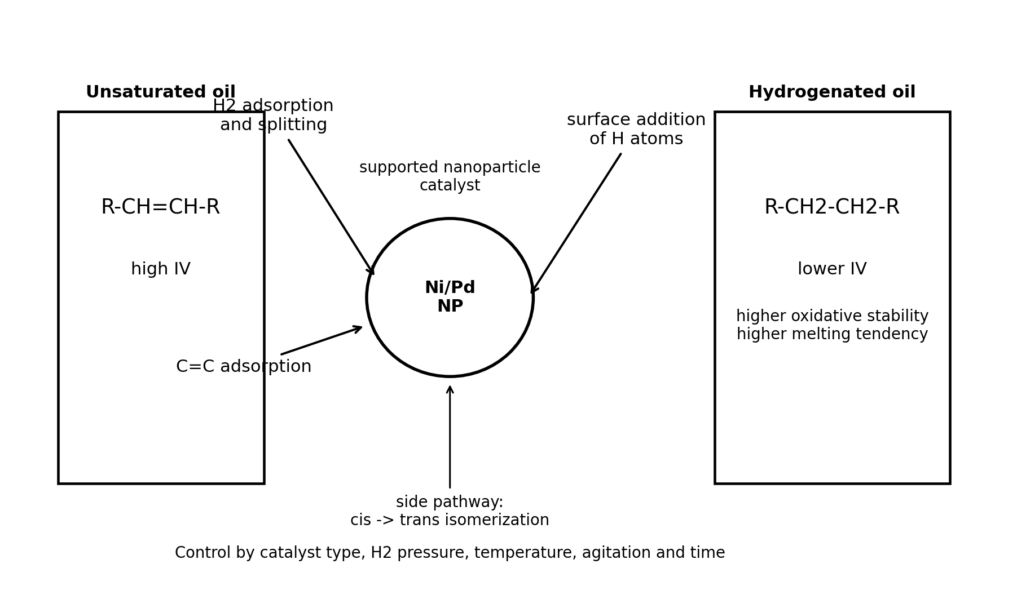
Figure 1. Simplified surface mechanism for nanoparticle-catalyzed oil hydrogenation.

4. Literature Evidence and Real Experimental Data
The table below compiles representative experimental data from a 2025 RSC Advances comparison table of supported catalysts, supplemented by the study's Pd/bentonite results. These data show that nanoparticle or supported-metal catalysts can reduce iodine value substantially, but the trans-fat and saturated-fat outcomes depend strongly on catalyst type and process conditions.
Catalyst | Oil | T (C) | H2 pressure (psi) | IV0 | IVf | Time (min) | Trans fat (%) | SFA (%)
Pd-Ru/SBA-15 | Sunflower | 110 | 73.47 | 130 | 70 | 60 | 29.0 | 18.0
Ni-Al-Ce | Canola | 180 | 304.57 | 115 | 70 | 13 | 20.9 | 18.1
Pt-Ni/SiO2 | Sunflower | 170 | 43.51 | 128 | 70 | 300 | 16.8 | 23.0
Ni-Mg/SiO2 | Sunflower | 180 | 72.52 | 124 | 70 | 59 | 13.7 | 34.4
Ni-Cu-Mg/Kieselguhr | Soybean | 110 | 60.92 | 130 | 70 | 75 | 21.1 | 20.6
Ni (Pricat 9920) | Sunflower | 110 | 73.47 | 130 | 60 | 60 | 30.0 | 30.0
Pd/bentonite, 70C | Soybean | 70 | 550 | 127 | 71 | 71 | 28.3 | 13.0
Pd/bentonite, 25C | Soybean | 25 | 550 | 127 | 76 | 76 | 11.2 | 16.5
Source note: Data summarized from Herrera-Guzman et al., RSC Advances, 2025, Table 9 and abstract: Pd/bentonite achieved iodine values near 70 under 550 psi H2 at 25-70 C; Table 9 compares Pd, Ni and Pt-based supported catalysts.
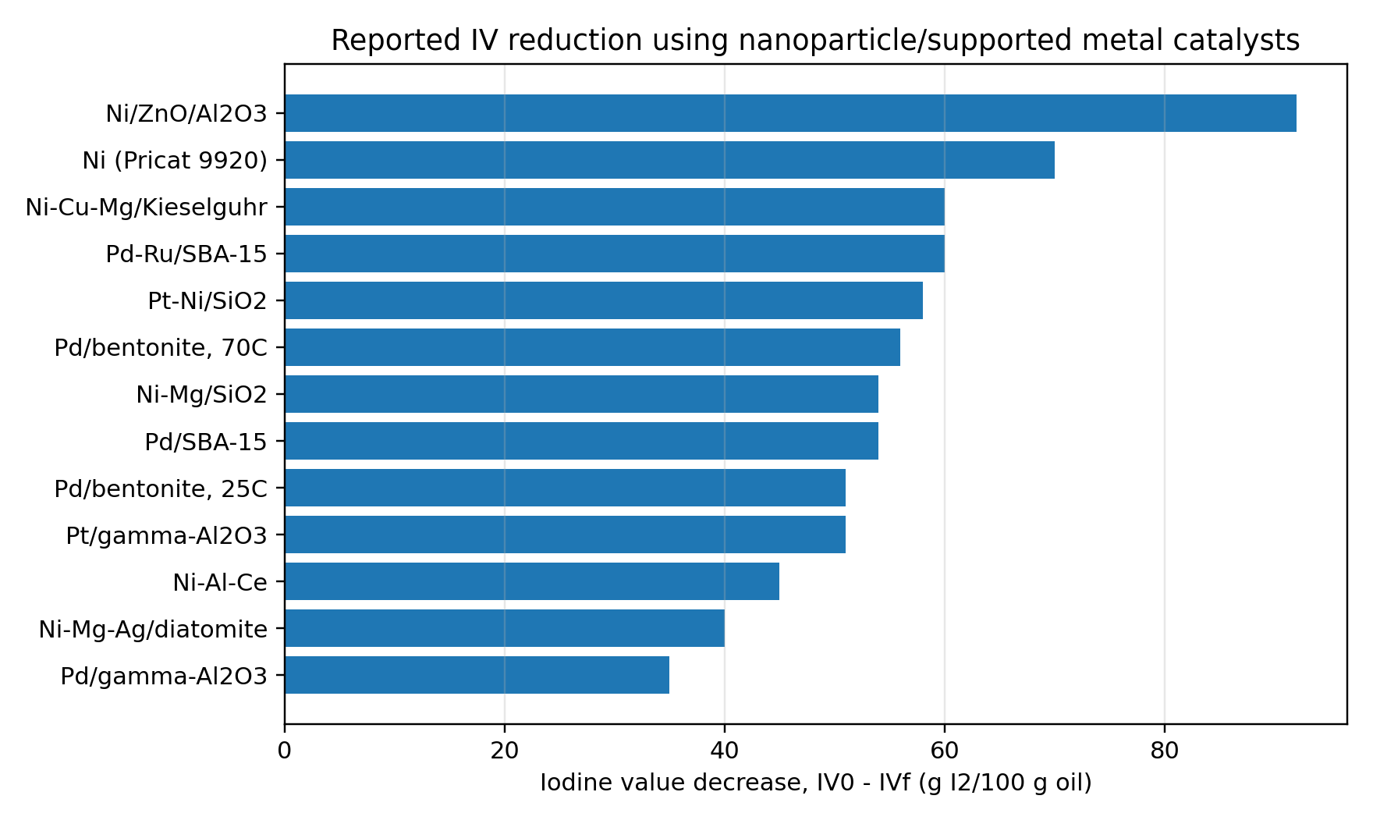
Figure 2. IV reduction reported for supported metal catalysts. Larger IV decrease means stronger reduction of unsaturation.
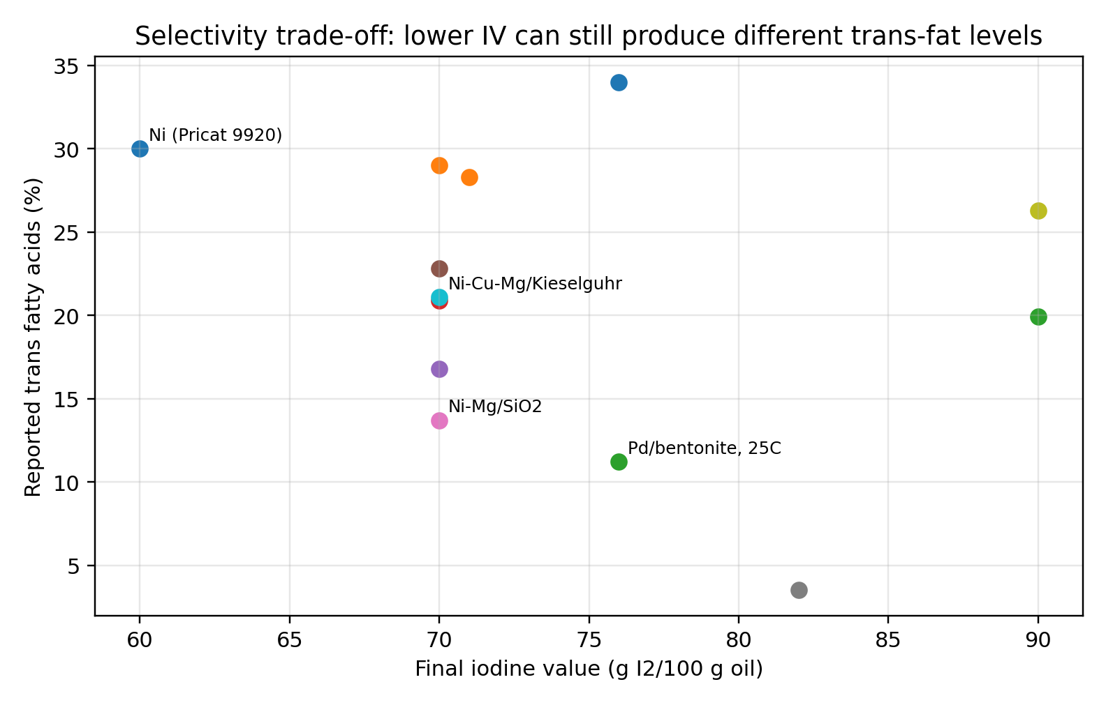
Figure 3. Final IV versus trans-fat formation. Lower IV is not automatically better if edible-oil quality is important.

5. Which Nanoparticle Catalyst Should Be Used?
Catalyst family | Advantages | Main risks | Recommended use
Ni nanoparticles / supported Ni | Low cost, industrially proven, high activity at 120-180 C | Trans-fat formation, Ni residue, catalyst deactivation, possible soap formation | Industrial hardening, biodiesel stabilization, non-food oils, cost-sensitive systems
Pd nanoparticles / supported Pd | High activity, can work at lower temperature, often more tunable | Expensive, can over-hydrogenate, pressure may still be high | Mild partial hydrogenation, research, selective processes
Pt or Ru nanoparticles | Very high H2 activation ability | Cost, over-hydrogenation, specialized handling | Laboratory screening or high-value products
Bimetallic systems, e.g. Pd-Ru, Ni-Cu, Ni-Ag | Can tune selectivity, activity and trans-fat tendency | More complex preparation and scale-up | Optimization when selectivity matters
Magnetic supported catalysts, e.g. Fe3O4-based supports | Easier recovery by magnet, good for lab recycling | Support leaching/compatibility must be tested | Reusable catalyst development
Best practical starting point: For most engineering trials, start with supported Ni if cost and strong IV reduction matter, or supported Pd if mild temperature and selectivity matter. Do not use free unsupported nanoparticles in a production oil unless you have a proven separation and residue-control method; supported catalysts are safer and easier to filter.

6. How to Maximize Reduction of Unsaturation
Maximizing hydrogenation is a balance between chemical conversion and product quality. Increasing temperature, H2 pressure, catalyst loading, metal dispersion, agitation and reaction time generally lowers IV faster, but can also increase saturated fatty acids, trans isomers, catalyst deactivation and metal contamination.
Parameter | Effect on IV reduction | Risk if too high | Recommended control
Catalyst loading | More active sites and faster IV decline | More metal residue, filtration load, possible selectivity loss | Screen 0.05-0.5 wt% active Ni or 0.01-0.1 wt% Pd relative to oil for lab trials
Temperature | Faster H2 addition and lower viscosity | More trans-isomerization and thermal degradation | Use lower temperature for edible oil; higher temperature for industrial full saturation
H2 pressure | Higher H2 availability at catalyst surface | Equipment risk and over-hydrogenation | Keep enough pressure to avoid hydrogen-starved catalyst surface
Agitation | Improves gas-liquid-solid mass transfer | Foaming or vortexing if excessive | Maintain catalyst suspension and good gas dispersion
Oil purification | Reduces catalyst poisoning | Extra pre-treatment cost | Dry, degum and remove soaps, sulfur/phosphorus impurities and water
Reaction time | Directly lowers IV | Over-hydrogenation and more SFA | Stop by IV endpoint, not by fixed time only
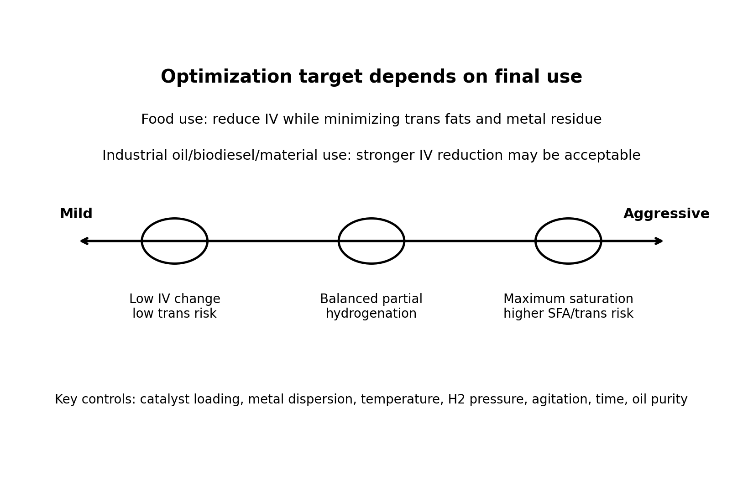
Figure 4. Practical optimization window. The best condition depends on the final application, not only on the lowest iodine value.

7. Recommended Experimental Plan
A small factorial experiment is recommended before scale-up. The response should not be only iodine value; it should include trans-fat content, saturated-fat content, catalyst residue, peroxide value, viscosity and melting/solid-fat behavior.
Run | Catalyst | Active metal | Temp. (C) | H2 pressure | Time | Purpose
C0 | No catalyst | 0 | same as trial | same | same | Check that H2 alone is insufficient under chosen conditions
N1 | Ni/SiO2 or Ni/kieselguhr | 0.05 wt% Ni | 140-160 | moderate | 30-90 min | Mild Ni baseline
N2 | Ni/SiO2 or Ni/kieselguhr | 0.10-0.20 wt% Ni | 160-180 | moderate-high | 30-120 min | Stronger IV decrease
P1 | Pd/C, Pd/bentonite or Pd/Al2O3 | 0.01-0.05 wt% Pd | 50-100 | moderate-high | 30-120 min | Lower-temperature selective trial
B1 | Pd-Ru or Ni-Cu system | same total metal as best run | optimized | optimized | endpoint | Selectivity tuning
Endpoint | Best catalyst | fixed | fixed | fixed | stop at IV target | Confirm reproducibility at target IV

8. Measurements Needed
- Iodine value: Primary measure of unsaturation. Lower IV means fewer double bonds.
- GC-FAME fatty acid profile: Quantifies oleic, linoleic, linolenic, stearic and trans isomers.
- 1H NMR: Tracks olefinic proton signals and can estimate unsaturation rapidly.
- Peroxide value and oxidative stability: Confirms whether lower unsaturation improves oxidation resistance.
- Metal residue, ICP-OES/ICP-MS: Verifies removal of Ni/Pd/Pt/Ru after filtration or bleaching.
- Melting point, cloud point, viscosity: Important for practical oil behavior after hydrogenation.

9. Safety and Practical Warnings
- Hydrogen gas is flammable and explosive. Use proper pressure reactors, purge procedures, leak detection and ignition control.
- Dry nickel catalysts can be pyrophoric; handle according to supplier procedures and never expose active catalyst carelessly to air.
- Nickel residue is undesirable in edible oils and can be restricted by regulations; final oil must be filtered and tested.
- For edible oils, partial hydrogenation can form trans fats. A low IV alone is not enough to claim a good food-grade product.
- For industrial oils, trans content may be less critical, but oxidative stability, pour point, viscosity and catalyst contamination remain important.

10. Literature Data Notes Used in This Paper
This section is included as source notes rather than a separate reference list.
Source | Data or claim used | Why it matters
Spiekermann & Seidensticker, Catalysis Science & Technology, 2024 | Review of catalytic processes for selective hydrogenation of fats and oils; notes Ni as historically common and highlights selectivity/trans-fat issues. | Provides scientific background and industrial context.
Herrera-Guzman et al., RSC Advances, 2025 | Pd/bentonite hydrogenation of soybean oil and comparison table of supported catalysts reaching IV near 70. | Provides real catalyst data used in Figures 2 and 3.
Gabrovska et al., International Journal of Molecular Sciences, 2024 | Ni/SiO2 catalyst activation by reduction to metallic Ni and the importance of Ni surface area/dispersion. | Supports catalyst-selection and activation discussion.
AOCS Hydrogenation in Practice, 2022 | Industrial hydrogenation practice, Ni-catalyst deactivation, and soybean oil hardened to IV 70. | Supports practical processing warnings.
USDA ARS List et al., 2007 | Ni-catalyzed hydrogenation at 175 C and 15 psi showed high trans-fat levels near IV 70; lower IV near 40 reduced trans but increased stearic acid. | Shows why IV reduction and quality must be optimized together.
Oriental Journal of Chemistry, 2014 | Pd-B/gamma-Al2O3 sunflower-oil optimization: IV declined from 125 to 72.5 with 10.6% TFA at optimized conditions. | Supports DOE and optimization approach.

11. Conclusion
Nanoparticle catalysts can reduce oil unsaturation effectively by catalytic hydrogenation. The strongest practical route is oil + H2 + supported metal nanoparticles + controlled heat/pressure/agitation. The best catalyst depends on the target: supported Ni is economical and strong, while supported Pd can work under milder conditions and may be better for selectivity optimization. The quality target should be an IV range, not simply the lowest IV possible. For edible oils, the formulation must minimize trans-fat formation and metal residue; for industrial oils, stronger saturation may be acceptable if viscosity, oxidative stability and catalyst removal are controlled.
Recommended starting strategy: screen Ni/SiO2 or Ni/kieselguhr against Pd/C or Pd/bentonite at a small scale, stop the reaction at the target IV, and evaluate IV, GC-FAME, trans-fat content, saturated fatty acids, peroxide value, viscosity, melting behavior and metal residue before scale-up.

