Adaptation of Vision Foundation Models for Knee Osteoarthritis Classification
Jonah Belback
1. PURPOSE
Knee osteoarthritis is a very common degenerative joint disease, caused by the cartilage in your knee joints breaking down and causing the bones to rub together. This is associated with pain, swelling, and stiffness. It is diagnosed by a medical professional evaluating a radiograph of the knee. It affects roughly 23% of adults over 40 worldwide, impacting 365 million people. Medical professionals are very busy and the evaluation of radiographs are a prime target to use with automated AI tools to decrease the amount of time it takes a medical professional to make their diagnosis.

2. METHODS
2.1 The Proposed Model Architecture
Figure 1 shows the overall model structure where DinoV2[1], or rather ViT, is used as a backbone to extract features from out input images. These features are then given to an MLP as a classification head for a binary label decided by a threshold of 0.5 on the confidence percentage that the input image shows Knee Osteoarthritis.
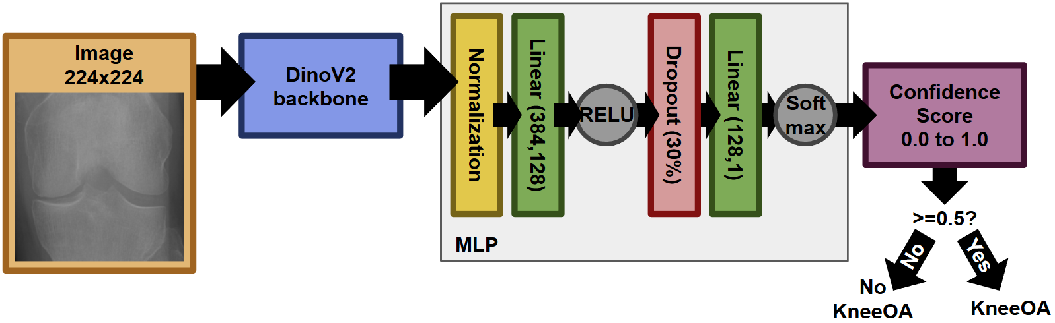
Figure 1. Architecture of the proposed machine learning structure for predicting Knee Osteoarthritis.

2.2 Evaluation
The model was trained on a split of training data that is adjusted with a separate validation split during training, and able to be evaluated with another split of testing data that is unseen. This is open to change as discussed later in capturing certain results. Given a split of 70% training data, the other 30% is split evenly between the validation and testing set.
They were ran on CUDA on a personal PC.
It utilized the Cross Entropy Loss function and was optimized with Adam.
Metrics used for evaluation was AUC, accuracy, marco-f1, and for both classes: precision, recall, and f1-score. There was also a generated Confusion Matrix, Loss curve, and ROC-AUC curve.

2.3 Experiments
The best learning rate to use for the model architecture was found by evaluating the model at a 70% training / 15% validation / 15% testing split, batch size of 16, epoch of 15, and then from 0.1 to 0.0000001 by steps of 10. This was done separately for both finetuning and not finetuning DinoV2. The evaluation was done with the split of unseen testing data, after being trained on the training split then adjusted with the validation split every epoch.
The results of these can be found in Table 1, where it was decided to go ahead with the standard learning rate of 1e-6 for without-finetuning and 1e-5 for with-finetuning from overall best performance across all metrics.
Table 1. Evaluation of learning rate to use as a standard. Metrics evaluated from on a separate 15% testing data split
 | Learning Rate | AUC | Accuracy | Macro-F1 | Precision |  | Recall |  | F1-score
 |  |  |  |  | Knee OA | No Knee OA | Knee OA | No Knee OA | Knee OA | No Knee OA
No Finetuning  DinoV2 | 0.1 | 0.500 | 0.29 | 0.225 | 0.23 | 0 | 1.00 | 0 | 0.45 | 0
No Finetuning  DinoV2 | 0.01 | 0.500 | 0.29 | 0.225 | 0.29 | 0 | 1.00 | 0 | 0.45 | 0
No Finetuning  DinoV2 | 0.001 | 0.500 | 0.27 | 0.215 | 0.27 | 0 | 1.00 | 0 | 0.43 | 0
No Finetuning  DinoV2 | 0.0001 | 0.520 | 0.32 | 0.255 | 0.30 | 0.92 | 0.99 | 0.05 | 0.46 | 0.09
No Finetuning  DinoV2 | 0.00001 | 0.956 | 0.98 | 0.965 | 1.00 | 0.97 | 0.91 | 1.00 | 0.95 | 0.98
No Finetuning  DinoV2 | 0.000001 | 0.967 | 0.96 | 0.950 | 0.87 | 1.00 | 0.99 | 0.94 | 0.93 | 0.97
No Finetuning  DinoV2 | 0.0000001 | 0.926 | 0.95 | 0.940 | 0.96 | 0.95 | 0.87 | 0.98 | 0.91 | 0.97
Finetuning  DinoV2 | 0.1 | 0.500 | 0.29 | 0.225 | 0.29 | 0 | 1.00 | 0 | 0.45 | 0
Finetuning  DinoV2 | 0.01 | 0.500 | 0.29 | 0.225 | 0.29 | 0 | 1.00 | 0 | 0.45 | 0
Finetuning  DinoV2 | 0.001 | 0.500 | 0.32 | 0.245 | 0.32 | 0 | 1.00 | 0 | 0.49 | 0
Finetuning  DinoV2 | 0.0001 | 0.537 | 0.63 | 0.545 | 0.35 | 0.74 | 0.36 | 0.73 | 0.35 | 0.74
Finetuning  DinoV2 | 0.00001 | 0.981 | 0.99 | 0.980 | 0.98 | 0.99 | 0.97 | 0.99 | 0.97 | 0.99
Finetuning  DinoV2 | 0.000001 | 0.965 | 0.98 | 0.970 | 0.99 | 0.97 | 0.93 | 1.00 | 0.96 | 0.98
Finetuning  DinoV2 | 0.0000001 | 0.932 | 0.96 | 0.945 | 0.98 | 0.94 | 0.87 | 0.99 | 0.92 | 0.97

3. RESULTS
Table 2 Shows the effect of data availability and how it impacts performance. These metrics were not derived from a unseen testing split; if we did that then when the amount of training data increases, there is fewer data to do the evaluation. This would result in it being evaluated on very specific cases and will peak at around 70% before decreasing around the limit of 100% which can’t be evaluated as there is no unseen data to use, as seen in Table 3. For this reason we did the final evaluation on the data it was trained on.
Following this, as the amount of data increases, so does the performance. This is because as the model gets more and more data, it is introduced to new cases it hasn’t seen before and becomes more generalizable to said data. With smaller amounts of data there is also the possibility of overfitting to a bias present in your small sample that will affect your performance to unseen data
Models with a frozen DinoV2 backbone were better compared to models that did finetuning. Although the performance can be considered comparable in many metrics, especially when there isn’t much to improve with such high scores, frozen always lead to a higher AUC. This can also be seen in their ROC graphs in figures 2c and 3c, where the curve for frozen is almost a right angle, while the finetuning is not as lucky. Also in the confusion matrixes 2a and 3a where frozen has an almost perfect alignment, while finetuning has a very poor false positive rate.
The best model overall is a finetuned DinoV2 on a learning rate of 1e-5, with a batch size of 16, and given as much data as possible.
In terms of consistency finetuning was a little more sporadic with results, sometimes it’d go really well to not as good to even better as you move in a certain direction.

Table 2. Results of model on its training data when the amount of training data shifts. Ran with batch size of 16, epoch of 20, and the optimal learning rate found previous. Metrics are evaluated from the same set of data used to train.
 | Amount of Data | AUC | Accuracy | Macro-F1 | Precision |  | Recall |  | F1-score
 |  |  |  |  | Knee OA | No Knee OA | Knee OA | No Knee OA | Knee OA | No Knee OA
Frozen  DinoV2 | 20% | 0.986 | 0.99 | 0.985 | 0.99 | 0.99 | 0.98 | 0.99 | 0.98 | 0.99
Frozen  DinoV2 | 30% | 0.977 | 0.99 | 0.985 | 0.99 | 0.98 | 0.96 | 1.00 | 0.98 | 0.99
Frozen  DinoV2 | 40% | 0.989 | 0.99 | 0.990 | 0.99 | 0.99 | 0.98 | 1.00 | 0.99 | 0.99
Frozen  DinoV2 | 50% | 0.987 | 0.99 | 0.985 | 0.99 | 0.99 | 0.98 | 1.00 | 0.98 | 0.99
Frozen  DinoV2 | 60% | 0.983 | 0.99 | 0.985 | 1.00 | 0.99 | 0.97 | 1.00 | 0.98 | 0.99
Frozen  DinoV2 | 70% | 0.982 | 0.98 | 0.970 | 0.94 | 1.00 | 0.99 | 0.97 | 0.96 | 0.98
Frozen  DinoV2 | 80% | 0.987 | 0.99 | 0.985 | 0.96 | 1.00 | 0.99 | 0.98 | 0.98 | 0.99
Frozen  DinoV2 | 90% | 0.970 | 0.98 | 0.980 | 1.00 | 0.98 | 0.94 | 1.00 | 0.97 | 0.99
Frozen  DinoV2 | 100% | 0.987 | 0.99 | 0.985 | 0.99 | 0.99 | 0.98 | 1.00 | 0.98 | 0.99
Finetuning  DinoV2 | 20% | 0.970 | 0.98 | 0.970 | 0.98 | 0.98 | 0.95 | 0.99 | 0.96 | 0.98
Finetuning  DinoV2 | 30% | 0.946 | 0.93 | 0.920 | 0.82 | 1.00 | 0.99 | 0.90 | 0.89 | 0.95
Finetuning  DinoV2 | 40% | 0.984 | 0.98 | 0.980 | 0.95 | 1.00 | 0.99 | 0.98 | 0.97 | 0.99
Finetuning  DinoV2 | 50% | 0.967 | 0.96 | 0.950 | 0.88 | 1.00 | 0.99 | 0.94 | 0.93 | 0.97
Finetuning  DinoV2 | 60% | 0.985 | 0.99 | 0.985 | 0.98 | 0.99 | 0.98 | 0.99 | 0.98 | 0.99
Finetuning  DinoV2 | 70% | 0.973 | 0.97 | 0.965 | 0.91 | 0.99 | 0.99 | 0.96 | 0.95 | 0.98
Finetuning  DinoV2 | 80% | 0.947 | 0.93 | 0.920 | 0.80 | 1.00 | 0.99 | 0.90 | 0.89 | 0.95
Finetuning  DinoV2 | 90% | 0.930 | 0.91 | 0.895 | 0.77 | 0.99 | 0.99 | 0.87 | 0.86 | 0.93
Finetuning  DinoV2 | 100% | 0.973 | 0.97 | 0.965 | 0.91 | 0.99 | 0.99 | 0.96 | 0.95 | 0.98

Table 3. Results of model on unseen data when the amount of training data shifts. Ran with batch size of 16, epoch of 20, and the optimal learning rate found previous. Metrics are evaluated from a separated split of unseen data.
 | Split of Data | AUC | Accuracy | Macro-F1 | Precision |  | Recall |  | F1-score
 |  |  |  |  | Knee OA | No Knee OA | Knee OA | No Knee OA | Knee OA | No Knee OA
Frozen  DinoV2 | 20% | 0.961 | 0.97 | 0.965 | 0.97 | 0.97 | 0.94 | 0.99 | 0.95 | 0.98
Frozen  DinoV2 | 30% | 0.966 | 0.97 | 0.965 | 0.94 | 0.98 | 0.96 | 0.98 | 0.95 | 0.98
Frozen  DinoV2 | 40% | 0.942 | 0.92 | 0.910 | 0.80 | 0.99 | 0.98 | 0.90 | 0.88 | 0.94
Frozen  DinoV2 | 50% | 0.968 | 0.98 | 0.970 | 0.97 | 0.98 | 0.95 | 0.99 | 0.96 | 0.98
Frozen  DinoV2 | 60% | 0.954 | 0.97 | 0.965 | 0.99 | 0.96 | 0.91 | 1.00 | 0.95 | 0.98
Frozen  DinoV2 | 70% | 0.969 | 0.98 | 0.980 | 0.99 | 0.98 | 0.94 | 1.00 | 0.97 | 0.99
Frozen  DinoV2 | 80% | 0.978 | 0.97 | 0.965 | 0.91 | 1.00 | 0.99 | 0.96 | 0.95 | 0.98
Frozen  DinoV2 | 90% | 0.978 | 0.98 | 0.970 | 0.94 | 0.99 | 0.99 | 0.97 | 0.96 | 0.98
Frozen  DinoV2 | 98% | 0.928 | 0.93 | 0.920 | 0.86 | 0.97 | 0.92 | 0.93 | 0.89 | 0.95
Finetuning  DinoV2 | 20% | 0.958 | 0.95 | 0.945 | 0.88 | 0.99 | 0.97 | 0.95 | 0.92 | 0.97
Finetuning  DinoV2 | 30% | 0.964 | 0.96 | 0.950 | 0.89 | 0.99 | 0.97 | 0.95 | 0.93 | 0.97
Finetuning  DinoV2 | 40% | 0.972 | 0.98 | 0.975 | 0.98 | 0.98 | 0.95 | 0.99 | 0.97 | 0.98
Finetuning  DinoV2 | 50% | 0.980 | 0.95 | 0.975 | 0.99 | 0.98 | 0.98 | 0.98 | 0.96 | 0.99
Finetuning  DinoV2 | 60% | 0.933 | 0.96 | 0.950 | 0.98 | 0.95 | 0.87 | 0.99 | 0.93 | 0.97
Finetuning  DinoV2 | 70% | 0.968 | 0.97 | 0.965 | 0.93 | 0.99 | 0.97 | 0.97 | 0.95 | 0.98
Finetuning  DinoV2 | 80% | 0.956 | 0.97 | 0.965 | 1.00 | 0.96 | 0.91 | 1.00 | 0.95 | 0.98
Finetuning  DinoV2 | 90% | 0.898 | 0.87 | 0.860 | 0.71 | 0.98 | 0.97 | 0.93 | 0.82 | 0.90
Finetuning  DinoV2 | 98% | 0.926 | 0.93 | 0.915 | 0.85 | 0.97 | 0.92 | 0.94 | 0.88 | 0.95

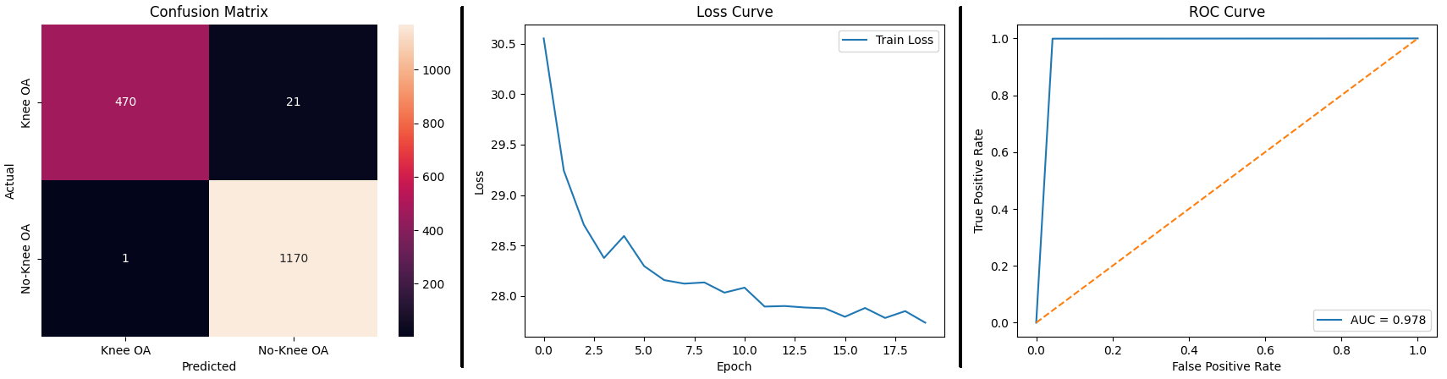
Figure 2a,b,c. The Confusion matrix (left, a), The Loss Curve (middle, b), The ROC Curve (right, c); from the best frozen DinoV2 model; also referenced in bold in Table 2. Take from 40% split.
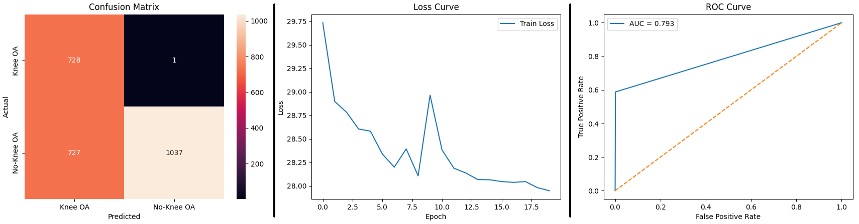
Figure 3a,b,c. The Confusion matrix (left, a), The Loss Curve (middle, b), The ROC Curve (right, c); from the best finetuning DinoV2 model; also referenced in bold in Table 2. Take from 60%

4. DISCUSSION
In this study we developed a model to evaluate the likelihood of knee osteoarthritis in radiographs using the DinoV2 model. Our results shows that as the amount of data increases, so does the performance and generalizability of our model. We were also able to evaluate the effects of finetuning or freezing the DinoV2 model and were able to achieve an extremely high level of performance.

REFERENCES
[1] Oquab, M., Darcet, T., Moutakanni, T., Vo, H., Szafraniec, M., Khalidov, V., Fernandez, P., Haziza, D., Massa, F., El-Nouby, A., Assran, M., Ballas, N., Galuba, W., Howes, R., Huang, P.-Y., Li, S.-W., Misra, I., Rabbat, M., Sharma, V., & Synnaeve, G. (2023, April 14). DINOv2: Learning Robust Visual Features without Supervision. ArXiv.org. https://doi.org/10.48550/arXiv.2304.07193

