DevicesInLan
Mariano Muñoz ©
Índice de contenido
1 ARP Message Format 1
2 Types of ARP 3
2.1 Gratuitous 3

ARP Message Format
Address resolution using ARP is accomplished through the exchange of messages between the source device seeking to perform the resolution, and the destination device that responds to it. As with other protocols, a special message format is used containing the information required for each step of the resolution process.
ARP messages use a relatively simple format. It includes a field describing the type of message (its operational code or opcode) and information on both layer two and layer three addresses. In order to support addresses that may be of varying length, the format specifies the type of protocol used at both layer two and layer three and the length of addresses used at each of these layers. It then includes space for all four of the address combinations we saw in the previous topic.
The format used for ARP messages is described fully in Table 42, and illustrated in Figure 49.

Table 42: Address Resolution Protocol (ARP) Message Format
Field Name | Size (bytes) | Description
HRD | 2 | 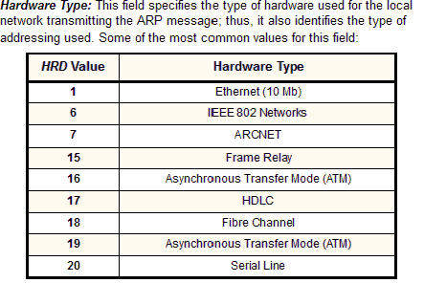
PRO | 2 | Protocol Type: This field is the complement of the Hardware Type field, specifying the type of layer three addresses used in the message. For IPv4 addresses, this value is 2048 (0800 hex), which corresponds to the EtherType code for the Internet Protocol.
HLN | 1 | Hardware Address Length: Specifies how long hardware addresses are in this message. For Ethernet or other networks using IEEE 802 MAC addresses, the value is 6.
PLN | 1 | Protocol Address Length: Again, the complement of the preceding field; specifies how long protocol (layer three) addresses are in this message. For IP(v4) addresses this value is of course 4.
OP | 2 | 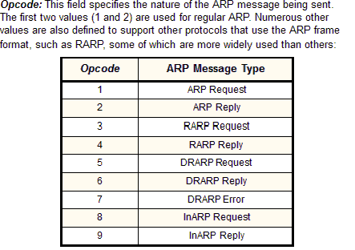
SHA | (Variable, equals value in HLN field) | Sender Hardware Address: The hardware (layer two) address of the device sending this message (which is the IP datagram source device on a request, and the IP datagram destination on a reply, as discussed in the topic on ARP operation).
SPA | (Variable, equals value in PLN field) | Sender Protocol Address: The IP address of the device sending this message.
THA | (Variable, equals value in HLN field) | Target Hardware Address: The hardware (layer two) address of the device this message is being sent to. This is the IP datagram destination device on a request, and the IP datagram source on a reply)
TPA | (Variable, equals value in PLN field) | Target Protocol Address: The IP address of the device this message is being sent to.

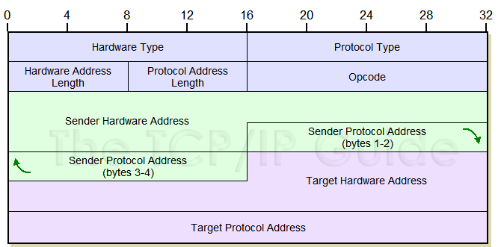
Figure 49: Address Resolution Protocol (ARP) Message Format
The ARP message format is designed to accommodate layer two and layer three addresses of various sizes. This diagram shows the most common implementation, which uses 32 bits for the layer three (“Protocol”) addresses, and 48 bits for the layer two hardware addresses. These numbers of course correspond to the address sizes of the Internet Protocol version 4 and IEEE 802 MAC addresses, used by Ethernet.

After the ARP message has been composed it is passed down to the data link layer for transmission. The entire contents of the message becomes the payload for the message actually sent on the network, such as an Ethernet frame. Note that the total size of the ARP message is variable, since the address fields are of variable length. Normally, though, these messages are quite small: for example, they are only 28 bytes for a network carrying IPv4 datagrams in IEEE 802 MAC addresses.

Types of ARP

Gratuitous
Gratuitous ARP could mean both gratuitous ARP request or gratuitous ARP reply. Gratuitous in this case means a request/reply that is not normally needed according to the ARP specification (RFC 826) but could be used in some cases. A gratuitous ARP request is an AddressResolutionProtocol request packet where the source and destination IP are both set to the IP of the machine issuing the packet and the destination MAC is the broadcast address ff:ff:ff:ff:ff:ff. Ordinarily, no reply packet will occur. A gratuitous ARP reply is a reply to which no request has been made.
Gratuitous ARPs are useful for four reasons:
- They can help detect IP conflicts. When a machine receives an ARP request containing a source IP that matches its own, then it knows there is an IP conflict.
- They assist in the updating of other machines' ARP tables. Clustering solutions utilize this when they move an IP from one NIC to another, or from one machine to another. Other machines maintain an ARP table that contains the MAC associated with an IP. When the cluster needs to move the IP to a different NIC, be it on the same machine or a different one, it reconfigures the NICs appropriately then broadcasts a gratuitous ARP reply to inform the neighboring machines about the change in MAC for the IP. Machines receiving the ARP packet then update their ARP tables with the new MAC.
- They inform switches of the MAC address of the machine on a given switch port, so that the switch knows that it should transmit packets sent to that MAC address on that switch port.
- Every time an IP interface or link goes up, the driver for that interface will typically send a gratuitous ARP to preload the ARP tables of all other local hosts. Thus, a gratuitous ARP will tell us that that host just has had a link up event, such as a link bounce, a machine just being rebooted or the user/sysadmin on that host just configuring the interface up. If we see multiple gratuitous ARPs from the same host frequently, it can be an indication of bad Ethernet hardware/cabling resulting in frequent link bounces.

