- Identify and explain three uses of Collections in VB applications.
- A collection is used to store and manage multiple values or objects in a single structure.
- Collections can store many related items such as names of students.
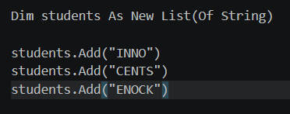
- Easy Searching and Accessing
Collections make it easy to find and access individual items.
- Managing Data Dynamically
Items can easily be added or removed while the program is running.

- Write short notes on Message Boxes and their types.
A Message Box is a small dialog box used to display information, warnings, questions, or errors to the user. And here are examples message box
Information
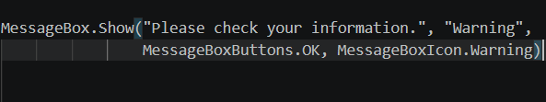
Warning
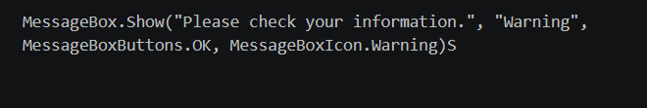
Error
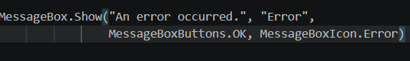
Question
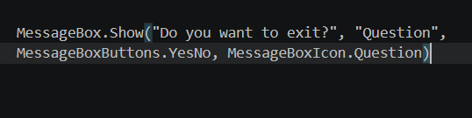

- Explain how the Solution Explorer assists in project management within Visual Studio.
Solution explorer is a window in Visual Studio that helps you view and manage the files and components of a project. It can allow you to:
- View projects and files in a solution.
- Open and edit forms, classes, and code files.
- Add or remove files from a project.
- Rename files and folders.
- View project references and dependencies.
- Access project properties and settings.

