Letter of Approval

To

**Name**: Fahim Montasir Turza

**Student ID**: 18CSE239

Department of CSE, BSMRSTU

**Subject**: Approval for “Speedy Send (Courier Service Website)” Project.

I am pleased to inform you that your “Speedy Send(Courier Service Website)” Project developed using React & Node has been approved. Your app showcases efficiency and meets our requirements effectively.

Thank you for your contribution and dedication to this project.

Best regards,

Nasif Ahmed

Assistant Professor

Department of CSE, BSMRSTU.

# Abstraction

Speedy Send is an innovative and user-centric parcel delivery service aimed at providing efficient, reliable, and convenient solutions to meet the ever-growing demands of modern logistics. This service is designed to streamline the process of sending parcels within the United States, offering both express and standard delivery options while prioritizing user experience and operational excellence.

With a strong focus on user accessibility and convenience, Speedy Send provides a user-friendly platform accessible through both web and mobile applications. Users can effortlessly schedule parcel pickups, select delivery preferences, track shipments in real-time, and securely pay for services, all within a seamless digital interface.

The core functionalities of Speedy Send revolve around efficient parcel management, leveraging cutting-edge technologies to optimize routing, enhance tracking accuracy, and ensure timely deliveries. By integrating existing GPS tracking systems and robust backend algorithms, Speedy Send aims to revolutionize the delivery experience, providing customers with peace of mind and reliability throughout the entire delivery process.

Administratively, Speedy Send offers a comprehensive backend system empowering administrators to oversee parcel logistics, manage driver assignments, analyze performance metrics, and promptly address customer inquiries. This multifaceted approach ensures operational efficiency while maintaining high standards of customer satisfaction.

Innovation remains at the forefront of Speedy Send's mission. The service continually adapts to market dynamics, explores strategic partnerships, and considers technological advancements to expand its reach and enhance service offerings. Moreover, compliance with regulatory frameworks and a commitment to ethical business practices underscore Speedy Send's dedication to integrity and responsibility in the logistics landscape.

By blending cutting-edge technology, operational expertise, and a customer-centric approach, Speedy Send endeavors to set new benchmarks in the parcel delivery industry, delivering not just packages but also reliability, convenience, and unparalleled service excellence to its users.

Table of Contents

Abstraction 2

Introduction 4

Purpose and Objectives 5

Technology Stack 6

Frontend 6

Backend 6

Deployment and Hosting 6

Other Tools and Technologies 7

Deployment Workflow 7

System Architecture 9

Key Features 10

Project Overview 12

Code Snippet 17

Challenges Faced 20

Testing and Quality Assurance 22

Future Enhancements 23

Conclusion 24

Reference 25

Figure 1 Home Page Banner 12

Figure 2 Home Page Statistics 12

Figure 3 Photo Gallery 13

Figure 4 Booking Form 13

Figure 5 User Parcel list 14

Figure 6 Default Admin Dashboard 14

Figure 7 All Parcels 15

Figure 8 Delivery Men 15

Figure 9 Assigned Parcel for Delivery man 16

Figure 10 Delivery Man Review 16

Figure 11 Folder Structure & Frontend setup 17

Figure 12 Private Route 18

Figure 13 Folder Structure & DB setup 19

# Introduction

In an era characterized by the relentless flow of goods and services, the need for efficient and dependable courier services has become increasingly crucial. Speedy Send emerges as an innovative and meticulously crafted solution designed to meet the escalating demand for streamlined logistics solutions. As a robust MERN-based web application, Speedy Send is purpose-built to simplify and enhance the package delivery process, catering to the diverse needs of businesses and individuals navigating the complexities of shipping.

At its core, Speedy Send sets out to bridge the geographical and logistical divide between senders and recipients, offering a sophisticated yet user-friendly platform that guarantees prompt, secure, and reliable deliveries. This platform is a testament to our commitment to facilitating seamless connections and ensuring the smooth transit of packages, irrespective of distance or destination.

The application's versatility is one of its defining features, catering to a wide spectrum of users. From e-commerce enterprises seeking to optimize their supply chain logistics to individual customers requiring straightforward and efficient shipping options, Speedy Send accommodates diverse needs and preferences. By offering a suite of comprehensive functionalities, including user registration, advanced package tracking capabilities, intuitive booking and delivery scheduling, secure payment processing, and a centralized administrative dashboard, Speedy Send becomes an all-encompassing solution for anyone looking to streamline their shipping process.

In essence, Speedy Send's significance lies in its adaptability and commitment to meeting the ever-evolving demands of the modern market. By leveraging cutting-edge technology and prioritizing user convenience, our platform aspires to redefine the courier service experience. Whether for businesses seeking operational efficiency or individuals craving hassle-free shipping experiences, Speedy Send aims to be the quintessential solution, surpassing expectations and setting new standards in the logistics domain.

# Purpose and Objectives

Speedy Send aims to transform traditional courier services by leveraging technology to streamline package delivery. Its primary objectives include enhancing delivery efficiency, bridging the gap between senders and recipients for swift and secure deliveries, catering to diverse user needs, leveraging technology for innovation, and prioritizing user convenience through a user-centric approach. This platform strives to offer seamless and reliable shipping experiences for businesses and individuals, setting new standards in the logistics industry.

**Addressing Market Needs**

Speedy Send was conceptualized and developed in response to the burgeoning demand for efficient, reliable, and user-friendly courier services within today's dynamic market. The platform strategically caters to several pressing market needs, starting with its unwavering focus on enhancing efficiency and reliability in package delivery. In a market where time-sensitive deliveries are paramount, Speedy Send optimizes logistics processes, ensuring swift and secure transportation while incorporating advanced tracking systems to bolster reliability and meet the market's need for dependable service.

Moreover, Speedy Send's adaptability and versatility represent pivotal attributes catering to a diverse spectrum of users. It accommodates the requirements of both businesses seeking robust logistics solutions for their supply chains and individual customers desiring straightforward, hassle-free shipping options. This adaptability aligns perfectly with the market's need for a flexible and all-encompassing courier service platform.

A key aspect where Speedy Send stands out is its integration of cutting-edge technology. By leveraging innovations such as advanced package tracking and secure payment processing, the platform meets the market's expectations for tech-driven solutions, enhancing convenience and providing a seamless user experience.

Central to its success is Speedy Send's commitment to a customer-centric approach. Addressing the market's increasing demand for services prioritizing user satisfaction, the platform boasts a user-friendly interface, responsive customer support, and efficient order management. These features collectively fulfill the market's need for a service that places customer needs at the forefront, ensuring a positive and fulfilling experience for all users.

Speedy Send, through its strategic approach emphasizing efficiency, adaptability, technological innovation, and customer satisfaction, effectively addresses crucial market needs, establishing itself as a frontrunner in the competitive landscape of courier services.

# Technology Stack

## Frontend

**React.js**: React.js is a powerful JavaScript library used for building user interfaces. It offers a component-based architecture for creating reusable UI elements and efficiently managing application state changes.

**Context API**: Context API is employed for state management in React.js applications, providing a centralized store to manage global application state and facilitate predictable data flow.

**HTML/CSS**: HTML is used for structuring web content, while CSS is employed for styling, ensuring visually appealing and responsive designs.

**JavaScript (ES6+)**: Modern JavaScript, specifically ES6 and newer features, is utilized to enhance functionality, introduce cleaner syntax, and leverage advanced programming constructs for frontend development.

## Backend

**Node.js**: Node.js is a server-side runtime environment for executing JavaScript code, allowing the development of scalable and efficient backend applications.

**Express.js**: Express.js is a lightweight and flexible web application framework for Node.js, simplifying the creation of robust APIs and handling HTTP requests and responses.

**MongoDB**: MongoDB is a NoSQL database known for its flexibility, scalability, and document-oriented data storage, ideal for managing and storing application data.

**Mongoose**: Mongoose is an ODM (Object Data Modeling) library for MongoDB, providing a schema-based solution for interacting with MongoDB databases using JavaScript objects.

## Deployment and Hosting

**Frontend**: Firebase Hosting (Frontend): The frontend of the Speedy Send application is deployed on Firebase Hosting. Firebase Hosting offers a fast and reliable hosting service for web applications, providing a scalable platform to deploy static assets, including HTML, CSS, and JavaScript files. It ensures the availability and efficient delivery of the frontend to users.

**Backend**: Vercel (Backend): The backend of the Speedy Send application is deployed on Vercel. Although Vercel is primarily known for hosting frontend applications, it can also host serverless functions and backend APIs. Leveraging its capabilities, the backend logic or APIs for Speedy Send are deployed on Vercel, utilizing its deployment workflows and serverless architecture.

**Authentication:** Firebase Authentication: Firebase Authentication is a service provided by Firebase, offering secure and reliable user authentication and authorization functionalities for web applications.

## Other Tools and Technologies

**Axios/Fetch API:** Axios or Fetch API is used to make HTTP requests from the frontend to backend APIs, enabling efficient communication between the client and server.

**JWT (JSON Web Tokens):** JWT is employed for secure user authentication and authorization, ensuring data integrity and enabling users to access protected resources across the application.

**Git/GitHub**: Git version control system and GitHub platform are utilized for collaborative development, enabling version tracking, team collaboration, and code management.

## Deployment Workflow

**Frontend Deployment**

Develop and build the frontend application using React.js, HTML, CSS, etc.

Configure Firebase Hosting by linking the project to Firebase and setting up deployment configurations.

Use Firebase CLI or integration with CI/CD pipelines to deploy the frontend codebase to Firebase Hosting.

Upon deployment, the frontend application becomes accessible via a Firebase Hosting URL, ensuring fast and reliable access for users.

**Backend Deployment**

Implement the backend logic or APIs using Node.js with Express.js and MongoDB for data storage.

Utilize Vercel's serverless functions or API routes to deploy the backend codebase.

Configure Vercel's deployment settings, environment variables, and routing for the backend APIs or serverless functions.

Deploy the backend codebase to Vercel using the Vercel CLI or through continuous deployment pipelines.

After deployment, the backend services are accessible via Vercel's serverless architecture, allowing seamless execution of backend logic and API requests.

**Integration and Testing**

Ensure proper integration between the frontend (hosted on Firebase) and backend (hosted on Vercel) by configuring API endpoints or URL connections.

Conduct thorough testing to verify the communication between the frontend and backend, ensuring data exchange and functionality across the application.

**Monitoring and Maintenance**

Regularly monitor the deployed frontend and backend for performance, uptime, and any potential issues.

Apply updates, bug fixes, and enhancements to both frontend and backend as needed, maintaining the application's reliability and functionality.

# System Architecture

**Frontend Architecture (Firebase Hosting)**

The frontend architecture of Speedy Send involves client-side components responsible for the user interface and interactions. Hosted on Firebase Hosting, the frontend is primarily developed using React.js along with HTML, CSS, and JavaScript resources.

React.js Components: Leveraging React.js, the frontend is structured using modular components that manage the user interface and facilitate seamless interactions. These components ensure a responsive and dynamic user experience.

Context API: Context API is employed for centralized state management in the frontend, maintaining application-wide states and enabling efficient data flow between React components.

API Requests: The frontend communicates with the backend (built using Node.js and Express.js with MongoDB) by making HTTP requests to specific API endpoints. These requests handle data retrieval and updates.

**Backend Architecture (Vercel Deployment)**

The backend architecture of Speedy Send, deployed on Vercel, comprises the server-side logic, APIs, and database operations. It utilizes Node.js with Express.js along with MongoDB through Mongoose for data storage and retrieval.

Node.js with Express.js: Backend development involves Node.js with Express.js, providing a robust framework for creating RESTful APIs and handling server-side logic. Express.js simplifies route management and middleware integration for efficient request handling.

Mongoose with MongoDB: Mongoose, an ODM (Object Data Modeling) library, interfaces with MongoDB, enabling schema-based data modeling and interactions. It facilitates seamless communication between the Node.js application and the MongoDB database, ensuring data integrity and structure.

**Integration and Communication**

The frontend communicates via RESTful APIs or serverless functions, triggering parcel management, delivery updates, and user authentication. The backend uses Mongoose to perform CRUD operations in MongoDB, ensuring smooth data storage and retrieval.

# Key Features

1. Parcel Booking Functionality:

* Effortless Booking: Simple and user-friendly interface for hassle-free scheduling of parcel pickups and choosing delivery preferences.
* Dynamic Pricing: Automated price calculation based on parcel weight and delivery options for transparent and quick cost estimation.
* Booking Status Management: Ability to save bookings as 'pending' until confirmed, providing flexibility in scheduling.

2. Real-time Parcel Tracking:

* Live Tracking: Robust system enabling users to monitor parcel status in real-time, keeping them updated throughout the delivery process.
* Status Notifications: Automated alerts for crucial delivery updates (pickup, transit, delivery), ensuring users stay informed.

3. Diverse Delivery Options:

* Flexible Choices: Various delivery options like same-day, next-day, and standard, catering to diverse user needs.
* Transparent Pricing: Clear breakdown of costs for each delivery choice, aiding users in decision-making.

4. Secure Payment Gateway:

* Convenient Payment Method: Provision for users to pay for parcels upon delivery, allowing for cash payments upon receiving the parcel.
* Flexibility and Convenience: Offers users an alternative payment choice, enhancing convenience and accommodating those preferring cash transactions upon delivery.

5. Enhanced User Experience:

* Intuitive Interface: User-centric design for easy navigation and interaction, ensuring a pleasant user journey.
* Personalized Profiles: User profiles allowing personalization, parcel history management, and profile picture uploads.

6. Backend Management Tools:

* Admin Dashboard: Comprehensive control panel empowering admins to efficiently manage accounts, parcels, and delivery operations.
* Route Optimization: Advanced algorithms ensuring efficient parcel routing for timely deliveries.

7. Delivery Men Interface:

* Assigned Parcels Overview: Dashboard for delivery personnel to manage assigned parcels effectively.
* Review Management: Access to user feedback for self-improvement and service enhancement.

8. Review and Feedback System:

* User Feedback Mechanism: Platform allowing users to provide feedback and ratings for delivery personnel's services.
* Transparency and Accountability: Establishing transparency and accountability within the delivery process.

9. Search and Filtering Options:

* Customizable Search: Tailored search and filtering for specific parcels or users based on defined criteria.
* Pagination Support: Efficient data handling using pagination for a smoother user experience.

# Project Overview

**Home Page**

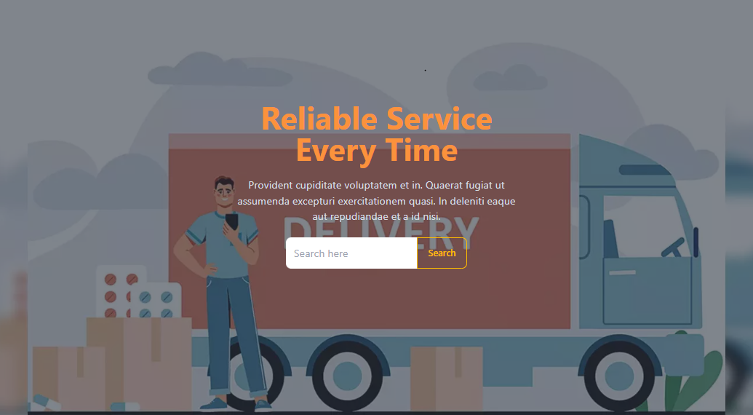

Figure 1 Home Page Banner

Welcome to Speedy Send, the cutting-edge parcel delivery solution designed for efficiency, reliability, and seamless user experiences. Our banner encapsulates the essence of a user-friendly platform, inviting users into a world of effortless parcel management and swift deliveries.

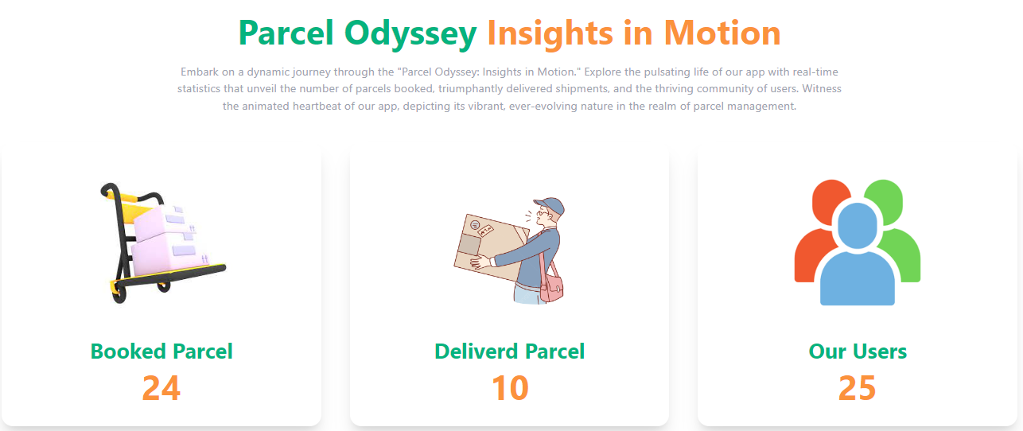

Figure 2Home Page Statistics

Witness the impressive statistics that define Speedy Send's operational prowess. Our platform thrives on these numbers, reflecting our commitment to efficiency, reliability, and user satisfaction.



Figure 3Photo Gallery

Witness the dedication and commitment of Speedy Send's delivery professionals in action through our exclusive photo gallery. Each snapshot encapsulates the hard work and diligence of our delivery team as they ensure prompt and secure deliveries.

**User Dashboard Page**

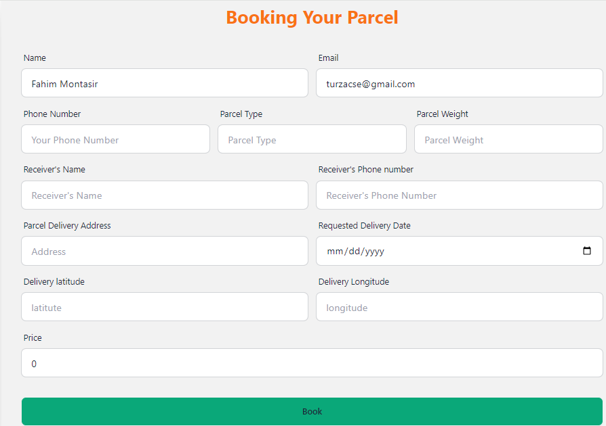

Figure 4 Booking Form

Experience the convenience of parcel booking through Speedy Send's intuitive form. Our user-friendly booking interface simplifies the process, allowing users to input essential details effortlessly.

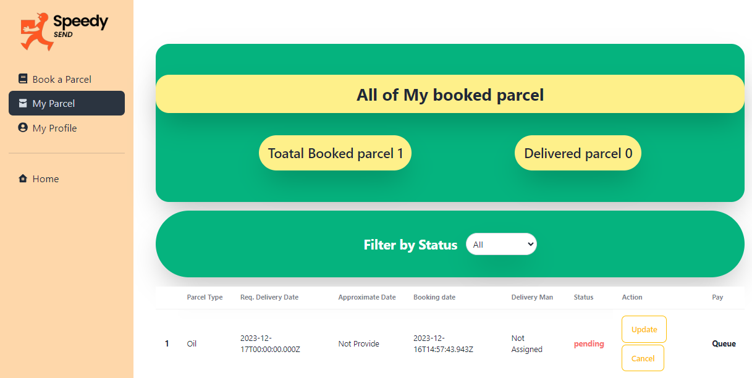

Figure 5 User Parcel list

Explore the comprehensive overview of your booked parcels through Speedy Send's user-centric interface. This feature empowers users to effortlessly monitor and manage their parcel deliveries in one centralized location.

**Admin Dashboard page**

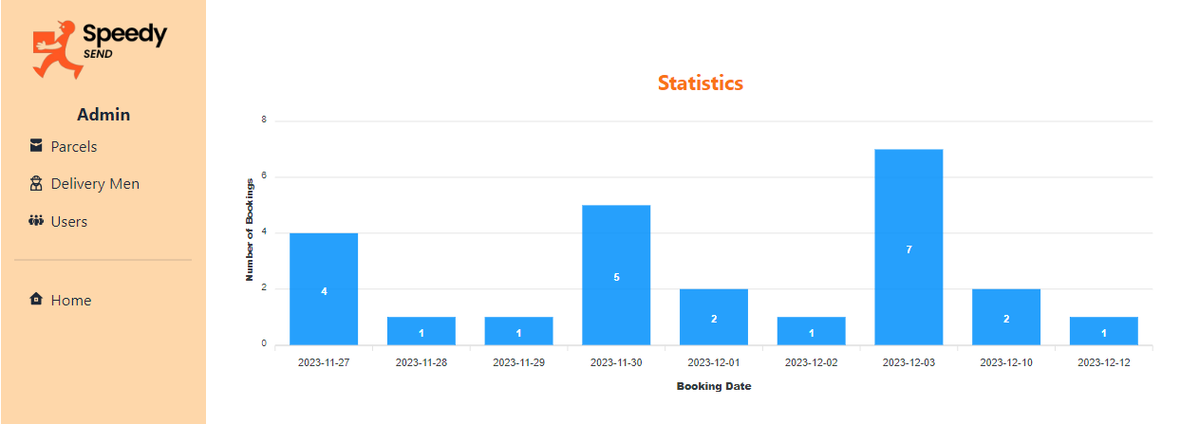

Figure 6 Default Admin Dashboard

Speedy Send's default Admin dashboard offers insightful statistics, providing a comprehensive daily overview of booking trends. Admins gain access to crucial data, enabling informed decision-making and optimized operational strategies.

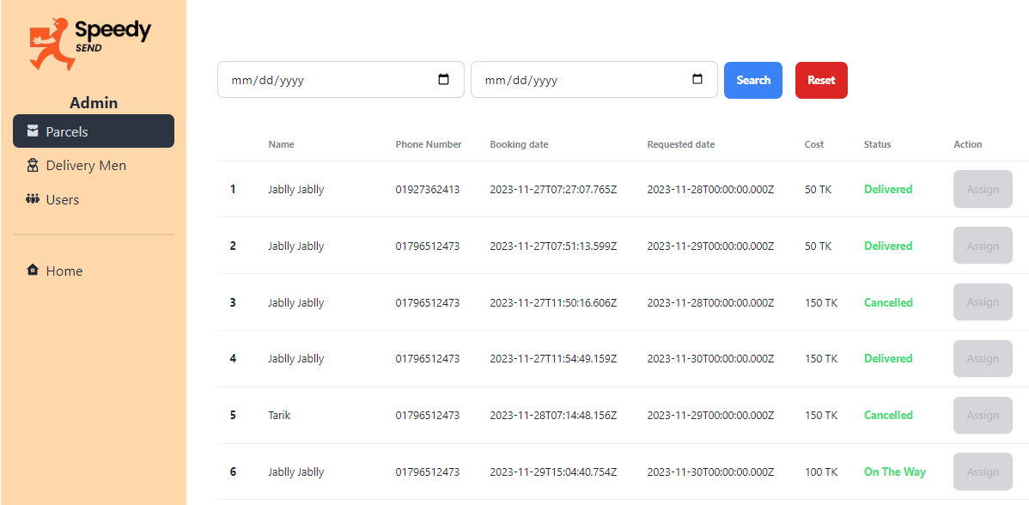

Figure 7 All Parcels

Speedy Send's Admin dashboard presents a detailed tabular view encompassing all parcels, offering a consolidated overview for efficient management. This feature empowers administrators with comprehensive parcel details for streamlined oversight and effective operational control.

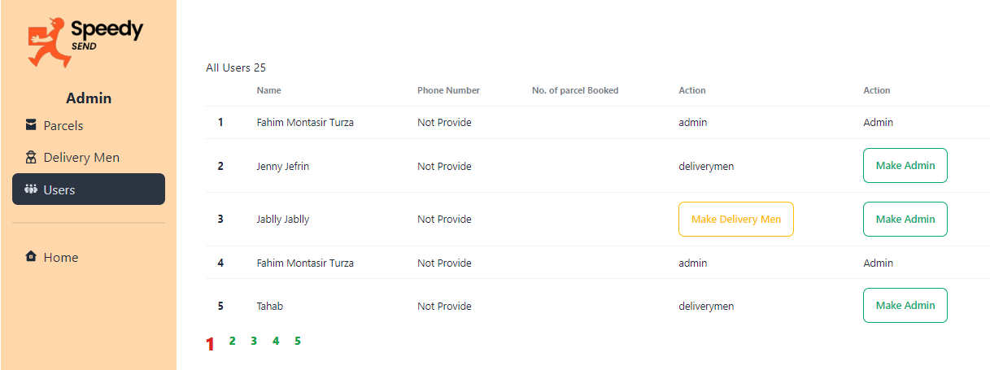

Figure 8 Delivery Men

Speedy Send's Admin dashboard presents an exhaustive list of all delivery personnel, enabling seamless oversight and management. This feature provides administrators with a comprehensive view of delivery personnel details for efficient resource allocation and supervision.

**Delivery Man Dashboard Page**

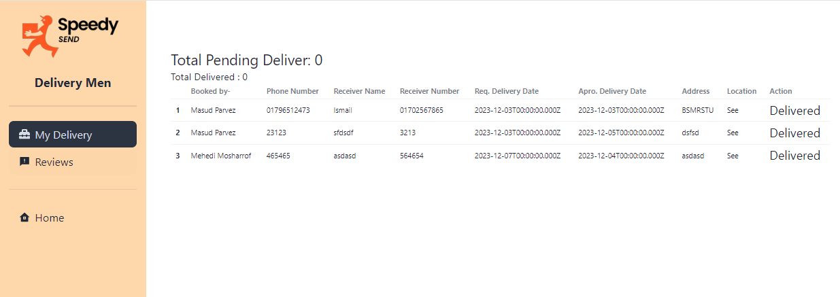

Figure 9 Assigned Parcel for Delivery man

Speedy Send provides delivery personnel with a comprehensive list of parcels assigned for efficient delivery management. This feature equips delivery personnel with detailed insights into their assigned parcels, ensuring organized and timely deliveries.

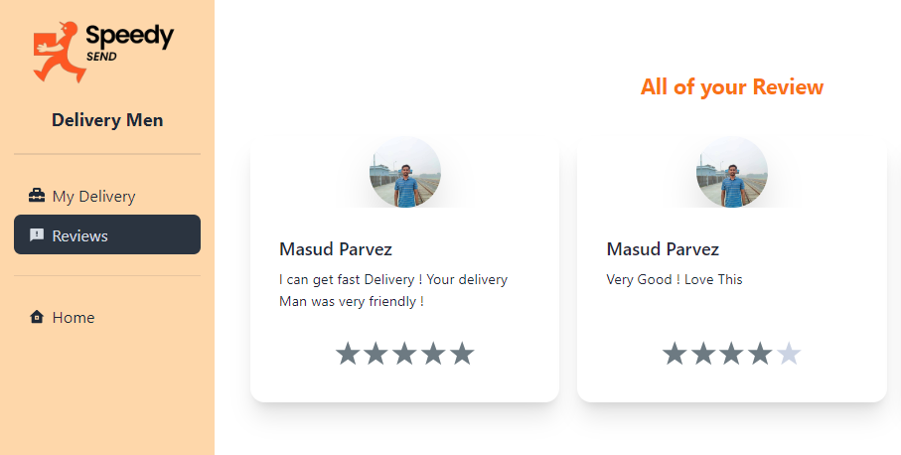

Figure 10 Delivery Man Review

Speedy Send offers delivery personnel an insightful overview of their received reviews, showcasing valuable feedback and ratings from satisfied customers. This feature empowers delivery personnel to track and analyze their performance, fostering continuous improvement and customer satisfaction.

# Code Snippet

**Frontend**

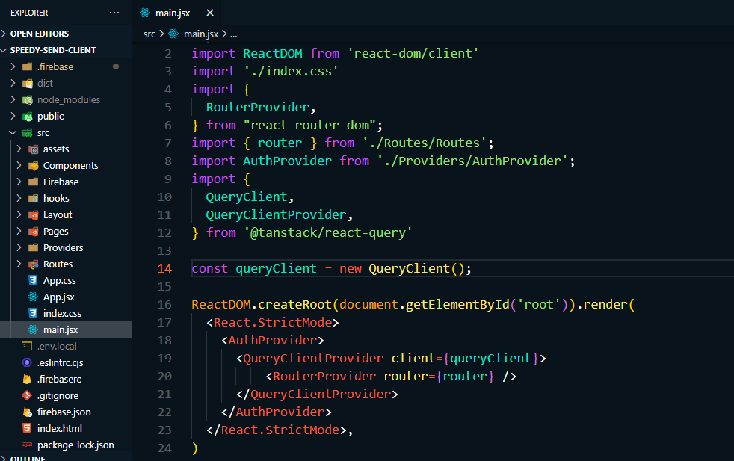

Figure 11 Folder Structure & Frontend setup

The 'src' directory stands as the foundation of the Speedy Send frontend, housing a well-structured architecture to streamline development and maintainability.

* **assets**: This directory serves as a repository for static assets, encompassing images, fonts, and other media essential for the application's visual elements.
* **components**: It holds modular and reusable UI components vital for building various sections and views across the application, promoting a consistent and efficient UI development approach.
* **firebase**: The 'firebase' directory consolidates Firebase-related configurations and functionalities, such as authentication, database settings, and any other Firebase-specific logic used in the application.
* **hooks**: Here, custom React hooks reside, encapsulating reusable logic and state management utilities, facilitating code abstraction and enhancing code reusability.
* **layout**: This directory contains layout components defining the structural layout of the application, including headers, footers, and navigation bars, ensuring a cohesive and standardized UI design.
* **page**: It hosts individual page components representing distinct sections or views within the application, allowing for a clear separation of concerns and easy navigation.
* **provider**: The 'provider' directory houses context providers or global state management setups, enabling efficient data sharing and management across the application.
* **routes**: This directory manages routing configurations, defining navigation paths and associating components with specific routes, ensuring smooth navigation and view rendering.
* **main**: The 'main' directory encapsulates the entry file, 'main.jsx,' serving as the starting point of the application, initializing the React rendering and setup.

The 'src' folder's organized structure fosters a modular and scalable approach, streamlining development efforts and ensuring code maintainability and extensibility within the Speedy Send frontend.

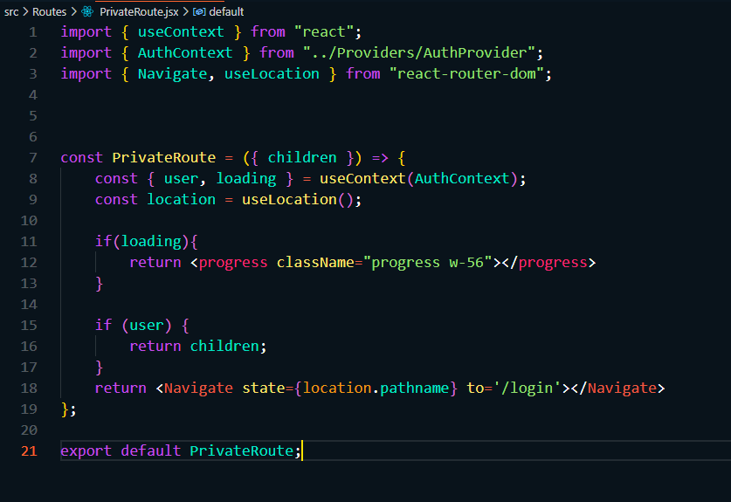

Figure 12 Private Route

The PrivateRoute component in Speedy Send's frontend architecture manages authenticated routes. By leveraging 'AuthContext' from 'AuthProvider,' it checks user authentication. Authenticated users gain access to specified routes, while unauthenticated users are redirected to '/login.' This component ensures route security and a seamless user experience.

**Backend**

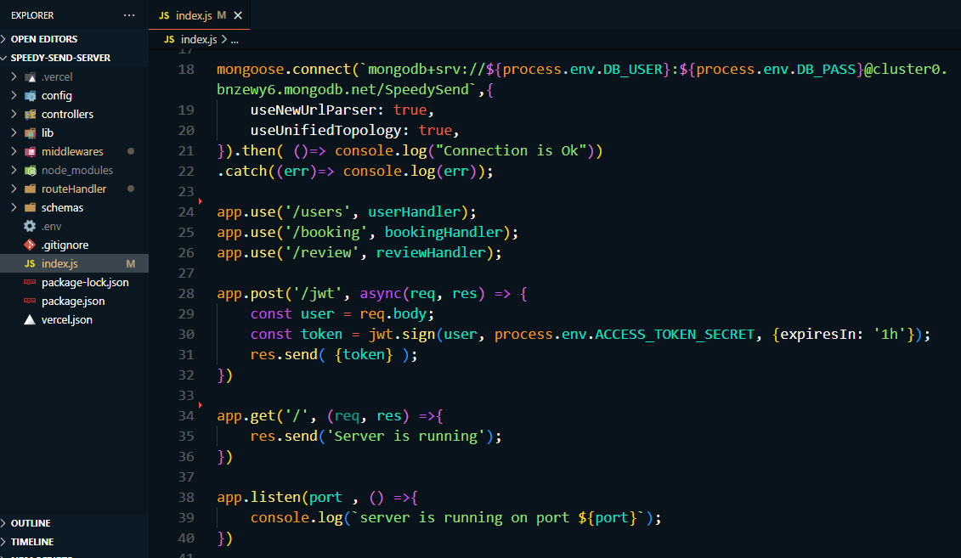

Figure 13 Folder Structure & DB setup

The 'src' directory serves as the backbone of the Speedy Send backend, embracing a well-organized structure to streamline development and maintainability.

* **config**: This directory holds configuration files that manage settings, environment variables, and other configurations essential for the backend's functionalities.
* **controllers**: It houses the controller modules responsible for handling business logic, processing incoming requests, and generating appropriate responses, ensuring separation of concerns in the application.
* **lib**: The 'lib' directory contains utility functions or helper modules utilized across various parts of the backend, promoting code reuse and modularity.
* **middlewares**: Here, middleware modules reside, providing a mechanism to intercept and modify incoming requests or responses, enabling additional functionalities or validations in the request-response cycle.
* **routeHandlers**: This directory encapsulates modules that define specific route handlers, facilitating the handling of different endpoints and their associated functionalities.
* **schemas**: It houses schema definitions or models used for data validation, database interaction, or defining data structures employed within the application.
* **index.js**: The 'index.js' file serves as the entry point of the backend application, orchestrating the initialization of server configurations, routes, and other essential setup procedures.

The structured organization within the 'src' folder ensures a cohesive and scalable approach to backend development, fostering code maintainability, extensibility, and efficient collaboration among development teams.

# Challenges Faced

1. Learning Curve with Mongoose and MongoDB

Challenge: Acquiring familiarity with Mongoose, a MongoDB object data modeling library, posed a learning curve, impacting the development timeline and database integration.

Impact: Initial delays and adjustments in understanding MongoDB's schema-based approach affected the efficiency of database integration and modeling.

2. Sole Reliance on Cash on Delivery Payment Method

Challenge: Relying exclusively on cash on delivery raised challenges in implementing a seamless payment process and managing unpaid deliveries.

Impact: Ensuring a robust system for tracking and confirming cash payments upon delivery became crucial, requiring dedicated protocols to handle unpaid parcels.

3. Integration Complexity with MongoDB

Issue: Integrating MongoDB using Mongoose for the first time introduced complexities in structuring data models and ensuring seamless backend-database interactions.

Impact: Struggles in defining efficient data models and ensuring accurate CRUD operations impacted the efficiency of database interactions within the project.

**Strategies Employed**

1. Comprehensive Planning

Approach: Thorough planning sessions conducted at the project's outset to anticipate potential challenges and devise mitigation strategies.

Outcome: Insights gained from planning sessions helped in identifying potential hurdles and devising proactive solutions for smoother development.

2. Agile Development

Approach: Adoption of an agile methodology to iteratively address challenges, ensuring flexibility in adapting to changing project requirements.

Result: Iterative development cycles allowed for prompt adjustments, ensuring alignment with evolving project needs.

3. Collaborative Communication

Approach: Regular team meetings and open communication channels facilitated efficient problem-solving and ensured alignment on solutions.

Outcome: Enhanced collaboration minimized miscommunications and accelerated the resolution of development challenges.

4. Continuous Testing

Approach: Rigorous testing implemented throughout the development lifecycle to identify and rectify issues promptly.

Result: Early detection and rectification of issues ensured a more stable and reliable application.

5. Adaptability and Flexibility:

Approach: Readiness to adapt to evolving project needs and technological changes, ensuring solutions remained agile and scalable.

Outcome: Flexible approaches allowed for quick adaptation to emerging challenges and technology advancements.

6. Focused Learning and Exploration:

Approach: Dedicated learning sessions focused on Mongoose and MongoDB documentation, tutorials, and practical experimentation to grasp data modeling and interaction intricacies.

Outcome: Improved understanding of Mongoose functionalities, leading to refined data modeling practices and more efficient database interactions.

# Testing and Quality Assurance

1. Unit Testing:

Description: Testing individual components, functions, or modules in isolation to validate their correctness.

Purpose: Ensuring each unit functions as expected, identifying and rectifying bugs at an early development stage.

2. Integration Testing:

Description: Verifying interactions between integrated components or modules to assess their collective functionality.

Purpose: Confirming the proper functioning of integrated units, identifying interface issues or data flow inconsistencies.

3. End-to-End (E2E) Testing:

Description: Assessing the application flow from start to finish, simulating real user scenarios.

Purpose: Validating the application's behavior and performance in real-world usage scenarios.

**Tools Used for Testing and Their Impact on Project Quality**

4. MongoDB Mocking Libraries:

Usage: Employed to mock MongoDB interactions during testing for database-related functionalities.

Impact: Enabled isolated testing of database interactions without affecting the actual database, ensuring data integrity and consistency.

Impact on Project Quality:

Early Bug Identification: Comprehensive testing methodologies facilitated early bug identification and resolution, ensuring the application's stability.

Enhanced Reliability: Rigorous testing cycles enhanced the reliability and robustness of the application by validating functionalities across different layers.

Improved User Experience: E2E testing ensured a seamless user experience, detecting and rectifying user-centric issues, thereby improving user satisfaction.

Consistency and Data Integrity: Effective use of testing tools maintained data consistency and integrity by validating database interactions and responses.

# Future Enhancements

**Subscription-based Services**

Description: Introducing subscription models for frequent parcel senders with benefits like discounted rates for regular senders.

Value Addition: Offers cost-effective solutions for regular users, ensuring consistent revenue streams and fostering long-term partnerships with frequent senders.

**Enhanced Parcel Tracking and Notifications**

Description: Enhancing the real-time tracking system with more detailed parcel tracking information and notifications.

Value Addition: Provides users with more precise parcel status updates, ensuring transparency and reducing anxiety related to parcel deliveries, thus improving user satisfaction.

**Chat Support and Customer Service Integration**

Description: Integrating chat support within the application for instant assistance and issue resolution.

Value Addition: Offers real-time support, addressing user queries promptly, enhancing user experience, and providing efficient issue resolution.

**Predictive Delivery Time Estimates**

Description: Implementing predictive algorithms to estimate delivery times more accurately based on various parameters.

Value Addition: Provides users with more precise delivery time estimates, improving reliability and helping users plan better around their deliveries.

**User Review Enhancement**

Description: Expanding the review system to allow for more detailed feedback and enhancing the credibility of reviews.

Value Addition: Offers users more insights into delivery personnel and service quality, aiding in decision-making and fostering a trustworthy environment.

**Smart Parcel Packaging Suggestions**

Description: Offering users suggestions for optimal packaging based on parcel dimensions and contents.

Value Addition: Assists users in ensuring safe and cost-effective packaging, improving parcel safety during transit and reducing costs.

**Improved Payment Options**

Description: Introducing additional secure and convenient payment options beyond cash on delivery.

Value Addition: Provides users with more flexibility in payment choices, enhancing convenience and encouraging secure transactions.

**Advanced Analytics and Reporting**

Description: Implementing robust analytics tools for users and admins to track parcel delivery trends and performance metrics.

Value Addition: Offers insights into delivery patterns, user preferences, and service performance, aiding in strategic decision-making and service enhancements.

# Conclusion

Speedy Send emerges as an innovative solution reshaping the landscape of parcel delivery services. This project embodies a culmination of cutting-edge technologies and meticulous development methodologies aimed at providing an unparalleled user experience. Leveraging the robustness of the MERN (MongoDB, Express.js, React.js, Node.js) stack coupled with Firebase and Vercel for deployment and authentication, Speedy Send ensures a seamless and responsive platform for users, delivery personnel, and administrators alike.

The project's success stems from its user-centric design, facilitating effortless parcel booking, real-time tracking, and secure payment options. The frontend's intuitive layout, bolstered by components, private routing, and global state management, guarantees a cohesive and efficient user journey. Simultaneously, the backend's structured organization, including controllers, middlewares, and schema definitions, underscores a commitment to reliability, scalability, and robust backend functionality.

The strategic folder structure, from 'src' directories housing assets, components, and routes in the frontend to 'controllers,' 'middlewares,' and 'schemas' in the backend, reflects a meticulous approach towards maintainability and extensibility. Additionally, the implementation of essential features such as PrivateRoute for authentication and secure routes, and dedicated sections like user reviews and delivery personnel oversight, enriches the platform's functionality, security, and user engagement.

Speedy Send's successful execution signifies a new chapter in logistics management, promising swift, secure, and personalized parcel deliveries. By embracing modern technologies and adhering to best practices, this project sets a benchmark for logistics solutions, aiming not only to meet but exceed user expectations. Its scalable architecture, robust features, and commitment to user satisfaction mark it as an innovative and disruptive force in the realm of parcel delivery services.

# Reference

**Front End**

1. <https://themeforest.net>
2. <https://reactrouter.com/en/main>
3. <https://github.com/brillout/awesome-react-components>
4. <https://daisyui.com>
5. <https://console.firebase.google.com>

Back End

1. <https://www.mongodb.com/docs/drivers/node/current/quick-start>
2. <https://mongoosejs.com>
3. <https://www.mongodb.com/cloud/atlas>