## **Curriculum Vitae**

## 

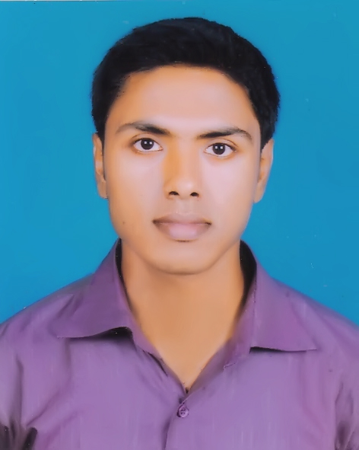**md. turza ibna muksud**

|  |
| --- |
| **Present Address:** |
| Md. Turza Ibna Muksud  Deogaon (South)  P/O: Rajasion, Savar, Dhaka-1340. |
| Contact number: 01757-212029.  Email: [turza.muksud.cse@ulab.edu.bd](mailto:turza.muksud.cse@ulab.edu.bd)  [turzamuksud@ymail.com](mailto:turzamuksud@ymail.com)  LinkedIn: [linkedin.com/in/turzamuksud](https://www.linkedin.com/in/turzamuksud/)  GitHub: [github.com/turzamuksud](https://github.com/turzamuksud) |
| **PERMANENT ADDRESS:**  Md. Turza Ibna Muksud  Deogaon (South)  P/O: Rajasion, Savar, Dhaka-1340. |

|  |
| --- |
| **Education** |

* **B.Sc.** in Computer Science & Engineering **: CGPA 3.28**

**University of Liberal Arts Bangladesh**

* **H.S.C.** Science group **: 2013, GPA 4.10**

**Savar Model College**

* **S.S.C.** Science group **: 2011, GPA 4.69**

**St. Joseph’s High School**

|  |
| --- |
| **Skills** |

* Web development (PHP, HTML, CSS, JS)
* Laravel, Bootstrap and Ionic framework
* Database (mySQL)
* Arduino UNO, MEGA 2560, Arduino IDE, Processing Arduino
* Programming language (Python, C, C++, Java)
* Object oriented programming
* Android app development (Angular JS)
* Adobe Photoshop cs6, 13.0.1.3

|  |
| --- |
| **Achievements** |

* Solved more than 50 problems in UVa Online Judge.
* Working in a undergraduate research program since November 2015, under the supervision of [Dr. Garga Chatterjee](http://www.isical.ac.in/~garga/labwebsite/?page_id=82) from ISI (Indian Statistical Institute), naming “3 Cognitive Test”.
* Working under the supervision of [Dr. Nabeel Mohammed](http://ulab.edu.bd/academics/faculty-list/profile/81/) for “mPrice” project part of “[ই-কৃষক](http://wp.ekrishok.com/?p=1427)”, of BIID.
* Did a training program lead by ICT Division, naming “[Top-Up](http://www.lict.gov.bd/oldlict/topup_it_training.php)”.
* Created amodel of division of labor in antswith [Dr. Sifat Momen](http://ulab.edu.bd/academics/faculty-list/profile/79/) using NetLogo.
* Course based Arduino projects with [Dr. Iftekharul Mobin](http://ulab.edu.bd/academics/faculty-list/profile/82/)
  + Measure distance and angle using ultrasonic sensor.
  + Measure temperature and humidity using DHT22 sensor, python, pubnub, plotly and matplotlib.

|  |  |  |  |  |  |
| --- | --- | --- | --- | --- | --- |
| **Language Skills Proficiency** | | | | | |
|  | **Language** | **Speak** | **Read** | **Write** |
|  | Bangla | ✓ | ✓ | ✓ |
|  | English | ✓ | ✓ | ✓ |
|  |  |  |  |  |

|  |
| --- |
| **Personal Interests** |

Love to play cricket, football and chess. In leisure period love to do raw coding and singing. Also have interest in photography and playing video games like Fifa.

|  |
| --- |
| **References** |

Md. Shah Najim Ud-Daulah

Deputy Director,

National Institute of Local

Government (NILG)

29, Agargaon, Sher-e-Bangla Nagar,

Dhaka – 1207.

Phone: 01740-104205.

Dr. Sifat Momen

Assistant Professor & Head of Department (Acting),

Department of Computer Science & Engineering

University of Liberal Arts Bangladesh (ULAB)

Email: [sifat.momen@ulab.edu.bd](mailto:sifat.momen@ulab.edu.bd)

Dr. Nabeel Mohammed

Assistant Professor,

Department of Computer Science & Engineering

University of Liberal Arts Bangladesh (ULAB)

Email: [nabeel.mohammed@ulab.edu.bd](mailto:nabeel.mohammed@ulab.edu.bd)