Final Project
Worldwide Sentiment Analysis of LLMs
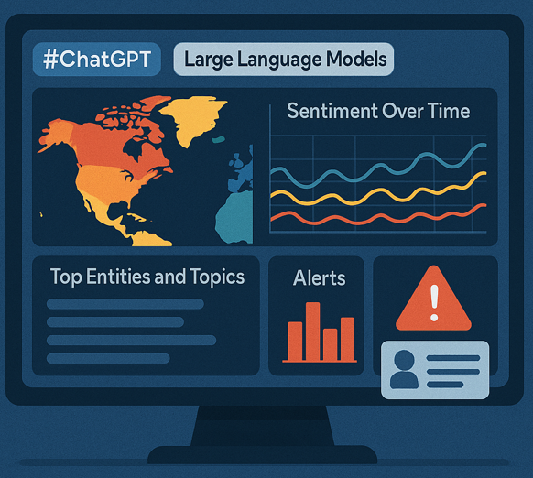
Pennsylvania State University
DAAN 545 - Data Mining: Fall 2025
October 13, 2025
Team members:
Tushar, Saakshaat Saini, Julien Hill
- Problem Framing and Requirements:
The primary objective of this project is to equip AI policymakers with actionable insights by monitoring and analyzing public sentiment regarding large language models (LLMs) in real-time, broken down by geographic regions. This involves creating a visual heatmap that shows sentiment by area, along with time series data on sentiment trends both overall and by specific topics. Additionally, we'll identify key entities and narratives by region and time frame, and set up a robust alert system to notify users whenever negative sentiment surpasses certain thresholds.
Since the main stakeholders are AI policy teams and analysts, it's essential that all outputs on the dashboard are user-friendly and easy to understand, allowing for detailed exploration from general regional summaries to individual user comments. The key performance indicators (KPIs) will focus on tracking sentiment scores by region over time, monitoring the rate of negative sentiment in relation to its thresholds and regional patterns, assessing data coverage and latency per region, and evaluating the incidence of false positives in the alert system. These features will ensure that our solution remains practical, transparent, and actionable for managing and guiding real-world AI policies.
We have been working on this large dataset from Twitter/X, which includes over 305,000 posts related to ChatGPT and various topics related LLMs. The first step involved a thorough preprocessing of the data—this included cleaning the text, identifying the languages used, geocoding user locations, and pulling out engagement metrics. We are using some advanced analytical techniques like pattern mining, clustering, and supervised learning to uncover and visualize negative sentiment trends in different geographic areas. These foundational work sets the stage for detailed time-series analysis and will help us develop real-time alerts to support policy decisions in the future.
- Why this research/project matters?
This research is important because it helps us understand how artificial intelligence is accepted and perceived in different cultures. This understanding is crucial for ensuring that technological advancements are ethical, inclusive, and genuinely beneficial on a global scale. By taking into account regional needs and cultural nuances, along with addressing potential risks like AI-induced psychosis, researchers and policymakers can foster the development of safe and responsible AI. This approach not only builds trust and reduces bias but also enhances the positive impact of AI in various fields such as healthcare, public policy, and everyday life. Ultimately, it supports the creation of technologies that resonate with a diverse range of human values.
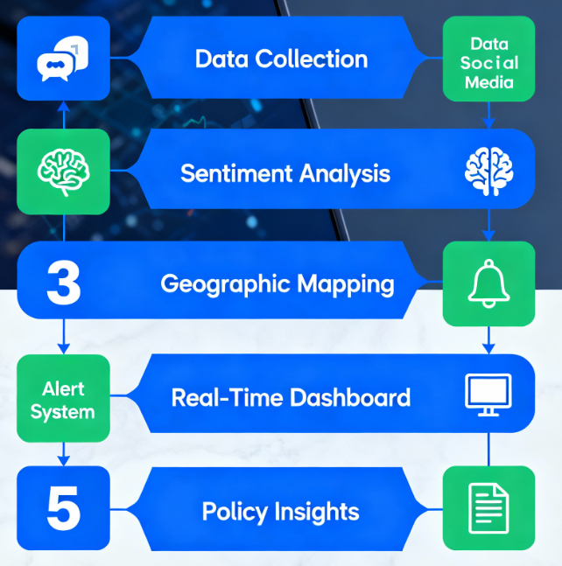
Figure 1: High level workflow for the Project
- Selecting a Dataset:
(rows, columns): (305432, 12)
This dataset contains around 305,000 tweets gathered from platform X, where users engage in discussions about large language models (LLMs). We chose this dataset because it aligns perfectly with our project goals. One of its key features is a region column, which is essential for performing detailed sentiment analysis based on different regions.
Worldwide Sentiment Analysis of LLMs High Level E2E Workflow Diagram
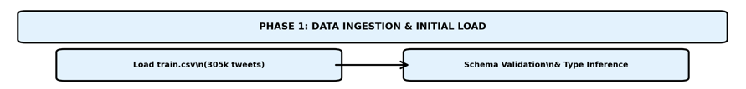

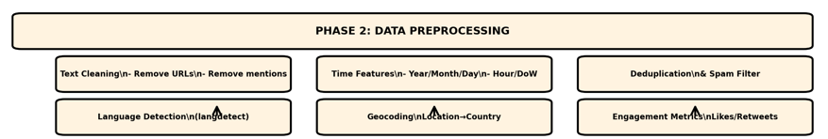

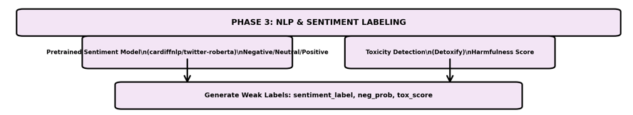

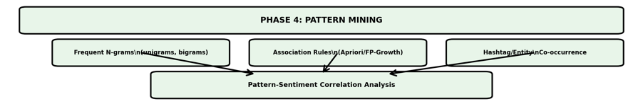

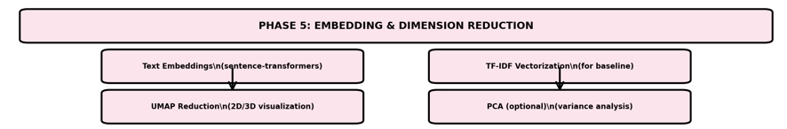

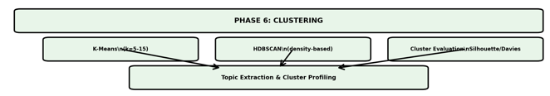

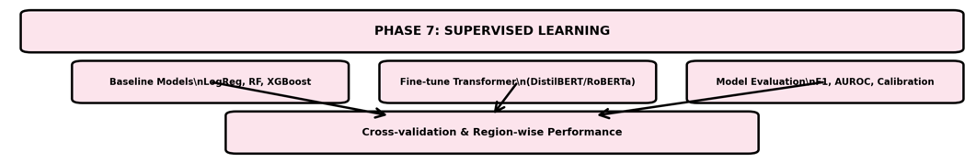

Future Phases...

- Data Understanding & Exploration:
We’ve loaded the dataset and taken a first look at structure and key fields to care about (text, location, date, etc.).
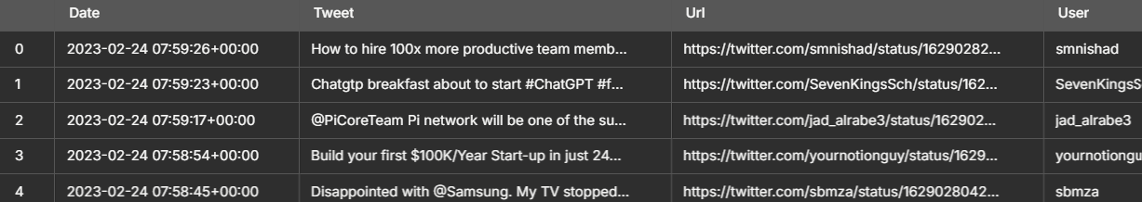
Figure 2: first few rows from the initial dataset
- Below is the finding from EDA(Exploratory Data Analysis):
- The dataset includes the following columns: Date, Tweet, URL, User, User Creation Date, User Verification Status, User Followers Count, User Friends Count, Retweets Count, Likes Count, Location, and User Description.
- It consists of 305,432 rows with a total of 12 columns.
- There are some missing values in the dataset:
- 76,420 entries lack a specified location.
- 14,777 entries do not have a user description.
- Additionally, a few other columns have small amounts of missing data.
- Parsed Date and UserCreated column to datetime also coercing errors:

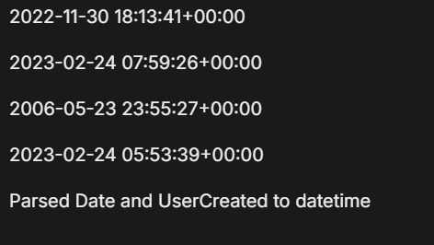
Figure 3: minimum and maximum dates for Date and UserCreated
- The tweets span a date range from November 30, 2022, to February 24, 2023, covering roughly three months.
- The account creation dates range from May 23, 2006, to February 24, 2023, indicating that the accounts included have been active for about 17 years.
- Coerced numeric columns:

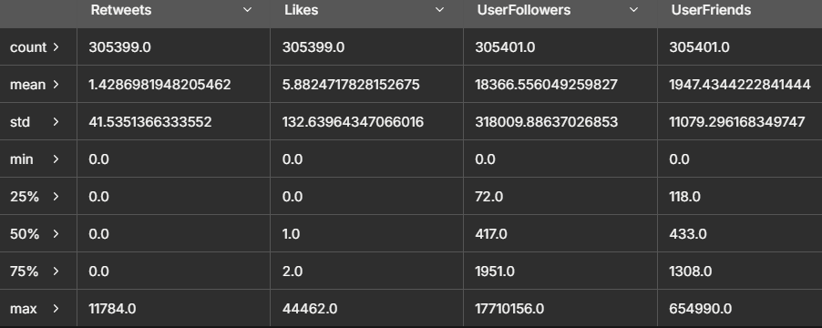
Figure 3: numeric representation of columns
- All metrics related to engagement and followers have been converted to numeric values.
- The majority of tweets show no retweets and relatively few likes, with a median of just 1 like, although there are a few standout tweets that went viral, reaching up to 44,462 likes.
- User follower counts differ significantly, with a median around 417 followers and a maximum count of 17 million.

- Top 15 Locations (raw text):
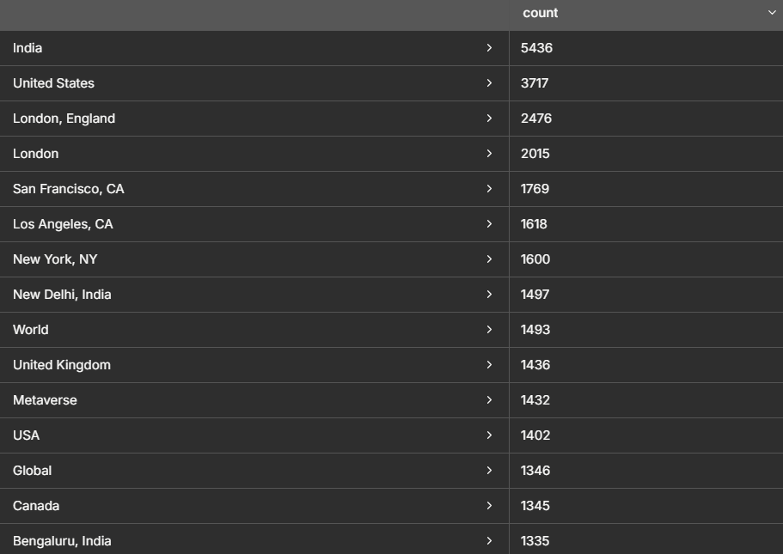
Figure 4: Top 15 Locations

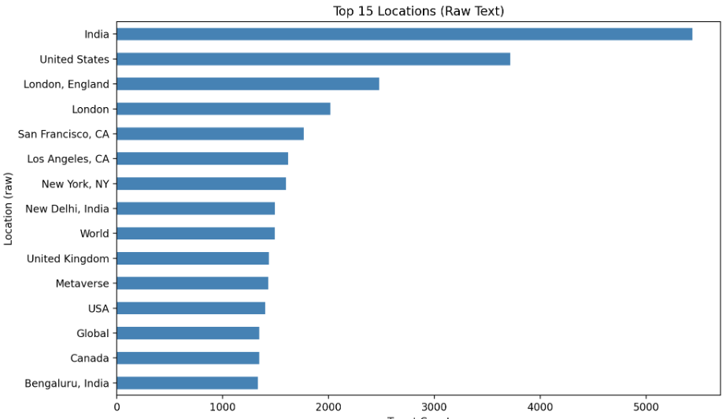
Figure 5: Top 15 Locations bar graph
- India and the United States are the leading contributors in the dataset.
- There are several variations in location names, such as "London" compared to "London, England," or "USA" versus "United States."
- Some location entries are quite vague, like "World," "Metaverse," or "Global," which will require some cleaning to ensure accuracy.
- Approximately 76,000 tweets are missing location information.
- Daily tweet volume over time:

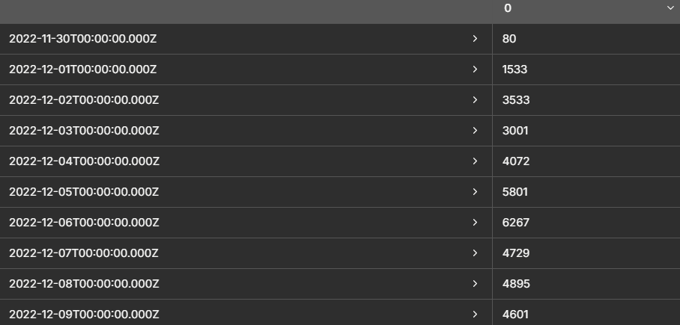
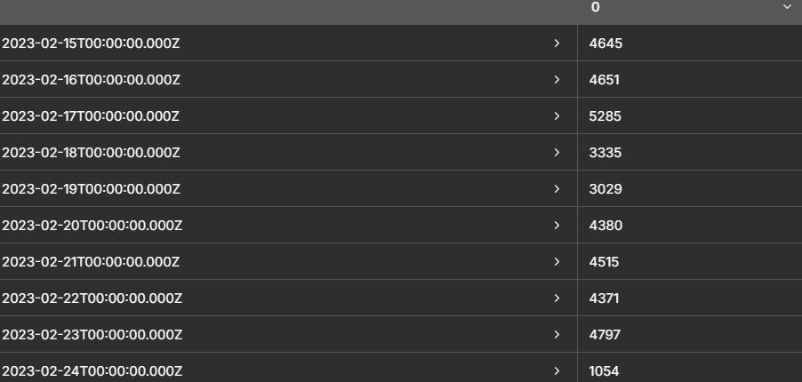
Figure 6: Daily tweet volume over time

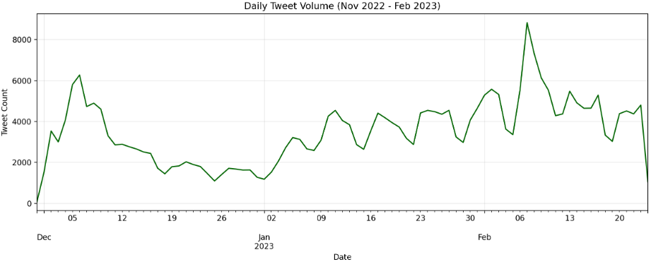
Figure 7: Daily tweet volume line graph

- Interesting Insights consolidated:

- The dataset covers the period from November 30, 2022, to February 24, 2023, which is about three months.
- There was a rapid increase in tweet volume in early December, coinciding with the buzz surrounding the launch of ChatGPT.
- From December through to February 2024, there has been a consistent output of approximately 3,000 to 6,000 tweets per day.
- The final day of the dataset (February 24) includes only 1,054 tweets, making it a partial day.
- In total, the dataset encompasses 87 days.

- Tweet counts by Day (basic stats):
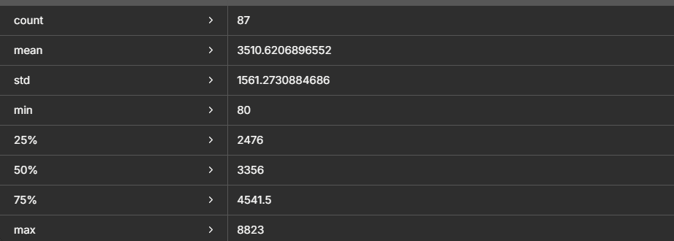
Figure 8: Tweet counts per day

- Tweet counts by Language:
- The majority of the tweets are in English, totaling 302,919, which makes up 99.2% of the dataset.
- A few other languages are represented, including French (324), German (297), Dutch (272), and Indonesian (243).
- In total, the dataset contains tweets in 36 different languages.
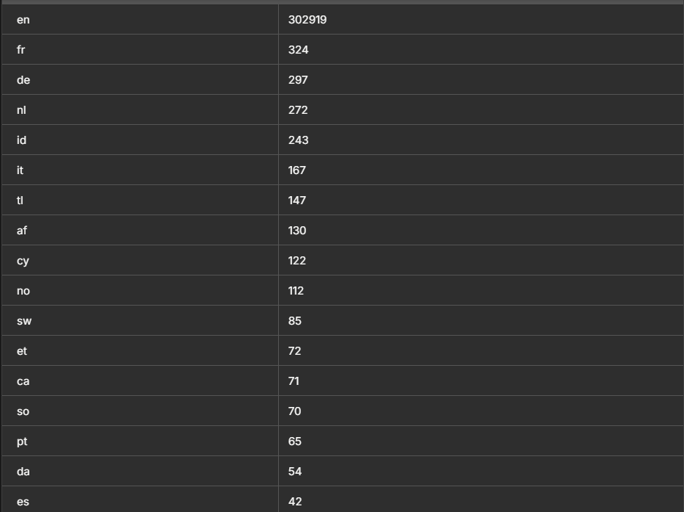
Figure 9: Tweet counts per Language
- Tweet counts by Location:
- There is a total of 33,739 unique locations identified in the dataset.
- A significant number of tweets, 76,420, do not have any location information.
- Meanwhile, 229,012 tweets do include location data.
- Interesting Insights:
- The most mentioned locations include India (5,436), the United States (3,717), different variations of London (4,491 combined), as well as major cities across the U.S.
- There are also many generic entries such as "World," "Metaverse," "Earth," and "Global," which will require normalization for clarity.
- Missing Values per column (percentage):
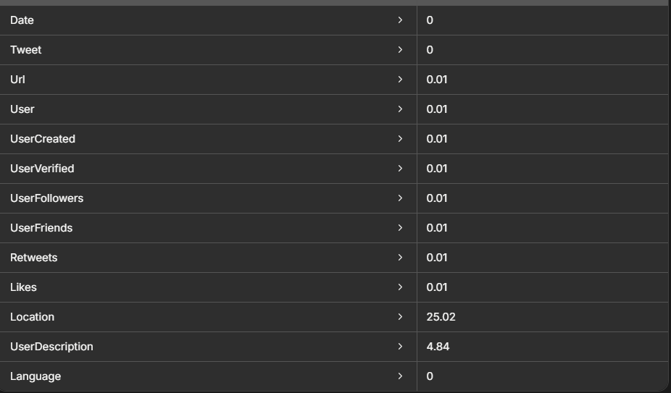
Figure 10: percentage of Tweet counts

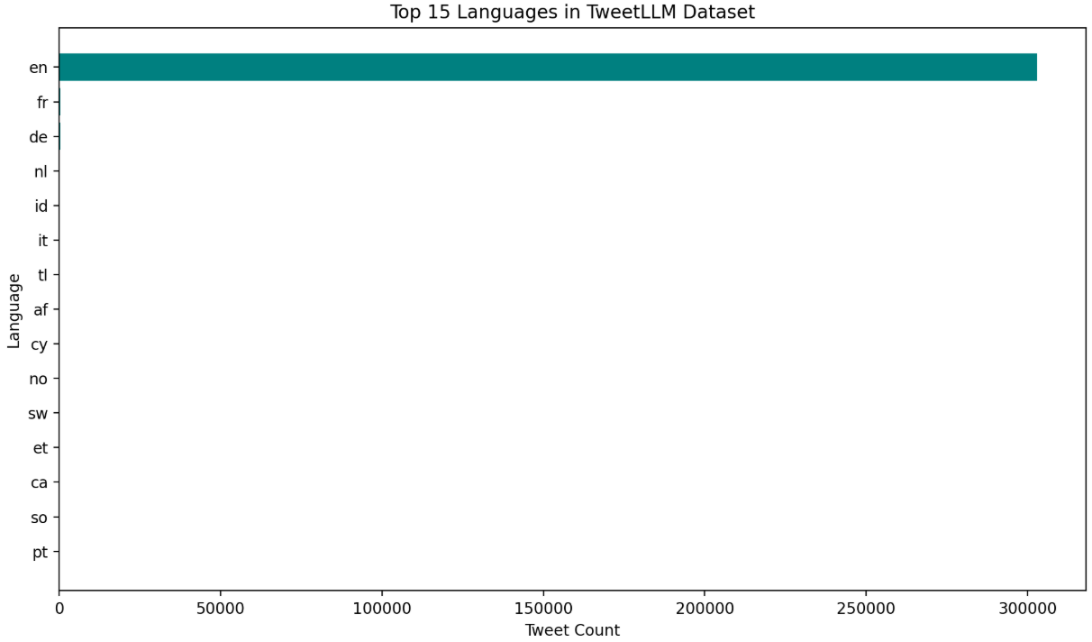
Figure 11: Bar graph for languages in dataset

- Interesting Insights about missing and duplicate values:
- The location data has the highest variance, with about 25% of the entries missing, which is common in user profiles.
- Approximately 4.8% of users are missing their user descriptions.
- There are a few entries with missing information for URL, user creation date, retweets, and likes, but the dates and tweet texts are nearly all complete.
- There are 30 duplicate URLs, indicating that the same tweet may have been captured multiple times.
- The dataset includes 2,162 duplicate tweets, which are identical texts that appear across different users, retweets, or spam accounts.
- There are 5 completely identical rows, representing exact duplicates in the dataset.
- Visualization:
- Word Cloud (overall corpus):
The dataset features a range of prominent terms, including AI, GPT, Google, Bard, Microsoft, Bing, ChatGPT, as well as words like new, use, like, work, data, model, and language. These terms capture the current conversations surrounding large language models (LLMs). They highlight not only ChatGPT but also its competitors, such as Bard and Bing, while delving into various discussions centered around real-world applications and use cases.
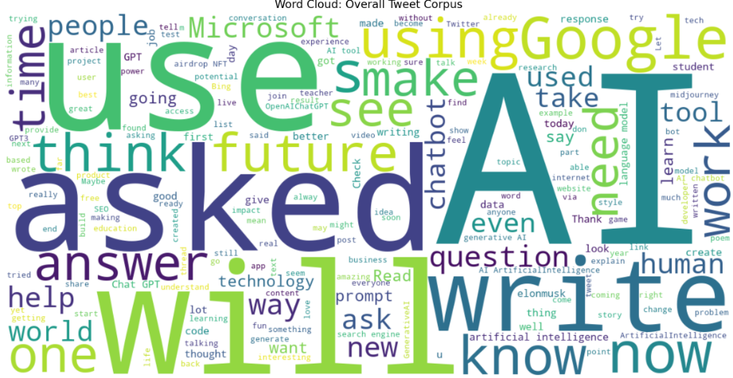
Figure 12: word cloud in dataset
- Distribution of tweet lengths:
The majority of tweets fall within the range of 100 to 200 characters, although there is a longer tail that reaches up to Twitter's maximum character limit of approximately 280. There are very few tweets that are extremely short, indicating that most users are engaging in meaningful commentary rather than simply posting hashtags or mentions.
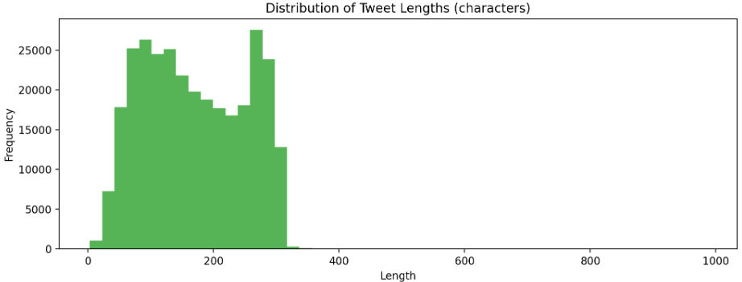
Figure 13: tweet length bar graph

- Data Cleaning & Pre-processing:
- Removing URLs, mentions, emojis, and hashtags symbols (keep hashtag words):
We have chosen to exclude URLs and @mentions from our dataset, but we will keep hashtags and emojis. This decision stems from the fact that URLs and mentions can introduce noise that negatively impacts sentiment analysis and clustering efforts. On the other hand, hashtags and emojis add significant value by offering insights into sentiment and relevant topics, which is why we decided to retain them.
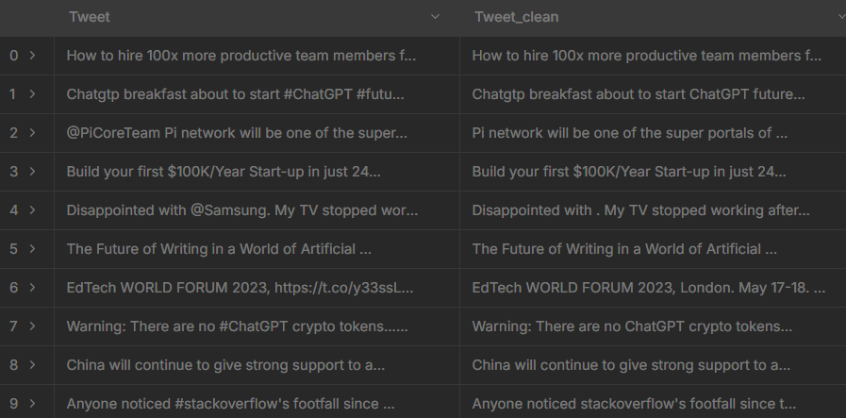
Figure 14: Dataset after removing URL, mentions etc.
- lowercasing and stopword removal from Tweet_clean:
We converted all the text to lowercase to maintain consistency. The text was then tokenized based on word boundaries. Additionally, we removed common English stop words using the NLTK library and relied on a minimal list when necessary.
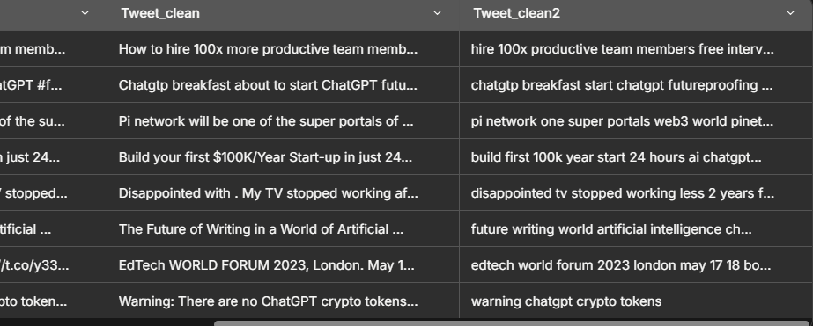
Figure 15: new column added tweet_clean2
- Parse and standardize created_at timestamps:
-We parsed the tweet timestamp and the account creation date in UTC format.
- From the Date, we extracted several time-related features, including the year, month, day, hour, day of the week (with Monday as 0), and an indicator for weekends (where Saturday and Sunday are marked as 1).
- All of these adjustments were made directly within the existing data frame to keep the integrity of the data intact.
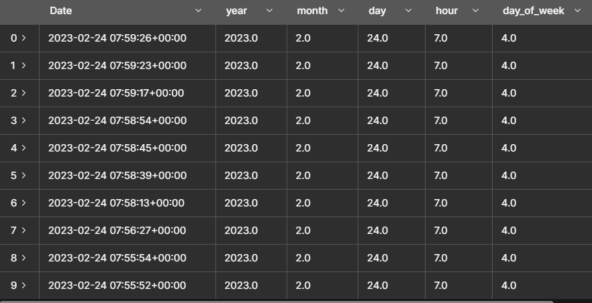
Figure 16: time-related features
- Fixing the Missing values – Date:
- We addressed the missing dates through the following methods:
For the Date:
- We parsed it from tweet URLs using Twitter Snowflake IDs whenever it was unavailable.
- We then applied a forward-fill followed by a backfill to deal with any remaining gaps.
For UserCreated dates:
- We filled in these dates for each user using either the most common (mode) or the median account creation date associated with that user.
- Additionally, we utilized forward and backward filling within each user’s data.
- As a final measure, we resorted to the overall median through quantile to ensure completeness.
- Fixing the Missing values – Location:
In the first iteration it we found below
- 76,420 rows (25%) have missing/null location (shown as "").
- India and United States dominate the valid entries.
- Many variations exist for the same place:
- "London" vs "London, England"
- "USA" vs "United States" vs "New York, USA"
- Whimsical entries like "Metaverse", "World", "Earth", "Global", "Worldwide"
- 33,736 unique location strings mean heavy fragmentation and inconsistency.
- What we did to fix them:

- Normalized obvious aliases and noise
- Mapped common aliases and whimsical entries:
  - usa/u.s./u.s.a → United States
  - uk/u.k/great britain → United Kingdom
  - nyc → New York, NY
  - sf/san fran → San Francisco, CA
  - bangalore → Bengaluru, India
  - metaverse/world/earth/global/worldwide → Unknown
- Inferred locations from user bios for missing rows
- Scanned User Description for conservative city/country keywords (e.g., London, India, united states, New York, Seattle, Paris) and filled missing Location norm where matched.
- Marked remaining as Unknown and created a Country field
- Filled still-missing normalized locations as Unknown.
- Extracted a rough Country based on string patterns (e.g., India, United Kingdom, common US state abbreviations like, CA, NY).

- Location distribution: before vs after normalization:
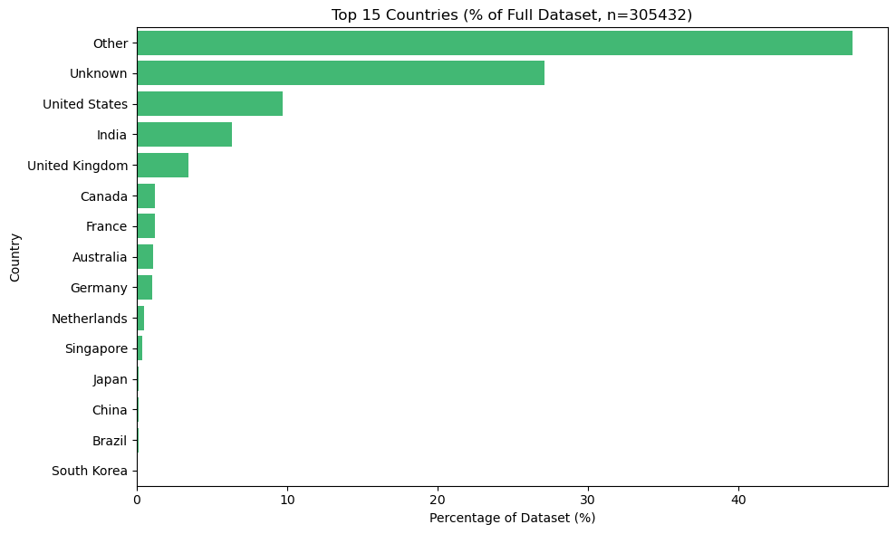
Figure 17: Top 15 countries after normalization
- Cleaned Dataset:
Total rows: 305432 Total columns: 25
Columns included: Date, Tweet, Url,User, UserCreated, UserVerified, UserFollowers, UserFriends, Retweets, Likes, Location, UserDescription,Language_final_bucket, Location_norm, Country, Tweet_clean, Date_dt, UserCreated_dt,date,year, month,day,hour,day_of_week,is_weekend.

Problem Arises here that now we have Unknown + Others locations in our Dataset contributing to below 🤯
– 2,22,435 rows, which constitutes 72.83% of the entire dataset.
- “Other” denotes locations that we could parse or normalize to a place name (city/region), but for which we could not confidently identify a specific country.
Common reasons:
- Uncertain or incomplete locations (e.g., “London”, “California, USA”, “Europe”)
– Mixed formats (for example, “London, UK.” vs “London, UK”)
– Branded or non-geographic strings in location fields (e.g., “The AI ZONE Cloud”). City/state provided without a country and disambiguation failed.

- What we did to fix Unknow + Other location to reduce noise and get more accurate sentimental analysis:

- Expanded the rules/lookup table for city-to-country resolution (e.g., London -> United - Kingdom, New York -> United States).
- Using a geocoding service (rate-limited) to resolve ambiguous city/region names.
- Cleaning common punctuation variants and suffixes (e.g., “UK.” -> “United Kingdom”).
- Applying probabilistic disambiguation for common city names when coupled with state/region (e.g., “California, USA” -> United States).

- After the 1st Refinement pass we reached to below improvements:

- Other+Unknown decreased to 65.7% from 72.83%.
- Rows shifted from Other to designated countries: 21780
- Created a mapping of common cities/regions to their respective countries (e.g., London → United Kingdom, New York/SF/California → United States, Nairobi → Kenya, Mumbai/Delhi → India, Dubai UAE → United Arab Emirates, etc.).
- Decreased Other + Unknown by 7.13 percentage points, transferring 21,780 rows from “Other” to designated countries.

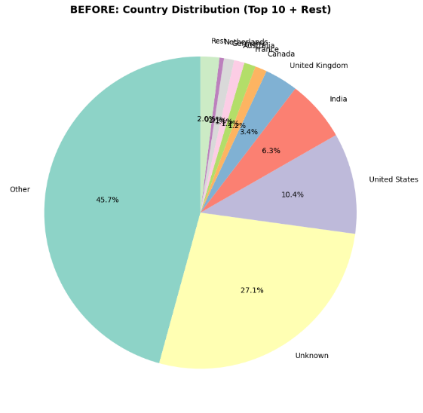
Figure 18: distribution unknown+others before refinement passes
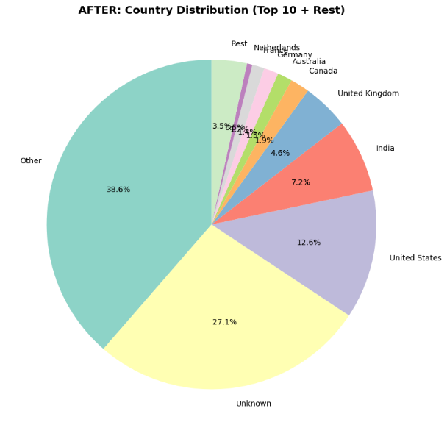
Figure 19: distribution unknown+others after 1st refinement pass

- After Applying multiple smart heuristics refinement passes to reach our acceptance criteria < 45%:

- Multiple refinement passes:
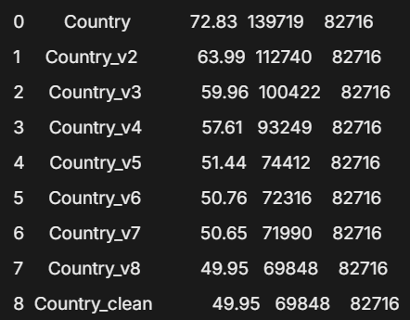
Figure 20: Percentage decrease of unknow+other countries after multiple refinement passes
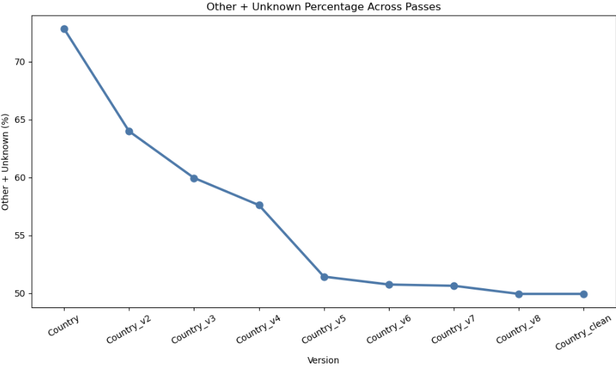
Figure 21: line graph showing decrease of unknow+other countries after multiple refinement passes

- we did throttle geocoding burst to reach our goal.
- Other+Unknown AFTER v18 (final): 43.85% (Acceptance criteria reached) 🥳.

- Tweet-level Linear Regression:
Model Setup
- Target: log-transformed likes (log(1 + likes)) to handle skewness
- Algorithm: Ridge regression (L2 regularization, alpha=1.0)
- Train/test split: Trained on data before Feb 1, 2023; tested on Feb 1-24, 2023
Features Used
- User metrics: log(followers), log(friends), verified status, account age
- Tweet characteristics: length, number of hashtags, number of mentions
- Temporal: hour of day, day of week, weekend indicator
- Categorical: language (one-hot encoded), country (one-hot encoded)
Performance
- R² on test set (log-likes): 0.1468 (14.7% variance explained)
- R² on test set (raw likes): 0.0019 (near zero after back-transform)
- Interpretation: Model captures moderate linear signal in log space but struggles with raw engagement due to high skewness
Key Insights
- Follower count and verification status show positive linear relationship with engagement
- Time-of-day and day-of-week patterns contribute to predictions
- High variance in tweet engagement limits linear model effectiveness
- Exponential back-transformation amplifies prediction errors, especially for viral tweets

- Daily Time-Series Forecast

Data & Aggregation
- Aggregated tweets to daily counts over the dataset window.
- Engineered exogenous features:
  - Day-of-week one-hot to capture weekly seasonality
  - 7-day rolling mean for short-term momentum
Model
- SARIMAX with exogenous regressors
  - Order: (1,1,1)
  - Seasonal order: (1,1,1, 7) for weekly seasonality
  - Exogenous: day-of-week dummies + 7-day rolling mean
Train/Test split:
  - Train through 2023-02-10
  - Test window 2023-02-11 to 2023-02-24 (14 days)
Practical Insights
- Weekly seasonality is a strong driver of daily volume
- Momentum (7-day rolling mean) improves short-horizon stability
- Including event/holiday indicators can further enhance spikes handling

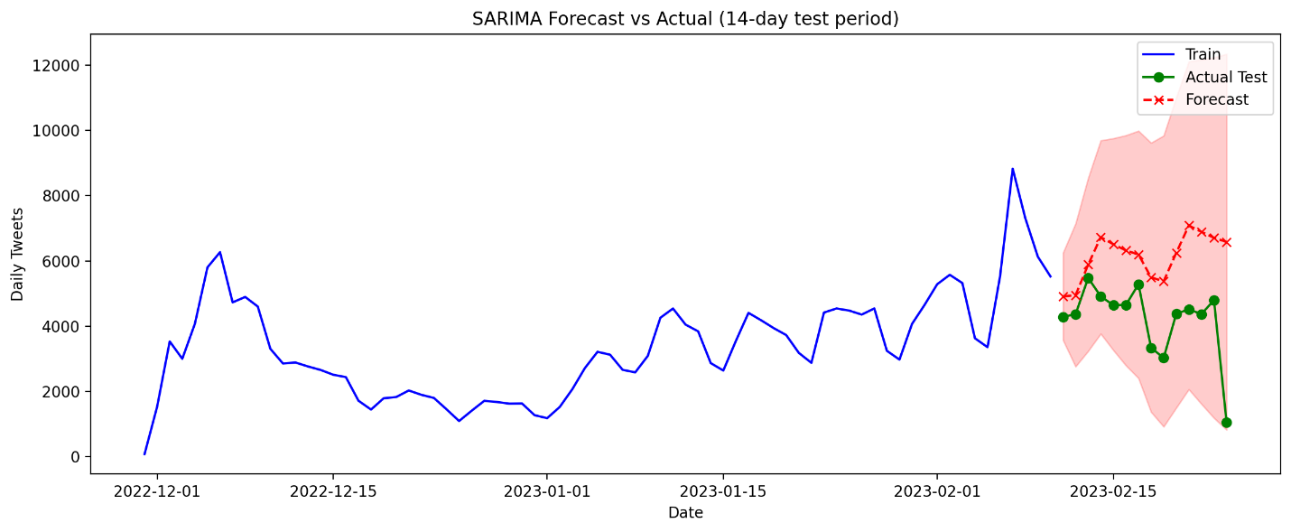
Figure 22: SARIMA forecast vs actuals for the last 14 days. The shaded band is the 95% confidence interval.
- Sentimental Analysis on cleaned Dataset:
We choose tweet_clean column for the sentimental analysis and have rule-based baseline: VADER (NLTK) for our analysis.
- Why we choose VADER(NLTK)?
- Rule-based sentiment analysis tool optimized for social media texts (Tweet Dataset).
- It uses a predefined lexicon of words with assigned sentiment values.
- VADER analyzes each word in a sentence, assigning scores for positive, negative, and neutral sentiment using its lexicon.
- VADER is especially robust for social media, handling slang, emojis, and abbreviations better than many traditional tools.
- It is not an ML-based model and thus does not need training on domain-specific data, which makes it intuitive, transparent, and quick to use.
- What we did?
- Detected the text column as Tweet and validated non-null coverage.
- Applied NLTK VADER across all tweets, generating:
  - sentiment_label (positive, neutral, negative)
  - sentiment_score (compound in [-1, 1])
  - sentiment_positive, sentiment_neutral, sentiment_negative (proportions)
- Insight:
Distribution shows a higher share of positive tweets, followed by neutral, then negative.
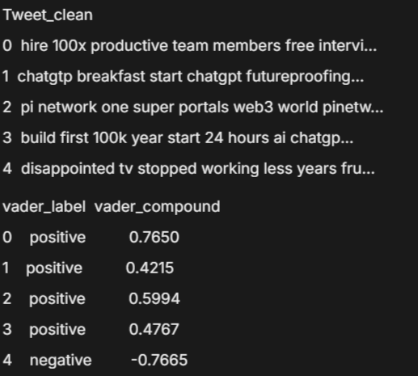
Figure 23: vader compounds

- Sentiment distribution full Dataset:
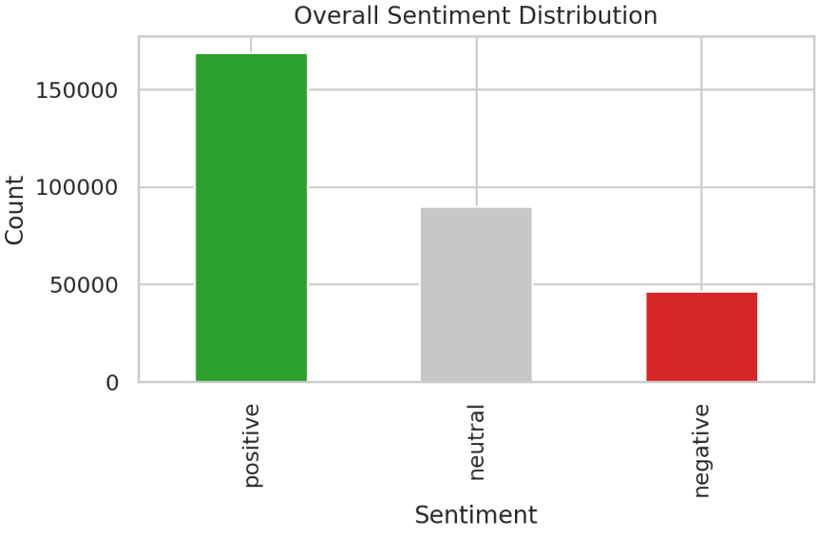
Figure 24: Sentiment Analysis of full data set (Tweet_clean)
- Mean sentiment by region:
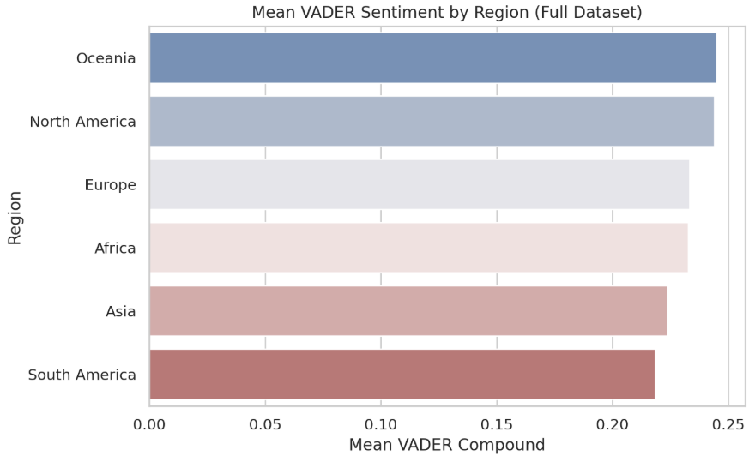
Figure 25: Mean VADER compound by region

- Mean sentiment by location full Dataset:

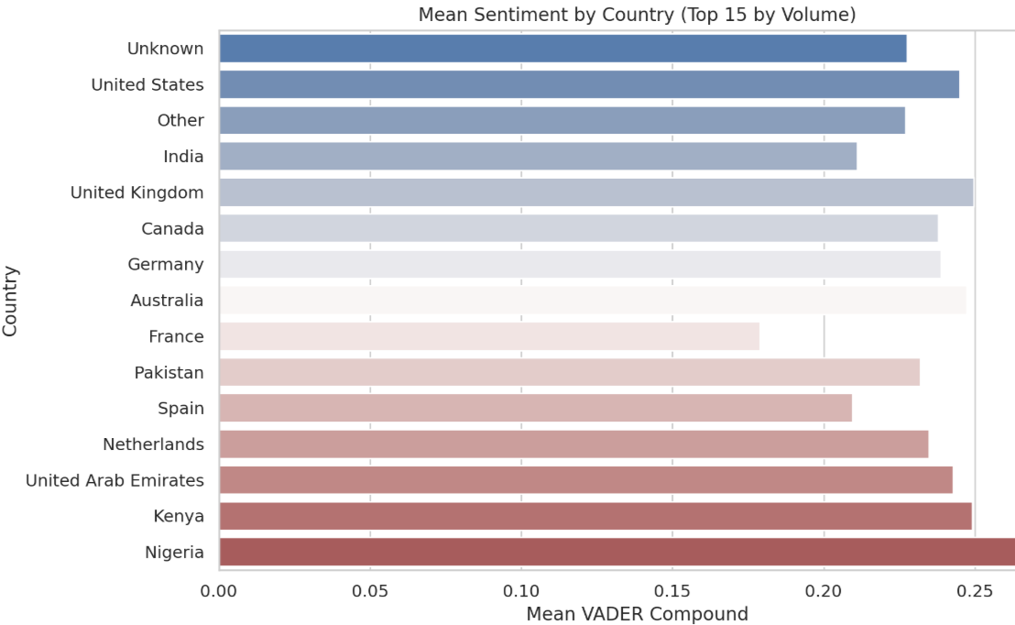
Figure 26: Mean VADER compound by Location

- Stacked bar chart: Top 20 countries by volume:
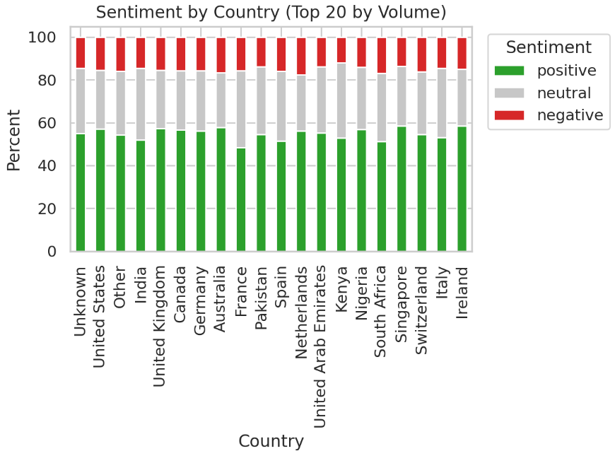
Figure 27: sentiments of stacked bar for top 20 countries

- This illustrates the percentage distribution of positive, neutral, and negative sentiment among the top 20 countries ranked by tweet volume.

- Scatterplot: Mean sentiment vs. volume by country:
– Each country is represented as a point; the x-axis (logarithmic scale) shows tweet volume, while the y-axis indicates mean VADER sentiment. This aids in pinpointing countries with a high volume of activity that have sentiment levels that are either particularly elevated or diminished.
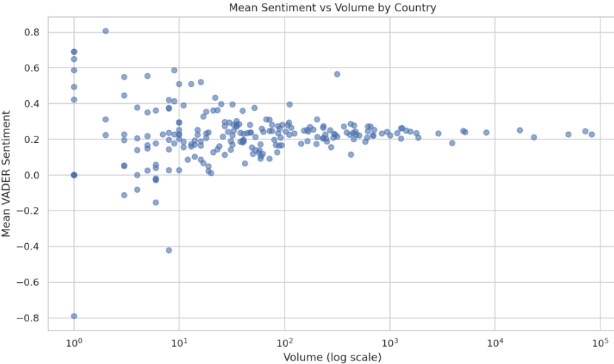
Figure 28: Mean Vader sentiment vs volume by country

- Heatmap: Sentiment share by region:
- The heatmap shows the proportion of positive, neutral, and negative tweets across different regions.
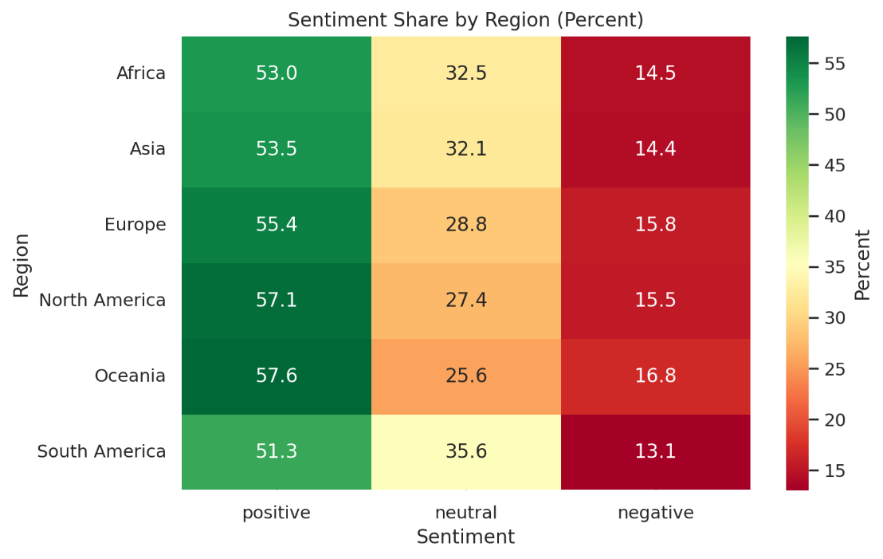
Figure 29: Sentiment by region

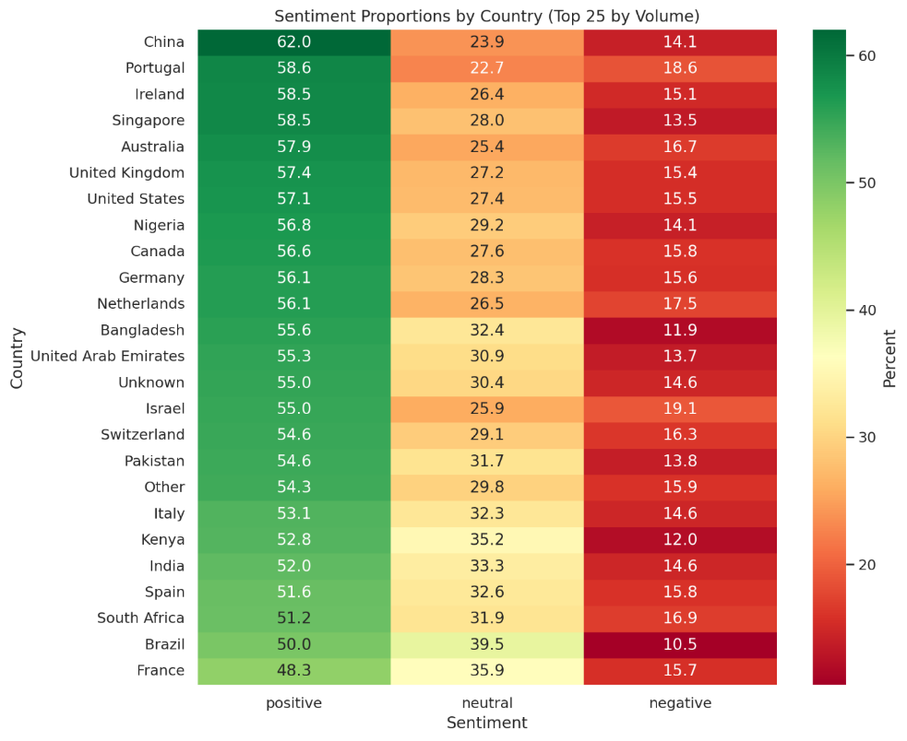
- Heatmap: Sentiment proportions across top locations

Figure 30: sentiments by locations
- Choropleth: negative sentiment by location
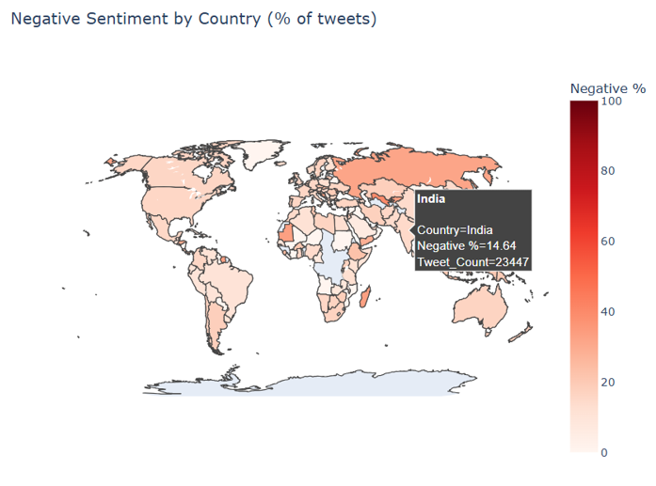
Figure 31: negative sentiments for India

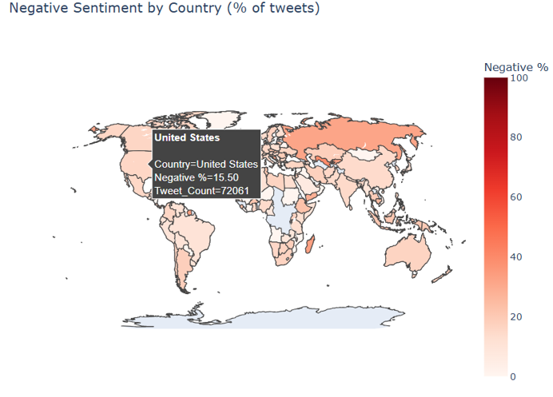
Figure 32: negative sentiments for united states

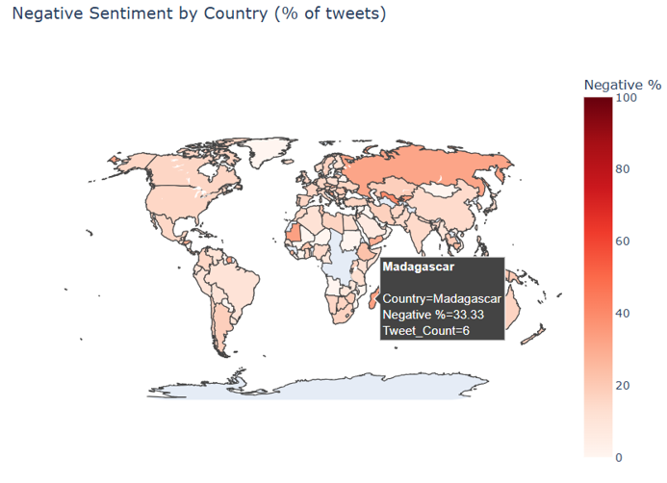
Figure 33: negative sentiments for Madagascar

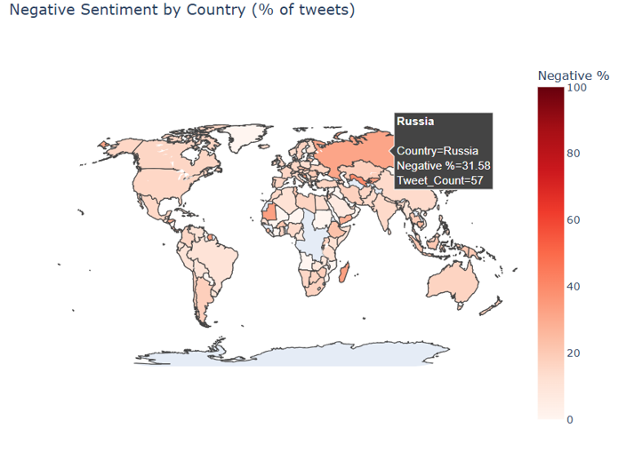
Figure 34: negative sentiments for Russia
- Key Findings:

- WHERE SENTIMENT IS WORSENING:

- South America: -0.052 delta (largest decline) the sentiment decreased from 0.249 to 0.197, suggesting an increase in skepticism or worry regarding AI developments in the area.
- Oceania: -0.022 delta there is a decline from 0.272 to 0.250, indicating that concerns are arising even though sentiment has been positive historically.
- North America: -0.022 delta sentiment dropped from 0.259 to 0.237, indicating a rise in caution or criticism in a market with high volume.
- Asia: -0.022 delta decrease from 0.237 to 0.215, potentially influenced by regulatory discussions and competitive pressures.
- Europe: -0.012 delta There is a slight decrease from 0.241 to 0.229, which aligns with the ongoing regulatory discussions (such as the EU AI Act).
- Africa: +0.001 delta (stable) with a value of approximately 0.24, sentiment continues to be stable, reflecting a balanced discourse.

- WHICH ENTITIES DRAW MOST CONCERN:

- Bard/Gemini (Google):
Asia: 0.122 mean sentiment (1,355 mentions)
North America: 0.139 (1,101 mentions)
Europe: 0.143 (583 mentions)

- Bard consistently ranks as the entity with the most negative sentiment across major regions, suggesting public skepticism about Google's AI offerings, possibly due to competitive comparisons or trust concerns.

- POSITIVE SENTIMENT DRIVERS:
– Hashtags that concentrate on innovation (#Innovation, #innovation) have a score of 0.51–0.59 in North America and Europe.

- Creative AI tools like Midjourney and Stable Diffusion exhibit a positive sentiment (0.31-0.33), reflecting public enthusiasm for generative art.

- In Asia, the hashtags related to smart cities and digital health (0.78-0.80) indicate a positive outlook on the use of AI in infrastructure and healthcare.

- POLICY IMPLICATIONS:

- The significant decline in sentiment in South America calls for an examination of local AI adoption barriers, misinformation, or economic issues.

- The consistently low sentiment for Bard indicates that Google could be experiencing trust deficits; regulators ought to keep an eye on competitive practices and transparency.

- The mixed sentiment surrounding ChatGPT, despite its high volume, suggests that clearer public communication regarding AI safety, limitations, and governance is necessary.

- Concerns regarding cybersecurity are widespread; it is essential for policymakers to give precedence to standards for AI security and frameworks for incident response.

- The negative sentiment surrounding #teaching in North America indicates concern about AI's involvement in education, highlighting the necessity for proactive teacher training and ethical guidelines.

- RECOMMENDED MONITORING ACTIONS:

- Implement automated sentiment analysis and trend monitoring for AI-related discussions in South America, Oceania, and North America. This should be integrated with current threat intelligence systems to generate weekly updates, monthly trend analyses, and daily notifications of anomalies, thus facilitating the early identification of public backlash or misinformation efforts.​

- Carry out qualitative analyses of references to key AI products (such as Bard/Gemini and ChatGPT) through bi-weekly and quarterly reviews in order to discover the underlying factors behind negative sentiment (e.g., performance, privacy) and pinpoint nascent dangers like electoral abuse and problems with academic integrity, while also flagging hashtags that fall below sentiment thresholds for cross-sector coordination.​

- Set up regional roundtables and involve AI firms (OpenAI, Google, Anthropic) to tackle issues of transparency and trust. At the same time, perform extended time-series analyses to correlate sentiment trends with regulatory and industry events in order to differentiate between temporary patterns and significant changes.​

- Conclusion:
There are indications of stress in global AI sentiment, especially in South America, Oceania, and North America. Discussions about Bard/Gemini and cybersecurity are vital areas of focus. To sustain public trust and guarantee responsible AI development, it is crucial to engage regionally, communicate transparently, and monitor proactively.

- Git hub:
https://github.com/tus2014ar

