答题纸

**选择题：**

|  |  |  |  |
| --- | --- | --- | --- |
| 1 | D | 11 | B |
| 2 | C | 12 | C |
| 3 | D | 13 | D |
| 4 | B | 14 | A |
| 5 | B | 15 | B |
| 6 | D | 16 | D |
| 7 | C | 17 | C |
| 8 | B | 18 | A |
| 9 | B | 19 | B |
| 10 | B | 20 | C |

**填空题：**

|  |  |
| --- | --- |
| 1 | 3389 |
| 2 | 22 |
| 3 | 虚拟专用网络 |
| 4 | 0 |
| 5 | 橙白-橙-绿白-蓝-蓝白-绿-棕白-棕 |
| 6 | 文件传输 |
| 7 | 目标可达性 |
| 8 | Vlan |
| 9 | 1 |
| 10 | 255.255.255.224‬ |

**判断题：**

|  |  |  |  |
| --- | --- | --- | --- |
| 1 | T | 6 | T |
| 2 | F | 7 | T |
| 3 | F | 8 | T |
| 4 | T | 9 | T |
| 5 | F | 10 | F |

**操作题：**

**Linux：**

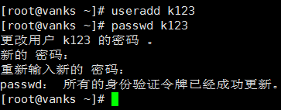

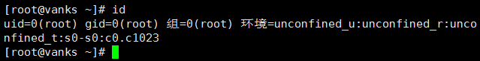



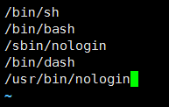



**Windows：**

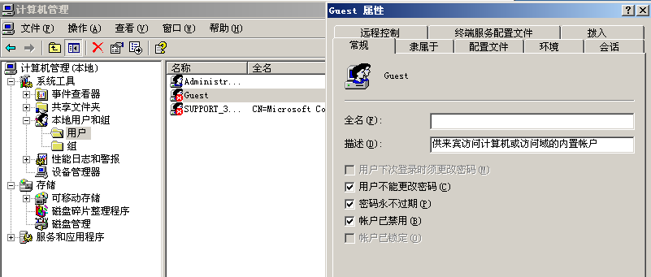

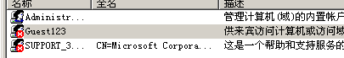

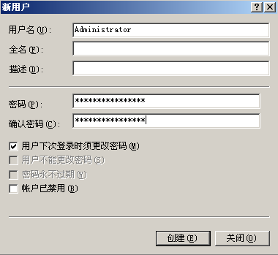

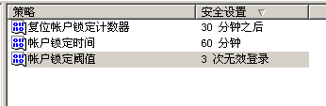

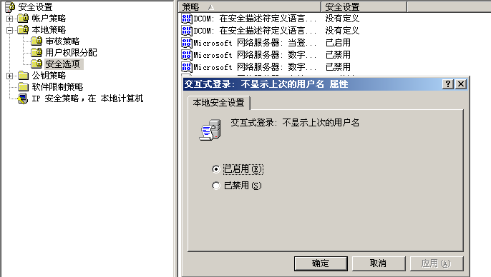

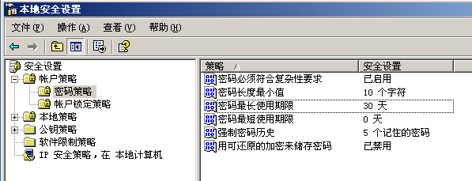

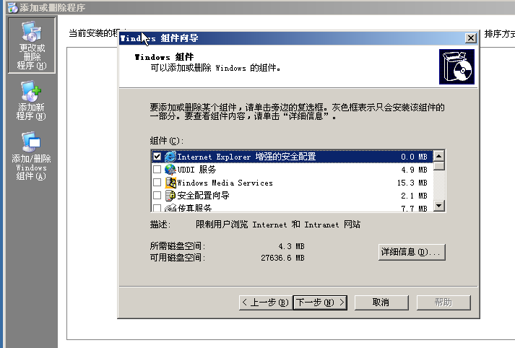

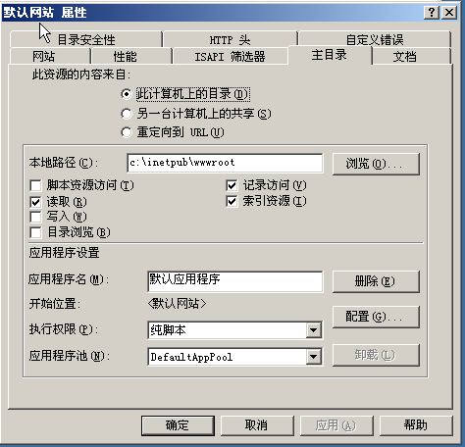

**编程题：**

**答：**

|  |
| --- |
| **#include<stdio.h>**  **//#include<math.h>**  **/\***  **int main(void) {**  **int a,i;**  **for(a=0;a<=100; a++) {**  **//每次都从2开始**  **for(i=2;i<a-1; i++) {**  **//能整除肯定不是质数 跳出**  **if(a%i==0) {**  **break;**  **}**  **}**  **//跳出来的肯定不是, 需要判断一下**  **if(i==(a-1)) {**  **printf("%d ",a);**  **}**  **}**  **return 0;**  **}**  **\*/**  **/\***  **int main(void){**  **int a=1;**  **for(;a<5;a++){**  **int b=1;**  **for(;b<5;b++){**  **int c=1;**  **for(;c<5;c++){**  **if(a!=b && a!=c && b!=c){**  **printf("%d,%d,%d \n",a,b,c);**  **}**  **}**  **}**  **}**  **return 0;**  **}**  **\*/**  **int main(void) {**  **int a=0;**  **for(; a<101; a++) {**  **int i=2;**  **for(; i<a/2; i++) {**  **if(a%i==0) {**  **break;**  **}**  **}**  **if(i==a/2) {**  **printf("%d ",a);**  **}**  **}**  **return 0;**  **}**  **/\***  **int main(void) {**  **int a=100;**  **for(; a<200; a++) {**  **int i=2;**  **for(; i<sqrt(a); i++) {**  **if(a%i==0) {**  **break;**  **}**  **}**  **if(i>=sqrt(a)) {**  **printf("%d ",a);**  **}**  **}**  **return 0;**  **}**  **\*/** |

**答案：**

