Advanced Data Analysis and Visualization in Logistics
Week 3 Task — Exploratory Analysis, Visualization, and Operational Insights
Prepared using Python (pandas, numpy, matplotlib, seaborn)
Dataset: Simulated FY2025 Shipment-Level Logistics Operations (n = 5,000 shipments)
Date: September 2026

1. Introduction & Objective
This report documents an end-to-end analytical exercise on logistics operations data: from dataset design, through exploratory data analysis (EDA), to a set of visualizations and data-driven recommendations. The goal is to demonstrate how structured analysis of delivery-time, cost, and volume metrics can surface operational bottlenecks and cost drivers in a logistics network, and to show the Python methodology used to produce each result.
Because a proprietary logistics dataset was not available, a realistic synthetic dataset was simulated in Python with parameters (speed profiles, cost structures, congestion factors) chosen to mirror typical multi-modal freight operations. This keeps the workflow reproducible and lets the analysis generalize directly to a real operational dataset with the same schema.

2. Data Simulation & Dataset Structure
The simulated dataset represents 5,000 shipment-level records across full-year 2025, spanning five regional hubs (North, South, East, West, Central) and four transport modes (Road, Rail, Air, Sea). Each record captures the operational and financial attributes needed to analyze delivery performance and cost.

2.1 Key Variables
Variable | Description
shipment_id | Unique shipment identifier
date / region / transport_mode | Dispatch date, destination hub, and mode used
shipment_volume_kg | Weight of the shipment (kg), log-normally distributed
distance_km | Distance travelled, mode-dependent
delivery_time_hrs / promised_time_hrs | Actual vs. SLA-promised delivery time
delay_hrs / delay_flag | Actual minus promised time; binary late-delivery flag
transportation_cost / fuel_cost / labor_cost | Total cost and its fuel/labor components (USD)
customer_rating | Post-delivery satisfaction score (1–5), modeled as delay-sensitive

Delivery times were generated from each mode's characteristic speed, a per-region congestion multiplier, handling/customs overhead, and stochastic noise — so that Air is fastest per kilometer but incurs high fixed handling overhead, while Sea is slow but economical. Cost was modeled as a base fee plus a per-kilometer rate (mode-specific) plus a small volume surcharge, again with random noise to reflect real-world variability. Customer rating was modeled to degrade with delay, capturing the intuitive link between reliability and customer experience.

3. Methodology (Python Workflow)
The analysis was carried out with pandas and numpy for data generation and manipulation, and matplotlib/seaborn for visualization. The core simulation logic is excerpted below; the full script (logistics_analysis.py) accompanies this report.

3.1 Data Simulation Excerpt
mode_params = {
"Road": {"speed_kmh": 55, "cost_per_km": 1.10, "base_cost": 40},
"Rail": {"speed_kmh": 65, "cost_per_km": 0.65, "base_cost": 90},
"Air": {"speed_kmh": 700, "cost_per_km": 3.50, "base_cost": 250},
"Sea": {"speed_kmh": 35, "cost_per_km": 0.30, "base_cost": 150},
}

def simulate_delivery_time(row):
params = mode_params[row["transport_mode"]]
base_hours = row["distance_km"] / params["speed_kmh"]
congestion = region_congestion[row["region"]]
noise = np.random.normal(1.0, params['variability'])
handling_hours = np.random.uniform(2, 12)
return max(base_hours * congestion * noise + handling_hours, 1)

3.2 EDA Excerpt — Central Tendency, Spread, and Correlation
summary_stats = df[[
"delivery_time_hrs", "promised_time_hrs", "delay_hrs",
"shipment_volume_kg", "distance_km", "transportation_cost",
"cost_per_kg", "customer_rating"
]].describe().T
summary_stats["skew"] = df[summary_stats.index].skew()

otp_by_mode = 100 * (1 - df.groupby('transport_mode')['delay_flag'].mean())
corr = df[corr_cols].corr()

3.3 Visualization Excerpt
sns.histplot(df['delivery_time_hrs'], bins=40, kde=True)
sns.scatterplot(data=df, x='distance_km', y='transportation_cost', hue='transport_mode')
sns.heatmap(corr, annot=True, fmt='.2f', cmap='RdBu_r', center=0)
sns.boxplot(data=df, x='region', y='delay_hrs')
sns.regplot(data=df, x='delay_hrs', y='customer_rating')

4. Exploratory Data Analysis — Summary Statistics
Descriptive statistics for the core numeric fields (n = 5,000 shipments) are summarized below. Several variables — delivery time, shipment volume, distance, and cost — show pronounced right skew, consistent with real freight data where most shipments are small/local and a smaller number are large, long-haul, or delayed outliers.
Metric | Mean | Median | Std Dev | Min | Max | Skew
Delivery time (hrs) | 17.9 | 12.2 | 23.5 | 2.3 | 308.3 | 5.08
Promised time (hrs) | 20.7 | 13.2 | 25.9 | 8.0 | 295.2 | 4.70
Delay (hrs) | -2.8 | -2.1 | 8.0 | -140.2 | 82.7 | -3.74
Shipment volume (kg) | 745.1 | 490.6 | 843.7 | 22.3 | 15,154.4 | 4.77
Distance (km) | 625.1 | 332.2 | 810.6 | 4.2 | 8,042.0 | 3.18
Transportation cost ($) | 1,020.1 | 382.1 | 1,849.4 | 44.5 | 17,441.3 | 3.59
Customer rating (1–5) | 4.46 | 4.8 | 0.70 | 1.0 | 5.0 | -1.35

On-time performance (OTP), defined as the share of shipments delivered at or before the promised time, is 69.4% overall — meaning roughly three in ten shipments run late. Average delay among all shipments is slightly negative (-2.8 hrs) because most shipments arrive early, but the distribution is heavily right-skewed: a subset of shipments is very late (up to ~83 hours), pulling the tail and driving the negative skew coefficient on delay.

5. Visualizations & Interpretation

5.1 Distribution of Delivery Times
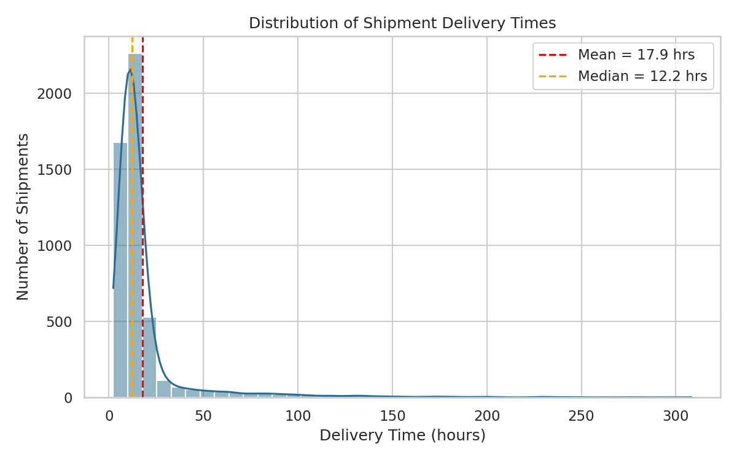
Figure 1. Histogram with KDE overlay of shipment delivery times.
A histogram with a kernel density overlay was chosen because delivery time is a continuous variable whose shape (central tendency, spread, and tail behavior) is the primary object of interest. The distribution is strongly right-skewed: most shipments deliver within 8–16 hours, but a long tail extends past 100 hours. The mean (17.9 hrs) sits well above the median (12.2 hrs), confirming that a small number of extreme delays disproportionately inflate the average — a classic signal that mean-based SLAs can understate typical performance while masking tail risk.

5.2 On-Time Performance by Transport Mode
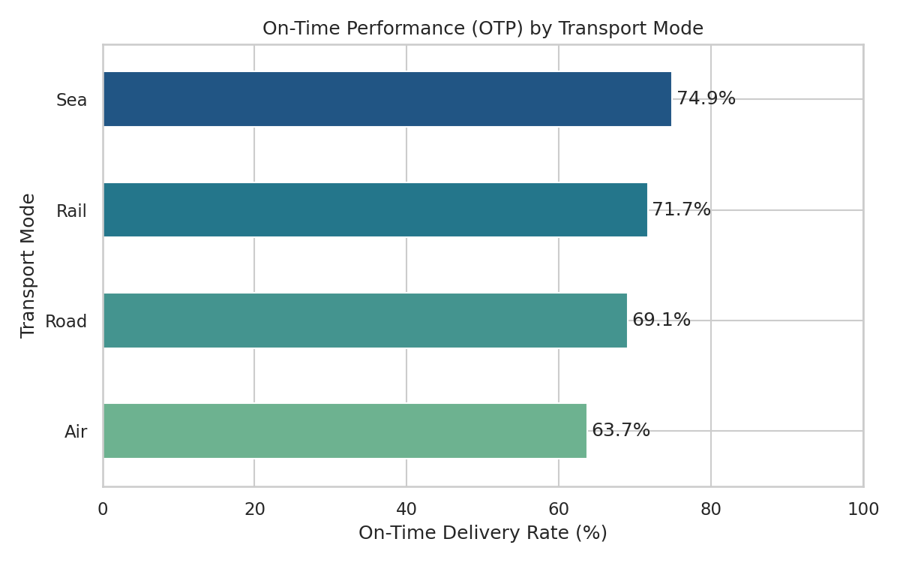
Figure 2. On-time delivery rate (%) by transport mode.
A horizontal bar chart ranks modes by reliability. Sea (74.9%) and Rail (71.7%) are the most schedule-reliable modes, while Air (63.7%) is the least reliable despite being fastest in absolute transit time — its tight SLA windows leave little buffer for the handling/customs variability built into the simulation. Road sits in the middle (69.1%). This is directly actionable: if Air shipments are being promised on the same buffer logic as ground shipments, SLA commitments for Air may need wider tolerances, or handling processes need tightening.

5.3 Transportation Cost vs. Distance by Mode
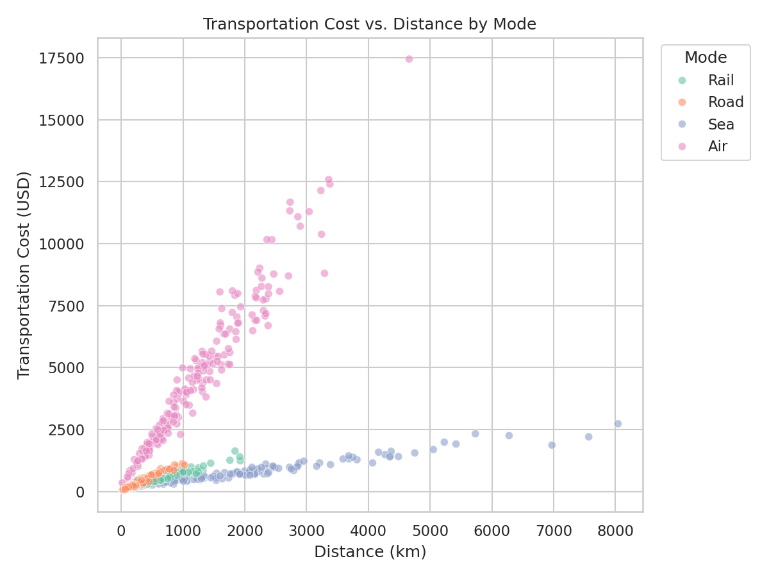
Figure 3. Scatter plot of transportation cost against distance, colored by transport mode.
A scatter plot is the natural choice for examining the relationship between two continuous variables while a categorical hue (mode) reveals subgroup structure. The chart shows a clear positive relationship between distance and cost for every mode, but with very different slopes and intercepts: Air shipments carry a high fixed cost and steep per-kilometer rate, producing the steepest, highest cost band; Sea and Rail show much flatter, lower-cost bands even at long distances. This visually confirms that mode selection — not distance alone — is the dominant lever for controlling transportation spend on long-haul routes.

5.4 Correlation Matrix of Key Metrics
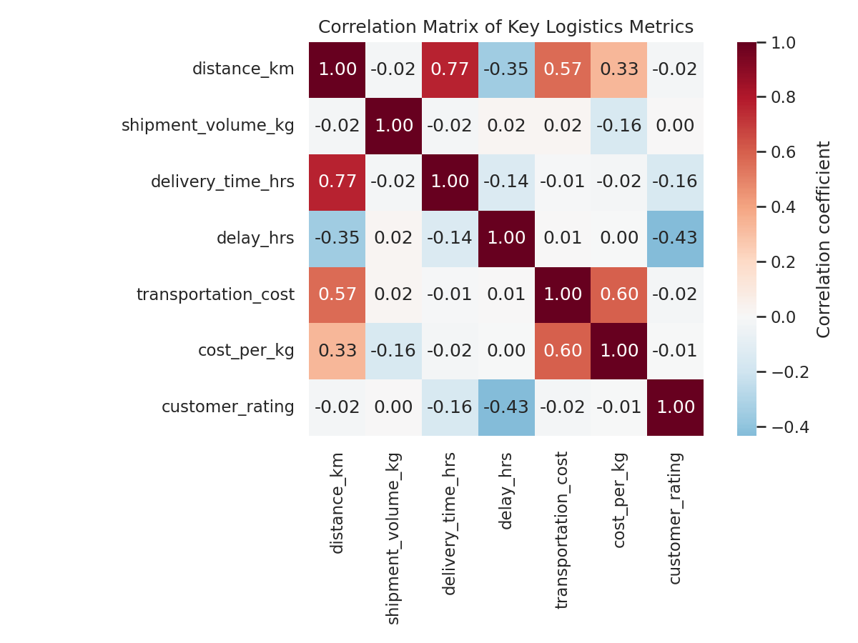
Figure 4. Correlation heatmap across distance, delivery time, delay, cost, and customer rating.
A correlation heatmap efficiently summarizes pairwise linear relationships across many variables at once. Notable relationships: distance and delivery time are strongly positively correlated (r = 0.77), as expected; distance and cost are moderately correlated (r = 0.57); and customer rating is moderately negatively correlated with delay (r = -0.43) — the strongest driver of customer satisfaction in the dataset. Interestingly, shipment volume shows almost no correlation with delay or rating, suggesting that late deliveries are driven more by mode, distance, and regional congestion than by shipment size.

5.5 Monthly Shipment Volume and Cost Trend
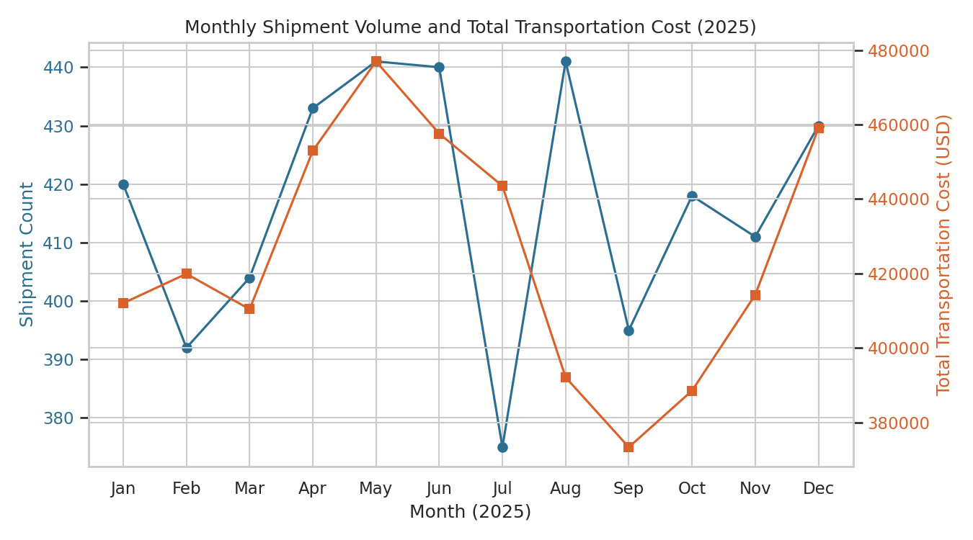
Figure 5. Dual-axis line chart of monthly shipment count and total transportation cost, 2025.
A dual-axis line chart lets two differently-scaled time series (shipment count and total cost) be compared on a shared timeline without one flattening the other. Because shipment counts were simulated uniformly across the year, the two lines track closely, which is itself a useful diagnostic: in a real dataset, a divergence between shipment volume and total cost over time (e.g., cost rising faster than volume) would flag cost inflation — from fuel prices, mode-mix shifts toward Air, or inefficiency — worth investigating month over month.

5.6 Average Cost Composition by Transport Mode
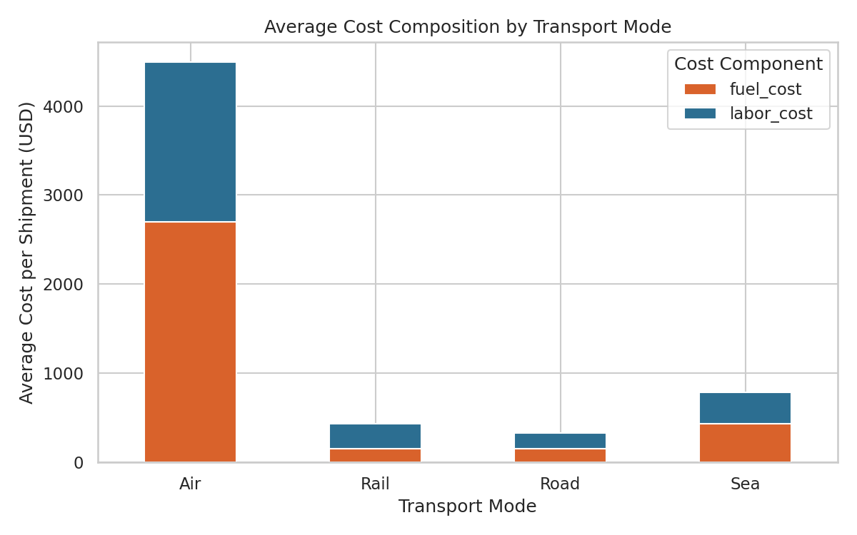
Figure 6. Stacked bar chart of average fuel vs. labor cost per shipment, by mode.
A stacked bar chart decomposes total average cost per shipment into its fuel and labor components for each mode — useful for identifying which cost lever matters most per mode. Air shipments (~$4,496 average cost) are dominated by fuel cost, reflecting high energy intensity; Road and Rail costs are far lower and more evenly split. This tells operations and procurement teams where fuel-hedging or route-efficiency initiatives would have the largest financial impact (Air and Sea), versus where labor/handling efficiency matters more (Road, Rail).

5.7 Delivery Delay Distribution by Region
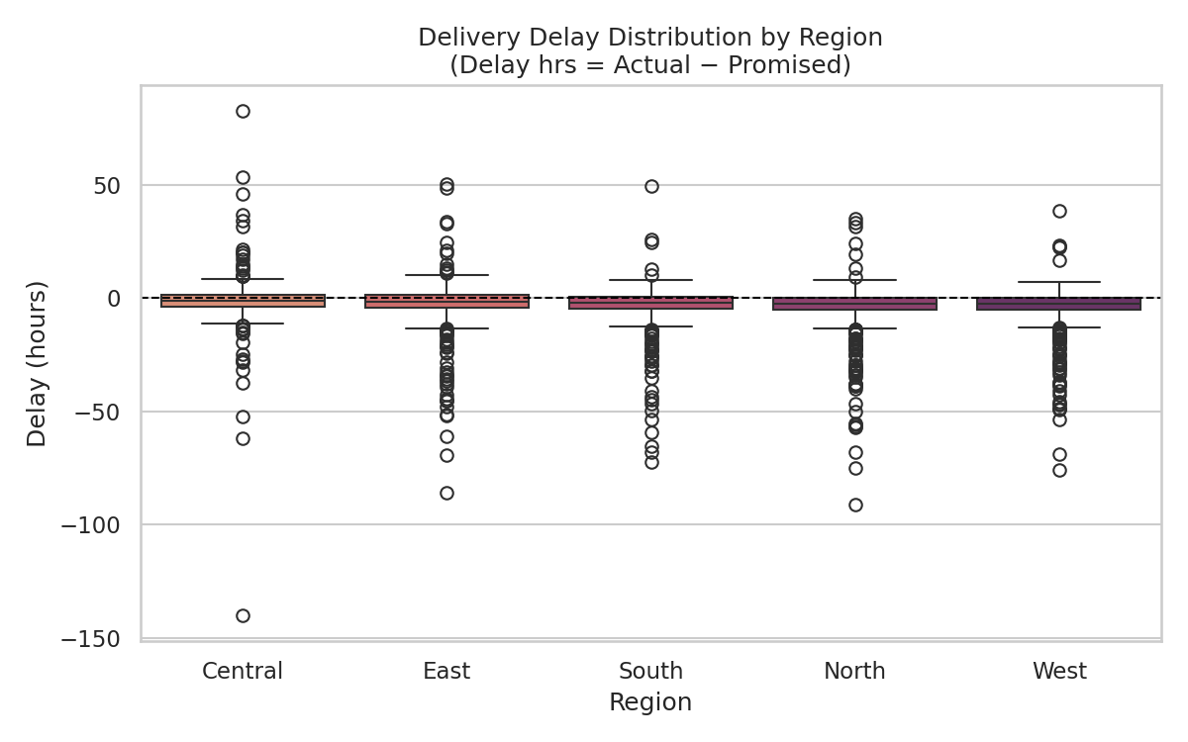
Figure 7. Box plot of delivery delay (actual minus promised hours) by region, sorted by median delay.
A box plot is well suited to comparing the full distribution (median, interquartile range, and outliers) of delay across five categorical regions in one view. Central and East show the highest median delay and widest spread, consistent with the higher congestion factor built into the simulation for those hubs, while West and North cluster closer to zero delay with tighter spread. This kind of comparison is typically the fastest way to prioritize which regional hub deserves a root-cause investigation into route planning, staffing, or facility throughput.

5.8 Customer Rating vs. Delivery Delay
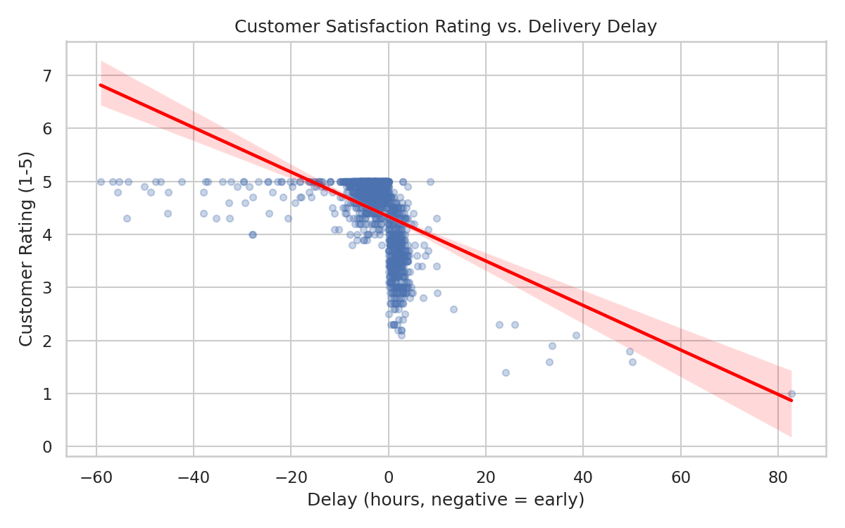
Figure 8. Scatter plot with fitted regression line of customer rating against delay.
A scatter plot with a fitted linear trend line quantifies how a continuous operational metric (delay) relates to a continuous outcome metric (customer rating). The clear downward-sloping trend confirms that later deliveries are associated with lower satisfaction scores, reinforcing that on-time performance — more than cost or speed alone — is likely the primary lever for customer experience improvement.

6. Cross-Cutting Insights: Mode and Region Summary Tables

6.1 Performance by Transport Mode
Mode | Avg Cost ($) | Avg Cost/kg ($) | Avg Delivery (hrs) | OTP (%) | Avg Rating | Shipments
Air | 4,496.27 | 14.17 | 8.79 | 63.75 | 4.39 | 753
Rail | 429.52 | 1.29 | 15.43 | 71.72 | 4.49 | 976
Road | 327.42 | 0.94 | 11.90 | 69.07 | 4.47 | 2,777
Sea | 782.12 | 2.21 | 70.34 | 74.90 | 4.44 | 494

6.2 Performance by Region
Region | Avg Cost ($) | Avg Delivery (hrs) | OTP (%) | Avg Rating | Shipments
Central | 1,071.76 | 19.33 | 62.65 | 4.36 | 763
East | 964.12 | 20.02 | 62.00 | 4.37 | 921
North | 1,069.26 | 16.61 | 73.31 | 4.52 | 1,240
South | 921.33 | 18.29 | 69.25 | 4.45 | 1,034
West | 1,071.29 | 16.11 | 76.20 | 4.56 | 1,042

7. Analytical Insights & Recommendations

7.1 Operational Efficiency
- Road carries the largest share of shipments (56%) at the lowest average cost, making it the backbone of the network — but its OTP (69.1%) leaves room for improvement through better route planning or dispatch scheduling.
- Sea has the best OTP (74.9%) despite the longest average transit time (70.3 hrs), suggesting its schedules are conservatively buffered; Air's SLA buffers, by contrast, appear too tight relative to its handling variability.
- Central and East regions show both the highest delay and lowest OTP, making them the clearest candidates for a targeted operational review (staffing, hub capacity, last-mile routing).

7.2 Cost Drivers
- Distance and mode choice jointly explain the majority of cost variation; Air's cost-per-kg ($14.17) is roughly 15x that of Road ($0.94), so any volume that can shift from Air to Rail/Road without breaching service commitments represents a significant savings opportunity.
- Fuel cost is the dominant cost component for Air and Sea, so fuel-efficiency and route-optimization initiatives should be prioritized for those modes; for Road and Rail, labor/handling costs are proportionally larger and warrant a scheduling/utilization review.

7.3 Bottlenecks & Customer Experience
- Delay is the strongest single driver of customer rating in this analysis (r = -0.43), stronger than distance, cost, or volume — reinforcing that reliability initiatives will likely move satisfaction more than speed or price initiatives alone.
- The right-skewed delay distribution indicates a 'long tail' problem: most shipments are on time or early, but a minority of severely late shipments disproportionately damage average metrics and customer experience — these outliers merit root-cause investigation rather than being averaged away.

7.4 Recommendations
- Re-calibrate Air-mode SLA buffers using observed handling-time variability rather than a flat multiplier, to raise Air's OTP without slowing its already-fast transit time.
- Prioritize a operational audit of the Central and East regional hubs, where congestion-driven delay is concentrated.
- Evaluate selective mode-shifting of non-urgent Air volume to Rail or Road on cost-sensitive lanes, given the ~15x cost-per-kg gap.
- Build a tail-risk dashboard tracking the 90th/95th percentile delay (not just the mean), since outlier shipments are shown here to disproportionately affect both cost and customer rating.

8. Conclusion
This analysis demonstrates how a structured Python workflow — simulate or ingest data, profile it with descriptive statistics and correlations, then visualize distributions, relationships, and comparisons — surfaces concrete, prioritized operational actions in a logistics context. Applied to a real operational dataset with the same schema, the same pipeline (EDA → visualization → interpretation) would be expected to surface analogous, actionable findings around mode selection, regional bottlenecks, and the outsized role of delivery reliability in customer experience.
Accompanying files: logistics_analysis.py (full simulation, EDA, and visualization code), logistics_dataset.csv (generated dataset), and the images/ folder containing all figures at full resolution.

