 

INSTITUTE FOR ADVANCED

COMPUTING AND

SOFTWARE DEVELOPMENT

AKURDI, PUNE

Documentation On

**“Cost Estimation of Solar Plant along with Net Metering Portal”**

*Submitted By: Submitted to:*

**Group 87 Mr. Milind Arjun**

Tushar Kaushik (219217) **Project Guide**

Rajnikant Tiwari (219139)

**Table Of Contents**

# Introduction

### Purpose

### Scope

### Definition

### Overview

# Use Case Direction

# Specific Requirements

# Functional Specification

# Non-Functional Requirements

# Performance requirements

# Technical Issues

# Hardware Requirement

# System Design Specification

# System Flow Diagram

# ER Diagram

# Data Flow

# Database Design

# Future Scope

# References

**Cost Estimation of Solar Plant along with Net Metering Portal**

### 1.1 Purpose:

This document is meant to delineate the features of Solar Plant Designing and net metering Portal, so as to serve as a guide to the developers on one hand and software validation document for the prospective client on the other.

It is a system design especially for rooftop solar power plants which could be setup at domestic or small-scale industrial areas. This system will help to calculate the estimated cost of the power plant and further net-metering will help to calculate the payback period of the plant. The benefit of which is that after this calculation client can sell surplus power back to government.

### 1.2 Scope:

This system allows the Customer to have an idea of installing a rooftop solar plant as well as to create an awareness towards renewable energy sources. Even a small capacity solar plant can reduce a considerable amount of CO2 emissions.

### 1.3 Definitions:

RSP- Rooftop Solar Plant

SRS- Software Requirement Specification

GUI- Graphical User Interface

**1.4 Overview:**

It is a system design especially for rooftop solar power plants which could be setup at domestic or small-scale industrial areas. It provides complete functionality of cost calculation and then net-metering. In this system, government policies related to solar energy, different solar equipment related information will also be provided.

This proposed system can be used by any naïve users and it does not require any educational level, experience or technical expertise in computer or energy field but it will be of good use if user has the good knowledge of how to operate a computer.

**NEED FOR THIS SYSTEM**

* As we know that India had faced energy crisis many times so it is needed to look for alternative sources such as solar, wind etc.
* This system is totally focused of rooftop solar plant which will provide an idea to a consumer that how solar system works and what would the installation cost.
* This system also help consumer to calculate payback period.
* After calculation of payback period this system is capable to estimate the benefit of the customer which he is earning while selling surplus power to government.
* At last as we know that solar energy is the source of green energy which helps to reduce the carbon emissions.
* An inquiry is easily done by user in the system.

**2.Overall Description**:

This application enables an admin to add the user details such as name, location, contact details. User to view information of his estimated cost of plant, payback period, solar equipment brands, power generation, power consumption, net power output, his monthly earning by selling power, government policies according to different states. Also, as we know that this is a pandemic situation so with the ease of this system a user no need to be present physically at the plant installers. This system provides required information to the user from any corner of the country. It is a hassle-free system where he will just get the output doing any complex calculations.

**2.1 Product Perspective**:

This product aimed toward a person who is interested in installing rooftop solar plant without doing tough and complex calculation. Also helps user to know his benefits from government while selling the surplus power.

**2.2 Product Functions**:

This System should support this use case:

**Use Case Diagram**: A Use case is a description of set of sequence of actions. Graphically it is rendered as an ellipse with solid line including only its name. Use case diagram is a behavioral diagram that shows a set of use cases and actors and their relationship. It is an association between the use cases and actors. An actor represents a real-world object.

**Use Case diagram for User**

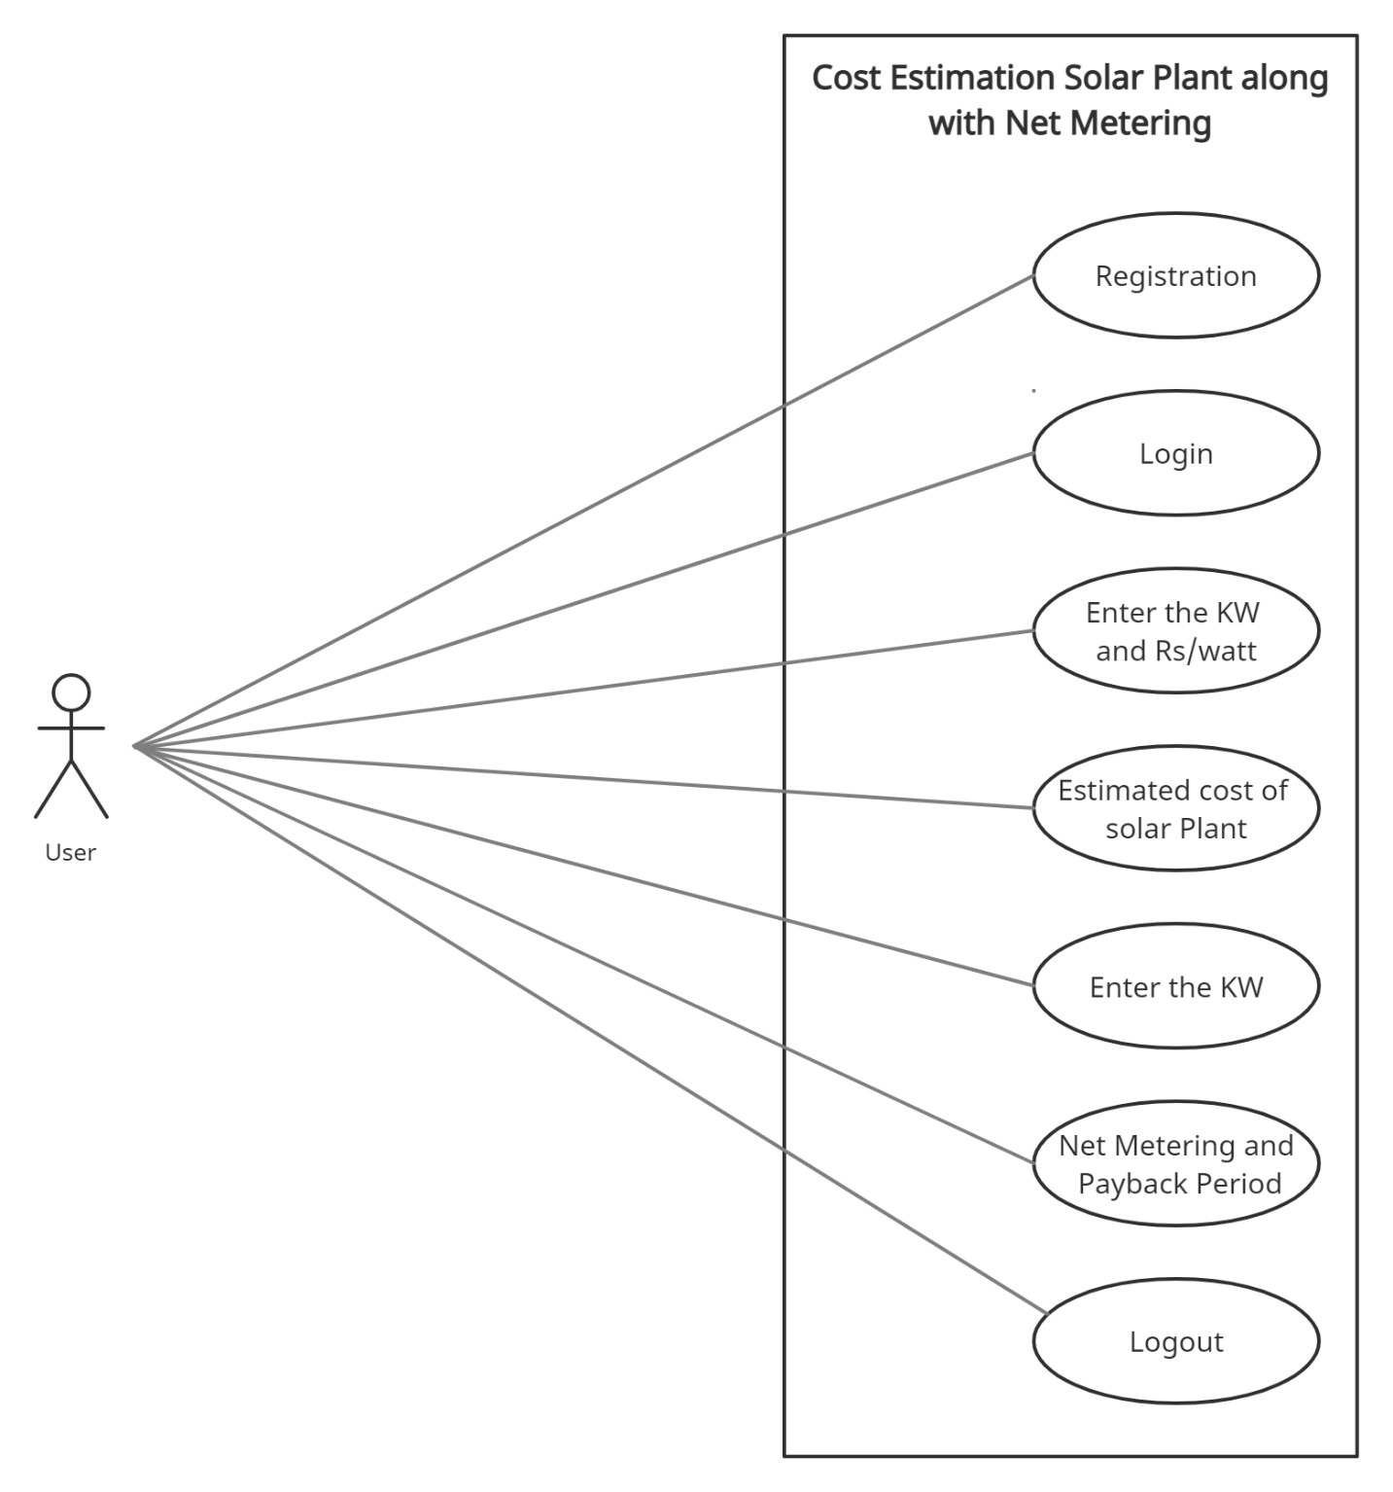

**2.3 User Characteristics**:

User should be familiar with the terms like login, register etc.

**2.5 General Constraints**:

A full internet connection is required for this system.

**2.6 Assumptions and Dependencies**:

Working of this system need Internet Connection.

**3. Specific Requirements**:

**3.1** **FUNCTIONAL SPECIFICATION**

**User:**

User can view information of installation cost of solar power plant on the basis of inputs such as KW and Rs/Watt as well as information on net metering while entering KW.

**MODULE SPECIFICATION**

**User**

**•Registration:**

In this the user has to first register and then he will be able to access the portal

**•Login:**

The users need to enter email and password to login into their respective account.

**•View Solar Plants Installation Cost:**

It is a system designed especially to estimate the cost of RSP for household purpose. In this the user can enter KW and Rs/Watt (Rs/watt plays a vital role in cost as it defines the cost of solar panels).

**• View Net-Metering and Payback Period:**

The user can enter the KW as per available options(1/5/10 in KW) so that he will have an idea regarding benefits of solar plant along with monthly data which will also include payback period.

***Note -*** *Payback Period is a period in years in which the user’s respective plant will be almost free.*

**•Logout:**

The User can logout from his/her account and then he/she will re-directed to home page.

**• Home Page:**

Here the user can access different redirection links such as what is solar energy, what is net metering different solar equipment brands and different solar policies of Indian states.

**3.2 Non-Functional Requirements**:

Following Non-Functional Requirements will be there in the

insurance to the internet:

(i) Secure access to consumer’s confidential data.

(ii) 24X7 availability.

(iii) Better component design to get better performance at peak

time.

(iv) Flexible service-based architecture will be highly desirable for

future extension. Non-Functional Requirements define system

properties and constraints.

Various other Non-Functional Requirements are:

➢ Security

➢ Reliability

➢ Maintainability

➢ Portability

➢ Extensibility

➢ Reusability

➢ Compatibility

➢ Resource Utilization

**3.3 Performance Requirements**:

In order to maintain an acceptable speed at maximum number of uploads allowed from a particular customer as any number of users can access to the system at any time. Also the connections to the servers will be based on the attributes of the user like his location and server will be working 24X7 times.

**3.4 Technical Issues**:

This system will work on client-server architecture. It will require an internet server and which will be able to run Java Web application. The system should support some commonly used browser such as Mozila firefox, chrome etc.

**HARDWARE REQUIREMENT**

Minimum hardware requirements for insurance on internet

will be same for both parties which are as follows:

|  |  |
| --- | --- |
| **RAM** | 4 GB |
| **Hard disk** | 320 GB |
| **Processor** | i3 (11th Gen) |

**Software Requirements**

**Client side:**

|  |  |
| --- | --- |
| **Web Browser** | Google Chrome or any  compatible browser |
| **Operating System** | Windows or any equivalent OS |

**Server side:**

|  |  |
| --- | --- |
| **Web Server** | Java EE (Spring Boot Framework) |
| **Server side Language** | Thymeleaf |
| **Database Server** | MYSQL |
| **Web Browser** | Google Chrome or any  compatible browser |
| **Operating System** | Windows or any equivalent OS |

**5.System Design Specification:**

**System Flow Chart**

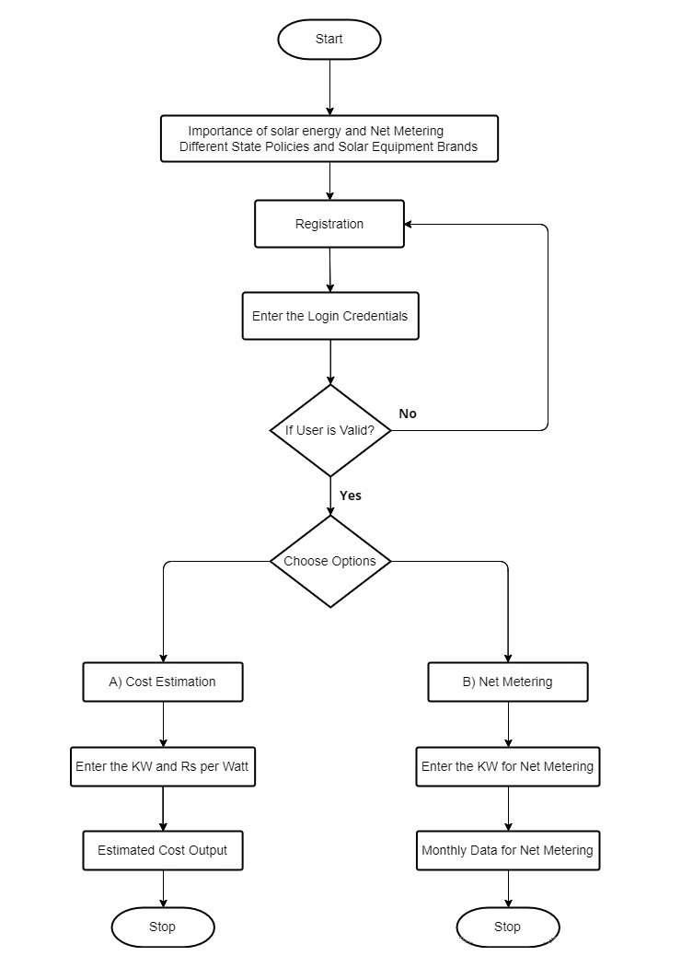

**ER DIAGRAM**

The Entity-Relationship (ER) model was originally proposed by Peter in 1976 [Chen76] as a way to unify the network and relational database views. Simply stated the ER model is a conceptual data model that views the real world as entities and relationships. A basic component of the model is the Entity-Relationship diagram which is used to visually represent data objects. Since Chen wrote his paper the model has been extended and today it is commonly used for database design for the database designer, the utility of the ER model is:

* It maps well to the relational model. The constructs used in the ER model can easily be transformed into relational tables.
* It is simple and easy to understand with a minimum of training. Therefore, the model can be used by the database designer to communicate the design to the end user.
* In addition, the model can be used as a design plan by the database developer to implement a data model in specific database management software.

.

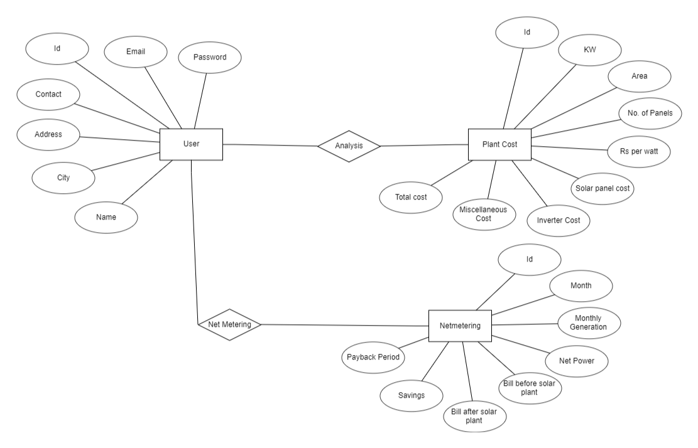

**DATA-FLOW DIAGRAM**

A data-flow diagram is a way of representing a flow of data through a process or a system (usually an information system). The DFD also provides information about the outputs and inputs of each entity and the process itself. A data-flow diagram has no control flow — there are no decision rules and no loops.

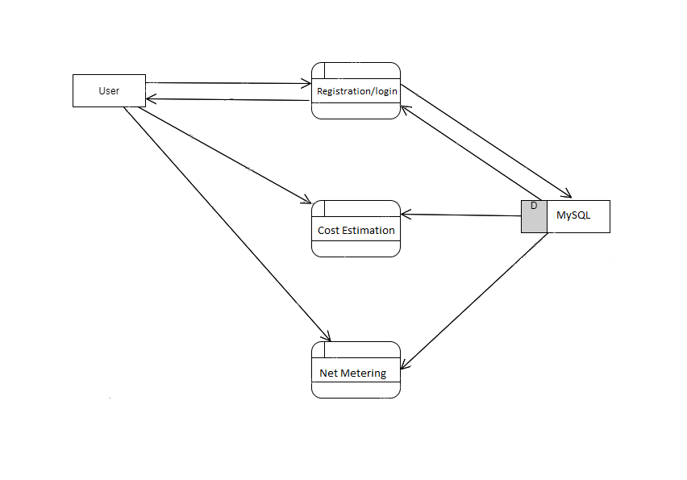

**DATABASE DESIGN**

The data in the system has to be stored and retrieved from database. Designing the database is part of system design. Data elements and data structures to be stored have been identified at analysis stage. They are structured and put together to design the data storage and retrieval system.

A database is a collection of interrelated data stored with minimum redundancy to serve many users quickly and efficiently. The general objective is to make database access easy, quick, inexpensive and flexible for the user. Relationships are established between the data items and unnecessary data items are removed. Normalization is done to get an internal consistency of data and to have minimum redundancy and maximum stability. This ensures minimizing data storage required, minimizing chances of data inconsistencies and optimizing for updates. The MS Access database has been chosen for developing the relevant databases.

**6.FUTURE SCOPE**

As we observe and conclude that ,World is shifting towards alternative Renewable Energy Sources by 2050,so there is a huge potential that is still to be tapped by Planting more solar roof panels and mitigate the energy shortages both at individual as well as community level.We can see significant growth in the entrepreneurs promoting it not just as an efficient energy fulfilling means but also as an income source for both individuals and community.

**7.REFERENCES**

* <https://spring.io/projects/spring-boot>
* <https://www.wikipedia.org/>
* <https://docs.microsoft.com/en-IN/aspnet/core/tutorials/min-web-api?view=aspnetcore-6.0&tabs=visual-studio>
* [Schemes for Solar energy by Ministry of New and Renewable Energy| National Portal of India](https://www.india.gov.in/schemes-solar-energy-ministry-new-and-renewable-energy)
* [Spring Boot - Thymeleaf with Example - GeeksforGeeks](https://www.geeksforgeeks.org/spring-boot-thymeleaf-with-example/)