TASK 1: DNA/Protein Sequence Analysis Using BLASTp
1. Introduction
Bioinformatics is an interdisciplinary field that combines biology, computer science and data analysis to study biological information. Protein sequence analysis is an important application of bioinformatics because protein sequences can be compared to identify similar or homologous proteins.
BLAST (Basic Local Alignment Search Tool) is a widely used sequence-comparison tool developed by NCBI. It compares a query sequence with sequences present in a biological database and identifies sequences with significant similarity. BLAST results can provide information such as percentage identity, query coverage, alignment score and E-value.
In this study, the human hemoglobin subunit beta (HBB) protein sequence was obtained from the NCBI Protein database. The sequence was analyzed using BLASTp to identify homologous protein sequences and evaluate their sequence similarity.
2. Objective
• To obtain a protein sequence from the NCBI database.
• To perform BLASTp analysis of the selected protein sequence.
• To identify homologous protein sequences.
• To compare the sequences based on percentage identity, query coverage, E-value and alignment score.
• To examine the sequence alignment and interpret the BLAST results.
3. Selected Protein Sequence
The protein selected for this analysis was hemoglobin subunit beta (HBB) from Homo sapiens.
Parameter | Details
Protein | Hemoglobin subunit beta
Organism | Homo sapiens
Gene | HBB
NCBI Accession | NP_000509.1
Molecule type | Protein
Sequence length | 147 amino acids
Database | NCBI Protein
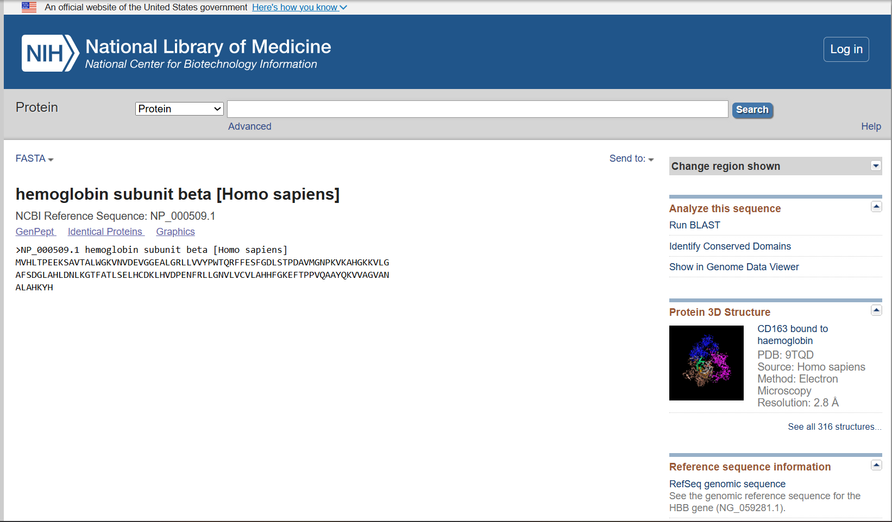
Figure 1. NCBI FASTA sequence of human hemoglobin subunit beta
4. Tools and Database Used
NCBI Protein Database: Used to obtain the HBB protein sequence.
NCBI BLASTp: Used to compare the selected protein sequence against protein sequences in the database and identify homologous sequences.
5. Methodology
• The human hemoglobin subunit beta protein record was retrieved from the NCBI Protein database using accession number NP_000509.1.
• The FASTA sequence was obtained from the NCBI record and submitted as the query for BLASTp.
• The BLAST search was performed using the ClusteredNR database.
• Homologous sequences were examined based on query coverage, percentage identity, E-value and alignment score.
• Pairwise alignments were examined to determine identical and similar amino-acid positions and gaps.

6. BLASTp Analysis
The human hemoglobin subunit beta protein sequence (NP_000509.1) was used as the query sequence for BLASTp. The query sequence contains 147 amino acids. The BLASTp search identified several protein sequences showing significant similarity to the query.
Table 1. Top BLASTp Results
No. | Homologous protein | Organism | Accession | Score  (bits) | E-value | Coverage | Identity
1 | Hb Monza protein | Homo sapiens | XEF57200.1 | 288 | 2e-97 | 100% | 86.47%
2 | Beta-globin | Homo sapiens | AAA35597.1 | 277 | 2e-93 | 100% | 93.20%
3 | Hemoglobin subunit beta-like | Canis lupus familiaris | NP_001257812.1 | 275 | 1e-92 | 100% | 89.80%
4 | Hemoglobin subunit delta | Ailuropoda melanoleuca | NP_001291814.1 | 273 | 7e-92 | 100% | 89.80%
5 | Hemoglobin subunit beta-like | Ailuropoda melanoleuca | NP_001291812.1 | 273 | 7e-92 | 100% | 89.80%
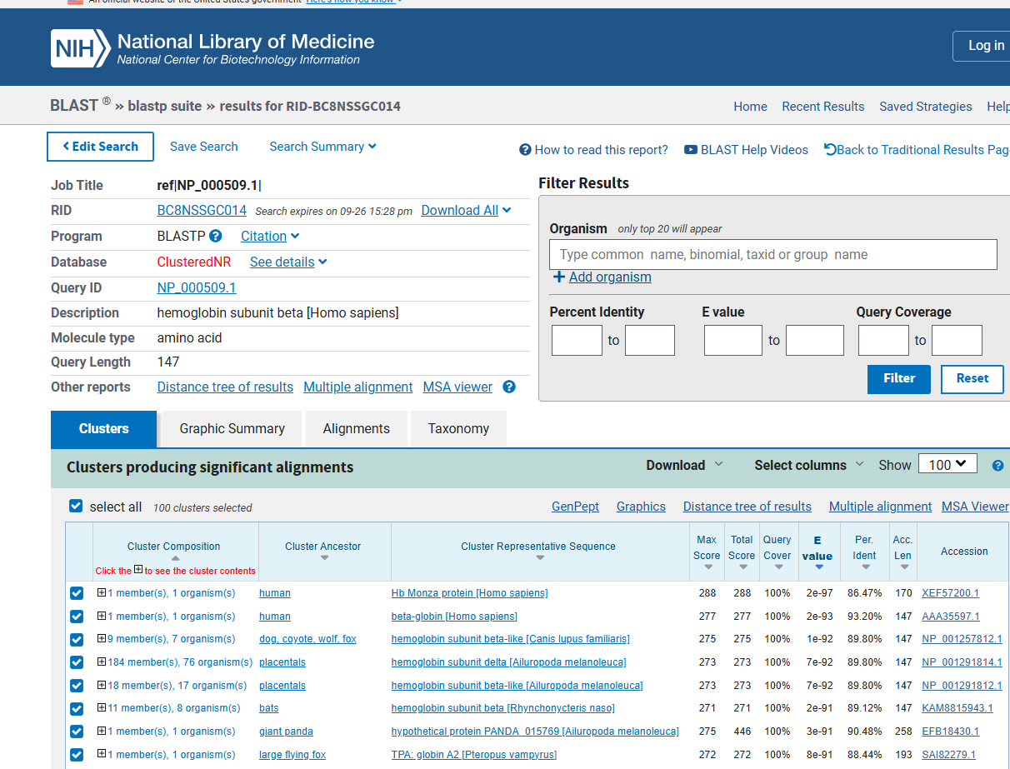
Figure 2. BLASTp results showing homologous protein sequences
7. Interpretation of BLASTp Results
All five selected hits showed 100% query coverage, indicating that the complete query sequence was represented in the reported alignments. Percentage identity ranged from 86.47% to 93.20%, with the beta-globin protein from Homo sapiens showing the highest identity (93.20%) among the five selected hits.
The alignment scores ranged from 273 to 288 bits. The Hb Monza protein showed the highest score (288 bits). The E-values ranged from 2e-97 to 7e-92, indicating that the observed sequence similarities are statistically significant and very unlikely to have occurred by chance.
Overall, the BLASTp results demonstrate strong sequence similarity between the HBB query protein and several hemoglobin-related proteins.

8. Pairwise Sequence Alignment Analysis
The pairwise alignment of the human HBB query sequence with the beta-globin [Homo sapiens] hit was examined to further evaluate sequence similarity.
Parameter | Result
Alignment score | 277 bits
E-value | 2e-93
Identical residues | 137/147 (93%)
Positive residues | 137/147 (93%)
Gaps | 0/147 (0%)
Query coverage | 100%
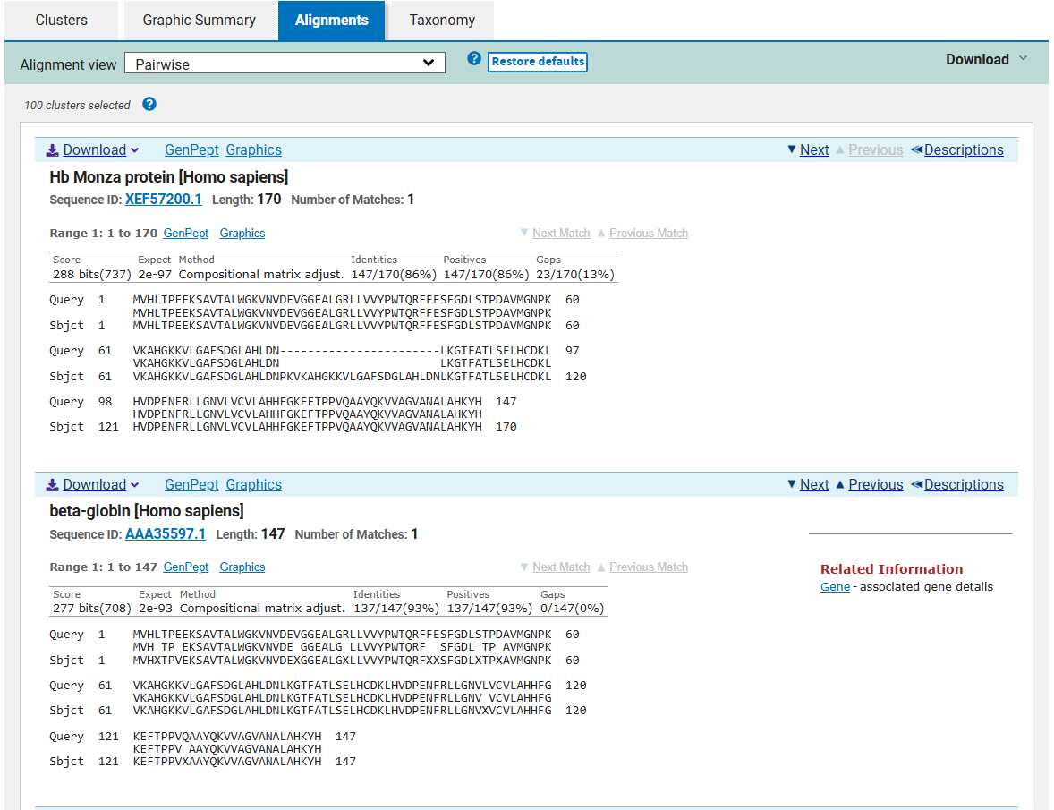
Figure 3. Pairwise BLASTp alignment
Interpretation of Alignment
The pairwise alignment showed 137 identical amino-acid residues out of 147, corresponding to 93% sequence identity. The alignment also showed 93% positive residues, indicating that the aligned amino acids were either identical or had similar biochemical properties. The alignment had no gaps and the query coverage was 100%, indicating that the complete HBB query sequence was aligned with the subject sequence.
The 277-bit alignment score and extremely low E-value of 2e-93 further support the statistical significance of the alignment.
9. Discussion
BLASTp analysis is useful for identifying proteins related to a given query sequence. In this analysis, the human hemoglobin subunit beta sequence produced several significant matches in the protein database. High query coverage and high percentage identity indicate that many amino-acid residues are conserved among the identified hemoglobin-related proteins. The very low E-values indicate that the observed alignments are highly unlikely to be obtained by chance.
10. Conclusion
The human hemoglobin subunit beta protein sequence (NP_000509.1) was successfully retrieved from the NCBI Protein database and analyzed using BLASTp. Several homologous hemoglobin-related proteins were identified. The selected BLAST results showed 100% query coverage, high sequence identity and extremely low E-values. The detailed pairwise alignment showed 93% identity, 93% positive residues, 0% gaps, a 277-bit score and an E-value of 2e-93.
11. References
1. National Center for Biotechnology Information (NCBI), Protein Database — Human hemoglobin subunit beta, accession NP_000509.1.
2. National Center for Biotechnology Information (NCBI), BLAST: Basic Local Alignment Search Tool.
3. UniProt Knowledgebase, Hemoglobin subunit beta (HBB), Homo sapiens, UniProt accession P68871.

