**SRI GURU TEGH BAHADUR INSTITUTE OF MANAGEMENT**

**AND INFORMATION TECHNOLOGY**

**(2019-22)**

Affiliated To

**GURU GOBIND SINGH INDRAPRASTHA UNIVERSITY, DELHI**



**PROJECT REPORT**

**ON**

**Card War GAM**

SUBMITTED IN PARTIAL FULFILLMENT OF THE REQUIREMENTS FOR

THE DEGREE OF

**BACHELOR OF COMPUTER APPLICATION**

**UNDER THE SUPERVISION OF : SUBMITTED BY :**

MS. SUPREET KAUR Tushal bhola

(05690202019) BCA 5B

**Certificate**

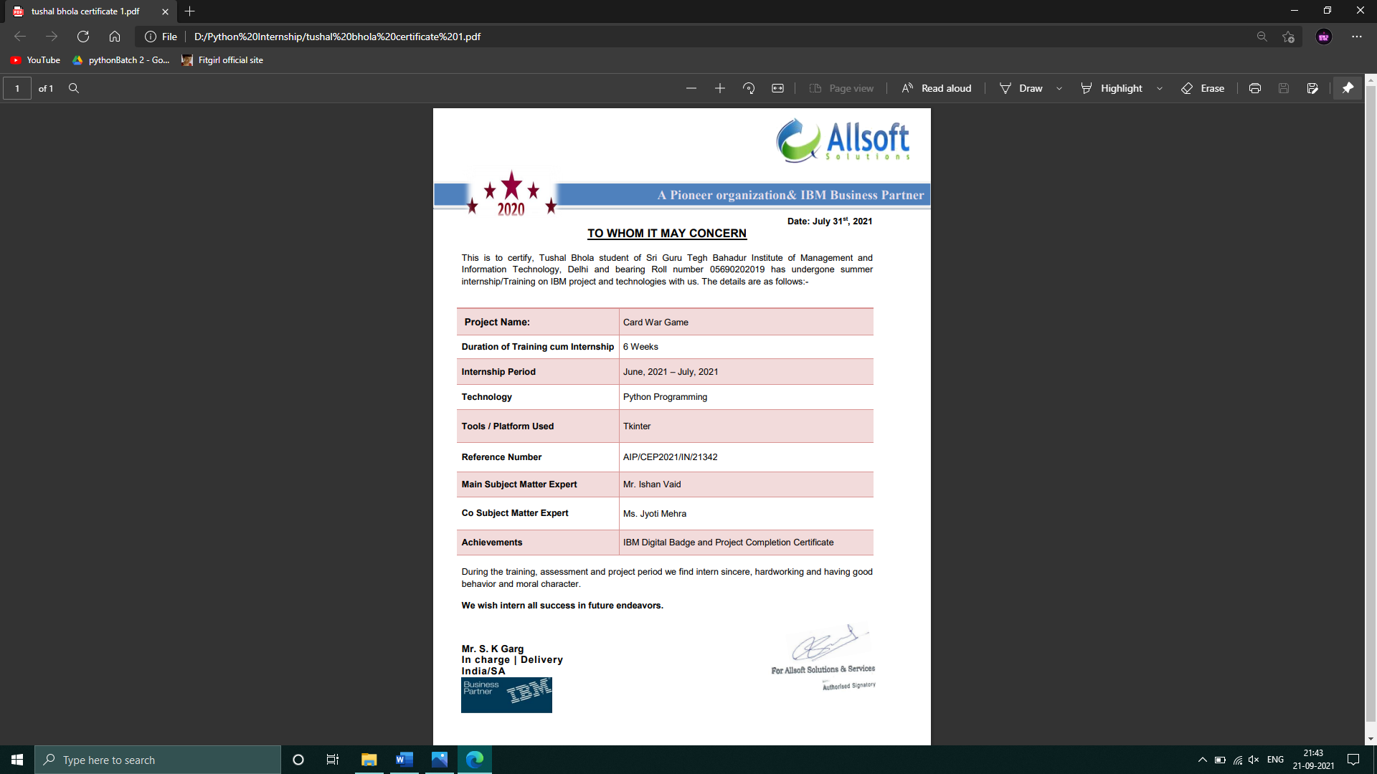

**Abstract**

This is a **Card War Game** in this game, We have a deck of 52 Card and in deck Each card have their own Value in deck ,here we already remove joker card because its value is 0 so there is no reason to insert joker card in deck .

Rank of cards are:

* Two of heart , Two of diamond , Two of spade,Two of clubs- 1
* Three of heart ,Three of diamond ,Three of spade ,Three of clubs- 2
* Four of heart ,Four of diamond ,Four of spade,Four of clubs- 3
* Five of hearts ,Five of diamond ,Five of spade ,Five of clubs - 4
* Six of heart ,Six of diamond ,Six of spade ,Six of clubs-5
* Seven of hearts ,Seven of diamond ,Seven of spade ,Seven of clubs - 6
* Eight of heart ,Eight of diamond ,Eight of spade ,Eight of clubs 7
* Nine of heart ,Nine of diamond , Nine of spade ,Nine of clubs – 9
* Ten of heart ,Ten of diamond ,Ten of spade ,Ten of clubs- 10
* Jack of heart,Jack of diamond,Jack of spade, Jack of clubs -11
* Queenof hearts,Queen of diamond,Queen of spade,Queen of clubs - 12
* king of heart,King of diamond,King of spade,King of clubs13
* Ace of heart,Ace of diamond,Ace of spade,Ace of clubs – 14

The Real card war game is to long to play Due to which we made a little changes In this game to make this game more intresting and Easy to play .

This is two player game , But in this game you are playing with computer so you only have to turn your own cards.

**Introduction**

In the card War game this is two player game but In our case one player is you and other player is computer .

So ,as we know a basic deck contain 52 cards here we first divide half of Deck to each player so each player have 26 cards ,and some random card taken from each deck and then we compare a value of cards so whom having high rank card is win that round .

In our special case which is both player have a same value card then there is war ,In war each player have to remove 5 cards from their deck and then both have to turn their

One card and whom card value is greater that player win the war round and all money lose till now .

In our game you have to first bet some amount to continue game .

To implement this python Card War Game project, we’ve used the basic concept of python with tkinter , pillow , pygame and random module.

**tkinter:**

Python offers multiple options for developing GUI (Graphical User Interface). Out of all the GUI methods, tkinter is the most commonly used method. It is a standard Python interface to the Tk GUI toolkit shipped with Python. Python with tkinter is the fastest and easiest way to create the GUI applications.

**pillow:**

Python Imaging Library (expansion of PIL) is the de facto image processing package for Python language. It incorporates lightweight image processing tools that aids in editing, creating and saving images.

**pygame:**

Game programming is very rewarding nowadays and it can also be used in advertising and as a teaching tool too. Game development includes mathematics, logic, physics, AI, and much more and it can be amazingly fun. In python, game programming is done in pygame and it is one of the best modules for doing so.

**random:**

Python defines a set of functions that are used to generate or manipulate random numbers through the**random module.** Functions in the random module rely on a pseudo-random number generator function **random()**, which generates a random float number between 0.0 and 1.0.

**Objective of Project**

With this project we are able to understand the concept of cards which help students to identify and analyse the statistics , probability of wining the game and probability of Some particular card coming and probability of wining that particular card .

And games are most basic thing which every person is playing in this world from kid to old age every one ,so we develop a card war game which is easy to play and learn many thing like disiplane ,bankroll management ,risk and reward,patience,decision making and many more things .

**Software Requirments**

* Anaconda Navigator
* Jupiter Notebook
* Window 8 or higher
* Python 3.5 or Newer
* Browser Recommend-chrome and opera mini

**Hardware Requirements**

* x86 64-bit CPU (Intel / AMD architecture)
* Hard Disk space : 2.5GB
* Processor: Minimum 1 GHz; Recommended 2GHz or more
* Memory (RAM): Minimum 1 GB; Recommended 4 GB or above
* Sound card with speakers

**Use Case Diagram**

sdfsd

**USER Computer**

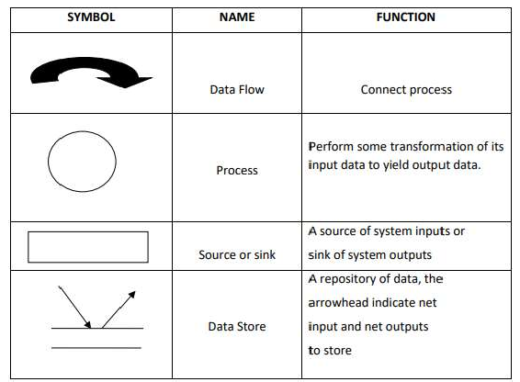**DFD(Data Follow Diagram)**

* **LEVEL - 0**

Computer Player

**Turn card Check user Card value**

Card war

game

**Name Card Face**

**Accept Conditions Winning Amount**

**Enter Bet Amount**

**Turn Card**

**Claim prizzes**

Player

* **LEVEL – 1**

**User**

Player

**Successful Entry**

Card War Game

**Amount>500 Game Play**

**If win**

**Screenshots**

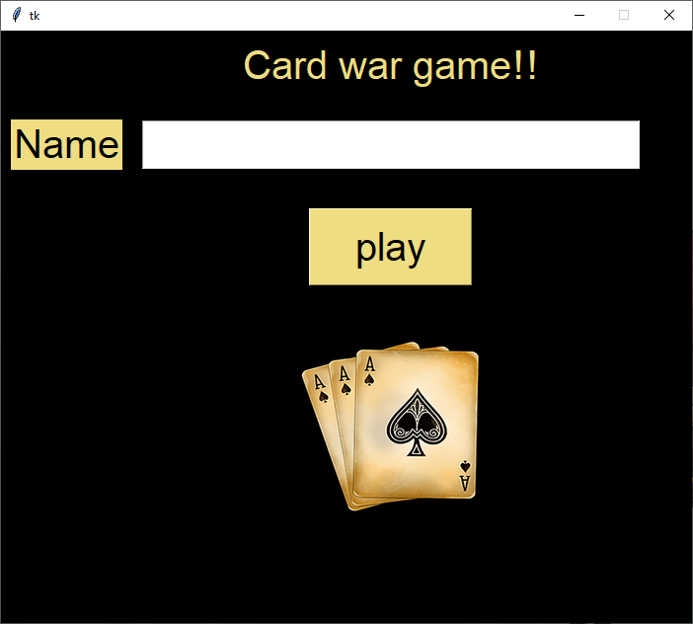

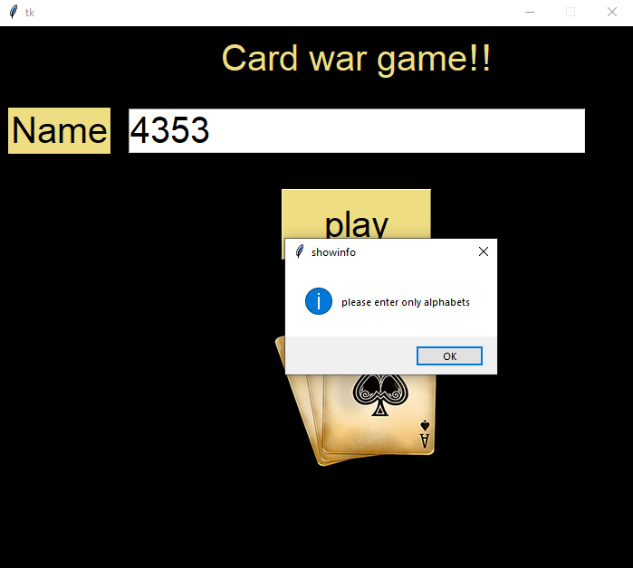

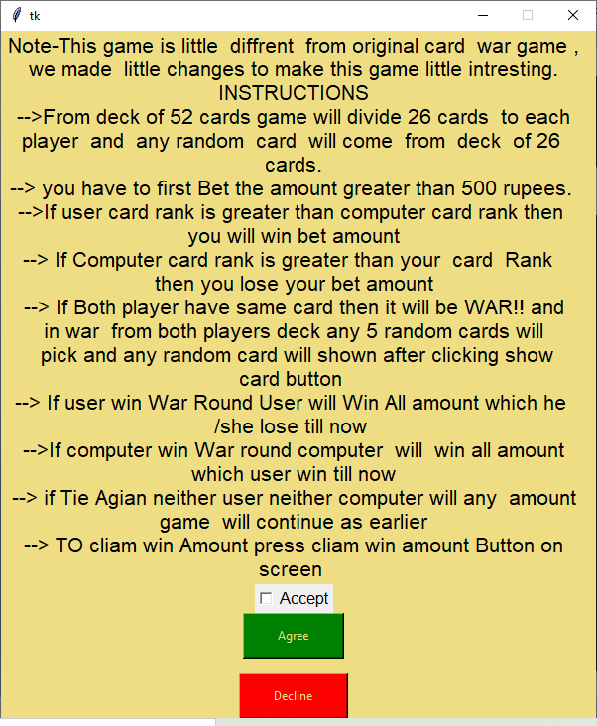

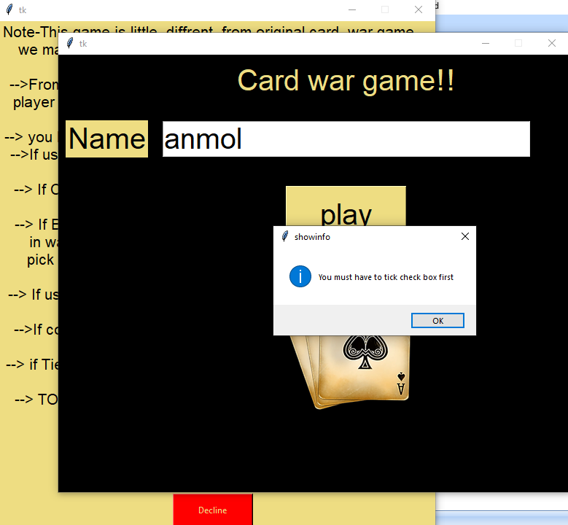

**Enter Bet Amount:**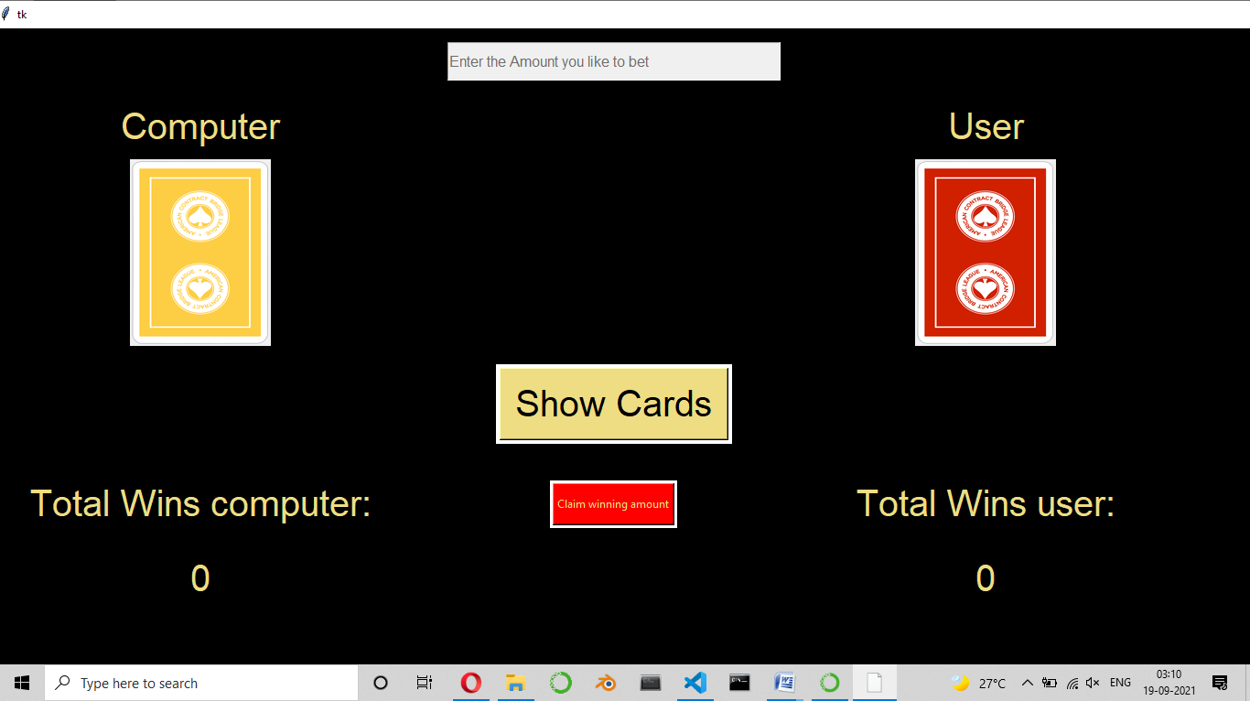

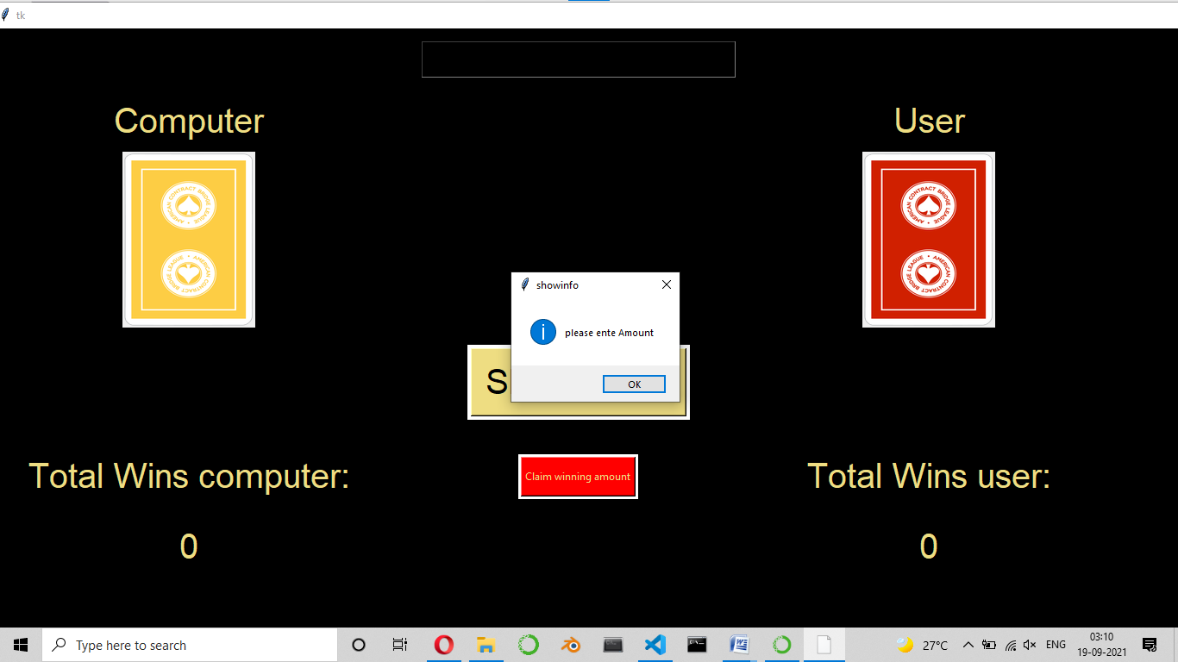

**Enter Bet Amount Greater than 500**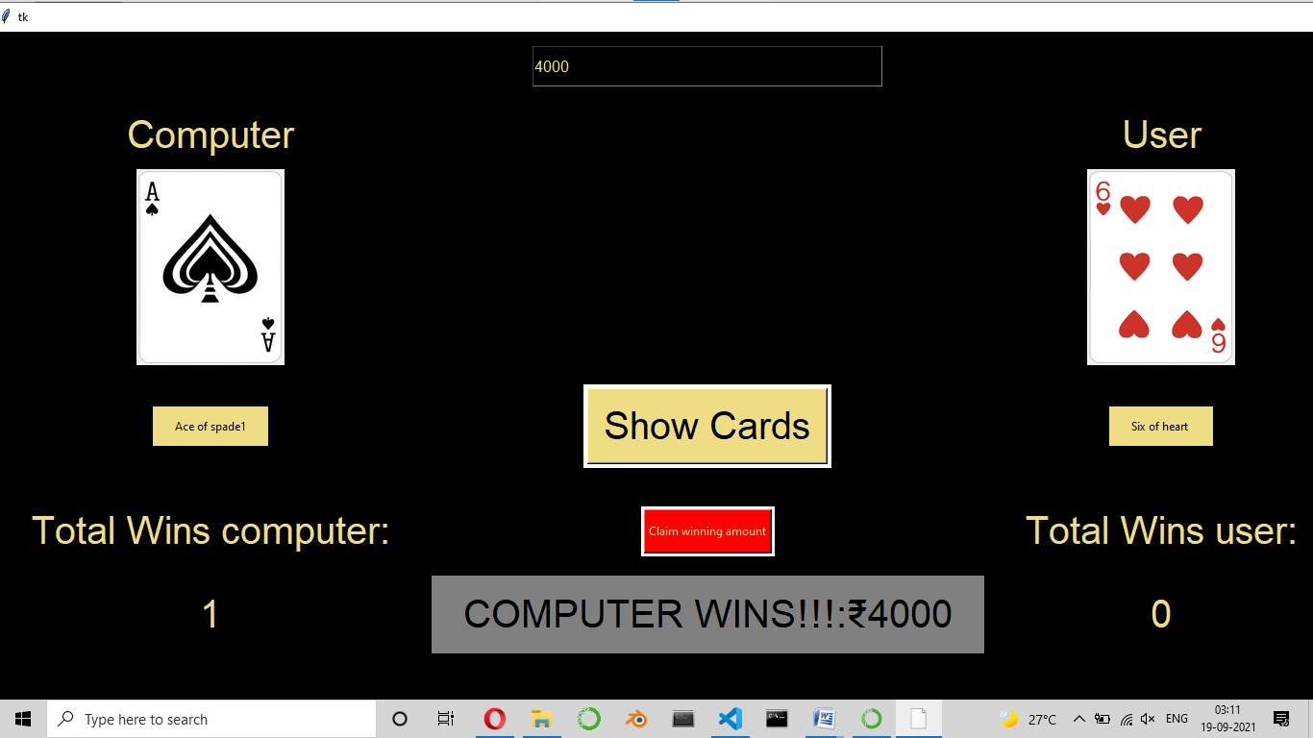

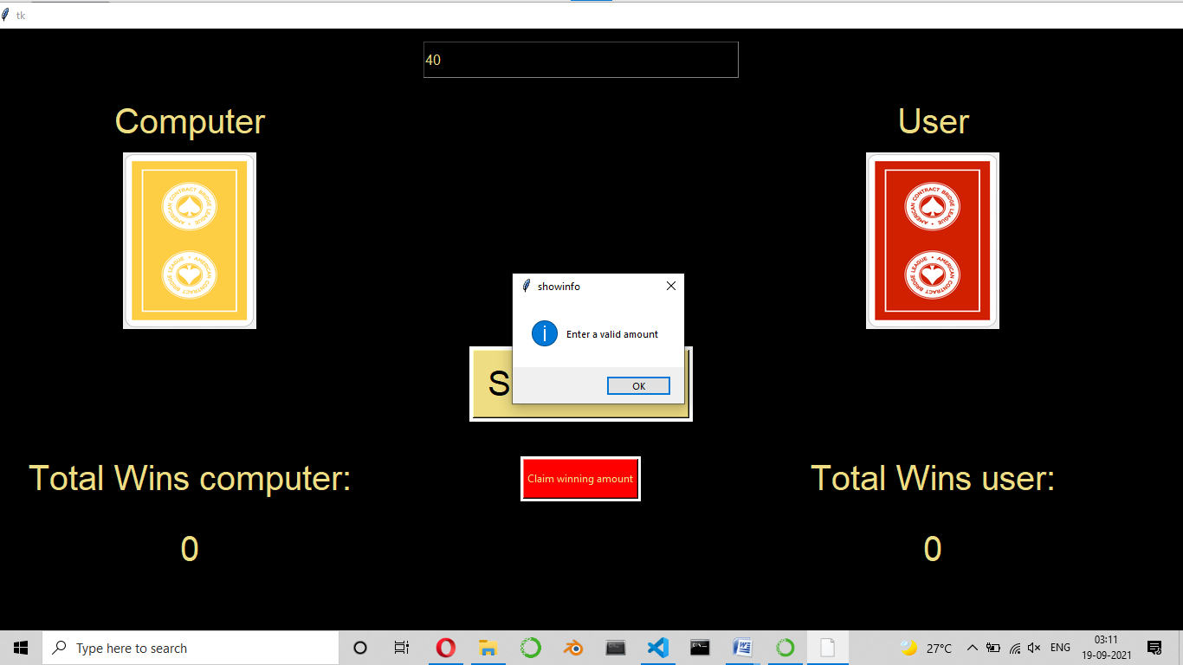

**If You Claim Amount Without Winning Any Amount:**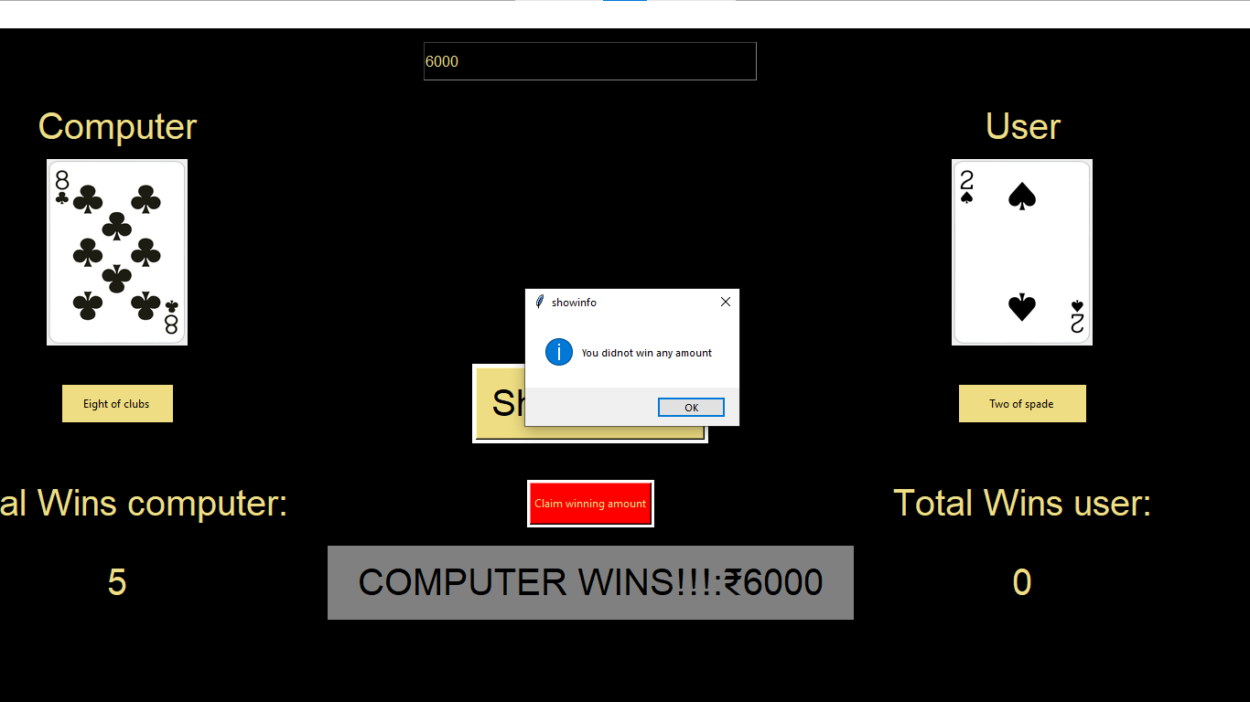

**Win A round:**

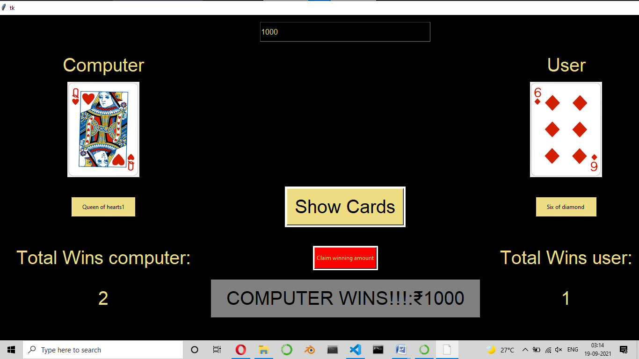

**Claim Winning Amount:**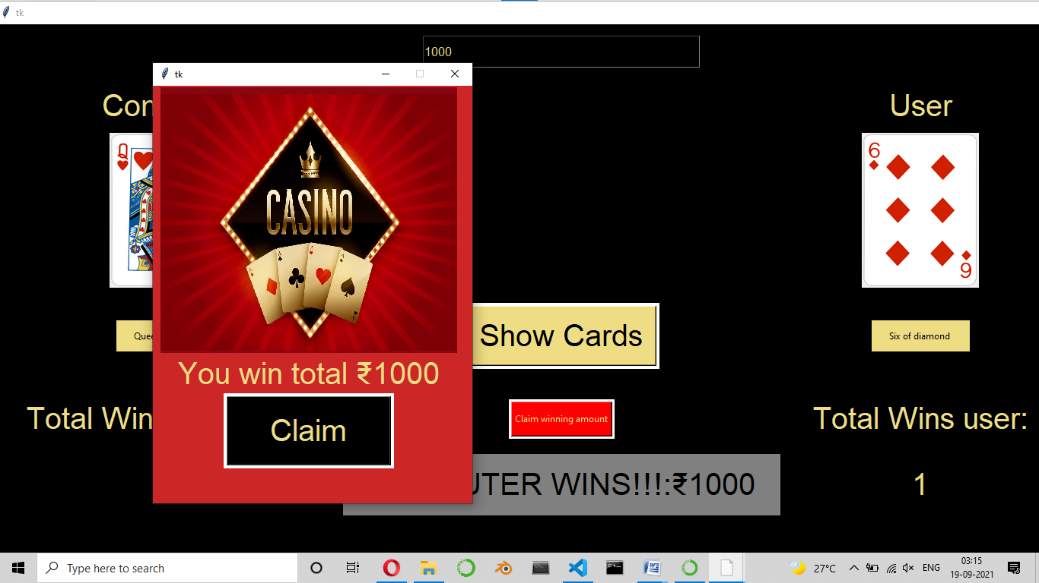

**War!!!!!**

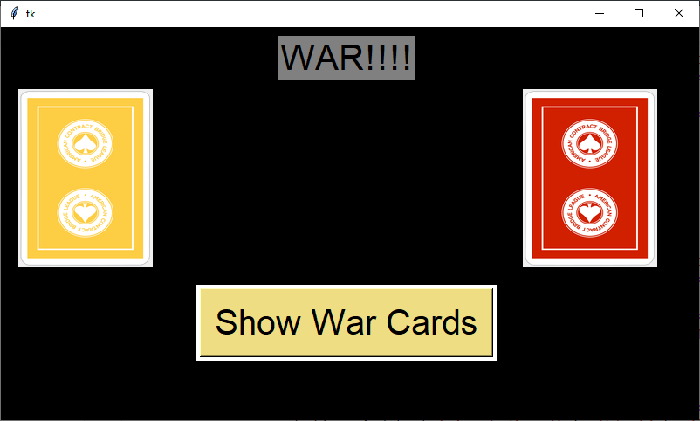

**User Wins War:**

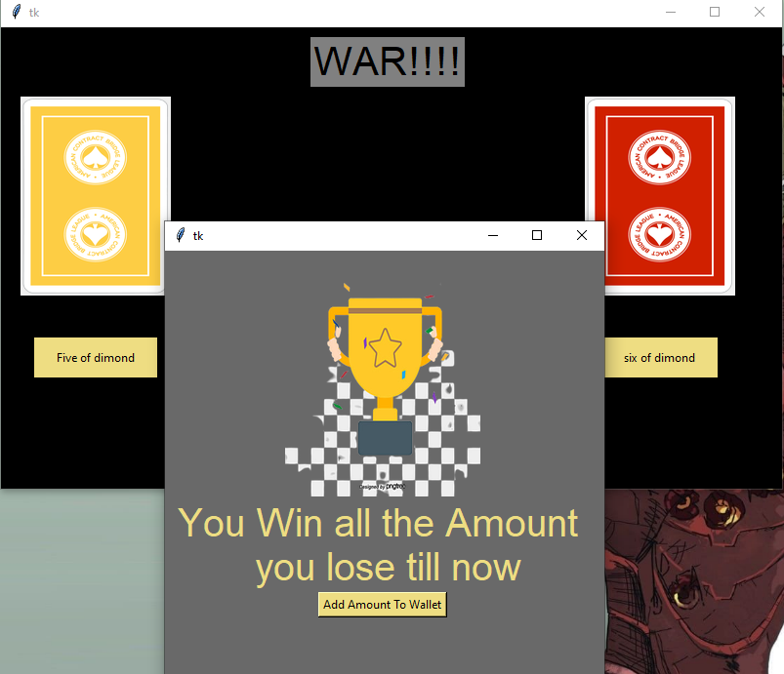

**Source code**

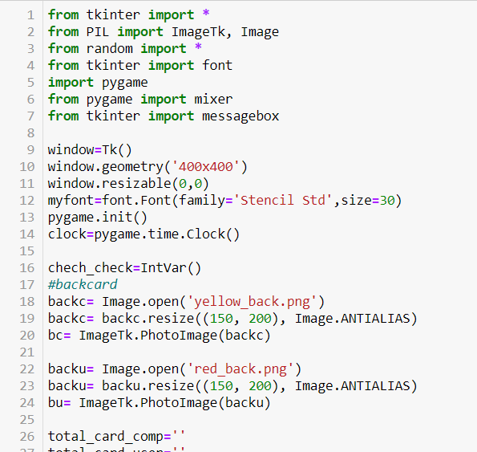

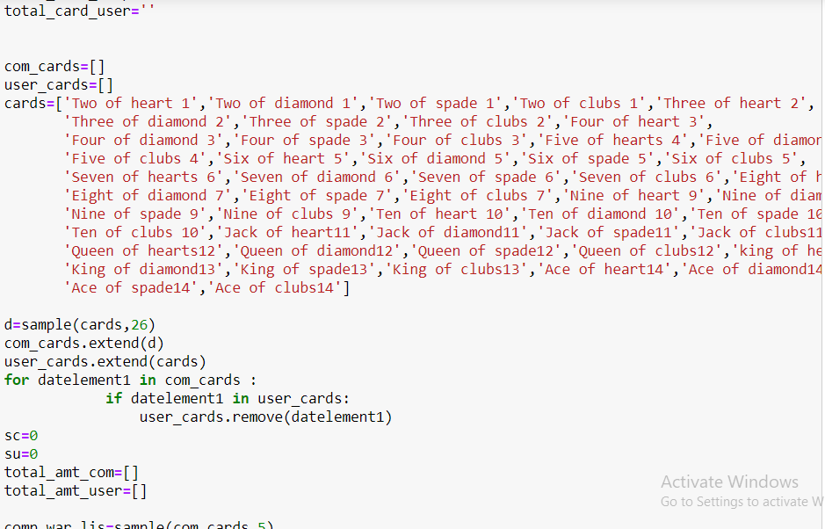

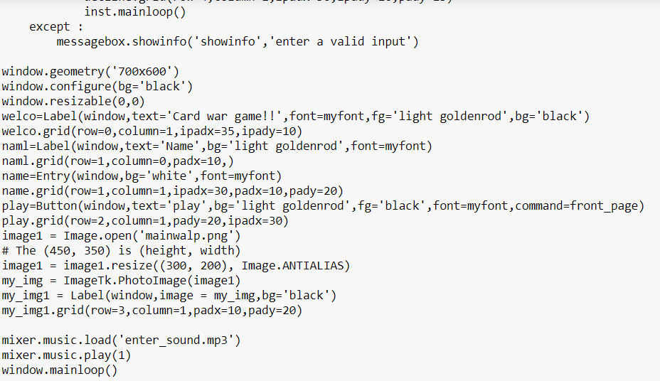

**Conclusion**

This project is great combinations of our Python advance Modules and packages Which Make this project more easier to make and Less data wastage because of automatic garbage Collection of python , most durable and efficient feature of python list which make us easy to work on lots of data ,help to sort things from list .this project is only possible with our hardwork and teamwork and our Internship instructor help us to learn advance python functions and help to make fundamentals of this project.

The project from a personal point of view also helped us in understanding the following aspects of project development:

* To learn statistics, and probability with the help of deck
* To learn concept of Functions ,classes and use of Predefined Functions of python
* How to use pre build modules and packages of python
* How the pygame library and tkinter works
* Most amazing thing to full my dream of making games
* Help to know how the flow of code work and how to transform or assign different things to others

This project includes our ever efforts , learning , ideas ,thoughts , abality to make a basic design of algorithms and find different ways to do the same work and identify which way is best suitable at that time and make all together and create Card War Game.