**Computer Network CS1508**

|  |  |
| --- | --- |
| **CO1** | Understand and identify the engineering fundamentals concerning Data Communication and Computer Network. |
| **CO2** | Identify the complex engineering problem involved in Data communication and its architecture for a successful network based communication. |
| **CO3** | Ability to Practice and formulate a solution for an engineering problem concerning any layers in Data Communication model |
| **CO4** | Demonstrate an ability to formulate and interpret a model based on the fundamentals of Computer Networks |
| **CO5** | Compare and understand the OSI reference model and TCP-IP reference model for data communication. |

|  |  |  |
| --- | --- | --- |
| 1 | INTRODUCTION | * Introduction to fundamentals of Data * Communications and Computer networks * Data Representation and Data Flow * Concepts of Communication in Computer Networks. |
| 2 | NETWORK ARCHITECTURE | * Layered Architecture, OSI, TCP/IP * **ATM Network Models** * Addressing of Network Devices. |
| 3 | PHYSICAL LAYER | * Data and Signal Fundamentals * Analog and Digital Signals * Transmission Impairments * Data Rate Limits * Performance. |
| 4 | TRANSMISSION MEDIA | * Characteristics and performance * parameters of various twisted pair * Coaxial, and fibre optic cables. Unguided media: Radio waves * Microwaves and infra-red |
| 5 | DATA TRANSMISSION | * Digital Encoding Techniques * Scrambling Techniques * Pulse Code Modulation (PCM) * Modulation, Transmission Modes (Parallel, Serial) |
| 6 | MULTIPLEXING | * FDM * WDM * CDM * Time division multiplexing (synchronous and statistical) * Spread spectrum (FHSS and DSSS) |
| 7 | SWITCHING | * Circuit-switched * Datagram and virtual circuit networks * **Message switching.** |
| 8 | DATA LINK LAYER | * Data link layer design Issue * Error Detection and correction – Parity bit * Modulo-2 Arithmetic, Polynomial  1. FEC-Hamming Code, and Internet Checksum. |
| 9 | ELEMENTARY DATA LINK PROTOCOL | * Stop-and-wait ARQ * Sliding Window * Go-back-n, Selective Repeat * Case Study of HDLC and PPP. |
| 10 | MULTIPLE ACCESS | * Random Access: CSMA * CSMA/CA, CSMA/CD * **Controlled Access: Reservation, Polling** * **Channelization: FDMA, TDMA, CDMA.** |
| 11 | NETWORK LAYER | * Design issues of network layer protocols * Network layer protocols of TCP/IP model: Internet Protocol version 4 (IPv4) * Internet Protocol version 6 (IPv6), * Addressing mechanism of IPv4 and IPv6. |
| 12 | **CASE STUDIES OF LAN TECHNOLOGIES** | * Ethernet LAN: IEEE specification of physical media * Wireless LAN: IEEE 802.11 specification * **WLAN architecture.** |

* individually.

# OSI Model

* OSI stands for **Open System Interconnection** is a reference model that describes how information from a [software](https://www.javatpoint.com/software) application in one [computer](https://www.javatpoint.com/what-is-computer) moves through a physical medium to the software application in another computer.
* OSI consists of seven layers, and each layer performs a particular network function.
* OSI model was developed by the International Organization for Standardization (ISO) in 1984, and it is now considered as an architectural model for the inter-computer communications.
* OSI model divides the whole task into seven smaller and manageable tasks. Each layer is assigned a particular task.
* Each layer is self-contained, so that task assigned to each layer can be performed independently.

## Characteristics of OSI Model:

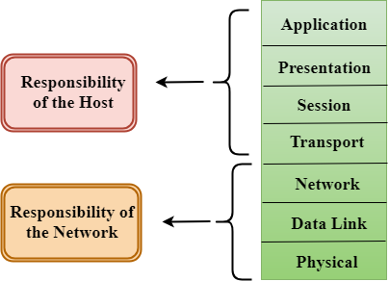

* The OSI model is divided into two layers: upper layers and lower layers.
* The upper layer of the OSI model mainly deals with the application related issues, and they are implemented only in the software. The application layer is closest to the end user. Both the end user and the application layer interact with the software applications. An upper layer refers to the layer just above another layer.
* The lower layer of the OSI model deals with the data transport issues. The data link layer and the physical layer are implemented in hardware and software. The physical layer is the lowest layer of the OSI model and is closest to the physical medium. The physical layer is mainly responsible for placing the information on the physical medium.

## Functions of the OSI Layers

There are the seven OSI layers. Each layer has different functions. A list of seven layers are given below:

1. Physical Layer
2. Data-Link Layer
3. Network Layer
4. Transport Layer
5. Session Layer
6. Presentation Layer
7. Application Layer

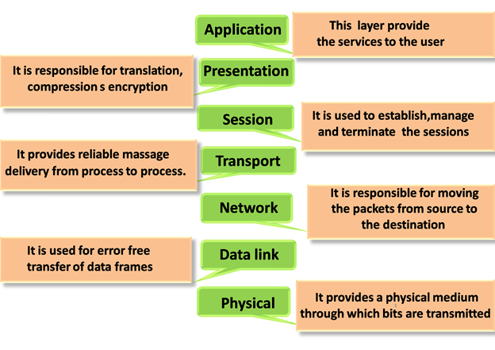

### Physical layer

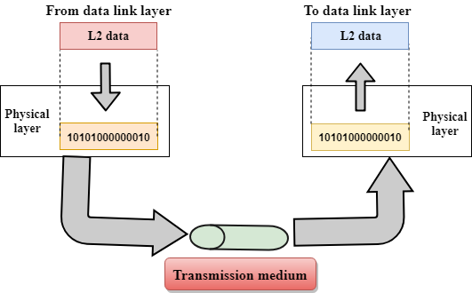

* The main functionality of the physical layer is to transmit the individual bits from one node to another node.
* It is the lowest layer of the OSI model.
* It establishes, maintains and deactivates the physical connection.
* It specifies the mechanical, electrical and procedural network interface specifications.

## Functions of a Physical layer:

* **Line Configuration:** It defines the way how two or more devices can be connected physically.
* [**Data Transmission**](https://www.javatpoint.com/computer-network-transmission-modes)**:** It defines the transmission mode whether it is simplex, half-duplex or full-duplex mode between the two devices on the network.
* [**Topology**](https://www.javatpoint.com/computer-network-topologies)**:** It defines the way how network devices are arranged.
* **Signals:** It determines the type of the signal used for transmitting the information.

### Data-Link Layer

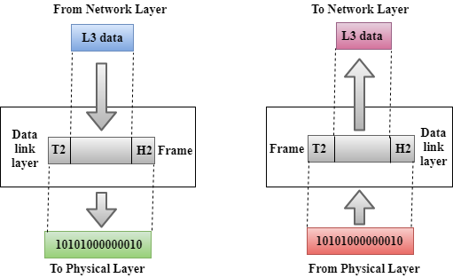

* This layer is responsible for the error-free transfer of data frames.
* It defines the format of the data on the network.
* It provides a reliable and efficient communication between two or more devices.
* It is mainly responsible for the unique identification of each device that resides on a local network.
* It contains two sub-layers:
  + **Logical Link Control Layer**
    - It is responsible for transferring the packets to the Network layer of the receiver that is receiving.
    - It identifies the address of the network layer protocol from the header.
    - It also provides flow control.
  + **Media Access Control Layer**
    - A Media access control layer is a link between the Logical Link Control layer and the network's physical layer.
    - It is used for transferring the packets over the network.

## Functions of the Data-link layer

* **Framing:** The data link layer translates the physical's raw bit stream into packets known as Frames. The Data link layer adds the header and trailer to the frame. The header which is added to the frame contains the hardware destination and source address.

OSI Model

* **Physical Addressing:** The Data link layer adds a header to the frame that contains a destination address. The frame is transmitted to the destination address mentioned in the header.
* **Flow Control:** Flow control is the main functionality of the Data-link layer. It is the technique through which the constant data rate is maintained on both the sides so that no data get corrupted. It ensures that the transmitting station such as a server with higher processing speed does not exceed the receiving station, with lower processing speed.
* **Error Control:** Error control is achieved by adding a calculated value CRC (Cyclic Redundancy Check) that is placed to the Data link layer's trailer which is added to the message frame before it is sent to the physical layer. If any error seems to occurr, then the receiver sends the acknowledgment for the retransmission of the corrupted frames.
* **Access Control:** When two or more devices are connected to the same communication channel, then the data link layer protocols are used to determine which device has control over the link at a given time.

### Network Layer

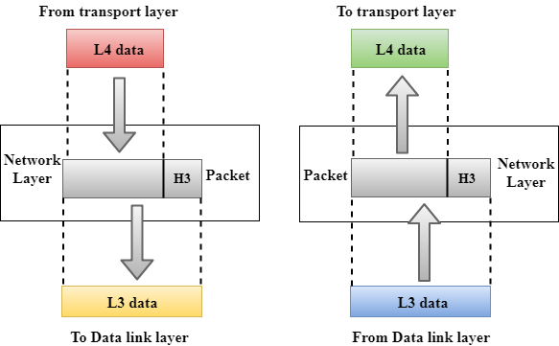

* It is a layer 3 that manages device addressing, tracks the location of devices on the network.
* It determines the best path to move data from source to the destination based on the network conditions, the priority of service, and other factors.
* The Data link layer is responsible for routing and forwarding the packets.
* Routers are the layer 3 devices, they are specified in this layer and used to provide the routing services within an internetwork.
* The protocols used to route the network traffic are known as Network layer protocols. Examples of protocols are IP and Ipv6.

## Functions of Network Layer:

* **Internetworking:** An internetworking is the main responsibility of the network layer. It provides a logical connection between different devices.
* [**Addressing**](https://www.javatpoint.com/network-addressing)**:** A Network layer adds the source and destination address to the header of the frame. Addressing is used to identify the device on the internet.
* [**Routing**](https://www.javatpoint.com/computer-network-routing)**:** Routing is the major component of the network layer, and it determines the best optimal path out of the multiple paths from source to the destination.
* **Packetizing:** A Network Layer receives the packets from the upper layer and converts them into packets. This process is known as Packetizing. It is achieved by internet protocol (IP).

### Transport Layer

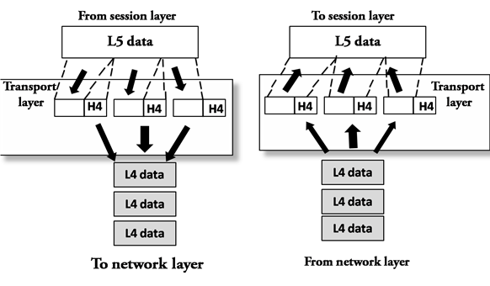

* The Transport layer is a Layer 4 ensures that messages are transmitted in the order in which they are sent and there is no duplication of data.
* The main responsibility of the transport layer is to transfer the data completely.
* It receives the data from the upper layer and converts them into smaller units known as segments.
* This layer can be termed as an end-to-end layer as it provides a point-to-point connection between source and destination to deliver the data reliably.

**The two protocols used in this layer are:**

* **Transmission Control Protocol**
  + It is a standard protocol that allows the systems to communicate over the internet.
  + It establishes and maintains a connection between hosts.
  + When data is sent over the TCP connection, then the TCP protocol divides the data into smaller units known as segments. Each segment travels over the internet using multiple routes, and they arrive in different orders at the destination. The transmission control protocol reorders the packets in the correct order at the receiving end.
* **User Datagram Protocol**
  + User Datagram Protocol is a transport layer protocol.
  + It is an unreliable transport protocol as in this case receiver does not send any acknowledgment when the packet is received, the sender does not wait for any acknowledgment. Therefore, this makes a protocol unreliable.

## Functions of Transport Layer:

* **Service-point addressing:** Computers run several programs simultaneously due to this reason, the transmission of data from source to the destination not only from one computer to another computer but also from one process to another process. The transport layer adds the header that contains the address known as a service-point address or port address. The responsibility of the network layer is to transmit the data from one computer to another computer and the responsibility of the transport layer is to transmit the message to the correct process.
* **Segmentation and reassembly:** When the transport layer receives the message from the upper layer, it divides the message into multiple segments, and each segment is assigned with a sequence number that uniquely identifies each segment. When the message has arrived at the destination, then the transport layer reassembles the message based on their sequence numbers.
* **Connection control:** Transport layer provides two services Connection-oriented service and connectionless service. A connectionless service treats each segment as an individual packet, and they all travel in different routes to reach the destination. A connection-oriented service makes a connection with the transport layer at the destination machine before delivering the packets. In connection-oriented service, all the packets travel in the single route.
* **Flow control:** The transport layer also responsible for flow control but it is performed end-to-end rather than across a single link.
* **Error control:** The transport layer is also responsible for Error control. Error control is performed end-to-end rather than across the single link. The sender transport layer ensures that message reach at the destination without any error.

### Session Layer

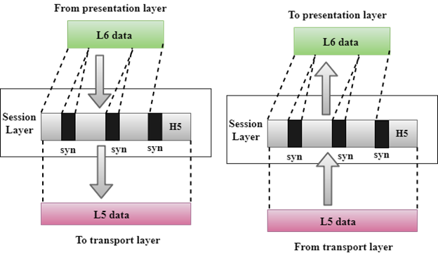

* It is a layer 3 in the OSI model.
* The Session layer is used to establish, maintain and synchronizes the interaction between communicating devices.

## Functions of Session layer:

* **Dialog control:** Session layer acts as a dialog controller that creates a dialog between two processes or we can say that it allows the communication between two processes which can be either half-duplex or full-duplex.
* **Synchronization:** Session layer adds some checkpoints when transmitting the data in a sequence. If some error occurs in the middle of the transmission of data, then the transmission will take place again from the checkpoint. This process is known as Synchronization and recovery.

### Presentation Layer

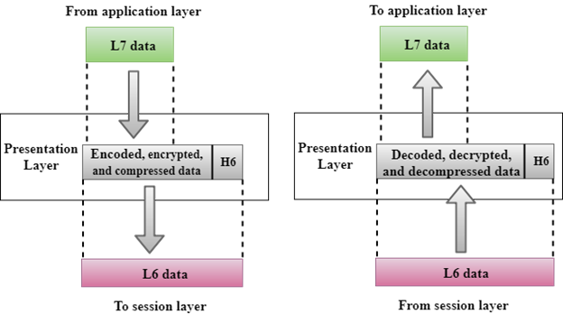

* A Presentation layer is mainly concerned with the syntax and semantics of the information exchanged between the two systems.
* It acts as a data translator for a network.
* This layer is a part of the operating system that converts the data from one presentation format to another format.
* The Presentation layer is also known as the syntax layer.

## Functions of Presentation layer:

* **Translation:** The processes in two systems exchange the information in the form of character strings, numbers and so on. Different computers use different encoding methods, the presentation layer handles the interoperability between the different encoding methods. It converts the data from sender-dependent format into a common format and changes the common format into receiver-dependent format at the receiving end.
* **Encryption:** Encryption is needed to maintain privacy. Encryption is a process of converting the sender-transmitted information into another form and sends the resulting message over the network.
* **Compression:** Data compression is a process of compressing the data, i.e., it reduces the number of bits to be transmitted. Data compression is very important in multimedia such as text, audio, video.

### Application Layer

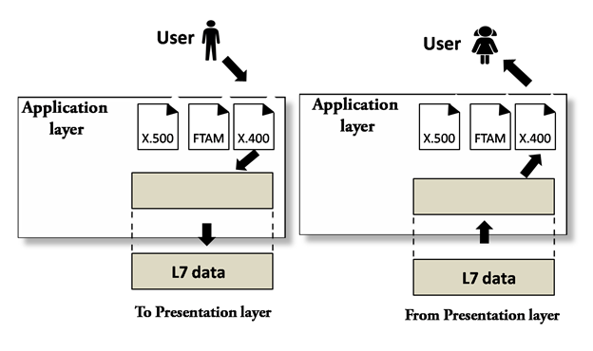

* An application layer serves as a window for users and application processes to access network service.
* It handles issues such as network transparency, resource allocation, etc.
* An application layer is not an application, but it performs the application layer functions.
* This layer provides the network services to the end-users.

## Functions of Application layer:

* **File transfer, access, and management (FTAM):** An application layer allows a user to access the files in a remote computer, to retrieve the files from a computer and to manage the files in a remote computer.
* **Mail services:** An application layer provides the facility for email forwarding and storage.
* **Directory services:** An application provides the distributed database sources and is used to provide that global information about various objects.

# TCP/IP model

* The TCP/IP model was developed prior to the OSI model.
* The TCP/IP model is not exactly similar to the OSI model.
* The TCP/IP model consists of five layers: the application layer, transport layer, network layer, data link layer and physical layer.
* The first four layers provide physical standards, network interface, internetworking, and transport functions that correspond to the first four layers of the OSI model and these four layers are represented in TCP/IP model by a single layer called the application layer.
* TCP/IP is a hierarchical protocol made up of interactive modules, and each of them provides specific functionality.

Here, hierarchical means that each upper-layer protocol is supported by two or more lower-level protocols.

## Functions of TCP/IP layers:

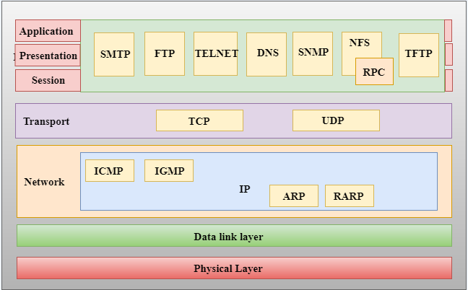

## Network Access Layer

* A network layer is the lowest layer of the TCP/IP model.
* A network layer is the combination of the Physical layer and Data Link layer defined in the OSI reference model.
* It defines how the data should be sent physically through the network.
* This layer is mainly responsible for the transmission of the data between two devices on the same network.
* The functions carried out by this layer are encapsulating the IP datagram into frames transmitted by the network and mapping of IP addresses into physical addresses.
* The protocols used by this layer are ethernet, token ring, FDDI, X.25, frame relay.

## Internet Layer

* An internet layer is the second layer of the TCP/IP model.
* An internet layer is also known as the network layer.
* The main responsibility of the internet layer is to send the packets from any network, and they arrive at the destination irrespective of the route they take.

### Following are the protocols used in this layer are:

**IP Protocol:** IP protocol is used in this layer, and it is the most significant part of the entire TCP/IP suite.

Following are the responsibilities of this protocol:

* **IP Addressing:** This protocol implements logical host addresses known as IP addresses. The IP addresses are used by the internet and higher layers to identify the device and to provide internetwork routing.
* **Host-to-host communication:** It determines the path through which the data is to be transmitted.
* **Data Encapsulation and Formatting:** An IP protocol accepts the data from the transport layer protocol. An IP protocol ensures that the data is sent and received securely, it encapsulates the data into message known as IP datagram.
* **Fragmentation and Reassembly:** The limit imposed on the size of the IP datagram by data link layer protocol is known as Maximum Transmission unit (MTU). If the size of IP datagram is greater than the MTU unit, then the IP protocol splits the datagram into smaller units so that they can travel over the local network. Fragmentation can be done by the sender or intermediate router. At the receiver side, all the fragments are reassembled to form an original message.
* **Routing:** When IP datagram is sent over the same local network such as LAN, MAN, WAN, it is known as direct delivery. When source and destination are on the distant network, then the IP datagram is sent indirectly. This can be accomplished by routing the IP datagram through various devices such as routers.

**ARP Protocol**

* ARP stands for **Address Resolution Protocol**.
* ARP is a network layer protocol which is used to find the physical address from the IP address.
* **The two terms are mainly associated with the ARP Protocol:**
  + **ARP request:** When a sender wants to know the physical address of the device, it broadcasts the ARP request to the network.
  + **ARP reply:** Every device attached to the network will accept the ARP request and process the request, but only recipient recognize the IP address and sends back its physical address in the form of ARP reply. The recipient adds the physical address both to its cache memory and to the datagram header

**ICMP Protocol**

* **ICMP** stands for Internet Control Message Protocol.
* It is a mechanism used by the hosts or routers to send notifications regarding datagram problems back to the sender.
* A datagram travels from router-to-router until it reaches its destination. If a router is unable to route the data because of some unusual conditions such as disabled links, a device is on fire or network congestion, then the ICMP protocol is used to inform the sender that the datagram is undeliverable.
* An ICMP protocol mainly uses two terms:
  + **ICMP Test:** ICMP Test is used to test whether the destination is reachable or not.
  + **ICMP Reply:** ICMP Reply is used to check whether the destination device is responding or not.
* The core responsibility of the ICMP protocol is to report the problems, not correct them. The responsibility of the correction lies with the sender.
* ICMP can send the messages only to the source, but not to the intermediate routers because the IP datagram carries the addresses of the source and destination but not of the router that it is passed to.

## Transport Layer

The transport layer is responsible for the reliability, flow control, and correction of data which is being sent over the network.

The two protocols used in the transport layer are **User Datagram protocol and Transmission control protocol**.

* **User Datagram Protocol (UDP)**
  + It provides connectionless service and end-to-end delivery of transmission.
  + It is an unreliable protocol as it discovers the errors but not specify the error.
  + User Datagram Protocol discovers the error, and ICMP protocol reports the error to the sender that user datagram has been damaged.
  + **UDP consists of the following fields:**  
    **Source port address:** The source port address is the address of the application program that has created the message.  
    **Destination port address:** The destination port address is the address of the application program that receives the message.  
    **Total length:** It defines the total number of bytes of the user datagram in bytes.  
    **Checksum:** The checksum is a 16-bit field used in error detection.
  + UDP does not specify which packet is lost. UDP contains only checksum; it does not contain any ID of a data segment.

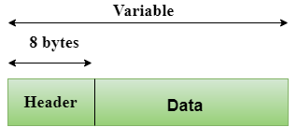  
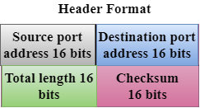

* **Transmission Control Protocol (TCP)**
  + It provides a full transport layer services to applications.
  + It creates a virtual circuit between the sender and receiver, and it is active for the duration of the transmission.
  + TCP is a reliable protocol as it detects the error and retransmits the damaged frames. Therefore, it ensures all the segments must be received and acknowledged before the transmission is considered to be completed and a virtual circuit is discarded.
  + At the sending end, TCP divides the whole message into smaller units known as segment, and each segment contains a sequence number which is required for reordering the frames to form an original message.
  + At the receiving end, TCP collects all the segments and reorders them based on sequence numbers.

## Application Layer

* An application layer is the topmost layer in the TCP/IP model.
* It is responsible for handling high-level protocols, issues of representation.
* This layer allows the user to interact with the application.
* When one application layer protocol wants to communicate with another application layer, it forwards its data to the transport layer.
* There is an ambiguity occurs in the application layer. Every application cannot be placed inside the application layer except those who interact with the communication system. For example: text editor cannot be considered in application layer while web browser using **HTTP** protocol to interact with the network where **HTTP** protocol is an application layer protocol.

### Following are the main protocols used in the application layer:

* **HTTP:** HTTP stands for Hypertext transfer protocol. This protocol allows us to access the data over the world wide web. It transfers the data in the form of plain text, audio, video. It is known as a Hypertext transfer protocol as it has the efficiency to use in a hypertext environment where there are rapid jumps from one document to another.
* **SNMP:** SNMP stands for Simple Network Management Protocol. It is a framework used for managing the devices on the internet by using the TCP/IP protocol suite.
* **SMTP:** SMTP stands for Simple mail transfer protocol. The TCP/IP protocol that supports the e-mail is known as a Simple mail transfer protocol. This protocol is used to send the data to another e-mail address.
* **DNS:** DNS stands for Domain Name System. An IP address is used to identify the connection of a host to the internet uniquely. But, people prefer to use the names instead of addresses. Therefore, the system that maps the name to the address is known as Domain Name System.
* **TELNET:** It is an abbreviation for Terminal Network. It establishes the connection between the local computer and remote computer in such a way that the local terminal appears to be a terminal at the remote system.
* **FTP:** FTP stands for File Transfer Protocol. FTP is a standard internet protocol used for transmitting the files from one computer to another computer.

**Network Addressing**

* Network Addressing is one of the major responsibilities of the network layer.
* Network addresses are always logical, i.e., software-based addresses.
* A host is also known as end system that has one link to the network. The boundary between the host and link is known as an interface. Therefore, the host can have only one interface.
* A router is different from the host in that it has two or more links that connect to it. When a router forwards the datagram, then it forwards the packet to one of the links. The boundary between the router and link is known as an interface, and the router can have multiple interfaces, one for each of its links. Each interface is capable of sending and receiving the IP packets, so IP requires each interface to have an address.
* Each IP address is 32 bits long, and they are represented in the form of "dot-decimal notation" where each byte is written in the decimal form, and they are separated by the period. An IP address would look like 193.32.216.9 where 193 represents the decimal notation of first 8 bits of an address, 32 represents the decimal notation of second 8 bits of an address.

• **Let's understand through a simple example.** 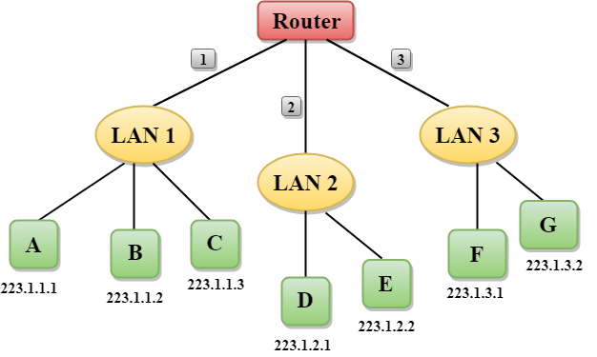

* In the above figure, a router has three interfaces labeled as 1, 2 & 3 and each router interface contains its own IP address.
* Each host contains its own interface and IP address.
* All the interfaces attached to the LAN 1 is having an IP address in the form of 223.1.1.xxx, and the interfaces attached to the LAN 2 and LAN 3 have an IP address in the form of 223.1.2.xxx and 223.1.3.xxx respectively.
* Each IP address consists of two parts. The first part (first three bytes in IP address) specifies the network and second part (last byte of an IP address) specifies the host in the network.

**Classful Addressing**

An IP address is 32-bit long. An IP address is divided into sub-classes:

* Class A
* Class B
* Class C
* Class D
* Class E

**An ip address is divided into two parts:**

* **Network ID:** It represents the number of networks.
* **Host ID:** It represents the number of hosts.

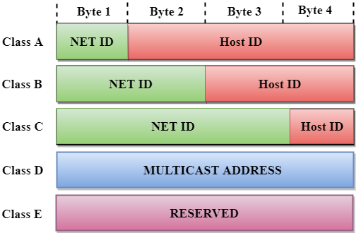

In the above diagram, we observe that each class have a specific range of IP addresses. The class of IP address is used to determine the number of bits used in a class and number of networks and hosts available in the class.

**Class A**

In Class A, an IP address is assigned to those networks that contain a large number of hosts.

* The network ID is 8 bits long.
* The host ID is 24 bits long.

In Class A, the first bit in higher order bits of the first octet is always set to 0 and the remaining 7 bits determine the network ID. The 24 bits determine the host ID in any network.

The total number of networks in Class A = 27 = 128 network address

The total number of hosts in Class A = 224 - 2 = 16,777,214 host address

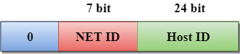

**Class B**

In Class B, an IP address is assigned to those networks that range from small-sized to large-sized networks.

* The Network ID is 16 bits long.
* The Host ID is 16 bits long.

In Class B, the higher order bits of the first octet is always set to 10, and the remaining14 bits determine the network ID. The other 16 bits determine the Host ID.

The total number of networks in Class B = 214 = 16384 network address

The total number of hosts in Class B = 216 - 2 = 65534 host address

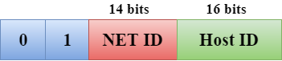

**Class C**

In Class C, an IP address is assigned to only small-sized networks.

* The Network ID is 24 bits long.
* The host ID is 8 bits long.

In Class C, the higher order bits of the first octet is always set to 110, and the remaining 21 bits determine the network ID. The 8 bits of the host ID determine the host in a network.

The total number of networks = 221 = 2097152 network address

The total number of hosts = 28 - 2 = 254 host address

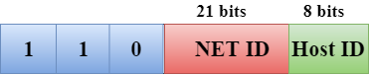

**Class D**

In Class D, an IP address is reserved for multicast addresses. It does not possess subnetting. The higher order bits of the first octet is always set to 1110, and the remaining bits determines the host ID in any network.

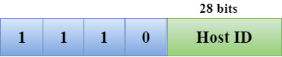

**Class E**

In Class E, an IP address is used for the future use or for the research and development purposes. It does not possess any subnetting. The higher order bits of the first octet is always set to 1111, and the remaining bits determines the host ID in any network.

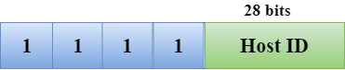

**Rules for assigning Host ID:**

The Host ID is used to determine the host within any network. The Host ID is assigned based on the following rules:

* The Host ID must be unique within any network.
* The Host ID in which all the bits are set to 0 cannot be assigned as it is used to represent the network ID of the IP address.
* The Host ID in which all the bits are set to 1 cannot be assigned as it is reserved for the multicast address.

**Rules for assigning Network ID:**

If the hosts are located within the same local network, then they are assigned with the same network ID. The following are the rules for assigning Network ID:

* The network ID cannot start with 127 as 127 is used by Class A.
* The Network ID in which all the bits are set to 0 cannot be assigned as it is used to specify a particular host on the local network.
* The Network ID in which all the bits are set to 1 cannot be assigned as it is reserved for the multicast address.

**Classful Network Architecture**

|  |  |  |  |  |  |  |
| --- | --- | --- | --- | --- | --- | --- |
| **Class** | **Higher bits** | **NET ID bits** | **HOST ID bits** | **No.of networks** | **No.of hosts per network** | **Range** |
| A | 0 | 8 | 24 | 27 | 224 | 0.0.0.0 to 127.255.255.255 |
| B | 10 | 16 | 16 | 214 | 216 | 128.0.0.0 to 191.255.255.255 |
| C | 110 | 24 | 8 | 221 | 28 | 192.0.0.0 to 223.255.255.255 |
| D | 1110 | Not Defined | Not Defined | Not Defined | Not Defined | 224.0.0.0 to 239.255.255.255 |
| E | 1111 | Not Defined | Not Defined | Not Defined | Not Defined | 240.0.0.0 to 255.255.255.255 |