**INDEX**

|  |  |  |
| --- | --- | --- |
| NO. | Chapter No. | Page No. |
| 1 | Acknowledgement | 2 |
| 2 | Introduction | 3 |
| 3 | Input / Output | 4-7 |
| 4 | Screenshot | 8 |
| 5 | Conclusion | 9 |
| 6 | Refrence | 10 |

**ACKNOWLEDGEMENT**

We would like to thank our course faculty **Mayuri Patel** giving his almost attention and guidance for our project. We are especially thankful to head of department **PROF. M. P. PARMAR** for his warm response toward us.

We are also thankful to all faculties and our colleagues of the information technology department who helped us for the project and also provide us useful information to complete 4nd semester micro project.

- RATHOD TUSHAR (236340316058)

**INTRODUCTION**

* **The Word Counter program is a simple Java-based application designed to count the number of words and characters in a given input sentence.**
* **This program helps users analyze text by providing a quick and efficient way to determine its length. It uses Java's Scanner class to take user input and implements string manipulation techniques to count words and characters accurately.**
* **The program is designed for beginners and diploma- level students to understand basic string operations, user input handling, and function implementation in Java.**
* **By running this program, users can gain insights into how text processing works, which is a fundamental aspect of programming and data analysis.**

# INPUT

import javax.swing.*; import java.awt.*; import java.awt.event.*; import java.util.Timer;

import java.util.TimerTask;

public class TextCounter {

public static void main(String[] args) { SwingUtilities.invokeLater(() -> {

new TextCounterFrame();

});

}

}

class TextCounterFrame extends JFrame { private JTextArea textArea;

private JLabel wordCountLabel; private JLabel charCountLabel; private JLabel timeLabel; private JButton retestButton; private JButton stopButton;

private boolean isCounting = true; private Timer timer;

private int secondsElapsed;

public TextCounterFrame() { setTitle("Text Counter"); setSize(500, 450);

setDefaultCloseOperation(JFrame.EXIT_ON_CLOSE); setLocationRelativeTo(null);

JPanel topPanel = new JPanel(new BorderLayout());

JLabel paragraphLabel = new JLabel("Type your text below: Java is a programming language and computing platform that can be used to create applications, operating systems, and software. It's one of the most popular programming languages today. Java is used to create mobile apps, enterprise software, and big data applications.It's used to create smartphone operating systems", SwingConstants.CENTER);

paragraphLabel.setFont(new Font("Arial", Font.BOLD, 14)); timeLabel = new JLabel("Time: 0m 0s", SwingConstants.CENTER); timeLabel.setFont(new Font("Arial", Font.BOLD, 14));

topPanel.add(paragraphLabel, BorderLayout.NORTH); topPanel.add(timeLabel, BorderLayout.SOUTH);

textArea = new JTextArea(); textArea.setLineWrap(true); textArea.setWrapStyleWord(true); textArea.setEnabled(true); textArea.addKeyListener(new KeyAdapter() {

@Override

public void keyReleased(KeyEvent e) { if (isCounting) {

updateCounts();

}

}

});

wordCountLabel = new JLabel("Words: 0"); charCountLabel = new JLabel("Characters: 0");

startTimer();

retestButton = new JButton("Retest"); stopButton = new JButton("Stop");

retestButton.addActionListener(e -> { textArea.setText(""); wordCountLabel.setText("Words: 0");

charCountLabel.setText("Characters: 0"); timeLabel.setText("Time: 0m 0s"); secondsElapsed = 0;

isCounting = true; textArea.setEnabled(true); textArea.requestFocus(); startTimer();

});

stopButton.addActionListener(e -> { isCounting = false; textArea.setEnabled(false); timer.cancel(); showCountPopup();

});

JPanel panel = new JPanel(new BorderLayout()); panel.add(topPanel, BorderLayout.NORTH);

panel.add(new JScrollPane(textArea), BorderLayout.CENTER);

JPanel statusPanel = new JPanel(); statusPanel.add(wordCountLabel); statusPanel.add(charCountLabel);

JPanel buttonPanel = new JPanel(); buttonPanel.add(retestButton); buttonPanel.add(stopButton);

panel.add(statusPanel, BorderLayout.SOUTH); panel.add(buttonPanel, BorderLayout.AFTER_LAST_LINE); add(panel);

setVisible(true);

}

private void startTimer() { if (timer != null) {

timer.cancel();

"s");

}

timer = new Timer(); secondsElapsed = 0;

timer.scheduleAtFixedRate(new TimerTask() { @Override

public void run() { SwingUtilities.invokeLater(() -> {

int minutes = secondsElapsed / 60; int seconds = secondsElapsed % 60;

timeLabel.setText("Time: " + minutes + "m " + seconds +

secondsElapsed++;

});

}

}, 1000, 1000);

}

private void updateCounts() {

String text = textArea.getText(); int charCount = text.length();

int wordCount = text.trim().isEmpty() ? 0 : text.trim().split("\\s+").length;

wordCountLabel.setText("Words: " + wordCount); charCountLabel.setText("Characters: " + charCount);

}

private void showCountPopup() {

String message = wordCountLabel.getText() + "\n" + charCountLabel.getText() + "\n" + timeLabel.getText();

JOptionPane.showMessageDialog(this, message, "Text Count Summary", JOptionPane.INFORMATION_MESSAGE);

}

}

# OUTPUT

Words: 5

Characters: 29 Time: 0m 12s

**SCREEN SHOT**

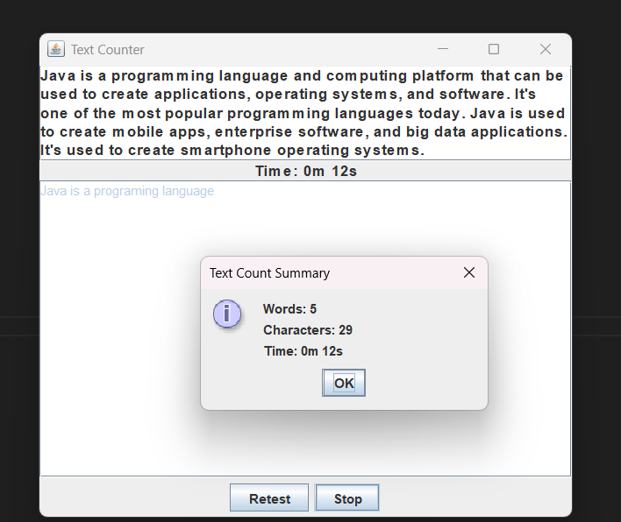

**CONCLUSION**

The **Word Counter** program successfully demonstrates the implementation of basic text-processing operations in Java. It efficiently calculates the number of words and characters in a given input, providing users with a quick and reliable way to analyze textual content.

Through this project, we have explored fundamental programming concepts such as user input handling, string manipulation, and function-based problem-solving. This program serves as a foundational step for learners aiming to develop more advanced text analysis applications in the future.

**REFRENCE**

Web site :-

https:[//www.google.com/](http://www.google.com/)

Book :-

* OOPJ sem4