## Project number – 25 (Photographer’s Website)

### Reg no: 12000061

Roll no: RK20MPB94

### Name: Abubakar Wazih Tushar

Completed: Home page, Blog page, Engagement page

* I used FontAwesome ( <https://fontawesome.com/>) icons for showing icons in the website.
* I used jQuery & OwlCarousel ( <https://owlcarousel2.github.io/OwlCarousel2/>) for Add Sliders in Home pages.
* In Full website I use external css(style.css) file for the webpages.

For Blog & Engagement page layout I used css Flexbox*(display:flex)*. I used *keyframes* for animated some part of the webpages. I used css *transform* for Blog page image hover & css *opacity* in Engagement Page image hover. So that on hover images looks pretty good. In the html tag I use different class for different section so that I can easily write css for each section. In the css file I mostly used margin, padding, border, font-size, transform, transition, font-weight, border-radius, color, background etc.

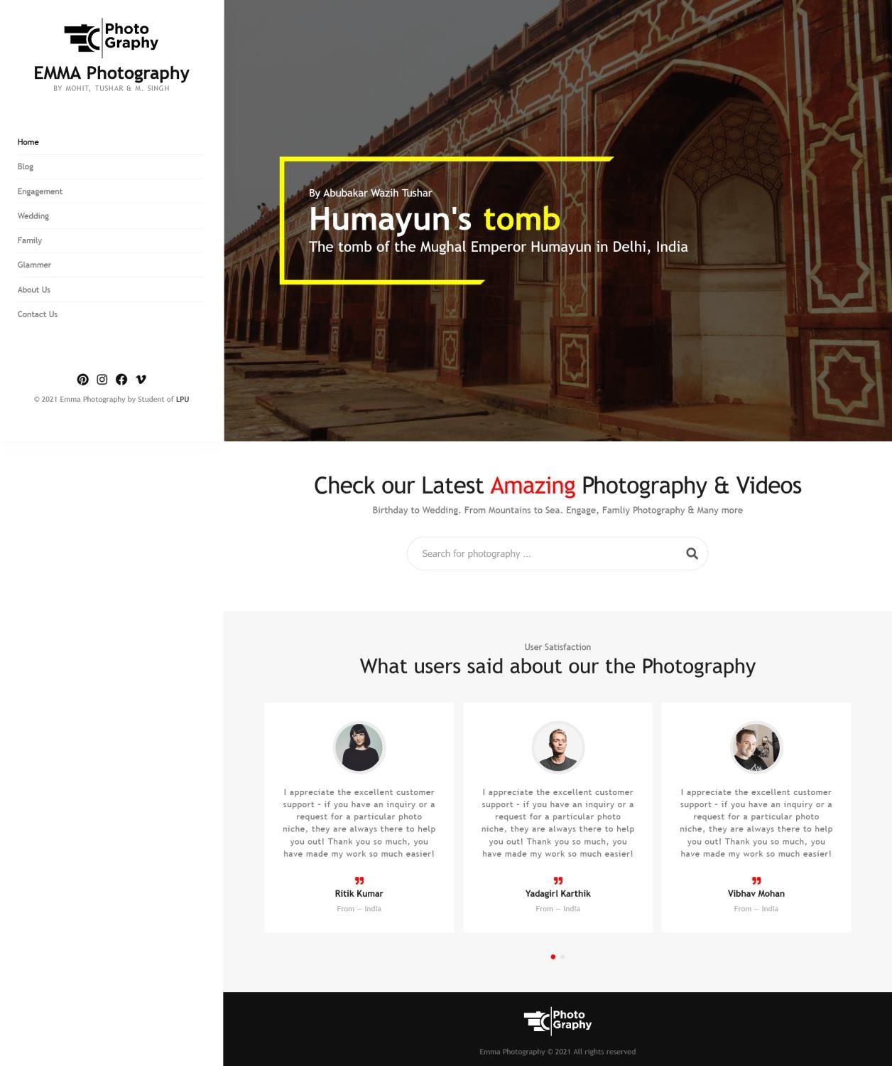

# Home page

### Left sidebar



* + - <img> tag in Logo
    - <h1>, <a> tag in Website Title
    - <span> tag in Website description
    - <ul>, <li>, <a> tag in Navigation menu
    - *Font-awesome*(<https://fontawesome.com/>) font icon along with



<ul>, <li>, <a> for bottom social icon

* + - <p> tag used in Bottom copyright text

### Top slider

* + - *OwlCarousel*(<https://owlcarousel2.github.io/OwlCarousel2/>), *jQuery*

library used for slider



* + - <img>, <h1>, <h2> tag in used in Slider each item

### Search bar



* + <h2>, <p> tag used accordingly for Search bar Heading & Description



* + <form>, <input> tag in search from

### Bottom slider



* + - *OwlCarousel*, *jQuery* library as well as <img>, <p>, <h4> used in this slider



* + - <h2>, <p> tag in used in Slider heading & description accordingly

# Blog page

### Heading Title



* + <p> tag used for Heading short description
  + <h2> tag for Heading Page Title

### Each item Layout



* + <div>, tag used as a parent container
  + <img> tag for Blog image
  + <h1> tag for Blog Title
  + <p> tag for Blog meta, *Font-awesome* font icon used for comment meta icon



* + <p> tag used for Blog Excerpt

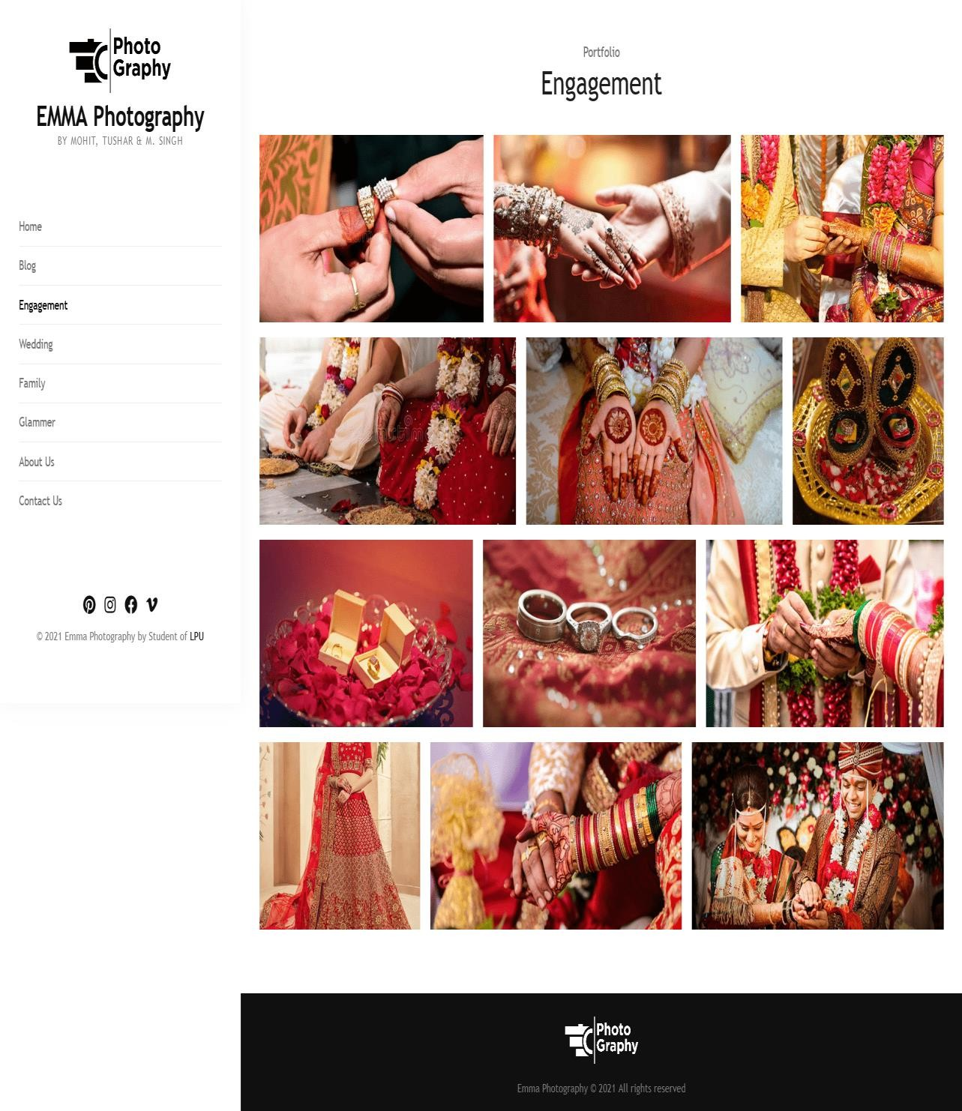

# Engagement page

### Heading Title



* + - * <p> tag used for Heading short description
      * <h2> tag for Heading Page Title

### Layout



* + - * <ul> tag used as a parent tag
      * <li> tag used for each photo container
      * <img> tag used for each photo

Project number – 25 (Photographer’s Website)

### Reg no: 12014538

Roll no: RK20MPB85 Name: Mohit

### Completed: Wedding page, Family page

This below pages is the portfolio of wedding and family for photographer’s website. I tried making this page elegant and a bit simple as this page is only of photos so simplicity will make it more graceful. I used ‘div’ and ‘class’ for every part of arrangement. I used different class for every row of photos to make it in proper alignment and also used margin, padding and other few attributes of image. Also used different fonts and alignment using div , class , margin and padding.

I didn’t make these image clickable as several links had to made but I made it to touch blur effect. I was able to achieve my idea the way I thought the site would appear it looks exact same. Both Wedding and Family portfolio pages were made by me.

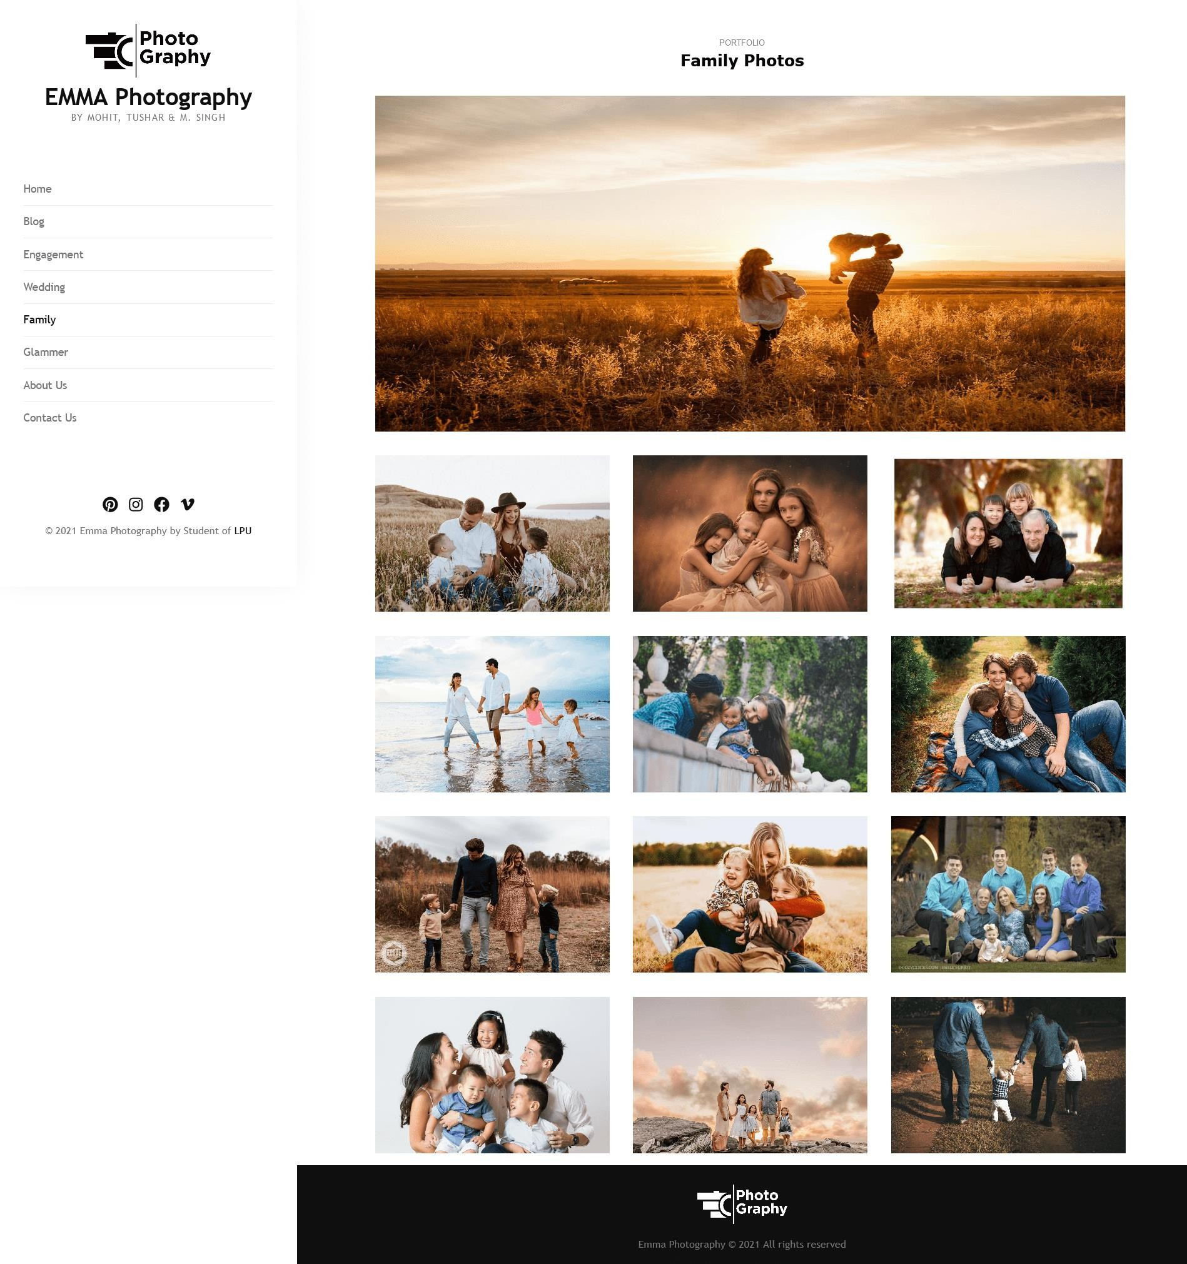

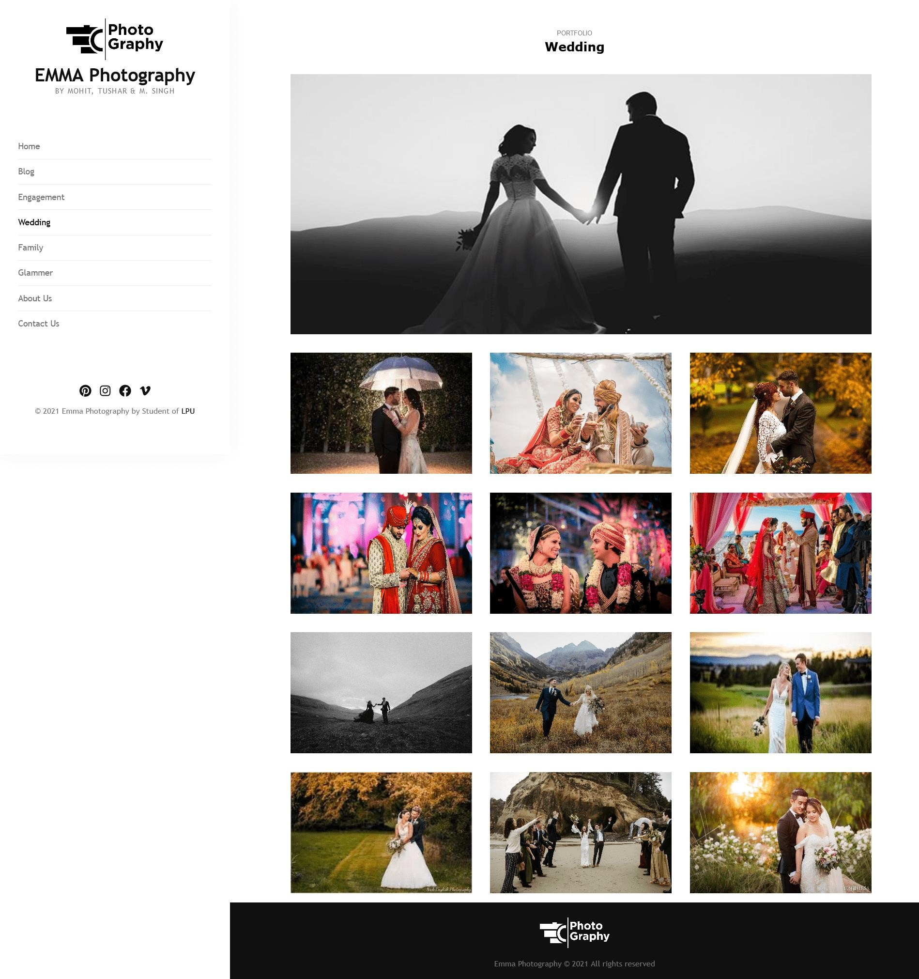

## Project number – 25 (Photographer’s Website)

### Reg no: 12015402

Roll no: RK20MPB92 Name: Mohit Singh

### Completed: About Us page, Contact Us page

