**CAR AUCTION**

A web application to buy and Sell Cars



002

Tushar -300355492

Vy Do - 300358156

Zi An Wang- 300466378

#### **Introduction**

A Car Auction application is a software platform that allows users to buy and sell used cars online. It provides a convenient and accessible way for individuals and businesses to participate in the market for used cars, which can be a more affordable and practical option than buying a new car.

The application typically includes features such as search and filtering options to help users find the type of car they are looking for, a listing system that enables users to create and post ads for the cars they want to sell, and a messaging system that allows buyers and sellers to communicate and negotiate directly with each other.

Car Auction applications are commonly used by individuals who are looking to sell their used cars quickly and easily, as well as by buyers who are searching for a reliable and affordable vehicle. They offer a transparent and efficient way to buy and sell cars, allowing both buyers and sellers to achieve fair prices and maximize their returns.

**Application Url**: <https://front-car-auction-8obes1sfd-tushar-lang.vercel.app/addcar>

* 1. **Features**

**Home Page**: The first screen is the landing page, and the data related to cars id rendered and fetched through the MongoDB cars collection.

**SEARCH FILTER**: This feature allows users to search for cars by name, or brand. It helps users find cars they are interested in quickly and easily.

**ADD CAR**: Add a car page allows users to add cars to the list of cars to get it displayed on the homepage. This feature helps users to add cars to sell they want. The data is entered into the MongoDB cars collection.

**CART**: The cart feature allows users to add cars to their virtual shopping cart before proceeding to checkout. It enables users to browse and select multiple cars to purchase in one transaction, making the process more convenient and efficient.

**LOGIN**: The login feature allows users to access their personal account by entering their username and password. This feature enables users to view their order history, manage their personal information, and track the status of their orders.

**SIGNUP**: The signup feature allows new users to create a personal account by providing their name, email address, and password. This feature will enable users to access additional features such as order tracking, personalized recommendations, and wish list creation in future.

**Future Auction**: We are going to implement the bid auction for cars according to brands in the next release of the application.

* 1. **Tools and Technologies**

**MERN**: MERN is a full-stack JavaScript framework consisting of MongoDB, Express JS, ReactJS, and NodeJS. It enables developers to build web applications using a unified language and platform, making development faster and more efficient.

**Public API:** Used a public API to fetch the Car’s list Auction Details, this feature is working and for now we are fetching the details of cars and the auction feature we are planning to introduces in next version of Car Auction Application.

* 1. **Structure of API**



When building APIs with the MERN stack, the structure is commonly used:

**Routes**: Define the HTTP methods (GET, POST, PUT, DELETE) and endpoints for the API using Express, a minimalist web framework for Node.js.

**Controllers**: Handle the logic for each route, such as retrieving or updating data from the database, and return responses to the client.

**Server**: Create an instance of the Express app and start the server to listen for incoming requests.

**Client**: On the client-side, react is used to create the UI and interact with the API endpoints by making requests to the server using libraries like axios.

Overall, this structure ensures a separation of concerns between the various parts of the application, making it easier to manage and maintain code.

* 1. **Files and Folders**

**Car Auction application have 3 folders**

* CarAuction_back – Contains **BACKEND** project of the application
* CarAuction_front - Contains **FRONTEND** project of the application
* Postman_collection - Contains POSTMAN **API collection** of the application
* **FRONTEND**

**Public/img**- Contains the images used in the project.

**Components** – All the .js files in the components folder contains the logic of each rendering component and also the data fetching calls as well

**Deployment**: The frontend part of the project is deployed via vercel and the URL generated via vercel is provided in the introduction sections.

* **BACKEND**

**carsApi’s.js**- Folder Contains all API calls and the schemas of MongoDB which are used in the project i.e., cars schema, cart schema, user schema.

**Deployment**: The backend part of the project is deployed via render and the link generated via render successfully implemented in frontend project.

1. **Work Contribution**
   1. **Front-end Contributions:**

**Tushar**: Designed the **Home page, Add a Car** page**, About Us, Login** page **and Cart** Pages of the website. Tushar has utilized React to create responsive and visually appealing user interfaces for these pages. For animation Tushar has used react aminate-bounce library and few animations are implemented via **CSS**. Created the data (JSON) for cars and Tushar has saved the JSON in the **mongo DB** collection and fetching the data on the various pages of the application.

**Do Vy**: Designed the **Signup**, **Pagination**, project CSS pages of the website. Do Vy has utilized React to create responsive and visually appealing user interfaces for these pages.

**Zi An Wang**: Zi An is responsible for Implementing the Future Auction page. Zi an is using a public API to fetch the details of cars.

* 1. **Back-end Contributions:**

**Tushar**: Created the **Home** page, **Add a Car page**, **Login** page and **Cart** Pages APIs. **Tushar** has used Node to create a robust API backend that provides users with relevant information about cars and other products available on the website.

**Do Vy**: Created **Signup** API used Node to create a robust backend API. She also implemented the pagination part in the project.

**Project Notes Completion:**

Professor, we have covered all the features according to the marking criteria. The demonstration of the **UI** and **backend API** is covered in the video.

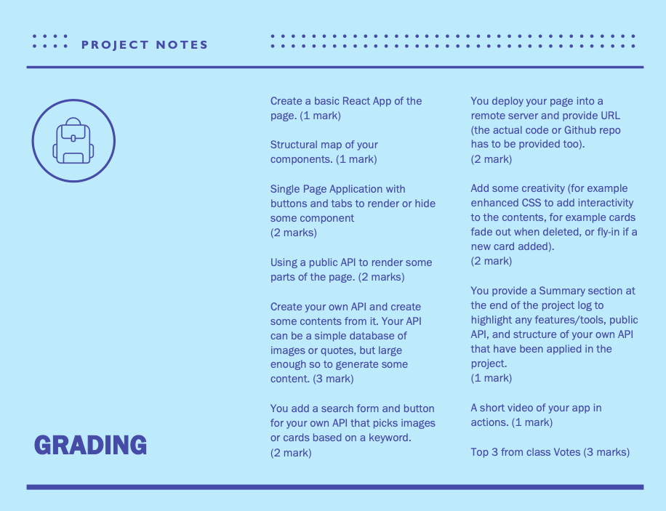

**POSTMAN API Testing screenshots:**

**Below are the Screenshots of all the API’s created for Car Auction application.**

**Add To Cart API:**

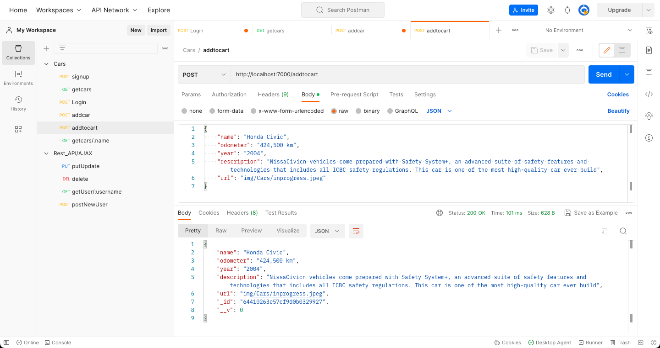

**Login API:**

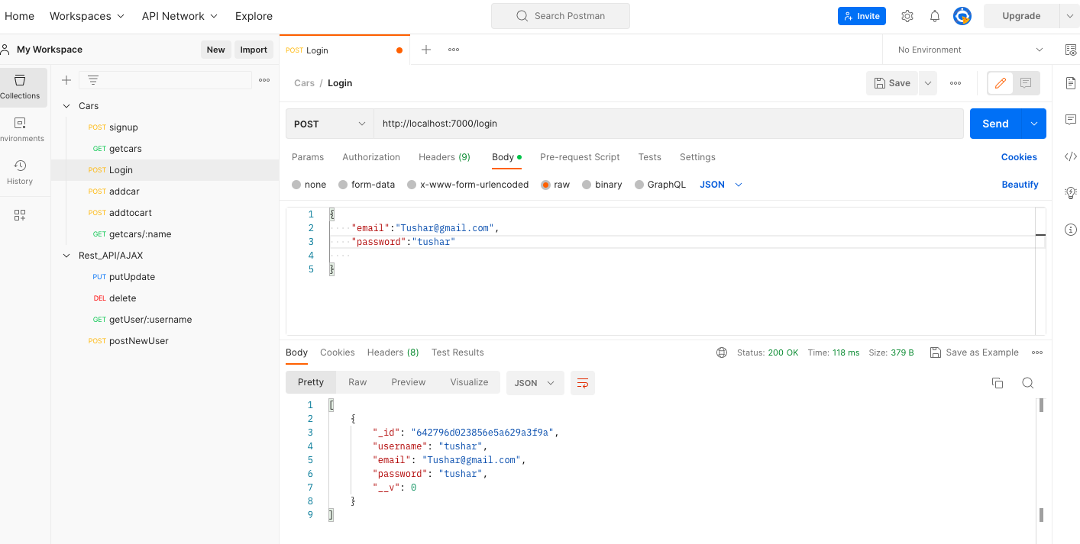

**Add Car API:**

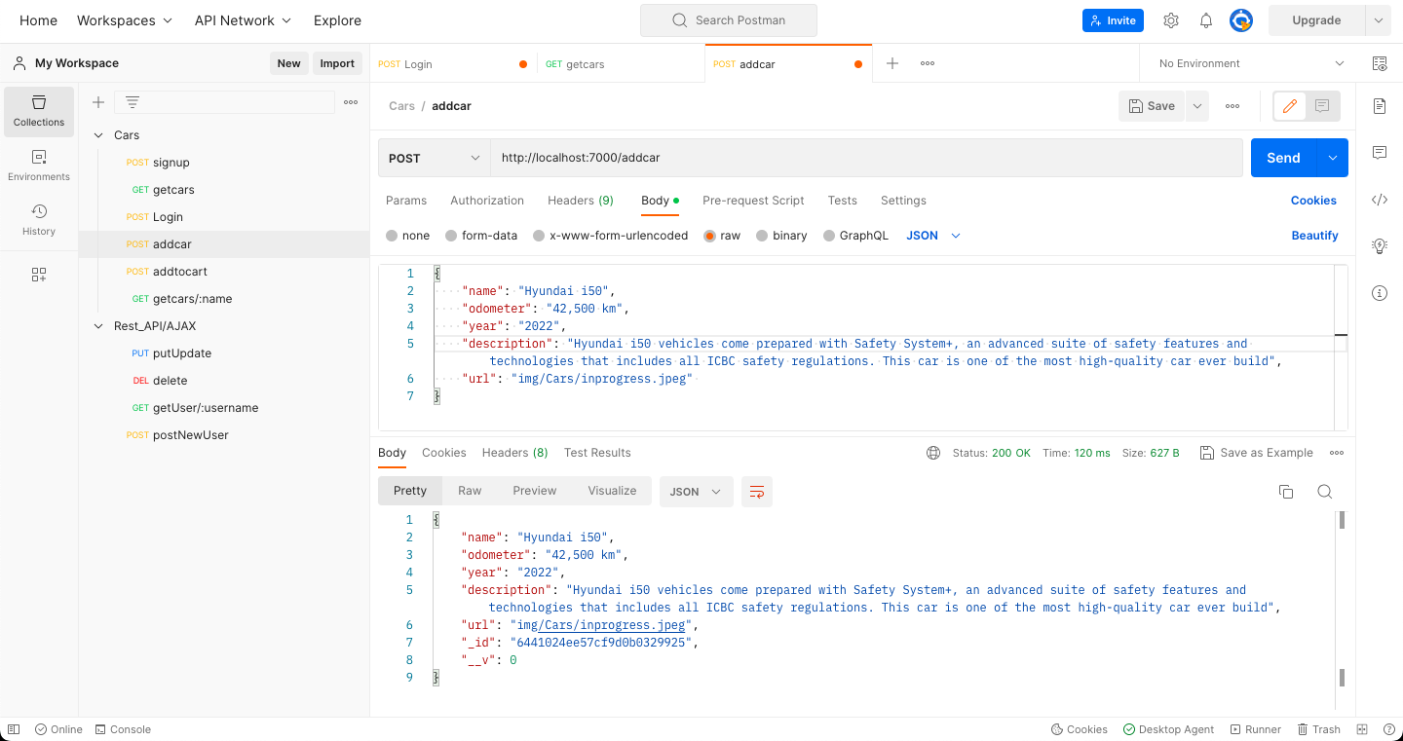

**Get Car Details by Name API (Search Filter):**

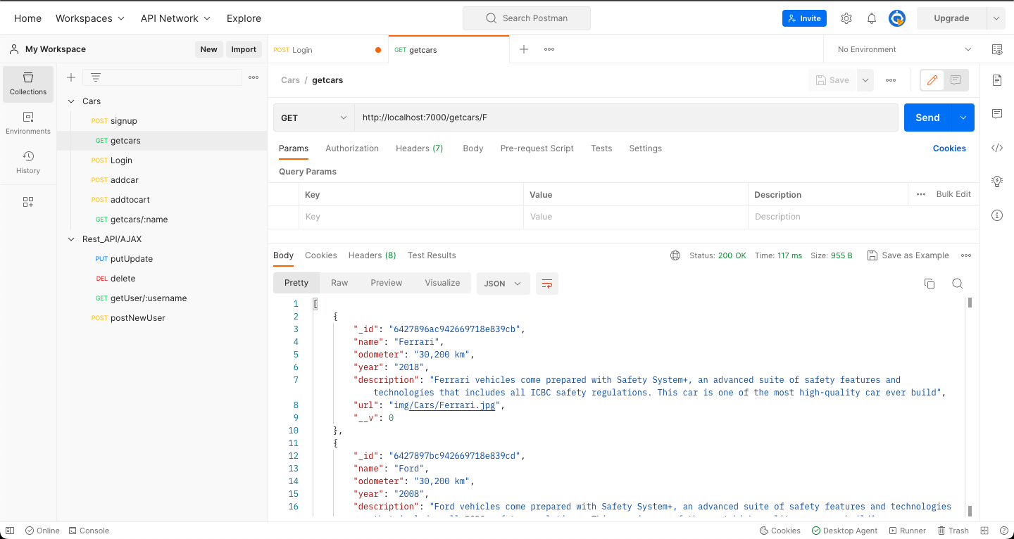

**Signup API:**

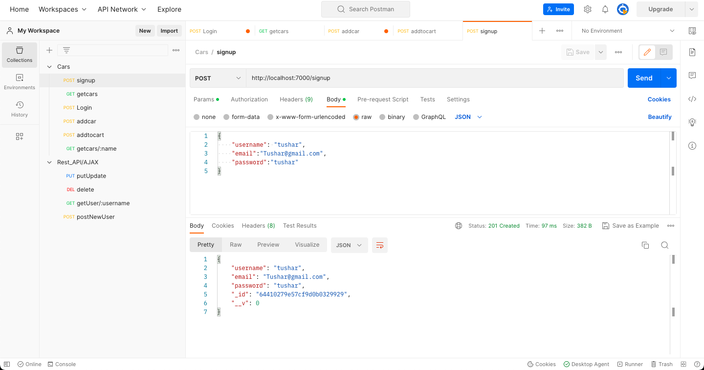

**Get Cars Details API:**

