The document will show the flow of the Quiz-Time application

Once loaded the below screen renders questions which are read from a json file

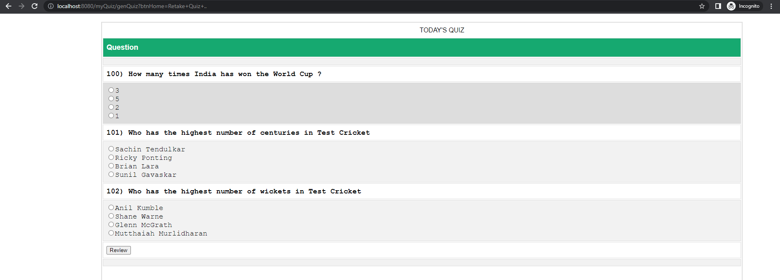

User can then attempt to answer the questions mentioned and then click on the “Review” button to know the result of the quiz.

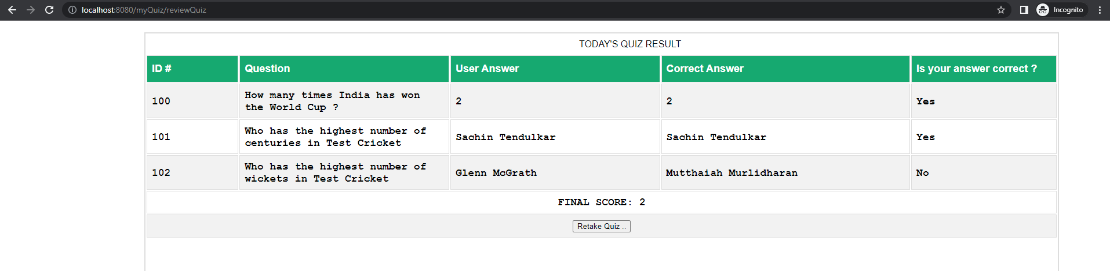

This screen will show the user answers and the correct answers and show the final score.

The user has an option to retake the quiz by clicking on the “Retake Quiz” button.

This will take user back to the main page to attempt the quiz again.

