KIIT DU • SAP Integration Developer Program
Batch: 2027_SAP(OE)

SAP CAPSTONE PROJECT REPORT

SAP Enterprise Blueprint: End-to-End Configuration of a Pharmaceutical Manufacturing Company

Company: ZenithPharma India Pvt. Ltd.
Industry: Pharmaceutical Manufacturing & Distribution

Submitted By

Name: Tushar Raj Padhy
Roll Number: 23052851
Program: SAP Integration Developer
Batch: 2027_SAP(OE)

Submission Date: April 21, 2026 | KIIT DU

1. Project Title & Problem Statement

1.1 Project Title
SAP Enterprise Blueprint — Configuration of ZenithPharma India Pvt. Ltd. across Financial Accounting (FI), Materials Management (MM), and Sales & Distribution (SD) modules of SAP ECC 6.0 / S/4HANA.

1.2 Problem Statement
The Indian pharmaceutical sector is among the most regulated and complex industries globally. A mid-sized pharma manufacturer must simultaneously manage batch-controlled raw material procurement, strict quality-compliance inventory, government-mandated pricing structures (DPCO — Drug Price Control Order), GST-compliant invoicing, and multi-channel distribution across wholesale, retail, and hospital segments. Managing these operations through disconnected legacy systems results in:

- Inability to trace raw material batches to finished drug batches — a critical regulatory requirement under Schedule M of the Drugs and Cosmetics Act.
- Manual reconciliation between procurement records and financial books, leading to audit failures and delayed month-end closing.
- Inaccurate inventory valuation due to multiple costing methods applied inconsistently across warehouses.
- Delayed billing cycles and poor accounts receivable management leading to cash flow problems.
- Lack of real-time visibility into plant-wise production costs and profitability by product line.

This Capstone Project presents a detailed SAP configuration blueprint for ZenithPharma India Pvt. Ltd. — a fictitious pharmaceutical manufacturing and distribution company — addressing all the above challenges through a structured, integrated SAP implementation covering the FI, MM, and SD functional modules.

2. Company Profile — ZenithPharma India Pvt. Ltd.

2.1 About the Company
ZenithPharma India Pvt. Ltd. is a fictitious mid-sized pharmaceutical manufacturing and distribution company incorporated under the Companies Act, 2013. The company is headquartered in Hyderabad, Telangana, and operates two GMP-certified manufacturing plants — one in Hyderabad and one in Ahmedabad. ZenithPharma produces a range of formulations including tablets, capsules, syrups, and injectables, and distributes them through a network of wholesale distributors, hospital chains, and direct retail pharmacies across India and select export markets.

2.2 Company Overview

Field | Details
Company Name | ZenithPharma India Pvt. Ltd.
Industry Sector | Pharmaceutical Manufacturing & Distribution
Headquarters | Hyderabad, Telangana, India
Manufacturing | Hyderabad Plant (ZP01), Ahmedabad Plant (ZP02)
Founded | 2004
Annual Turnover | INR 620 Crores (approx.)
Employees | ~2,100
Regulatory Status | GMP Certified | WHO-GMP | ISO 9001:2015
Product Lines | Tablets, Capsules, Syrups, Injectables, APIs
Markets Served | Domestic (PAN India) + Exports (South-East Asia, Africa)
Currency | Indian Rupee (INR)
Fiscal Year | April 1 to March 31 (Indian Fiscal Year)
SAP Platform | SAP ECC 6.0 (with planned S/4HANA migration)

2.3 SAP Organizational Hierarchy — Overview
The SAP enterprise structure for ZenithPharma is a multi-level hierarchy that maps every real-world organizational unit to a corresponding SAP object. The hierarchy flows as follows: Client → Company Code → Business Area → Plants → Storage Locations (MM side) and Client → Company Code → Sales Organization → Distribution Channel → Division → Sales Area (SD side). All financial postings from MM and SD roll up automatically into the FI general ledger.

[ SCREENSHOT — SAP Logon Screen / SAP Easy Access Menu ]
T-Code / Path: SAP GUI → Open SAP Logon → Log in to Client 200
▼ 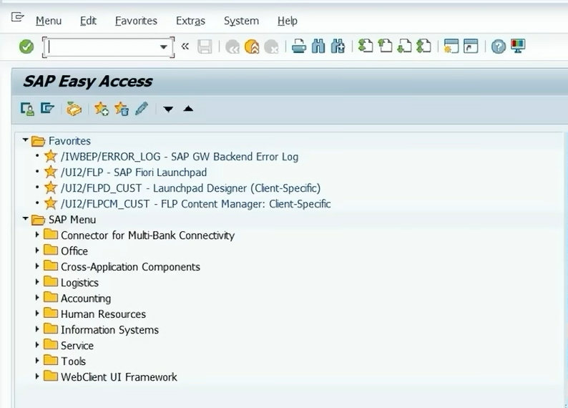

3. Financial Accounting (FI) Module — Configuration

3.1 Module Overview
The Financial Accounting (FI) module is the financial backbone of ZenithPharma's SAP system. It records every business transaction in real time and produces statutory financial statements — Balance Sheet, Profit & Loss Account, and Cash Flow Statement — in compliance with the Companies Act, 2013, and Indian Accounting Standards (Ind AS). The FI module for ZenithPharma is configured with a focus on pharma-specific requirements: batch-level cost tracking, excise and GST compliance, and strict inter-company reconciliation between the two manufacturing plants.

3.2 Client Configuration
In SAP, the Client is the top-most organizational unit. All configuration, master data, and transactional data exist within a client. ZenithPharma operates on a dedicated production client.

SAP Parameter | Configured Value | Description
Client ID | 200 | ZenithPharma production client
Client Name | ZPIL SAP Live | Live production environment
Default Currency | INR | Indian Rupee
Default Language | EN | English

3.3 Company Code
The Company Code is the smallest SAP organizational unit for which a complete, self-contained set of accounts can be maintained. It corresponds to a legal entity for which statutory financial statements are prepared. ZenithPharma has one Company Code representing its registered Indian entity.

Parameter | Value
Company Code | ZPIL
Company Name | ZenithPharma India Pvt. Ltd.
Street / City | Plot No. 47, Genome Valley, Hyderabad
State | Telangana
Country | India (IN)
Currency | INR
Language | EN (English)
Chart of Accounts | ZPCA
Fiscal Year Variant | ZV (April–March, 12+4 periods)
Posting Period Variant | ZP01
Credit Control Area | CC01

[ SCREENSHOT — Company Code Configuration Screen ]  T-Code / Path: SPRO → Enterprise Structure → Definition → Financial Accounting → Edit Company Code (OX02)  ▼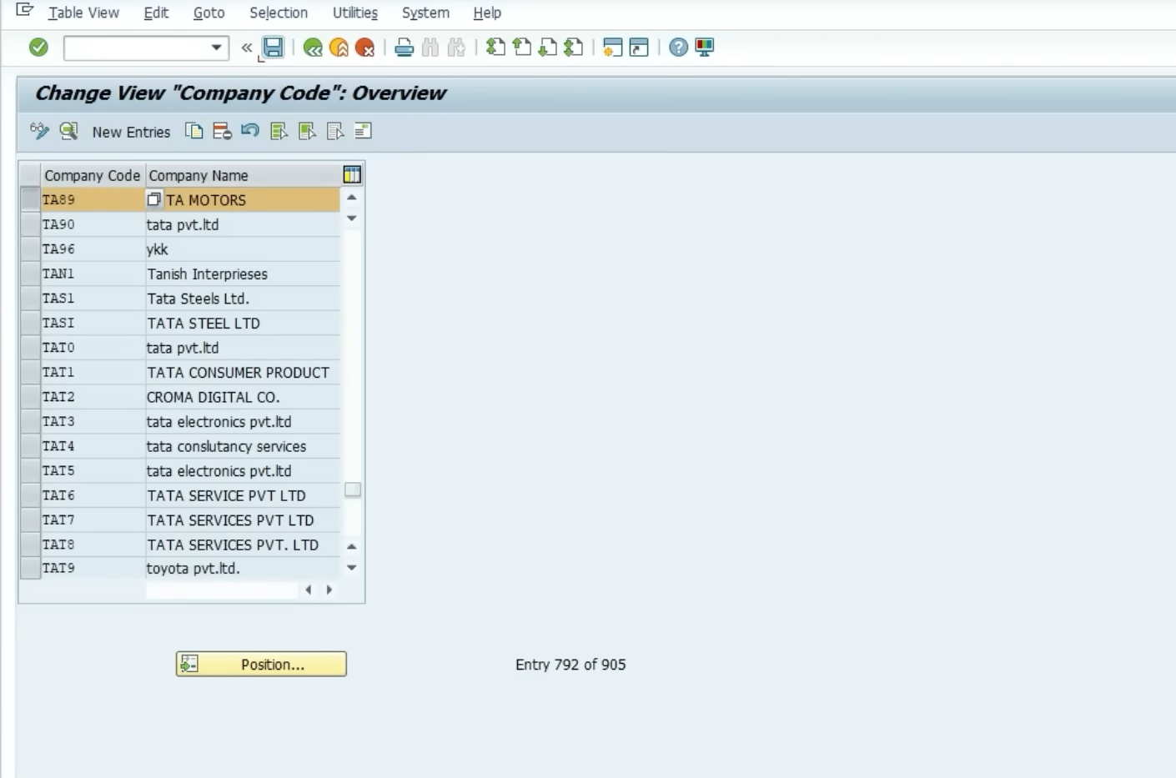 | ▼ Paste your screenshot here ▼

3.4 Chart of Accounts (COA)
ZenithPharma uses a custom Chart of Accounts named ZPCA, structured in alignment with Schedule III of the Companies Act, 2013 and pharma industry accounting norms. The COA defines all G/L account numbers used across both plants.

Account Range | Category | Account Type | Description
100000–149999 | Fixed Assets | Balance Sheet | Plant, Machinery, Lab Equipment, Vehicles
150000–199999 | Current Assets | Balance Sheet | Inventory, Cash, Bank, Receivables
200000–249999 | Liabilities | Balance Sheet | Vendor Payables, Loans, Provisions
250000–299999 | Equity | Balance Sheet | Share Capital, Reserves & Surplus
300000–349999 | Revenue | P&L | Product Sales, Export Revenue
350000–399999 | COGS | P&L | Raw Material Consumption, Batch Costs
400000–449999 | Operating Exp | P&L | R&D, Regulatory, QA/QC Expenses
450000–499999 | Tax Accounts | P&L | GST, TDS, Deferred Tax

3.5 Fiscal Year & Posting Period Configuration
ZenithPharma follows the Indian financial year — April 1 to March 31. The fiscal year variant ZV is configured with 12 regular posting periods (April to March) and 4 special periods reserved for year-end audit adjustments and closing entries.

Period No. | Month | Opening Date | Closing Date | Status
1 | April | 01.04.2025 | 30.04.2025 | Closed
2 | May | 01.05.2025 | 31.05.2025 | Closed
3 | June | 01.06.2025 | 30.06.2025 | Closed
4 | July | 01.07.2025 | 31.07.2025 | Closed
5 | August | 01.08.2025 | 31.08.2025 | Closed
6 | September | 01.09.2025 | 30.09.2025 | Closed
7 | October | 01.10.2025 | 31.10.2025 | Closed
8 | November | 01.11.2025 | 30.11.2025 | Closed
9 | December | 01.12.2025 | 31.12.2025 | Closed
10 | January | 01.01.2026 | 31.01.2026 | Closed
11 | February | 01.02.2026 | 28.02.2026 | Open
12 | March | 01.03.2026 | 31.03.2026 | Open — Current
13–16 | Special Periods | Year-End Only | Year-End Only | Open during closing

3.6 Document Types & Number Ranges
SAP uses Document Types to classify financial transactions. Each document type is assigned a number range, which controls how document numbers are generated. ZenithPharma's document types are configured as follows:

Doc Type | Code | Description | Number Range | Account Types Allowed
Vendor Invoice | KR | Pharma supplier invoices | 5100000000–5199999999 | Vendor + G/L
Customer Invoice | DR | Sales invoices to distributors | 5200000000–5299999999 | Customer + G/L
GL Journal Entry | SA | Internal adjustment entries | 5000000000–5099999999 | G/L only
Outgoing Payment | ZP | Payment to vendors | 5300000000–5399999999 | Vendor + Bank
Incoming Payment | ZR | Collections from distributors | 5400000000–5499999999 | Customer + Bank
Credit Memo | KG | Vendor credit / returns | 5500000000–5599999999 | Vendor + G/L
Asset Acquisition | AA | Lab/plant equipment purchases | 5600000000–5699999999 | Asset + G/L

3.7 Key FI Customization Steps
Step 1 — Define Company
Navigation Path: SPRO → IMG → Enterprise Structure → Definition → Financial Accounting → Define Company
- Company ID: ZPIL | Name: ZenithPharma India Pvt. Ltd.
- Country: IN | Currency: INR | Language: EN
- T-Code reference: OX15

Step 2 — Create and Configure Company Code
Navigation Path: SPRO → Enterprise Structure → Definition → Financial Accounting → Edit, Copy, Delete, Check Company Code
- Company Code ZPIL created with all parameters as per Section 3.3
- T-Code: OX02

Step 3 — Assign Company Code to Chart of Accounts
Navigation Path: SPRO → Financial Accounting → General Ledger → G/L Accounts → Master Data → Assign Company Code to Chart of Accounts
- ZPIL → ZPCA | T-Code: OB62

Step 4 — Define and Assign Fiscal Year Variant
Navigation Path: SPRO → Financial Accounting → Financial Accounting Global Settings → Fiscal Year → Maintain Fiscal Year Variant
- Variant ZV: April (Period 1) to March (Period 12) + 4 Special Periods
- Assignment: T-Code OB37 — Assign ZV to Company Code ZPIL

Step 5 — Configure Field Status Variants
Field Status Variants control which fields are mandatory, optional, or suppressed during document entry. ZenithPharma requires batch fields and profit center fields to be mandatory for all inventory-related G/L accounts.
- Field Status Variant: ZFS1 | Assigned to Company Code ZPIL via T-Code OBC4

Step 6 — Define Tax Procedure (TAXINN)
India uses the TAXINN tax procedure for GST calculations. ZenithPharma has the following GST rates configured for pharma products:

Product Category | HSN Code Range | GST Rate | Condition Type
Essential Medicines (DPCO) | 3004 | Nil / 5% | JIVP
OTC Formulations | 3004 | 12% | JIVC
API / Bulk Drugs | 2941 | 12% | JIVP
Medical Devices / Equipment | 9018 | 12% | JIVC
Nutraceuticals / Vitamins | 2106 | 18% | JIVC

4. Materials Management (MM) Module — Configuration

4.1 Module Overview
The Materials Management module handles all procurement and inventory management activities for ZenithPharma. Given the pharmaceutical industry's strict regulatory requirements, the MM module is configured with batch management, shelf-life tracking, quality inspection at goods receipt, and GMP-compliant storage location management. The module covers the complete Procure-to-Pay cycle from purchase requisition through goods receipt, invoice verification, and vendor payment.

4.2 Plant Configuration
A Plant in SAP represents a manufacturing facility, warehouse, or distribution center. ZenithPharma operates two GMP-certified plants:

Plant Code | Plant Name | Location | Type | Capacity
ZP01 | ZenithPharma Hyderabad Plant | Hyderabad, TG | Formulation Manufacturing | 500M tablets/year
ZP02 | ZenithPharma Ahmedabad Plant | Ahmedabad, GJ | API & Injectable Mfg. | 200M units/year

4.3 Storage Locations
Storage Locations represent physically separate storage areas within a plant. For a pharmaceutical company, these must align with GMP requirements — separate areas for quarantine, approved, rejected, and controlled substances.

Plant | Stor. Loc Code | Storage Location Name | GMP Zone
ZP01 | RM01 | Raw Material Store — General | Zone A
ZP01 | RM02 | Raw Material Store — Controlled Substances | Zone B (Restricted)
ZP01 | QA01 | Quarantine Store (Pre-QC approval) | Zone C
ZP01 | FG01 | Finished Goods Store — Approved | Zone A
ZP01 | RJ01 | Rejected Material Store | Zone D
ZP01 | WIP1 | Work-In-Progress / Dispensing Area | Zone A
ZP02 | RM03 | Raw Material Store — API Plant | Zone A
ZP02 | FG02 | Finished Goods — API / Injectable | Zone A
ZP02 | QA02 | Quarantine Store — Ahmedabad | Zone C

4.4 Purchase Organization
The Purchase Organization is responsible for all procurement activities and legal purchase agreements. ZenithPharma uses a centralized procurement model where a single Purchase Organization handles all purchasing for both plants. This enables consolidated vendor negotiations and volume-based contracts.

Parameter | Value
Purchase Org Code | ZP_PO
Purchase Org Name | ZenithPharma Central Procurement
Scope | Cross-Plant — Covers ZP01 and ZP02
Assigned Company Code | ZPIL
Currency | INR
Procurement Type | Domestic + Import (API, excipients)

4.5 Purchase Groups
Purchase Group | Code | Responsible For | Approx. Annual Spend
Active Pharma Ingredients | PG01 | APIs, bulk drugs, intermediates | INR 180 Cr
Excipients & Packaging | PG02 | Excipients, blister packs, labels | INR 95 Cr
Lab & QC Materials | PG03 | QC reagents, testing kits, media | INR 22 Cr
Engineering & Spares | PG04 | Plant equipment, spare parts | INR 18 Cr
IT & Services | PG05 | IT, AMC, contract services | INR 12 Cr

4.6 Material Types
Material Type | SAP Code | Description | Val. Method
Active Ingredients (API) | ROH | Raw APIs — core drug substances | Moving Avg.
Excipients | ROH | Binders, fillers, coatings | Moving Avg.
Packaging Materials | VERP | Primary & secondary packaging | Moving Avg.
Semi-Finished Goods | HALB | Granules, intermediate batches | Standard Price
Finished Formulations | FERT | Tablets, capsules, syrups, injectables | Standard Price
Lab Consumables | NLAG | Non-stock, expensed on consumption | N/A
Spare Parts | ERSA | Plant maintenance spares | Moving Avg.

4.7 Batch Management Configuration
Batch management is mandatory in pharmaceutical manufacturing for regulatory traceability. Every raw material and finished product must be tracked at batch level — from vendor's batch number through production batch to customer delivery. ZenithPharma configures batch management at plant level.

- Batch Level: Plant Level (each plant maintains independent batch records)
- Batch Number Format: ZP-YYYYMM-XXXXX (e.g., ZP-202604-00123)
- Shelf-Life Management: Minimum remaining shelf life enforced at GR — T-Code MIGO
- Batch Classification: Batch characteristics configured for potency, expiry date, vendor batch, COA reference
- Batch Status Management: Restricted batches blocked automatically until QA releases — T-Code MSC2N
📌 Note: Batch management is a pharma-specific MM configuration not typically required in other industries. This is one of the most critical compliance elements of this blueprint.

4.8 Vendor Account Groups
Account Group | Code | Description | Partner Function
Domestic API Vendors | DAPI | Indian API manufacturers / suppliers | LF (Vendor)
Import Vendors | IMPV | International raw material suppliers | LF (Vendor)
Packaging Vendors | PKGV | Packaging material suppliers | LF (Vendor)
Service Providers | SRVV | AMC, calibration, contract services | LF (Vendor)
One-Time Vendors | ONEV | Petty purchase / emergency vendors | LF (Vendor)

4.9 Key MM Customization Steps
Step 1 — Define Plants and Assign to Company Code
Path: SPRO → Enterprise Structure → Definition → Logistics General → Define Plant
- Create ZP01 (Hyderabad) and ZP02 (Ahmedabad) | T-Code: OX10
- Assign both plants to Company Code ZPIL | T-Code: OX18

Step 2 — Maintain Storage Locations
Path: SPRO → Enterprise Structure → Definition → Materials Management → Maintain Storage Location
- All 9 storage locations created across ZP01 and ZP02 | T-Code: OX09

Step 3 — Define and Assign Purchase Organization
- Create ZP_PO | T-Code: OX08
- Assign ZP_PO to Company Code ZPIL | T-Code: OX01
- Assign ZP_PO to Plants ZP01 and ZP02 | T-Code: OX17

Step 4 — Configure Material Master Views
Material Master records in SAP contain multiple views (organizational levels). For pharma, the following views are mandatory:
View | Tab in MM01 | Key Fields for Pharma
Basic Data 1 | Basic Data | Material desc., base UoM, HSN code
Purchasing | Purchasing | Purchase group, order unit, GR processing time
MRP 1/2 | MRP | MRP type, lot size, reorder point
Quality Management | QM | QM procurement active, inspection type 01
Warehouse Mgmt. | Warehouse | Storage type, picking strategy
Batch Classification | Classification | Batch characteristics: potency, expiry, COA
Accounting 1 | Accounting | Valuation class, price control (S/V), std. price

Step 5 — Configure Valuation and Account Determination
ZenithPharma uses the following valuation classes to map materials to G/L accounts automatically:
Valuation Class | Material Category | G/L Account (Stock) | G/L Account (Consumption)
3000 | APIs and Bulk Drugs | 150100 | 350100
3001 | Excipients | 150200 | 350200
3002 | Packaging Materials | 150300 | 350300
7900 | Finished Formulations | 155000 | 355000
7901 | Semi-Finished / WIP | 156000 | 356000

5. Sales & Distribution (SD) Module — Configuration

5.1 Module Overview
The Sales & Distribution module manages the complete Order-to-Cash cycle for ZenithPharma — from customer inquiry and drug price negotiations through sales order processing, outbound delivery, batch determination, billing, and accounts receivable collection. The SD module is configured with pharma-specific requirements: DPCO price controls, batch-level delivery tracking, export documentation support, and channel-wise pricing strategies for different customer segments.

5.2 Sales Organization
Parameter | Value
Sales Org Code | ZP_SO
Sales Org Name | ZenithPharma National Sales
Company Code | ZPIL
Currency | INR
Scope | PAN India + Export Markets
Sales Calendar | Indian business calendar (excl. national holidays)

5.3 Distribution Channels
Distribution Channels define the pathway through which ZenithPharma's products reach the end customer. Different channels have different pricing strategies, credit terms, and discount structures.

Channel Code | Channel Name | Customer Type | Pricing Strategy
WS | Wholesale Distributors | C&F agents, Super stockists | MRP minus scheme discount
HP | Hospital & Institution | Government hospitals, nursing homes | Tender pricing / DPCO rate
RT | Retail Pharmacy | Individual chemist outlets | Distributor landed price
EX | Export / International | Foreign buyers, NGOs | FOB/CIF USD pricing

5.4 Divisions
Division Code | Division Name | Product Lines
FO | Formulations Division | Tablets, Capsules, Syrups, Ointments
IN | Injectables Division | IV Fluids, Ampoules, Vials
AP | API / Bulk Drugs Division | Active Pharmaceutical Ingredients
NT | Nutraceuticals Division | Vitamins, supplements, health foods

5.5 Sales Areas
The Sales Area is the unique combination of Sales Organization + Distribution Channel + Division. ZenithPharma configures 8 Sales Areas to cover all meaningful business scenarios:

Sales Org | Channel | Division | Sales Area Description
ZP_SO | WS | FO | Wholesale — Formulations (Domestic)
ZP_SO | WS | IN | Wholesale — Injectables (Domestic)
ZP_SO | HP | FO | Hospital Segment — Formulations
ZP_SO | HP | IN | Hospital Segment — Injectables
ZP_SO | RT | FO | Retail Pharmacy — Formulations
ZP_SO | EX | FO | Export — Formulations
ZP_SO | EX | IN | Export — Injectables
ZP_SO | WS | AP | Wholesale — API / Bulk Drugs

5.6 Shipping Points & Routes
Shipping Point | Code | Plant | Dispatch Mode
Hyderabad Dispatch Hub | SPHYD | ZP01 | Road (National courier + own fleet)
Ahmedabad Dispatch Hub | SPAHM | ZP02 | Road + Rail for bulk API
Export Hub — Hyderabad | SPEXP | ZP01 | Air Cargo (IATA) + Sea Freight

5.7 Customer Account Groups
Account Group | Code | Description | Credit Mgmt.
Wholesale Distributor | WSCU | C&F Agents, Super Stockists | Credit limit enforced
Hospital / Institution | HOSP | Govt. & Private Hospitals | Government — extended 90 days
Retail Pharmacy | RTPH | Individual chemist shops | Cash / COD default
Export Customer | EXCU | International buyers | LC / advance payment
One-Time Customer | OTCU | Spot / emergency sales | No credit — advance only

5.8 Pricing Procedure — ZPRIC
ZenithPharma uses a custom pricing procedure named ZPRIC. This procedure calculates the final price for each sales document by applying a sequence of condition types in a specific order. The pharma industry has unique pricing requirements — MRP is a legally mandated maximum price (under DPCO), and all discounts are calculated from MRP downward.

Step | Cond. Type | Description | From | Calculation
10 | ZMRP | Maximum Retail Price (MRP — DPCO) | — | Manual entry — legally mandated
20 | ZSD1 | Trade Scheme / Primary Discount | 10 | % on MRP
30 | ZSD2 | Secondary Distributor Discount | 10 | % on MRP
40 | ZCD1 | Cash Discount (if applicable) | 10 | % on MRP
50 | ZNPV | Net Price to Distributor (NPD) | — | = Step 10 − 20 − 30 − 40
60 | JIVP | GST — CGST (2.5% / 6%) | 50 | % on Net Price
70 | JIVC | GST — SGST/IGST (2.5%/6%/12%/18%) | 50 | % on Net Price
80 | ZFRT | Freight Charges | — | Manual / condition record
90 | NETWR | Final Billing Value | — | = 50 + 60 + 70 + 80

📌 Note: DPCO (Drug Price Control Order) caps the MRP of essential medicines listed in the National List of Essential Medicines (NLEM). ZenithPharma's pricing procedure is configured to enforce DPCO compliance — the system will not allow billing above the DPCO-notified price for scheduled formulations.

5.9 Key SD Customization Steps
Step 1 — Define Sales Organization and Assign to Company Code
- Create ZP_SO | T-Code: OVX5
- Assign ZP_SO to ZPIL | T-Code: OVX3

Step 2 — Define Distribution Channels and Divisions
- Create WS, HP, RT, EX channels | T-Code: OVX1
- Create FO, IN, AP, NT divisions | T-Code: OVX2
- Assign channels to Sales Org | T-Code: OVX4
- Assign divisions to Sales Org | T-Code: OVX5

Step 3 — Set Up Sales Areas
- Define all 8 Sales Area combinations in Customizing
- Path: SPRO → SD → Sales → Sales Documents → Define Sales Area

Step 4 — Configure Sales Document Types
Document Type | Code | Usage
Standard Order | ZOR | Regular sales orders to distributors
Rush Order | ZRO | Emergency/urgent orders
Return Order | ZRE | Customer returns / expired stock recall
Export Order | ZEX | Orders for international customers
Consignment Fill | ZKB | Stock placed at distributor on consignment

Step 5 — Configure Output Types for Billing
Output types define what documents are automatically generated after billing. ZenithPharma configures:
- RD00 — Invoice printout (standard SAP)
- ZGS1 — GST-compliant e-Invoice output (mandatory for turnover > INR 5 Cr)
- ZEX1 — Export invoice with shipping bill reference

6. Cross-Module Integration — FI, MM & SD

6.1 Overview
One of SAP's most powerful capabilities is real-time, automatic integration between all modules. Every procurement and sales transaction in ZenithPharma automatically generates corresponding financial postings in the General Ledger — without any manual journal entries. This section documents the exact accounting entries triggered by each key business event.

6.2 MM–FI Integration: Procure-to-Pay Accounting Flow
Business Event | T-Code | Debit Account | Credit Account | Amount Basis
Purchase Order Created | ME21N | No FI posting (commitment only) | — | PO Value
Goods Receipt (GR) | MIGO | Stock Account (150100) | GR/IR Clearing (200500) | PO Price × Qty
Quality Release (QM) | QA32 | No FI posting | — | —
Invoice Verification | MIRO | GR/IR Clearing (200500) | Vendor Payable (200100) | Invoice Value
GST Input Tax Credit | MIRO | GST ITC Account (450100) | Vendor Payable (200100) | GST Amount
Vendor Payment | F110 | Vendor Payable (200100) | Bank Account (150900) | Payment Amount
TDS Deduction | F110 | Vendor Payable (200100) | TDS Payable (450200) | TDS Amount

6.3 SD–FI Integration: Order-to-Cash Accounting Flow
Business Event | T-Code | Debit Account | Credit Account | Amount
Sales Order Created | VA01 | No FI posting | — | —
Outbound Delivery | VL01N | No FI posting | — | —
Goods Issue (Delivery) | VL02N | COGS — Finished Goods(355000) | FG Stock Account (155000) | Std. Cost
Customer Billing | VF01 | Customer Receivable (150700) | Revenue Account (300100) | Billing Value
GST Output Tax | VF01 | Customer Receivable (150700) | GST Output Payable(450300) | GST Amount
Customer Payment | F-28 | Bank Account (150900) | Customer Receivable(150700) | Amt. Received
Credit Memo / Return | VF01 | Revenue Account (300100) | Customer Receivable(150700) | Credit Amt.

6.4 MM–SD Integration: Batch Traceability
In pharmaceuticals, end-to-end batch traceability is a regulatory requirement. SAP provides this through the Batch Where-Used List (MB56). When a finished drug batch is delivered to a customer, the system can trace back to the exact raw material batches used in its manufacture. ZenithPharma's batch traceability chain is:

- Vendor Batch (GR via MIGO) → ZenithPharma internal batch number assigned
- Dispensing (to production) → WIP batch created with linkage to RM batches
- Manufacturing Order completion → Finished goods batch created, linked to WIP
- Sales Delivery (VL01N) → Finished goods batch assigned to delivery line
- Full trace report available: T-Code MB56 — Batch Where-Used List

[ SCREENSHOT — SAP SPRO — IMG Configuration Tree ]
T-Code / Path: SAP GUI → T-Code: SPRO → 'SAP Reference IMG'
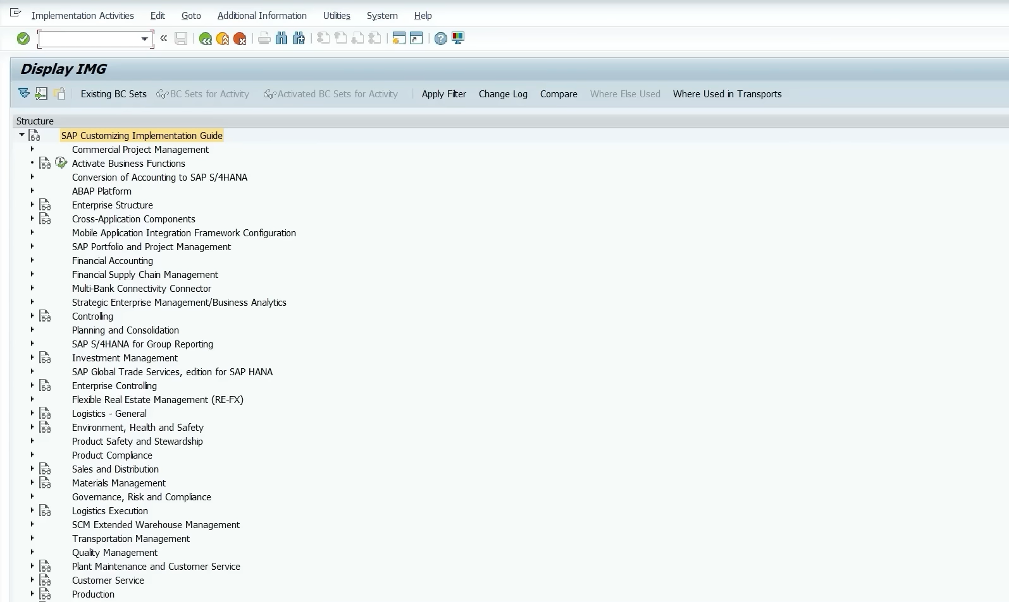

7. Tech Stack & Complete T-Code Reference

7.1 SAP Components Utilized
Component | Version / Type | Purpose in ZenithPharma
SAP ECC 6.0 | EhP 8 | Core ERP — all modules
SAP FI | Financial Accounting | GL, AP, AR, Asset Accounting
SAP CO | Controlling | Cost Center, Profit Center, Product Costing
SAP MM | Materials Management | Procurement, Inventory, Batch Mgmt.
SAP QM | Quality Management | Inspection lots, usage decisions, COA
SAP SD | Sales & Distribution | Order-to-Cash, pricing, billing
SAP WM | Warehouse Management | GMP-compliant storage type management
SAP SPRO / IMG | Configuration Tool | All customization activities
SAP GUI 7.60 | Front-End Client | User interface for all transactions
SAP Solution Manager | 7.2 | Project management, test cases, monitoring

7.2 Complete Transaction Code (T-Code) Reference
T-Code | Module | Transaction Name | Used For
OX15 | FI | Define Company | Create company entity
OX02 | FI | Edit Company Code | Configure Company Code ZPIL
OB62 | FI | Assign COA to Company Code | Link ZPCA to ZPIL
OB29 | FI | Maintain Fiscal Year Variant | Define ZV (Apr–Mar)
OB37 | FI | Assign FY Variant to Co. Code | Assign ZV to ZPIL
OBC4 | FI | Field Status Variants | Define mandatory fields
FB50 | FI | Enter GL Account Document | Manual journal entries
F110 | FI | Automatic Payment Run | Vendor payment processing
F-28 | FI | Post Incoming Payments | Customer payment posting
FS10N | FI | G/L Account Balance | View GL balances
OX10 | MM | Define Plant | Create ZP01, ZP02
OX18 | MM | Assign Plant to Company Code | ZP01/02 → ZPIL
OX09 | MM | Maintain Storage Locations | Create all storage locations
OX08 | MM | Define Purchase Organization | Create ZP_PO
OX17 | MM | Assign PurchOrg to Plant | ZP_PO → ZP01, ZP02
MM01 | MM | Create Material Master | Create new material records
MM03 | MM | Display Material | View material master data
ME21N | MM | Create Purchase Order | Raise PO to vendor
ME23N | MM | Display Purchase Order | View PO details
MIGO | MM | Goods Movement | GR, GI, transfer postings
MIRO | MM | Invoice Verification (LIV) | Post vendor invoices
MB52 | MM | Warehouse Stocks | View stock by storage location
MB56 | MM | Batch Where-Used List | Pharma batch traceability
MSC2N | MM | Change Batch Master | Change batch status (QA release)
OVX5 | SD | Define Sales Organization | Create ZP_SO
OVX3 | SD | Assign Sales Org to Co. Code | ZP_SO → ZPIL
OVX1 | SD | Define Distribution Channel | Create WS, HP, RT, EX
OVX2 | SD | Define Division | Create FO, IN, AP, NT
OVX4 | SD | Assign Channel to Sales Org | All channels → ZP_SO
VA01 | SD | Create Sales Order | Enter new customer order
VA03 | SD | Display Sales Order | View order details
VL01N | SD | Create Outbound Delivery | Pick and pack for shipment
VF01 | SD | Create Billing Document | Generate invoice / credit memo
VK11 | SD | Create Condition Records | Maintain pricing/discount records

8. Unique Features & Highlights of This Blueprint

8.1 What Distinguishes This Configuration
- Pharmaceutical-Specific Batch Management: Unlike generic SAP implementations, this blueprint includes full batch management configuration with shelf-life tracking, GMP zone classification, and QM inspection integration — a regulatory necessity under Schedule M of the Drugs & Cosmetics Act, 1940.
- DPCO-Compliant Pricing Procedure: The custom pricing procedure ZPRIC enforces Drug Price Control Order compliance — the system prevents billing above DPCO-notified MRP for scheduled essential medicines. This is unique to pharma implementations.
- GMP-Aligned Storage Location Design: Each storage location is mapped to a specific GMP zone (A/B/C/D) — quarantine zones prevent approved and unapproved material from mixing. This is a regulatory audit requirement under WHO-GMP guidelines.
- Multi-Channel Distribution with Channel-Specific Pricing: Four distribution channels (Wholesale, Hospital, Retail, Export) each carry distinct pricing strategies, credit terms, and discount structures — reflecting real-world pharma commercial operations.
- GST TAXINN Configuration with HSN-Level Tax Rates: Different pharma product categories attract different GST rates (Nil/5%/12%/18%). The blueprint maps each material type to its correct HSN code and GST condition type — essential for GST filing compliance.
- Centralized Cross-Plant Procurement: A single Purchase Organization (ZP_PO) serves both manufacturing plants, enabling consolidated vendor contracts, volume-based pricing, and unified vendor evaluation — a cost optimization strategy common in multi-plant pharma companies.
- Valuation Class — Material-to-Account Mapping: Five distinct valuation classes ensure that API costs, excipient costs, packaging costs, and finished goods costs flow into separate G/L accounts automatically — enabling product-line profitability analysis without manual allocation.

9. Future Improvements & Planned Enhancements

9.1 Short-Term Enhancements (0–6 Months)
- SAP QM (Quality Management) Full Configuration: Complete the Quality Management module integration — inspection plans, sampling procedures, usage decisions, and Certificate of Analysis (COA) generation for every finished goods batch. This is mandatory for export compliance.
- GST e-Invoicing Integration (IRP): Configure SAP SD to generate e-invoices via the Invoice Registration Portal (IRP) as mandated by GSTN for companies with turnover above INR 5 Crores. This includes IRN number generation and QR code printing on invoices.
- SAP MM Import Procurement Process: Configure complete import procurement cycle including Import Purchase Orders (in USD/EUR), customs duty condition types, Bill of Entry processing, and IGST on imports — required for API sourcing from China and Europe.

9.2 Medium-Term Enhancements (6–18 Months)
- SAP PP (Production Planning) Integration: Extend the blueprint into the Plan-to-Produce cycle — Bill of Materials (BOM) for drug formulations, Master Recipes (Process Orders for pharma), Work Centers (production lines), Batch Classification at production level, and integration with QM inspection lots.
- SAP S/4HANA Migration: Migrate the ECC 6.0 configuration to SAP S/4HANA. Key changes include: Universal Journal (ACDOCA merging FI + CO), Material Ledger activation for actual costing, SAP Fiori Launchpad replacing SAP GUI, and Business Partner (BP) replacing separate vendor/customer masters.
- SAP EWM (Extended Warehouse Management): Replace basic WM with Extended Warehouse Management for the Hyderabad plant — enabling temperature-zone controlled storage, automated pick-pack-ship workflows, and integration with RFID-based track-and-trace for cold chain products.

9.3 Long-Term Enhancements (18+ Months)
- SAP Track and Trace / Serialization: Implement serialization at saleable unit level to comply with DSCSA (US) and EU FMD regulations for export markets — assigning unique 2D barcodes to each pack for end-to-end supply chain visibility.
- SAP Analytics Cloud (SAC) Integration: Connect SAP S/4HANA data with SAP Analytics Cloud for real-time dashboards — plant-wise yield analysis, batch rejection trends, distributor performance scorecards, and DPCO compliance monitoring.
- Regulatory Document Management (SAP RIM): Implement SAP Regulatory Information Management for managing drug registration dossiers, license renewals, and country-wise regulatory submissions — critical for ZenithPharma's international expansion strategy.

10. Conclusion
This Capstone Project presents a detailed, industry-specific SAP configuration blueprint for ZenithPharma India Pvt. Ltd. — a fictitious pharmaceutical manufacturing and distribution company operating across Hyderabad and Ahmedabad. The blueprint covers all three mandated functional areas — Financial Accounting (FI), Materials Management (MM), and Sales & Distribution (SD) — with a level of depth and industry specificity that reflects real-world SAP implementation practice in the Indian pharmaceutical sector.

The FI configuration establishes a robust financial accounting foundation with Indian fiscal year compliance, GST-aligned tax procedures, pharma-specific document types, and a Chart of Accounts structured in accordance with Schedule III of the Companies Act, 2013. The MM configuration goes beyond standard procurement to address the unique demands of pharmaceutical manufacturing — batch management, shelf-life enforcement, GMP zone-based storage location design, QM-integrated goods receipt, and drug-specific material types with appropriate valuation classes. The SD configuration reflects the multi-channel commercial model of a pharma company — with DPCO-compliant pricing procedures, channel-wise discount structures, export documentation support, and GST e-invoicing readiness.

The cross-module integration documentation demonstrates a thorough understanding of how SAP's modules work together seamlessly — every procurement event triggers automatic FI postings, every billing event updates the General Ledger in real time, and every delivery creates a traceable audit trail from raw material batch to customer delivery. This level of integration eliminates manual reconciliation, reduces financial errors, and provides the real-time visibility that regulatory compliance in the pharma industry demands.

The future improvements roadmap reflects an awareness of the evolving SAP landscape — from GST e-invoicing compliance to S/4HANA migration, from QM integration to analytics — positioning ZenithPharma for sustainable growth and regulatory excellence.

— End of Report —

Submitted by: Tushar Raj Padhy | Roll No: 23052851
SAP Integration Developer | Batch: 2027_SAP(OE) | KIIT DU | April 2026

