1) Among the electrolytes, the most effective coagulating agent for Sb2S3 sol is

a)Na2SO4

b)CaCl2

c)Al2(SO4)3

d)NH4Cl

2) Consider the cell Ag(s) |AgBr(s)|Br- (aq)||AgCl(s)|Cl- (aq) |Ag(s) at 25o C. The solubility product constants of AgBr&AgCl are respectively 5 x 10-13& 1 x 10-10. For what ratio of the concentrations of Br-&Cl-ions would the emf of the cell be zero?

A) 1: 200

B) 1: 100

C) 1: 500

D) 200: 1

3)

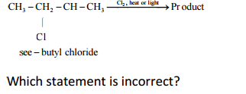

A) One of the products exists as three stereoisomers

B)Two pairs of diastereomers are obtained only

C) only one mesostereoismer is obtained

D) two pairs of enantiomers are obtained

4) Which of the following has the maximum number of unpaired electrons?

A )Mg2+

B )Ti3+

C) V 3+

D) Fe2+

5) Among the following compounds, the most acidic is

A) p-nitrophenol

B) p-hydrozybenzoic acid

C) o-hydroxybenzoic acid

D) p-toluic acid

6) Among the following the coloured compound is

A)CuCl

B)K3[Cu(CN)4]

C) CuF2

D)[Cu(CH3CN)4]BF4

7) The energy of electron in first Bohr’s orbit of H-atom is -13.6 eV. What will be its potential energy in n = 4.

A) -13.6eV

B) -3.4eV

C)-0.85eV

D)-1.70eV

8) The decreasing order of catenation of group 16 elements is

a) O> S > Se> Te

b) S>O>Se>Te

c) S> Se >O> Te

d) O > S> Te> Se

9) When pressure is applied to the equilibrium system

Ice ⇌ Water

Which of the following phenomenon will happen?

A) More ice will be formed

B) Water will evaporate

C) More water will be formed

D) Equilibrium will not be formed.

10) A crystal is made of particle X, Y and Z X forms FCC packing, Y occupies all octahedral voids of X and Z occupies all tetrahedral voids of X, if all the particles along one body diagonal are removed then the formula of the crystal would be –

A) XYZ2

B) X2YZ2

C) X6Y4Z5

D) X5Y4Z8

11) The heat of combustion of CH4(g), C(s) and H2(g) at 25o are – 212.4kcal, - 94.0 kcal and -68.4 kcal respectively, the heat of formation of CH4 will be:

A) +54.4kcal

B) -18.4kcal

C) -375.2kcal

D) +212.8kcal

12) [Fe(en)2(H2O)2] 2+ + en → complex (X). The correct statement about the complex (X) is

A)it is a low spin complex

B) it is diamagnetic

C)it shows geometrical isomerism

D) (A) and (B) both

13) Which one is classified as a condensation polymer?

A) Teflon

B) Acrylonitrile

C) Dacron

D) Neoprene

14) The olefin which on ozonolysis gives CH3CH2CHO and CH3CHO is

A) 1- butane

B) 2- butane

C) 1- pentene

D) 2-pentene

15) The solutions A and B are 0.1 and 0.2 molar in a substance. If 100 ml of A is mixed with 25 ml of B, and there is no change in volume, then the final molarity is

A) 0.15

B) 0.18

C) 0.20

D) 0.12

16) The pH of 0.10 M NH3 solution is [Given Kb = 1.8 × 10-5 ; log 1.35 = 0.13]

A) 1

B) 12.87

C) 11.13

D) 1.35

17) Cyclohexene on ozonlysis followed by reaction with zinc dust and water gives compound E. Compound E on further treatment with aqueous KOH yields compound F.

Compound F is –

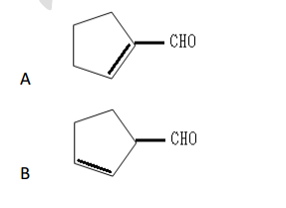

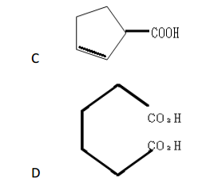

18) Which of the following statements is not correct regarding lanthanides and actinides ?

(a) Oxidation state of + 3 is predominant in both the series

(b) In both the series, f-orbitals are being progressively filled.

(c) All the elements of both the series are radioactive.

(d)Both the series show contraction as lanthanide contraction and actinide contraction

19) In the reaction of aA + bB + cC→products

(i) if concentration of A is doubled, keeping concentration of B and C constant, the rate of reaction becomes double.

(ii) if concentration of B is halved, keeping concentration of A and C constant, the rate of reaction remains unaffected.

(iii) if concentration of C is made 1.5 times, the rate of reaction becomes 2.25 times.

The order of reaction is

a) 1

b) 2.5

c) 3

d)3.5

20) Which of the following gases react with oxygen to form a brown colouredgas?

(a) CO

(b)N2

(c)NO

(d)Br2

21) In the preparation of p-nitro acetanilide from aniline, nitration is not done by nitrating mixture (a mixture of conc. H2SO4 and conc. HNO3 ) because

A) on nitration it gives a-nitro acetanilide

B) it gives a mixture of a-and p-nitro aniline

C) −NH2 group gets oxidized

D) it forms a mixture of a-and p-nitro acetanilide

22)

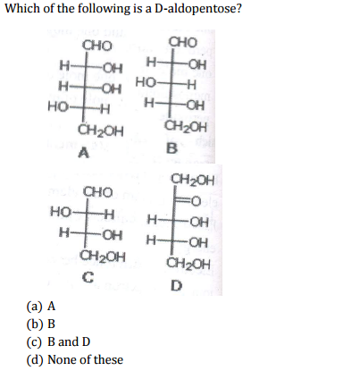

23) Which of the following is an example of a covalent solid?

(a) CaF2

(b) H2O

(c) CI2

(d) SiC

24) In the extraction of Cu, the reaction Cu2O + FeS→ FeO + Cu2S takes place during the

(a) Concentration

(b) Smelting

(c) Roasting

(d) Bassemerisation

25) The hybridization of atomic orbital of nitrogen in NO2 + , NO3 - and NH4 + respectively are

a) sp, sp3 and sp2

b) sp, sp2 and sp3

c) sp2 , sp and sp3

d) sp2 , sp3 and sp

26) A 3p orbital has

a. Two radial nodes

b. Two angular nodes

c. One radial and one angular node

d. One radial and two angular nodes.

27) To prepare a pure sample of n-hexane using sodium metal as one reactant, the other reactant will be

(a) Ethyl chloride and n-butyl chloride

(b) Methyl bromide and n-pentyl bromide

(c) n-propyl bromide

(d) ethyl bromide and n-butyl bromide

28) When 30.0 g of a non-volatile solute having the empirical formula CH2O is dissolved in 800 g of water, the solution freezes at - 1.16°C. What is the molecular formula of the solute? ( k f= 1.86°C/m)

a) CH2O

b) C2H4O2

c) C3H6O3

d) C4H8O8

29) CP – CV = R. This R is:

A)change in K.E.

B) change in rotational energy

C) work done which system can do on expanding the gas per mol per degree increase in temperature

D) all are correct

30)

