Physics and measurements

1) A new unit of length is chosen such that the speed of light in vacuum is unity. What is the distance between the Sun and the Earth in terms of the new unit if light takes 8 min and 20 s to cover this distance?

* 550
* 450
* 500
* 600

2) An aircraft executes a horizontal loop of radius 1.00 km with a steady speed of 900 km/h. Compare its centripetal acceleration with the acceleration due to gravity.

* 10 g
* 6.25 g
* 23 g
* 5 g

3)A circus performer is launched out of a cannon with a launch angle of 30o and an initial velocity of 40 m/s. What is height of the top of his trajectory from the ground ?(g=10m/s2 )

* 10m
* 20m
* 30m
* 40m

4) The driver of a three-wheeler moving with a speed of 36 km/h sees a child standing in the middle of the road and brings his vehicle to rest in 4.0 s just in time to save the child. What is the average retarding force on the vehicle? The mass of the three-wheeler is 400 kg and the mass of the driver is 65 kg.

* -2.5 ms-2, 1200 N
* -2.4 m s−2, 1100 N
* -2.3 m s−2, 1000 N
* -2.2 m s−2, 900 N

5) Balram exerts a steady force of magnitude 150 N on the stalled car as shown in the figure above; he pushes it a distance of 20 m. The car also has a flat tyre, so to make the car move straight he pushes at an angle of 30∘∘ to the direction of motion. How much work does he do?  
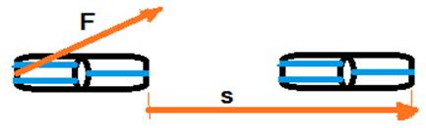

* 2299 J
* 2323 J
* 2598 J
* 2654 J

6) How much energy is required to accelerate a block of mass 2kg from rest to an initial speed of 5m/s?

* 25.0 J
* 50.0 J
* 10.0 J
* 20.0 J

7)The force of attraction due to a hollow spherical shell of uniform density, on a point mass situated inside it is

* negative
* positive
* Zero
* none of these

8)The M.I. of disc about an axis perpendicular to its plane and passing through its centre is http://www.questionpapers.net.in/MHT-CET/question_papers/physics/rotational_motion_paper-1_files/image014.gif Its M.I. about a tangent perpendicular to its plane will be **(MH-CET 2002)**

(a)    http://www.questionpapers.net.in/MHT-CET/question_papers/physics/rotational_motion_paper-1_files/image015.gif                  (b)      http://www.questionpapers.net.in/MHT-CET/question_papers/physics/rotational_motion_paper-1_files/image013.gif

(c)    http://www.questionpapers.net.in/MHT-CET/question_papers/physics/rotational_motion_paper-1_files/image016.gif                  (d)      Cannot be determined

Answer: (b)

9)Two circular discs A and B have equal masses and uniform thickness but have densities 1 and 2 such that 1 2. their moment of inertia is

(a)    I1  I2                    (b)      I1  I2

(c)    I1  I2                    (d)      I1  I2

10) Assuming the earth to be a sphere of uniform mass density, how much would a body weigh half way down to the centre of the earth if it weighed 250 N on the surface?

* 125 N
* 65 N
* 500 N
* 25 N

Read the following paragraph A thin magnetic needle has a time period of vibration as 6s in earth’s magnetic field. It suddenly breaks into two pieces of half lengths. Let T be the time period of unbroken needle and T’ be the time period of the broken piece. Now answer the following questions:

Q11. Ratio of moment of inertia of broken needle to normal is

(a) 1 : 1 (b) 1 : 2 (c) 1 : 4 (d) 1 : 8

Q12. Ratio of magnetic moment of broken needle to normal needle is

1. 1 : 1 (b) 1 : 2 (c) 1 : 4 (d) 1 : 8

Sol:

The mass m is reduced to half i.e m/2 for a half needle and length is reduced to l/2.

𝑇 = 2𝜋 𝑙 𝑀𝐵 And 𝑇 ′ = 2𝜋 𝑙 ′ 𝑀′ 𝐵 = 2𝜋 𝑙 ′ 𝑀′ 𝐵 Or 𝑟 ′ 𝑟 = 𝑙 ′ 𝑙 × 𝑀 𝑀′

Moment of Inertia of thin needle is 𝑙 = 𝑚 12 × 𝑙 2 ⇒ 𝑙 ′ = 𝑚 2×12 × 𝑙 12 2 ⇒ 𝑙 ′ 𝑙 = 1 8

Ratio of magnetic moments of unbroken needle and a piece is 𝑀′: 𝑀 = 1 :2 Ans is (2)

13)

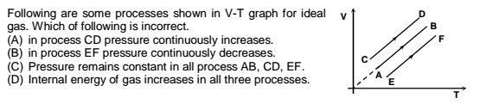

Ans :C

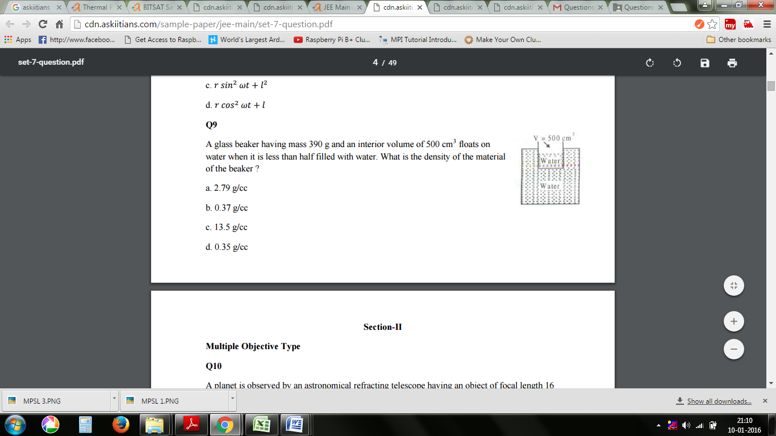14) A glass beaker having mass 390 g and an interior volume of 500 cm3 floats on water when it is less than half filled with water. What is the density of the material of the beaker ?

a. 2.79 g/cc

b. 0.37 g/cc

c. 13.5 g/cc

d. 0.35 g/cc

15)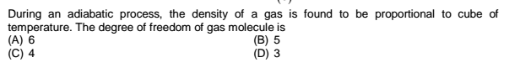

Ans:A

16)

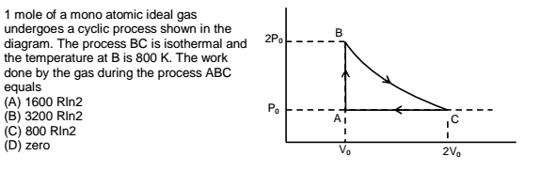

Ans:C

17) If v is the mean speed, vrms is the root mean square speed and Vp is the most probable speed of an ideal monoatomic gas at absolute temperature and mass of a gas molecule is m, then average kinetic energy of a molecule is

1. ½ mv2  (b) ¾ mv2  (c) ¾ mvrms 2 (d) ¾ mvp 2

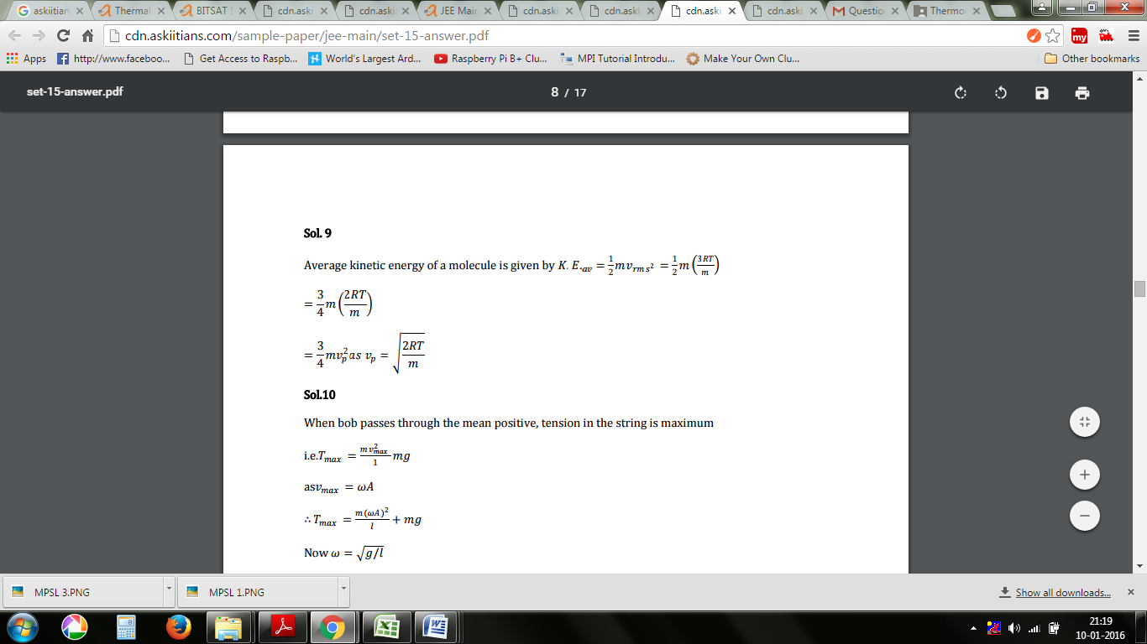

18) The bob of a simple pendulum of length 𝑙 is released at time t = 0 from the position of small angular displacement θ. Linear displacement of the bob at any time t is given as

1. lθ cos(gt/l)1/2 (b) lcos (gt / l)1/2 (c) lgsin θ (d) l θsin (gt/l)1/2

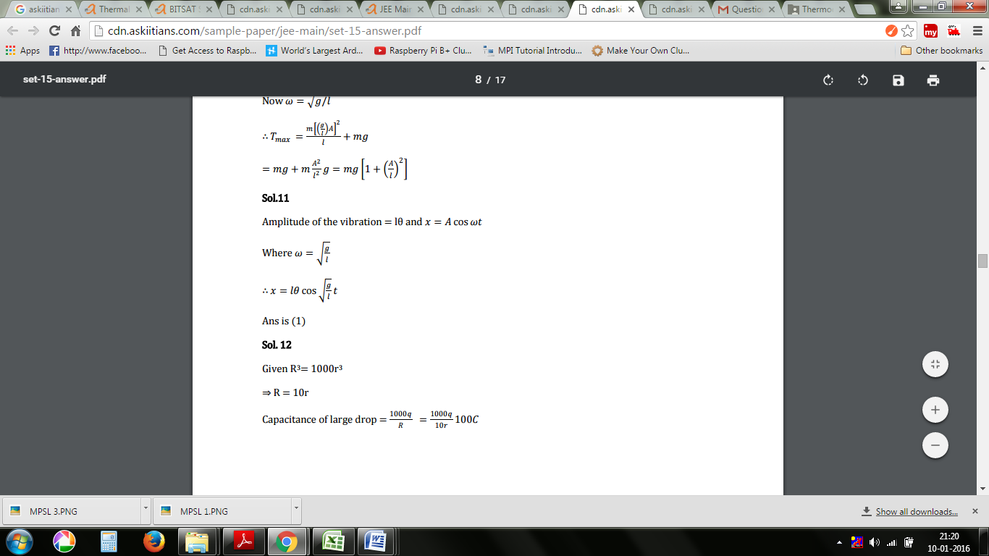

19)A resonance air column of length 20 cm resonates with a tuning fork of frequency 250 Hz .The speed of the air is

1. 75 m/s
2. 150 m/s
3. 200 m/s
4. 300 m/s

20) An iron rod of length 2m and cross sectional area of 50 mm2 stretched by 0.5 mm when a mass of 250 kg is hung from its lower end .Young’s modulus of iron rod is

1. 19.6 x 1020 N/m2
2. 19.6 x 1018 N/m2
3. 19.6 x 1010 N/m2
4. 19.6 x 1015 N/m2

21)

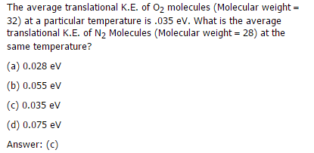

22)

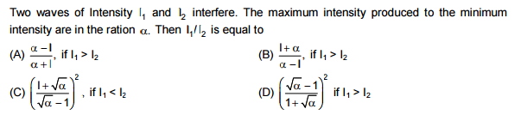

Ans C

23)

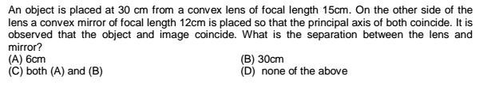

Ans C

24)

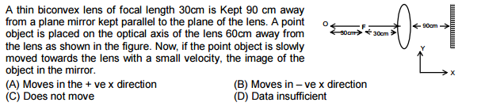

Ans B

25)How many geo synchronous satellites are required to provide the communication over the whole part of the earth?

(a) Minimum three

(b) Minimum one

(c) Minimum three

(d) Minimum four

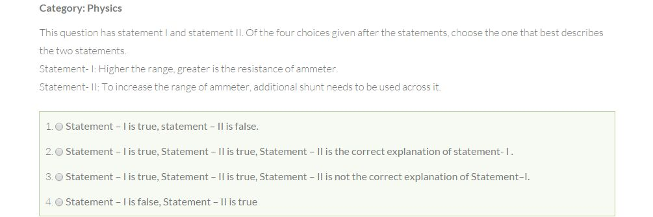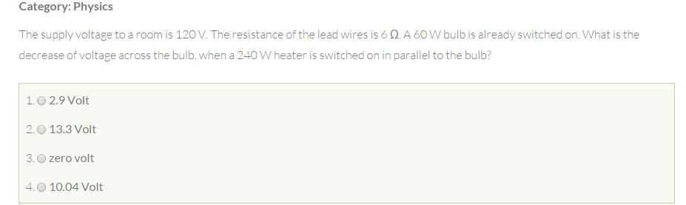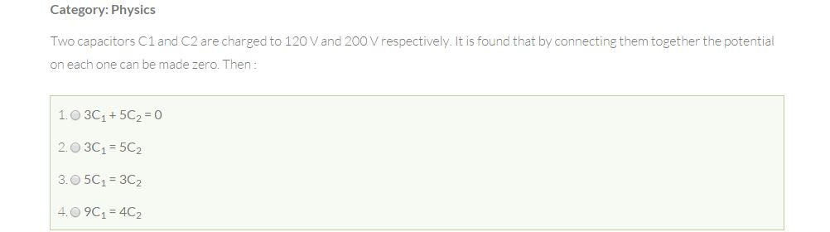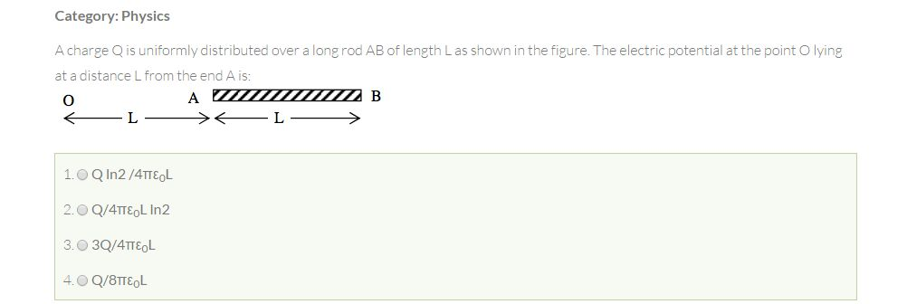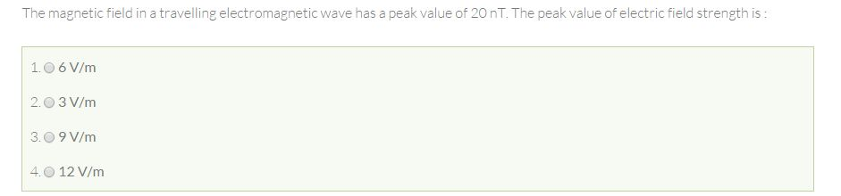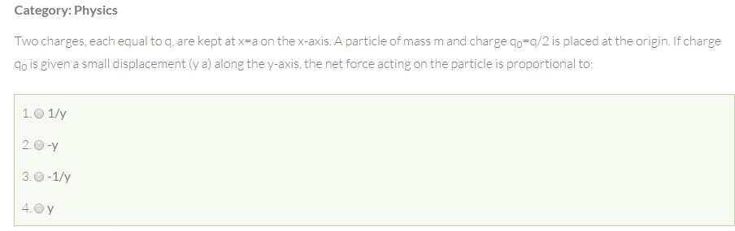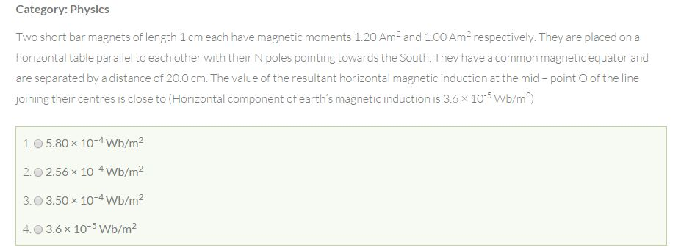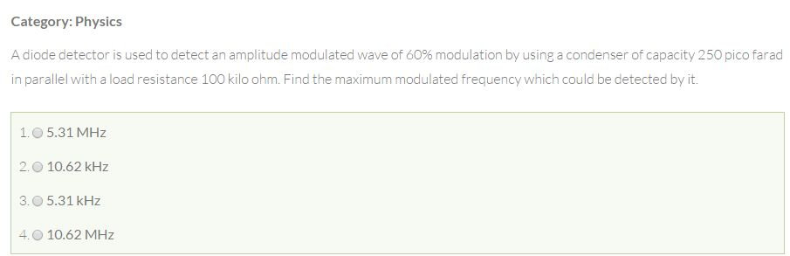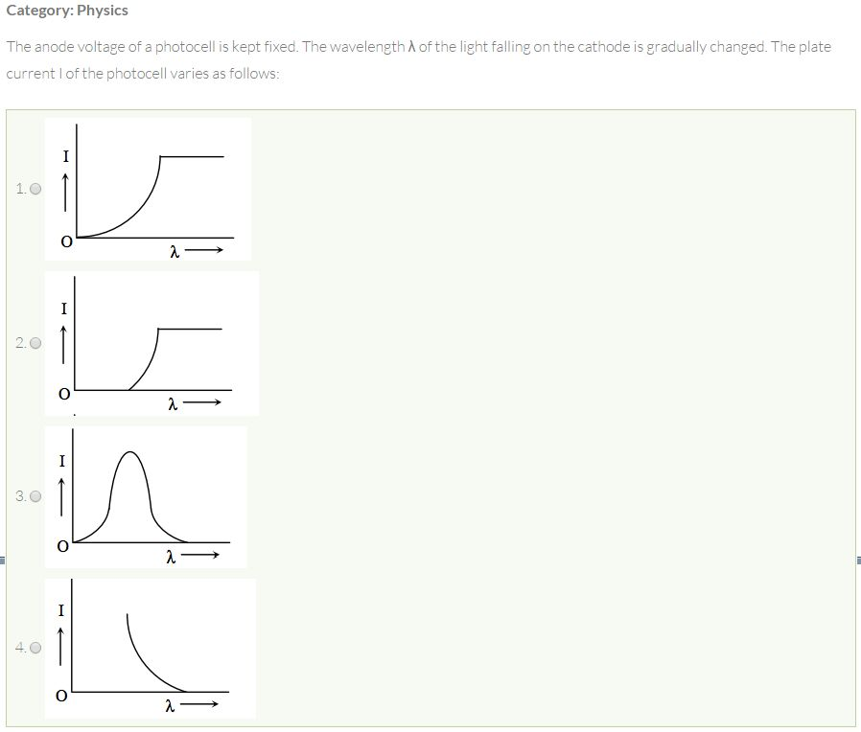

35)A parallel plate capacitor is charged by connecting its plates to a battery. Without disconnecting the battery, a dielectric is introduced between its plate, then

(a) Potential difference between the plates increases

(b) Charge on the plate decreases.

(c) Capacitance of the capacitor decreases

(d) Energy of the capacitor decreases

36)A photon and a deuteron moving with equal kinetic energies enter perpendicularly into a magnetic field. If rp and rd are the respective raddi of the circular path, the ratio rP/rd is

(a) 1

(b) √2/1

(c) 1/√2

(d) ½