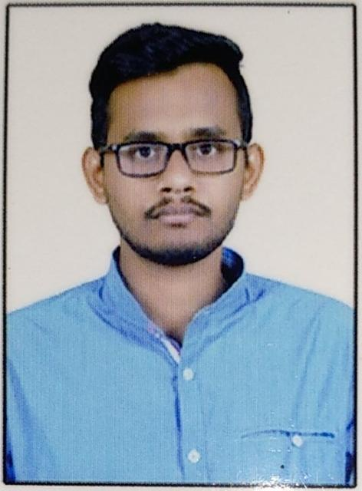

Abhijit Ingole

**Nagpur, Maharashtra, India**

**SUMMARY**Experienced Data Scientist, skilled in Python programming, Machine learning algorithms, NLP, Deep learning, and statistical modeling techniques, with a focus on Artificial intelligence and generative Ai applications. Proficient in data preprocessing, feature engineering, and model evaluation, having a database management capabilities in MySQL. Experienced in leveraging advanced AI techniques like RAG and LLM. Passionate about collaborating across teams to deliver innovative, data-driven solutions that address challenging business problems effectively

**HIGHLIGHTS**

|  |  |
| --- | --- |
| **Languages –** Python | **Database –** MYSQL,PHPMyAdmin |
| **Knowledge –** Python, Flask,NumPy, pandas, Keras, TensorFlow,CNN,Open Ai, Gen Ai, LLM, RAG, matplotlib, seaborn, Huggingface, Llama index, Huggingface, Langchain, OpenCV, Computer Vision,OCR.  NLTK,Spicy, Sk-learn | **Tools and Utilities –** Visual Studio Code, Jupyter Notebook,MySQL workbench, AWS,Jenkins, postman, Git, PHPMyAdmin,  NgRok, Streamlit ,Gradio. |
| **Operation System:** Windows, Linux, Ubuntu |  |

**PROFESSIONAL EXPERIENCE**

Sr. Associate Level-1 (Net Tech AI/ML)

**smartData Enterprise Ltd –** Nagpur,Maharashtra (02/2024 - Present)

Data Scientist

**Nexmoo Solutions Pvt Ltd –**  Chennai, Tamilnadu (Oct 2020 – Jan 2024)

**PROJECTS**

**Skin Cancer AI Detection App**The Skin Cancer AI Detection App aims to leverage artificial intelligence (AI) to enhance early detection of skin cancer through the analysis of skin images. Skin cancer is a prevalent and potentially deadly disease, but early diagnosis significantly improves the chances of successful treatment. This application intends to empower users to monitor their skin health conveniently and receive timely alerts for further medical evaluation.

**Responsibilities:**

* Develop and optimize deep learning models to classify skin images for early detection of skin cancer.
* Conduct thorough data preprocessing to optimize model performance and enhance accuracy in skin cancer detection.
* Iterate on model improvements based on feedback and ensure robust performance across diverse skin conditions and image qualities.

**Sigma Health Pro**This project involves transcribing a recorded medical conversation into text, generating a SOAP note, and extracting billing codes using the OpenAI GPT model. The transcription ensures accurate capture of information, the SOAP note summarizes the patient's history and treatment plan, and billing codes are extracted for reimbursement purposes. By leveraging AI, this process aims to streamline medical documentation and billing procedures.

**Responsibilities:**

* Develop and fine-tune machine learning models to transcribe medical conversations accurately using the OpenAI GPT model.
* Implement natural language processing techniques to generate SOAP notes that summarize patient histories and treatment plans from transcribed text.
* Design algorithms to extract billing codes automatically from the generated SOAP notes for efficient reimbursement processes.
* Conduct thorough testing and validation of AI-driven functionalities, ensuring robust performance and adherence to medical documentation standards.

**EDUCATION QUALIFICATION**

## **Bachelor of Engineering – Amravati University , Maharashtra , India.**

**PERSONAL INFORMATION**

**Date of Birth** 10 December 1993

**Nationality**  Indian

**LANGUAGE KNOWN**

**Reading/Writing -** English, Hindi, Marathi