# TUSHAR YADAV - DATA MANAGEMENT - HW2 - ACCOUNTS DB

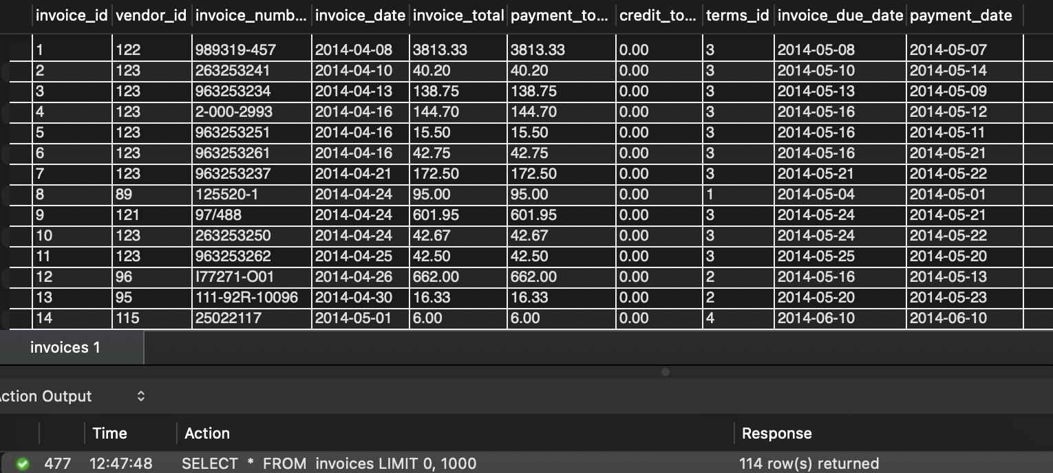Q1. Select all data from the Invoices table. **114 records**

Q2. Display the Invoice number, Invoice date, and the Invoice total. Sort in descending sequence 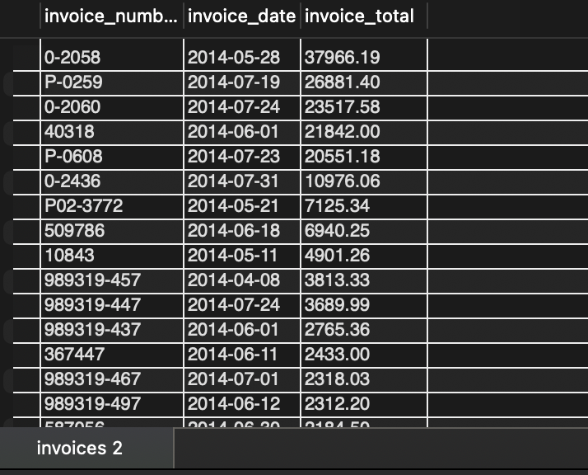by Invoice Total. **114 records**

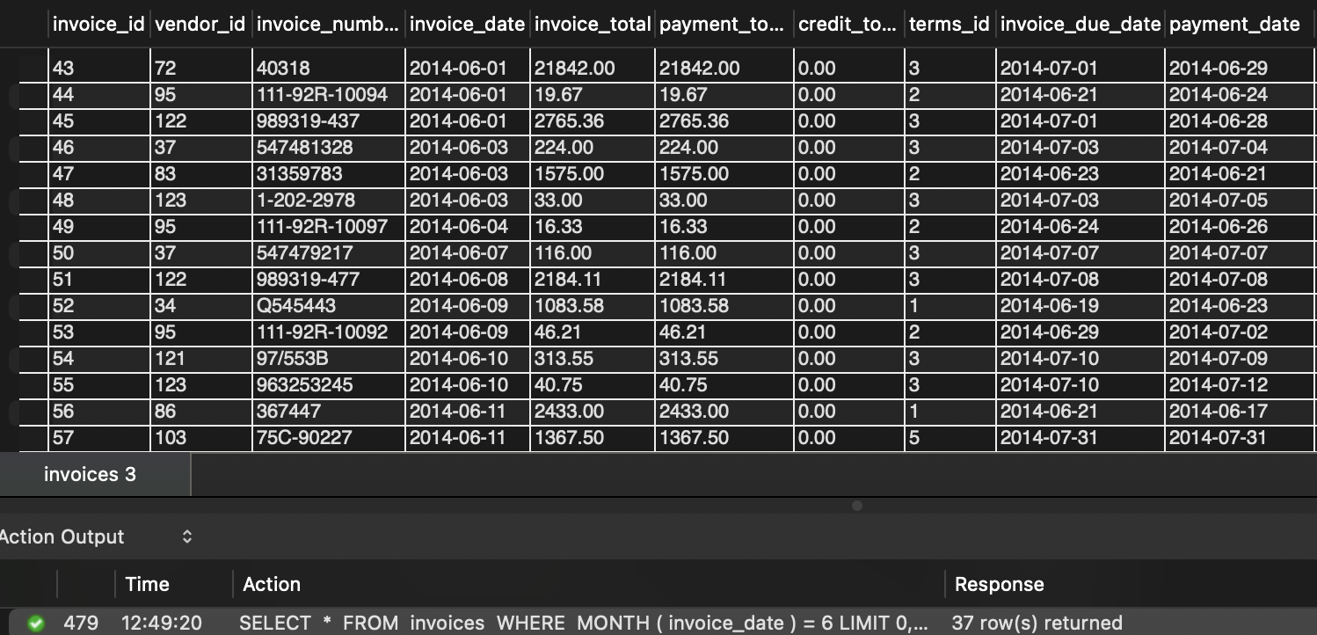Q3. Display all invoices from the month of June. **37 records**

Q4. Write a query to show all vendors. Then sort the result set by last name and then first name, 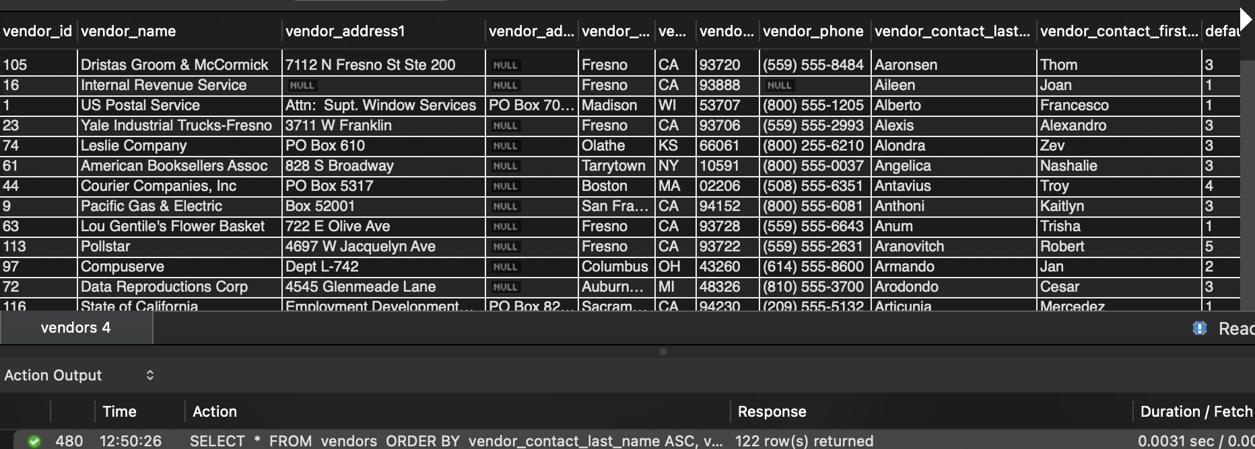both in ascending sequence. **122 records**

Q5. Write a query that returns vendor’s last name and first name. Sort the result set by last name and then first name in ascending sequence. Return only the contacts whose last name begins with 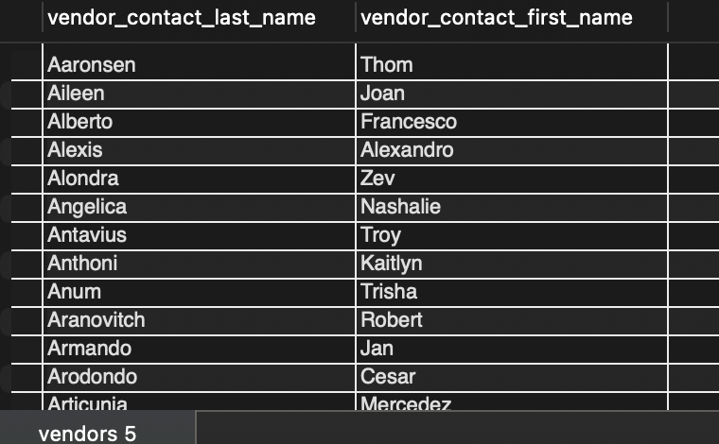the letter A, B, C, E.  **41 records**

Q6. Display the invoice due date and the invoice amounts increased by 10%. Return only the rows with an invoice total that is greater than or equal to 500 and less than or equal to 1000. Sort 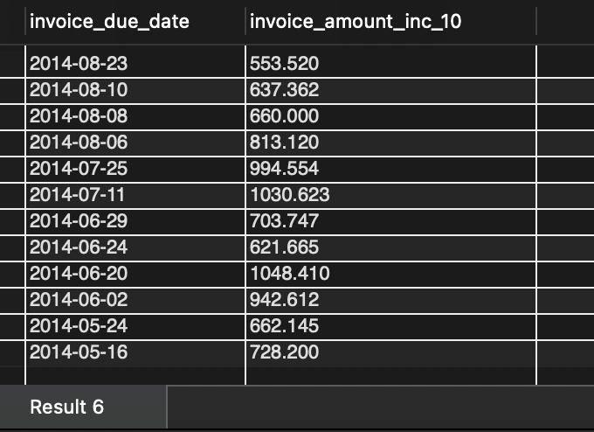the result set in descending sequence by the invoice due date. **12 records**

Q7. Write a query that displays the invoice number, invoice total, payment credit total, and balance due. Return only invoices that have a balance due greater that is than $50. Sort the result 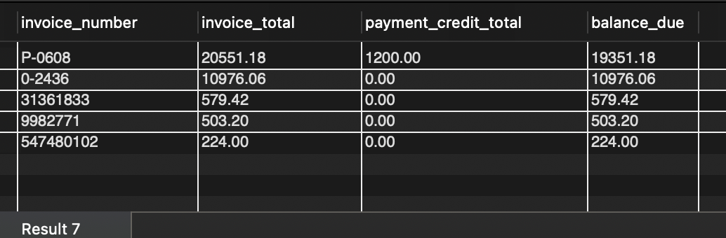set by balance due in descending sequence. Limit the result set to show only the results with the 5 largest balances. **5 records**

Q8. Display the invoices which have balance due. **11 records**

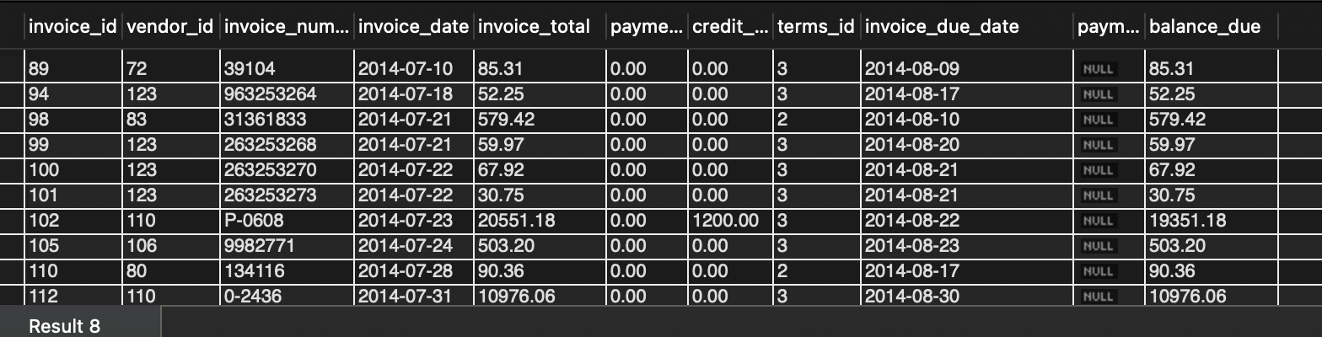

Q9. Display the names of the vendors who have balance due. **7 records**

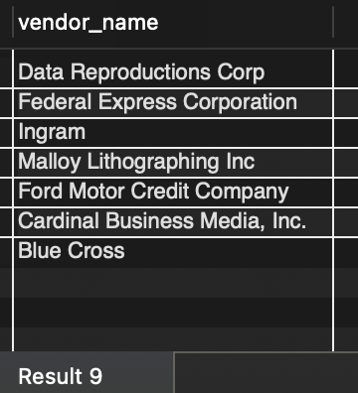

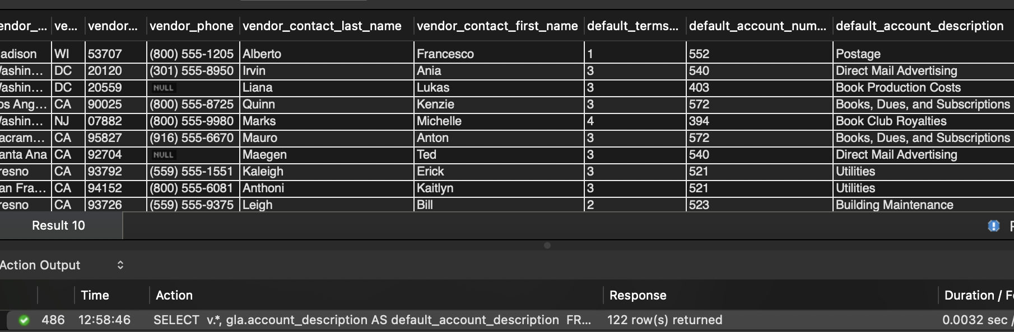Q10. Write a query to display information about the vendors and the default account description for each vendor. **122 records**

Q11. Write a query to display all invoices for each vendor. So for example, if a vendor has 2 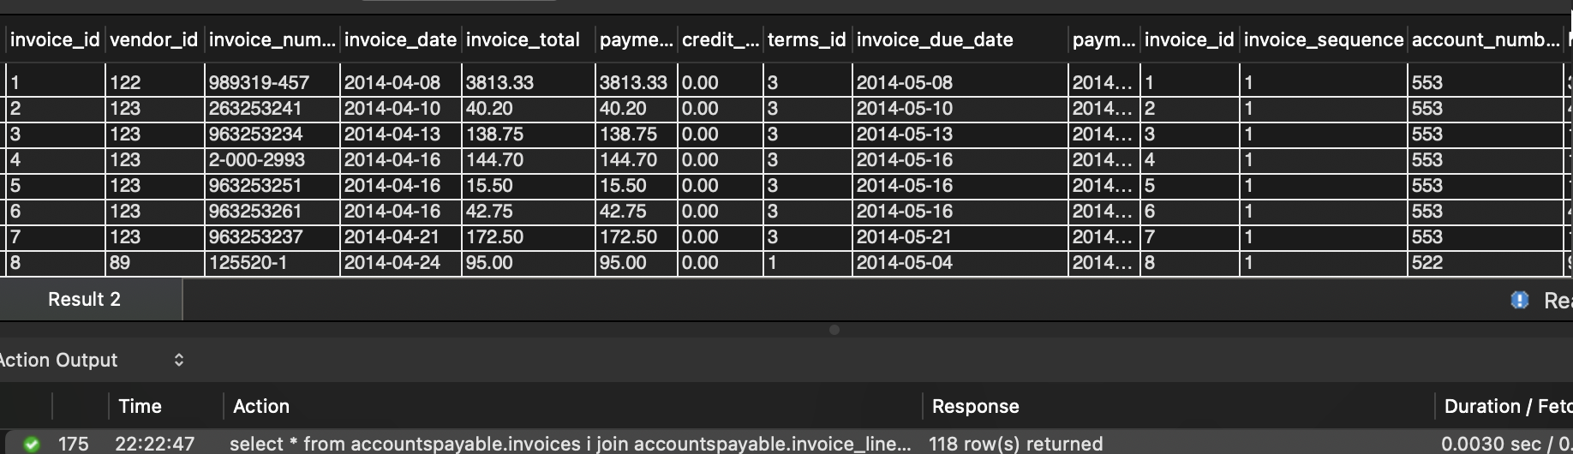invoices, then display all line item information for both invoices. Just an example to give you an idea. **118 records**

Q12. Write a query to return one row for each vendor whose contact has the same last name as another vendor’s contact. **2 records**

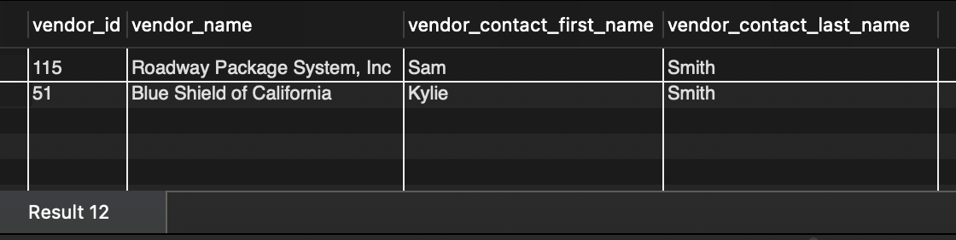

Q13. Write a query to return one row for each account number that has never been used. Sort the result set by Account Number. **54 records**

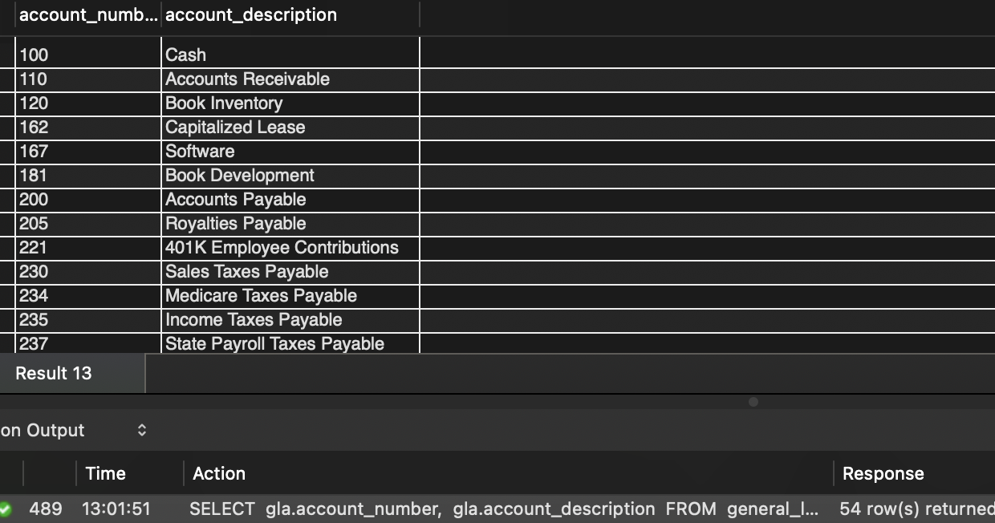

Q14. Generate the result set containing the following columns:

Vendor Name Vendor State

If the vendor is in California, the value in the Vendor State column should be “CA”; otherwise, the value should be “Outside CA.” Sort the final result set by Vendor Name. **122 records**

