# TUSHAR YADAV - DATA MANAGEMENT - HW2 - COLONIAL DB

Q1. List the trip name of each trip that has the season Late Spring. **12 records**

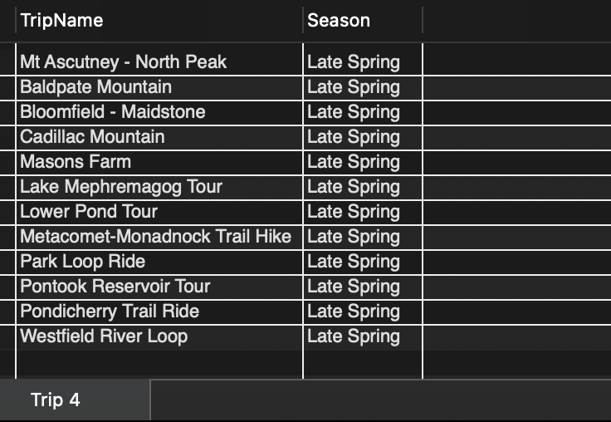

Q2. List the trip name of each trip that is in the state of Vermont (VT) or that has a maximum group size greater than 10. **17 records**

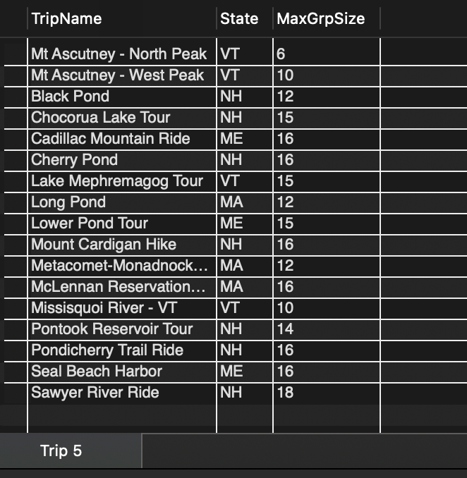

Q3. List the trip name of each trip that has the season Early Fall or Late Fall. **11 records**

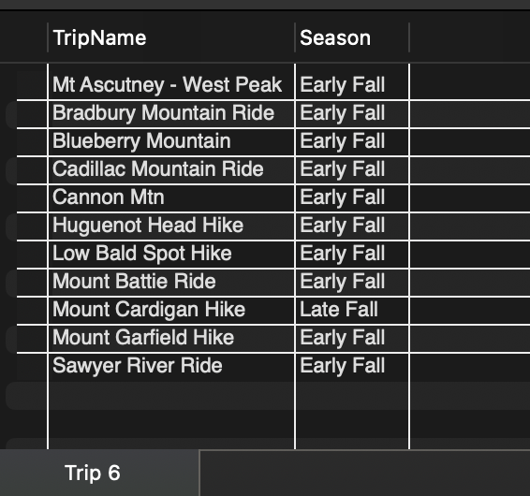

Q4. How many trips are in the states of Vermont (VT) or Connecticut (CT)? **1 record**

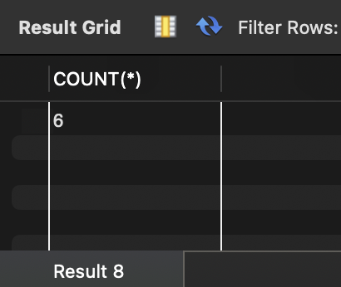

Q5. List the name of each trip that does not start in New Hampshire (NH). **22 records**

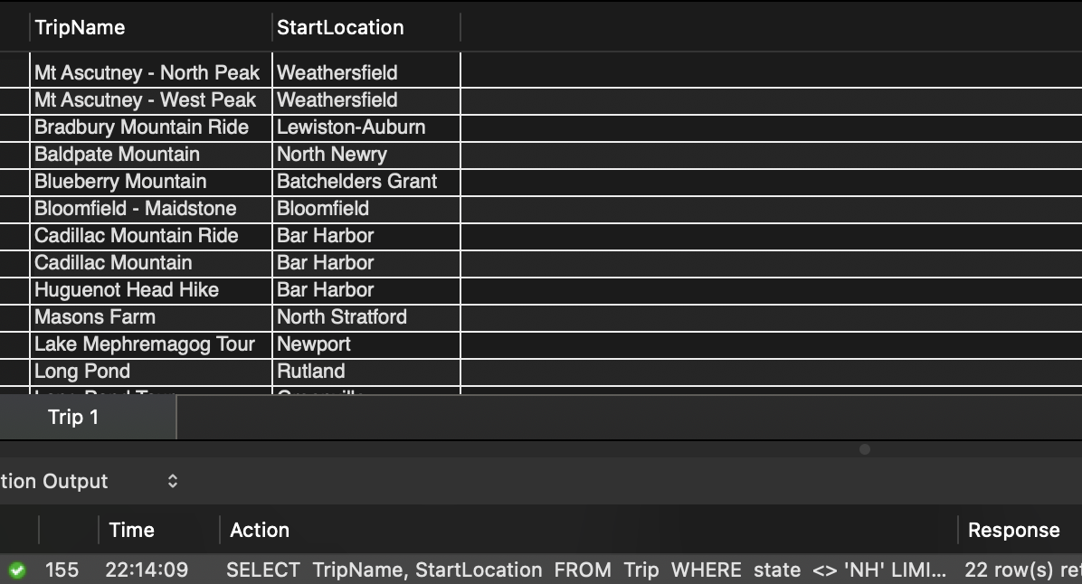

Q6. List the name and start location for each trip that has the type Biking. **8 records**

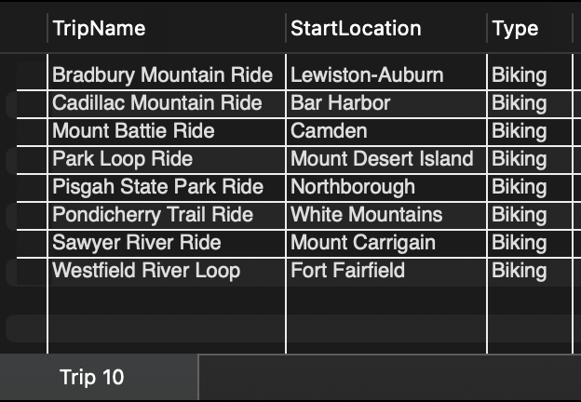

Q7. List the name of each trip that has the type Hiking and that has a distance of greater than six miles. Sort the results by the name of the trip. **10 records**

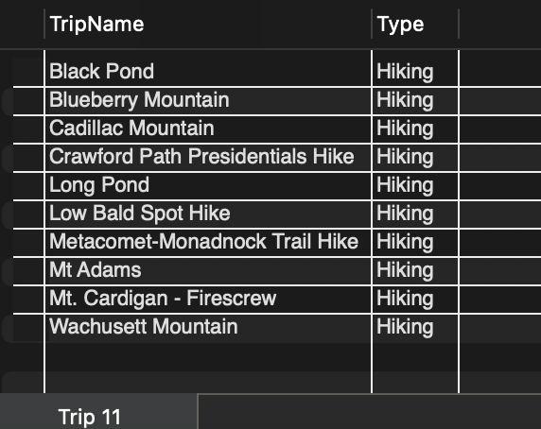

Q8. List the name of each trip that has the type Paddling or that is located in Vermont (VT). **11 records**

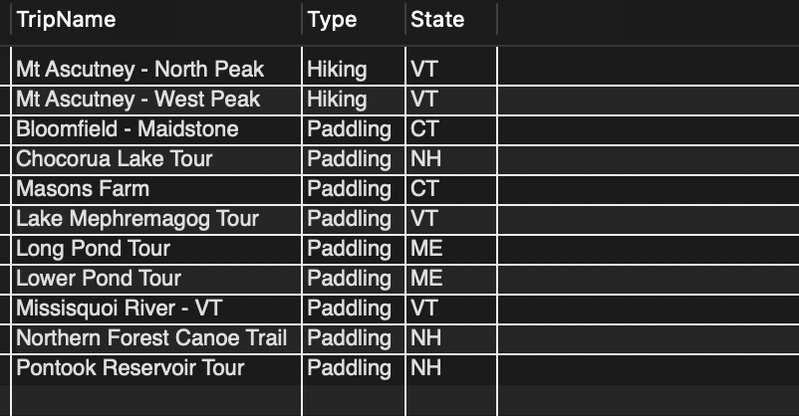

Q9. How many trips have a type of Hiking or Biking? **1 record**

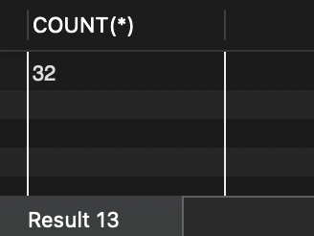

Q10. List the trip name and state for each trip that occurs during the Summer season. Sort the results by trip name within state. **14 records**

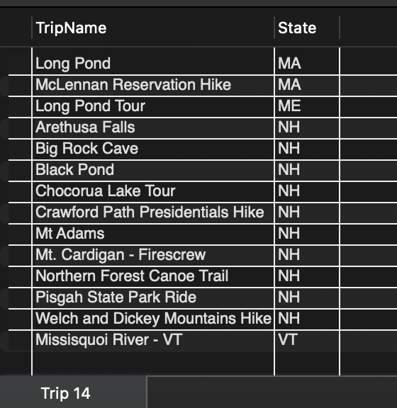

Q11. List the trip name of each trip that has Miles Abrams as a guide. **3 records**

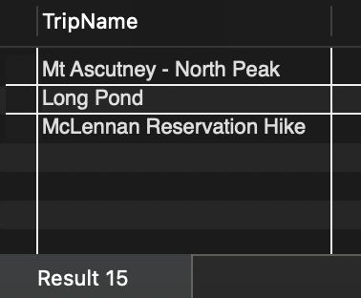Q12. List the trip name of each trip that has the type Biking and that has Rita Boyers as a guide. **4 records**

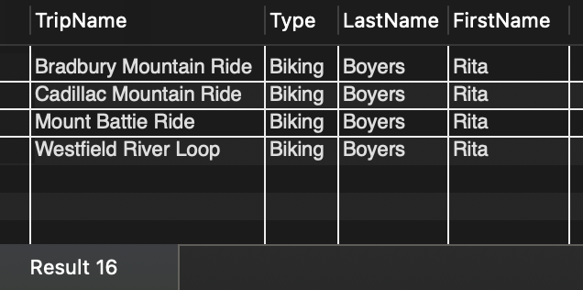

Q13. For each reservation that has a trip date of July 23, 2018, list the customer’s last name, the trip name, and the start location. **2 records**

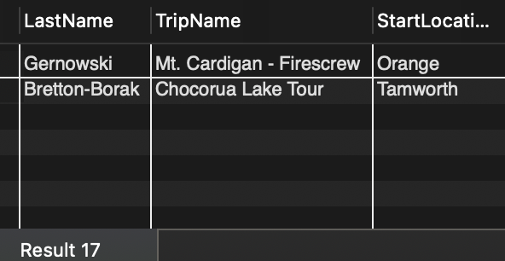

Q14. How many reservations have a trip price that is greater than $50.00 but less than $100.00? **1 record**

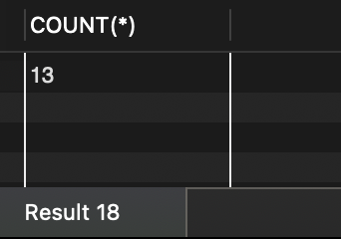

Q15. For each reservation with a trip price of greater than $100.00, list the customer’s last name, the trip name, and the trip type. **2 records**

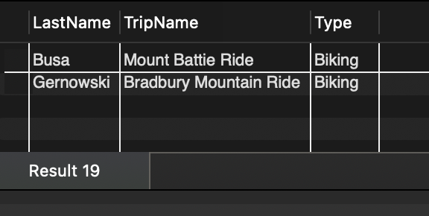

Q16. List the last name of each customer who has a reservation for a trip in Maine (ME). **5 records**

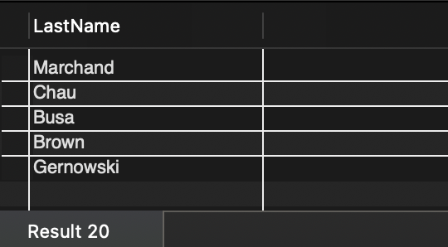

Q17. How many trips originate in each state? Order the results by the state. **5 records**

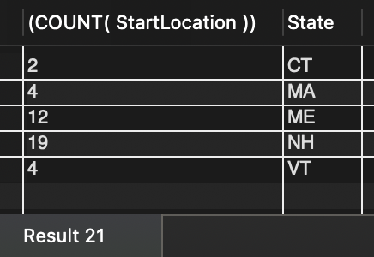

Q18. List the reservation ID, customer last name, and the trip name for all reservations where the number of persons included in the reservation is greater than four. **4 records**

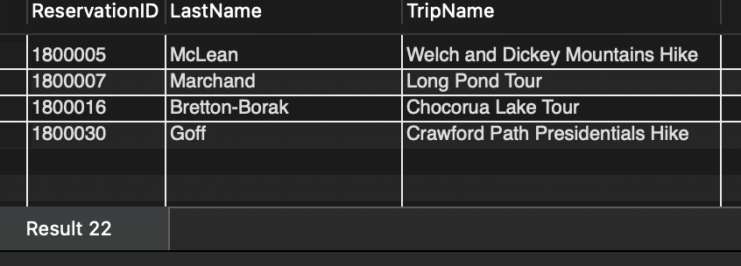

Q19. List the trip name, the guide’s first name, and the guide’s last name for all trips that originate in New Hampshire (NH). Sort the results by guide’s last name within trip name. **22 records**

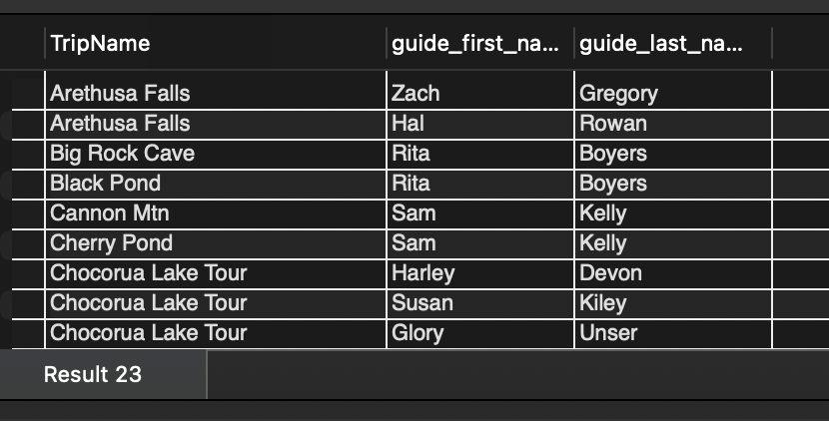

Q20. List the reservation ID, customer number, customer last name, and customer first name for all trips that occur in July 2018. **5 records**

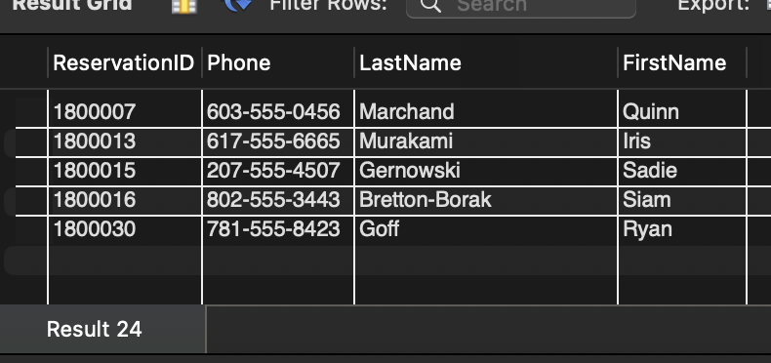

Q21. Colonial Adventure Tours calculates the total price of a trip by adding the trip price plus other fees and multiplying the result by the number of persons included in the reservation. List the reservation ID, trip name, customer’s last name, customer’s first name, and total cost for all reservations where the number of persons is greater than four. Use the column name TotalCost for the calculated field. **4 records**

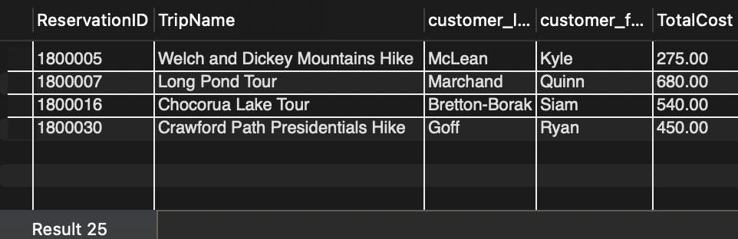

Q22. List all customers whose first name starts with L or S. Sort the results by FirstName. **6 records**

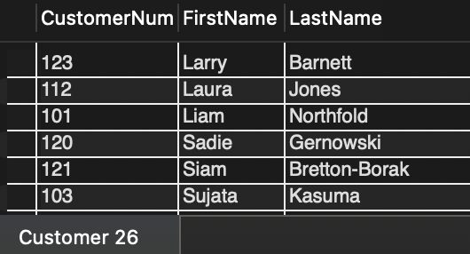

Q23. List all the trip names whose prices are between $30 and $50. **3 records**

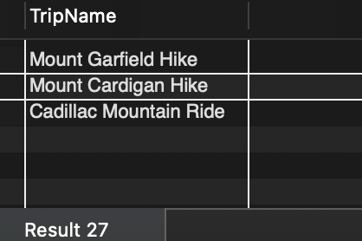

Q24. Write a query to determine how many trips have prices between $30 and $50. (Please note that this question is different from number 23 above.) **1 record**

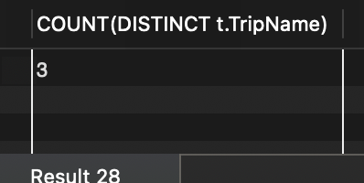

Q25. Display the trip ID, trip name, and reservation ID for all trips that do not yet have the reservations. **23 records**

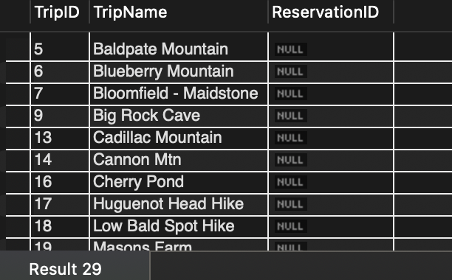

Q26. List the trip information for each pair of trips that have the same start location. **8 records**

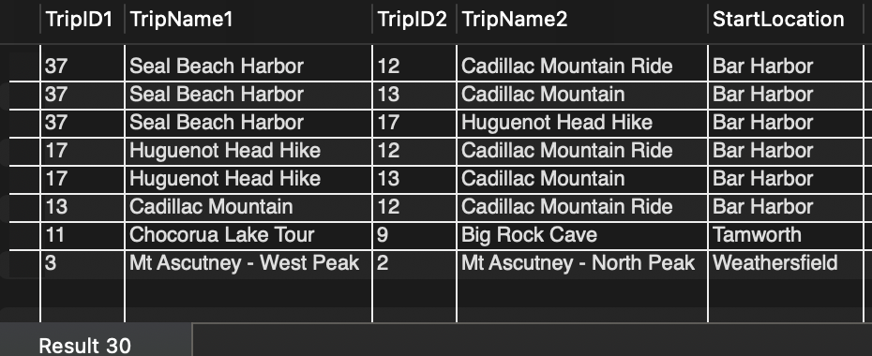

**Q27.** List information for each customer that either lives in the state of New Jersey (NJ), or that currently has a reservation, or both. **27 records**

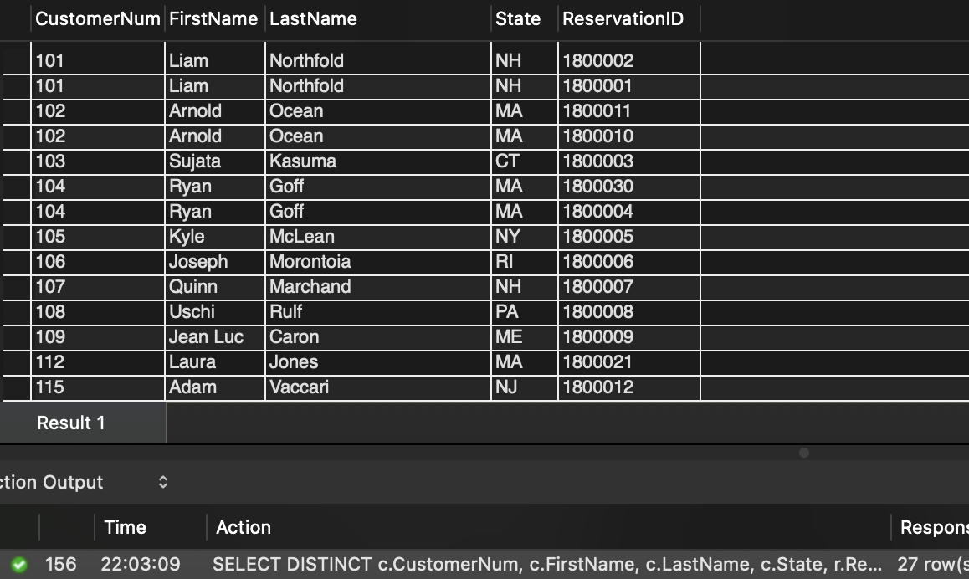

Q28. Display all guides who are not currently assigned to any trips. **1 record**

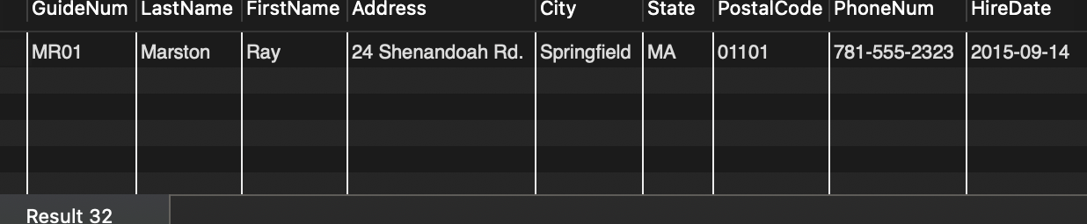

Q29. Display the guide information for each pair of guides that come from the same state. **9 records**

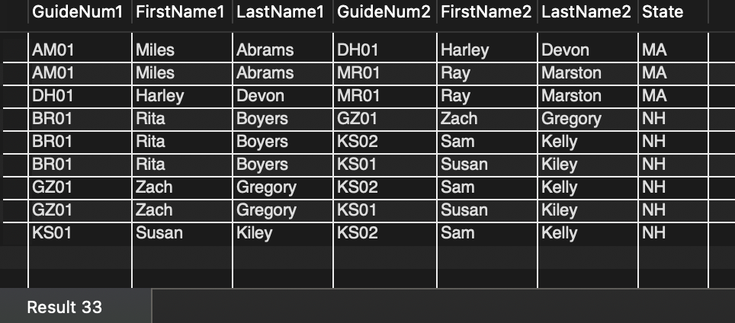

Q30. Display the guide information for each pair of guides that come from the same city. **1 record**

