Heat of Hydration of Portland and Composite Cements under Semi-Adiabatic Conditions
Abdur Nur Tushar¹, Zisan Zia¹, Rifat² and Raquib Ahsan³
1 Undergraduate Student, 2 Research Assistant, 3 Associate Professor, Department of Civil Engineering,
Bangladesh University of Engineering and Technology (BUET), Dhaka-1000, Bangladesh
Corresponding author:
ABSTRACT
Heat released during cement hydration governs early-age temperature rise and the risk of thermal cracking in mass concrete. This study compares the hydration heat evolution of four commercially produced cements conforming to BDS EN 197-1:2003 — CEM I 52.5 N, CEM II A-M 42.5 R, CEM II A-M 42.5 N and CEM II B-M 42.5 N — tested under semi-adiabatic, sealed conditions at a water-to-cement ratio of 0.40. Clinker mineralogy was characterized by X-ray diffraction (XRD), and temperature–time histories recorded with a calibrated bench-top semi-adiabatic calorimeter were converted to specific heat-generation rate and cumulative heat in MATLAB using a lumped heat-balance model with a degree-of-hydration-dependent heat capacity. The rate curves were resolved with a two-component Gaussian model, and the cumulative curves were represented by sixth-order polynomials (R² > 0.999) suitable for thermal simulation. Independent simulations with the NIST Virtual Cement and Concrete Testing Laboratory (VCCTL) were used for validation. CEM I 52.5 N produced the highest cumulative heat (≈467 J/g) and fastest kinetics, whereas CEM II B-M 42.5 N produced the lowest (≈255 J/g). The rapid-hardening CEM II A-M 42.5 R released ≈433 J/g — close to CEM I and well above the normal-strength CEM II A-M 42.5 N (≈284 J/g) — a consequence of higher fineness rather than clinker content. VCCTL reproduced the experimental ranking, agreeing within ≈3% for the high-clinker cements. The results provide practical hydration parameters and cement-selection guidance for mass concrete in tropical climates.
Keywords: Cement hydration; Heat of hydration; Semi-adiabatic calorimetry; Composite cement; Thermal cracking; VCCTL; Gaussian model.
1. INTRODUCTION
Cement hydration is an exothermic process in which the clinker phases — tricalcium silicate (C₃S), dicalcium silicate (C₂S), tricalcium aluminate (C₃A) and tetracalcium aluminoferrite (C₄AF) — react with water to develop strength while releasing heat. In mass concrete elements such as raft foundations, bridge piers and thick mats, this heat is retained in the core while the surface cools, generating temperature gradients and tensile stresses that can exceed the low early-age tensile capacity of concrete and cause thermal cracking. Reliable prediction of early-age temperature therefore requires accurate hydration-heat characterization of the cements actually used in practice.
Ordinary Portland cement (CEM I) hydrates rapidly and releases high heat because of its high clinker content, whereas composite cements (CEM II) incorporate limestone, slag, fly ash or other supplementary constituents that dilute the clinker, slow hydration and reduce cumulative heat. A practically important exception is the rapid-hardening (“R”) class, which achieves high early strength mainly through finer grinding rather than higher clinker content; its early-age thermal behaviour is frequently underestimated in mass-concrete design.
Despite extensive international work, semi-adiabatic hydration-heat data for commercially produced Bangladeshi cements conforming to BDS EN 197-1 remain scarce, and studies integrating mineralogical characterization, calorimetry, analytical modelling and numerical validation within a single framework are limited. This paper addresses that gap by comparing four such cements. The objectives are to (i) characterize clinker mineralogy by XRD; (ii) measure heat-generation rate and cumulative heat under semi-adiabatic conditions; (iii) develop two-component Gaussian and sixth-order polynomial models of heat evolution; (iv) validate the experimental ranking against NIST VCCTL simulations; and (v) translate the findings into cement-selection guidance for mass concrete in a tropical climate.
2. MATERIALS AND METHODS
2.1 Materials and Sample Identification
Four commercially available cements were selected to span the range of clinker content and mineral addition encountered in local construction (Table 1). All samples were collected from sealed bags and stored in airtight containers to limit pre-hydration and carbonation. Cement pastes were prepared at a water-to-cement ratio of 0.40 (cement mass 139 g, water mass 57 g), mixed to a uniform consistency, sealed in the calorimeter vial, and the moment of cement–water contact was taken as t = 0.
Table 1. Cement types investigated and their expected thermal role.
Sample | Commercial type | Strength class | Expected hydration / thermal role
Cement 4 | CEM I 52.5 N | High, normal | High clinker → fastest hydration, highest heat
Cement 3 | CEM II A-M 42.5 R | Rapid hardening | Composite but finely ground → high early-age heat
Cement 2 | CEM II A-M 42.5 N | Normal | Moderate clinker dilution → intermediate heat
Cement 1 | CEM II B-M 42.5 N | Normal | Highest mineral addition → lowest, slowest heat
2.2 Mineralogical Characterization (XRD)
Clinker mineralogy was determined with a PANalytical EMPYREAN diffractometer (Cu Kα, 45 kV / 40 mA) scanned over 6–90° 2θ at a step of 0.026°. Crystalline phases were identified by search-and-match against the ICDD PDF database, and a semi-quantitative phase distribution was obtained from the reference-intensity-ratio (scale-factor) method, in which the percentage of phase i equals its scale factor divided by the sum of all scale factors. The results are therefore approximate relative proportions used to explain hydration trends and to prepare VCCTL inputs.
2.3 Semi-Adiabatic Calorimetry and Calibration
A custom bench-top semi-adiabatic calorimeter — an insulated outer container enclosing a sealed sample vial with sample and ambient temperature sensors — logged temperatures at 60-second intervals. Two calibration constants were determined. Electrical (heater) calibration gave an effective system heat capacity of 3076.9 J/K, of which the insulator contributed 1386.6 J/K. A free-cooling experiment, fitted to a lumped exponential model, gave the heat-loss coefficient Kₗ. Under semi-adiabatic conditions the reaction heat flow is recovered from the temperature history by the lumped heat balance:
q_{reaction}(t) = C · dT/dt + K_{ₗ} · [T(t) − T_{amb}(t)] (1)
The first term is the heat stored in the system and the second the heat lost to the surroundings. The rate is normalized per unit mass of cement, and cumulative heat is obtained by Simpson’s 1/3 numerical integration:
q(t) = q_{reaction}(t) / m_{c} ; Q(t) = ∫₀ᵗ q(t) dt (2)
2.4 Data Processing and Analytical Models
Temperature data were imported into MATLAB, resampled onto a uniform 5-minute grid, smoothed, differentiated and heat-loss corrected. Because the specific heat of paste decreases as hydration advances, a degree-of-hydration-dependent heat capacity was applied following De Schutter and Taerwe, with the degree of hydration r(t) = Q(t)/Qₘₐₓ obtained from the heat curve and the apparent capacity scaled as Cₐ(r) = 1160.67 (1.5 − 0.5 r). The corrected heat-generation-rate curve, which displays an early aluminate shoulder and a dominant silicate peak, was resolved with a two-component Gaussian model:
q(t) = A₁ exp[−((t−μ₁)/σ₁)²] + A₂ exp[−((t−μ₂)/σ₂)²] (3)
The cumulative-heat curve was fitted with a sixth-order polynomial to provide a smooth, differentiable function for finite-element thermal analysis:
Q(t) = c₀ + c₁t + c₂t² + ··· + c₆t⁶ (4)
2.5 Numerical Validation (VCCTL)
Hydration was simulated independently with the NIST VCCTL using XRD-derived clinker phase proportions, a water-to-cement ratio of 0.40 and isothermal conditions. Simulated degree of hydration and cumulative heat release were extracted and compared with the experiment at a common age of 19 h. Agreement was assessed from the relative difference between experimental and simulated cumulative heat and from reproduction of the cement ranking.
3. RESULTS AND DISCUSSION
3.1 Clinker Mineralogy
The semi-quantitative phase compositions (Table 2, Fig. 1) follow a clear clinker-dilution sequence. CEM I 52.5 N has the highest alite (C₃S ≈ 58.8%) and essentially no inert filler, whereas CEM II B-M 42.5 N has the lowest alite (≈ 42.4%) and the largest filler/SCM fraction (≈ 30.3%). The two CEM II A-M cements are intermediate and nearly identical in clinker content, consistent with the manufacturer’s statement that the rapid-hardening grade differs chiefly in fineness, not composition. Because C₃S and C₃A are the principal heat-producing phases, this mineralogical ordering anticipates the calorimetric ranking discussed below.
Table 2. Semi-quantitative XRD phase composition (%).
Phase | CEM I 52.5 N | CEM II A-M 42.5 R | CEM II A-M 42.5 N | CEM II B-M 42.5 N
C₃S (Alite) | 58.8 | 51.5 | 50.7 | 42.4
C₂S (Belite) | 17.6 | 14.6 | 14.9 | 12.1
C₃A (Aluminate) | 9.8 | 7.8 | 7.0 | 6.1
C₄AF (Ferrite) | 9.8 | 7.8 | 7.0 | 6.1
Gypsum | 3.9 | 3.9 | 3.5 | 3.0
Filler / SCM | — | 14.4 | 16.9 | 30.3
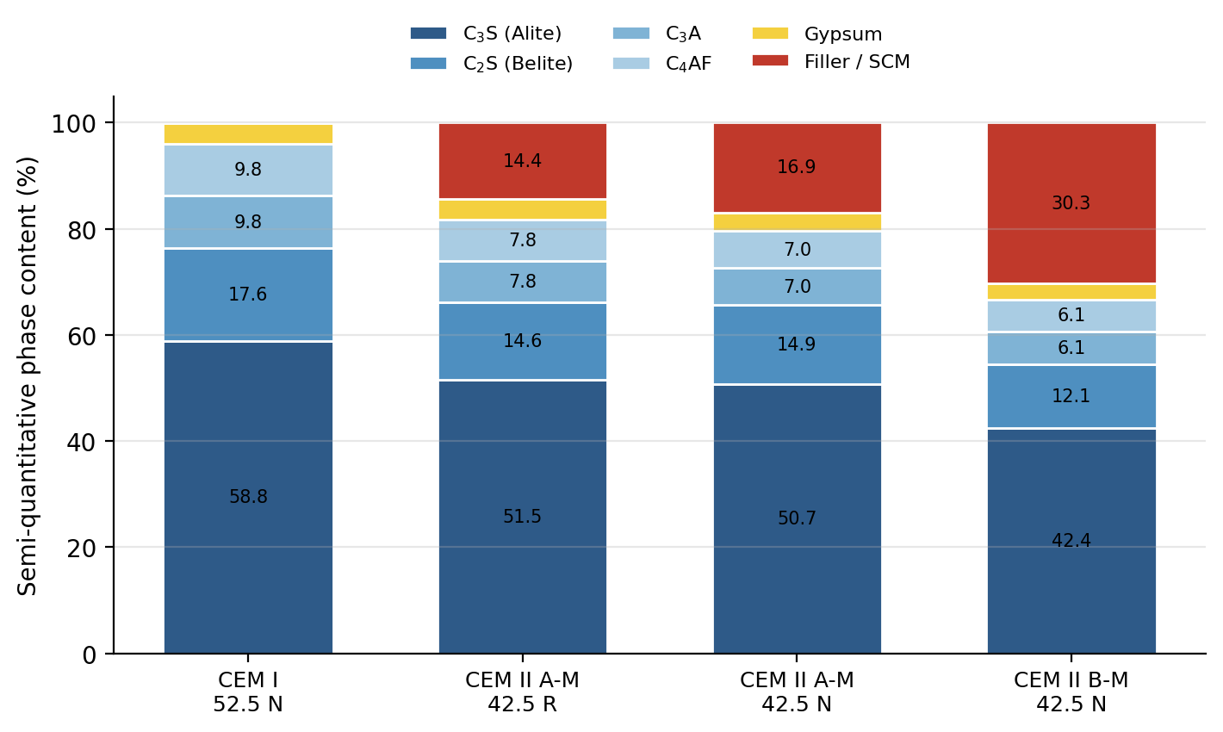
Fig. 1. Semi-quantitative XRD phase composition of the four cements, showing progressive clinker dilution from CEM I to CEM II B-M.
3.2 Heat-Generation Rate
The experimental specific heat-generation-rate curves (Fig. 2) show the characteristic early aluminate shoulder followed by the dominant silicate peak. CEM I 52.5 N exhibits the earliest and most intense main peak (≈ 3.0 J·min⁻¹·g⁻¹ near 290 min). CEM II A-M 42.5 R follows with a broad, high silicate peak, whereas the normal-strength CEM II A-M 42.5 N and CEM II B-M 42.5 N show progressively lower and more retarded peaks, reflecting clinker dilution and slower kinetics. The two-component Gaussian model reproduced the aluminate (G₁) and silicate (G₂) contributions; the fitted parameters and terminal cumulative heat are summarized in Table 3.
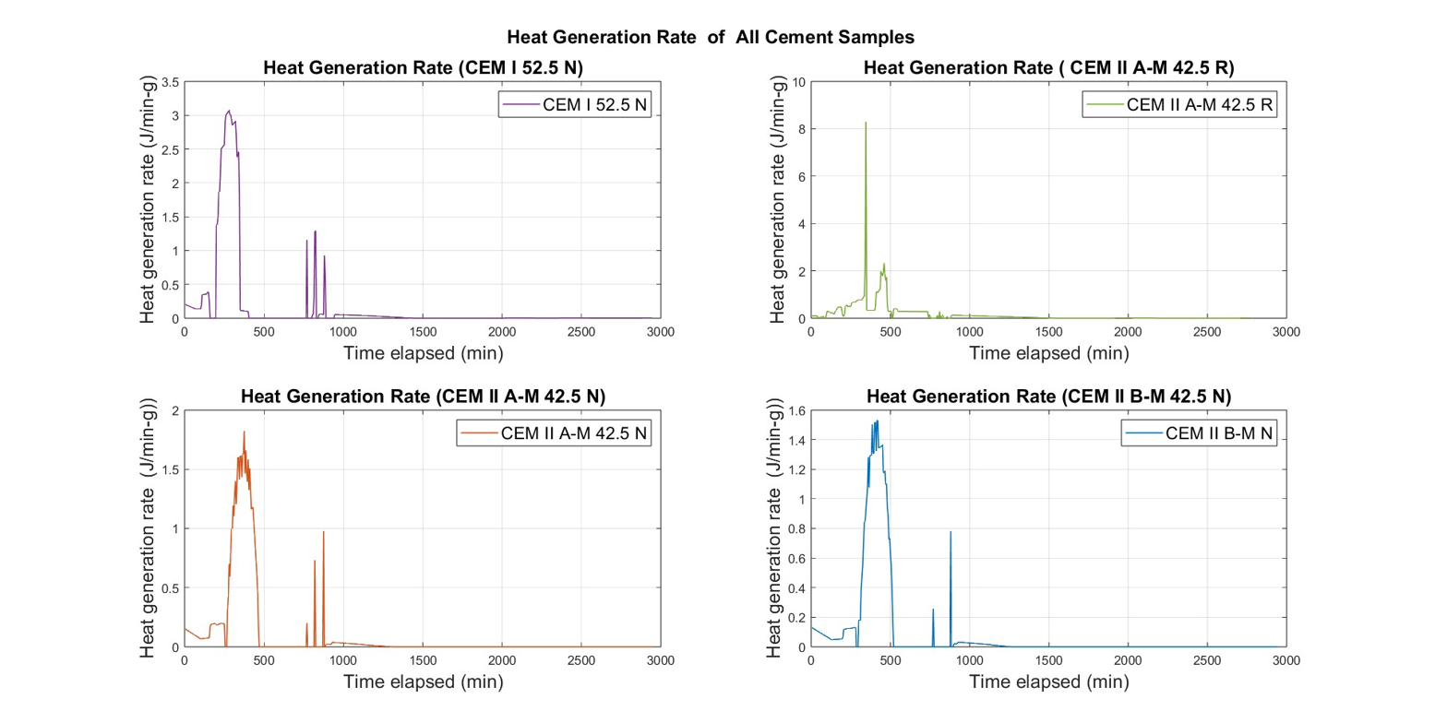
Fig. 2. Experimental heat-generation rate for the four cements (semi-adiabatic, w/c = 0.40).
Table 3. Two-component Gaussian parameters and terminal cumulative heat.
Parameter | CEM I 52.5 N | CEM II A-M 42.5 R | CEM II A-M 42.5 N | CEM II B-M 42.5 N
G₁ amplitude (J·min⁻¹·g⁻¹) | 0.40–0.45 | 0.30–0.40 | 0.15–0.20 | 0.12–0.16
G₂ amplitude (J·min⁻¹·g⁻¹) | 2.8–3.3 | 2.2–2.6 | 1.5–2.0 | 1.3–1.6
G₂ peak time (min) | 280–340 | 310–370 | 400–460 | 450–510
Terminal heat, exp. (J/g) | ≈467 | ≈433 | ≈284 | ≈255
Terminal heat, Gauss-2 (J/g) | ≈438 | ≈433 | ≈262 | ≈242
3.3 Cumulative Heat and Model Fits
The cumulative-heat curves (Fig. 3) confirm the ranking CEM I 52.5 N (≈ 467 J/g) > CEM II A-M 42.5 R (≈ 433 J/g) > CEM II A-M 42.5 N (≈ 284 J/g) > CEM II B-M 42.5 N (≈ 255 J/g). The most striking result is that the rapid-hardening CEM II A-M 42.5 R releases only about 7% less heat than CEM I and roughly 52% more than the normal-strength CEM II A-M 42.5 N of nominally the same composition — a direct consequence of its higher Blaine fineness accelerating C₃S hydration. Sixth-order polynomial fits to the cumulative curves achieved R² > 0.999 for every cement, providing continuous expressions directly usable in finite-element thermal models; the Gaussian rate model remains preferable for mechanistic interpretation of the individual hydration stages.
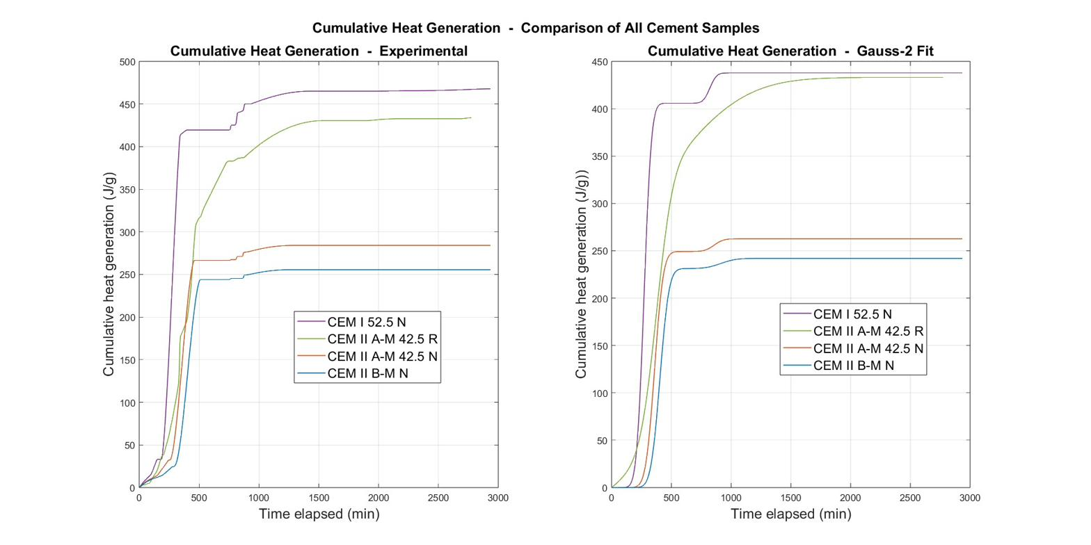
Fig. 3. Cumulative heat generation — experimental (left) and two-component Gaussian fit (right).
3.4 VCCTL Validation
The VCCTL simulations (Fig. 4) reproduce the experimental thermal ranking and the mineralogical interpretation. At 19 h, CEM I 52.5 N reaches the highest simulated heat release (≈ 480 kJ/kg), CEM II A-M 42.5 R the second highest (≈ 445 kJ/kg), the normal-strength CEM II A-M 42.5 N ≈ 390 kJ/kg and CEM II B-M 42.5 N the lowest (≈ 348 kJ/kg). As summarized in Table 4, the simulation agrees with experiment within about 3% for the high-clinker cements (CEM I and CEM II A-M 42.5 R) but over-predicts the slow blended cements by roughly 37%. This systematic over-prediction is expected: VCCTL runs under isothermal conditions and approaches the ultimate degree of hydration, whereas the semi-adiabatic test is heat-loss-corrected and time-truncated, so the slow blended reactions had not completed when monitoring ended. The high simulated degree of hydration of CEM II A-M 42.5 N (≈ 0.95) reflects this isothermal idealization rather than a contradiction of its modest measured heat.
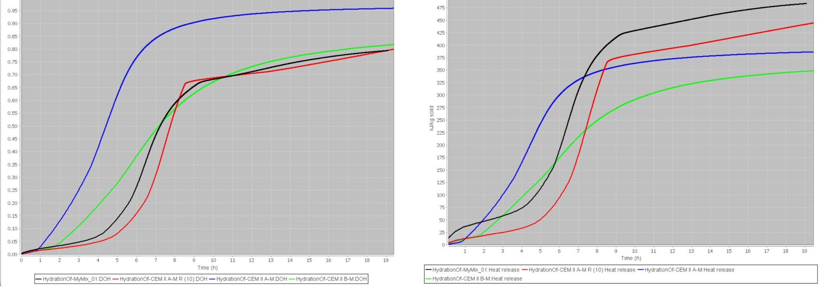
Fig. 4. VCCTL-simulated degree of hydration (left) and cumulative heat release (right) (isothermal, w/c = 0.40). Legend: MyMix_01 = CEM I 52.5 N; CEM II A-M = CEM II A-M 42.5 N; CEM II A-M R (10) = CEM II A-M 42.5 R; CEM II B-M = CEM II B-M 42.5 N.
Table 4. Experimental vs. VCCTL cumulative heat, simulated degree of hydration (DOH) at 19 h, and estimated thermal-cracking risk.
Cement | Exp. Q (J/g) | VCCTL Q (kJ/kg) | Rel. diff. (%) | DOH (19 h) | Est. ΔT (°C)
CEM I 52.5 N | ≈467 | ≈480 | +2.8 | 0.81 | >40
CEM II A-M 42.5 R | ≈433 | ≈445 | +2.7 | 0.80 | 32–38
CEM II A-M 42.5 N | ≈284 | ≈390 | +37.3 | 0.95 | 25–28
CEM II B-M 42.5 N | ≈255 | ≈348 | +36.5 | 0.825 | 22–25
3.5 Thermal-Cracking Risk and Practical Implications
Estimating the adiabatic temperature rise as ΔT ≈ Q / cₚ (with cₚ ≈ 1.0 kJ/kg·K) places CEM I 52.5 N above 40 °C and CEM II B-M 42.5 N at only 22–25 °C, so the thermal-cracking risk ranks CEM I 52.5 N > CEM II A-M 42.5 R > CEM II A-M 42.5 N > CEM II B-M 42.5 N. Against the 20 °C core-to-surface limit recommended by ACI 207R and CIRIA C660, CEM II B-M 42.5 N is clearly the most favorable for raft foundations, bridge piers and other temperature-sensitive placements, while CEM I requires active temperature control (pre-cooling, staged casting, insulation management) in thick sections. Critically, CEM II A-M 42.5 R must not be treated as a low-heat composite cement: its near-Portland heat output means it demands the same thermal precautions as CEM I. These conclusions are amplified in the tropical climate of Bangladesh, where high ambient temperatures further increase internal gradients.
4. CONCLUSIONS
A combined XRD–calorimetry–modelling–VCCTL study of four BDS EN 197-1 cements yielded the following conclusions:
(1) Cumulative heat ranked CEM I 52.5 N (≈467 J/g) > CEM II A-M 42.5 R (≈433 J/g) > CEM II A-M 42.5 N (≈284 J/g) > CEM II B-M 42.5 N (≈255 J/g), in agreement with the XRD clinker-dilution sequence.
(2) The rapid-hardening CEM II A-M 42.5 R behaved almost like a Portland cement, releasing only ≈7% less heat than CEM I despite its mineral additions, because early strength is achieved through fineness rather than clinker content.
(3) Two-component Gaussian models captured the aluminate and silicate stages, and sixth-order polynomials reproduced the cumulative curves with R² > 0.999, giving analytical inputs ready for finite-element thermal simulation.
(4) VCCTL reproduced the experimental ranking and matched the high-clinker cements within ≈3%, while over-predicting the slow blended cements by ≈37% as expected from its isothermal, near-ultimate idealization.
(5) For mass concrete in tropical conditions, CEM II B-M 42.5 N is the preferred low-heat option, whereas CEM II A-M 42.5 R should be managed as a high-heat cement.
5. ACKNOWLEDGEMENTS
The authors gratefully acknowledge their supervisor and the Department of Civil Engineering, BUET, for the laboratory facilities used in this study.
6. REFERENCES
[1] ACI Committee 207 (2005). Guide to Mass Concrete (ACI 207.1R). American Concrete Institute, Farmington Hills, MI.
[2] Bentz, D. P. (2007). Transient plane source measurements of the thermal properties of hydrating cement pastes. Materials and Structures, 40, 1073–1080.
[3] CIRIA (2007). Early-age thermal crack control in concrete (C660). CIRIA, London.
[4] De Schutter, G., & Taerwe, L. (1995). General hydration model for Portland cement and blast furnace slag cement. Cement and Concrete Research, 25(3), 593–604.
[5] Ferraro, C. C., Watts, B., Tao, C., & Masters, F. (2018). Advanced analysis, validation and optimization of virtual cement and concrete testing. University of Florida / FDOT.
[6] Klemczak, B., & Batog, M. (2016). Heat of hydration of low-clinker cements. Journal of Thermal Analysis and Calorimetry, 123(1), 1351–1360.
[7] Lothenbach, B., Scrivener, K., & Hooton, R. D. (2011). Supplementary cementitious materials. Cement and Concrete Research, 41(12), 1244–1256.
[8] Pane, I., & Hansen, W. (2005). Investigation of blended cement hydration by isothermal calorimetry and thermal analysis. Cement and Concrete Research, 35(6), 1155–1164.
[9] Rastogi, H., Moharana, S., & Subhash, S. (2024). Prediction of hydration properties and microstructure development of cement mortar using VCCTL. Discover Civil Engineering, 1, 152.
[10] RILEM TC 119-TCE (1997). Adiabatic and semi-adiabatic calorimetry to determine the temperature increase in concrete due to hydration heat of cement. Materials and Structures, 30(8), 451–464.
[11] Scrivener, K. L., Juilland, P., & Monteiro, P. J. M. (2015). Advances in understanding hydration of Portland cement. Cement and Concrete Research, 78, 38–56.
[12] Taylor, H. F. W. (1997). Cement Chemistry (2nd ed.). Thomas Telford, London.

