* **Yaml** overview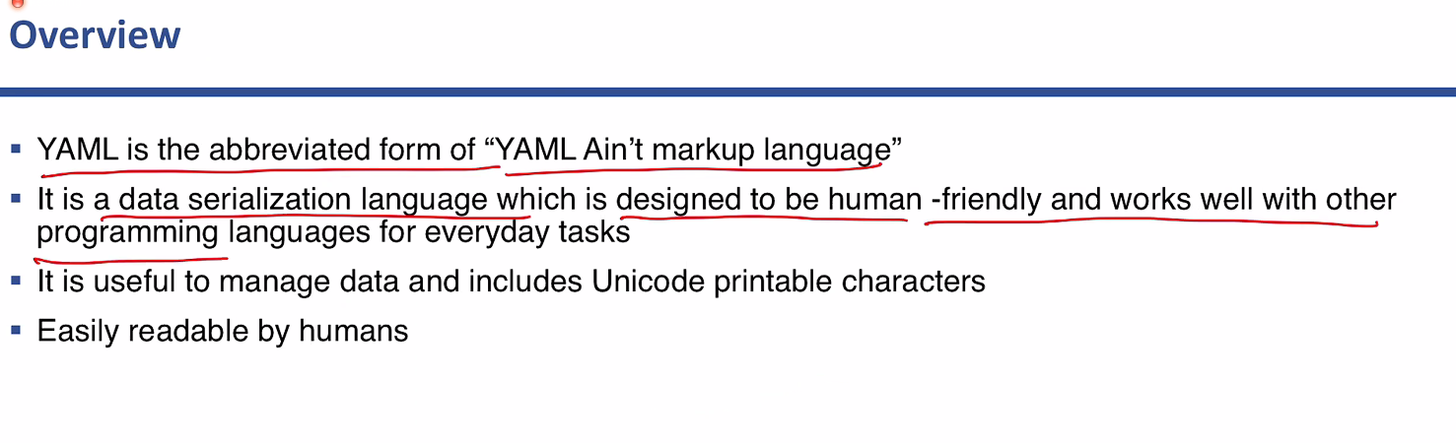
* <https://www.youtube.com/watch?v=pt0ovzQhqFc&feature=youtu.be>

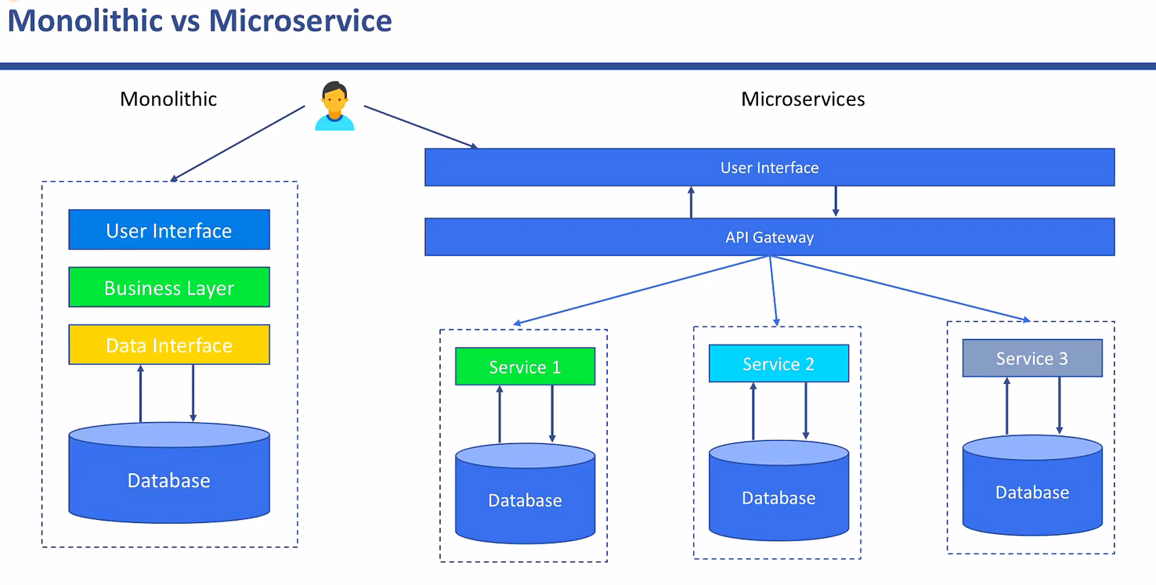

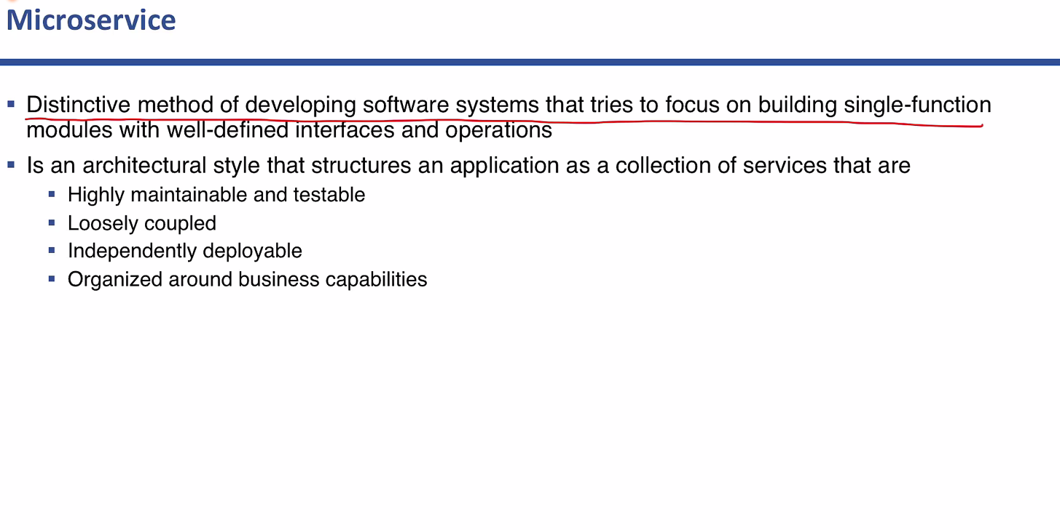

**Benefits for Microservice Architecture**

