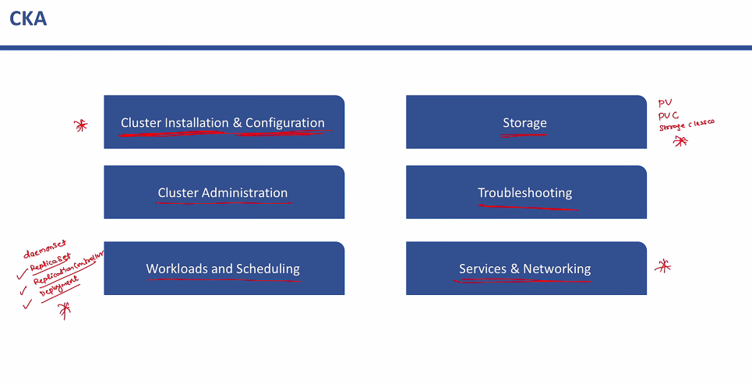

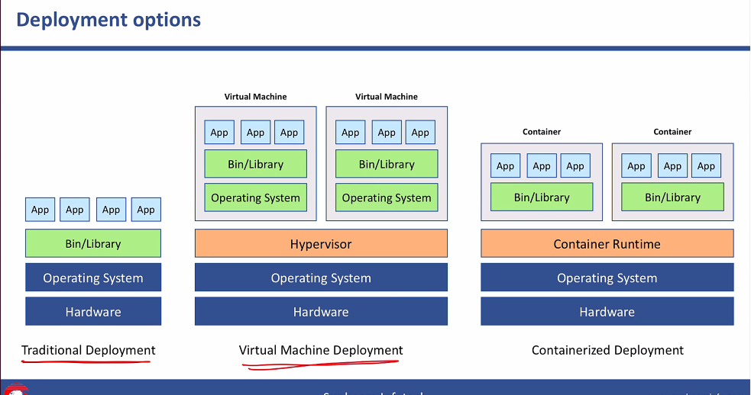

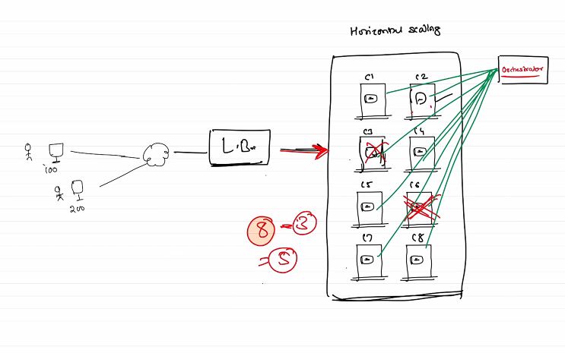

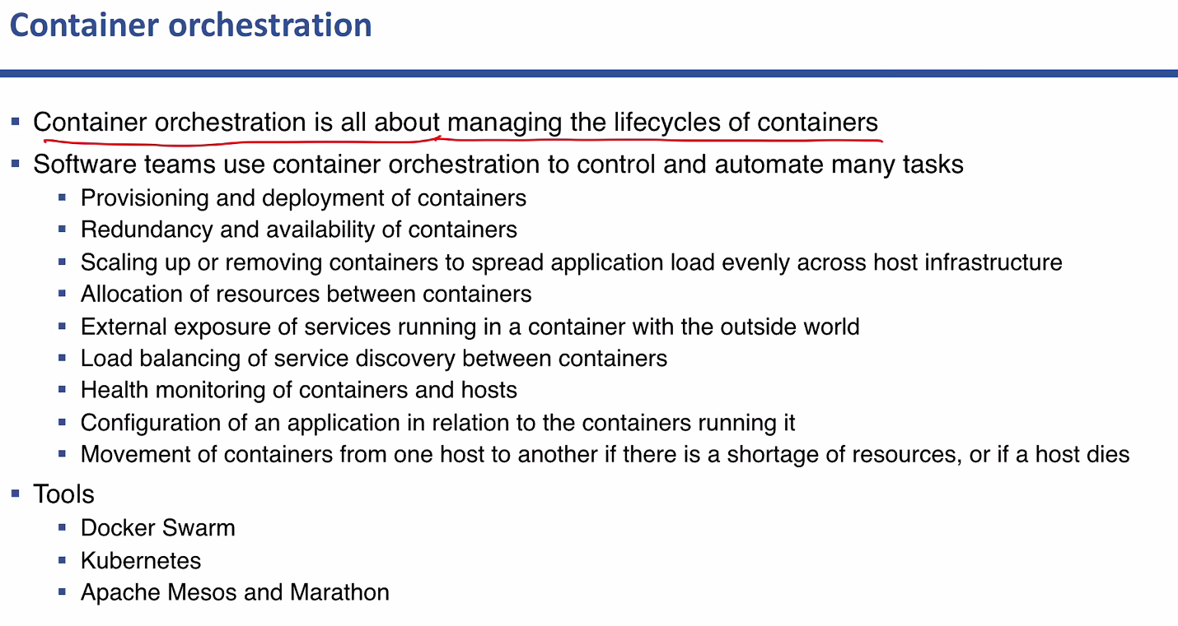

KUBERNETES

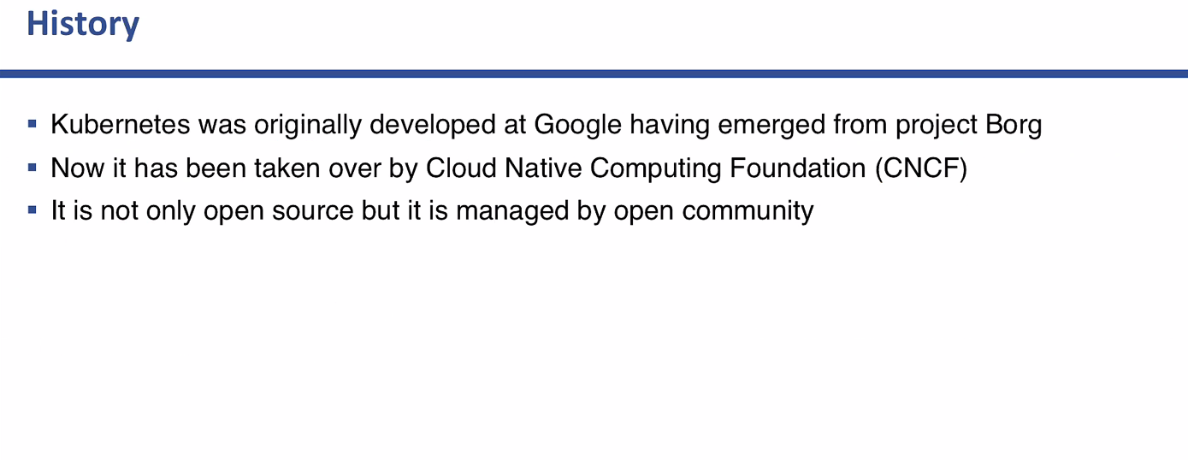

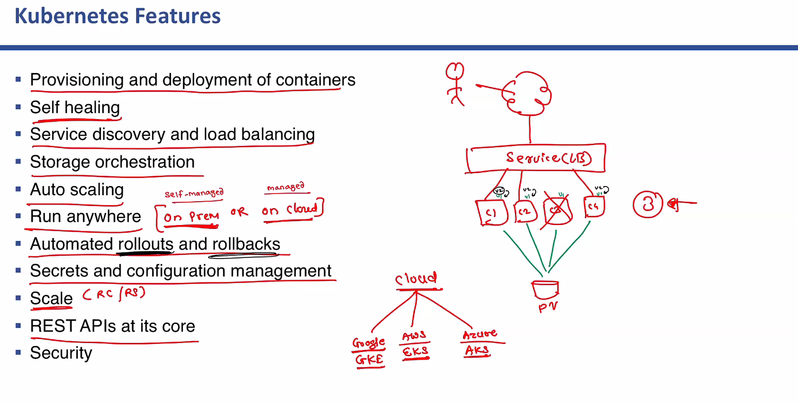

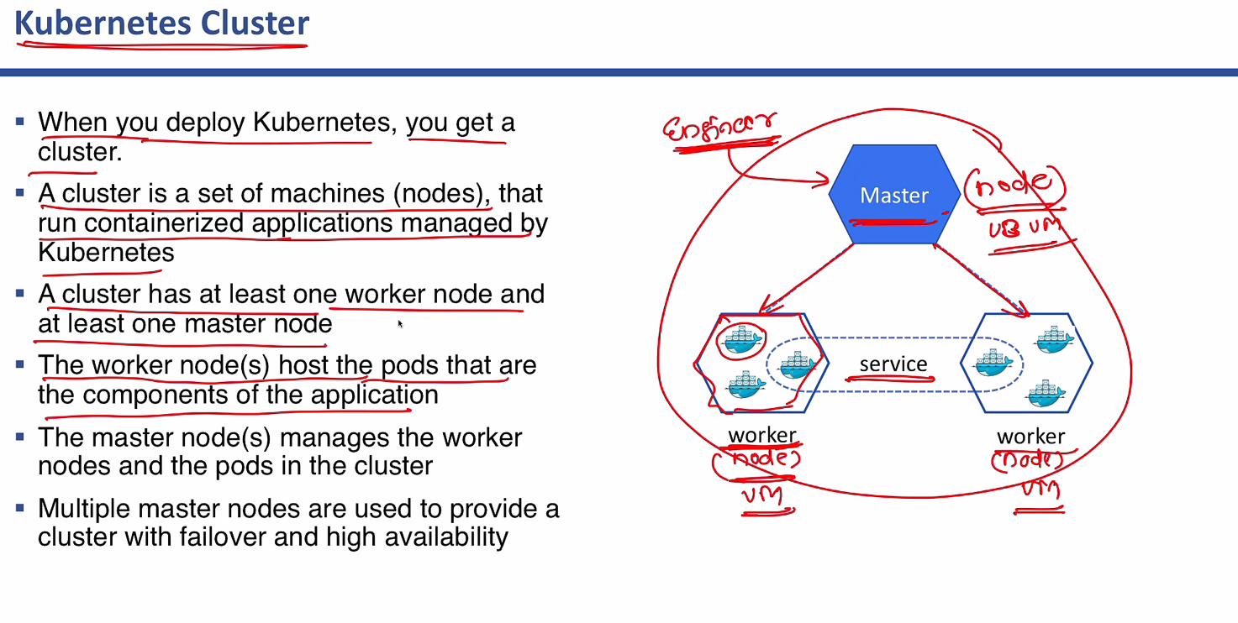

Commands:

-

https://www.youtube.com/watch?v=w5qylgABtww

<https://www.youtube.com/watch?v=O3LpWwvM34Y>

To setup the cluster: from this <https://v1-17.docs.kubernetes.io/docs/setup/production-environment/tools/kubeadm/create-cluster-kubeadm/>

-SSH Master:

vagrant ssh master

-Run this on master back to back:

sudo kubeadm init -sudo kubeadm init --apiserver-advertise-address=192.168.50.10 --pod-network-cidr=10.244.0.0/16

mkdir -p $HOME/.kube

sudo cp -i /etc/kubernetes/admin.conf $HOME/.kube/config

sudo chown $(id -u):$(id -g) $HOME/.kube/config

-Run the keys on both the nodes

kubeadm join 192.168.50.10:6443 --token s8orvx.c5mr17xb9tzoki0k \

--discovery-token-ca-cert-hash sha256:0d8d93dbfca4630655198866010670d59e32ca9a97d85da4e6e7a88e4467ac31

-On master run

kubectl apply -f "https://cloud.weave.works/k8s/net?k8s-version=$(kubectl version | base64 | tr -d '\n')"