Pod Design:

* First we have to dockerize the kubernetes container to run an application.
* 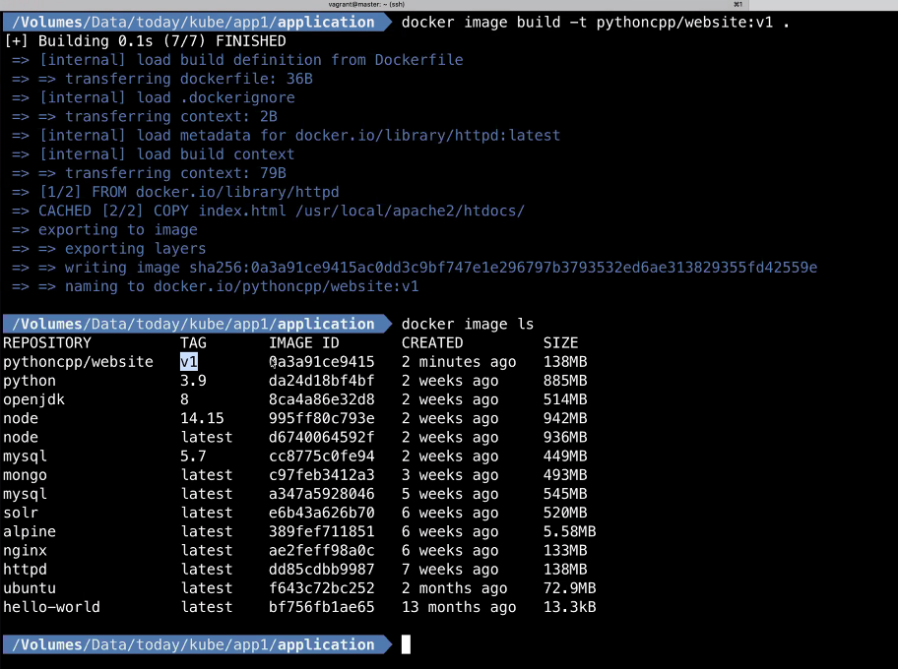
* 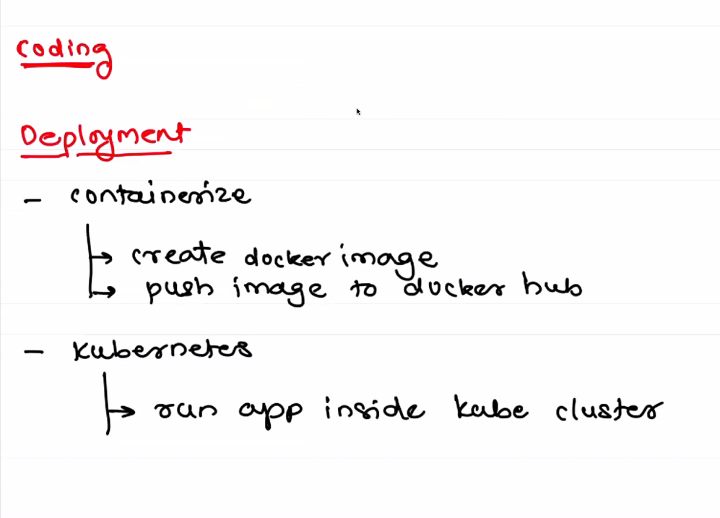
* k create -f pod.yml
* 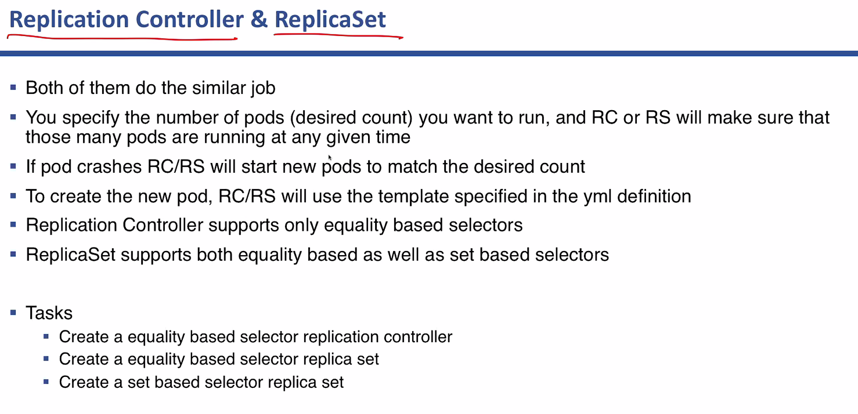
* 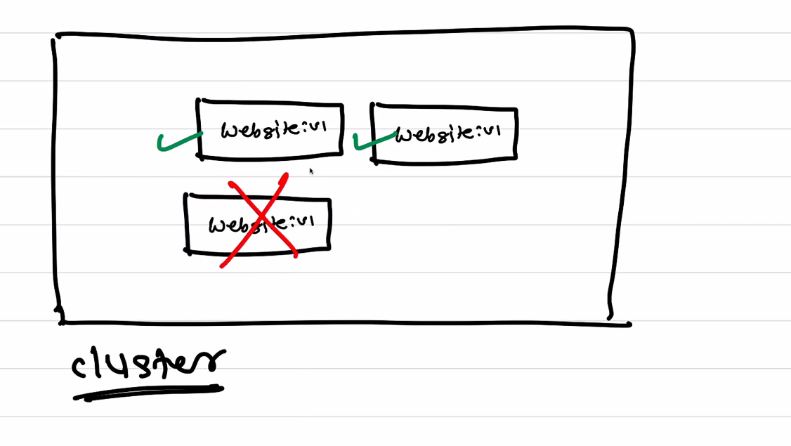
* A Labeling Mechanism is used by RC / RS to get to know which pod belongs to specific website.
* 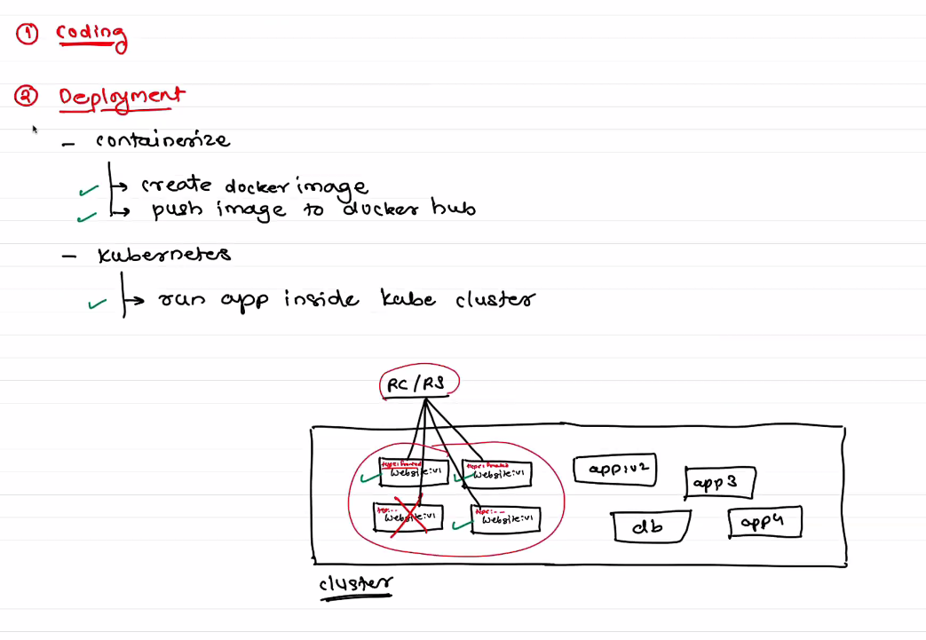
* In Replication controller, Selector label and metadata label on template should be same.

K apply replication-controller.yml

K get rc

k edit rc website

Difference b/w Replication controller and Replica set:

