* <https://kubernetes.io/docs/concepts/services-networking/service/>
* As the pods are terminating pods will have new IP addresses to communicate
* 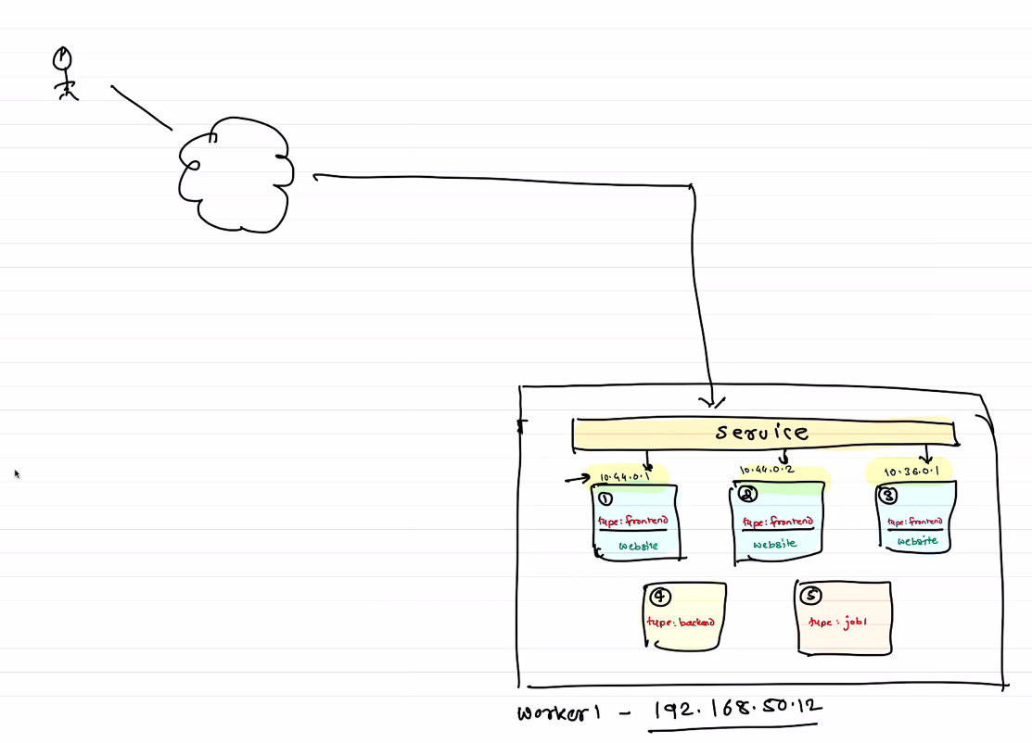
* 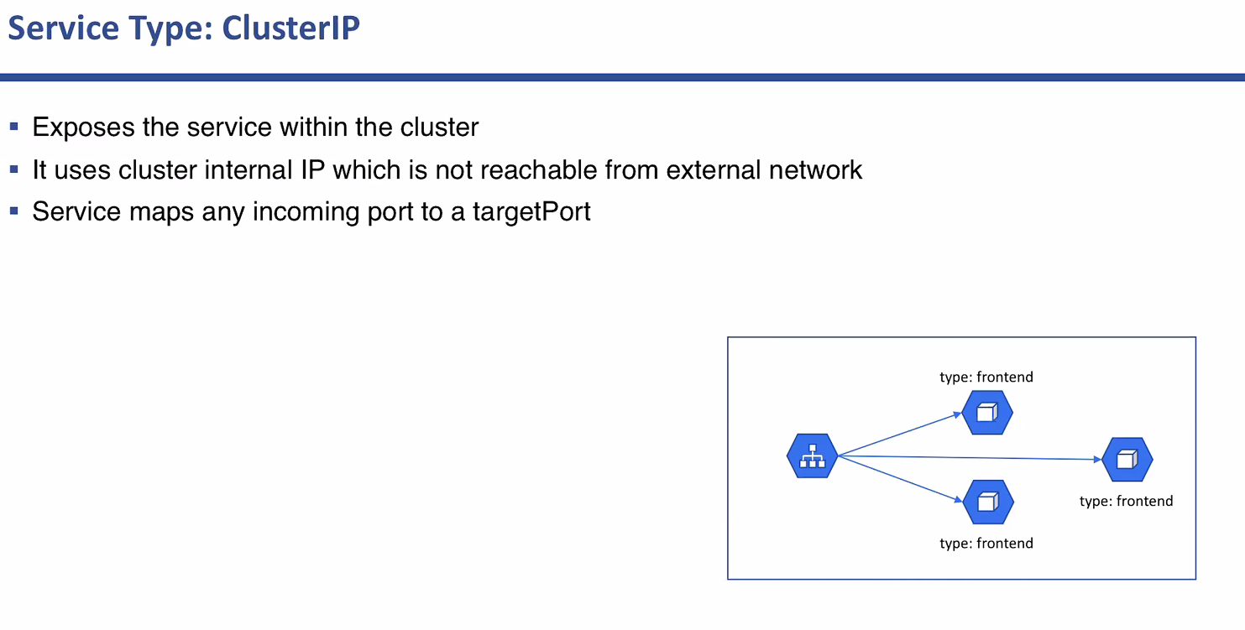
* 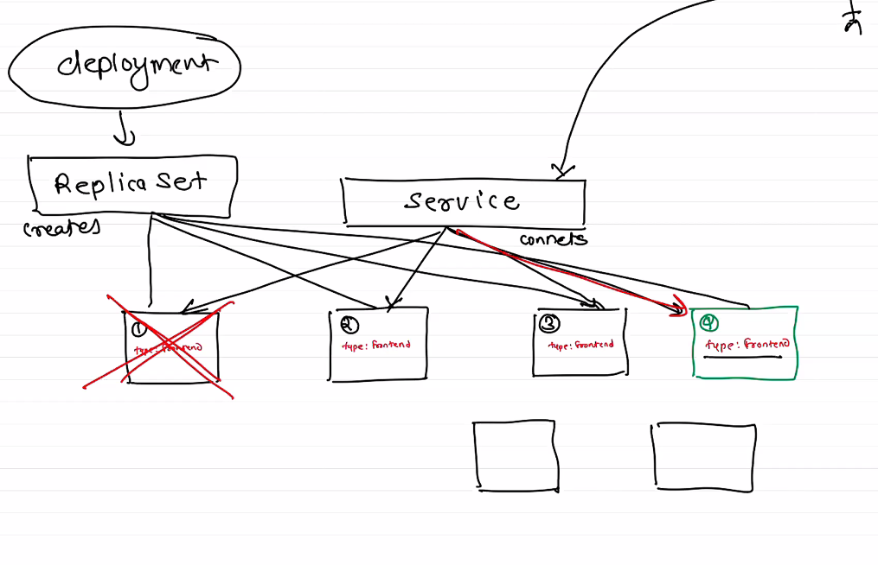
* Deployment/RS/RC is for managing the quantity (scaling) and Services is responsible for communication and availability with external world
* HPA, horizontal pod autoscaling.
* 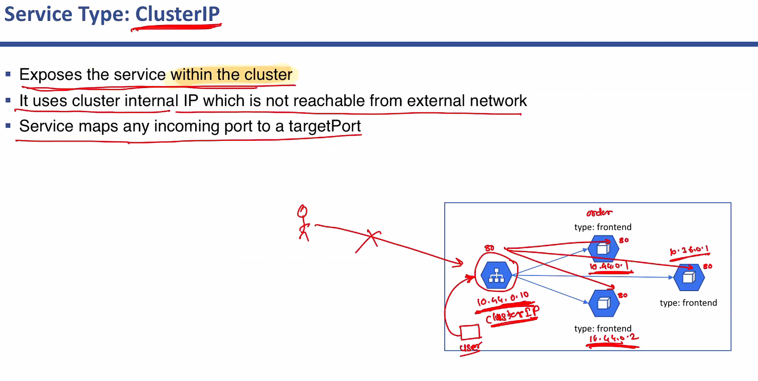
* 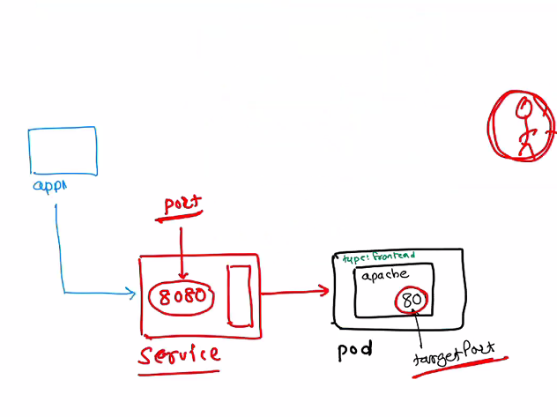
* 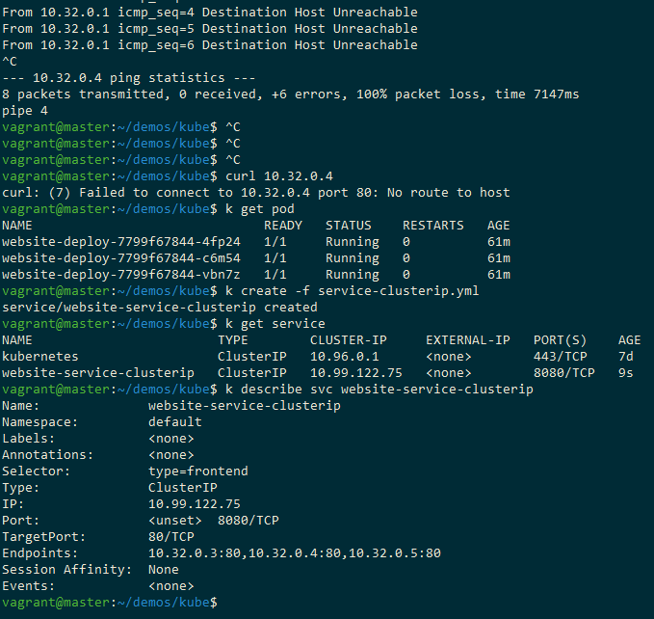
* Service should have end points to work.
* Service will detect all the pods with a specific selector label. Like type:frontend up here.

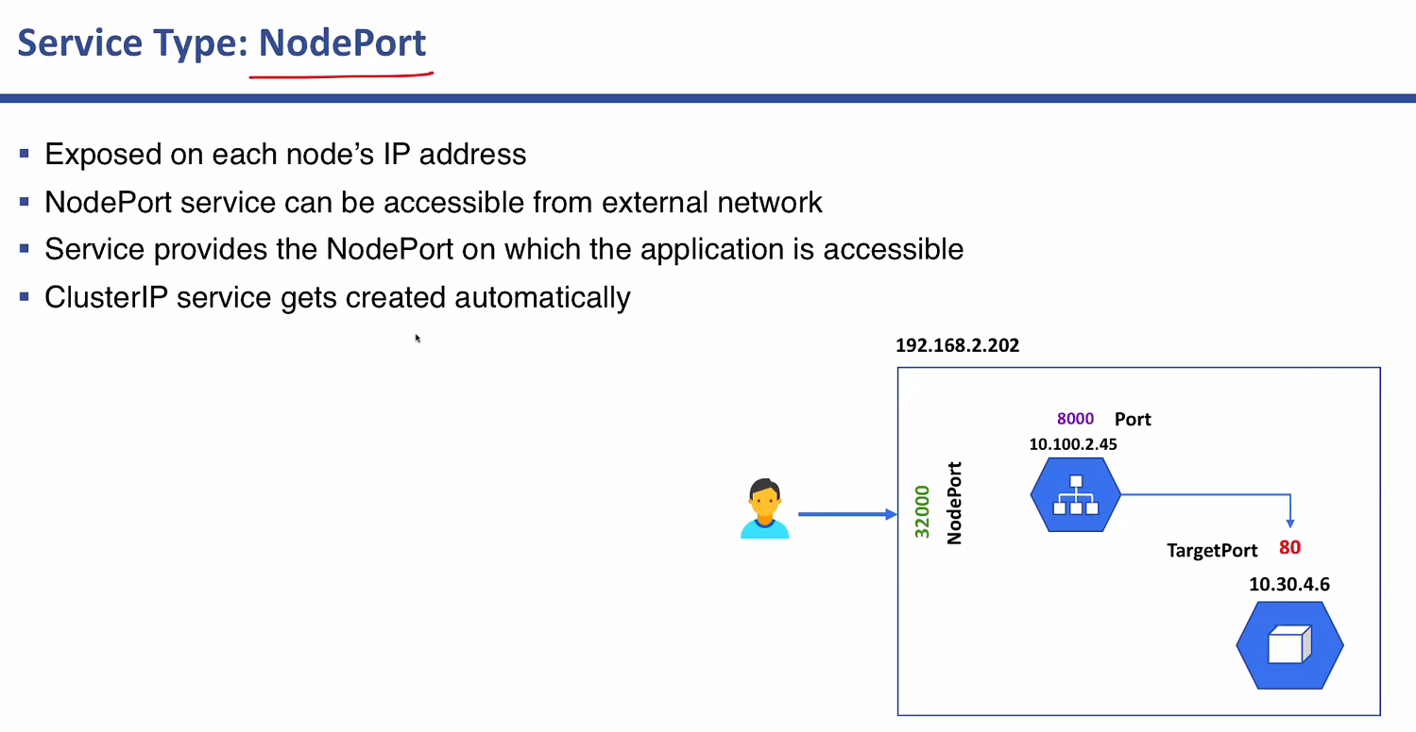

Nodeport will have an additional port for communicating with which outsite world.

Cluster IP can be accessed only within the cluster but nodeport can be access

alias k=kubectl

k get rc

k describe rc

k edit rc website

k describe node worker1

k describe node worker1 | less

k delete rc

k create -f replica-set.yml

k get rs

k describe rs

k create -f deployment.yml

k get deploy

k get rs

k get pod

k delete deploy website

k create -f service.yml

k get service